Create a new volume of 10 gb size in the same AZ as the ec2.

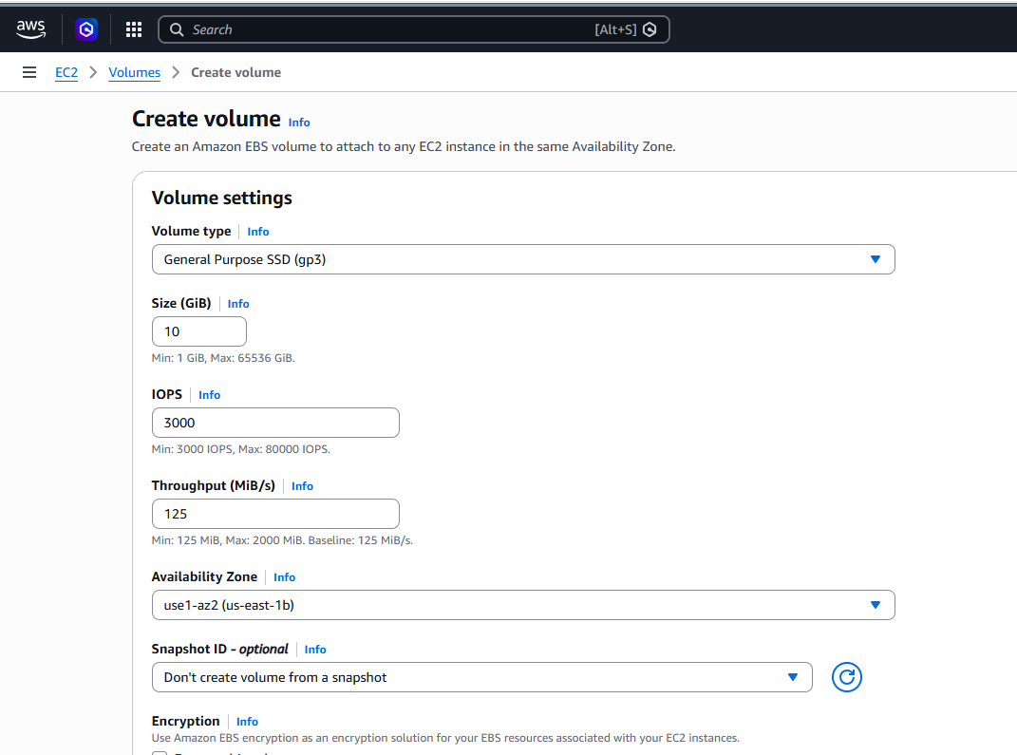

Attach the volume to the /dev/sdf location of the ec2

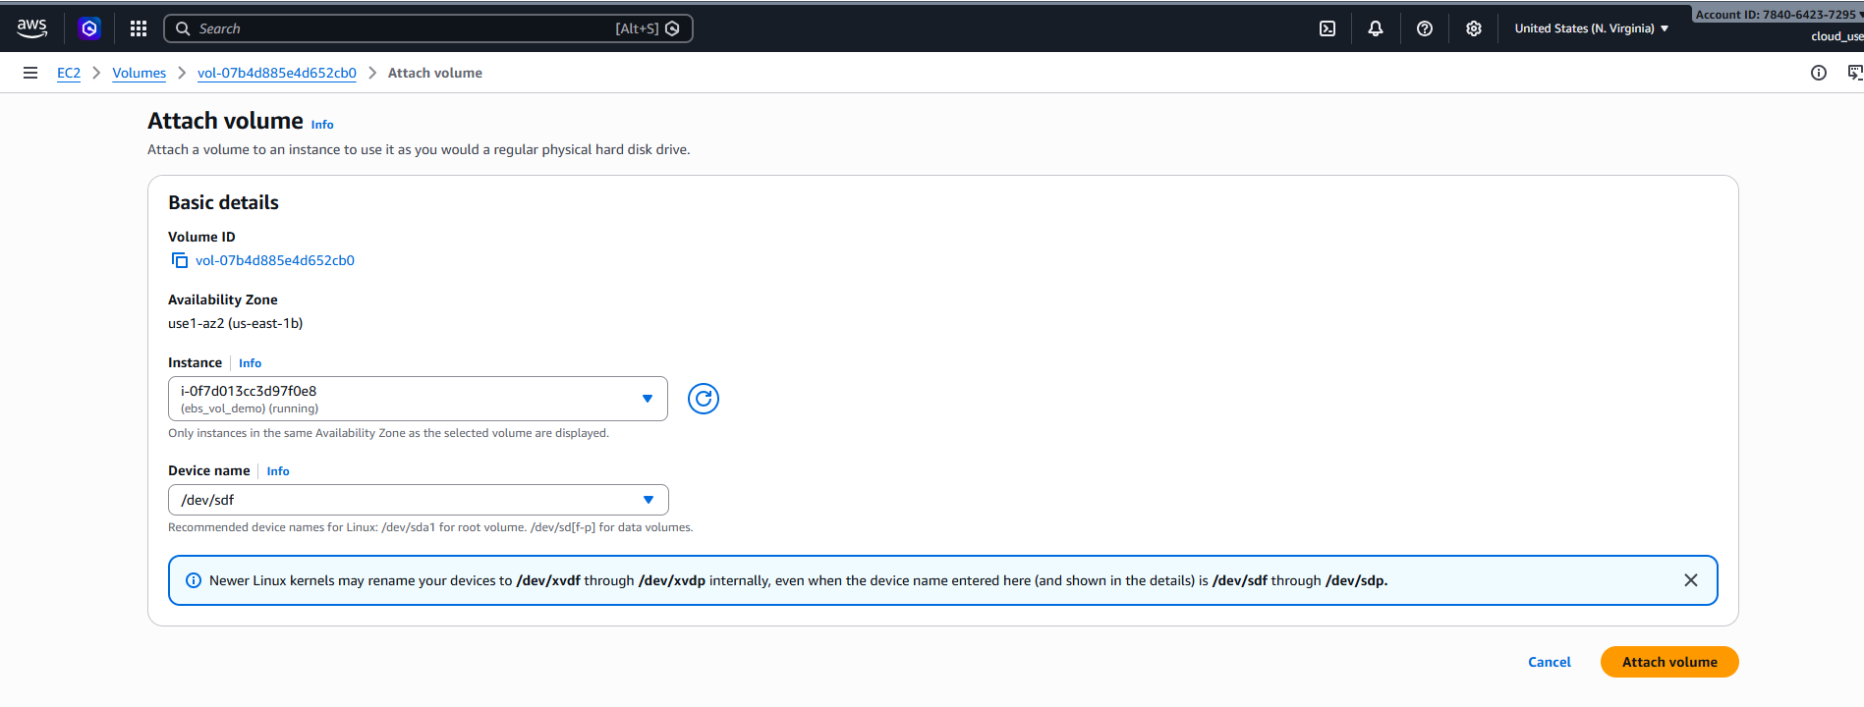

root@ip-10-0-1-139:~# lsblk
NAME MAJ:MIN RM SIZE RO TYPE MOUNTPOINTS
loop0 7:0 0 27.6M 1 loop /snap/amazon-ssm-agent/11797
loop1 7:1 0 74M 1 loop /snap/core22/2163
loop2 7:2 0 50.9M 1 loop /snap/snapd/25577
xvda 202:0 0 8G 0 disk
├─xvda1 202:1 0 7G 0 part /
├─xvda14 202:14 0 4M 0 part
├─xvda15 202:15 0 106M 0 part /boot/efi
└─xvda16 259:0 0 913M 0 part /boot
xvdf 202:80 0 10G 0 disk
root@ip-10-0-1-139:~# fdisk -l
Disk /dev/loop0: 27.65 MiB, 28991488 bytes, 56624 sectors
Units: sectors of 1 * 512 = 512 bytes
Sector size (logical/physical): 512 bytes / 512 bytes
I/O size (minimum/optimal): 512 bytes / 512 bytes

…………………………

Disk /dev/xvdf: 10 GiB, 10737418240 bytes, 20971520 sectors
Units: sectors of 1 * 512 = 512 bytes
Sector size (logical/physical): 512 bytes / 512 bytes
I/O size (minimum/optimal): 512 bytes / 512 bytes
root@ip-10-0-1-139:~#

Creating new partitions of xvdf.

root@ip-10-0-1-139:~# fdisk /dev/xvdf

Welcome to fdisk (util-linux 2.39.3).
Changes will remain in memory only, until you decide to write them.
Be careful before using the write command.

Device does not contain a recognized partition table.
Created a new DOS (MBR) disklabel with disk identifier 0xe7dff2ce.

Command (m for help): n
Partition type
p primary (0 primary, 0 extended, 4 free)
e extended (container for logical partitions)
Select (default p): p
Partition number (1-4, default 1): 1
First sector (2048-20971519, default 2048):
Last sector, +/-sectors or +/-size{K,M,G,T,P} (2048-20971519, default 20971519):

Created a new partition 1 of type 'Linux' and of size 10 GiB.

Command (m for help): w
The partition table has been altered.
Calling ioctl() to re-read partition table.
Syncing disks.

root@ip-10-0-1-139:~# lsblk
NAME MAJ:MIN RM SIZE RO TYPE MOUNTPOINTS
loop0 7:0 0 27.6M 1 loop /snap/amazon-ssm-agent/11797
loop1 7:1 0 74M 1 loop /snap/core22/2163
loop2 7:2 0 50.9M 1 loop /snap/snapd/25577
xvda 202:0 0 8G 0 disk
├─xvda1 202:1 0 7G 0 part /
├─xvda14 202:14 0 4M 0 part
├─xvda15 202:15 0 106M 0 part /boot/efi
└─xvda16 259:0 0 913M 0 part /boot
xvdf 202:80 0 10G 0 disk
└─xvdf1 202:81 0 10G 0 part

Format the partition
root@ip-10-0-1-139:~# mkfs.ext4 /dev/xvdf1
mke2fs 1.47.0 (5-Feb-2023)
Creating filesystem with 2621184 4k blocks and 655360 inodes
Filesystem UUID: 65cb15e5-3254-4a73-8f48-a8accb65a9b8
Superblock backups stored on blocks:
32768, 98304, 163840, 229376, 294912, 819200, 884736, 1605632

Allocating group tables: done
Writing inode tables: done
Creating journal (16384 blocks): done
Writing superblocks and filesystem accounting information: done

Creating /data directory where I want to mount the EBS block storage.
root@ip-10-0-1-139:~# mkdir /data
root@ip-10-0-1-139:~# mount /dev/xvdf1 /data
root@ip-10-0-1-139:~# df -kh
Filesystem Size Used Avail Use% Mounted on
/dev/root 6.8G 1.8G 5.0G 27% /
tmpfs 479M 0 479M 0% /dev/shm
tmpfs 192M 880K 191M 1% /run
tmpfs 5.0M 0 5.0M 0% /run/lock
/dev/xvda16 881M 89M 730M 11% /boot
/dev/xvda15 105M 6.2M 99M 6% /boot/efi
tmpfs 96M 12K 96M 1% /run/user/1000
/dev/xvdf1 9.8G 24K 9.3G 1% /data
root@ip-10-0-1-139:~#
LVM
root@ip-10-0-1-139:~# pvcreate /dev/xvdd
Physical volume "/dev/xvdd" successfully created.
root@ip-10-0-1-139:~# pvs
PV VG Fmt Attr PSize PFree
/dev/xvda14 my_vg lvm2 a-- 4.00m 0
/dev/xvdd lvm2 --- 10.00g 10.00g
root@ip-10-0-1-139:~# vgcreate titir_vg /dev/xvdd
Volume group "titir_vg" successfully created
root@ip-10-0-1-139:~# vgs
VG #PV #LV #SN Attr VSize VFree
my_vg 1 0 0 wz--n- 0 0
titir_vg 1 0 0 wz--n- <10.00g <10.00g
root@ip-10-0-1-139:~# lvcreate -L 8G -n titir_lv titir_vg
Logical volume "titir_lv" created.
root@ip-10-0-1-139:~# lvs
LV VG Attr LSize Pool Origin Data% Meta% Move Log Cpy%Sync Convert
titir_lv titir_vg -wi-a----- 8.00g
root@ip-10-0-1-139:~# mkfs.ext4 /dev/titir_vg/titir_lv
mke2fs 1.47.0 (5-Feb-2023)
Creating filesystem with 2097152 4k blocks and 524288 inodes
Filesystem UUID: b209b5f9-514d-46da-be8c-af485b790157
Superblock backups stored on blocks:
32768, 98304, 163840, 229376, 294912, 819200, 884736, 1605632

Allocating group tables: done
Writing inode tables: done
Creating journal (16384 blocks): done
Writing superblocks and filesystem accounting information: done

root@ip-10-0-1-139:~# mkdir -p /titir
root@ip-10-0-1-139:~# mount /dev/titir_vg/titir_lv /titir
root@ip-10-0-1-139:~# df -kh
Filesystem Size Used Avail Use% Mounted on
/dev/root 6.8G 1.8G 5.0G 27% /
tmpfs 479M 0 479M 0% /dev/shm
tmpfs 192M 888K 191M 1% /run
tmpfs 5.0M 0 5.0M 0% /run/lock
/dev/xvda16 881M 89M 730M 11% /boot
/dev/xvda15 105M 6.2M 99M 6% /boot/efi
tmpfs 96M 12K 96M 1% /run/user/1000
/dev/xvdf1 9.8G 24K 9.3G 1% /data
/dev/mapper/titir_vg-titir_lv 7.8G 24K 7.4G 1% /titir
root@ip-10-0-1-139:/titir# touch my_life
root@ip-10-0-1-139:/titir# vim my_life
root@ip-10-0-1-139:/titir# du -sh *
16K lost+found
4.0K my_life
root@ip-10-0-1-139:/titir#

