Progress Report

Thierry Sae-Lim – Norikazu Takahashi
Okayama University
July 24, 2026

Research Objective and Goal
The final goal of the project is to implement the distributed algorithm for PCA (Principal Component Analysis) developped by our lab and test its validity based on numerical experiment.

Short-Term Goals
8. Adding a new variable to set the number of iteration for the consensus of the matrices Y and Z separately.
9. Study the parameters T_CONS_Y and T_CONS_Z, and K1, K2, and EPS and its implication on the convergence speed.

Progress
8. Done

9. We consider those initial global variables for ploting the same exact instance:
NB_AGENT = 8, NB_EDGE = 25,
N_DIM = 5, P_DIM = 3,
T_PM = 14000, T_CONS_Y = 1, T_CONS_Z = 10,
K1 = 0.2, K2 = 0.4, EPS = 0.1

Here is some plots when:

- changing the number of iterations for the average consensus of the matrices Y_m(t) T_CONS_Y:
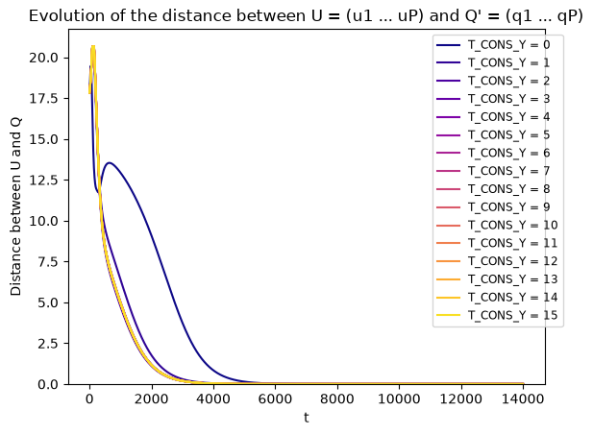
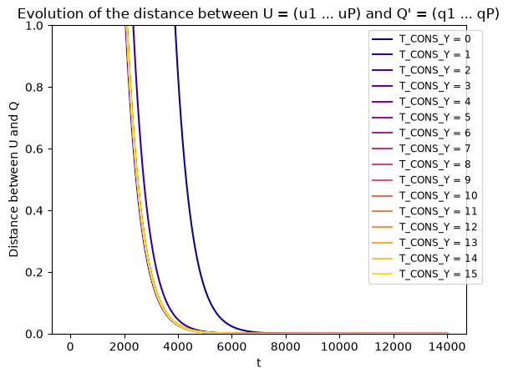
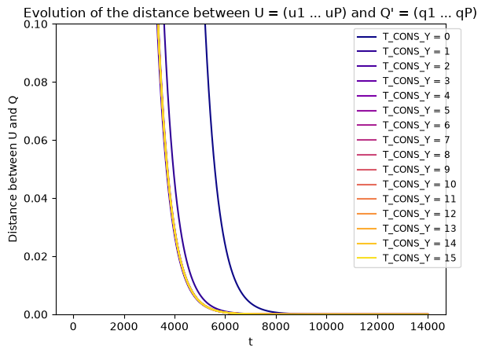
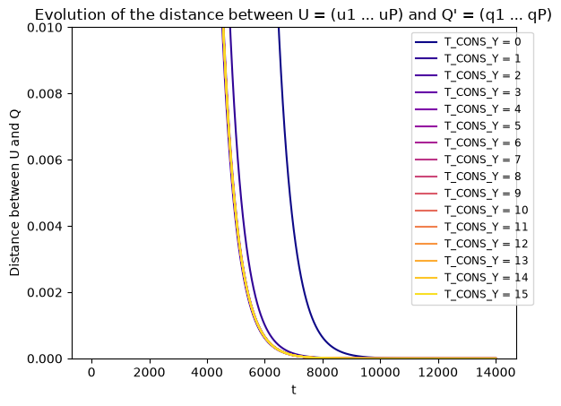
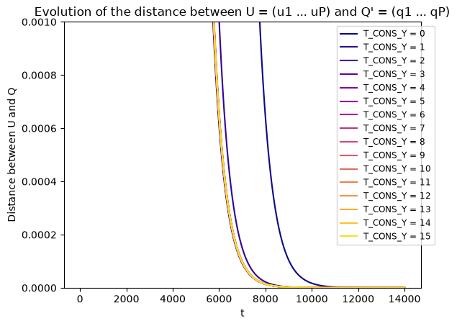
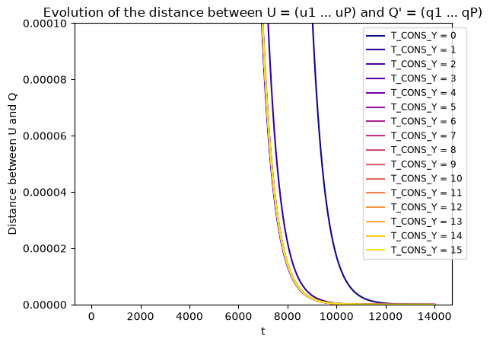

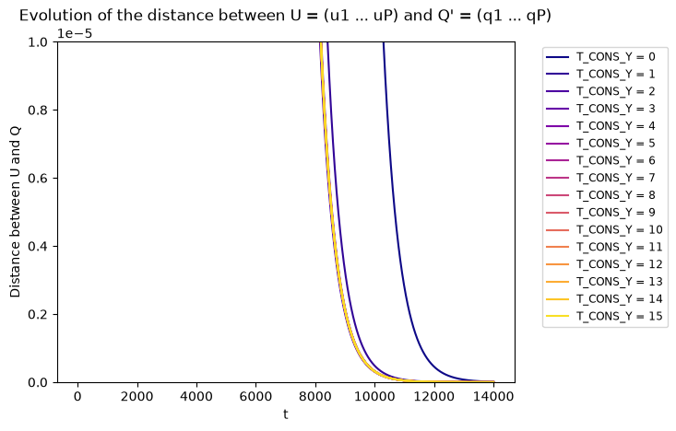
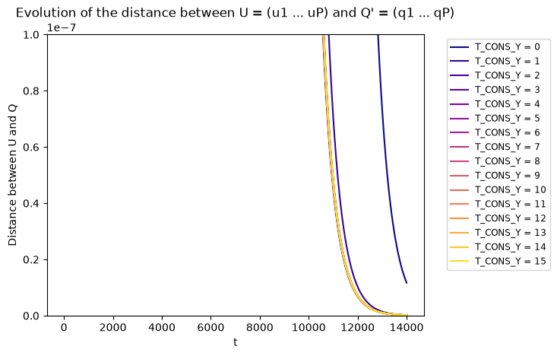
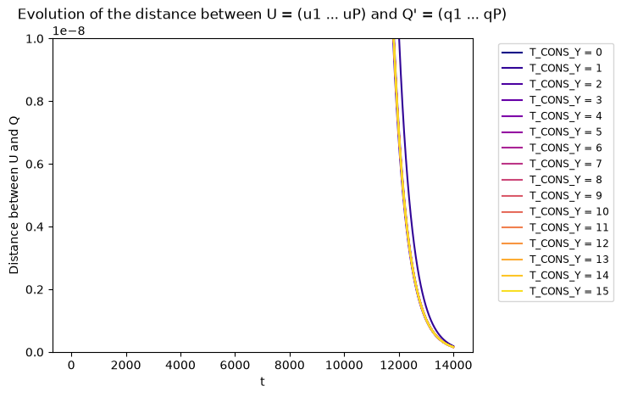
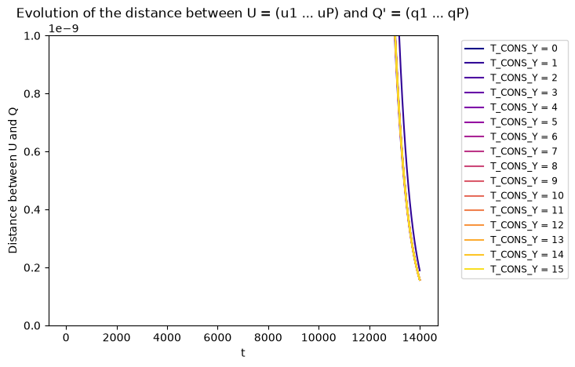
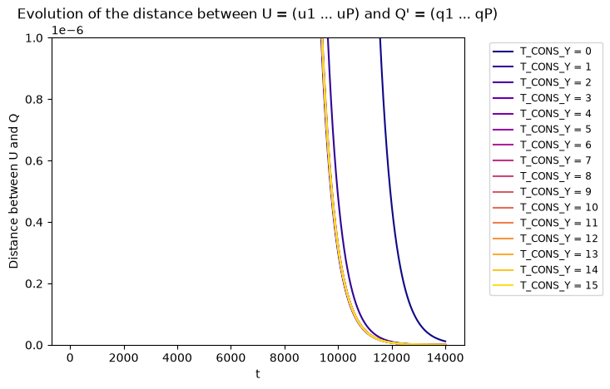
Table of accuracies of the found solutions U to the optimal solution Q’ while changing the T_CONS_Y value. (Red: inaccurate for all agents, Yellow: accurate and inacurrate for some agents, Green: accurate for all agents)

Accuracy at 1e-i  T_CONS_Y | 1 | 2 | 3 | 4 | 5 | 6
0
1
2
3
4
5
6
7
8
9
10
11
12
13
14
15

We can observe that the number of iterations for the averaging consensus of matrices Y doesn’t really affect the convergence. A smaller number of iterations can be conpensated with a larger number iterations of the update rule. A too large value of T_CONS_Y shouldn’t be necessary. The T_CONS_Y=0 curve is showing a convergence with 0 iteration of the averaging consensus of Y, that is to say, with the use of matrices U to compute Z. We can conclude that computing the matrices Y isn’t even necessary for the convergence with a sufficiently large number of iterations for the update rule T_PM.

- changing the number of iterations for the average consensus of the matrices Z_m(t) T_CONS_Z:
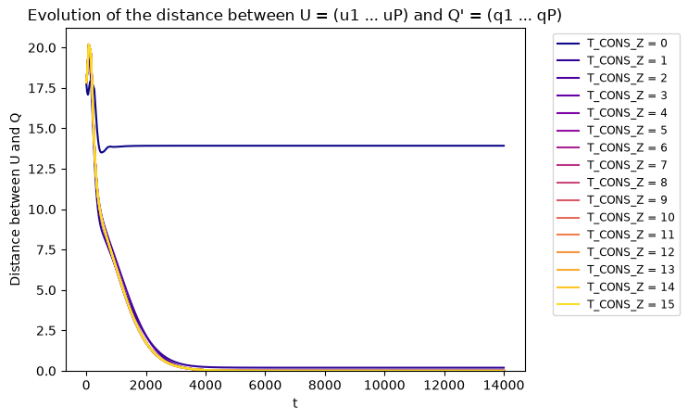
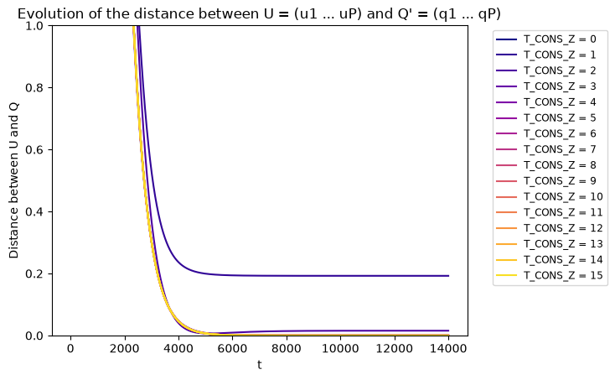
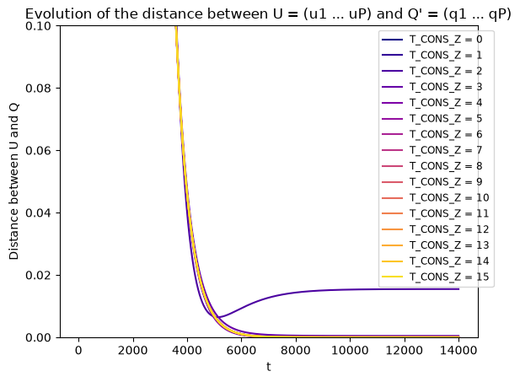
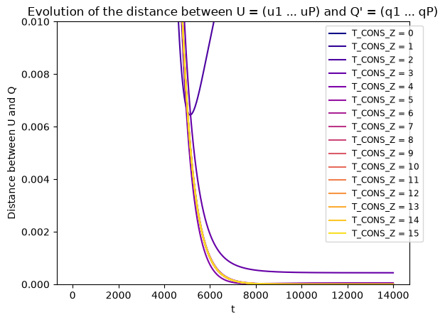
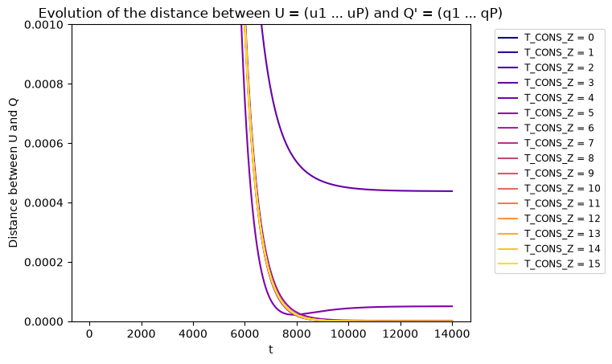
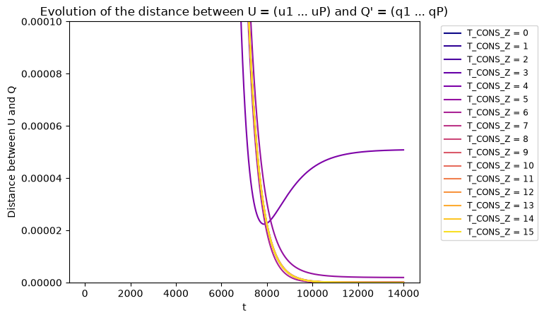
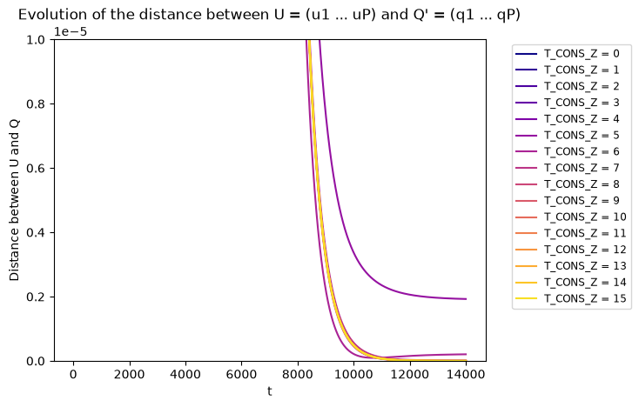
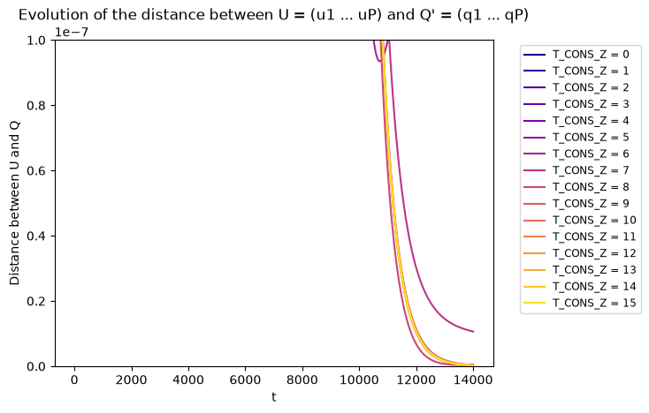
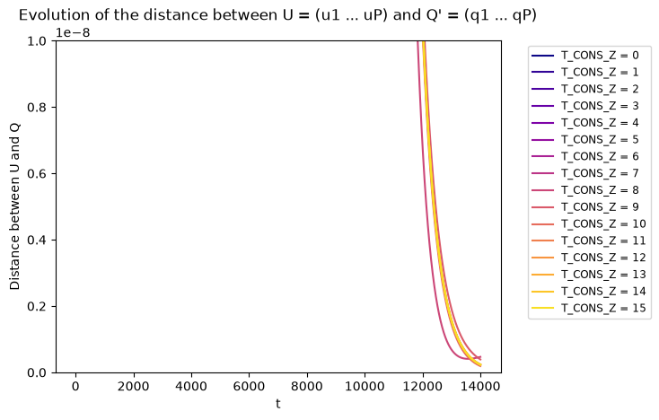
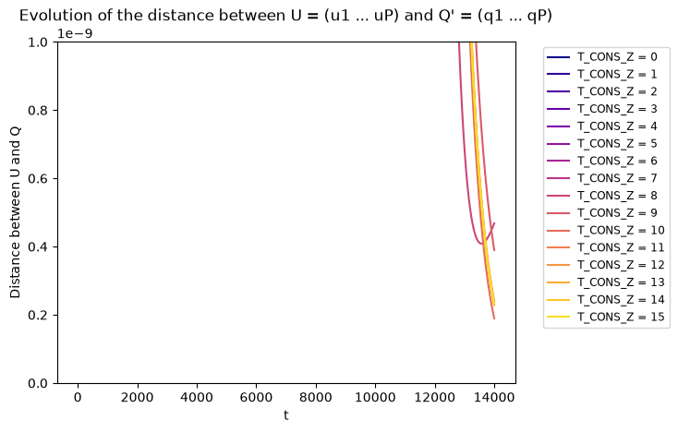
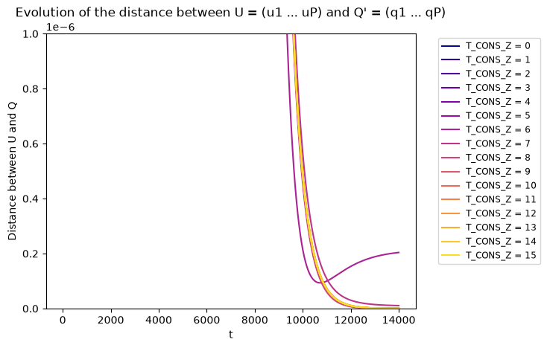
Table of accuracies of the found solutions U to the optimal solution Q’ while changing the T_CONS_Z value. (Red: inaccurate for all agents, Yellow: accurate and inacurrate for some agents, Green: accurate for all agents)

Accuracy at 1e-i  T_CONS_Z | 1 | 2 | 3 | 4 | 5 | 6
0
1
2
3
4
5
6
7
8
9
10
11
12
13
14
15

We can observe that having a larger number of iterations for the averaging consensus of the matrices Z reduces the convergence error. The more larger the number of iterations is, the more accurate the convergence is.

At first sight, the number of iteration T_CONS_Z doesn’t really affect the convergence speed but the accuracy of the convergence. However, the number of iterations T_CONS_Y - while not strictly necessary – can maybe be manipulated alongside with the number of iterations of the update rule T_PM to reduce the overall number of iterations of the decetralized algorithm for PCA.

- changing the update rule parameter K1
