Protocol # | Description | Objective | Reqt/Spec | Author
WIA- | Add new Groups | To verify that the user can add New Groups in Administrator.  In this test case following functionalities will be tested - creation new group, search created a group in the table, deletion of the group will be tested.

Prerequisites | - Standard System Configuration.  - User login.  - The user must be logged into the Web Interface as an administrator.
Procedure | - Log in as a web interface.  - Click on Administration link from the top right menu.  - Click on 'Groups' tab from the administration list.  ER 1 – List of Groups with '(+) Add New' link in the Web interface  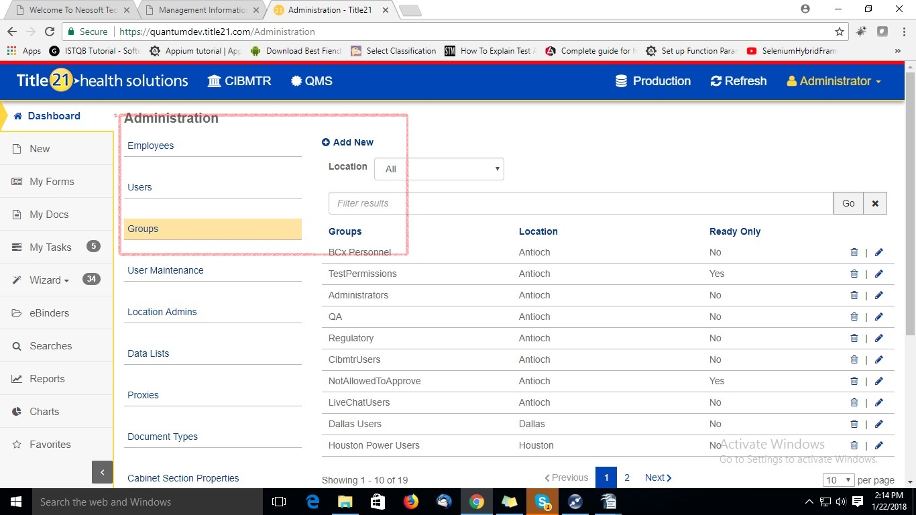  - Click on '+ Add New' link.  ER 2 – User select Location with the new Group name.  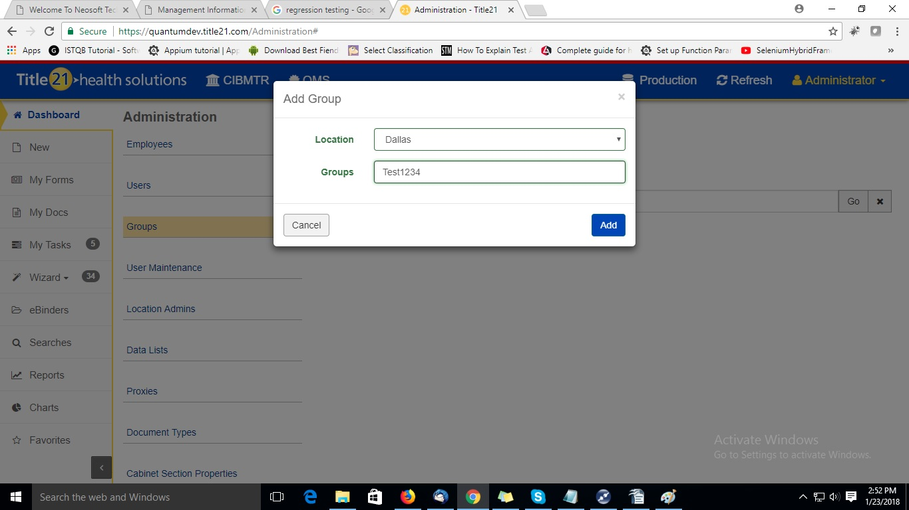  - Click on 'Add' button  ER 3 – Verify Message with Group 'Test289' added successfully with Close button.  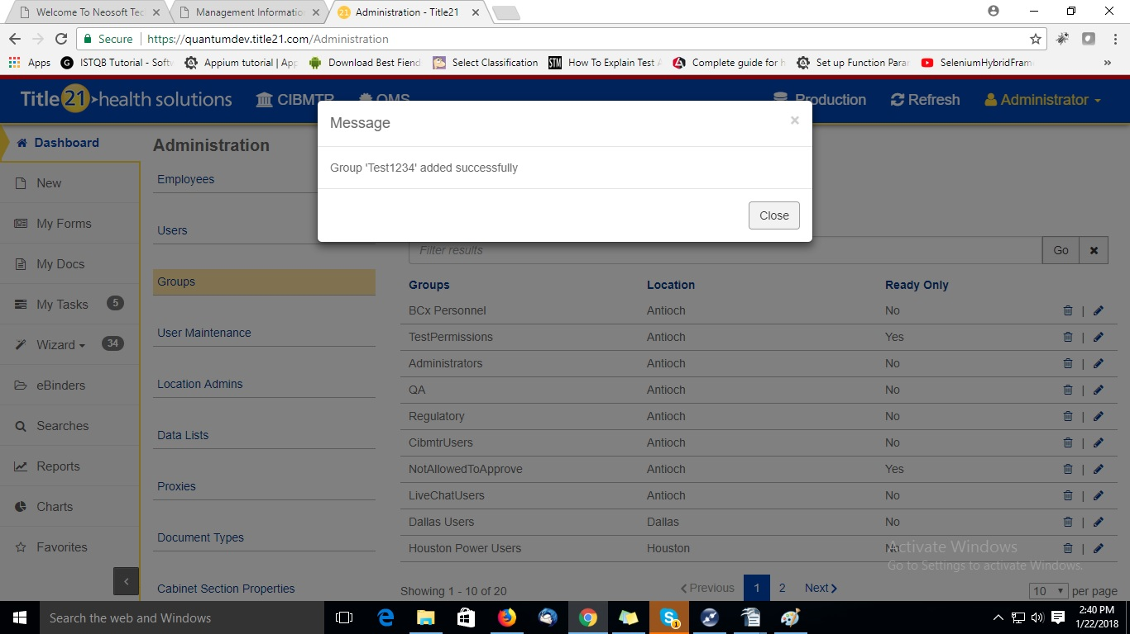  - Click on 'Close' button. And user should navigate to the previous screen. (ER 1)  - Again click on '+ Add New' link.  - Select the same Location with Group name which is previously created.  - Click on 'Add' button  ER 4- Validation message 'This name already exists. Please enter another name.'  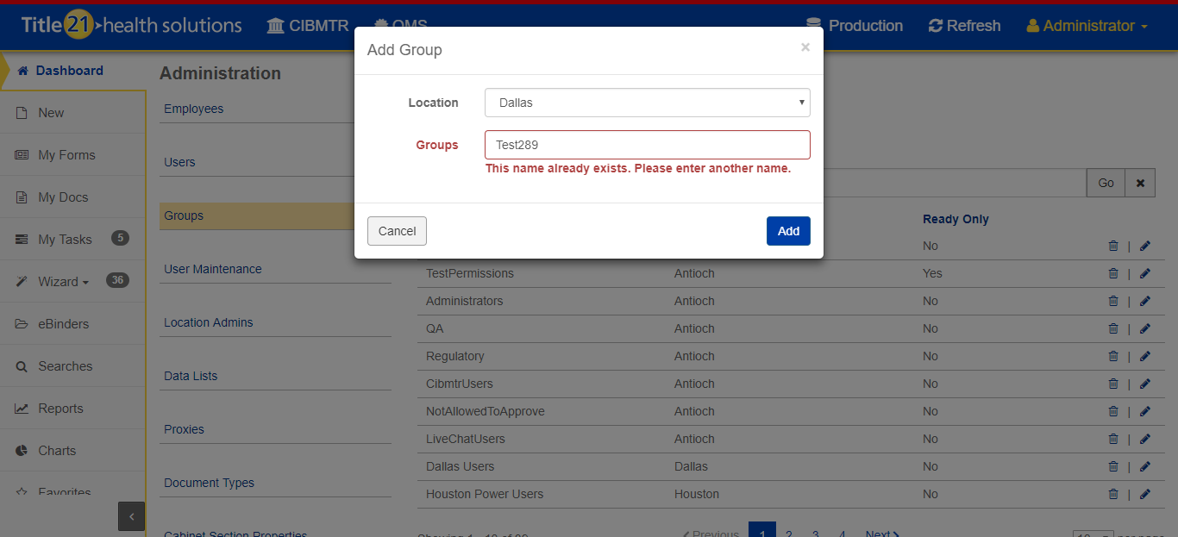  - Filter the results with the newly created group in 'filter results' text field.  ER 5 – Search newly created group 'Test1234'  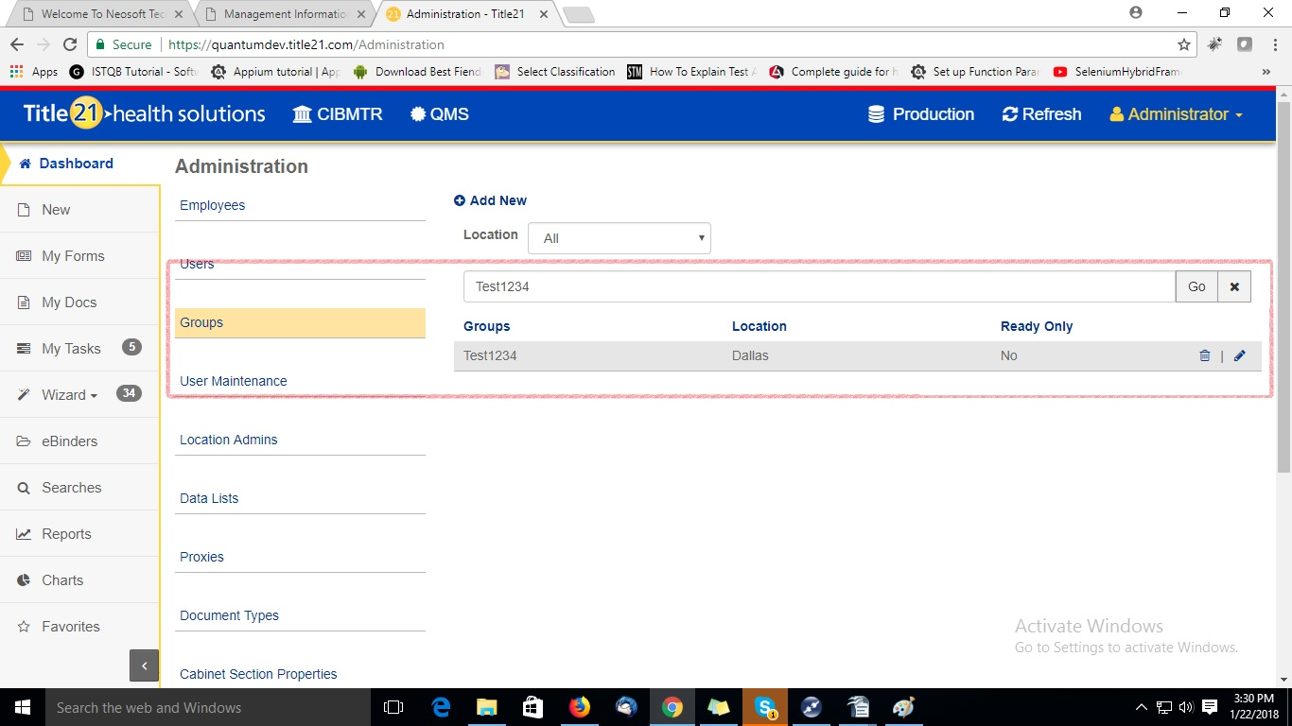  - Click on delete icon for 'Test1234' group.  ER 6 – Delete group message with “Are you sure you want to delete 'Test1234'?” with 'No' and 'Yes' button  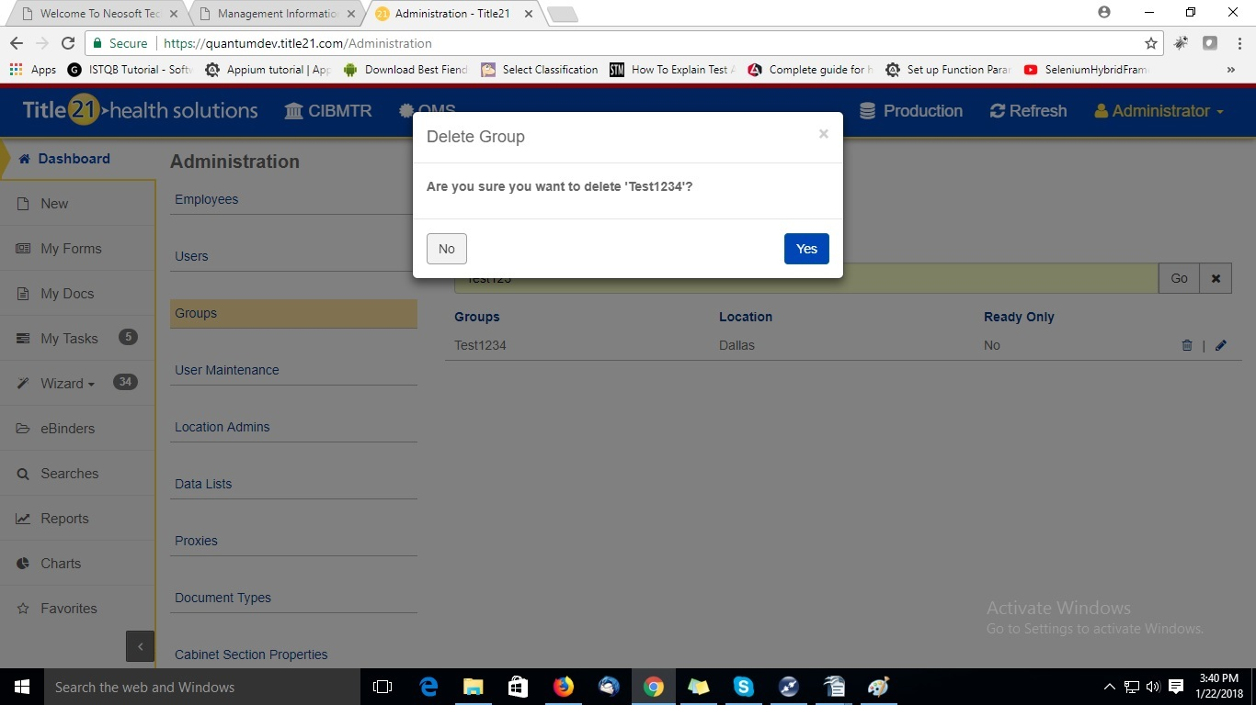  - Click on 'Yes' button.  ER 7 – Group gets deleted and the successful message is displayed.  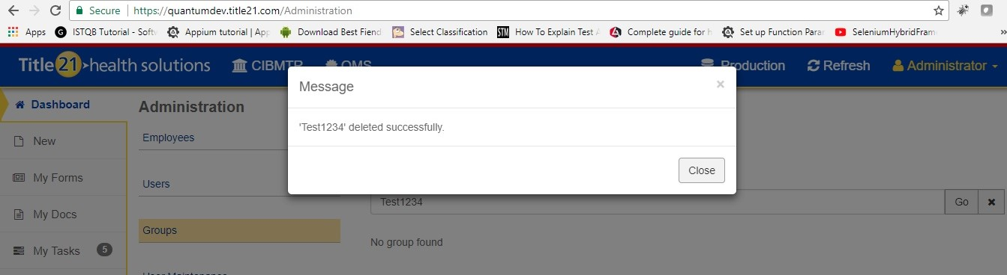  - Click on 'Close' button.  - Type deleted Group name like 'Test1234' in the 'filter results' text field.  ER 8 – No group found message displayed.  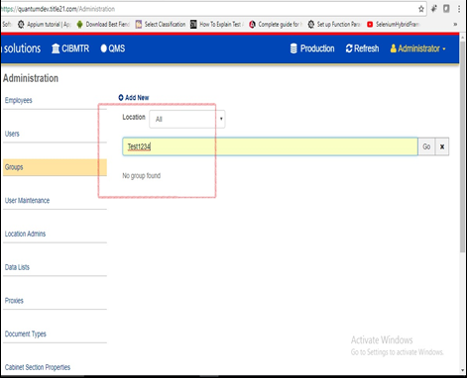
Pass/Fail | Pass:  Fail: | Type of Execution:
Pass/Fail | Pass:  Fail: | Automation: | Manual:
Notes/Deviations
Additional Remarks in case of Manual Execution
Name of Tester(if Manual)
Test Case Review/Approval | Signature of  Reviewer/Approver: |  |  | Date of Approval:

