Protocol # | Description | Objective | Reqt/Spec | Author
WI-0002 | Logout | To verify that the User can Logout Successfully.

Prerequisites | - Standard System Configuration.  - User login exists.
Procedure | - Login to the web interface.  - Click on Username Dropdown at the top. (navigation bar dropdown – in the name of logged in’s user.)  - Click on Log out link.  ER 1 – User should be able to navigate Confirm Log out pop up Screen.  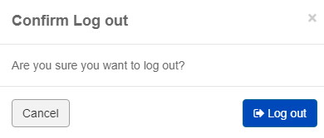  - Click on Cancel button in Confirmation Log out screen.  ER 2 – User should not Log out.  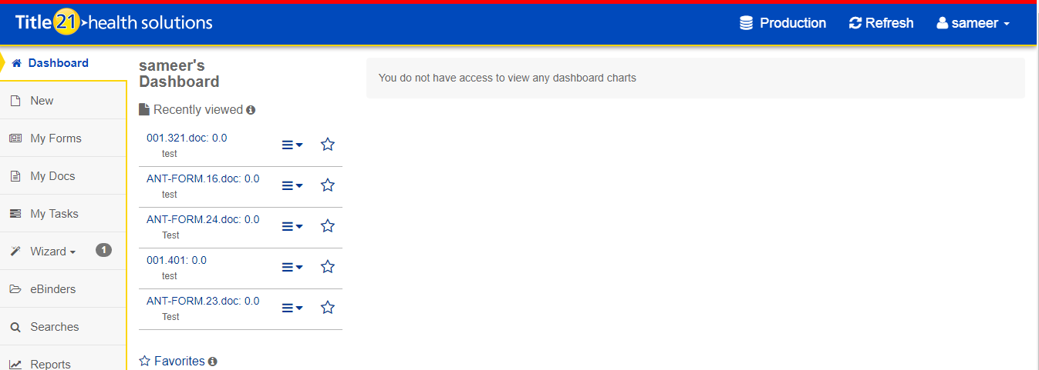  - Click on Log out button in Confirmation Log out screen.  ER 3 – User should Log out and navigate to the Login Page.  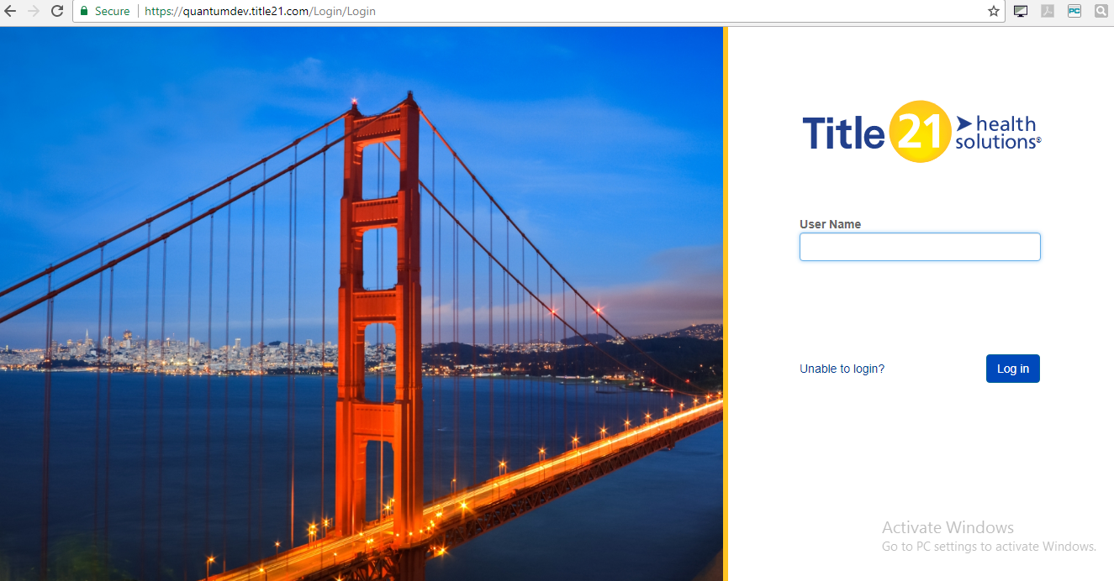  - When logged out, navigate directly to any of the pages directly by entering the URL into the browser address bar (E.G: https://qa21.title21health.com/Training).  ER 4 – User remains logged out and cannot navigate to the page (E.G: Training)  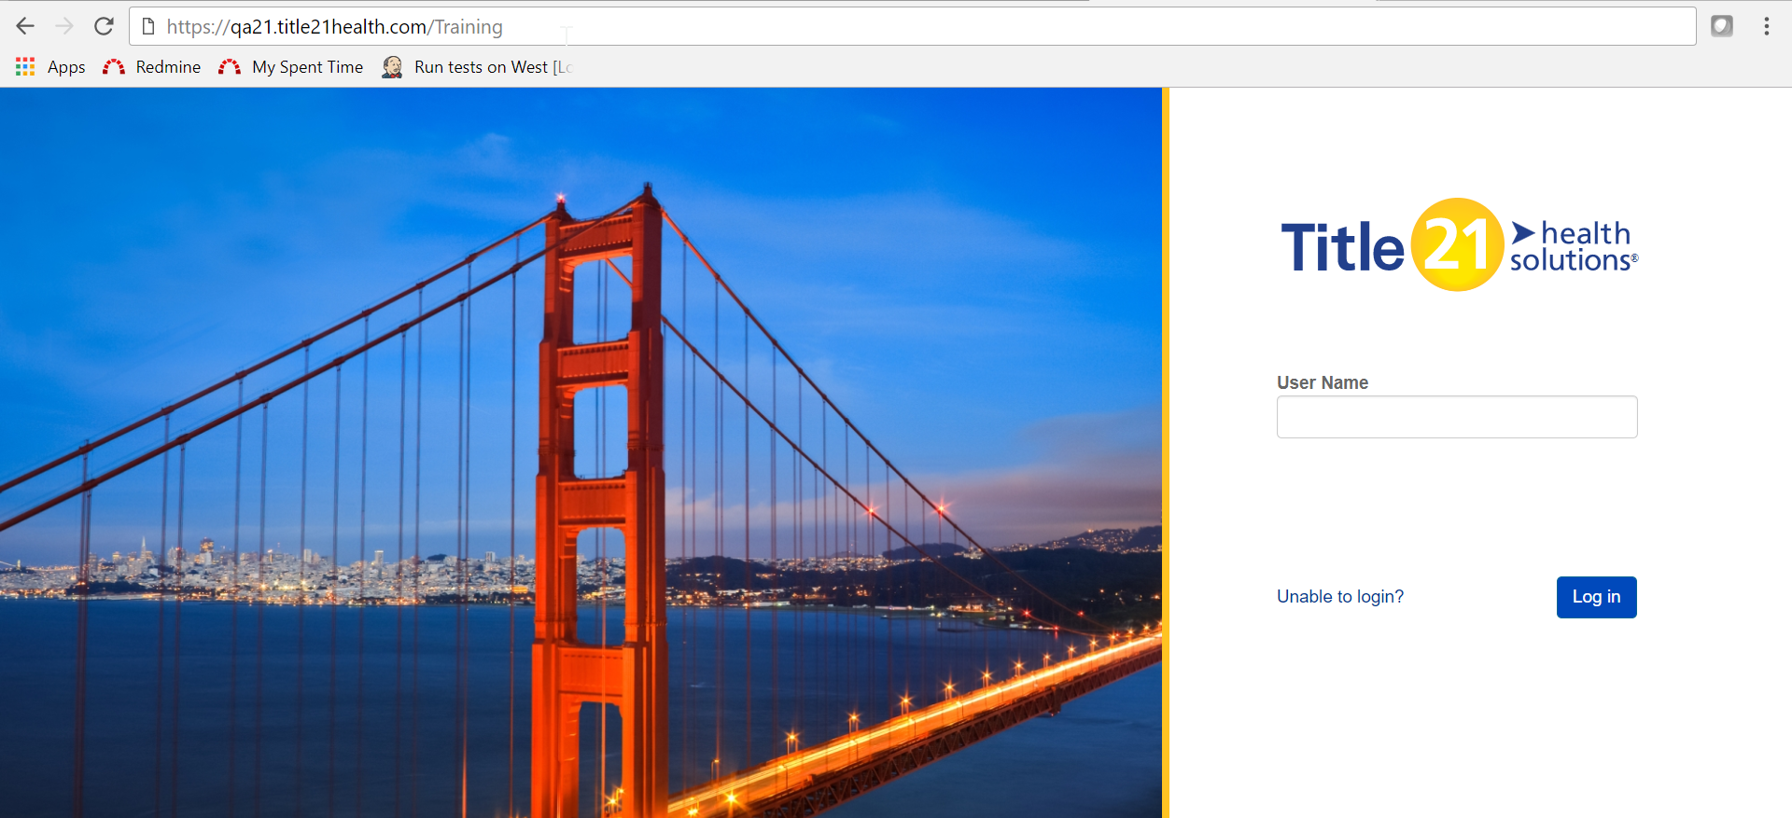

Pass/Fail | Pass:  Fail: | Type of Execution: |  | Date:
Pass/Fail | Pass:  Fail: | Automation: | Manual: | Date:
Notes/Deviations
Additional Remarks in case of Manual Execution
Name of Tester(if Manual)
Test Case Review/Approval | Signature of  Reviewer/Approver: |  |  | Date of Approval:

