Protocol # | Description | Purpose | Reqt/Spec | Author
Emp002 | Update Employee | To verify that the User can Update Employee Successfully. |  | Saurabh Pawar

Prerequisites | - Standard System Configuration  - User must be logged In to the web interface  - User must have local or system administrative privileges
Procedure | - Login to the web interface.  - Click on Administration link from the top right menu.  ER 1 – Administration Screen is displayed.  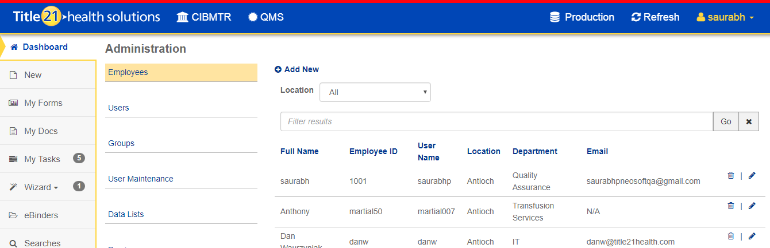  - Select Employee link  ER 2 – Employee records are listed.  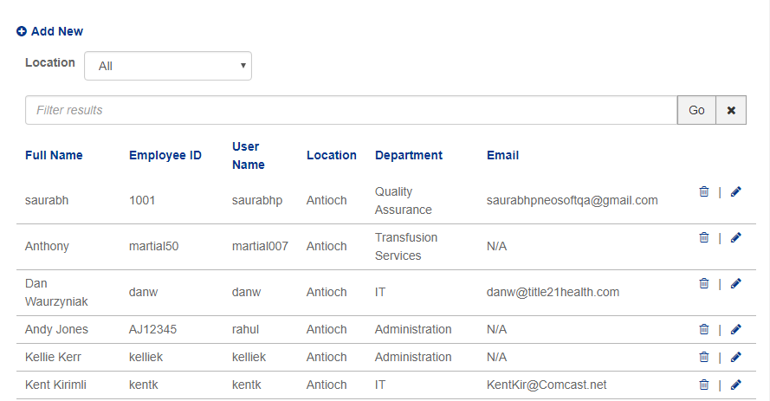  - Click on location drop-down and select the specific location (for E.G.. Dallas).  ER 3- Only Employees of selected location are displayed.  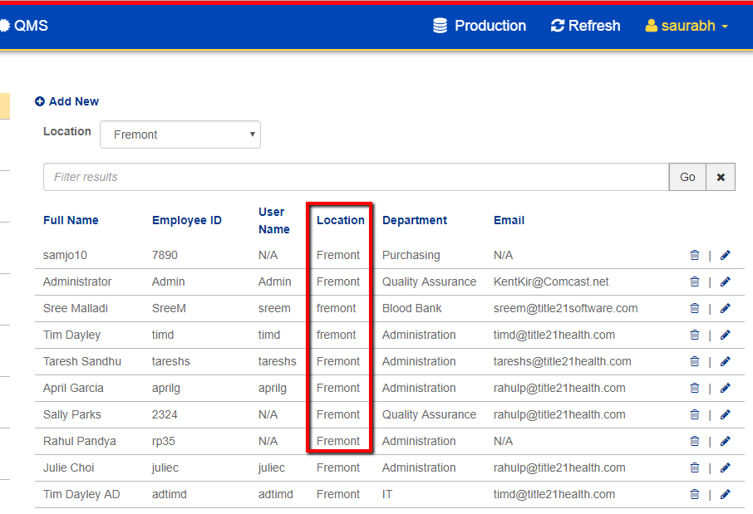  - In the text filter, enter text/data for which no employee exists and click the “GO” button.  ER 4 – Validation message indicating that no employees found/exist is displayed.  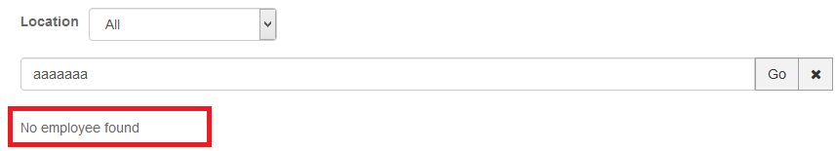  - In the text filter, enter text/data for which at least one employee exists. (For Eg. Full name, Employee ID, User Name, Department, and Email) and click on GO button.  ER 5 – Employee(s) are listed as per text filter criteria.  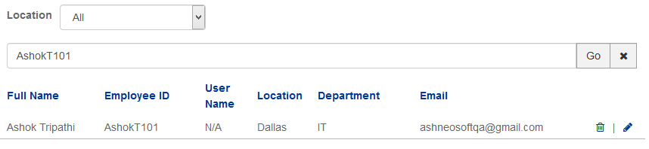  - Click on Edit Employee Button.  ER 6 - Update employee dialog is displayed and the general tab is presented  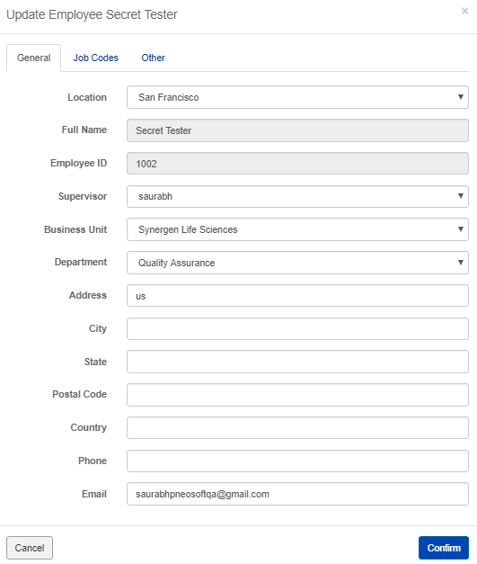  - Edit the supervisor, Business Unit, department, state and country  - Click on confirm button.  ER 7 – A message confirming successful update is displayed.  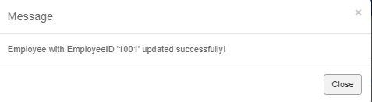  - Again click on edit button for the same employee edited in previous steps.  ER 8 – All changed fields are properly updated with changes made in step 8.  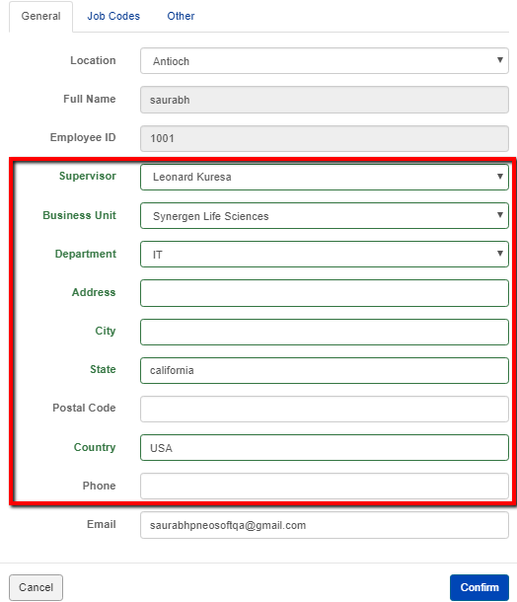  - Try to edit “Full Name” and “Employee ID” field.  ER 9 – User should not be able to edit the Full name and Employee ID field.  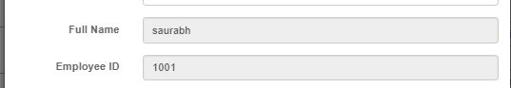  - Edit the data from some field.  - Click on the cancel button.  - Click on edit for the same employee again and verify if the canceled edits from step 12.  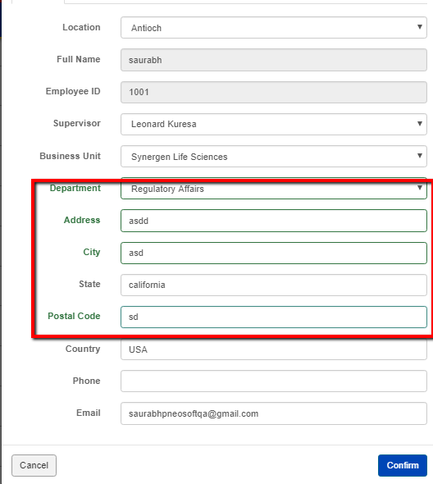  ER 10 – Records should be unchanged.  - Click on Job Codes Tab in Update Employee Screen.  ER 11 – User should be navigated to “Job Codes” Screen and job codes list should be visible.  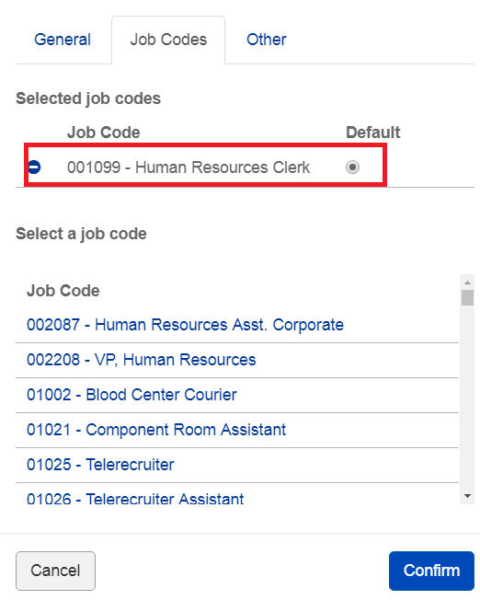  - Select one job code from “Select a Job code section”.  ER 12 – It should get added to “selected job codes” section.  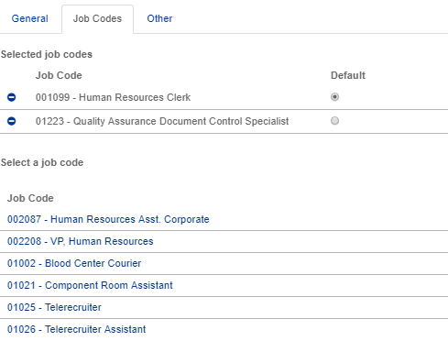  - Click on minus button from selected job codes section.  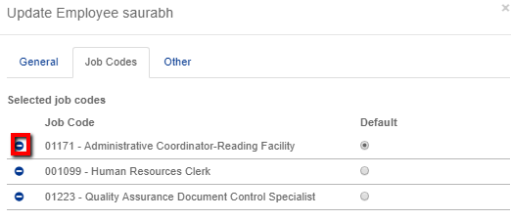  ER 13 – Job code is removed and default job code is changed.  - Change the default job by clicking on the radio button.  - Click on confirm  - Again click on edit button  ER 14 – Default job code is changed  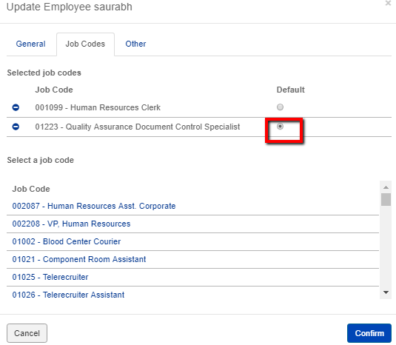
Pass/Fail | Pass:  Fail: | Type of Execution:
Pass/Fail | Pass:  Fail: | Automation: | Manual:
Notes/Deviations
Additional Remarks in case of Manual Execution
Name of Tester(if Manual)
Test Case Review/Approval | Signature of  Reviewer/Approver: |  |  | Date of Approval:

