Protocol # | Description | Purpose | Reqt/Spec | Author
WI-0020 | eBinders | To verify  - e-Binders available for the user  - Add e- Binder through the admin  - Group permission to use e-Binder  - Add document for e-Binder  - Events identified as Favorites from eBinders are available in the user’s Favorites list.

Prerequisites | - Standard System Configuration  - User login exists  - The user is logged into the web interface
Procedure | - Click on the eBinders tab  - Click to expand them  ER 1 – List of binders available are displayed and available branches are visible on expanding  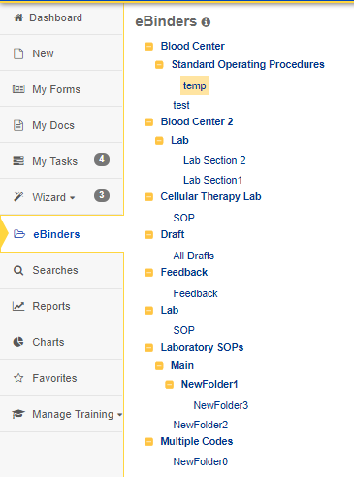  - Click on one of the organizers to view a list of documents available within it  ER 2 – A list of the document available within the organizer is displayed  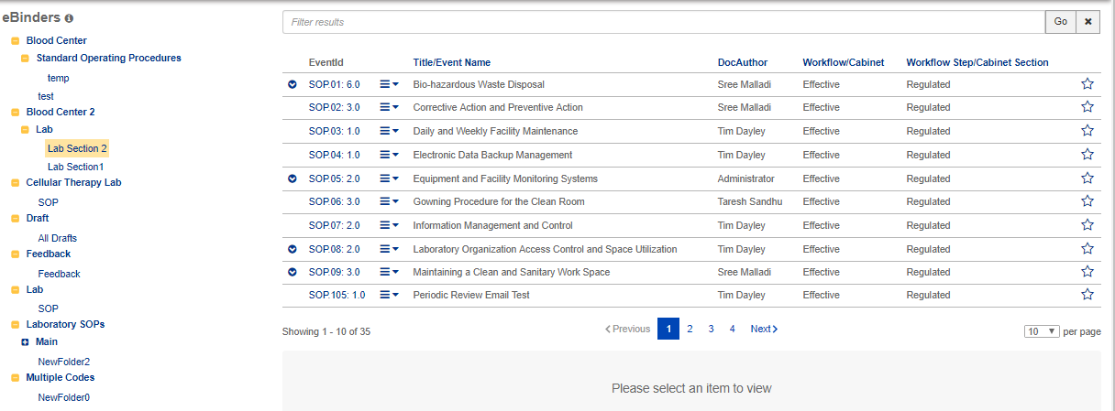  - Logout from the test user  - Login with admin user  - Go to administration page  - Click on e-Binder  ER 3 – A List of eBinders available are displayed  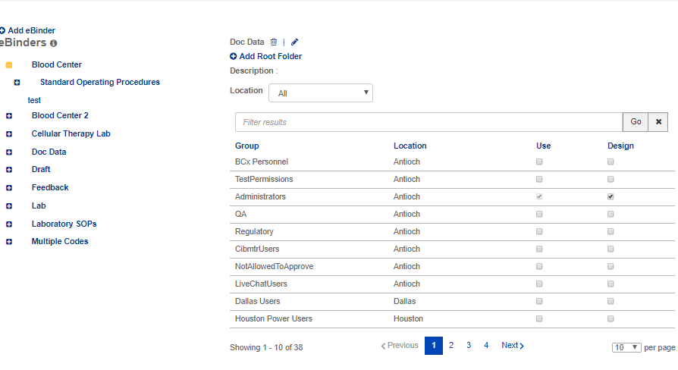  - Click on add eBinder button  ER 4 – Add eBinder popup screen is displayed.  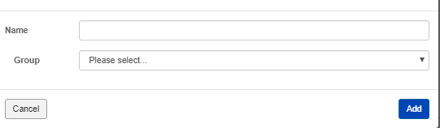  - Enter name  - Enter group  - Click on add button  ER 5 – A message confirming eBinder successful added is displayed.  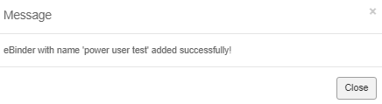  - Click on close button  - Click on the newly added binder and click on add root folder.  ER 6 – Add Root Folder popup screen is displayed.  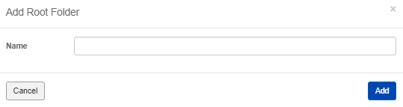  - Enter the name and click on add button.  ER 7 – A message confirming Root folder successful added is displayed  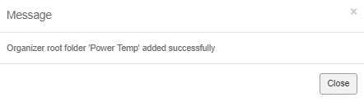  - Click on close.  ER 8 – The created eBinder record is displayed  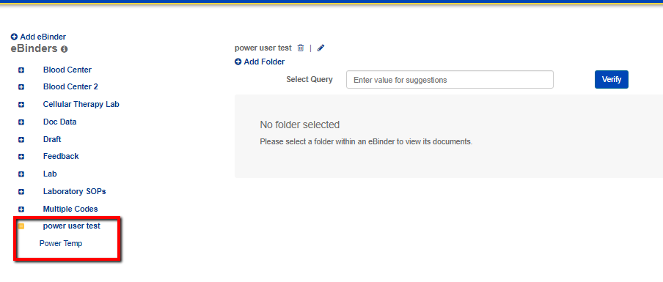  - Click on ebinder(for ex: power user test)  ER 9 – The permission page for selected ebinder is displayed  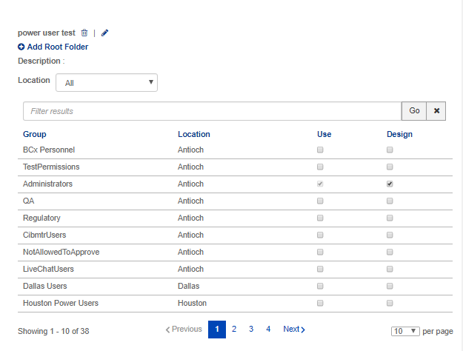  - Select location from location drop-down.(For ex: san Francisco)  - Select the group whom you want to give permission.  - Check the “use” checkbox  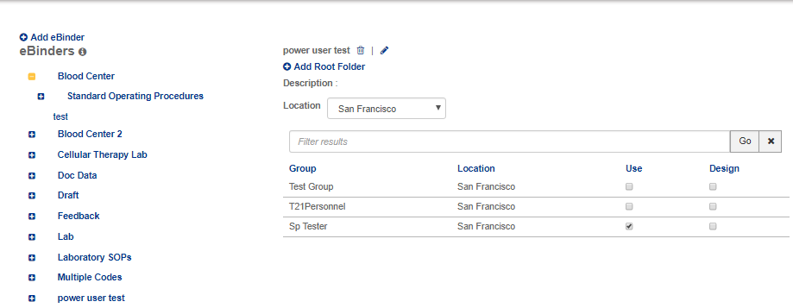  - Click on the root folder  - Enter a query in the select query text box  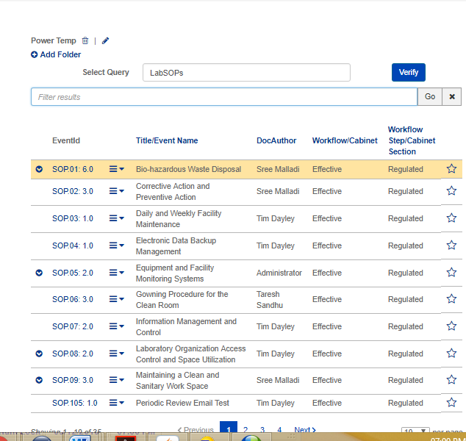  - Click on verify.  - Logout with admin user  - Login with test user belongs to the group from step 18  - Go to eBinder  ER 10 – EBinder is present in the eBinder section.  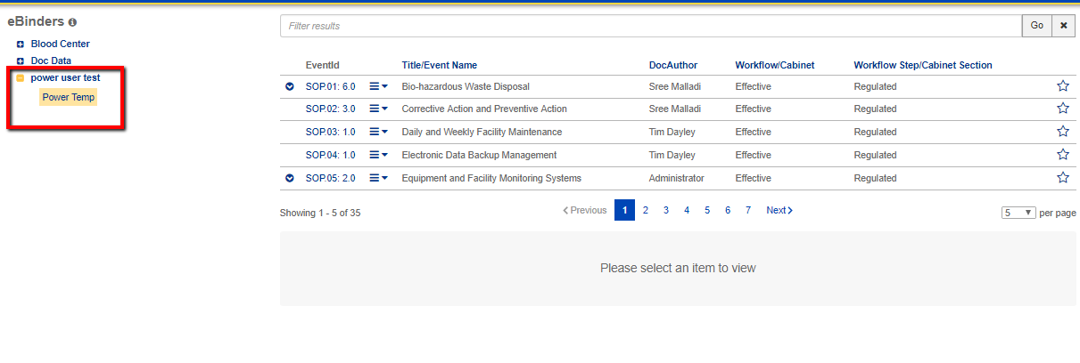  - click on the star icon for any of the documents/events listed within the organizer  ER 11 – The star icon is highlighted to indicate that the event has been added to favorites  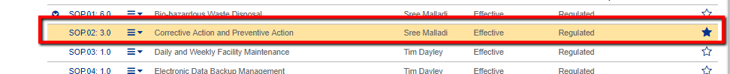  - Click on the Favorites tab.  ER 12 – The document/event added to Favorites from the binder is available in the Favorites list  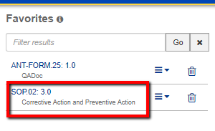
Pass/Fail | Pass:  Fail: | Type of Execution:
Pass/Fail | Pass:  Fail: | Automation: | Manual:
Notes/Deviations
Additional Remarks in case of Manual Execution
Name of Tester(if Manual)
Test Case Review/Approval | Signature of  Reviewer/Approver: |  |  | Date of Approval:

