

FIRST EDITION
About this report
An open public research report from TitleChain Foundation - Q3 2026

M5Index - SHADOW CAMEL REPORT
Tracking the real economy behind the headlines.
PUBLIC RESEARCH STANDARD
This first edition is a working public-research release. SHADOW separates verified records from unresolved questions. It is not a title-insurance product, appraisal, legal opinion, investment recommendation, or official bank CAMELS rating. Unknown remains unknown until evidence resolves it.

Initial focus sectors
- Government assets: federal and other public real estate entering disposition, transfer, reuse, or redevelopment.
- Commercial real estate: property, debt, lender, ownership, servicing, maturity, restructuring, foreclosure, and value-migration signals.
- Farmland: title, operator, lease, debt, water, mineral, pipeline/easement, environmental, productivity, and long-term stewardship state.
Public Commons access
titlechainfoundation.org
github.com/TitleChain-Foundation
CONTENTS
What is inside

1. Executive Summary
2. What SHADOW M5Index Measures
3. Q3 2026 Market Lens and Preliminary SHADOW CAMEL
4. M5 Economics Cheat Sheet
5. TitleChain Asset State
6. Priority Sectors: Government, Commercial Real Estate, Farmland
7. Initial Findings from the Seed Dataset
8. Featured Asset Profiles
9. People’s Trust Pathway
10. M5 Global Index and Exchange Feed
11. Methodology, Evidence, and Contribution Rules
Appendix A. All Featured Properties
Appendix B. Code Sheet
Sources and Notes
01
Executive Summary
A first public map of old-world holdings, deal flow, title state, risk, and opportunity

36  SEED ASSET RECORDS | 25  CLOSED DISPOSITIONS | 11  ACTIVE / PRE-CLOSE | $570.8M  KNOWN CONSIDERATION

Seed dataset totals reflect the working SHADOW M5Index workbook as of the Q3 2026 research cut. Not every record is yet canonical; 25 records are marked SUBMITTED and 11 SOURCE_VERIFIED.
SHADOW M5Index is a transition-intelligence system. It begins with legacy holdings - public property, commercial real estate, debt, liens, rights, institutional ownership and underused assets - and follows the events that can move them: maturity, extension, modification, disposition, auction, note sale, foreclosure, transfer, acquisition, redevelopment, refinance and resale. The purpose is not to assume where value went. The purpose is to prove it.
THE CENTRAL QUESTION
What is moving out of the legacy economy, who is positioned to acquire it, what state is the title actually in, what obligations travel with it, and where does the ownership and economic value go next?

- Federal disposition data often identifies the asset and transaction stage before it resolves the ultimate buyer, sponsor, lender, and capital source.
- Commercial real-estate stress is uneven: aggregate banking conditions remain resilient, while office and maturity-driven CMBS stress are materially higher than systemwide averages.
- A deed does not equal an unencumbered asset. Rights, liens, easements, environmental obligations, successor liabilities, and transfer restrictions must be represented as state.
- Public/nonprofit buyers and community-oriented acquisition attempts are present alongside private capital. SHADOW is designed to measure the actual proportions rather than assume them.
- The public value question is not only who finances an acquisition, but who retains the productive asset and residual economics after financing obligations are satisfied.
02
What SHADOW M5Index Measures
Systemic Holdings, Assets, Debt & Ownership Watch

Code | Word | Common meaning
S | Systemic | What else is this asset connected to?
H | Holdings | What does this person or entity actually hold or control?
A | Assets | What is the thing of legal or economic value?
D | Debt | Who is owed money, how much, and when does it become a pressure point?
O | Ownership | Who legally owns, economically controls, and ultimately benefits?
W | Watch | What is changing now?
The SHADOW deal-flow feed
- GSA/public disposition notices and auctions
- County deeds, mortgages, assignments, releases and foreclosure records
- Bank Call Reports and public financial filings
- CRE maturity and CMBS servicing events
- Note sales, restructurings and receivership/foreclosure events
- Public-benefit conveyances and People’s Trust nominations
- Development entitlements, acquisition financing and subsequent refinancings
ASSET → OWNER → DEBT → LENDER → CAPITAL → RIGHTS → JURISDICTION → THREAT → TRANSFER → VALUE
03
Q3 2026 Market Lens
Strong aggregate bank capital; concentrated CRE and maturity pressure

>99%  BANKS WELL CAPITALIZED* | $325.1B  Q1 UNREALIZED SECURITIES LOSSES | 12.00%  AUG OFFICE CMBS DELINQUENCY | 16.90%  AUG OFFICE SPECIAL SERVICING

*Federal Reserve: over 99% of banks were well capitalized at year-end 2025; aggregate CET1 ratios were about 13% for large and small banks. FDIC Q1 2026 unrealized securities losses were $325.1B. Trepp August 2026 office CMBS delinquency was 12.00% and office special servicing 16.90%.
The system-level picture is not the same as the property-level picture.
The Federal Reserve’s June 2026 supervision report described bank capital as strong and continued to focus on institutions concentrated in commercial real estate, especially office and multifamily. The 2026 stress test projected more than $708 billion of losses under a severe hypothetical recession while aggregate capital still remained above minimum requirements. At the same time, Trepp’s August data show materially higher stress inside securitized commercial real estate, particularly office. SHADOW treats that divergence as a reason to go bank-by-bank, loan-by-loan, and asset-by-asset rather than infer a systemwide crisis from one indicator.
Preliminary SHADOW CAMEL - public-data system read
PRELIMINARY SCORE: 1.8 / 5 - BAND 2 (STABLE / WATCH)
This is an experimental open-data index, not a confidential regulatory CAMELS rating. M* and S* are explicitly public proxies/inferences. The composite uses C 20%, A 25%, M* 10%, E 15%, L 15%, S* 15%. Confidence: B / methodology v0.1.

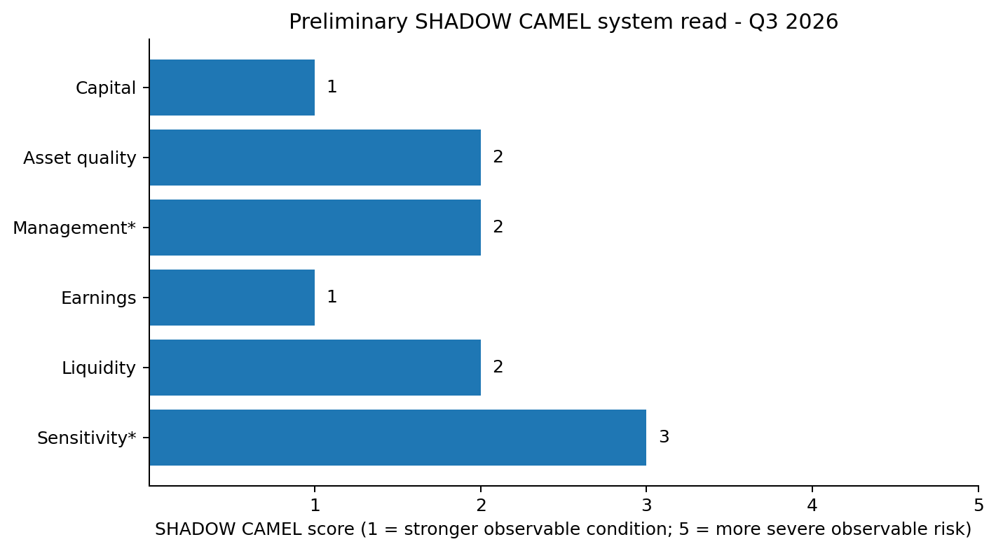
- C - Capital: 1. Strong aggregate capitalization and stress-test resilience.
- A - Asset Quality: 2. Broadly stable, with concentrated CRE/office and consumer pockets.
- M* - Management proxy: 2. Lowest-confidence component because internal governance/exam findings are not public.
- E - Earnings: 1. FDIC-insured institutions reported $80.5B of Q1 2026 net income and 1.26% ROA.
- L - Liquidity: 2. Broadly stable in aggregate; institution-level funding mix remains important.
- S* - Sensitivity: 3. Unrealized securities losses and property/refinancing repricing remain material public signals.
04
M5 Economics Cheat Sheet
Common language for the M5 stack, classifications, rights, and codes

M5 IS THE SHIFT FROM USER TO ISSUER
The architecture starts with the accountable human or legal principal - identity, authority, jurisdiction, records, assets and delegated capability - rather than treating the person as merely a user inside someone else’s platform.

Canonical identity and authority chain
M5IAM → TCID / M5HUM → private M5POD → M5-CV / SOPHIA → M5Canon → bounded M5AGT
Authority | Meaning | Asset class | Meaning
M1 Bank of Me | Individual human/self; creator, owner, worker, sole proprietor, personal principal | M1 | Utility / network / payment-like value
M2 Bank of Us | Cooperative, collective, community, association, DAO, union, member-governed structure | M2 | Commodities
M3 Bank of Business | Company, venture, employer, vendor, partnership, commercial organization | M3 | Titled one-of-a-kind / unique real-world assets
M4 Bank of Institution | Regulated institution, agency, university, bank, nonprofit, fiduciary, institutional authority | M4 | Securities / financial instruments
M5 Bank of Governance / Government | Tribal, local, state, national, treaty, intergovernmental or governmental authority | M5 | Sovereign / interbank
M1-M5 asset classes are internal M5/USC classifications and do not replace statutory, regulatory, tax, accounting, securities, commodity, title, or other legal classifications.
SR1-SR5 sovereign-right constraints
- SR1 - Sovereign Identity
- SR2 - Data Sovereignty
- SR3 - Financial Privacy
- SR4 - Self-Determination
- SR5 - Portability
Core M5 terms
M5HUM - Credentialed human principal and root of delegated authority.
M5AGT - Bounded software/AI agent; never receives more authority than the accountable principal.
M5POD - Member-controlled private evidence container.
M5-CV - Member-controlled roles, qualifications, credentials, capability and current-status record.
M5Canon - Deterministic ontology/state machine evaluating authority, policy, consent, jurisdiction, restrictions, lifecycle, revocation and approvals.
M5MST - Origination, Minting, Sovereign Registration, Transfer Authority - the M5 lifecycle/state layer.
M5 Global Index and Exchange - Public economic-intelligence/index layer for provenance-aware data, methodologies and signals; “Exchange” does not mean a securities exchange or ATS.
05
TitleChain Asset State
A verified deed is not the same thing as an unencumbered asset

STATE BEFORE SCORING
Before SHADOW scores an asset - and before a People’s Trust review or transfer - TitleChain must establish what is actually true about the titled asset right now, according to what authority, verified by whom, when, and subject to which rights, claims, obligations, restrictions, liabilities and unresolved conditions.

State element | What SHADOW / TitleChain must know
Asset identity | Parcel / legal description / deed or controlling record / jurisdiction / improvements
Provenance | Origination and chained title/right events
Title verification | Authoritative source, verifier, credential, method, time, freshness, limitations
Rights | Surface, subsurface, mineral, oil/gas, water, air, development, timber, access, leasehold, utility, pipeline, beneficial interests
Encumbrances | Mortgage, deed of trust, liens, easements, rights-of-way, leases, covenants, options, environmental liens
Claims | Asserted, recorded, disputed, validated, satisfied, released, unresolved
Obligations | Maintenance, tax, remediation, restoration, decommissioning, pipeline abandonment, plugging, preservation, tenant/public-benefit obligations
Environmental state | Known/suspected contamination, hazardous materials, underground infrastructure, remediation orders, responsible party, successor liability
Authority state | Owner, signer, manager, trustee, lender consent, governmental/regulatory/court authority
Transfer state | Restrictions, approvals, lien releases, title cure, eligibility, authorization, pending, recorded
TSI - Title State Integrity
TSI measures how complete, current, verified and transferable the known title-and-rights state is. It does not replace title insurance or a legal opinion. It is the gate that prevents a seemingly inexpensive asset from being treated as “clean” when unresolved easements, pipeline rights, mineral reservations, remediation duties or successor liabilities may dominate the economics.
SHADOW state codes
Code | Family | Meaning
P0-P8 | Public transition | Identified → Review → Marketed → Bidding → High bidder → Under contract → Closed → Redevelopment → Refinance/resale
S0-S4 | Transaction proof | Listed → Auction completed → Award announced → Closing confirmed → Deed confirmed
O0-O5 | Ownership resolution | Buyer undisclosed → Grantee → Principals → Sponsor → Lender → Ultimate capital resolved
Evidence | Claim state | Submitted → Source verified → Corroborated → Canonical; also Disputed / Unresolved / Rejected / Corrected / Superseded
06
Priority Sectors
Government assets, commercial real estate, and farmland

GOVERNMENT ASSETS
PUBLIC VALUE + ACCOUNTABILITY
Disposition stage, statutory process, title/restrictions, current occupancy, deferred maintenance, public-benefit eligibility, buyer/capital provenance, post-transfer value migration.
COMMERCIAL REAL ESTATE
DEBT + TRANSITION PRESSURE
Borrower/SPE, lender, mortgage/deed of trust, maturity, DSCR/LTV, modifications/extensions, CMBS trust/servicers, foreclosure/REO, new buyer, refinance and final value.
FARMLAND
FOOD + LONG-HORIZON STEWARDSHIP
Title, acreage, operator, lease, debt, soil/productivity, water rights, mineral rights, easements/pipelines, conservation restrictions, environmental obligations, land-use law, succession and productive cash flow.
The Q3 2026 seed dataset is heavily weighted toward federal/public real estate because that is where the first SHADOW tranches were built. Farmland is a stated priority sector for expansion; the current seed file should not be read as a representative national farmland sample.
07
Initial Findings from the Seed Dataset
What the first 36 records show - and what they do not yet prove

16  TRANCHE 1 | 9  TRANCHE 2 | 11  TRANCHE 3 | 17  BUYER UNDISCLOSED / NOT YET SELECTED

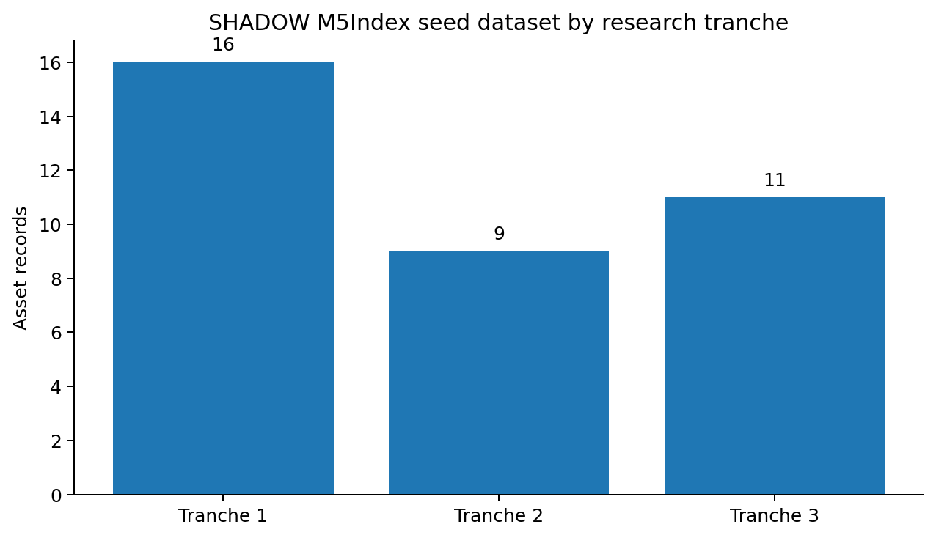
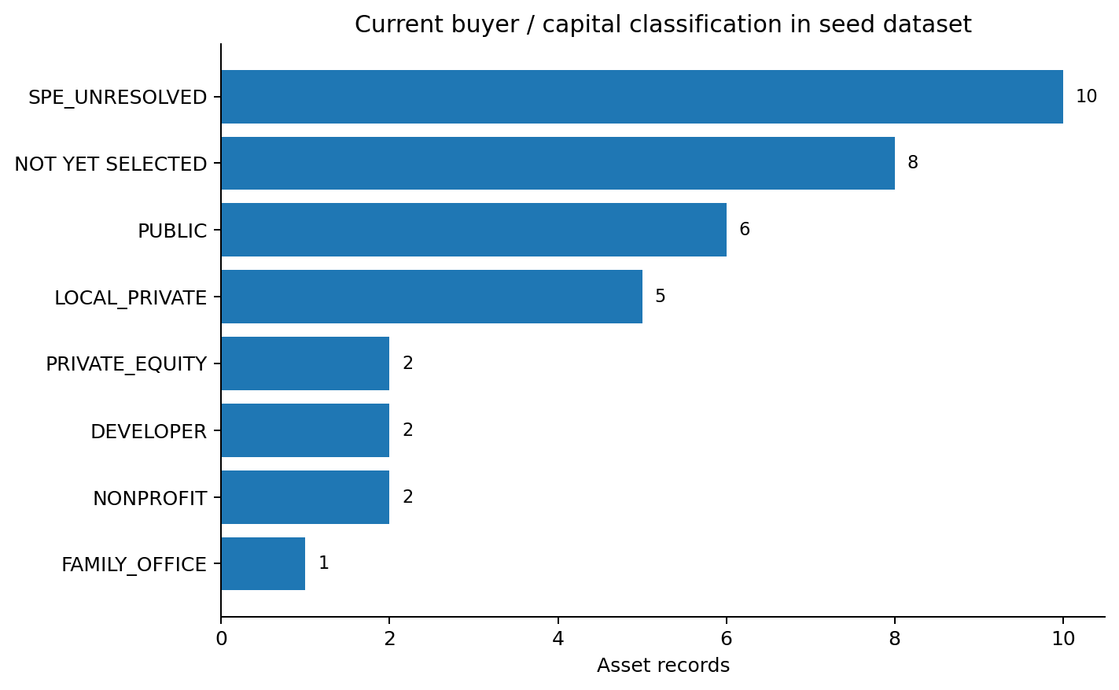
The buyer/capital chart includes unresolved and not-yet-selected categories. This is not a market-share estimate. The seed sample is intentionally weighted toward large, researchable or strategically relevant cases.
- The working dataset contains 36 asset records: 16 substantially resolved/known-capital cases, 9 unresolved-buyer/rights cases, and 11 active/pre-transfer cases.
- Known closed consideration in the seed workbook totals approximately $570.8M. Some public-benefit transfers have no cash consideration in the dataset, and some reported prices are floors rather than exact final values.
- The first Tranche shows both private and public/nonprofit recipients; this is why SHADOW should publish denominators and evidence rather than imply that every public disposition is private capture.
- Tranche 2 demonstrates the public-data gap: sale and price can be known while beneficial ownership, lender, or rights state remain unresolved.
- Tranche 3 moves the work upstream: watch significant assets before closing so communities and researchers can evaluate title state, capital needs and public-benefit alternatives while the transaction is still forming.
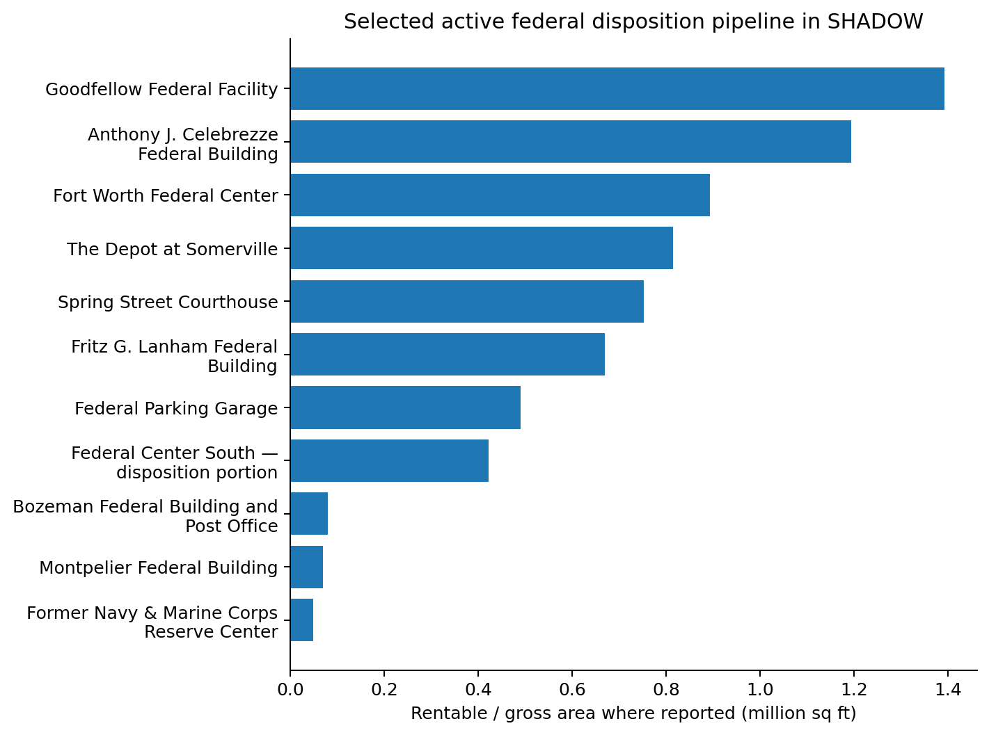
08
Featured Asset Profiles
Priority cases for the first edition

PPT-EZ-CA-0001 - Spring Street Courthouse
312 N Spring Street, Los Angeles, California | P2 MARKETED / S0 LISTED
FEDERAL LISTING: Courthouse
RENTABLE AREA: 751,791 sf on GSA accelerated-disposition list
GSA TESTIMONY: 35% vacancy; almost $153M of capital-maintenance liabilities avoided if disposed
BUYER: None announced
WHY IT MATTERS
This is the first reference asset for the proposed People’s Public Trust workflow because it can be evaluated before ownership leaves the public sector.
OPEN RESEARCH
Complete TitleChain Asset State: parcel/title, occupancy and court-use obligations, historic restrictions, liens, environmental state, disposition authority, capital need and public-benefit eligibility.
Source: GSA accelerated disposition / testimony

Fort Worth Federal Center
501 W Felix Street, Fort Worth, Texas | P2 MARKETED / S0 LISTED
TYPE: Office / warehouse / service / other
RENTABLE AREA: 893,565 sf
BUYER: None announced
WHY IT MATTERS
Large multi-use federal campus and a potential second-city People’s Trust feasibility screen.
OPEN RESEARCH
TitleChain Asset State, environmental history, parcel configuration, occupancy/relocation, disposition path, redevelopment constraints and public-benefit feasibility.
Source: GSA accelerated disposition

Fritz G. Lanham Federal Building + Parking Garage
819 Taylor Street / 401 Texas Street, Fort Worth, Texas | P1 REVIEW / S0 LISTED
LANHAM RENTABLE AREA: 669,264 sf
GARAGE: 8,340 rentable sf; 490,101 gross sf reported by GSA
GSA ANNOUNCEMENT: Added September 10, 2026; GSA says downtown Fort Worth dispositions will save more than $348M
WHY IT MATTERS
Together with the Fort Worth Federal Center, this creates a large cluster of federal real-estate transition activity in one city.
OPEN RESEARCH
Determine parcel/title relationships, whether garage and building move separately, air/development rights, occupancy, capital requirements and buyer emergence.
Source: GSA Fort Worth announcement

The Depot at Somerville
Roycefield Road / Somerville-Hillsborough, New Jersey | P5 UNDER CONTRACT / O0 BUYER UNDISCLOSED
REPORTED AREA: 815,469 sf
LAND: ~83.5 acres
USE: Industrial / warehouse campus
BUYER: Prospective buyer not publicly resolved in seed record
WHY IT MATTERS
This is the immediate live ownership-resolution case: the public transition has advanced to under contract while the buyer/capital chain is still unresolved in the working dataset.
OPEN RESEARCH
Resolve buyer SPE, sponsor, ultimate capital, acquisition lender, final consideration, title, environmental obligations and redevelopment strategy.
Source: GSA accelerated disposition

Anthony J. Celebrezze Federal Building
1240 E 9th Street, Cleveland, Ohio | P2 MARKETED / S0 LISTED
RENTABLE AREA: 1,194,675 sf
TYPE: Office
GSA ESTIMATE: More than $180M in maintenance/redevelopment costs potentially avoided
WHY IT MATTERS
A single building at roughly 1.2 million square feet can support a full adaptive-reuse, title-state and capital-stack analysis on its own.
OPEN RESEARCH
Resolve current occupancy, title restrictions, redevelopment feasibility, environmental state, capital needs and buyer interest.
Source: GSA Celebrezze announcement

Goodfellow Federal Center
4300 Goodfellow Boulevard, St. Louis, Missouri | P2 MARKETED / S0 LISTED
RENTABLE AREA: 1,392,628 sf
TYPE: Laboratory / specialized federal campus
ENVIRONMENTAL: GSA maintains a dedicated environmental reading room documenting asbestos, PCB and other contamination concerns in parts of the campus
WHY IT MATTERS
Goodfellow demonstrates why a property cannot be scored only on price and square footage. Environmental and decommissioning state may dominate transfer economics.
OPEN RESEARCH
Map buildings/parcels, contamination/remediation, responsible parties, successor liability, utilities, title/rights and specialized reuse constraints before any opportunity score.
Source: GSA environmental reading room

Federal Center South - disposition portion
4735 E Marginal Way S, Seattle, Washington | P2 MARKETED / S0 LISTED
GSA SCOPE: 1201 Building, BIA Building and slab only - not the entire complex
RENTABLE AREA: 422,195 sf
WHY IT MATTERS
The partial-complex structure makes exact asset identity and parcel/building boundary resolution especially important.
OPEN RESEARCH
Resolve exact parcels/buildings, waterfront/industrial environmental state, easements, infrastructure, title and disposition structure.
Source: GSA accelerated disposition

Montpelier Federal Building
87 State Street, Montpelier, Vermont | Auction completed; community high bid later rejected / no transfer
BUILDING: ~70,000 sf on ~1.6 acres per GSA auction release
COMMUNITY BIDDER: 87 State Street Local Development Corporation in working research
STATE: No completed transfer in seed dataset
WHY IT MATTERS
Montpelier is the counterexample that keeps SHADOW neutral: a community/public-benefit structure can participate in the process, yet winning an auction is not the same as acquiring the asset.
OPEN RESEARCH
Track next federal disposition step, authoritative environmental/remediation obligations, valuation, community capital and any future buyer.
Source: GSA Montpelier auction release

Former Navy & Marine Corps Reserve Center
1863 Monroe Ave NW, Grand Rapids, Michigan | P4 HIGH BIDDER / S1 AUCTION COMPLETED
BUILDINGS: Four
AREA: 48,120 gross sf
LAND: ~3.47 acres
GSA SAVINGS CLAIM: ~$350K annual operating cost and $27M cost avoidance
WHY IT MATTERS
An operating-company high bidder is analytically different from a private-equity acquisition. SHADOW classifies capital rather than flattening all private buyers into one category.
OPEN RESEARCH
Confirm federal acceptance, closing, deed, acquisition financing and final asset-state obligations.
Source: GSA Grand Rapids auction release

Hawkinsville Air Force Space Surveillance Station
Hawkinsville, Georgia | P6 CLOSED / O0 BUYER UNDISCLOSED
WORKING CONSIDERATION: $730K
LAND: ~131.8 acres
RIGHTS FLAGS: Water, mineral, oil/gas rights noted in seed research
WHY IT MATTERS
This is a TitleChain Asset State priority because the economic object may be more than the surface parcel. Rights, reservations and environmental/decommissioning obligations must be resolved independently.
OPEN RESEARCH
Obtain recorded deed/assignment; identify buyer, exact rights conveyed or reserved, leases/operators, abandoned infrastructure, remediation/decommissioning and successor liability.

Big Spring Mineral Acres
Big Spring, Texas | P6 CLOSED / O3 SPONSOR IDENTIFIED
WORKING CONSIDERATION: $3.90M
INTEREST: ~133.6 net mineral acres
WORKING BUYER: Pransh Minerals LLC
SPONSOR: Pransh Group - working research
WHY IT MATTERS
A rights-only asset illustrates why SHADOW cannot assume the “property” is a building or surface estate. The title object itself may be a severed mineral interest.
OPEN RESEARCH
Capture the recorded conveyance, exact mineral estate, reservations, leases, operator interests, royalties/burdens, transferability and ultimate capital.

Former SSA Office - Racine
4020 Durand Ave, Racine, Wisconsin | P6 CLOSED / S4 DEED CONFIRMED / O1 GRANTEE IDENTIFIED
WORKING CONSIDERATION: $625,151
RECORDED OWNER IN SEED RESEARCH: RAMA LLC
SUBSEQUENT LISTING: Working research observed an asking price of $895,000 - asking price is not a market value or completed resale
WHY IT MATTERS
Racine is an early Public Value Migration case: federal sale, LLC ownership, subsequent market positioning and proposed adaptive use can be tracked as separate state events.
OPEN RESEARCH
Resolve RAMA LLC beneficial ownership, acquisition financing, subsequent use approvals, any resale/refinance, and the relationship - if any - among similarly named parties in public records. Do not infer relationships from names alone.

Former USGS / Rockaway Grove
Menlo Park, California | P6 CLOSED / O3 SPONSOR IDENTIFIED
WORKING CONSIDERATION: $137.0M
WORKING GRANTEE: USGS Menlo Park LLC
WORKING SPONSOR: Presidio Bay Ventures
WHY IT MATTERS
One of the largest priced transactions in the seed sample and useful for measuring buyer competition, redevelopment plans and ultimate capital behind a federal disposition.
OPEN RESEARCH
Capture recorded deed, lender, equity capital, final entitlements and post-disposition valuation before promoting the entire chain to canonical status.

Chet Holifield Federal Building / “Ziggurat”
Laguna Niguel, California | P6 CLOSED / O3 SPONSOR IDENTIFIED
WORKING CONSIDERATION: > $207M
WORKING GRANTEE: Laguna Ridge Health Care Development LLC
WORKING SPONSOR: Hoag Memorial Hospital Presbyterian / nonprofit
WHY IT MATTERS
This is the clearest large-value nonprofit/institutional counterweight in the seed sample and prevents a simplistic public-to-private-equity narrative.
OPEN RESEARCH
Capture exact final consideration, deed, restrictions, environmental obligations, development plan and any financing structure.

09
People’s Trust Pathway
Research first. State first. Authority before action.

THE QUESTION IS NOT “INVESTORS OR NO INVESTORS.”
Major real-world assets may require outside debt and equity. The structural question is who retains the productive asset and residual economics after defined capital obligations are repaid, and what public-benefit restrictions remain attached to the asset.

Conventional path
PUBLIC / DISTRESSED ASSET → ACQUISITION SPE → EQUITY + DEBT → REDEVELOPMENT → REFINANCE / SALE → PRIVATE RESIDUAL VALUE
People’s Trust research path
ASSET → TITLECHAIN STATE REVIEW → JURISDICTION-SPECIFIC PUBLIC-BENEFIT STRUCTURE → STRUCTURED CAPITAL → REHABILITATION → PRODUCTIVE REVENUE → REPAYMENT → DEFINED RESIDUAL ECONOMICS → ENDURING STEWARDSHIP
Nomination workflow
- Discovered / nominated
- Evidence review
- Title and jurisdiction review
- Debt and liens
- Rights, claims and obligations
- Environmental state
- Public-benefit eligibility
- Operating and capital feasibility
- Community review
- Advance / hold / decline / need more evidence
Nomination creates no ownership right, security, investment right, membership, financing commitment or acquisition obligation.
10
M5 Global Index and Exchange Feed
From chained asset events to privacy-preserving economic intelligence

SHADOW M5Index is the asset/debt/ownership transition index. M5 Global Index and Exchange is the broader public economic-intelligence layer. “Exchange” refers to the exchange of index data, methodologies, signals and market/agency intelligence - not a securities exchange, ATS or broker-dealer venue.
REAL-WORLD ASSET → TITLECHAIN STATE EVENT → M5CANON / ORBITALYS → SHADOW M5INDEX → PUBLIC-SAFE AGGREGATE SIGNAL → M5 GLOBAL INDEX AND EXCHANGE
- TITLE_VERIFIED
- LIEN_ADDED / LIEN_RELEASED
- RIGHT_RESERVED
- DEBT_REFINANCED
- ENVIRONMENTAL_OBLIGATION_IDENTIFIED
- TRANSFER_AUTHORIZED / TRANSFER_RECORDED
- REMEDIATION_COMPLETE
- ASSET_RETURNED_TO_PRODUCTIVE_USE
WHY THIS MATTERS
Economic intelligence can be grounded in actual asset-state changes while private M5POD evidence remains private. The public layer should see provenance-aware signals and aggregates, not private title files, credentials or secrets.

11
Methodology, Evidence, and Contribution Rules
Open research that preserves uncertainty instead of hiding it

- Evidence before inference: verify a record when it can be verified.
- State before scoring: do not score an asset until the known state is represented.
- Provenance before automation: every consequential state needs evidence lineage.
- Authority before action: no score, model, agent or threat vector creates legal authority.
- Unknown means unknown: do not fill gaps with model confidence.
- Events, not overwrites: preserve historical states, corrections and superseded claims.
- Rights are separable: surface ownership does not imply control of every right.
- Obligations travel too: remediation, decommissioning, liens and successor liability must travel with the opportunity analysis.
- Public/private separation: private M5POD evidence stays outside the public Commons.
Evidence states
SUBMITTED → SOURCE_VERIFIED → CORROBORATED → CANONICAL | DISPUTED / UNRESOLVED / REJECTED / CORRECTED / SUPERSEDED
Build the public knowledge commons
- Inspect it.
- Challenge it.
- Add evidence.
- Resolve an owner.
- Trace a lender.
- Follow a deed.
- Map a threat.
- Correct the record.
- Download the data.
- Build from it.
- Nominate an asset.

APPENDIX A
All Featured Properties
Seed dataset - 36 working records

ID | Property | City | ST | P-State | O-State | Price | Buyer / Grantee | Type | Priority | Evidence | Open research
SHD-001 | Former USGS / Rockaway Grove | Menlo Park | CA | P6 CLOSED | O3 SPONSOR_IDENTIFIED | $137.00M | USGS Menlo Park LLC | DEVELOPER | HIGH | SUBMITTED | Capture recorded deed, acquisition lender, ultimate capital source
SHD-002 | GSA Regional Office Building | Washington | DC | P6 CLOSED | O3 SPONSOR_IDENTIFIED | $24.26M | Dalian Development affiliate | FAMILY_OFFICE | HIGH | SUBMITTED | Resolve exact grantee, acquisition lender, capital stack
SHD-003 | Old Post Office | Washington | DC | P6 CLOSED | O3 SPONSOR_IDENTIFIED | $80.00M | Affiliate of BDT & MSD Partners / existing leaseholder | PRIVATE_EQUITY | HIGH | SUBMITTED | Resolve exact acquisition entity, financing, leasehold vs title interests
SHD-004 | Liberty Loan Building | Washington | DC | P6 CLOSED | O4 LENDER_IDENTIFIED | $17.00M | 401 14 ST SW 2025 LLC | LOCAL_PRIVATE | HIGH | SUBMITTED | Capture deed; confirm OakNorth debt terms and ultimate equity capital
SHD-005 | Gus J. Solomon U.S. Courthouse | Portland | OR | P6 CLOSED | O3 SPONSOR_IDENTIFIED | $1.80M | ScanlanKemperBard (SKB) | PRIVATE_EQUITY | MEDIUM | SUBMITTED | Resolve exact grantee, lender, redevelopment plan
SHD-006 | Historic U.S. Courthouse | Des Moines | IA | P6 CLOSED | O2 PRINCIPALS_IDENTIFIED | $2.60M | 123 E Walnut LLC | LOCAL_PRIVATE | MEDIUM | SUBMITTED | Do not infer VC fund money; resolve acquisition capital and lender
SHD-007 | Twin Cities Army Ammunition Plant parcel | Arden Hills | MN | P6 CLOSED | O3 SPONSOR_IDENTIFIED | $3.58M | Maplewood Development | DEVELOPER | HIGH | SUBMITTED | Resolve parcel/deed, environmental history, acquisition lender
SHD-008 | Former Madawaska Land Port of Entry | Madawaska | ME | P6 CLOSED | O2 PRINCIPALS_IDENTIFIED | $173K | 63 Bridge St LLC | LOCAL_PRIVATE | MEDIUM | SUBMITTED | Document crowdfunding/equity structure and any lender
SHD-009 | Big Spring mineral acres | Big Spring | TX | P6 CLOSED | O3 SPONSOR_IDENTIFIED | $3.90M | Pransh Minerals LLC | LOCAL_PRIVATE | VERY HIGH | SUBMITTED | Obtain deed/assignment image; identify exact mineral interests, burdens and operator rights
SHD-010 | Chet Holifield Federal Building / Ziggurat | Laguna Niguel | CA | P6 CLOSED | O3 SPONSOR_IDENTIFIED | $207.00M | Laguna Ridge Health Care Development LLC | NONPROFIT | HIGH | SUBMITTED | Capture deed, restrictions, environmental obligations and exact consideration above $207M floor
SHD-011 | Kefauver Federal Building site | Nashville | TN | P6 CLOSED | O3 SPONSOR_IDENTIFIED | $52.03M | Nashville Convention Center Authority | PUBLIC | MEDIUM | SUBMITTED | Capture deed and public-use restrictions
SHD-012 | Federal Building West + parking parcels | San Antonio | TX | P6 CLOSED | O3 SPONSOR_IDENTIFIED | $30.00M | City of San Antonio | PUBLIC | MEDIUM | SUBMITTED | Capture deed, sale-leaseback obligations and parcel-level records
SHD-013 | Former DOL property / Texas State transfer | San Marcos | TX | P6 CLOSED | O3 SPONSOR_IDENTIFIED | $1.68M | City of San Marcos / Texas State University | PUBLIC | MEDIUM | SUBMITTED | Resolve parcel split, title path and use restrictions
SHD-014 | Phillips Memorial Army Reserve Center | Silver City | NM | P6 CLOSED | O3 SPONSOR_IDENTIFIED | $340K | Town of Silver City | PUBLIC | MEDIUM | SUBMITTED | Capture deed, federal-use restrictions and environmental state
SHD-015 | Federal Executive Institute campus | Charlottesville | VA | P6 CLOSED | O3 SPONSOR_IDENTIFIED | — | University of Virginia | PUBLIC | MEDIUM | SUBMITTED | Capture conveyance instrument, consideration if any, reversion/public-benefit restrictions
SHD-016 | Huntsville Courthouse / Post Office | Huntsville | AL | P6 CLOSED | O3 SPONSOR_IDENTIFIED | — | City of Huntsville | PUBLIC | MEDIUM | SUBMITTED | Capture conveyance instrument and restrictions
SHD-017 | Former NCUA Office Condo — Building 5 | Austin | TX | P6 CLOSED | O0 BUYER_UNDISCLOSED | $3.49M | Undisclosed in public auction interface | SPE_UNRESOLVED | VERY HIGH | SUBMITTED | Obtain Travis County deed; identify grantee, principals and lender
SHD-018 | Former SSA Office | Racine | WI | P6 CLOSED | O1 GRANTEE_IDENTIFIED | $625K | RAMA LLC | SPE_UNRESOLVED | VERY HIGH | SUBMITTED | Resolve RAMA LLC beneficial owner; determine relationship, if any, to Bhupendra Patel / Parit Patel / Aura Senior Living
SHD-019 | Former Coast Guard Housing | Jonesport | ME | P6 CLOSED | O0 BUYER_UNDISCLOSED | $1.18M | Undisclosed | SPE_UNRESOLVED | VERY HIGH | SUBMITTED | Resolve deed/grantee, lender, restrictions, environmental/shoreline rights
SHD-020 | Former Atterbury Job Corps parcel | Edinburgh / Nineveh | IN | P6 CLOSED | O0 BUYER_UNDISCLOSED | $1.64M | Undisclosed | SPE_UNRESOLVED | VERY HIGH | SUBMITTED | Resolve deed for parcel 41-11-26-014-002.000-020; buyer, lender, rights and environmental state
SHD-021 | Former Hawkinsville Air Force Space Surveillance Station | Hawkinsville | GA | P6 CLOSED | O0 BUYER_UNDISCLOSED | $730K | Undisclosed | SPE_UNRESOLVED | CRITICAL | SUBMITTED | Resolve buyer and deed; confirm ownership/transfer of water, mineral, oil/gas rights; environmental and decommissioning obligations
SHD-022 | FAA NDB Site | Helena / East Helena | MT | P6 CLOSED | O0 BUYER_UNDISCLOSED | $625K | Undisclosed | SPE_UNRESOLVED | HIGH | SUBMITTED | Resolve deed/grantee, lender, easements and aviation-related restrictions
SHD-023 | Former U.S. Army Reserve Center | Washington | IA | P6 CLOSED | O0 BUYER_UNDISCLOSED | $610K | Undisclosed | SPE_UNRESOLVED | HIGH | SUBMITTED | Resolve June 2025 recorded owner for parcel 11-08-351-002; environmental state and lender
SHD-024 | Agua Fria parcel | Peoria | AZ | P6 CLOSED | O0 BUYER_UNDISCLOSED | $425K | Undisclosed | SPE_UNRESOLVED | HIGH | SUBMITTED | Resolve deed/grantee, floodway restrictions, water/drainage rights and lender
SHD-025 | Teeds Grove repeater site | Teeds Grove | IA | P6 CLOSED | O0 BUYER_UNDISCLOSED | $84K | Undisclosed | SPE_UNRESOLVED | MEDIUM | SUBMITTED | Resolve deed/grantee, easements, utilities and any communications infrastructure obligations
SHD-026 | Former Navy & Marine Corps Reserve Center | Grand Rapids | MI | P4 HIGH_BIDDER | O3 SPONSOR_IDENTIFIED | — | Morrison Industrial Equipment Co. | LOCAL_PRIVATE | HIGH | SOURCE_VERIFIED | Confirm federal acceptance, closing, deed and financing
SHD-027 | Montpelier Federal Building | Montpelier | VT | P4 HIGH_BIDDER | O3 SPONSOR_IDENTIFIED | — | 87 State Street Local Development Corporation | NONPROFIT | VERY HIGH | SOURCE_VERIFIED | Track relisting/next disposition path; capture environmental obligations and federal valuation rationale
SHD-028 | The Depot at Somerville | Hillsborough Township / Somerville | NJ | P5 UNDER_CONTRACT | O0 BUYER_UNDISCLOSED | — | Undisclosed prospective buyer | SPE_UNRESOLVED | CRITICAL | SOURCE_VERIFIED | Resolve buyer immediately when award/closing records appear; identify lender and ultimate capital
SHD-029 | Spring Street Courthouse | Los Angeles | CA | P2 MARKETED | O0 BUYER_UNDISCLOSED | — | — | — | CRITICAL | SOURCE_VERIFIED | Build complete TitleChain Asset State; parcel/title, restrictions, court occupancy, environmental, maintenance and disposition authority
SHD-030 | Fort Worth Federal Center | Fort Worth | TX | P2 MARKETED | O0 BUYER_UNDISCLOSED | — | — | — | VERY HIGH | SOURCE_VERIFIED | TitleChain Asset State, environmental history, disposition path and public-benefit feasibility
SHD-031 | Fritz G. Lanham Federal Building | Fort Worth | TX | P1 REVIEW | O0 BUYER_UNDISCLOSED | — | — | — | VERY HIGH | SOURCE_VERIFIED | TitleChain Asset State, federal occupancy/relocation, environmental and capital requirements
SHD-032 | Federal Parking Garage | Fort Worth | TX | P1 REVIEW | O0 BUYER_UNDISCLOSED | — | — | — | HIGH | SOURCE_VERIFIED | Determine whether garage transfers separately or as linked asset; title/air rights/development rights
SHD-033 | Anthony J. Celebrezze Federal Building | Cleveland | OH | P2 MARKETED | O0 BUYER_UNDISCLOSED | — | — | — | VERY HIGH | SOURCE_VERIFIED | Build TitleChain Asset State, occupancy, title restrictions, redevelopment feasibility and capital requirements
SHD-034 | Goodfellow Federal Facility | St. Louis | MO | P2 MARKETED | O0 BUYER_UNDISCLOSED | — | — | — | CRITICAL | SOURCE_VERIFIED | Environmental/specialized facility obligations, title, utilities, hazardous materials, public-benefit feasibility
SHD-035 | Federal Center South — disposition portion | Seattle | WA | P2 MARKETED | O0 BUYER_UNDISCLOSED | — | — | — | VERY HIGH | SOURCE_VERIFIED | Resolve exact parcels/buildings, waterfront/industrial environmental state, easements and disposition structure
SHD-036 | Bozeman Federal Building and Post Office | Bozeman | MT | P2 MARKETED | O0 BUYER_UNDISCLOSED | — | — | — | HIGH | SOURCE_VERIFIED | Title restrictions, historic preservation obligations, postal/federal use and eventual buyer/capital

APPENDIX B
Code Sheet
Common labels used in the report and dataset

SHADOW indices
TSI | Title State Integrity
ASI | Asset Stress Index
DPI | Debt Pressure Index
OOI | Ownership Opacity Index
CCI | Capital Concentration Index
PVMI | Public Value Migration Index
PBOI | Public Benefit Opportunity Index
SHADOW CAMEL
C | Capital
A | Asset Quality
M* | Public Management-Risk Proxy
E | Earnings
L | Liquidity
S* | Publicly Inferred Sensitivity to Market Risk
M5 rights
SR1 | Sovereign Identity
SR2 | Data Sovereignty
SR3 | Financial Privacy
SR4 | Self-Determination
SR5 | Portability

SOURCES
Selected public sources and report basis
The public report should remain auditable and updateable

1. Federal Reserve - Supervision and Regulation Report, June 2026 - https://www.federalreserve.gov/publications/2026-june-supervision-and-regulation-report.htm
2. Federal Reserve - Banking System Conditions, June 2026 - https://www.federalreserve.gov/publications/2026-june-supervision-and-regulation-report-report-banking-system-conditions.htm
3. Federal Reserve - 2026 Stress Test Results - https://www.federalreserve.gov/newsevents/pressreleases/bcreg20260624a.htm
4. FDIC - Quarterly Banking Profile, Q1 2026 - https://www.fdic.gov/quarterly-banking-profile/quarterly-banking-profile-q1-2026
5. Trepp - August 2026 CMBS Delinquency - https://www.trepp.com/trepptalk/overall-cmbs-delinquency-rate-decreased-in-august-2026
6. Trepp - August 2026 CMBS Special Servicing - https://www.trepp.com/trepptalk/cmbs-special-servicing-rate-climbs-in-august-2026
7. GSA - Assets for Accelerated Disposition - https://www.gsa.gov/real-estate/real-property-disposition/assets-identified-for-accelerated-disposition
8. GSA - Spring Street testimony / capital-maintenance estimate - https://www.gsa.gov/about-gsa/newsroom/congressional-testimony/commissioner-heller-before-ti-12112025
9. GSA - Fort Worth dispositions - https://www.gsa.gov/about-gsa/newsroom/news-releases/gsa-saves-more-than-348-million-with-downtown-fort-worth-dispositions-09102026
10. GSA - Goodfellow environmental reading room - https://www.gsa.gov/real-estate/real-property-disposition/goodfellow-federal-center-environmental-reading-room
11. GSA - Montpelier auction release - https://www.gsa.gov/about-gsa/newsroom/news-releases/historic-montpelier-federal-building-goes-to-auction-06152026
12. GSA - Grand Rapids auction release - https://www.gsa.gov/about-gsa/newsroom/news-releases/gsa-auctions-grand-rapids-property-will-save-taxpayers-millions-05202026
Dataset basis
The property appendix is generated from SHADOW_M5Index_Master_Dataset_v0.1.xlsx. The workbook distinguishes SUBMITTED from SOURCE_VERIFIED evidence and deliberately leaves unresolved buyer, lender, title, rights and environmental fields open for public contribution and later canonicalization.
TITLECHAIN FOUNDATION • BUILD THE COMMONS • INSPECT IT • CHALLENGE IT • ADD EVIDENCE
titlechainfoundation.org • github.com/TitleChain-Foundation

