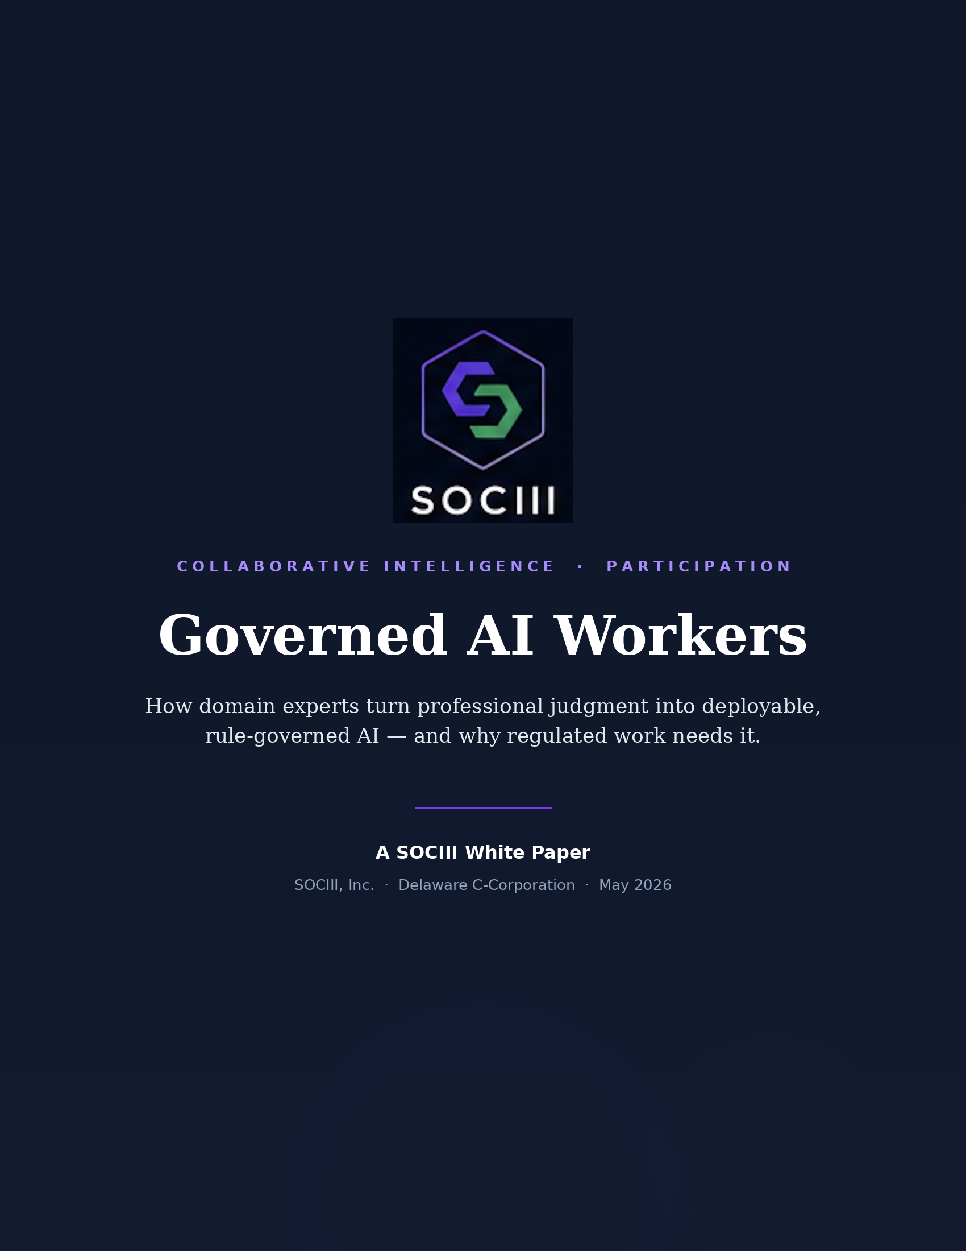

ABSTRACT
This paper explains what SOCIII is, the problem it addresses, and how the platform works. SOCIII is a platform on which domain experts build, govern, and earn from AI workers that operate inside the rules of their professions. It exists because a generation of practitioners holds judgment that no textbook captures, and because general-purpose AI — fluent but unaccountable — cannot safely do regulated work. The sections below describe the digital-worker model, the four-tier rules engine that governs every output, the cryptographic audit trail that makes each decision provable, the no-code authoring path that lets experts build without engineers, and the reasons regulation forces all of this to be local and verifiable rather than generic.
1. The premise
Two facts sit underneath everything SOCIII does. First, the most valuable knowledge in regulated work is experiential, not written down. The ICU nurse with twenty years at the bedside, the master mechanic who diagnoses by sound, the title clerk who knows a county's unwritten practices, the broker who has lived through three market cycles — their judgment is real, durable, and largely undocumented. As that generation retires, the judgment leaves with them.
Second, general-purpose AI is fluent but unaccountable. A consumer chatbot will answer a question about approach minima, a controlled-substance dose, or a securities disclosure with the same confident tone it uses for a dinner recipe. In a regulated setting, a confident wrong answer is not a harmless error — it is a safety event, a compliance breach, or a liability. The model has no structural obligation to the rules of the domain, and no record of what it decided or why.
SOCIII addresses both at once: it captures the expert's judgment into a digital worker, and it wraps every one of that worker's outputs in enforced rules and a permanent audit trail. The expert keeps practicing; the worker scales their knowledge to colleagues, juniors, and the next generation; and every action the worker takes is governed before it commits and provable after the fact.
2. What a digital worker is
A digital worker is not a chatbot with a costume. It is a scoped, rule-governed software agent built to do one job well inside one profession — flight planning for a specific aircraft type, a nursing assessment under a hospital's protocols, an F&I close at an auto dealership, a cap-rate analysis for commercial real estate. Each worker carries the domain knowledge of the expert who authored it, the regulatory context of its industry, and the operating policies of the organization that deploys it.
The difference that matters is governance. A worker proposes an output; the rules engine evaluates that output against a composed hierarchy of constraints; and only a validated result reaches the user. The worker is therefore less like a freewheeling assistant and more like a licensed practitioner working inside a compliance framework — capable, but bounded.
The unit of the platform. Built once by someone who knows the work, operated continuously, governed on every output, and recorded for audit. A worker is durable infrastructure, not a single conversation.
3. RAAS — the four-tier rules engine
SOCIII's governance layer is called RAAS: Rules + AI-as-a-Service. Every worker output passes through four tiers of rules, composed in order, before it is allowed to commit. The model proposes; the rules engine disposes.
TIER | WHAT IT GOVERNS | WHO CONTROLS IT
Tier 0 — Platform Safety | Universal safety invariants. Violence, protected health information, and harmful content are blocked on every worker. Cannot be overridden by anyone. | SOCIII, immutable
Tier 1 — Industry Regulations | Real statutes and standards: FAR/AIM in aviation, NCLEX-aligned practice in nursing, state real-estate law, HIPAA, Reg D in securities. Compiled once and treated as immutable for the deployment. | Compiled from law
Tier 2 — Operator Policies | The deploying organization's own rules — hospital protocols, dealership SOPs, a company operations manual. Specific to one operator. | Creator / operator-editable
Tier 3 — User Preferences | Individual settings and context that personalize a worker, always within every tier above. Makes the worker feel personal without loosening any constraint. | Subscriber-editable

The ordering is the point. A user preference can never relax an operator policy; an operator policy can never relax a regulation; a regulation can never relax platform safety. Compliance is a property of the structure, not a disclaimer bolted on at the end.
4. The audit trail
Because the workers operate in regulated settings, what they did has to be provable later — to a regulator, a court, or a counterparty. SOCIII records every significant output in an append-only audit trail. Each record binds together the worker and its version, the input that triggered the decision, the exact version of the rule set in effect at that moment, the rule-by-rule evaluation outcome, the worker's output, and the final action taken — executed, blocked, or routed to a human.
A cryptographic hash of each record is anchored to a public blockchain, which provides tamper-evidence: the record is provably unchanged from the time of the decision. The full payload, which often contains sensitive data, is kept in encrypted off-chain storage accessible only to authorized parties. This split — hash on-chain, data off-chain — gives the tamper-evidence of a blockchain with the confidentiality regulated industries require. An authorized auditor can present a hash and retrieve exactly the record it corresponds to, and nothing else.
This architecture is the subject of SOCIII's patent filings — a family of U.S. provisional applications filed May 2026, covering the audit trail, the rules engine, the no-code authoring pipeline, document control, the digital-title primitive, and the knowledge-capture pipeline. The audit layer itself descends from earlier blockchain-anchored title work, now repurposed to make AI decisions investigable.
5. Build without code
The platform's accessibility thesis is that the people who should build workers are the people who know the work — not the people who know how to code. SOCIII offers two authoring paths. In the Sandbox, a domain expert describes their work and its rules in plain conversation, and the platform composes a worker around that description; no programming is required. In the Terminal, engineers pair-program with AI to build workers in code. Both paths emit workers governed by the same rules engine and recorded by the same audit trail.
This is what turns expertise into recurring income. A practitioner builds a worker in an afternoon, their colleagues subscribe, and the creator earns a majority share of every subscription against the worker they authored. The platform's growth is therefore bounded by the number of professionals willing to participate, not by the number of engineers a company can hire — a fundamentally larger pool.
6. Why regulation is local
Regulated work does not run on universal rules; it runs on jurisdictional ones. Nevada records a deed differently than California. A maintenance interval legal in one operation is out of limits in another. A disclosure adequate in one state is deficient next door. This is why every SOCIII worker is state-aware: the same worker enforces different constraints depending on where and for whom it operates. A generic model trained on the average of the internet cannot do this, because the correct answer is not the average — it is the specific rule that applies to this jurisdiction, this operator, and this moment.
7. The platform builds the platform
SOCIII runs its own company on its own workers. The functions a startup would normally hire for — finance, marketing, people operations, investor relations, customer relationship management, the chief-of-staff role that routes work across the team — are themselves digital workers deployed internally, governed by the same rules engine and recorded by the same audit trail as any customer's worker. There is no separate “internal version” of the product.
This has two consequences. The first is capital efficiency: the production platform was built across eight industries on roughly $35,000 of operating burn over five months, because the platform was building itself as it went. The second is credibility: every operational problem SOCIII hits is a problem its customers also hit, discovered from inside the work rather than guessed at from outside it.
A compounding system. Every new worker, rule set, and industry adds to the platform rather than restarting it. The cost curve bends down as coverage grows, because the same governance, audit, and authoring machinery serves each new domain.
8. Where it runs today
SOCIII is in production, not in pilot. More than 1,000 rule-governed workers (state-augmented) operate across eight regulated industries today, with Banking coming online now and new industries added regularly:
- Aviation — flight planning, logbook, and risk-assessment workers under FAR/AIM.
- Real Estate — commercial analysis, cap-rate, and lease-review workers.
- Auto Dealer — finance-and-insurance, VIN decode, and deal-desk workers.
- Title & Escrow — title-search and document-control workers built on the digital-title audit layer.
- Web3 — governance, treasury, and token-analytics workers.
- Government — recording, permitting, licensing, and inspection workflows.
- Health / EMS — nursing-assessment and protocol-advisor workers under clinical rules.
- Solar — site, compliance, and documentation workers.
- Banking — coming online now; the newest industry on the platform.
9. The economic model, briefly
SOCIII earns across five streams so that no single behavior has to dominate for the platform to work: Subscription, Data Credits, API Pass-Through, Audit Trail, and Creator License — three of which run at near-100% gross margin. Subscriptions span individual workers ($29/$49/$79 per month), a Business in a Box ($99, every worker a specific business needs), and all workers ($299). Data Credits meter usage above each subscription's baseline; API Pass-Through marks up third-party data and inference; the Audit Trail bills per anchored record; and a Creator License lets domain experts publish workers and keep the majority of subscription revenue. Subscriptions are how customers enter; compute, data, and audit records are how the platform earns at scale. As headline AI subscription prices fall across the industry, the entry barrier drops and usage volume rises — which moves more revenue onto the compute, data, and audit lines rather than less.
10. Why it matters
The agent-platform category is forming now, and most entrants are building for engineers or for general consumers. SOCIII's bet is narrower and, it argues, more durable: that the platforms which compound in regulated, high-judgment professions will be the ones where the practitioners themselves can build, where every output is governed by the actual rules of the field, and where every decision is provable after the fact. Expertise becomes infrastructure; compliance becomes structural; and the knowledge that would otherwise retire with a generation of professionals becomes something their communities can keep using.
This white paper is for general informational and educational purposes. It is not an offer to sell or a solicitation to buy any security, and it is not investment, legal, or tax advice. Product capabilities, figures, and roadmap items described here are current as of May 2026 and subject to change. SOCIII, Inc. — Delaware C-Corporation, Las Vegas, Nevada · alex@sociii.ai · www.sociii.ai

