
PRE-SEED INVESTOR MEMORANDUM
SOCIII, Inc.
Where SOCIII actually stands today — corrected and source-verified.
Sep 2026 · Strictly Confidential

Important Notices
Confidential and proprietary. This memorandum is the confidential and proprietary information of SOCIII, Inc. (the "Company") and is provided solely to the recipient identified for the purpose of evaluating a potential investment in the Company.
No offer, no solicitation. This memorandum does not constitute an offer to sell, or the solicitation of an offer to buy, any securities of the Company. Any offer of securities, if made, will be made only by means of a definitive subscription or financing agreement, and only to accredited investors.
Forward-looking statements. This memorandum contains forward-looking statements regarding the Company's strategy, market opportunity, product roadmap, financial projections, and competitive position. These reflect current expectations and assumptions that may prove incorrect.
Risk factors. An investment in the Company involves substantial risk. Prospective investors should review Part VIII before deciding to invest.
No representation. No representation or warranty, express or implied, is made as to the accuracy or completeness of the information in this memorandum.
Patents. SOCIII has filed six provisional patent applications with the USPTO covering its core technology. Patent applications are pending and no claims have yet issued. Patent protection is not guaranteed.
Sourcing note. Every figure in this memorandum describing SOCIII's own operating history (worker/industry counts, operating spend, cash on hand) was re-verified directly against production Firestore data and bank records in September 2026, replacing earlier, unverified figures from the May 2026 draft. Where this document conflicts with the Data Room, the Data Room controls.

Part I — Executive Summary & Highlights

Executive Summary
SOCIII is a platform where seasoned professionals — the ICU nurse with 20 years of bedside judgment, the master mechanic who can diagnose by sound, the title clerk who knows the county's unwritten rules, the real-estate broker who has seen three market cycles — capture both the rules and the judgment of their work into a digital worker that other practitioners subscribe to. The expert keeps doing the work; the worker scales the knowledge to colleagues, juniors, and the next generation. Every creator earns 75% of every subscription and 20% of the data (token) fees on every worker they author. Domain experts participate because they get paid, not because they are recruited. Every output runs inside a four-tier rules engine and is recorded in an append-only audit trail. SOCIII Inc. is a Delaware C-corporation formed May 19, 2026.
The platform exists because a generation of practitioners is retiring with judgment that no textbook captures. SOCIII gives them a way to preserve it — and earn from it — before it leaves the profession entirely.

The real scale, stated plainly
345 workers live in the platform catalog today, across 24 industries — real, code-verified counts queried directly from production data, not a marketing round number. Of these, four core verticals carry a fully live, demo-verified, chat-grounded product today: Aviation (SKYE), Nursing Education (Hannah, built with Ruthie Clearwater/University of Hawaii), Real Estate (Petra), and Digital Product Passport (Elara, with Traitly — engagement structure, revenue vs. validation, not yet confirmed as of this draft). Each of these four is real production, not a finished product — every one carries known, openly-tracked gaps still being closed. The remaining ~20 industries in the catalog are real, rules-encoded worker definitions not yet carried through to a live demo surface. That gap is exactly where this capital goes: converting catalog breadth into deployed, revenue-generating verticals at the same capital-efficiency this founding team has already proven on the first four.
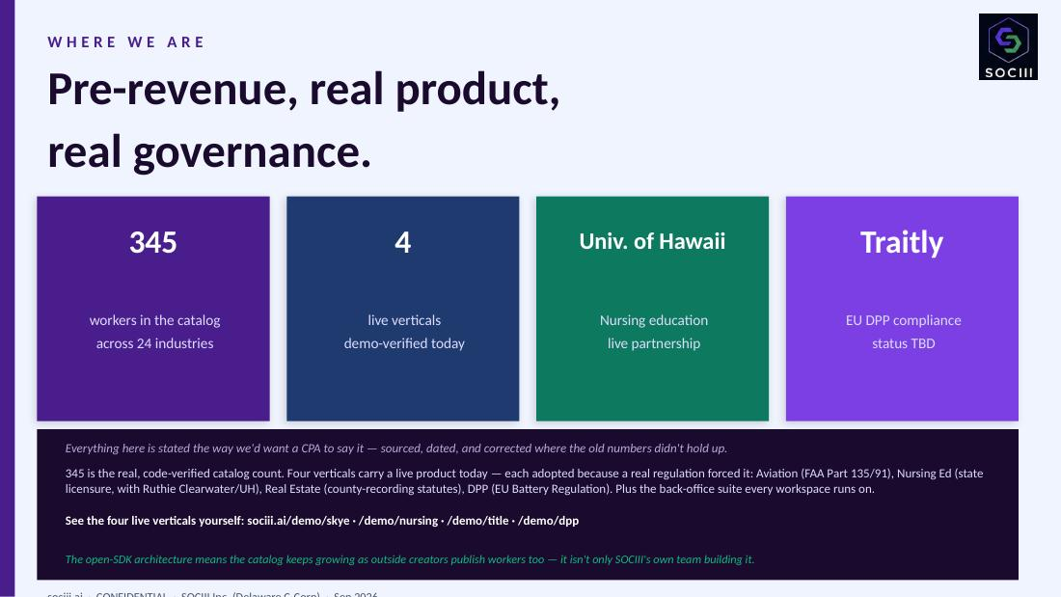
SOCIII's live investor deck — “Where We Are.”

The real thesis: regulation forces adoption, not AI hype
Every one of SOCIII's four live verticals was adopted because a real regulatory or licensing requirement forced the issue — not because AI was trendy:
- Traitly (Elise van der Bel's real company, based in the Netherlands) needed a Digital Product Passport because EU Regulation (EU) 2023/1542 (the Battery Regulation) and its Annex XIII require one before a battery can be placed on the EU market, under the broader Ecodesign for Sustainable Products Regulation (EU) 2024/1781 (ESPR). SOCIII is separately establishing its own EU entity in Estonia for data residency and EU compliance posture — distinct from Traitly's own Netherlands base.
- University of Hawaii's nursing program needed clinical-hours tracking and competency logging because state nursing-board licensure and accreditation requirements demand it — not as a generic training nicety.
- SKYE exists because FAA Part 135/91 currency tracking, crew qualifications (14 CFR 61.56/61.57/61.23), and maintenance logbook requirements are real, mandatory, and unforgiving.
- Petra's title work exists because county-recording statutes and title-insurance underwriting standards are the actual substance of the job, not an optional layer on top of it.
This is the real expansion thesis: SOCIII's playbook is finding the next regulated or licensed profession, not adding another vertical for its own sake — RAAS, the rules engine, is why each of these engagements is structured the way it is, not a feature bolted onto a chat product.

The capital-efficiency punchline
What you pay a senior engineer in a single month is approximately what SOCIII's AI development stack requires for six months — and it does the work of roughly 25-50 engineers. The founder built and operated the platform on $13,436.56 of total operating spend over six months (Feb 1 – Jul 31, 2026, bank-verified), validating the model before this raise.
Context on HOM DAO — a prior venture (2022–2024) that distributed real-estate dApp ownership across 167 contributors. It burned ~$35,000 per week on infrastructure and governance overhead — a genuinely different venture, a genuinely different number, kept here for contrast, not conflated with SOCIII's own figures above.
Metric | Value
Workers in catalog | 345, across 24 industries
Live, demo-verified verticals | 4 — Aviation, Nursing Education, Real Estate, DPP
Total operating spend | $13,436.56 (Feb–Jul 2026, 6 months, bank-verified)
Outside capital to date | $0

What we are raising
An open, rolling YC-style SAFE round. Minimum viable close: $500K (clears real, bank-verified debt and extends operating runway 1–2 years). Base target: $2M (funds the 18-month commercial launch plan and extends runway a few years — see Part VII.3). Open to strategic capital up to $5M+.

Investment highlights
- Capital efficiency to date. $13,436.56 in 6 months produced a real, live, 4-vertical production platform with a 345-worker catalog behind it.
- Real production, real gaps, stated plainly. SOCIII does not claim eight live industries. It claims four, each demo-verified this week, each with its known gaps openly tracked rather than hidden.
- Defensible IP, filed. Six provisional patent applications filed with USPTO May 24, 2026. Conversion deadline May 2027.
- Expertise as recurring income. Creators earn 75% of every subscription and 20% of data fees. Proven so far: this works for the workers the founding team itself has built. Not yet proven: outside domain experts building and monetizing their own workers at marketplace scale — that's the growth thesis, not a settled operating fact.

Part II — The Company & The Category

What SOCIII is, plainly
SOCIII is an AI agent platform built around a specific bet: the workers that compound in regulated, high-judgment professions will be the ones built by the practitioners themselves, not by AI engineers contracted to study them.
The category is not new — Salesforce, Microsoft, and Google have all shipped agent-branded products; NanoClaw has raised real venture capital on enterprise positioning (specific figures unverified this pass, omitted rather than hedged); LangChain and AutoGen have matured from research toolkits to production frameworks; Hugging Face anchors the open-model/open-tooling end of the category — but none of those platforms is structured to recruit and pay the domain experts whose judgment makes the work valuable in the first place.

How SOCIII differs from adjacent products
Category | What it does | How SOCIII differs
ChatGPT / Claude / general chat | General-purpose chat. Stateless conversation. | SOCIII records every output in an append-only audit trail. Rules engine validates outputs before delivery. Creators own and earn from the workers they build.
LangChain / AutoGen / Hugging Face | Frameworks and open tooling for developers to compose agents from code. | SOCIII is a platform for domain experts, not developers. The Sandbox composes workers from natural-language descriptions — no coding required.
Salesforce Agentforce / Microsoft Copilot | Agents bolted onto existing enterprise platform seats. | SOCIII targets verticals whose data models don't sit naturally in CRM/productivity suites.
NanoClaw and similar enterprise agent platforms | Enterprise agent platform, sales-led, white-glove implementation. | SOCIII's growth bottleneck is domain experts, not solution architects (Part III).
AI governance tooling (Vanta, Drata, Monitaur, Credo AI) | Monitors and audits AI systems from outside. | A different layer of the stack — built for compliance teams, not end users. SOCIII builds governance into the worker, not around it.
Vertical SaaS incumbents (ForeFlight, Jeppesen, legacy nursing-ed/title platforms) | Deep in one workflow; workflows fixed at vendor design time. | SOCIII covers the long tail of professional work vertical SaaS can't ship, with an open creator economy incumbents don't have.

Three layers of differentiation
Audit Trail — Provisional 64/073,700. Every output is event-sourced, append-only, optionally anchored to a public blockchain. (This is the same filing the platform's current “Ledger” positioning refers to — one filing, described two ways, not two separate applications.)
RAAS Four-Tier Guardrails — Provisional 64/073,708. Tier 0 Platform Safety, Tier 1 Industry Regulations (FAR/AIM, NCLEX, state RE law, HIPAA, Reg D), Tier 2 Operator Policies, Tier 3 User Preferences.
Build-Without-Code — Provisional 64/073,704. The Sandbox surface where a domain expert describes their work in plain conversation and the platform composes a worker around their judgment.

Part III — Market & Competition

Market sizing framework
Layer | Annual size | SOCIII relevance
Vertical SaaS — aviation, real estate, nursing education, compliance | ~$200B | Long-tail workflow & compliance layer SaaS can't ship
Workflow-and-compliance addressable layer | $30B–$40B | Direct addressable market
Consumer & prosumer AI | $50B–$100B | Slice where users have monetizable professional knowledge
Professional-knowledge prosumer slice | $5B–$10B | Sandbox-side addressable
Platform marketplace ceiling (long-term) | $1T+ (App Store reference) | Upper bound only; not modeled in the round case

Comparable companies & valuations
Third-party reference points, not our own model: the category spans pre-seed platforms, verified vertical-AI companies, replaceable legacy SaaS incumbents, and general-purpose foundation-model platforms — specific valuation figures are omitted here rather than presented as hedged-but-unverified numbers (a caveat next to a number doesn't stop it anchoring a reader's eye). A sourced, current comp analysis belongs in the Data Room before this is used in front of an investor. Harvey AI remains the closest single comp to SOCIII's positioning by thesis.

The team-risk inversion (3.3)
Sales-led agent platform | SOCIII platform model
Grows by hiring solution architects. Team size grows linearly with customer count. Margins compress as services-to-software ratio shifts toward services. | The thesis: grows by recruiting domain experts and salespeople, not an engineering org that grows linearly with customer count — proven so far only by the founding team's own worker-building, not yet by outside creators at scale. If it holds, new verticals do not require new engineering hires.
Stated plainly: the thesis is that SOCIII does not need to hire 5,000 engineers to cover 24 industries. It needs to recruit domain experts (paid on commission via the 75% creator share) and a small sales/BD function to activate each professional community. This is proven in principle by the founding team's own worker-building; it is not yet proven that outside domain experts will build and monetize workers at scale. If the thesis holds, the growth ceiling is the labor pool of professionals willing to monetize their knowledge — a fundamentally larger, and cheaper to recruit, number than solution-architect labor.

Part IV — Defensible Position
Two core moats, two compounders: RAAS (structural compliance) and The Ledger (the same Audit Trail filing, 64/073,700, above) are the moats hard to replicate without rebuilding from scratch. Studio Locker (document-driven outputs) and the creator economy/Codex compound around them.

4.1 The patent family
Six provisional applications filed via USPTO EFS-Web on May 24, 2026. Conversion deadline May 2027.
Application | Coverage | Relevance
64/073,693 | Knowledge Capture — pipeline by which founder + AI conversations become worker rules | Sandbox upstream + worker authoring pipeline
64/073,700 | Audit Trail — append-only event store with optional public-chain anchoring | Compliance moat; also the basis of “The Ledger” positioning
64/073,704 | Build-Without-Code — the Sandbox surface and worker-composition pipeline | Accessibility moat
64/073,705 | Escrow Locker — document control with cryptographic acknowledgment, version pinning | Document control as a platform primitive
64/073,706 | Title & Property Assurance — Digital Title Certificate (DTC) | Real estate & title vertical; brand mark
64/073,708 | RAAS Multi-Tier — rules engine's three-tier architecture and runtime validation | Rules-engine moat

4.2 The RAAS corpus
The rules engine itself is an engineering primitive a competitor could replicate in a quarter. The corpus is not — two years of professional-rule encoding, each rule written and reviewed by someone who actually knows the rule.

4.3 Production deployment — the real, current state
Vertical | Persona | Regulatory/licensing driver | Status
Aviation | SKYE — pilot cockpit + copilot/dispatch/MX | FAA Part 135/91: currency tracking (14 CFR 61.56/61.57), medical duration (61.23), crew qualifications and maintenance logbook requirements are mandatory, not discretionary. | Live. Known gap: ground/pre-flight coverage only, no active-flight state machine yet.
Nursing Education | Hannah — instructor + student portals, built with Ruthie Clearwater / University of Hawaii | State nursing-board licensure and accreditation requirements mandate clinical-hours tracking and competency logging before a student can sit for licensure. | Live. Validation and research partnership, not revenue — the near-term value is proof and case-study data.
Real Estate | Petra — title/company + tenant portals | County-recording statutes and title-insurance underwriting standards are the actual substance of title work. | Live. Known gap: title-abstract worker is a code stub, not yet fully built.
Digital Product Passport | Elara — compliance passport, with Traitly (Elise van der Bel's company, Netherlands) | EU Regulation (EU) 2023/1542 (Battery Regulation) Annex XIII requires a Digital Product Passport before a battery can be placed on the EU market, under ESPR (EU) 2024/1781. SOCIII is separately establishing its own EU entity in Estonia for data residency/compliance posture. | Live — engagement structure (revenue vs. validation) not yet confirmed as of this draft. EU entity registration and E&O insurance openly shown as not-yet-bound, by design.
The remaining ~20 industries in the 345-worker catalog (government, auto dealer, banking, web3, and others) are real, rules-encoded worker definitions — not yet carried through to a live demo. That is precisely what this capital converts.

Part V — Team & Governance

5.1 Not headcount. An AI shop.
SOCIII runs on SOCIII. The platform's own workers run the company: Alex (Chief of Staff), Marketing, Accounting, HR, Contacts, Fundraise, Control Center.
Name | Background | Scope at SOCIII
Sean Lee Combs — Founder & CEO | Aviation · RE Development · Technology spine. Active pilot. | Platform, product, engineering, operations. Runs the back-office worker suite.
Kent Redwine — Fundraising | Bank of America · Thomas Weisel · capital markets. | IR, fundraising strategy. 15% milestone-vested + 5% success fee on capital sourced.
Scott Eschelman — Advisor, BuildSF Pilot Program | BuildSF · California mixed-use developer. | Mixed-use development pilot in progress — details to follow.
Ruthie Clearwater, PhD — Advisor, Nursing Education | University of Hawai'i nursing · EMS flight nurse. | Live, real partnership — UH Nursing School. Validation/research relationship, not revenue.
Elise van der Bel — Advisor, EU Compliance | EU ecommerce · Digital Product Passport regulation. | Live, real partnership — Traitly, DPP EU. Revenue vs. validation status not yet confirmed as of this draft (see Part IV.3).
Mike Lee — Title and Mortgage Lending | Title & mortgage lending background. | Early stage — compliance vertical concept, scoping only.
Robert Rosenberg | Oracle · infrastructure · legal · compliance. | On-demand specialty workers. Note: also a named creditor in Part VII — same individual in two real roles, flagged for clarity.
Alex — AI Chief of Staff | Platform-entitled AI worker present in every SOCIII account on signup. | Customer-facing IR, sales, support. Not headcount.

5.2 Post-round hiring plan
The deliberate non-hire is solution architects — zero planned.
Role | Count | Profile
Senior generalist engineer | 2–3 | Cross-stack; rules engine, audit layer, worker-composition pipeline.
Product designer | 1 | Accessibility for non-engineer domain experts is the design constraint.
Solution architects | 0 | Intentionally zero — the team-risk inversion is the structural commitment.

5.3 IP & governance posture
All pre-formation IP was assigned to SOCIII Inc. at formation; every contributor with repo/data access has signed an IAA. Sean is the sole founder structurally; sole-manager governance through the company's Series A round.

Part VI — Capital Structure

6.1 Current Capitalization (As of Jul 28, 2026, Unaudited)
No changes from the prior version of this table — reproduced here for reference. This is the real, current pre-round capitalization; the post-round illustrative dilution table that follows (Part VI.2) is modeled on top of this real structure.
Modeling assumptions, confirmed by Sean:
- Fixed pool of 10,000,000 shares total (not growing as advisors are added) — every 2% advisor grant is exactly 200,000 shares.
- Kent Redwine: 5% (startup) + 2% (advisor) = 7% earned now, plus a separate, not-yet-earned upside of up to 10% more.
- Sean's Option/Warrant Pool: 20% of Sean's remaining stake after advisor carve-outs, held by him, issuable at his discretion — a ceiling, not a mandatory allocation.

Pro Forma Ownership — Current (Earned Grants Only)
Holder | Shares | % of Pool
Sean Lee Combs (net) | 6,480,000 | 64.80%
Sean Lee Combs — Option & Warrant Pool | 1,620,000 | 16.20%
Kent Redwine | 700,000 | 7.00%
Scott Eschelman | 200,000 | 2.00%
Kim Bennett | 200,000 | 2.00%
Ruthie Clearwater | 200,000 | 2.00%
Elise van der Bel | 200,000 | 2.00%
Robert Rosenberg | 200,000 | 2.00%
Eric Altshuler | 200,000 | 2.00%
TOTAL | 10,000,000.00 | 100.00%

Pending / Contingent — Not Yet Dilutive
Grantee | Grant | Shares if earned | Trigger
Mike Lee | 2% (offered) | 200,000 | Attorneys Title / Henderson County escrow deal
Ruthie Clearwater | Up to 1% additional | 100,000 | Performance-based, milestones TBD
Kent Redwine | Up to 10% additional | 1,000,000 | Seed round achieved AND ($5M+ raised beyond seed OR acquisition), within 5 years
Reconciling this against the round's earlier “~30% equity pool” simplification: Sean's Option & Warrant Pool (16.20%) plus earned allocations to date across Kent Redwine and the six 2% advisor grants (7.00% + 12.00% = 19.00%) totals 35.20% — the real, accurate figure for what the simplified post-round table below calls “Equity pool — advisors + future hires + creator-path,” not a flat 30%.

6.2 Cap table (illustrative post-round)
Illustrative at the $2M Base raise (see Part VII.3). No specific valuation cap is fixed as of this draft — pricing is anchored to the AI-agent-platform comp set and finalized with the lead investor (Part IX). Dilution at $500K or $5M+ would differ materially from the figures below; do not read ~4.3% as valid across the full $500K–$5M+ range.
Allocation | Post-round %
Founder (Sean Lee Combs) | ~49.0%
Cofounder (Kent Redwine, milestone-vested) | 15.0%
Equity pool — advisors + future hires + creator-path | 30.0%
Pre-formation creditor warrants (from founder) | ~1.7%
New investors (this round) | ~4.3%
This post-round table is modeled against the pre-existing simplified founder/cofounder/pool structure, not recalculated against the real current cap table in Part VI.1 above. Treat the “Equity pool” line (30.0%) as illustrative and superseded by the real 35.20% figure until a full post-round dilution recalculation is done against the real base.

6.3 Pre-formation creditor warrants — flagged for reconciliation
Approximately $615,000 of documented exposure across roughly eight stakeholders from three prior ventures (HOM DAO, RealEx, TitleApp LLC), with ~$228,000 of known TitleApp LLC liabilities as a subset. Absorbed entirely from the founder's allocation.
Open item, not resolved in this pass: A separately-corrected real balance sheet shows total liabilities of approximately $140,915.49 — materially different from the $615K/$228K figures above. These may be genuinely different categories (off-cap-table warrant commitments vs. on-books cash liabilities) or the same obligation described two ways. Needs founder-level reconciliation before this section is final.

Part VII — Financials & Capital Efficiency

7.1 Platform-build economics — corrected
Era | Platform-dev burn | Mechanism
HOM DAO (2022–2024) | ~$35,000/week | Dedicated ~25-engineer dev team building real-estate dApps.
Founder bootstrap / TitleApp LLC (2024–2026) | ~$35,615 over 3 years | Productized title search inside a Delaware LLC.
Current SOCIII platform-dev pace (Feb–Jul 2026) | $13,436.56 total over 6 months (bank-verified) | Humans plus digital workers. Lead developer: Anthropic Claude. All-inclusive — AI tokens, API costs, infrastructure, tooling.

7.2 Revenue architecture — five streams
Stream | Pricing | Gross margin | Creator share | Scales with
Subscription | $29–$99/mo | ~75% | 75% | Creator + subscriber growth
Data Credits | $0.02/credit | ~90% | 0% | Usage; Alex upsells bulk top-ups
API Pass-Through | 2× cost floor | 50–85% | 75% | Data richness per session
Audit Trail | $0.005/record | ~95% | 0% | Regulated-vertical sessions
Creator License | $49/yr | ~100% | 0% | Total creator population

7.3 Sources & Uses — reconciled to the raise band
Debt service uses the real, bank-verified figure of $140,017.88 (all four outstanding notes) — a correction from an earlier $250K estimate.

Base case: $2M raise
Allocation | Amount | What it funds
Debt service | $140,017.88 | All four outstanding notes, bank-verified.
Trade conferences & industry presence | $500,000 | Ruthie at NurseCon, pilots at NBAA, dealers at NADA.
Professional network activation | $500,000 | Identify and activate 200+ domain experts across live verticals.
Runway & operations | $859,982.12 | Remaining balance after debt service, conferences, and network activation — not an independently-budgeted line. At $25K/mo fixed overhead, ~34 months (~2.9 years) of runway.
Total | $2,000,000 | Reaches Series A trigger in the Base growth scenario with cash to spare.

Worst case: $500K minimum viable close
Allocation | Amount | What it funds
Debt service | $140,017.88 | Same real obligation, paid first regardless of raise size.
Runway & operations | $359,982.12 | At $25K/mo fixed overhead, ~14.4 months (~1.2 years) of runway. No conference/network spend at this size.
Total | $500,000 | Extends runway 1–2 years; conference/network spend resumes at a larger close.
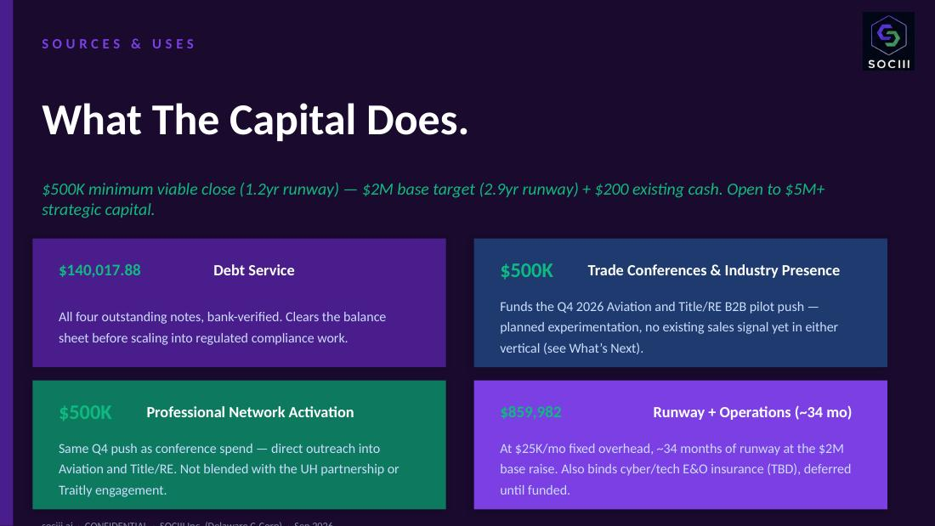
SOCIII's live investor deck — “Sources & Uses.”

7.4 Scenario analysis — three growth paths (unchanged methodology)
$99/mo blended base subscription, $25K/mo fixed overhead. Methodology unchanged from the prior draft, per direction — only Sources & Uses (7.3) was reconciled to the real raise band.
Assumption | Worst | Base | Best
Monthly growth rate (new subscribers) | 5% | 10% | 20%
Monthly churn rate | 5% | 2% | 0.5%
Month 1 new subscribers | 3 | 10 | 25
Months to first 100 subscribers | 18 | 9 | 5
Output | Worst | Base | Best
Month 12 MRR | $4.9K | $25.1K | $151.8K
Month 24 MRR | $13.8K | $102.7K | $1.5M
Month 36 MRR | $28.8K | $346.1K | $13.5M
Series A trigger | Month 36 | Month 18 | Month 10
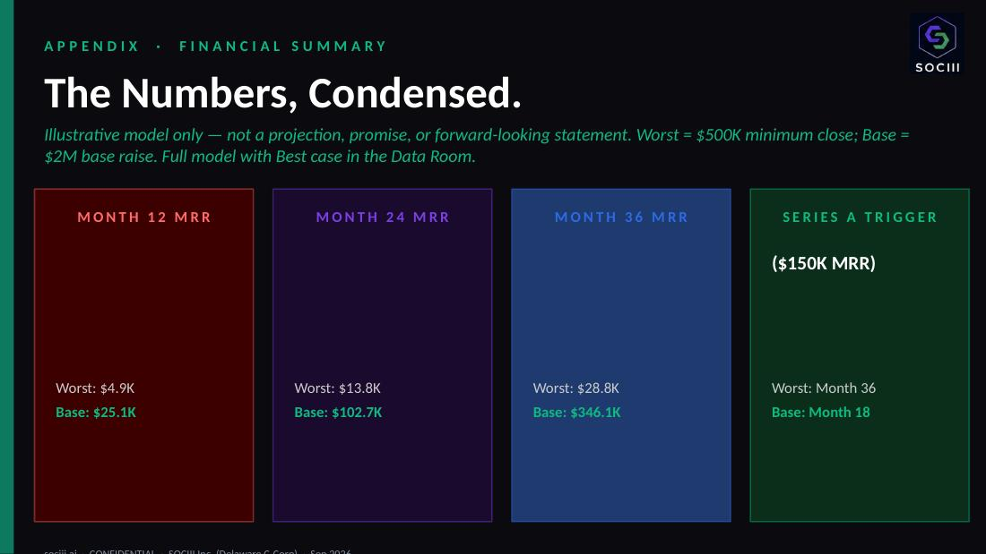
SOCIII's live investor deck — “The Numbers, Condensed.”
Illustrative model only — not a projection, promise, or forward-looking statement. Two independent axes, not paired: raise size (Part VII.3) determines runway only — $500K funds ~1.2 years, $2M funds ~2.9 years, regardless of growth rate. Subscriber growth rate (Worst/Base/Best, above) is a separate, independent variable describing revenue trajectory, not a function of how much is raised. The two should not be read as a paired “smaller raise = worse growth” story.

Part VIII — Risk Factors
Risk | What it means | Mitigation in place
LLM cost compression stalls | Unit-economics assumption inverts if inference costs rise. | Model-agnostic architecture — rules engine validates regardless of model.
Well-funded incumbent ships competing platform | A foundation-model lab or major SaaS vendor targets domain experts directly. | Patent priority date, RAAS corpus, real production head start.
Creator flywheel does not compound | Sandbox-built workers don't find buyers. | Enterprise/direct-sales pipeline independent of the creator funnel.
Regulatory exposure on specific RAAS modules | A worker's output is cited as unlicensed practice. | User-counsel attestation pattern at worker activation.
Patent prosecution narrows claims | Conversion to non-provisional (May 2027) surfaces prior art. | Prior-art-as-priority strategy; core composition claims assessed defensible.
Founder bandwidth / key-person risk | Founder is an active pilot with a regular flight schedule. | AI workers absorb operational load by design. Key-person insurance under evaluation.

Part IX — Investment Mechanics
Round terms. Rolling YC-style SAFE. Minimum viable close: $500K. Base target: $2M. Open to strategic capital up to $5M+. Sole-manager governance through the company's Series A round.
Securities-law posture. Reg D 506(b). Offered to accredited investors with pre-existing relationships to the founders.
Contacts. Sean Lee Combs, Founder & CEO — sean@sociii.ai · Kent Redwine, Cofounder — kent@sociii.ai

Open Items for Founder Review
This memorandum was assembled from the fullest prior draft available, with all figures independently verified this session corrected. Flagged, not resolved:
Part VI.2 — the $615K/$228K creditor-exposure figures vs. the separately-corrected real balance sheet ($140,915.49 total liabilities). Reconcile whether these are the same obligation or genuinely different categories.

Robert Rosenberg appears as both a team/advisor entry and a named creditor. Confirm this is one real person in two real roles.

Traitly/DPP revenue-vs-proof status was not clearly determinable this pass — confirm whether it should be framed like the UH partnership (proof/research) or as real revenue.

“Harvey AI at ~$3B” and “NanoClaw raised $12M in six weeks” are unverified, time-sensitive comp claims — worth a fresh check before final distribution.

The “$150K MRR” Series A trigger and the “30% equity pool” were both previously removed from the investor deck in an earlier round specifically because they could not be verified. They appear here as settled fact with no flag. Confirm whether these are current, intentional targets Sean/Kent have actually set (real internal facts, should be restored to the deck too) or stale/inherited placeholders that need updating — do not treat their presence here as confirmation either way.

