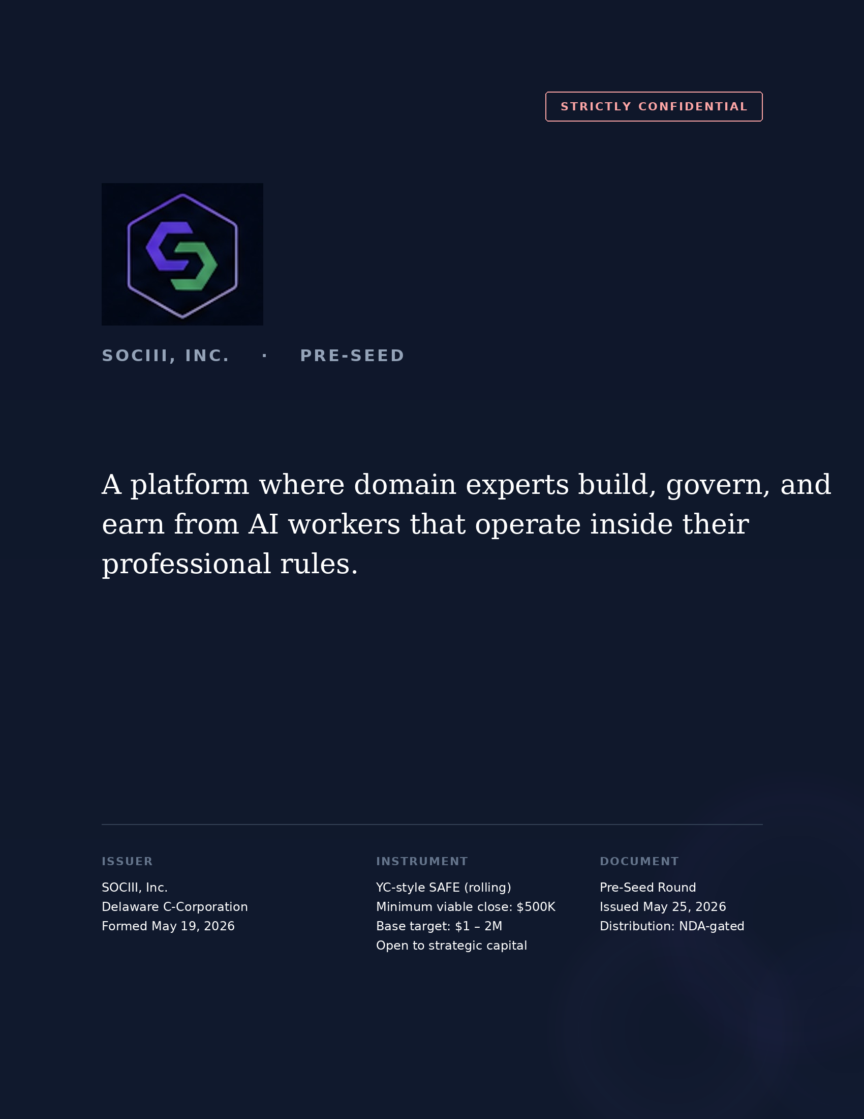

PART I
Executive Summary
SOCIII is a platform where seasoned professionals — the ICU nurse with 20 years of bedside judgment, the master mechanic who can diagnose by sound, the title clerk who knows the county's unwritten rules, the real-estate broker who has seen three market cycles — capture both the rules and the judgment of their work into a digital worker that other practitioners subscribe to. The expert keeps doing the work; the worker scales the knowledge to colleagues, juniors, and the next generation. The creator earns 75% of every subscription. Every output runs inside a four-tier rules engine and is recorded in an append-only audit trail. 1,000+ workers (state-augmented) live across 8 industries. SOCIII Inc. is a Delaware C-corporation formed May 19, 2026.
The platform exists because a generation of practitioners is retiring with judgment that no textbook captures. SOCIII gives them a way to preserve it — and earn from it — before it leaves the profession entirely.
The capital-efficiency punchline. What you pay a senior engineer in a single month is approximately what SOCIII's AI tools require for an entire year — and they do the work of roughly 50 engineers. SOCIII does not hire and lay off armies of humans to scale; it starts without that exposure and grows as fast as the underlying AI models grow. The founder built a production platform across eight industries on $35K of operating burn over five months, validating the model before SOCIII Inc. ever opened a checking account.

Context on HOM DAO — a prior venture (2022–2024) that distributed real-estate dApp ownership across 167 contributors. It burned ~$35K per week on infrastructure and governance overhead. The technical learnings (blockchain-anchored title) carried forward into SOCIII's audit layer; the governance learnings (distributed control without enforcement is a hostage situation) shaped SOCIII's sole-manager structure. See §V.3.
1,000+  WORKERS (STATE-AUGMENTED) | 8  LIVE INDUSTRIES | $35K  TOTAL BURN, 5 MONTHS | $0  OUTSIDE CAPITAL TO DATE
What we are raising
An open, rolling YC-style SAFE round. Minimum viable close: $500K (clears inherited debt service and extends operating runway). Base target: $1–2M (funds the 18-month commercial launch plan in §VII.4). Upper end: open to strategic capital up to $5M+ if the right partners participate. Pricing is anchored to the AI-agent-platform comp set and finalized with the lead investor; vertical-AI references (Harvey AI at ~$3B) anchor the upside framing. The founder self-funded the prior twelve months of personal runway; SOCIII is choosing this raise rather than requiring it. Any close above $500K materially advances the plan; the band scales with investor demand rather than capping it.
Investment highlights
Capital efficiency to date. $35K in 5 months produced what VC-backed competitors spend $5M+ to build — ~200× compression versus traditional headcount-scaled engineering. The mechanism is the platform building the platform: SOCIII runs on SOCIII's own workers (Alex, Marketing, Accounting, HR, Contacts, Control Center), with Anthropic Claude as the lead developer. The next dollar of capital extends the ratio rather than resetting it.
The investor question this memo answers. The AI agent category opened up commercially in the last six months. NanoClaw raised $12M in six weeks. The question is no longer "is this a category?" but "which platforms in this category will compound?" SOCIII argues that the platforms which compound are the ones where the people who know the work — not the people who know to code — can participate. That accessibility-to-domain-experts thesis is what this document defends.

Defensible IP, filed. Six provisional patent applications filed with USPTO May 24, 2026, covering audit trail, rules engine, Sandbox composition, document control, DTC primitive, and multi-tier RAAS architecture. Conversion deadline May 2027.
Production, not pitch. Platform has been live since 2024 across aviation Part 135/91, real estate, auto dealer, government, and title & escrow. Reference customers available in each industry.
Expertise as recurring income. Creators earn 75% of every subscription against workers they build. The nurse, the mechanic, the broker monetizes their judgment for the first time — and SOCIII's growth bottleneck becomes the labor pool of professionals willing to participate, not the labor pool of engineers we can hire.

PART II
The Company & The Category
What SOCIII is, plainly
SOCIII is an AI agent platform built around a specific bet: the workers that compound in regulated, high-judgment professions will be the ones built by the practitioners themselves, not by AI engineers contracted to study them. A nurse with 20 years of clinical experience can describe her judgment in conversation and the platform composes a worker that captures it. Her colleagues subscribe. She earns 75% of every subscription on a worker she built in an afternoon. The category is not new — Salesforce, Microsoft, and Google have all shipped agent-branded products; NanoClaw raised $12M on enterprise positioning; LangChain and AutoGen have matured from research toolkits to production frameworks — but none of those platforms is structured to recruit and pay the domain experts whose judgment makes the work valuable in the first place.
How SOCIII differs from adjacent products
ADJACENT PRODUCT | WHAT IT DOES | HOW SOCIII DIFFERS
ChatGPT / Claude | General-purpose chat. Stateless conversation. | SOCIII records every output in an append-only audit trail. Rules engine validates outputs before delivery. Creators own and earn from the workers they build.
LangChain / AutoGen | Frameworks for developers to compose agents from code. | SOCIII is a platform for domain experts. The Sandbox composes workers from natural-language descriptions of work and rules — no coding required.
Salesforce Agentforce / Microsoft Copilot | Agents bolted onto existing enterprise platform seats. | SOCIII targets industries whose data models do not sit naturally in CRM or productivity suites: aviation maintenance, county recording, dispatch.
NanoClaw | Enterprise agent platform, sales-led, white-glove implementation. | SOCIII's growth bottleneck is domain experts, not solution architects. See §3.3 on the team-risk inversion.
Vertical SaaS incumbents | Software for a specific industry; workflows fixed at vendor design time. | SOCIII covers the long tail of professional work that vertical SaaS cannot economically ship as features.

Three layers of differentiation
SOCIII's architectural identity is described as three things, all of which are running in production today.
Audit Trail · Provisional 64/073,700 Every output is event-sourced, append-only, optionally anchored to a public blockchain. State is computed from event history; records are never overwritten. For regulated industries this is not a feature — it is a deployability prerequisite.

RAAS Four-Tier Guardrails · Provisional 64/073,708 Tier 0 Platform Safety — universal rules, immutable. Tier 1 Industry Regulations — FAR/AIM, NCLEX, state RE law, HIPAA, Reg D, compiled once. Tier 2 Operator Policies — creator-editable for the deployment. Tier 3 User Preferences — subscriber-editable within all tiers above. The model proposes; the rules engine validates; only validated outputs reach the user.

Build-Without-Code · Provisional 64/073,704 The Sandbox surface where a domain expert describes their work in plain conversation and the platform composes a worker around their judgment. The expert keeps their day job; the worker scales their judgment to colleagues, juniors, and the next generation — and pays the expert on every subscription. Accessibility to the people who know the work is the long-term moat.

PART III
Market & Competition
Market sizing framework
The agent platform category is forming, so market sizing is more useful as framing than precision. Three reference layers:
LAYER | ANNUAL SIZE | SOCIII RELEVANCE
Vertical SaaS — aviation, real estate, auto dealer, gov, healthcare | ~$200B | Long-tail workflow & compliance layer SaaS can't ship
Workflow-and-compliance addressable layer | $30B – $40B | Direct addressable market
Consumer & prosumer AI | $50B – $100B | Slice where users have monetizable professional knowledge
Professional-knowledge prosumer slice | $5B – $10B | Sandbox-side addressable
Platform marketplace ceiling (long-term) | $1T+ (App Store reference) | Upper bound only; not modeled in the round case

Comparable companies & valuations
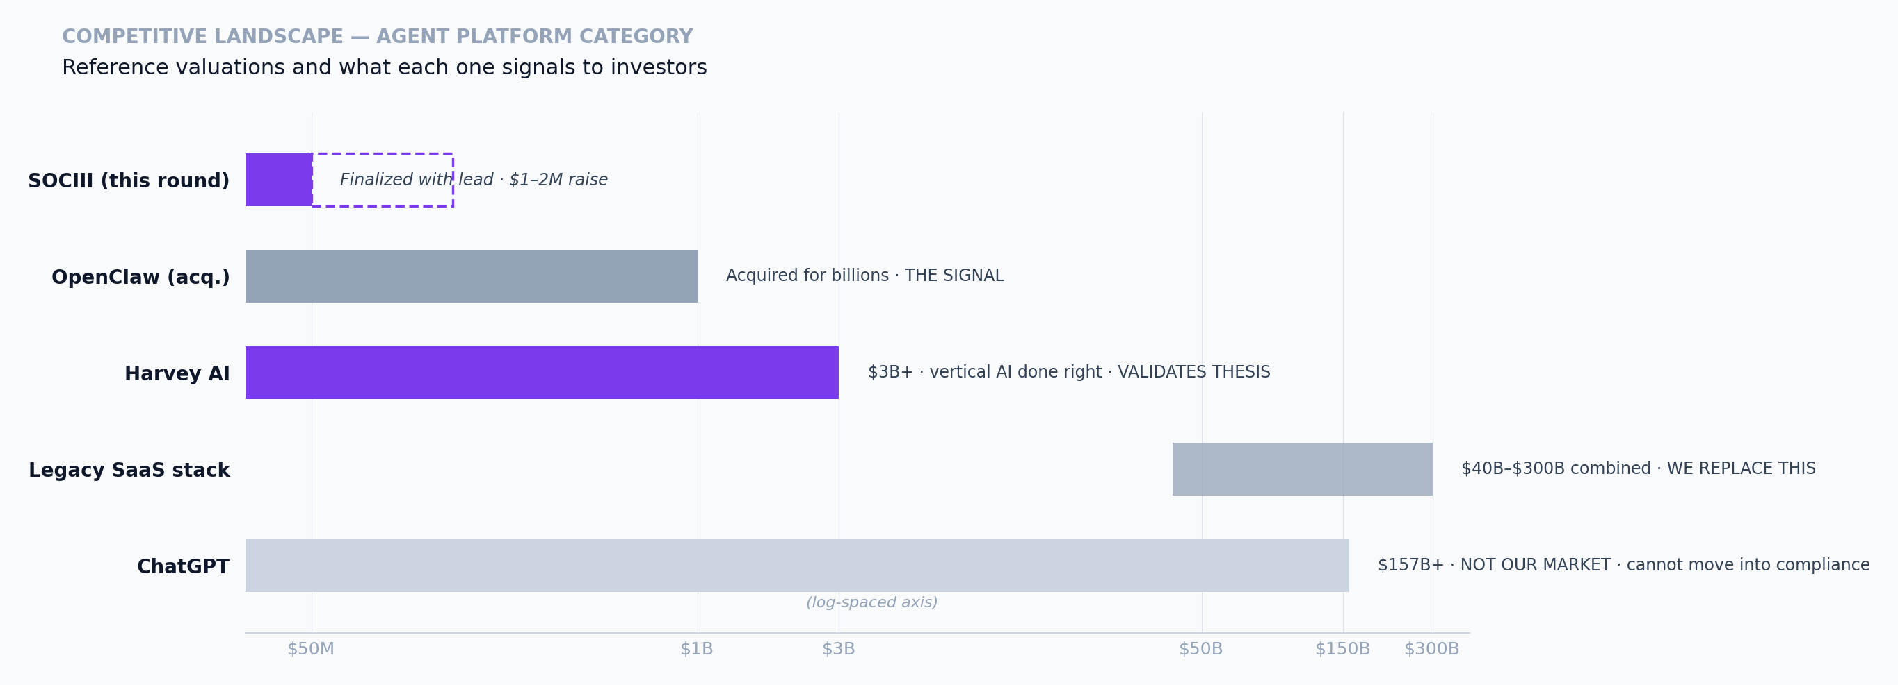
Bar widths reflect a log-spaced visualization — not linear — designed to show the category sweep from pre-seed (~$50M) through verified vertical AI ($3B) through replaceable legacy SaaS ($40–300B) through unreachable general-purpose ($157B). Harvey AI is the closest single comp to SOCIII's positioning.
The team-risk inversion
The cleanest single frame for the difference between SOCIII and a sales-led agent platform.
SALES-LED AGENT PLATFORM | SOCIII PLATFORM MODEL
Grows by hiring solution architects. Each new customer requires a custom implementation. Team size grows approximately linearly with customer count. Margins compress as the services-to-software ratio shifts toward services. Growth ceiling is set by recruitable solution-architect labor. | Grows by recruiting domain experts to build their own workers. New industries do not require new engineering hires. Team-size growth scales with platform and ops needs, not implementation work. Growth ceiling is set by the labor pool of professionals willing to monetize their knowledge — a fundamentally larger number.

The investor question this frames. Are you funding a platform that needs to scale its services org with its revenue, or a platform that compounds without growing a services org at all? The unit economics of the two are not comparable.

PART IV
Defensible Position
Four layers, listed in descending order of how quickly they can be replicated by a well-funded entrant.
4.1 The patent family
Six provisional applications filed via USPTO EFS-Web on May 24, 2026. Each application cites a 2023 patent (18/398,973, now public) and a December 2024 logbook as the foundation for a continuous invention thread. The strategy is prior-art-as-priority: new claims protect system-level composition that builds on the cited foundation, not primitives a competitor could independently invent. Conversion deadline is May 2027.
APPLICATION | COVERAGE | RELEVANCE
64/073,693 | Knowledge Capture — pipeline by which founder + AI conversations become worker rules and platform knowledge | Sandbox upstream + worker authoring pipeline
64/073,700 | Audit Trail — append-only event store with optional public-chain anchoring | Compliance moat for regulated industries
64/073,704 | Build-Without-Code — the Sandbox surface and worker-composition pipeline | Accessibility moat
64/073,705 | Escrow Locker — document control with cryptographic acknowledgment, version pinning, distribution tracking | Document control as a platform primitive
64/073,706 | Title & Property Assurance — Digital Title Certificate (DTC), parent-child certificate composition | Real estate & title industry; brand mark
64/073,708 | RAAS Multi-Tier — rules engine's three-tier architecture and runtime validation pipeline | Rules-engine moat

4.2 The RAAS corpus
The rules engine itself is an engineering primitive a competitor could replicate in a quarter. The corpus is not. Two years of professional-rule encoding across more than 200 industries, each rule written and reviewed by someone who actually knows the rule, is the layer that does not show up in a feature comparison and does not compress on a roadmap.
What a competitor sees, and what they do not. A competitor reading our patent applications sees the architecture. They do not see how long it took to make it work in production, how many domain experts we burned through before we knew what a rule definition needed to look like, or which rule formulations regulators actually accept under audit. Those are corpus facts, not architecture facts.

4.3 Production deployment
SOCIII has been in production since 2024 across aviation Part 135/91, real estate, auto dealer, government (DMV, recording, permitting, inspections), and title & escrow. Healthcare and EMS are in development. A buyer doing a reference call to a Part 135 operator running a SOCIII dispatch worker gets a different signal than a buyer doing a demo with a platform still in pilot.

PART V
Team & Governance
5.1 Not headcount. An AI shop.
SOCIII runs on SOCIII. Eight humans set strategy. The platform's own workers run the company: Alex (Chief of Staff), Marketing, Accounting, HR, Contacts, Fundraise, Control Center. That is the dogfood proof and the structural reason the team scales without friction.
NAME | BACKGROUND | SCOPE AT SOCIII
Sean Combs  Founder & CEO | Aviation · RE Development · Technology spine. Active pilot. Built the platform 2024–present; self-funded prior twelve months. | Platform, product, engineering, operations. Runs Alex (CoS), Marketing, Accounting, HR, Contacts, Control Center workers.
Kent Redwine  Cofounder | Bank of America · Thomas Weisel · capital markets. | Fundraising & investor reporting. Operates the Fundraise worker, IR, cap table, Data Room. 15% milestone-vested + 5% success fee on capital sourced.
Scott Eschelman  Advisor | BuildSF · California mixed-use developer. | Development & security. Claude Code dev workers + security scanning. ~$5K/mo replaces a 25-person dev shop.
Ruthie Clearwater, PhD  Creator community lead | University of Hawai'i nursing · EMS flight nurse. | Onboarding, support, payouts, marketplace ops. The professional-community distribution model exemplified.
Elise van der Bel | EU ecommerce · Digital Product Passport regulation. | Sandbox — no-code worker authoring. Domain experts build workers by conversation.
Eric Altshuler | Naval Aviator — Top Gun graduate · FedEx 777 Pilot. | Terminal & open source. Engineers pair-program with AI; OSS contributions. Aviation industry sounding board.
Kim Bennett | PropertyRadar · real estate data pioneer. | Patent & IP. Provisional drafting, prior-art search, claim management.
Robert Rosenberg | Oracle · infrastructure · legal · compliance. | Plus on-demand specialty workers authored as the day requires.
Alex  AI Chief of Staff | Platform-entitled AI worker present in every SOCIII user account on signup. | Customer-facing IR, sales, support across all surfaces. Not headcount.

5.2 Post-round hiring plan
The deliberate non-hire is solution architects. SOCIII grows by recruiting domain experts to build their own workers, not by hiring a services org. First-six-months hires:
ROLE | COUNT | PROFILE
Senior generalist engineer | 2 – 3 | Cross-stack; rules engine, audit layer, worker-composition pipeline.
Product designer | 1 | Strong consumer-product instincts. Accessibility for non-engineer domain experts is the design constraint.
Business development contractors | 4 | Contract, industry-specific. Assist with targeted marketing and go-to-market in individual industries — not a permanent services org. Scoped to demand in each industry and unwound as creator-led distribution takes over.
Solution architects | 0 | Intentionally zero. The team-risk inversion is the structural commitment.

5.3 IP & governance posture
Day 0 IP assignment. All pre-formation IP — the platform, the worker library, the patent family, the RAAS corpus, the DTC audit layer — was assigned to SOCIII Inc. at formation. Every contributor with repo or data access has signed an Invention Assignment Agreement (IAA) before access. Institutional capital can wire same-day; there is no IP-cleanup tail.
Sole-manager governance. Sean is the sole founder structurally; the company operates under sole-manager governance through the Series A trigger ($150K MRR). Kent operates as cofounder externally with milestone-vested equity scoped to fundraising and BD. Advisors hold equity but not voting control. The structural decision is engineered for fast institutional fundraising and clean exit optionality.
Why this posture, specifically. The HOM DAO experience produced this stance: distributed IP control without enforcement mechanisms is a hostage situation. Voting tokens are participation; cap-table equity is control. SOCIII separates the two intentionally. Pre-formation creditors are honored from the founder allocation, not from investor dilution — see §6.2.

HOM DAO's blockchain heritage evolved into the platform's Digital Title Certificate (DTC) audit layer. The same chain-anchor primitives that powered distributed real-estate dApp ownership now provide provable, traceable, defensible audit trails for every worker output. The technical inheritance is direct; the governance inheritance is exactly inverted.

PART VI
Capital Structure
6.1 Cap table (illustrative post-round)
Illustrative for the planning round size. Exact percentages depend on round size and are specified in the Data Room model. The founder allocation post-round lands between approximately 47% (worst case) and 60%+ (realistic case).
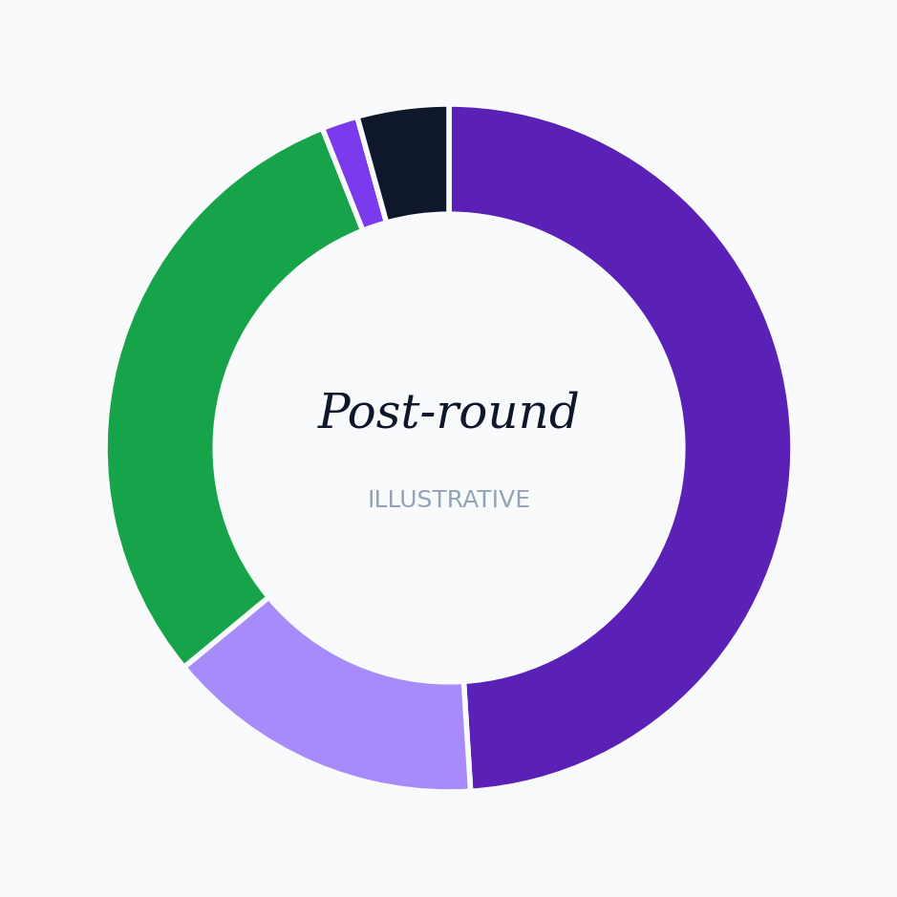
ALLOCATION | POST-ROUND %
Founder (Sean Combs) | ~49.0%
Cofounder (Kent Redwine, milestone-vested) | 15.0%
Equity pool — advisors + future hires + creator-path | 30.0%
Pre-formation creditor warrants (from founder) | ~1.7%
New investors (this round) | ~4.3%

The 30% equity pool is the institutional-grade structure: it absorbs advisors (up to 2.5%), future employees (the largest single sub-allocation), and creator-path warrants. New-investor % flexes with cap and raise size. Plus: 5% success fee on capital sourced paid to Kent on performance (not equity grant). Data Room model shows dilution at multiple cap and raise scenarios.
Illustrative model only — not a projection, promise, or forward-looking statement. See Important Notices on the back cover.
6.2 Pre-formation creditor warrants
Approximately $615,000 of documented exposure across roughly eight stakeholders from three prior ventures (HOM DAO, RealEx, TitleApp LLC). The resolution honors that exposure with basis-point warrant grants tiered to how many ventures the creditor participated in. The total cap-table footprint is approximately 1.7%, absorbed entirely from the founder's allocation, not from investor dilution.
Why this matters to a new investor. Prior-venture creditors are being paid first, from the founder's slice, before new investors see the cap table. The papering is documented in the Pre-Formation Creditor Warrants Memo (May 22, 2026, in the Data Room) and the legal instruments are counsel-reviewed.

PART VII
Financials & Capital Efficiency
7.1 Historical financials — TitleApp LLC (prior entity)
The platform underlying SOCIII was built inside TitleApp LLC over a three-year window. TitleApp LLC is now winding down and the platform, IP, and creditor positions are being papered into SOCIII Inc. The historical financials below describe what it cost to build the production platform — not what it cost to run a typical startup.
PERIOD | BUSINESS OPEX | NOTABLE ITEMS
HOM DAO operating peak | ~$35,000/week | Distributed real-estate dApp infrastructure. 167 contributors. The cost of doing it the wrong structural way.
TitleApp LLC 3-year build | ~$35,615 total | Productized title search inside a Delaware LLC. The worker platform that emerged became the real product.
SOCIII first 5 months (Jan–May 2026) | ~$35,000 total | 1,000+ workers (state-augmented) shipped across 8 industries. Lead developer: Anthropic Claude. ~$5K/mo AI burn replaces a ~25-person dev shop.

What this table is saying. What an established startup pays a single senior engineer in one month is roughly what SOCIII's AI development stack requires for a full year — while doing the work of approximately 50 engineers. Rather than hiring an engineering org and laying it off when the market turns, SOCIII starts without the exposure entirely and scales as fast as the underlying AI models scale. The prior-venture comparison (HOM DAO at $35K/week vs SOCIII at $35K/5-months) is the same point measured in dollars; the structural shift from distributed-token governance to sole-manager + AI-shop is the capital-efficiency mechanism.

OTHER PRIOR-ENTITY ITEMS, FOR COMPLETENESS
ITEM | AMOUNT | TREATMENT
Documented prior-venture creditor exposure (3 ventures) | ~$615,000 | Papered into SOCIII via creditor warrants (§6.2); absorbed from founder allocation.
Known TitleApp LLC liabilities at wind-down | ~$228,000 | Subset of the $615K above; resolution scheduled through wind-down packet.
SOCIII Inc. opening balance (shareholder loan from founder) | $1,000 | Stripe Atlas formation; Stripe Treasury operating account.

7.2 Capital efficiency benchmark
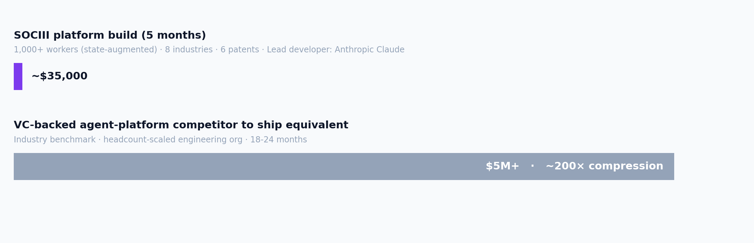
Visual not to scale: TitleApp bar is shown at minimum visible width to remain legible. At true scale TitleApp's $35.6K bar would be approximately one pixel wide against the industry benchmark.
The interpretation that matters: the founding team has already demonstrated that it can build a production AI platform across eight industries on a budget that would not fund a single senior engineer hire at most agent-platform competitors. Capital efficiency is the most expensive thing to teach a founding team; SOCIII does not need to be taught.
7.3 Revenue architecture — five streams, three near-100% margin
The platform monetizes through five independent revenue streams, three of which run at near-100% gross margin. Which stream dominates over the next two to three years is genuinely unknowable; it depends on which user behavior compounds fastest and how mass adoption unfolds. The structural point is that the platform does not depend on a single answer.
STREAM | PRICING | GROSS MARGIN | CREATOR SHARE | SCALES WITH
Subscription | $29/$49/$79 worker · $99 Business-in-a-Box · $299 all | ~75% | 75% | Creator + subscriber growth
Data Credits | $0.02/credit | ~90% | 0% | Usage; Alex upsells bulk top-ups
API Pass-Through | 2× cost floor | 50 – 85% | 75% | Data richness per session
Audit Trail | $0.005/record | ~95% | 0% | Regulated-industry sessions
Creator License | $49/yr | ~100% | 0% | Total creator population

The honest answer on revenue mix. We do not project which stream will dominate over the next 2–3 years. Subscriptions could lead if mass adoption arrives via creator-built workers. Data Credits and API Pass-Through could lead if enterprise workflow volume compounds faster than seat growth. Audit Trail could lead if regulated industries adopt fastest because the compliance pressure is most immediate there. The investor takeaway is that all five are wired and metering today; the platform balances on five streams rather than one.

7.4 Use of proceeds — $1.75M base allocation
First $250K clears inherited debt obligations. Remaining $1.5M funds commercial launch, community activation, and 18-month runway. Profitable at month 24 with or without this check.
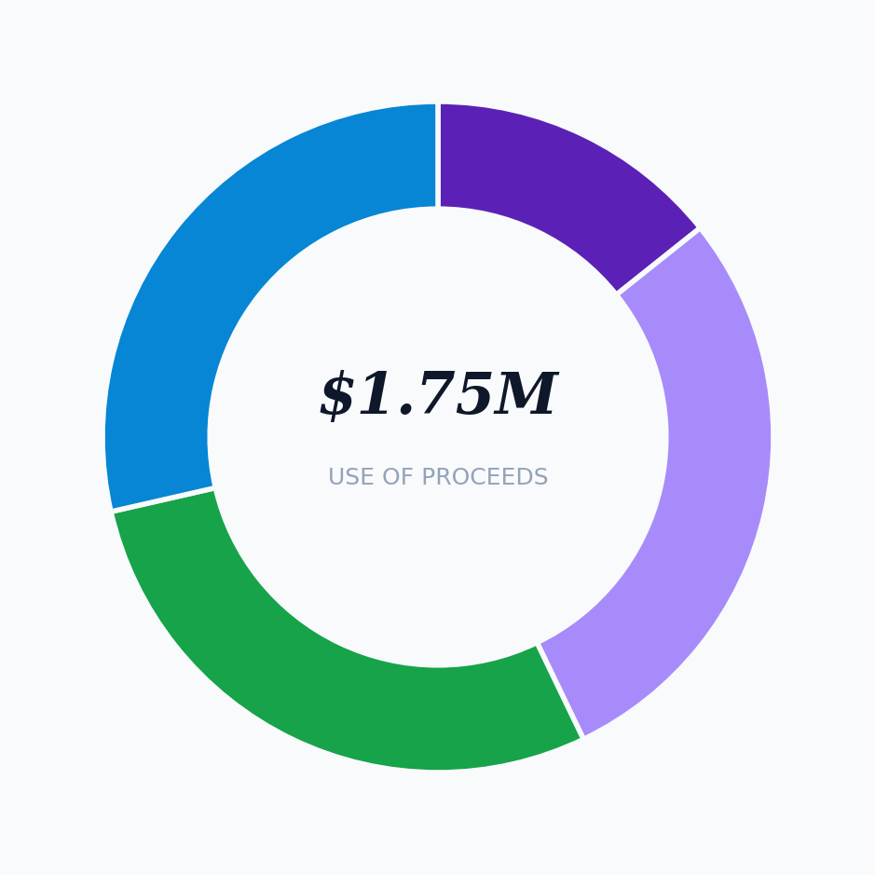
ALLOCATION | AMOUNT | WHAT IT FUNDS
Debt service | $250K | Honors outstanding pre-formation obligations: Robert Rosenberg ($100K), Chris Dunn ($15K), HOM DAO inherited accounts payable (~$100K), and remaining creditor positions. Clears the deck before commercial launch.
Trade conferences & industry presence | $500K | Ruthie at NurseCon. Pilots at NBAA. Dealers at NADA. The rooms where professionals gather. We send domain experts, not salespeople.
Professional network activation | $500K | Identify and activate 200+ domain experts across all industries — The Nurse, the pilot, the dealer, the inspector. Each one has a trusted community. Includes connector integrations and specialized industry API access.
18-month runway + operations | $500K | $25K/mo overhead × 18 months = $450K. Balance covers legal, accounting, and cap-table maintenance. We build with AI, not headcount.
Total (base case within $1–2M raise) | $1.75M | Profitable at month 24 in the modeled base case.

7.5 Scenario analysis — three growth paths
The mass-adoption curve for vertical AI agent platforms is genuinely unknowable at this stage. The model below does not predict which path SOCIII follows; it answers the question if mass adoption looks like X, then what does the math say. Three scenarios. One model. All scenarios use a $99/mo blended base subscription and $25K/mo fixed overhead. Scenarios differ only on monthly growth rate and churn.
ASSUMPTION | WORST | BASE | BEST
Monthly growth rate (new subscribers) | 5% | 10% | 20%
Monthly churn rate | 5% | 2% | 0.5%
Month 1 new subscribers | 3 | 10 | 25
% subscribers who are "active users" | 40% | 65% | 80%
Months to first 100 subscribers | 18 | 9 | 5

OUTPUT | WORST | BASE | BEST
MONTH 12
Total subscribers | 47 | 213 | 987
MRR | $4.9K | $25.1K | $151.8K ✓
MONTH 24
Total subscribers | 133 | 872 | 9,772
MRR | $13.8K | $102.7K | $1.5M
Profitability | Not yet | ✓ Profitable | ✓ Profitable
MONTH 36
Total subscribers | 278 | 2,938 | 88,108
MRR | $28.8K | $346.1K | $13.5M
ARR run-rate | $346K | $4.2M | $162.6M
LTV:CAC ratio | 4.0 | 38.9 | 1,550
Series A trigger ($150K MRR) | Month 36 | Month 18 | Month 10

What this table is saying. Even in the worst case (5% growth, 5% churn — the SaaS-industry-average churn), the platform reaches the Series A trigger by Month 36 and the company is still cash-positive on a $5M raise. The base case (10% growth, 2% churn — the community-led adoption pattern observed in Harvey AI and Figma) hits the Series A trigger at Month 18 with the company profitable by Month 24. The best case (20% growth, 0.5% churn — Ruthie's nursing community goes viral) hits Series A trigger at Month 10 and runs profitably from Month 9 forward.

Illustrative model only — not a projection, promise, or forward-looking statement. The model was built around a $5M reference raise to test cash-runway sensitivity; the current $1–2M raise (Base case use-of-proceeds: $1.75M) reaches Series A trigger in the Base scenario at Month 18 with operating cash to spare, and survives the Worst scenario through Month 36. The complete model with monthly cash trajectories, unit economics, sensitivity analysis, and per-revenue-stream attribution is in the Data Room. See Important Notices on the back cover.

PART VIII
Risk Factors
Honest enumeration of what could go wrong, ordered by probability-weighted impact.
RISK | WHAT IT MEANS | MITIGATION IN PLACE
LLM cost compression stalls | If inference costs rise or stop compressing, the unit-economics assumption inverts and runway shortens. | Model-agnostic architecture: the rules engine validates output regardless of which model produced it. We can move providers in a quarter.
Well-funded incumbent ships competing platform | Notion, Airtable, or a foundation-model lab decides to target domain experts directly. Twenty-times-our-funding gap is real. | Patent priority date, RAAS corpus, two-year head start in production. Forces them to license, replicate the corpus, or differentiate elsewhere.
Creator flywheel does not compound | Sandbox-built workers don't find buyers. Platform reduces to vertical SaaS with audit trails. | Enterprise pipeline (Kent's outbound) produces revenue independent of creator funnel. Downside case is still a viable company; upside requires the flywheel.
Regulatory exposure on specific RAAS modules | A worker proposing maintenance intervals or disclosure language is cited as unlicensed practice. | User-counsel attestation pattern: at worker activation the user's counsel attests outputs are reviewed before action. Counsel-reviewed agreements.
Patent prosecution narrows claims | Conversion to non-provisional in May 2027 surfaces prior art we did not find. Some claim breadth is lost. | Counsel assessment: the core composition claims are defensible; the breadth is the variable. Prior-art-as-priority strategy was designed for this.
Brand-transition challenge | A former TitleApp LLC creditor or stakeholder challenges the wind-down or the IP assignment to SOCIII. | Careful papering: creditor warrants from founder allocation, IP cleanly assigned at SOCIII formation. Wind-down packet drafted and counsel-reviewed.
Founder bandwidth | Founder also flies (active type ratings, regular flight schedule); operates the company at small team size. | AI workers absorb operational load by design. Kent's bounded scope on fundraising and BD. Planned engineering hires.

What the founder is most worried about. Mass adoption. The platform is structurally hedged across five revenue streams (subscriptions, data credits, API pass-through, audit trail, creator licenses) precisely because we do not know which one will lead over the next two to three years. We watch the funnel weekly and adjust ruthlessly. The model assumes adoption; the company is built to survive if adoption is slower than the base case and to compound if it is faster.

PART IX
Investment Mechanics
Round terms
Rolling YC-style SAFE. Minimum viable close: $500K. Base target: $1–2M. Open to strategic capital up to $5M+. Valuation cap finalized with the lead investor; comp-set anchoring described in §3.2. 30% equity pool reserved for advisors, future hires, and the creator path. Sole-manager governance through the Series A trigger ($150K MRR / ~$1.8M ARR). No discount layered on the cap. No MFN-plus terms. Designed to be readable and signable in fifteen minutes.
The round structure is deliberately flexible. SAFEs are signed and counted on a rolling basis as investors decide; the company calls the close when the cap fills or when strategic concentration is achieved. A $500K close meaningfully extends the runway. A $1–2M close funds the full 18-month plan in §VII.4. A $5M close accelerates engineering and creator-acquisition spend. Any close above the minimum is a successful raise; the band scales with investor demand, not against it.
Securities-law posture
Reg D 506(b). Offered to accredited investors with pre-existing relationships to the founders. Investors complete Stripe Identity verification (~3 minutes; SOCIII covers the fee) and provide accreditation representations before SAFE execution. Verification flow is integrated into the IR Worker on the SOCIII platform. Counsel has reviewed the SAFE template and the verification flow. No general solicitation; this memorandum is sent in confidence to a specific named investor.
End-to-end flow for an investor
STEP | ACTION | TIME
1 | Platform sends a magic link to your email. | —
2 | You click the magic link; IR flow opens on SOCIII. | 10 seconds
3 | Stripe Identity verification (SOCIII covers fee). | ~3 minutes
4 | Accredited-investor verification. | ~3 minutes
5 | Review the YC-style SAFE in Dropbox Sign. | ~5 minutes
6 | Sign. | ~30 seconds
7 | Executed SAFE files in your SOCIII Vault; confirmation email; wire instructions in the SAFE. | Immediate
Total | end-to-end including SAFE reading | ~15 minutes

Larger positions, co-investors, and SPVs
Commitments above $250K warrant direct involvement on terms; Sean or Kent runs that conversation. Introductions to co-investors are handled by sending the prospect's name and email to Sean or Kent. Syndicates and SPVs can be structured; a fifteen-minute scoping call is the starting point.
What lives in the Data Room (NDA-gated)
· Working cap-table model with dilution scenarios at multiple round sizes
· Use-of-proceeds model with sensitivities (hiring cadence, compute, marketing mix)
· Patent applications and counsel's prior-art analysis
· Pre-Formation Creditor Warrants Memo (May 22, 2026)
· SOCIII Inc. corporate formation documents (Stripe Atlas, EIN 42-2675951)
· Production deployment customer references (industry-tagged)
· Executed SAFE template and Reg D 506(c) verification flow

