# Digital Synesthesia: Using Mobile Technology to Interact with Our World

#### By

#### Santiago Eloy Alfaro Bernate

Submitted to the Program in Media Arts and Sciences,

School of Architecture and Planning,

In partial fulfillment of the requirements for the degree of

Doctor of Philosophy

at the

#### Massachusetts Institute of Technology

© Massachusetts Institute of Technology 2014

All rights reserved

Author:

Santiago Alfaro

Program in Media Arts and Sciences

­­

Thesis Supervisor:

V. Michael Bove Jr.

Principal Research Scientist

MIT Media Lab

Thesis Reader:

Joseph Paradiso

Professor of Media Arts and Science

MIT Media Lab

Thesis Reader:

Kevin Slavin

Assistant Professor of Media Arts and Sciences

MIT Media Lab

# Acknowledgements

Table of Contents

Digital Synesthesia: Using Mobile Technology to Interact with Our World 1

Acknowledgements 2

Executive Summary 6

Future Projection 7

Abstract 8

Introduction 9

Background and Related Work 9

Thermal Interfacing 9

Vibrotactile Interfacing 9

Mobile Communication 10

Sensory Substitution 10

New Senses 10

Situational Awareness 11

Neuroplasticity 11

Sensory Translation and Habituation **Error! Bookmark not defined.**

Digital Synesthesia 12

Why? 12

Design Approach 12

The importance of the single affordance 13

Implementations 13

First Study: Proximity Sensing 13

Second Study: Temperature Sensing 14

Third Study: Cellphone Sensors 14

System Description 16

Hardware **Error! Bookmark not defined.**

Software 20

Value Mapping **Error! Bookmark not defined.**

The three stages 17

User Studies (the successful ones) 18

Proximity to Vibration 19

Preparation 19

Test Procedure 19

Phase One 22

Phase Two 25

Phase Three 27

Temperature to Vibration 29

Preparation 29

Procedure 32

Results 32

Evaluation 33

Cell Sensors to Vibration 35

Preparation 35

Test Procedure 36

Results 36

Evaluation 37

Smell Explorations 39

Smell Explorations 1 “The Foodcam” 39

Preparation 39

Evaluation 39

Smell Explorations 2 “The smell-mixer” 40

Preparation 40

Results 40

Evaluation 40

User Studies (the less successful ones) 41

Temperature to Vibration 1 “the game” 41

Preparation 41

Evaluation 42

Glass to temperature 43

Preparation 43

Procedure 43

Results 43

Evaluation 44

Research Questions 45

Discreet and Continuous Data 45

Sensory Substitution 45

Sensory Augmentation 45

New Senses 46

The User and the New Stimuli 46

Escaping the visual user interface 47

Design Thinking 48

Contributions 56

Future vision 58

Conclusions 59

References 60

Non-Cited Bibliography 63

Bio 65

Santiago Eloy Alfaro 65

# Executive Summary

Humans have dreamt for many years of going beyond our physical capabilities. We have dreamt of flying, breathing underwater, exploring space or simply moving as fast as possible. All of these dreams have been made possible through the use of technology and our understanding of the physical world around us. We have also dreamt of augmenting our senses. In popular culture, we create characters that are able to see through walls, feel the presence of danger, use echolocation or sense the emotional state of others. Technology has already given us the tools to make most of these dreams a reality. Furthermore, mobile technology has made it possible for humans to use sensors as a ubiquitous just-in-time source of information. This ability to access digital information from anywhere at any time is the main value of mobile devices. But interaction with mobile devices relies heavily on transmitting information visually, which demands a high level of attention from the user.

This thesis explores a way of using sensor and mobile technology to create a superhuman sensory experience that feels as natural as possible to the user. I aim to develop a new paradigm of interaction between users and their mobile devices: one in which the device acts mainly as the “translator” of information while the users interact directly with the world they are trying to explore. This “Digital Synesthesia” can be achieved by using a sensory channel other than vision to relay the information detected by external sensors.

Digital Synesthesia refers to the ability to use mobile technology as the conduit between the body and aspects of the world that the human body is not able to sense. It will connect modern sensing technology with the brain’s interpretation of external data. I will show that by using natural sensory channels to represent information beyond human perception, the brain will be able to interpret and assimilate the new stimulation as a new sense. Instead of giving the users an absolute value of the information being detected, the users will feel this translation on their bodies. This will allow each user to find a personal meaning for the information that they are experiencing and interpret it in a unique way. By spreading out the interaction across more senses, the experience will feel more natural and thus allow the users to more easily divide their attention between concurrent tasks. Thus, Digital Synesthesia creates a richer, more immersive experience.

The related work falls mostly into two categories, those that replace a non-working sense with another, and those that give the user a completely new sense. The results of these projects have proved that there is a great opportunity in using senses other than vision or hearing. They have also demonstrated the plasticity of the brain in interpreting information when received through different senses. This thesis will go further by building on top of these findings and asking how we can use Digital Synesthesia to create a new interface paradigm, one that will allow the users to interact directly with the world and not with the mobile device. Since we understand our environment through our senses, having new sensory experiences will grant users a richer understanding of the world as they explore their new sensory capabilities.

The evaluation of this work will be done by conducting a series of studies in which users will wear devices that generate new sensory feedback loops. In these studies, the subjects will be asked to complete a task with the aid of one or more new digital senses. The studies will range from scenarios in which the subject simply compares the digital sense with a natural sense, to a situation where the subject can feel new information and has to discover what it means. Data will be collected on the time and accuracy of the completed task and a qualitative result will be obtained from discussion with the subjects about the wearable technology and the experience in general.

### Future Projection

Many animals use natural phenomena to their advantage every day, such as sensing ultra-violet light to choose the best flowers or sensing magnetic fields to find direction. When humans are able to interpret these physical phenomena in a way that is more in tune with their bodies and less of a cognitive interpretation of quantity, then our interaction and general experience in and with the world will change dramatically. By understanding and interpreting these natural phenomena, designers of digital synesthetic interfaces will be able to create new sensory loops that offer new experiences to the users. Digital Synesthesia will give everyday users the ability to turn senses on and off depending on the experience they seek.

# Abstract

Digital Synesthesia is the concept of using sensors and mobile technology to create a user experience that mimics the way people use their senses and enables the perception of information that is outside of our sensory spectrum. Modern technology already offers the ability to detect this information, but what has not been achieved is a way for our brains and body to incorporate this new information as a part of our sensory tool-belt. Then we can truly begin to understand our surrounding world in a new and undiscovered way.

The vision of Digital Synesthesia is to help the current idea of Human-Computer Interfacing evolve so that it gives way for a new Human-Environment Interfacing. Digital Synesthesia aims to keep our mobile devices in our pockets while allowing us to experience the world by sensing information outside of our sensory capabilities.

The system will not only collect data through sensors, but also find the best way to pass the information to the body while bypassing visual and auditory channels. This way, the brain will be able to interpret the new information without shifting or dividing attention from the current task.

# Introduction

In his theory of the Umwelt [1], author Jakob von Uexküll proposes that every creature has an individual and unique understanding of their environment, given the individual affordances offered by their senses. This leads to the belief that the access to new senses should expand the way in which humans experience their world and therefore is at the center of the Digital Synesthesia project. Modern technology already offers the ability to detect information from the world that is beyond our natural sensory spectrum, but what has not been achieved is the way for our brains and body to incorporate this new information as an addition to our sensory capabilities. Digital Synesthesia offers a way of taking new sensory experiences and transmitting them to the body in a way that mimics our other senses, without relying on a mostly visual and highly cognitive experience which demands a big part of the user’s attention. With Digital Synesthesia, we will be able to understand our surrounding world in a new and undiscovered way.

This project will look at the ability of a user to quickly assimilate an external stimulation and understand the significance of the signal. In order to do this, the user must be able to combine the information from the stimuli, their understanding of their context and surroundings and cues from proprioception that relate to the new sensory experience.

# Background and Related Work

Many projects and research have sought to understand the feasibility of using touch, thermal, vibration and haptics to communicate information to the brain. I’ll present here the research and projects that best support the basis of Digital Synesthesia.

## Thermal Interfacing

Studies on a person’s ability to discern between two materials using only thermal cues have been conducted. They show how such perception is possible when there is a large difference between the thermal capacity and conductivity of the materials[1]. Similar results have been used to present thermal cues to the users in virtual environments and teleoperated systems [2], [3]Digital Synesthesia will further this research by finding more effective ways of coding information through the sense of temperature.

## Vibrotactile Interfacing

LA Jones et al have tested a tactile display mounted on the user’s arm and back[4]. Simple commands and instructions were communicated through a vibration pattern and tested for accuracy and efficiency. SenseableRays[5] from Rekimoto Labs uses a small finger-mounted module that detects a structured light signal and emits a vibratory pulse giving the sense of feeling the projected light. LA Jones has shown that vibrotactile interfacing is a very effective way of transmitting information while Rekimoto shows the added value that the tactile sense brings to an experience. Digital Synesthesia will try to join these two efforts to create a more immersive and efficient experience.

## Mobile Communication

Rekimoto lab has presented AffectPhone[6], a system that gives a handset the ability to detect a user’s arousal level through Galvanic Skin Response sensors and transmit it to another user as hot or cold sensations in the hand. Similarly, Pressages[7] is a system that translates the pressure with which one user squeezes the sides of the mobile phone into a vibration on the receiving phone. Both these projects are looking to create a better communication by using sensory feedback of the users’ state. Connexus[8] was an ambitious project that attempted to detect several signals of the users in order to recreate an image of the non-verbal cues that were being lost in non-co-located communication. Even though these projects hit close to what Digital Synesthesia looks for, they are from the start limited in certain ways. Since Digital Synesthesia is based more on detecting occurring phenomena than on detecting the other users’ willingness communicate in a new way, the experience is more reliable. Perhaps with the findings from this thesis, other projects like the ones discussed can be revised with a better understanding of digital sensory loops.

## Sensory Substitution

Either because a person may be lacking one of the five senses or because a different sensory input may offer other benefits like greater detail, sensory substitution has been seen in several fields. Most sensors translate information, such as temperature, wind speed, distance or the passing of time. All are things our bodies can perceive but by using a sensor and translating the information to a coded visual form we add the ability of greater accuracy and universal understanding. Brainport[9] is a system that captures images through a camera and translates it into electrical signals that are felt on the tongue. The artist Neil Harbisson and his team have developed Eyeborg[10] so that Neil, who is completely color-blind, can use this device to capture color information through a camera on his forehead and translate it to sound he hears through bone conduction. These hit at the core of Digital Synesthesia. But what this project proposes is that these kinds of interfaces will be useful in the everyday experiences of the average user. In order for this to happen, the interface has to find a way to be less obtrusive and more user friendly.

## New Senses

Another big area in this field is creating completely new senses. Adding a new sense to our repertoire changes the way we understand and interact with the world. The FeelSpace[11] belt was a device with vibrators that could be worn around the waist. The vibrator closest to geographical north would constantly vibrate, giving the user a sense of direction. Another take on navigation is Momo[12], a handheld egg-like device that leans towards the direction in which the traveler needs to go. The change in the center of gravity of the device is perceptible in the hands of the user. Dan Berg, a writer and technology advisor, implanted a small magnet into the little finger of his right hand[13]. One of the reported effects was the ability to sense electrical flow by the disruptions on the magnetic field. Disney research has developed Aireal[14], which uses air vortices to create a tactile sensation of virtual images or images projected on the body. These projects hint at the ability of the brain to interpret new experiences. Digital Synesthesia will make use of this ability to understand how the brain can learn to adapt to new sensory inputs.

## Situational Awareness

Situational Awareness is the ability to extract information from our environment and integrate it with previous knowledge in order to form a coherent mental picture[15]. The US military has done extensive research on Situational Awareness. They have explored the limits of the brain when forced to work in an environment with many attention cues, as well as different strategies for reducing the cognitive load while conveying information to the brain through channels other than sight or sound. In addition to many studies in how to measure Situational Awareness in various users and situations, there are some papers on actual devices being tested that use Vibrotactile Displays[16] and Tactile Navigation Cueing[17]. The findings in these studies will inform Digital Synesthesia on the cognitive limits of the brain when presented with multiple sensory inputs at once.

## Neuroplasticity

The field of Neuroplasticity has explored the way in which the human brain is able to evolve and change given different sensory inputs. Studies have shown that a child’s brain exhibits a greater range of neuroplasticity than the adult brain but that the adult brain is still capable of change and adaptation[18][19]. This research brings a very interesting question to this project. There might be an interesting parallel process in the way the brain adapts to natural sensory inputs and how the brain will map to the new digital sensory inputs. Even though most studies show that the time scale for these changes in the brain to take effect is longer than what this thesis will allow, some new studies are looking into more immediate effects of learning new skills.[20][21][22]

# Digital Synesthesia

## Why?

The evolution of our mobile technologies has come hand in hand with the feeling that we are slowly isolating ourselves in a virtual social bubble where we can only acknowledge what the screen is showing us and only relate to our social networks. Many thinkers have looked at this issue from both positive and negative points of view (Alone Together, Smarter than you think) and most arriving to the conclusion that we are surrendering some of our social costumes in favor of newer virtual ways of relating to one another and to the world.

It is my view that our technology should be better at looking for a way to help us be closer to our physical surroundings and smarter at finding a way of giving us all of the benefits it offers without compromising our interactions with our world and peers. Digital Synesthesia is a way of attempting to do just that. I understand that what we have done with mobile devices is offer just-in-time information streams that enhance our understanding of every moment, place and time. But all this information is being bottlenecked through mainly one sensory channel and in doing so our brain is overwhelmed needing to place most of its attention to this one input and ignoring many others.

## Design Approach

Digital Synesthesia is divided in three major parts. Sensing, translation and feedback, the understanding and implementation of these three areas is the key to create a stable base for future designers to be able to build upon this project.

Sensing is the technology that will capture information from the world. This area brings interesting cross sections between fields. The designer needs to know about sensors that may be available to capture raw environmental data. Also knowledge of how other organisms may use information that is outside of our human sensory capabilities. Most importantly there is the need to understand that if one sensor may be detecting very specific phenomena, the interpretations and usefulness of that information to us humans might be completely unrelated to how other organisms might use it.

Translation is a more narrow area where the designer can implement knowledge in coding and electronics to interface the sensor to a mobile device in order to capture the data. The mobile device will then translate this information to the appropriate feedback. Translation also needs the design of a user interface. In the far future vision of Digital Synesthesia, this interface will let a user choose what sensor they want active and where, and how, they wish to experience this feedback. This way, depending on the user’s activities, they will be able to turn artificial senses on and off.

Feedback is the final step. At this stage, the designer will draw upon their knowledge of user interfaces and ergonomics to create a comfortable sensory experience that will make sense with the user’s need and surrounding context. The design of wearable technology will come into play as we find ways to comfortably generate the sensory signals that will respond to the sensors.

## The importance of the single affordance

All five of our senses are able to take-in multiple information at the same time. We can see many colors, smell combinations of smell, feel at various points in our body, detect pressure and temperature on our skin and taste different tastes, all at the same time. In a sense, each sensory experience is already acting to capacity and the brain is decoding and each sensory experience responds to signals with many affordances. So the brain is already working hard trying to identify, separate and interpret each of these affordances into a cohesive experience. To create a new sensory experience I chose to reduce the affordance of the signal to its minimum degree. This would give the brain the chance to understand the signal and the user to learn from the experience without much training. This is why I have chosen vibration where the only affordance is frequency or temperature to convey the signal information. My hope is that the brain will be able to couple the simple signal with other information around it to create the cohesive experience.

## Implementations

Three implementations have been developed in order to test the user’s ability to relate to artificial sensory systems. Each of the implementations was designed to test the user’s ability to relate to an artificial sense while reducing the familiarity with the experience. During the first user study the users would be able to try a new artificial sense that would provide a redundancy with an existing natural sense. This way, the users were able to quickly learn to understand the patterns of their new sense. The second user study was designed to take away the redundancy but still give the user some contextual information on the experience. The third user study would remove all redundancies and contextual information and simply ask the users to explore their world and try to understand what the artificial sense was responding to.

### First Study: Proximity Sensing

For this study, I gave the user a proximity sensor to wear on the palm of their hand and a vibration on the thumb of the same hand. The study was comprised of three stages. First, with a blindfold on, the user was asked to wave their open palm over a table where I had placed a certain amount of objects and try to sense how many objects there were. After every guess, the user was allowed to take the blind fold off and see the real answer. This was important because the users would then try to remember the feeling of the new experience and in essence calibrate themselves to be able to identify and ignore the noise in the signal.

The second stage used the same methodology but the user was asked to identify the shape of a single figure that was place on the table. The figure would be a square, circle or triangle. This time, the users had to rely on a 2D movement of their hand and also they would have to compare their expectation of how a shape would feel to what they were feeling.

The third and final stage asked to identify a 3D shape. So the choices were a cube, a square or a Prism.

### Second Study: Temperature Sensing

At this stage, the project will looked into the creation of new sensory experiences. This stage studied the users’ acceptance of new information that was consciously mapped to a particular sensory experience. This meant that the users had full understanding of the task to be accomplished, the new sense to be detected, and how the information was translated into what they felt. This allowed me to understand how quickly users can get used to their new sensory experiences and record their impressions on the experience.

For this study, the user was fitted with a head band that had a temperature (IR) sensor facing outwards and a vibrating transducer towards the inside, against the forehead. Four peltier modules were placed on the table in front of the subject. A program was written that would randomly choose one of the four peltier modules to warm up. The subject would have to try to read the feedback vibration on their forehead to decide which modules was on and press the corresponding button on the device. This way nor the subject or the investigator would know which module was active. The investigator would simply record how many responses out of 20 opportunities were successful.

### Third Study: Cellphone Sensors

Here the project set up a new sensory experience in which the users had no prior understanding of the translation taking place. This situation mimics the pattern in which a newborn might search for patterns in order to understand its new senses[23]. This experiment showed how quickly the users can find a correlation between information from the world around them and the sensory feedback.

This study was designed to be the closest to the future vision of Digital Synesthesia. The users were fitted with a baseball cap that supported the circuit and vibrating transducer. The vibration was felt on the forehead. An app was written that would scan the available sensors of the mobile device and connect the data stream to the transducer using a IOIO board. The subject where asked to spend 15 minutes walking around the lab, anywhere they wanted to go. After the 15 minutes they were asked to give their best guess as to what the feedback on their forehead was responding to.

As a whole, these studies were looking to understand the ability of a user to form a coherent story by adding together minimal artificial information, proprioception cues and contextual knowledge. They have proven that when the subject is confronted with minimal information about a sensory feedback, they are quite capable of forming a good causal relation between the experience and the world and that even when they don’t understand the actual sensing device; the mental mapping of the experience is still formed.

Figure 1 System

**Sensing**

The actual sensor or sensing system. It can be a single sensor like an IR sensor or a collection of sensor from a mobile device.

**Translation**

The software side of DS, where the sensor data is collected, analyzed and sent to the feedback system.

**Feedback**

The haptic system that will convey the information to the user.

User Interface

Here the user will find the access to options in the Digital Synesthesia system.

Sensor

User Interface

This is the way the sensor is attached to the user.

User Interface

This is the way the actuator is attached to the user.

IOIO Board

Actuator

Mobile Device

# System Description (Figure 1)

Three systems were designed for this project, all following a very similar architecture. A sensing system, a translation system and a feedback system are designed to be flexible enough to allow for future developing with evolving technologies, usage scenarios and user preferences.

## Hardware

The hardware setup for all studies is based on a IOIO-OTG[24] board. The IOIO is a board specially designed to work with Android 1.5 and later. The board provides robust connectivity to an Android device via a USB or [Bluetooth](https://github.com/ytai/ioio/wiki/IOIO-Over-Bluetooth) connection and is fully controllable from within an Android application using a Java API. Sensors communicate to the IOIO via I2C or Analog Input and the Android software controls a Digital Output Pin to turn High or Low. The Output Pin was connected to a “HEXFET IRLZ34N” from International Rectifier that would control the gate current to a surface transducer “Surface Transducer – Small COM-10917” from Sparkfun[25] or a Peltier device. On most cases a 9V battery was used to power the IOIO and the transducer while the sensor would be powered by the IOIO board.

## Software

There were two main types of application created for this thesis. The first was a User Interface that had two states, depending on if the subject or the examiner was operating it. The other was a simple app that would control the variable of the test in order to allow for a double blind user study.

All applications were coded in Android. The basic user interface application would read the data received by the IOIO from the sensor, map it to an output range and transform it into the frequency of the signal sent to the IOIO and from the IOIO to the transducer. Two forms of visual feedback were enabled. First, two set of numbers were shown, a numeric “value” would show the raw data coming from the sensor and a “rate” value would show the value after it had been mapped to the sensing range. Second, a graph would show the real time response of the sensor inside the sensing range.

A simple number picker interface offered the subject or examiner the ability to adjust the High and Low limits of the sensing range in order to adjust the sensitivity. In cases were the subject was given control of the sensitivity, the app would turn on a “Test in Progress” mode where it would hide all visual and numeric feedback from the subject.

## Sensitivity Mapping

# User Studies

There was a series of user studies designed for this thesis, at different levels of complexity and completion. Early in the process, I realized it would be advantageous to quickly iterate through different setups while trying to understand and discern the key concepts that would make up the design tree for Digital Synesthesia. The iterations would concentrate on testing different ways of conveying the data to the body I call this Testing the Feedback. Another variable for the studies was the type of signal I wanted to detect. Lastly, every test would change the amount of contextual information the user would have about the test.

## Testing the Feedback

The studies were created in order to test the best pairing of sensed data and feedback to be felt by the body. I wanted to test temperature, sound and vibration as feedback so three setups were created. The transducer can be used for either vibration or sound depending on where on the body it is located, on study used vibration to represent data from a proximity sensor worn by the subject in the palm, the transducer was placed in the thumb of the same hand. Sound was used to translate data from a temperature sensor and this was used in two user studies, the sensor was worn on the forehead looking outwards and the transducer was behind the sensor and against the forehead. Temperature as feedback was used in one study, the peltier device was worn in the nape and it responded to the location signal of the glass infrastructure around the Media Lab.

## Testing the Signals

I tried to find different types of signals to carry out the studies. The first distinction in the type of signals was either analog or binary. I chose as a binary signal a location based experience where the user would sense a feedback every time they walked in front of one of many screens at the lab that can recognize people via RFID. The analog signals I used were given by a proximity sensor and an IR sensor, these signals would slowly ramp up or down depending on the behavior of the user.

## Changing the Contextual Information

## User Studies (the successful ones)

Sensory substitution studies have proven that the brain is capable of interpreting data from one sensory input that is responding to another sensory input[26]. I am interested in understanding how not only the brain but the user is able to use these new sensory experiences in daily life. The distinction between brain and user implies that the user is also aware of what all the other senses are saying and of the previous knowledge around their present state and situation. Digital Synesthesia uses the power of the brain not to understand an isolated input but to interpret the aggregate of information of which one part is the artificial sense. If we allow the brain to understand an input in relation to the position of the sensor in the body, the position of the body itself, the speed at which the user is moving, what other conditions are being sensed by the body and what the user knows of the context in which they are, the experience with an artificial sense will be rich, easy to understand and immediately applicable in the users activity.

The user studies were based on a very simple haptic feedback, a vibration that would change its frequency according to the data received by the sensor. The idea was to give the user a minimal amount of data that came directly form a sensor with minimum processing, hoping that the user would be able to discern noise from signal and be able to understand the signal within the experience.

To this end, the 3 user studies used a feedback signal with only one affordance, frequency, and gradually took away the contextual cues in order to create a more isolated experience that the user would have to navigate through.

## Proximity to Vibration

This study used “proximity” as the artificial sense. The test was designed to be redundant to vision. This means that the subject was able to corroborate through vision what they were feeling through the artificial sense.

### Preparation

The system would randomly pick which hand was to be used by the subject. Then the subject would wear an ultrasonic sensor on the palm, of the selected hand, and a transducer on the thumb of the same hand.

#### 

#### Hardware

The system for the first stage and first user study implemented an Ultrasonic Range Finder LV-MaxSonar-EZ0 that interfaced with a IOIO OTG board through the analog interface. Both the sensor and the IOIO Board where worn by the subject. A two finger wood ring was made so that the sensor could be attached and the subject had a good enough understanding of the direction the sensor was facing, by moving the middle fingers. Different sizes were made to accommodate different users and give all the users the same amount of control over the sensor. The IOIO Board was inside a fabric wristband that also housed the 9V battery for power. The IOIO was connected via USB to the Android device, in this case a Sony Table S. The output of the IOIO was fed to the transducer that was attached to the thumb of the same hand that had the sensor.

#### 

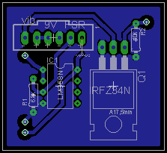

Figure 2 – Schematic and board

#### Software

The software side for this study was written to be used only by the examiner. In it they were able to see the numerical value coming from the sensor and the resulting frequency of the transducer after being mapped. Two number pickers gave the ability to change the sensitivity of the artificial sense.

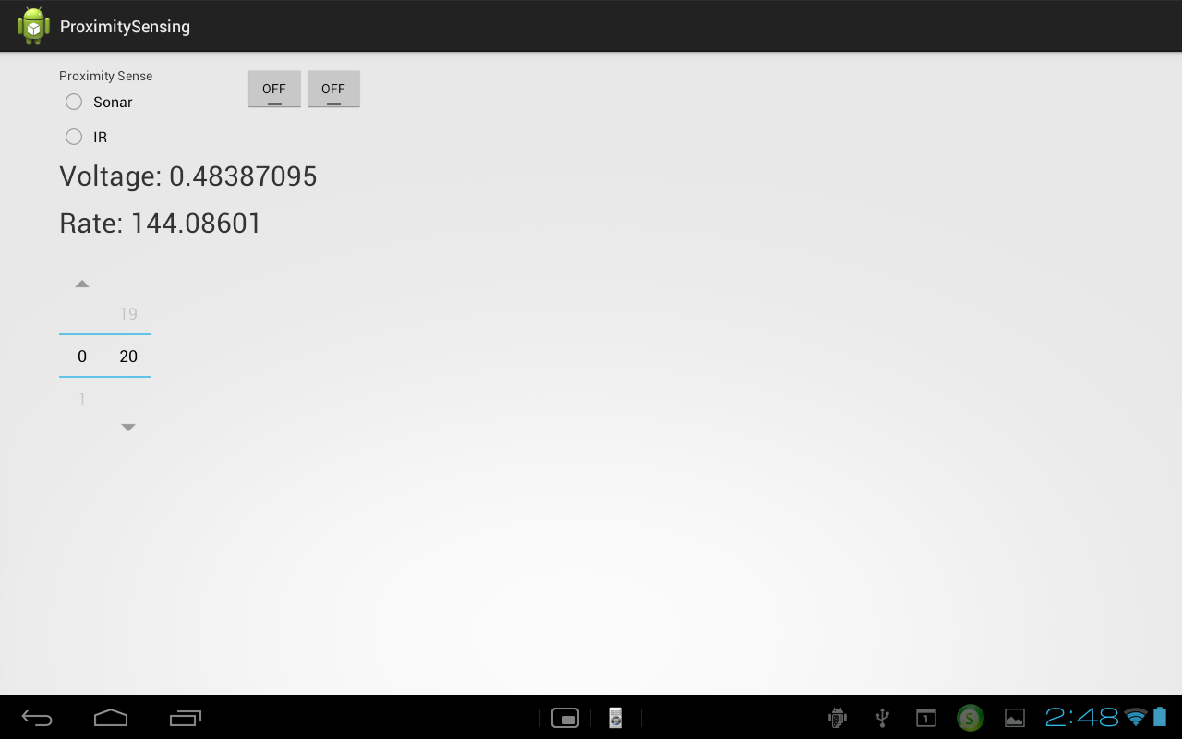

### Test Procedure

This test was divided in three phases; each phase would follow a similar structure. The subject would wear a blindfold and asked to identify object on the table. In all phases the subject was given two minutes to try to guess. At the end of the two minutes the subject had the choice of venturing and answer or using 2 more minutes.

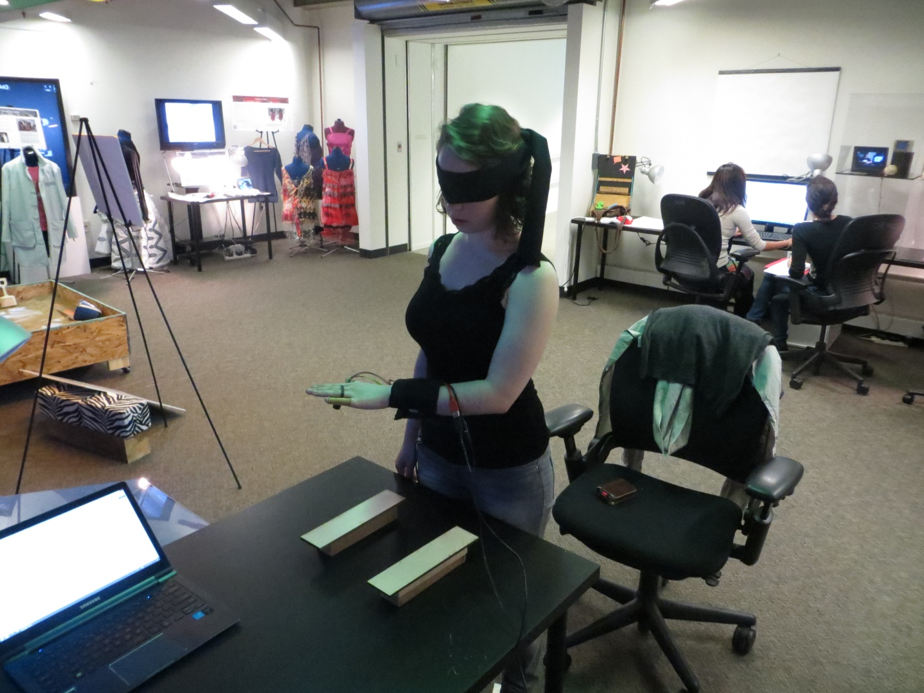

Figure subject during phase one

### Phase One

On phase one I used flat rectangular wooden pieces of 2” by 12” that were placed on the table in front of the subject. The subject’s task was to try to identify how many objects there were. The computer would choose at random any number from 0 to 3 objects that the examiner would place. This exercise was done 4 times while varying the height of the objects and the sensitivity level that was controlled by the examiner. After each try, the subject was allowed to take off the blindfold and compare their answer to the actual number of objects. The iterations were as follows:

First try. Random number of objects, at 2” tall from the table and a sensitivity of 10.

Second try. Random number of objects, at 2” tall from the table and a sensitivity of 5.

Third try. Random number of objects, at 1” tall from the table and a sensitivity of 10.

Fourth try. Random number of objects, at 1” tall from the table and a sensitivity of 5.

The sensitivity values were decided ahead of time and kept the same through the whole study for all users. The values were chosen by finding a mapping that would demonstrate the usefulness of having different sensitivity while demonstrating the balance between sensitivity and noise. With a low level of sensitivity (sensitivity 10) the subject could only feel small changes in the vibration frequency, with High sensitivity (sensitivity 5) the changes were more noticeable but the noise would also be more noticeable. The noise came from the sensor as well as from the stability of the subjects hand.

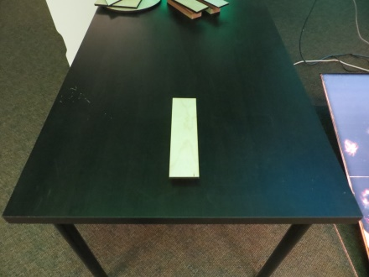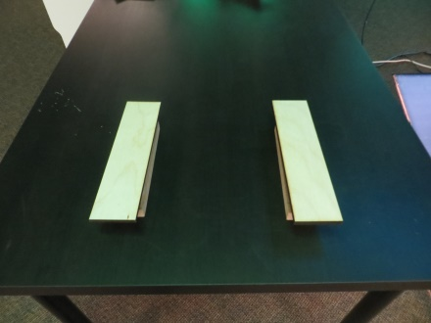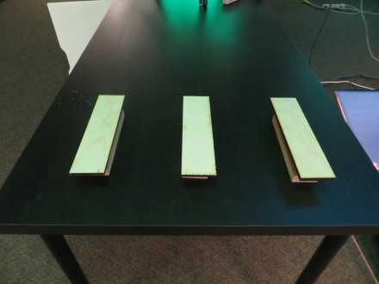

Figure One, Two and Three bars

#### Phase One Results

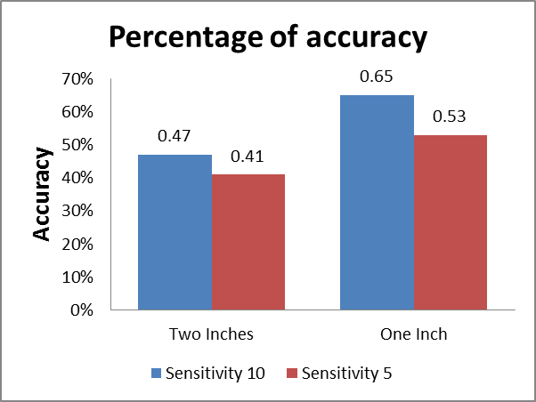

Figure 5 Accuracy on phase one

The results in Table 1 show that the subjects were close to 50 percent accuracy. This was encouraging since it was well above a random distribution that would be close to 25 percent given that the users had one of four choices to make. Table 1 shows the results of phase one.

Totaling the correct answers of phase one in the four tries and ignoring the height and sensitivity difference, we have a total (n) of 68 tries; the result gives a percentage of accuracy of 51%. When we compare this percentage to a random control group of 25% because of having to choose among 4 possible answers, we get a confidence value of p<0.002.

#### Phase One Evaluation

In this first phase the subject needed to only move their hand from side to side in the X axis and up and down in the Z axis (). Up and down would allow them to control the base line frequency they were comfortable with while scanning on the horizontal axis.

The users had no experience with this artificial sense except for a five to ten minute training activity in which they would see how the frequency behaved when the hand was waved over objects of different sizes and with different sensitivity levels.

I was expecting an advantage to having a higher sensitivity setting which would be sensitivity 5 but the results show that sensitivity 10 was easier for the subjects. I believe this to be that at sensitivity 5 the experience was vulnerable to unconscious movements of the hand. Some subjects would not notice if the hand went down slowly or small jerks movements that would affect the readings. These small movements were less noticeable at sensitivity 10 which was less sensitive.

Figure 6 X axis green, y axis blue and z axis red

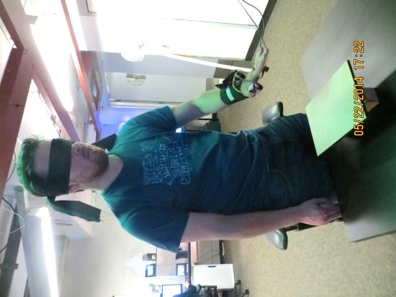

The subjects demonstrated different techniques to accomplish this task. Some subjects would simply scan and try to differentiate between noise and signal but some developed more nuanced strategies such as scanning at different speeds and compare their impressions or scan a different heights and compare. Even more would focus specially on the stability and movement of the hand while others focused on the feedback, tried to get the rhythm and then detect minor changes.

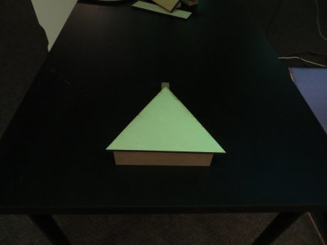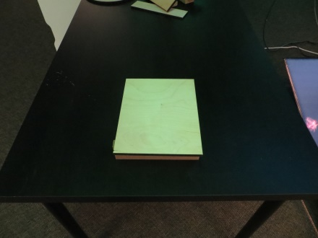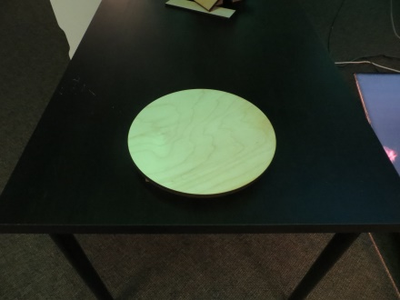

Figure different shapes for phase two

### Phase Two

Phase two presented the subject with just one object. The computer would randomly choose between a circle, a rectangle or a triangle. This exercise was made 4 times as follows.

First try. Random object, at 2” tall from the table and a sensitivity of 10.

Second try. Random object, at 2” tall from the table and a sensitivity of 5.

Third try. Random object, at 2” tall from the table and a sensitivity of 10.

Fourth try. Random object, at 2” tall from the table and a sensitivity of 5.

#### Phase Two Results

Once again the results are well above random, which in this case would be 33 percent given that there were three choices to be made. The object with the largest percentage of correct answers was the triangle, while the Rectangle had the lowest. This time the most sensitive setting of 5 was more successful. shows the results of phase two.

Figure 8 Percentage of Accuracy on phase two

Totaling the correct answers of phase two in the four tries and ignoring the sensitivity difference, we have a total (n) of 68 tries; the result gives a percentage of accuracy of 54%. When we compare this to a random result, which would be 33% because of having to choose amongst 3 possibilities, we get a confidence value of p<0.02.

#### Phase Two Evaluation

Having worked through the first phase, the subjects had a better handle on this artificial sensory experience. This exercise required the subjects to move their hand side to side and also front to back, giving them a 2D field to scan. Because of the first exercise, finding the edges was easy, their job was then to use that information to find a pattern they could compare with their mental expectation of how any of the shapes would feel.

The fact the triangle gave the best results was an interesting finding. Even though I expected this not to be the case given the familiarity of the other shapes, the triangle offers the most drastic change at the corners and made it easy to identify. The circle seems to have had an advantage when people would start inside the shape and then realize how long it took to find an edge.

Two main techniques were used successfully in this task. The most used was scanning the area on the X axis until an edge was found, then moving a bit on the Y axis and scanning again in the opposite way, much like a printer would make a line, advanced the paper and make the next line. The triangle would have a long distance between the edges at the bottom but very small distance at the top. The other technique implied searching for the first definite edge and then bouncing the hand along the edge of the object in an attempt to trace the shape and find the answer.

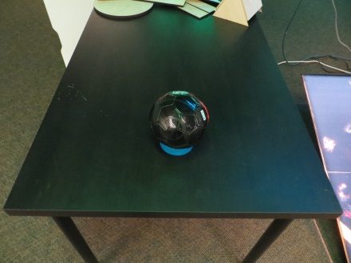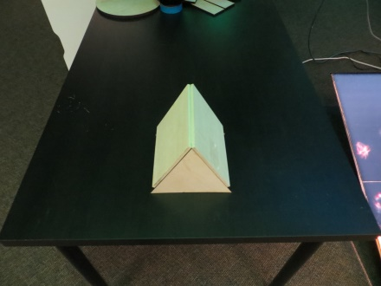

Figure 9 cUBE, SPHERE AND PRISM

### Phase Three

Phase three was about an object with three relevant dimensions. Since the first two phases had dealt with, essentially, 2D shapes. This phase presented a Cube, a Prism and a Sphere. Everything else was just like phase 2 as follows.

First try. Random object, at a sensitivity of 10.

Second try. Random object, at a sensitivity of 5.

Third try. Random object, at a sensitivity of 10.

Fourth try. Random object, at a sensitivity of 5.

#### Phase Three Results

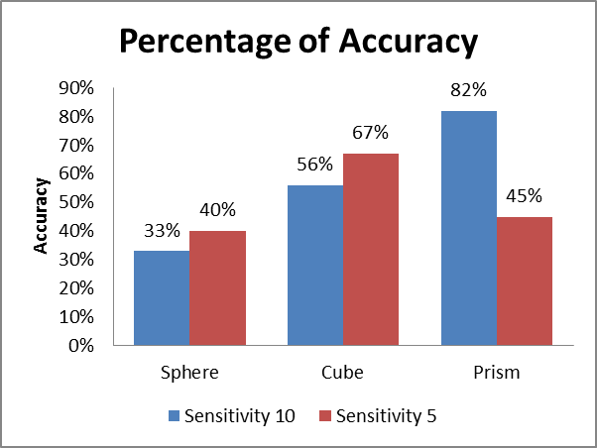

Figure 10 Percentage of accuracy on phase 3

The sphere shows a success rate barely above random whereas the Prism shows a success rate of more than 80%. Overall the success rate for all three shapes was 55%. The results of phase three are shown in table 3.

Totaling the correct answers of phase three in the four tries and ignoring the sensitivity difference, we have a total (n) of 66 tries; the results give a percentage of accuracy of 54%. When we compare this to a random result, which would be 33% because of having to choose amongst 3 possibilities, we get a confidence value of p<0.03.

#### Phase Three Evaluation

The most surprising result in this phase was the Prism. I expected this shape to be the most unfamiliar and hence the hardest to identify. But it happened that because of the ultrasonic nature of the sensor, the behavior of the feedback was not what the subject was expecting and for that same reason it was the most recognizable once the user knew that was the prism’s “signature”. What happened is that as the subject approached a side of the prism, the frequency would increase as expected for this and other shapes but once the subjects hand was over the apex of the prism, the wall would not bounce the signal back to the sensor and instead of the frequency being very high, it would jump back to slow, as if there was no object at all. This was confusing the first time the subject encountered but for those that got the prism more than once, it became the easiest shape to understand.

I believe this to be the most significant result because it is the result that shows that it is through the exploration of the artificial sense that we will learn to use it, even if what we feel might seem un-intuitive, as long as it is constant it will behave as a new sense with its own intricate patterns.

## Temperature to Sound

The objective of this study was to create an artificial sensory experience that was impossible to verify with other senses. In this case the only way to verify would be by touch, which the subjects were not allowed to use. So this study wants to explore the way that the subjects will learn to trust their new sense and if there is a different learning curve when given an outcome feedback or not. These changes in the level of comfort when using the artificial sense would be reflected in the time taken to make a guess.

### Preparation

At a desk with a computer monitor, the subject would find 3 peltier modules attached to the monitor at eye level. The tablet device would be placed in front of the subject, this would be the main UI for the test. The subjects were also given a mobile device that would be the UI for their sensory device.

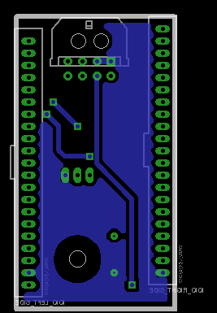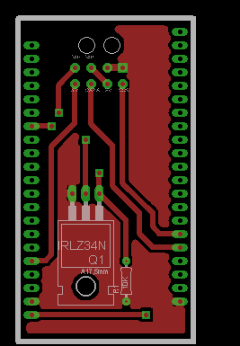

Figure 12 board top

Figure 12 board bottom

#### Hardware

There were two systems created for this study. First, the system worn by the subject consisted of an MLX90614BAA to detect the temperature of the peltier module. This sensor was connected via I2C to the IOIO OTG board and the board would connect to the transducer.

The second was to control the peltiers, and record the data. Three peltier modules were used, two 1x1 inch and one 1/2x1/2 inch. The two large peltiers were placed on the sides and the small one in the middle. They were controlled via PWM by a IOIO Board that was hooked up to a Sony tablet S.

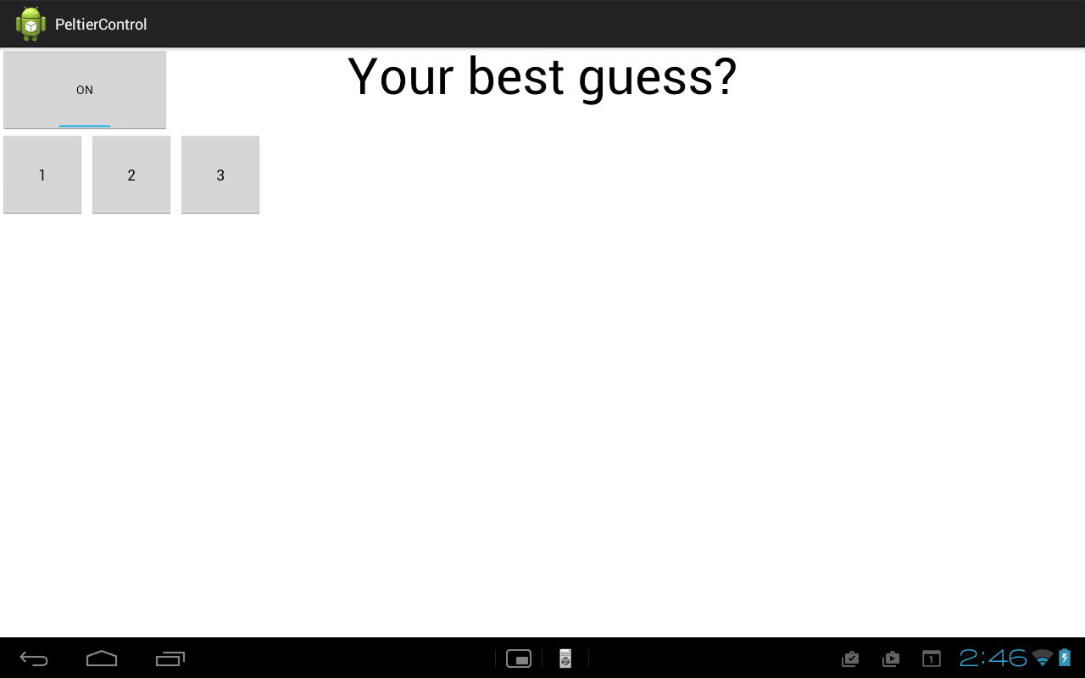

Figure User interface for second study

Software

Similarly, two Android apps were written for this study. One gives the user control of the sensory experience by giving control over the sensitivity range, all other visual feedback was disabled. The second app was written to give the subject control over the test. It was designed to be completely independent of the examiner and so create a double blind test. The app would first randomly decide if there would be a result feedback at the beginning or end of the session. Then it would offer the button to turn on the peltiers and give a countdown of how many turns were left. Three buttons corresponded to the three modules to allow the subject to enter their guess. At the end of the session the app would notify the subject that they were done and would give them the score out of twelve of correct responses.

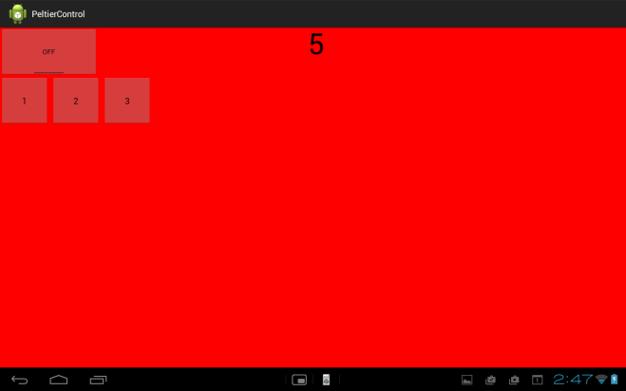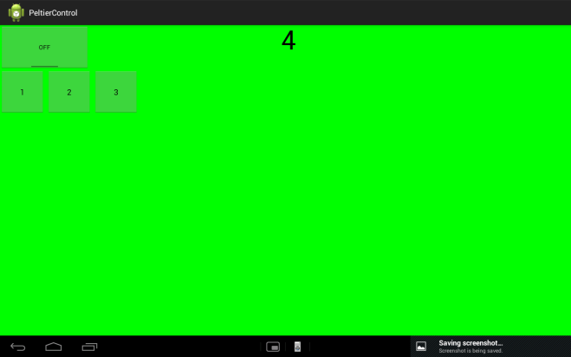

Figure green when correct, red when wrong

### Procedure

The subjects were seated in front of three peltier devices. At a given moment, only one of these devices would be hotter than the others. The subject’s task was to guess which device was hot.

The subjects were given a head band that would hold the sensor, transducer, IOIO and power. That IOIO would be connected via Bluetooth to a mobile device that would give sensitivity control to the users. Another device would control the peltier modules so that when a button was pressed, the device would randomly activate one of the peltier modules. The UI peltier control device would offer a button to activate the peltiers and begin timing and three buttons that corresponded to the subject’s guess.

Figure

Figure

The subjects would do this guessing activity twelve times, six times with a visual result that would tell the user if the guess was correct or not and six with no visual result. Whether the visual result would appear on the first or the last six turns was also randomized.

### Results

The initial result shows an average of 80% accuracy, but this was not the most exciting result or even the result I wanted to examine. This study was more about the subject’s ability to learn how to use this sense and it would be reflected in the time each subject took to make a guess. Overall we see that the time per turn goes down (table 4), and when compared with the average of right or wrong answer, the accuracy tends to remain well above 50%.

Another interesting result was the relation between time and the visual feedback. For 6 of the 12 turns the subject received a green light for correct answers and a red light of wrong answers. The results show that there was no significant advantage to having the visual feedback come at the beginning or at the end. The data was analyzed to compare the average time per turn when the visual feedback came first against when it came second (table 5), then the average time of the 6 turns with no feedback when these came before against when these came after and finally the average time of the last six turns when the feedback came first against

### Evaluation

|  |  |  |
| --- | --- | --- |
| Time and Accuracy of the last 6 turns, when feedback came first vs. second | | |
| Feedback | **Time(sec)** | **Accuracy** |
| Feedback first | 58.01 | 66.67 |
| Feedback Second | 50.22 | 83.33 |

|  |  |  |
| --- | --- | --- |
| Average time of feedback Vs no feedback | | |
| Feedback | **Time(sec)** | **Accuracy** |
| Feedback | 57.99 | 80 |
| No Feedback | 59.93 | 75 |

I expected to see the users get better as they performed the task and this is shown by the average time per turn decreasing to an average of little more than 30 seconds. This means that the user learns to understand their sense, but also that they get used to the task. For instance in most cases the middle peltier which was smaller than the other two was not really checked but chosen when the others were not giving a signal, so by elimination it had to be number two. But as the test advanced, the subjects obtained a better picture of where the sensor was in their foreheads and how to properly align it to the peltier module in question. This is what I was looking for, to see how quickly the subjects would adapt.

I didn’t expect to find that there was no significant difference from when the visual feedback was offered. I expected that when the visual feedback came first, it would help the learning curve and then it would make the last 6 turns be faster and more accurate. I found that the average time in the last 6 turns remained at around 50 seconds. Even so, there is an effect to having a visual feedback but this is only in the behavior of the subjects. Having a visual feedback of the result made the experience more enjoyable like a game. This means that the subjects felt more involved in the experience and tried extra hard to get it right, this was reflected in a slight increase in time when feedback was given over when there was none.

Overall the subjects reported the hardest thing to be locating the sensor on their forehead and once located, trying to align themselves again to the same position proved challenging. The use of the sensitivity dials was very consistent over all the subjects; they would search for a comfortable setting and then leave it still for the rest of the test.

## Cell Sensors to Vibration

This is the main study designed to test the ability of a subject to connect a new signal with its source, or better yet, the ability of a subject to find significance in a signal when compared to their surroundings. This study was geared towards a more qualitative analysis because I was not as interested in the accurate identification of the sensor but in the interpretation that the user would give the signal. These interpretations are the power behind Digital Synesthesia. When we experiment with phenomena that are completely outside of human perception, it will be the ability of the users to find significance in those signals that will bring this project to its fullest potential.

### Preparation

I took an old baseball cap and fitted it so it would support the IOIO board, the Bluetooth dongle and power. On the inside close to the left temple the transducer would vibrate next to the skull to generate both vibration and sound through bone conduction. A mobile app would activate a random sensor of the device and map the data inside the sensing range. Via Bluetooth the cellphone would send the data to the IOIO board to control the transducer.

#### Hardware

(photos and circuit diagrams and such)

The hardware designed for this test was more simple that the others because all the sensors were already working in the mobile device. I designed a board that would connect to the IOIO board and control the transducer. The IOIO would receive the data from the device via Bluetooth and transmit the frequency to the transducer.

#### Software

I wrote an app that scans the device for any and all available sensors and creates a button for each one as well as WiFi strength and surrounding sound levels. When the sensor is selected by the user, the app gives access to a sliding scale that controls the sensitivity as well as to a numeric feedback of the raw sensor value and the mapped value used as frequency. Finally a real-time scrolling graph gave additional visual feedback.

The app offers an interface to the examiner, which I described above, and a different interface to the subject. This second interface hides all the sensor buttons as well as all the feedback information so that the user has no idea what are the possible sensors to choose from. The subject has access only to the sliding scale that controls the sensitivity and a timer set to 15 minutes. After the 15 minutes an alarm sounds and the phone asks the subject to return to meet the examiner.

(photos and screenshots and such)

### Test Procedure

The subject would wear the cap and the examiner would pick a sensor to use as an example while the procedure and operation was explained. This explanation was done using the “examiner” interface so that all the visual feedback would help the subject understand the operation of the device and land on some strategies to successfully set the sensitivity values. Once the subject had a good grasp of the operation, the examiner would set up the study but choosing another random sensor and switching to the “study” interface, then give the device to the subject and instruct them to roam around the building for 15 minutes while trying to find a correlation between the signal and their surroundings. Lastly, the examiner ensures that the timer has started and sends the subject on their way.

One of three mobile devices were used, many of the sensors were present in all three. Changing the device would also help so the user would be less familiar with the technology in the device.

|  |  |  |  |
| --- | --- | --- | --- |
| Sensor \ Device Model | Samsung Galaxy S4 | Samsung Galaxy S3 | Huawei Ascend P6 |
| Light Sensor | X | X | X |
| Tilt Sensor / Accel | X | X | X |
| Magnetometer | X | X | X |
| Barometer | X | X |  |
| Temperature | X |  |  |
| Humidity | X |  |  |
| WiFi | X | X | X |
| Sound | X | X | X |

#### Setting sensitivity values

The subjects were instructed in how to set the sensitivity value by having them use the cap and trying to feel the change while looking at the visual feedback. If the change was very small or if there was no feeling of change at all, then the upper value of the sensitivity range was brought down until the frequency was fast. That way you had a good upper value, now without moving the upper value, the lower value was brought up until the frequency would slow down. Finally the user would test the sensor again until they were satisfied by the change being felt.

They were then asked to try and do this without looking at the visual feedback since there was not going to be any during the test.

### Results

A total of 17 subjects were tested with a percentage of correct answers of 47%. The total amount of possible sensors in the devices was 9 which give a minimum percentage of random at 11%. The correct results were guessed during the first 10 minutes of the test, with the last 5 minutes used to confirm and “play” with the sensor.

### Evaluation

The value of 11% based on the 9 sensors available is somewhat inaccurate. On one hand because the users had no knowledge on how many options there were and they were not picking out of a list presented to them. On the other hand, many of my users were very familiar with mobile technologies and had an idea of what the capabilities of different mobile devices could be. This said, what was important to me on this study was the thought process around finding out the connection between the feedback signal and the experience. In this sense, the familiarity with technology also proved problematic because some subjects would just spend their time going through the sensors one by one in order to simply eliminate possible sensors.

Figure 17

|  |  |
| --- | --- |
| The wrong responses | |
| Sensor | **Response** |
| Sound | Wind or weather related |
| Pressure | Has to do with the stairs. Shape, Distance or Materials |
| Temperature | No Idea |
| Accelerometer | Screens or Bluish light |

Table

The really exciting experiences were given when a user was not sure and came up with possibilities of what the experience was. When users who were feeling the sound level stepped outside of the lab, they would immediately think that the sensor had some environmental connection or that it detected wind speed. This is what I was hoping for, users interpreting in a useful or meaningful way the experience.

The most successful sensor was light intensity. It also created one of the most enjoyable experiences because it had a good range of change that was easy to feel and going from room to room there was always a change, but it wasn’t until the subject went down a hallway when a series of quick changes would happen and it became evident because the subject was walking under a series of light fixtures.

## Smell Explorations

Smell is a very difficult sense to work with and to generate experiences with. It is not easy to create costume smells and once a smell is in an area it is not easy to get rid of it in order to replace it with another. So the smell experiences designed for this study were made as a broad exploration of its possibilities and not as a strict user study.

### Smell Explorations 1 “The Foodcam”

The media lab has a system set in place to deal with leftover food from meetings and events. All the food is taken to a central location at the lab where there is a table designated for this purpose. Above the table there is a webcam that, when a button is pressed, will capture and image of the table and the food offerings and send this image as an email attachment to everybody in the lab, at which point people will head over to collect some free food.

### Preparation

I designed a system that would listen to any activity in the foodcam camera feed and also listen to the emails coming out of the foodcam account.

#### Hardware

I bought an “Air Wick® Freshmatic | Automatic Air Freshener dispenser and Spray” which is an aroma dispenser that can be programed to release a puff of aroma at a set time frame. It was easy enough to bypass the power, from the batteries to the servo-motor that would press the canister of scent, through a MOSFET so I could control the actuation with a IOIO OTG board. This board would be connected to a Sony Tablet device.

#### Software

An app was created to regularly look at the foodcam live feed for changes and to listen to the emails being sent. When activity was seen on the camera a signal would be sent to the IOIO to activate the servo for a very small amount of smell to be released. One the foodcam button was pushed the IOIO would send the signal to release a full burst of scent into my office.

### Evaluation

The experience of having a smell release when the foodcam was activated was more efficient that waiting for me to actively check my email. As a just-in-time interface it worked much better given that I was in my office. Even if I was near my office I would notice the smell change and know what it meant. There was the problem of lingering smell since after I had gotten the signal of the foodcam the smell was to remain. This would not only be inconvenient but in the cases when the foodcam was pressed in close succession, the second puff of scent would be unnoticeable. But the problem of the lingering smell showed a positive angle when I realized that I could broadly estimate the time passed since a foodcam signal was triggered by how faint the smell was.

## Smell Explorations 2 “The smell-mixer”

Another difficulty when working with smells is the creation of new smells. To this end, we[1] created a system of eight bottles and a pump that could be used to mix essential oils in different ratios to consistently create different smells.

### Preparation

Based on the science of perfumery, to create a smell you need at least 2 different scents, a base scent and a top scent. We have set up eight bottles to do just that.

#### Hardware

A regular pump is hooked to all eight bottles with plastic tubing that goes through a solenoid that controls the flow of air. The solenoids are controlled by relays that respond to a IOIO OTG board.

(Insert circuit diagram…)

#### Software

An app was created to offer a user two choices of bottle, a base and a top scent. Then the user can dial a scroll bar to decide the mix ratio of base to top. Given the choice, the app was programed to take divide ten seconds in whatever ratio was needed so if the ratio was 50:50, both solenoids would be open for 5 seconds. If the ratio was 30:70 the base would open for 3 seconds and the top for 7.

### Results

(in progress)

### Evaluation

(in progress)

## User Studies (the less successful ones)

## Stress to Sound

Working with a IR sensor was one of my biggest curiosities because it gave me the opportunity to experiment with a well know environmental effect as is temperature but also in a way that the body cannot perceive which is optically. So it would be an easy jump for the subject, I thought, as a fits approximation of how an unknown artificial sensory experience might be like.

There is literature that supports how small changes in a person’s facial temperature are related to that person’s emotional state[27]. Specifically in stressful situation like a high stakes poker game. I intended to replicate one of these studies by creating a game situation in which a player had the ability to detect the emotional state of the other players and use this to their advantage.

In order to test the validity of this thesis, I needed to first test the sensor to see if there would be any discernible change in a players temperature. Given that the players would be at an unspecified distance from each other and I was not going to be able to control where the sensor was pointing and how the subject would use it, I decided to set it up in such a way that it would always face one user. To achieve this I changed the design of the cap and the player who would wear it would have the IR sensor facing at its own face. This way the player was free to move their head and the sensor would remain fixed pointing at that players face. Everything else was kept the same.

### Preparation

A subject out of 4 to 6 subjects would wear a baseball cap with an IR sensor facing out from the forehead and a vibrating transducer on the temple. A game of Liar’s Dice[28] was set up and the rules explained. The group would play until the player with the cap was out and then another session would commence.

#### Hardware

A baseball cap was fitted to support a 9V battery, a IOIO Board, an IR Sensor and a tranducer. The 9V battery was the main power for the whole system. Data collected by the IR sensor would be transmitted to the IOIO Board and then to the mobile device via Bluetooth. The device would transform this signal to frequency and send it back to the board. The IOIO Board would then control the transducer and make it vibrate at the desired frequency.

(Insert images)

#### Software

Using and Android device, an app was made to be controlled solely by the examiner. The app would take the incoming sensor data, map it into the range set by the examiner through a couple of number pickers and send the data as frequency to the board. The examiner had numerical feedback of the incoming temperature value, the sensitivity range and the outgoing frequency. Additionally the app offered graphical feedback of the real-time variation of temperature value. A button was created for the examiner to be able to mark the beginning and end of the subjects turn, this mark would appear in the data stream being recorded of temperature so that the data could be analyzed by separating values during a turn and out of turn.

### Evaluation

This user study proved to be harder and I initially thought. The first thing I looked for in the collected data was for a difference in the average temperature when in turn against when out of turn. The differences where too small to be meaningful and there was no pattern to if it would increase or decrease when the subject was in turn.

This means that either my sensor was not adequate. Either not sensible enough or the FOV was too broad and it detected too much of the ambient temperature that would wash over the small changes I was looking for. The other possibility is that for this temperature and emotion correlation to be detectable, the activity has to be really stressful as is the case in no-limit poker when the subjects use their own money. It might be that the game of Liar’s Dice, as exciting as it may be, was not stressful enough to generate a noticeable difference in the subject’s temperature.

## Glass to temperature

This user study was designed to test a subject in the identification of an unknown signal. It is also the only study I made using a peltier device as the feedback mechanism, essentially using temperature as an output.

### Preparation

#### Hardware

The hardware configuration for this study was very similar to the ones discussed before. Incoming data was received by a IOIO OTG board and sent via PWM through a MOSFET to the Peltier Device. The data that the IOIO received was collected from the DoppelLab project at the MIT Media Lab.

The subject would wear a lanyard around their neck where the IOIO and power source would be hanging at their chest, while the peltier device would be in the back of the neck, against the skin. Since peltier devices can be used either on the warm or cold side, for this study only the cold side was used.

#### Software

The DoppelLab project uses a sensor network that reports a variety of real-time information to the web. An app was written to take the data from DoppelLab and use it as the input for the Digital Synesthesia system. For this study I used only the RFID Tag reader to give me location information. The system can recognize the user through the RFID Tag and the system knows where the reader is located in the building, essentially giving out location information.

The app creates a listener in the DoppelLab stream that is constantly looking for a specific ID. Once the ID is found, the signal would be sent to the IOIO to control the PWM to set the temperature of the peltier according to the distance between the subject’s current position and the location of their final objective.

### Procedure

Ahead of time, a specific sensor in the lab was selected. The subject’s task was to find this specific sensor by interpreting the signal in the back of their neck. The peltier would cold when passing in front of a sensor that was far away from the objective and would feel warmer as they got closer.

### Results

This experiment was not completed because it became clear early on that the temperature feedback was not clear enough for the users to be successful. But some important lessons where found from this experience.

### Evaluation

An interesting finding is that the subjects were much quicker at detecting the change in temperature when it became colder than when it became hotter, this might prove useful when the users need to be aware of something urgent that is detected through the artificial sense.

Another finding and the one that proved to be the hardest to overcome in the study was that even though the users were quick to notice a change, these changes were quickly assimilated to by the brain and so the concept of war to warmer or cold to colder was not successful. There was no sense of increment or decrease, only the feel of neutral to new temperature. In order to create the sense for gradual change, I would either have to start and stop the signal or use temperature values that would be outside of the comfortable area for most users.

The third finding was that once the brain had assimilated a constant temperature, stopping the signal would feel like a signal in itself. So if the first signal was cold, and it was kept at a constant temperature, the brain would ignore it after a while, if then I turned the peltier off, the brain would interpret that a big jump in temperature towards heat, even giving the illusion of close to burning. Even though I knew that the peltier was simply going from cold to room temperature. Again, there might be a future use for this effect where the user would feel a big change while not really needing to use any extreme temperatures that could be dangerous.

## User Studies Summary

|  |  |
| --- | --- |
| User Studies | Results and Conclusions |
| Proximity to Vibration |  |
| Temperature to Sound |  |
| Cellphone Sensors to Sound |  |
| Smell Notification |  |
| Smell Creation |  |
| Stress to Sound |  |
| Glass Infrastructure to Temperature |  |

# Research Questions

Overall, all studies were looking to understand the ways in which the brain is able to take a very basic artificial input and create a useful, coherent picture from that input and any other clues from the body and the context. Other questions to be addressed were A) the relation between the type of data and the mode of transmitting this data to the body; B) how the user will understand an analogous sense, a new sense or the substitution of a sense; and C) how quickly the user will understand the sensory feedback loop.

A more detailed list of questions that were addressed is:

## Discreet and Continuous Data

1. Will a discreet signal that just turns on and off to get the user’s attention be more effective than a continuous signal that requires the user’s interpretation of changing data?

The research showed that a vibration signal was very good for analog data that would cover a spectrum of values, allowing a user to understand progressive changes in a set condition. The first and third study showed this when users would slowly try to find the strongest signal by always looking for the small changes. Temperature proved not to be appropriate for this type of sensory experience because the skin would quickly assimilate the temperature and then ignore small changes. Incidentally, a vibration feedback would be less useful for a long-term experience since the users reported to not be willing to have a constant vibration signaling continuously, but a temperature feedback would be great for this precisely because the body would assimilate it and any change would then become apparent.

## Sensory Substitution

2. In a situation where vision is used to make a quick decision, will Digital Synesthesia prove to be a valid alternative to accomplishing the same task or part of that task?

It is very hard to compete with vision, since we use it so much and in so many situations. When the first test was designed to create an experience that could also be accomplished through vision, the artificial sense proved nowhere near as efficient or precise as vision. But I did find that the ability of the subjects to compare and confirm their findings through vision, greatly increased the ability to learn and understand the new experience. So even if we might not be able to replicate the functionality of vision, it is thanks to vision that artificial senses can be learned quickly and accurately.

## Sensory Augmentation

3. Will users be able to understand the ability to fine tune the sensitivity of an artificial sense?

During the first study, the users had no control over the sensitivity level. Instead, the experimenter would change the sensitivity according to the procedure of the test. This proved that the answer was not as simple as “more sensitivity is better” but that the users would show a preference of one over the other. This meant that it would be interesting for the users to have control over the sensitivity.

In the second and third studies, the subjects had full control over the sensitivity level of their artificial senses. The user interface gave them a scroll bar or a number picker with which they could change the full range of sensitivity. During the second user study, the subjects knew that they were looking for temperature changes and it became evident, after a short explanation, how the sensitivity level could be used. It was reported that they “played” with the values until they felt comfortable with the behavior of the sense, at this point; they would rarely move it again.

During the third study, the subjects again had access to the sensitivity levels but in this case they had no idea what was being sensed, so the experience had to bring together a combination of their exploration of the space and experimentation with the sensitivity level as they tested different theories of their experiences.

The first study proved that the control over sensitivity was to need a more nuanced approach. On the second study, the subjects found it very useful to have that control and made their performance more accurate. The third study would have been, except for one or two conditions, impossible without adjusting the sensitivity and the accuracy of the test proves that users would very quickly understand the concept of variable sensitivity.

## New Senses

4. Is the user able to understand and correctly interpret a new artificial sense that the body previously did not have?

Arguably, all three studies were based on a sensory experience that the body didn’t have. Even though on the first study the subjects could easily accomplish the test by using their sight, the experience of sensing proximity with their hands is a new sense. So it is safe to say that users in all three studies were very successful at understanding and successfully using their new sense to accomplish the task.

## The User and the New Stimuli

5. How accurate is the interpretation of data when experienced through new artificial senses?

6. Will there be feelings of “phantom sense” where the user will feel the effects of a stimulation that is not present anymore?

All three user studies have demonstrated a high level of accuracy when using artificial senses. This accuracy could be affected by proper use of the sensitivity adjustment and practice with the sense. There was no report of a phantom feeling, this could be because of the short term use of the system.

## Escaping the visual user interface

Because visual interfaces are the most common, we tend to think of the interfacing with new senses in purely visual terms, where input signal is translated to numeric data and transmitted to the eyes.

7. Can this research start to uncover the particular ways in which information should be understood and interpreted when transmitted to the skin (or other senses)? Perhaps the idea of “value” is mostly a visual construct.

Because of the success of the experiences designed in this thesis, I can say that finding ways to work around the visual sense is very possible. During the tests, there was no mention of numerical values and so the subjects learned to interpret the frequency changes of the feedback into references to compare when the feedback changed. I find this to be important because it shows that the artificial sensory experience can have a similar interpretation as the natural experiences.

# Design Thinking

Throughout this thesis I have been looking for a way to radically change the mobile experience. I have done this by using sensory substitution in a way that may benefit all kinds of people. For this to work, I will propose in this section what I think are the building blocks for a design oriented approach to Digital Synesthesia and Artificial Sensory Experiences.

The first thing to keep in mind is that I am proposing the ability to turn sensory experiences on and off as the user may need. To this end, the user studies have looked into how a user may be able to quickly turn on an artificial sense and get satisfactory results in a short amount of time and in different situations.

1. What is the main activity?
2. What type of sensing do we want to create?
3. What kind of signal are we tracking?
4. What control does the user have over the signal?
5. Are there any redundancies with other senses?
6. What type of feedback can we use?
7. Where are the sensor and feedback located?
8. Can we set up a learning environment?

## The Main activity

It is important to remember that digital synesthesia is not an end to itself but a means to enhance an experience by creating richer connections between the user and the environment. So the main activity is that in which the user will be taking part in and in which Digital Synesthesia will be a part of. For the designer it will be important to be aware of how much attention does the activity demand of the user because the artificial senses will need to make room in the user’s attention span.

Take for example sailing as a main activity. The main experience should remain the same; the user wants to go out sailing in the same manner as before. Digital Synesthesia will offer the ability to feel wind speed, tilt of the boat and direction of north. Depending on the user’s experience, sailing can demand different amounts of attention. For the beginner sailor, the artificial senses must be clear and relevant enough for the user to successfully and willingly be aware of them. The experienced sailor might be more relaxed and have the ability to add to the sailing experience other senses that are not as intrusive, as well as less obvious. The experienced sailor will have no need for wind speed or tilt of boat so they can choose to be aware of depth of the water under the boat or distance to other boats if they are in a race.

## Type of sensing

I have recognized two distinct categories of artificial sensing, active and passive sensing. In passive sensing, the user does not need to be constantly aware of the sensory feedback being generated; rather, the user wants to either be aware of big changes or of when a signal passes a set threshold. This is also the case when the sense changes very slowly and the user want to track it during that long period of time. This means that the feedback giving the signal has to be discreet enough to not annoy the user but effective in grabbing the user’s attention when a threshold has been reached. Active sensing is when a signal is completely under the user’s control, it changes quickly and the user’s actions affect the way in which the user feels this signal. The feedback for an active sensing experience can be strong since the attention of the user will be placed on the sense and will last only as much as the activity lasts. It can be turned on and off easily so once the activity is done, the sense disappears.

## Type of signal to be tracked

The type of signal will determine how we present it to the user and how we do the translation. Is this a signal that changes quickly or slow? What is the range of change? Do we need continuous feel of will checking a value every once in a while be enough? Is it quantifiable as a single value that can be mapped to another sense or will it be more complex? Is there a better mental map of the signal than a simple quantity?

Most signals whether quick or slow are given to be quantifiable and hence are easy to represent in another modality like frequency or temperature. But a signal can be more complicated. Going back to the sailing example, the sense of tilt of boat could be represented as a quantity for angle from horizon, but it might be better represented to the user by two vibrations that move up or down on the sides of the user, like a level (confusing, insert figure), and this might prove to be easier for the user to understand with less training.

## What control does the user have over the signal

Our sailor is enhancing its sailing experience with the artificial sensing of wind speed, tilt of boat, north and depth. Some of these senses are completely out of the sailor’s control, like wind speed and north. Some are under partial control like depth or tilt of boat, depending on the experience of our sailor. So if a signal is given to change with no action from the user, that sense is said to be completely outside of the user’s control. If the signal will never change, but by direct action of the user, then the signal is under control. A signal like tilt of boat changes with the actions of the sailor but also because of environmental factors like wind or waves, so that signal is only under partial control.

In general, most senses that are out of user control are good for a passive experience. Since the user can’t control the signal, they can only be aware of the changes. Depending on the importance of this signal to the main experience, the user will want to be constantly aware of minor changes or simply notice big changes as they happen, the feedback should be placed according to these conditions. The feedback must be able to grab the attention of the user at the right moment. A sense like depth or tilt of boat are under the user’s control in the sense that the user’s actions will immediately change the signal and the artificial sense will help create a close feedback loop that the user will use to successfully navigate the experience. So changes in the depth will inform the sailor on the best direction to steer the boat which will then change the depth as the boat sails to a different location. That makes it an important sense for the experience and the translation of such sense should be clear but since the signal will be under the user’s control then the attention of the user will be largely on the signal itself so the feedback does not have to grab the attention, it simply needs to be clear and not intrusive in the active experience.

## Are there any redundancies with other senses?

Digital Synesthesia can be used to create sensory experiences that are completely outside of the sensory capabilities of our bodies, but also to enhance a sensory experience that might be sensed by the body in other ways. These sensory redundancies have resulted useful in different ways and the designer should be aware of the opportunities that these redundancies might present.

If what is happening is a simple enhancement of an existing sense, the artificial sensory experience is acting in a similar way to a natural experience that the user is used to. An example of this can be a pressure sensor on the tip of a finger. Even though the finger can feel pressure, the artificial sense can be dialed to be more sensitive than the natural counterpart. These redundancies allow the user to quickly understand and make sense of the new sensory experience.

The artificial sense can also be a substitution of an existing sense, so like in the case of the first user study, the sensory experience was used to determine information that was readily attainable through the visual sense. This creates a very close feedback loop that will have important effects on the acceptance of the information through the artificial sense, learning will be quick and when time comes that the user can’t use the redundant natural sense, then the artificial sense will suffice. If we think back to our sailing experience, wind speed is something we can naturally feel through our skin and hair but our brain is not used to paying too much attention to these signals, so the artificial sense can be a way of helping the brain create an understandable experience of the natural sense until time comes that the artificial sense is no longer needed.

Lastly, the user might be using an artificial sense of a signal completely foreign to our five senses. As in the second user study, training is the hardest because there is no real feedback loop except trusting that they are correct in their assessment of the artificial sense. In these cases, extra care must be put into the learning process. The second study even though it showed that there was no difference between the times when the users had a visual feedback and when they didn’t, it was clear that in every case, having the visual feedback made the learning experience more enjoyable and the results were more encouraging.

## What type of feedback can we use?

In this project I centered in two types of feedbacks that created three kinds of feeling. The peltier devices would generate temperature through the skin while the transducer could be used to create either vibration on the skin or sound through bone conduction.

I have shown how a peltier device giving temperature signals will be better suited for a passive sensing experience where the user does not want to be aware of small changes but instead wishes to feel significant changes through long time periods. It might be possible to increase the opportunities for using temperature as a sense by using other devices than the peltiers given that some of the problems I had were because of physical constraints of the device and not of the experience.

The transducer, whether used for vibration or bone conduction, was very well suited for active sensing and quick changing signals. On the other hand, the transducer proves to be not adequate for passive sensing because the users reported not wanting to have that signal constantly during longer periods of time. I did not test for the advantages of bone conduction over vibration and this would be interesting to dive into. But for bone conduction to work, the transducer must be places close to the head and/or bone, and as we will see there are other constraints when it comes to the location of the feedback.

## Where are the sensor and feedback located?

Where to locate the sensor and the feedback is a key question to be considered by the designer. All of the previous points I have discussed will have a direct effect on this step. There are basic design issues like not allowing the sensor or feedback to hinder the user’s natural ability to physically perform the main activity. So if the main activity requires the user to grip a controller then nor the sensor or feedback should be in the palm of the hand where they would not allow the user to properly grip the control.

The research has uncovered a more nuanced approach to the consideration of sensor and feedback placement. When the experience is of passive sensing, the sensor can be anywhere, either on the user’s garments or on the mobile device, since the user will mostly not be aware of the sensing experience until a big change happens, the location of the sensor is irrelevant. The location of the feedback is concerned only with the ability of this feedback to grab the attention of the user at the given time and depending on how much attention is already being used by the main activity, the feedback will have to be in more sensitive parts of the body. A good cold feeling down the neck and back should be able to give a good jolt of urgency to the user.

For active sensing, there are two situations to be examined. The users can have control of the sensor or not. When a user has no control over the sensor, it means that either they are not wearing the sensor or the sensor is tracking signals that have no influence by the users’ body movements. In these cases, the feedback can be anywhere on the body as long as it still obeys the rules previously discussed.

If the users have full control over the sensor, it means that they are wearing it and that their body movements have a direct effect on how and what the sensor detects. Think of this as the way we use our nose to find a smell by moving it around looking for the strongest scent, or how we move our hands in front of our bodies in the temporary absence of vision. Here I have found some interesting situations, mainly having to do with whether the user can visually confirm the precise location of the sensor in the body. If the user can see the actual sensor, the brain can create a very tight feedback loop with the movements of the sensor, the object or direction being sensed and the feeling of the feedback. This is a perfect situation for quick learning of the artificial sense and the most effective and accurate use of it. Also, in this situation, the location of the feedback in relation to the sensor is not very important and some freedom can be taken in were to locate it.

In the case that the user has no visual confirmation of the sensor’s precise position, like in the second study when the sensor was in the forehead, the accuracy of the experience goes down because of a low sense of proprioception of the user. The user might have an idea of where the sensor is by touching it but when it comes time to aim the sensor towards a particular direction I noticed that the users would not be accurate in where the sensor was or where it was pointed. In these cases, an effort must be made to locate the feedback exactly behind the sensor, the feedback becomes the only clue the user has to the location of the sensor and so they will attempt to line up their sensor with the object or direction they are interested in by assuming the sensor is where they feel the feedback.

## Can we set up a natural learning environment?

An important element for the success of an artificial sensory experience is the training and learning phase. Some sensory experiences will be easier to learn than others. If there is a redundancy between the artificial sense and a natural sense then an activity should be created so that the users can get accustomed to the overlapping feelings between the artificial and natural senses, then the activity should change so that only the artificial sense is felt with the possibility of checking the users’ performance by confirming from time to time with the natural sense. This will not only generate valuable practice but also eventually will re-enforce the users’ confidence in their artificial sense.

When users can visually confirm the location of the sensor and feedbacks on their bodies, the learning process will be faster. This applies to active sensing when the accuracy of the artificial sense is related to the user’s control of their body. Proprioception and Kinesthesis are senses that vary wildly from person to person and some users will only be able to master an artificial sense by being able to see how their movements affect the experience.

My results have shown that having confirmation of whether the users’ response is correct or not has no significant effect on learning, it does however, have an important effect on the experience of learning, making it more enjoyable and interesting and hence making it a better learning experience.

## Examples

Given this guideline I’ll attempt to propose artificial sensory experiences for three main activities.

1. What is the engulfing activity?

Sailing

1. What type of sensing do we want to create?

Both active and passive

1. What kind of signal are we tracking?

Wind speed – quick changes, passive

North – slow gradual change, passive

Tilt of boat – quick changing, active

Depth – slow gradual change, passive

1. What control does the user have over the signal?

Partial control over Depth and Tilt of boat

1. Are there any redundancies with other senses?

Wind speed and tilt of boat have redundancies

North and depth don’t have redundancies.

1. What type of feedback can we use?

For North and Depth we can use temperature. Depth can be a passive sense that is activated once the depth becomes shallower than a specified value. North will be a slow changing signal and can be represented by more than one peltier device.

For wind speed and tilt, vibration will work.

1. Where are the sensor and feedback located?

Because of the main activity, hands are out of the question.

The sense of North can be with a belt of peltier devices, it is not intrusive and the body will assimilate the temperature under a particular peltier and when direction changes the body will feel a signal from the newly activate peltier as well as from the de-activated peltier.

Depth must be place in a sensitive area and hopefully away from the North signal. The back of the neck would work.

For winds speed I would choose the forearm, it is close to the hands which the brain will already be paying attention to since they will be controlling the main line and tiller but in the forearm it will be out of the way.

Tilt of boat I would try an approach of three or four vibrators along the side of each thigh that would work in tandem, if the boat inclines towards the left, the bottom left and the top right vibrators would be on.

1. Can we set up a natural learning environment?

Training for north and winds peed would be easy to set up as it might simply be wearing the feedbacks at any moment when walking outside.

Tilt of boat, if we want to put in the effort, could be trained by creating a surface that tilts under the users weight and then the user can get used to the new sense.

Depth, being a passive sense that will only respond to a limit value does not need training, we simply need to make sure that the user can feel it at any moment.

# Contributions

With this study I have proven that a user is able to understand and accurately use an artificial sense, not only during a structured task but also when the context was completely open to many interpretations. Also importantly, the users were able to get good results with very little time to practice or to assimilate the new sense. This proves that the idea of creating a system of artificial senses that are able to turn on and off depending the user’s needs and desires is viable.

I have shown that the brain is able to form a useful and coherent story from a poor quality signal given by the artificial sense. The users were able to differentiate between signal and noise and also compensate for individual motor skills. This will allow for a greater impact of artificial sensory experiences in the general populations since there is greater room to experiment without worrying too much about the quality of the sensors or signals.

I have recognized two distinct categories of artificial sensing, active and passive sensing. Active sensing is when the user recognizes an experience that will directly be influenced by the use of an artificial sense. The user will activate an artificial sense and start probing their environment looking for a particular response. This is akin to using the sense of smell and bringing your nose close to the source in question. For this type of sensing, the sensor should be in one extremity that can easily be moved in the area to be probed. The fact that the user can see the sensor and confirm its location on the body will only aid in the accuracy of the experience. Active sensing will require feedback that is appropriate to active comparison of a continuous signal.

Passive sensing is when a user needs to be notified of a change in a situation and immediate action is only needed when that change happens. This type of experience is very long term and it needs a signal that is not annoying to the user but strong enough to get the user attention at any moment. This research shows that the use of temperature will be appropriate to this end. It will also be necessary to locate this feedback where the user will not find it cumbersome in a daily routine. This means that coupling the feedback in a wearable design will be most successful. The study used the back of the neck which points to a scarf or necklace. Also the lower back, meaning a belt would be adequate.

As a user experience, passive and active sensing can function in tandem allowing the user to be made aware through passive sensing of a major change and then changing to active sensing for close inspection of the situation. This would, for example, change the feedback from a temperature felt somewhere in the back, to a sensor worn on the index finger and vibration in the right temple.

A set of recommendations has been established in order to successfully implement artificial sensory interfaces in the future and to push the research forward into the future of Digital Synesthesia and artificial interfaces. The placement of the feedbacks around the body is one of the main takeaways from this thesis. Not only will this depend on general ergonomics principles but there is a clear effect of the type of sensing and relative position to the sensor that will have to be taken into account. Another is the relation between type of signal and type of feedback, some feedback will work better with different type of signals.

Most of the research and direction of the industry around artificial sensory experiences is geared towards a group of users with sensory disabilities. I have proven that not only is the general population able to successfully use these interfaces but also that it can be done in a way that is unobtrusive and comfortable to the user.

# Future vision

I see as the final objective of Digital Synesthesia and artificial sensory experiences a system in which a user will be able to decide a group of sensory experiences to activate depending on the activity they want to undertake. So if a user wants to go sailing, they might want to activate a sense for north at the waist, for wind speed on the temple and distance to other boats on the chest, responding to glance direction from the forehead. This means that their apparel must come with the feedbacks built in or a set of wearable feedbacks must be available. The user will use the mobile app to create this sensor-feedback link, so the app will show the sensors available and the feedbacks in the body and make the connection. Once the activity is over, the user will turn off the sensors and be on their way.

Future specialized garments will take into account the need to offer artificial sensory experiences and will have embedded different feedbacks around the body. This can apply for sports apparel or general day wear. Also work related apparel for jobs requiring high levels of attention and quick reaction. An air traffic controller can wear an feedback while working that will keep him or her informed of anomalies in the traffic pattern as well as quickly orient them to where the anomaly is happening

Another exciting avenue for this system involves Virtual Reality. One big drawback of virtual reality systems is the lack of haptic feedback that might respond to the virtual world. I propose that an avid VR user can create an artificial sensory experience that responds in the real world in order to train their body to react to a specific condition in the virtual world. So if the user wants to have a good feeling of the distance between their hand and a virtual object, perhaps they can wear a proximity sensor and feedback in the hand and get used to how the artificial sense feels when approaching different objects with their hand in the real world. Once in the virtual world, the feedback will take the signal not from a sensor but from the VR machine. The user’s brain should be able to relate both experiences and make the virtual experience much richer.

# Conclusions

This thesis began with many ideas and inspirations that loosely pointed towards a same objective. The mobile interface is not evolving fast enough because of its high dependence on vision. Our mobile devices have a much greater capability than what common use demands of them. In order to advance the mobile user interface we need to advance the mobile experience at the same time. The sense of vision is overused and it uses too much of the brain’s capacity. There is a clear ability of the brain to re-route sensory experiences that needs to be explored. Mobile devices and mobile technology are so concerned with creating immersive experiences, that we are losing our sense of immersion in our immediate surroundings. With four more senses other than vision, we must be able to tap into some of them to reduce the load on vision for mobile interfacing. There are so many interesting and useful signals in our environment that we are missing because of our limited sensory capability and even some we had and have now lost.

Roughly as the project took form, all these ideas got reduced to fewer questions. We agree that there must be some useful application to tapping into an unfelt environmental signal but this always clashes with the fact that since we can’t feel it then we don’t know how to use these signals or to what end. So a really important question for me was if a user can take completely unknown signals with no context whatsoever and slowly start to identify patterns that will reveal the significance and possible usefulness of such signals. The second question that arises from that is if a user needs an extended amount of practice with a particular signal in order to be able to do something useful with it. This thesis has proven both this points by creating situations that did not give subjects and extended amount of practice time and that would progressively reduce the amount of contextual information known by the user.

# References

[1] L. A. Jones and M. Berris, “Material discrimination and thermal perception,” in *11th Symposium on Haptic Interfaces for Virtual Environment and Teleoperator Systems, 2003. HAPTICS 2003. Proceedings.*, 2003, pp. 171–178.

[2] L. A. Jones and H.-N. Ho, “Warm or Cool, Large or Small? The Challenge of Thermal Displays,” *IEEE Trans. Haptics*, vol. 1, no. 1, pp. 53–70, Jan. 2008.

[3] G. Wilson, M. Halvey, S. A. Brewster, and S. A. Hughes, “Some Like it Hot ? Thermal Feedback for Mobile Devices,” *Hum. Factors*, pp. 2555–2564, 2011.

[4] L. A. Jones, J. Kunkel, and E. Piateski, “Vibrotactile pattern recognition on the arm and back.,” *Perception*, vol. 38, no. 1, pp. 52–68, Jan. 2009.

[5] J. Rekimoto, “SenseableRays: opto-haptic substitution for touch-enhanced interactive spaces,” *CHI’09 Ext. Abstr. Hum. Factors …*, p. 2519, Apr. 2009.

[6] K. Iwasaki, T. Miyaki, and J. Rekimoto, “AffectPhone: A Handset Device to Present User’s Emotional State with Warmth/Coolness.,” *B-Interface*, 2010.

[7] E. Hoggan, C. Stewart, L. Haverinen, G. Jacucci, and V. Lantz, “Pressages : Augmenting Phone Calls with Non-Verbal Messages,” pp. 555–562, 2012.

[8] E. Paulos, “Connexus: a communal interface,” *Proc. 2003 Conf. Des. …*, 2003.

[9] Y. Danilov and M. Tyler, “Brainport: an alternative input to the brain.,” *J. Integr. Neurosci.*, vol. 4, no. 4, pp. 537–50, Dec. 2005.

[10] J. Peng and S. Seymour, “Envisioning the Cyborg in the 21st Century and Beyond.”

[11] S. K. Nagel, C. Carl, T. Kringe, R. Märtin, and P. König, “Beyond sensory substitution--learning the sixth sense.,” *J. Neural Eng.*, vol. 2, no. 4, pp. R13–26, Dec. 2005.

[12] C. WANG and K. O’FRIEL, “MOMO: a haptic navigation device.”

[13] D. Berg, “Body Hacking: My Magnetic Implant.” [Online]. Available: http://www.iamdann.com/2012/03/21/my-magnet-implant-body-modification.

[14] R. Sodhi, I. Poupyrev, M. Glisson, and A. Israr, “AIREAL: interactive tactile experiences in free air,” *ACM Trans. Graph. …*, 2013.

[15] Wikipedia contributors, “Situation awareness - Wikipedia, the free encyclopedia,” *Wikipedia, The Free Encyclopedia.*, 2013. [Online]. Available: http://en.wikipedia.org/wiki/Situation_awareness. [Accessed: 05-Sep-2013].

[16] A. K. Raj, S. J. Kass, and J. F. Perry, “Vibrotactile Displays for Improving Spatial Awareness,” *Proc. Hum. Factors Ergon. Soc. Annu. Meet.*, vol. 44, no. 1, pp. 181–184, Jul. 2000.

[17] M. C. Dorneich, P. M. Ververs, S. D. Whitlow, and S. Mathan, “Evaluation of a Tactile Navigation Cueing System and Real-Time Assessment of Cognitive State,” *Proc. Hum. Factors Ergon. Soc. Annu. Meet.*, vol. 50, no. 24, pp. 2600–2604, Oct. 2006.

[18] B. Draganski, C. Gaser, and V. Busch, “Neuroplasticity: changes in grey matter induced by training,” *Nature*, pp. 311–312, 2004.

[19] A. Pascual-Leone, A. Amedi, F. Fregni, and L. B. Merabet, “The plastic human brain cortex.,” *Annu. Rev. Neurosci.*, vol. 28, pp. 377–401, Jan. 2005.

[20] Y. Sagi, I. Tavor, S. Hofstetter, S. Tzur-Moryosef, T. Blumenfeld-Katzir, and Y. Assaf, “Learning in the fast lane: new insights into neuroplasticity.,” *Neuron*, vol. 73, no. 6, pp. 1195–203, Mar. 2012.

[21] G. Schlaug, M. Forgeard, L. Zhu, A. Norton, A. Norton, and E. Winner, “Training-induced neuroplasticity in young children.,” *Ann. N. Y. Acad. Sci.*, vol. 1169, pp. 205–8, Jul. 2009.

[22] E. Dayan and L. G. Cohen, “Neuroplasticity subserving motor skill learning.,” *Neuron*, vol. 72, no. 3, pp. 443–54, Nov. 2011.

[23] Wikipedia contributors, “Neuroplasticity,” 2014. [Online]. Available: http://en.wikipedia.org/w/index.php?title=Neuroplasticity&oldid=594594354. [Accessed: 21-Feb-2014].

[24] Y. Ben-Tsvi, “IOIO Documentation,” 2012. .

[25] Sparkfun, “Surface Transducer - Small.” [Online]. Available: https://www.sparkfun.com/products/10917.

[26] P. Bach-y-Rita, C. C. Collins, F. A. Saunders, B. White, and L. Scadden, “Vision substitution by tactile image projection.,” *Nature*, vol. 221, pp. 963–964, 1969.

[27] M. Sung and A. S. Pentland, “PokerMetrics : Stress and Lie Detection through Non-Invasive Physiological Sensing.”

[28] W. Contributors, “Liar’s dice,” *Wikipedia, The Free Encyclopedia.*, 2014. [Online]. Available: http://en.wikipedia.org/w/index.php?title=Liar%27s_dice&oldid=627905730.

# Non-Cited Bibliography

Auvray, Malika, Sylvain Hanneton, Charles Lenay, and Kevin O’Regan. 2005. “There Is Something Out There: Distal Attribution in Sensory Substitution, Twenty Years Later.” Journal of Integrative Neuroscience 4 (04): 505–521. <http://www.worldscientific.com/doi/abs/10.1142/S0219635205001002>.

Auvray, Malika, and Erik Myin. 2009. “Perception with Compensatory Devices: From Sensory Substitution to Sensorimotor Extension.” Cognitive Science 33 (6): 1036–1058. http://onlinelibrary.wiley.com/doi/10.1111/j.1551-6709.2009.01040.x/full.

Deroy, Ophelia, and Malika Auvray. 2012. “Reading the World through the Skin and Ears: a New Perspective on Sensory Substitution.” Frontiers in Psychology 3. http://www.ncbi.nlm.nih.gov/pmc/articles/PMC3491585/.

Jones, L.A. 2006. “Thermal Model for Hand-Object Interactions.” In 2006 14th Symposium on Haptic Interfaces for Virtual Environment and Teleoperator Systems, 461–467. IEEE. http://ieeexplore.ieee.org/lpdocs/epic03/wrapper.htm?arnumber=1627108.

Jones, L.A., and M. Berris. 2002. “The Psychophysics of Temperature Perception and Thermal-Interface Design.” In Proceedings 10th Symposium on Haptic Interfaces for Virtual Environment and Teleoperator Systems. HAPTICS 2002, 137–142. IEEE Comput. Soc. http://ieeexplore.ieee.org/lpdocs/epic03/wrapper.htm?arnumber=998951.

Lederman, Susan J., and Lynette A. Jones. 2011. “Tactile and Haptic Illusions.” IEEE Transactions on Haptics 4 (4) (July): 273–294. http://ieeexplore.ieee.org/lpdocs/epic03/wrapper.htm?arnumber=5710913.

Spirkovska, Lilly. 2013. “Summary of Tactile User Interfaces Techniques and Systems.” Accessed August 6. http://citeseerx.ist.psu.edu/viewdoc/summary?doi=10.1.1.102.6863.

Sodhi, Rajinder, I Poupyrev, M Glisson, and A Israr. 2013. “AIREAL: Interactive Tactile Experiences in Free Air.” ACM Transactions on Graphics …. http://dl.acm.org/citation.cfm?id=2462007.

Gygi, Brian, and Valeriy Shafiro. 2010. “From Signal to Substance and Back: Insights from Environmental Sound Research to Auditory Display Design.” Auditory Display: 306–329. http://link.springer.com/chapter/10.1007/978-3-642-12439-6_16.

Vazquez-Alvarez, Yolanda, Ian Oakley, and Stephen a. Brewster. 2011. “Auditory Display Design for Exploration in Mobile Audio-Augmented Reality.” Personal and Ubiquitous Computing 16 (8) (September 18): 987–999. doi:10.1007/s00779-011-0459-0. http://link.springer.com/10.1007/s00779-011-0459-0.

Walker, Bruce N., and Gregory Kramer. 2005. “Mappings and Metaphors in Auditory Displays.” ACM Transactions on Applied Perception 2 (4) (October 1): 407–412. doi:10.1145/1101530.1101534. http://dl.acm.org/citation.cfm?id=1101530.1101534.

Kramer, Gregory, Terri Bonebright, and John H Flowers. 2010. “Sonification Report : Status of the Field and Research Agenda.”

# Bio

## Santiago Eloy Alfaro

Santiago has received a B. in Industrial Design from the “Universidad Jorge Tadeo Lozano” in Bogotá, Colombia in 2003, a Master in Industrial Design from the “Rhode Island School of Design” in 2007 and a S.M. in Media Technology from MIT in 2010. During his time before MIT Santiago worked in areas as varied as Media Broadcasting, Architecture and Education. During his master at the Media Lab, he started to look into the interfaces between users and mobile devices with an emphasis on video storytelling. He has also taught courses on fabrication and design.

1. With my advisor V. Michael Bove