WASILI
Retailers Delivery Management System
ARCHITECTURE, ERD & SYSTEM DESIGN
━━━━━━━━━━━━━━━━━━━━━━━━━━━━━━━━━━━━━━━━━━━━━
Document type | Technical Design Document
Version | 1.0
Prepared by | ____________________________
Registration / Team | ____________________________
Date | 30 August 2026

System stack
HTML / CSS / JavaScript • Appwrite Auth • TablesDB • Realtime • Node.js 22 Functions

Document Control
This document describes the architecture and technical design of the current Wasili implementation. It was prepared from the project source code, Appwrite deployment configuration, domain rules and setup script rather than from a generic system template.
Item | Details
System | Wasili — Retailers Delivery Management System
Purpose | Delivery coordination for small retailers
Primary users | Retailer Staff, Dispatcher and Rider
Backend platform | Appwrite (Authentication, TablesDB, Functions and Realtime)
Frontend | Role-specific static web portals
Runtime for Functions | Node.js 22
Document status | As-built design, version 1.0

Revision History
Version | Date | Change
1.0 | 30 Aug 2026 | Initial as-built architecture, ERD and system design documentation.

How to Read This Document
The document moves from the outside in: first the system context and roles, then the container/component architecture, data model, workflow rules, security model and deployment. Diagrams use conventional architecture and UML-style views so that each diagram answers a different design question rather than repeating the same information.

1. System Overview
Wasili is a web-based delivery coordination system for small retailers. It supports the operational path from a retailer creating a delivery request, through dispatcher assignment, to rider execution and final customer confirmation. The system is intentionally scoped around the delivery lifecycle; route optimisation and a customer self-service portal are outside the MVP boundary.
The implementation uses Appwrite as a managed backend. The browser handles role-specific presentation and permission-gated reads, while serverless Functions handle business-rule writes. This split keeps the user interface lightweight without moving critical rules such as capacity checks, vehicle compatibility or delivery-state transitions into client-side code.
As-built basis. The design in this report reflects the uploaded source. Where comments or README notes differ from executable code/configuration, the implementation is treated as the source of truth and the difference is called out explicitly.

1.1 System Objectives
- Provide a simple way for retailer staff to create and follow delivery requests.
- Give dispatchers a live view of requests and rider availability before assigning work.
- Prevent assignments that violate rider capacity, operational status or vehicle requirements.
- Guide riders through a controlled delivery lifecycle instead of allowing arbitrary status changes.
- Keep an accountability trail showing who changed a delivery status and when.
- Use a customer confirmation code as proof of delivery without exposing that code to the rider client.

1.2 Scope Boundary
In scope | Outside / deferred
Username/password sign-in; role portals | SMS OTP authentication
Delivery creation, assignment and reassignment | Automated route optimisation
Rider capacity and vehicle compatibility | Customer account / customer portal
Accept, reject, pickup, out-for-delivery, confirm | Advanced analytics and notifications
Realtime operational refresh | Full production-grade admin management

2. Users and Responsibilities
Actor | Responsibility in Wasili
Retailer Staff | Creates delivery requests, views permitted deliveries and may cancel an eligible request.
Dispatcher | Views operational demand and rider availability, assigns or reassigns eligible riders, and monitors active deliveries.
Rider | Accepts or rejects an assignment, progresses the delivery, confirms completion, and can manage own availability.
Customer | Has no system account in the MVP. Supplies the final confirmation code to the rider at delivery.
Admin | An admin UI and admin seed/permissions exist in source, but function execution configuration is not fully aligned for every admin command. Treat this as partial/in-progress capability rather than a completed v1 role.

3. Architecture

3.1 System Context — C4-style View
At the context level, Wasili is one system used by three operational roles. Appwrite is the external managed platform that supplies identity, storage, serverless execution and realtime events.
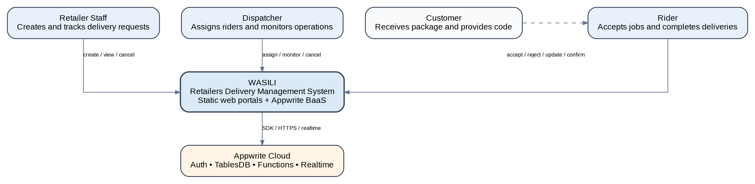
Figure 1. System context for Wasili.

3.2 Container View
The browser portals do not call a custom Express server. Instead, a shared JavaScript client uses the Appwrite Web SDK. Queries that are safe to permission at row level go directly to TablesDB. Commands that carry business meaning are sent to dedicated Appwrite Functions.
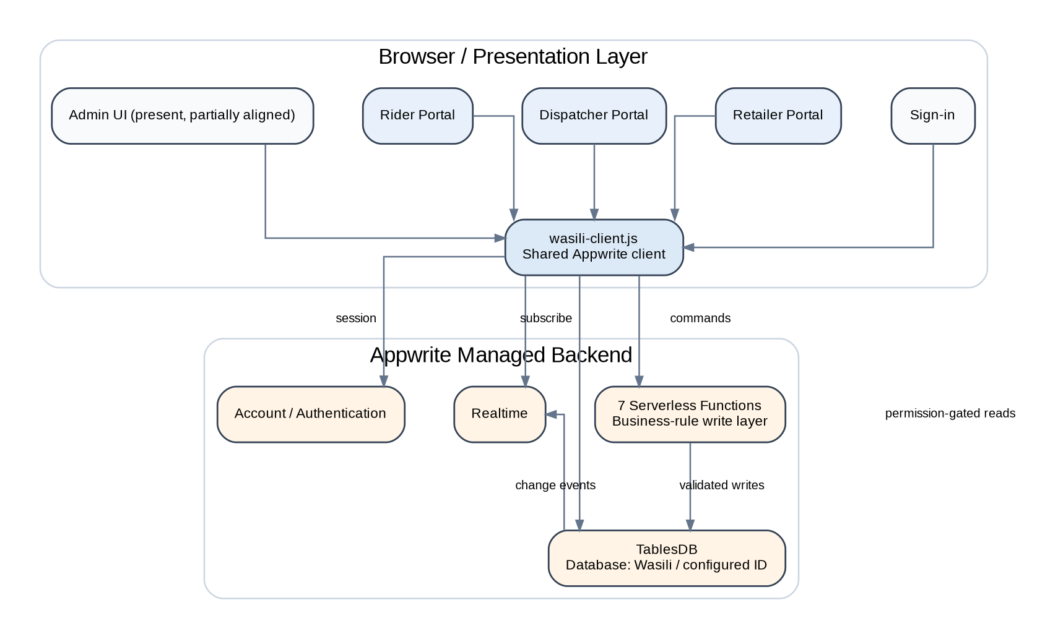
Figure 2. Container-level architecture.
Design rationale. Using direct reads plus Function-based commands is a pragmatic BaaS architecture: reads stay fast and simple, while state-changing rules remain server-controlled. The main cost is that Appwrite permissions and Function deployment configuration become part of the application architecture, not merely infrastructure.

3.3 Major Components
Component | Implementation | Responsibility
Sign-in | public/index.html + index.js | Creates Appwrite session and routes user according to role label.
Retailer portal | retailer.html + retailer.js | Delivery request entry and retailer-facing tracking.
Dispatcher portal | dispatcher.html + dispatcher.js | Delivery queue, rider eligibility, assignment and monitoring.
Rider portal | rider.html + rider.js | Assignment response, status progression and delivery confirmation.
Shared client | public/js/wasili-client.js | Appwrite SDK setup, function calls, reads and Realtime subscriptions.
Business functions | functions/*/src/main.js | Server-side validation and state-changing operations.
Domain rules | DOMAIN_RULES.js + copied function constants | Delivery states and vehicle-tier policy.
Setup/seed | scripts/setup.js | Creates database/tables, permissions and demo accounts.
Deployment config | appwrite.config.json | Defines Function runtimes, scopes and execute labels.

4. Data Design

4.1 Entity Relationship Diagram
Appwrite TablesDB does not require traditional SQL foreign-key constraints, so the relationships below are logical relationships implemented through stored user/row IDs. The rider row is intentionally keyed by the same ID as the rider’s Appwrite user account.
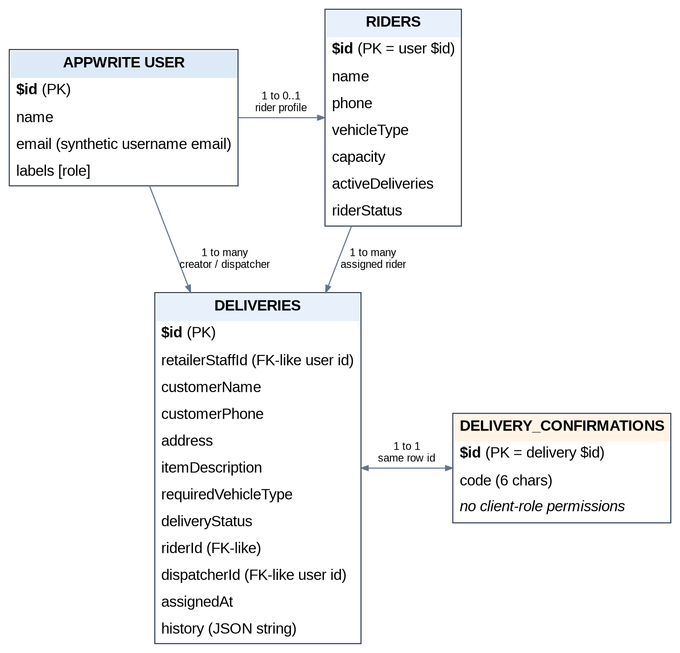
Figure 3. Logical ERD for the implemented data model.

4.2 Data Dictionary
Table | Attribute | Type / rule | Purpose
deliveries | $id | Appwrite row ID | Unique delivery identifier.
deliveries | retailerStaffId | String(64), required | User who created the request.
deliveries | customerName | String(128), required | Recipient name.
deliveries | customerPhone | String(20), required | Recipient contact.
deliveries | address | String(256), required | Delivery destination.
deliveries | itemDescription | String(256), required | Package description.
deliveries | requiredVehicleType | Enum, required | Minimum vehicle tier for the job.
deliveries | deliveryStatus | Enum, required | Current lifecycle state.
deliveries | riderId | String(64), optional | Current assigned rider.
deliveries | dispatcherId | String(64), optional | Dispatcher responsible for assignment.
deliveries | assignedAt | String(40), optional | Assignment timestamp.
deliveries | history | String(6000), JSON | Audit events for status changes.
riders | $id | Appwrite row ID = user ID | Links rider profile to authentication identity.
riders | vehicleType | Enum | BICYCLE, MOTORCYCLE, CAR, VAN or TRUCK.
riders | capacity | Integer 1–50 | Maximum active assignments.
riders | activeDeliveries | Integer 0–50 | Current active assignment count.
riders | riderStatus | Enum | AVAILABLE, AT_CAPACITY, OFFLINE or UNAVAILABLE.
delivery_confirmations | $id | Same as delivery ID | One protected confirmation row per delivery.
delivery_confirmations | code | String(6), required | Customer proof-of-delivery code.

Security-sensitive table. delivery_confirmations is created with no client-role permissions. The browser cannot read the confirmation code; only the server-side confirmation Function is expected to validate it.

5. Business Rules and State Design

5.1 Delivery State Machine
The lifecycle is deliberately linear. Normal rider progress can only move one state forward. Rejection is a controlled exception that returns an assigned/accepted delivery to OPEN. Cancellation is allowed from non-terminal states according to caller permissions.
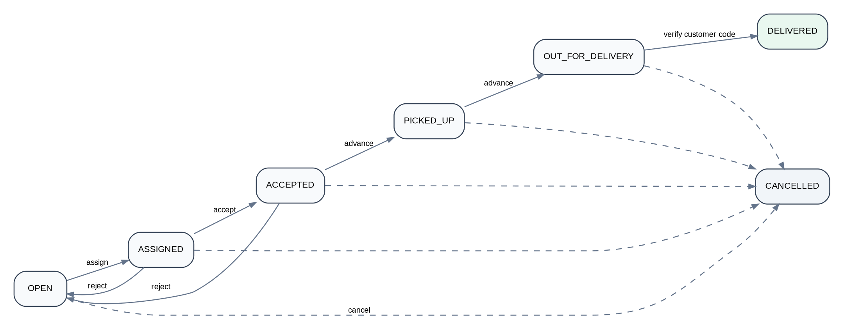
Figure 4. Delivery lifecycle state machine.
Current state | Action | Result
OPEN | Dispatcher assigns eligible rider | ASSIGNED
ASSIGNED | Rider accepts | ACCEPTED
ASSIGNED / ACCEPTED | Rider rejects | OPEN
ACCEPTED | Rider advances | PICKED_UP
PICKED_UP | Rider advances | OUT_FOR_DELIVERY
OUT_FOR_DELIVERY | Correct customer code | DELIVERED
Any non-terminal state | Authorized cancellation | CANCELLED

5.2 Vehicle Compatibility
Vehicle suitability is tiered rather than exact-match. A larger-capability vehicle may cover a smaller requirement. The rule is evaluated server-side when assignment is attempted.
Required job | Eligible rider vehicles
BICYCLE | BICYCLE, MOTORCYCLE, CAR, VAN, TRUCK
MOTORCYCLE | MOTORCYCLE, CAR, VAN, TRUCK
CAR | CAR, VAN, TRUCK
VAN | VAN, TRUCK
TRUCK | TRUCK

5.3 Capacity and Availability
- A rider is rejected for assignment when activeDeliveries is greater than or equal to capacity.
- OFFLINE and UNAVAILABLE are manual operational states and prevent assignment.
- AVAILABLE and AT_CAPACITY are system-oriented states derived from workload during assignment/release operations.
- On reject, confirm or eligible cancellation/reassignment, the affected rider capacity is released.

6. Core Interaction Design

6.1 End-to-End Sequence
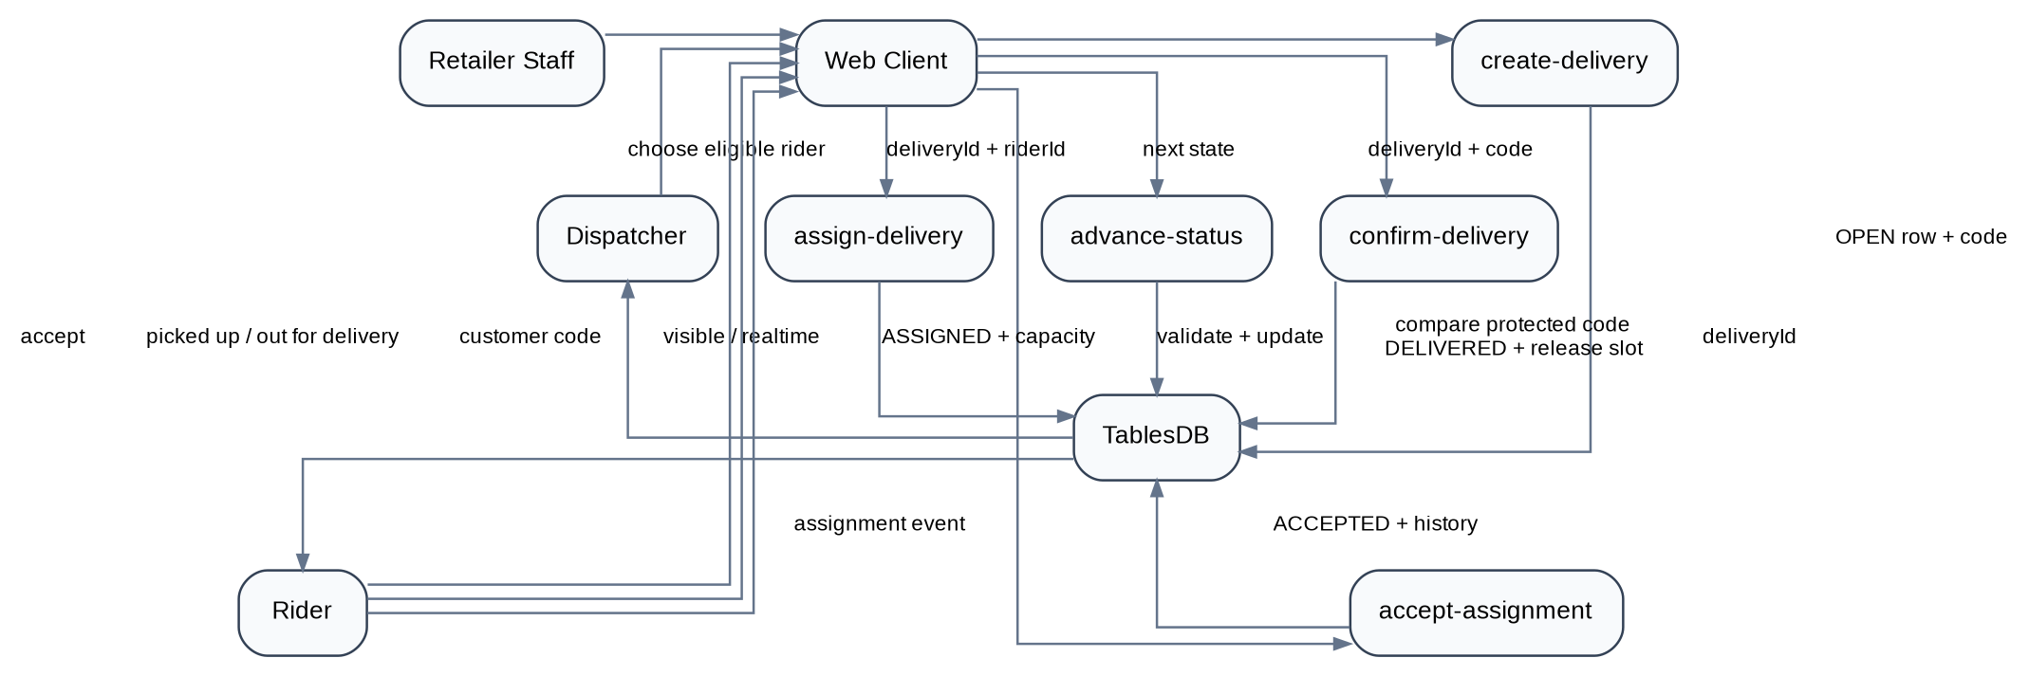
Figure 5. Simplified delivery sequence from request to confirmation.

6.2 Create Delivery
- Retailer Staff signs in and submits customer, address, item and vehicle requirement.
- create-delivery verifies identity/role and validates the payload.
- A new delivery row is written in OPEN state and the initial history event is recorded.
- A six-character confirmation code is stored in the protected confirmation table.
- The newly created delivery becomes visible to permitted operational users.

6.3 Assign and Execute
- Dispatcher chooses an OPEN delivery and a rider.
- assign-delivery verifies rider status, remaining capacity and vehicle compatibility.
- The system records the rider, dispatcher and assignment time, then increments rider workload.
- The rider accepts or rejects the job.
- If accepted, the rider advances through pickup and out-for-delivery one state at a time.
- At handover, the rider enters the customer code. confirm-delivery compares it server-side and completes the delivery only when the code matches.

7. Function / API Design
Wasili’s command API is expressed as Appwrite Function executions. This means there is no custom REST router in the project; each Function acts as one application command and receives JSON data from the shared web client.
Function | Allowed caller in config | Core responsibility
create-delivery | retailerstaff | Validate and create OPEN delivery plus protected code.
assign-delivery | dispatcher | Validate rider eligibility and assign/reassign.
accept-assignment | rider | Verify ownership and move ASSIGNED → ACCEPTED.
reject-assignment | rider | Return job to OPEN and release capacity.
advance-status | rider | Enforce one-step forward transition.
confirm-delivery | rider | Validate customer code and mark DELIVERED.
cancel-delivery | dispatcher, retailerstaff | Cancel eligible delivery and release capacity where needed.

Implementation note. The source contains an admin UI and admin label/row permissions, but appwrite.config.json does not grant the admin label execution access to assign-delivery or cancel-delivery. If admin is intended to operate those commands in production, the deployment configuration should be aligned with the UI/code intent.

8. Security Design

8.1 Authentication
Appwrite Account email/password sessions are used. The application presents username-style sign-in and converts the username into a synthetic email address for Appwrite. Phone numbers are contact data, not authentication identifiers.

8.2 Authorization
Authorization is layered. Appwrite labels identify the role; Function execute permissions determine who may invoke a command; Function code re-checks the caller/ownership where necessary; and row-level TablesDB permissions limit data visibility and updates.
Control | What it protects
Appwrite session | Establishes authenticated user identity.
Role labels | Separates retailer, dispatcher, rider and admin capabilities.
Function execute labels | Blocks unauthorized command invocation at platform boundary.
Server-side checks | Enforces ownership, state and domain rules even if client code is modified.
Row security / permissions | Limits direct browser reads and rider self-updates.
Protected confirmation table | Prevents the rider client from reading proof-of-delivery codes.

8.3 Auditability
Each delivery carries a history JSON string containing status, timestamp, user ID, role and optional note. The business Functions append a history event when they change delivery status. This makes the delivery row self-contained for MVP auditing, although a separate immutable event table would be preferable at larger scale.

9. Realtime and User Interface Synchronisation
The shared client subscribes to Appwrite Realtime channels for delivery and rider rows. Operational pages can therefore refresh when an assignment, rider workload or delivery state changes. Realtime events remain subject to Appwrite permissions, so the subscription does not bypass the read model.
Why this matters. Dispatching is a coordination problem. Realtime updates reduce the chance that two users act on stale assignment or capacity information, although the server-side Function remains the final authority for validating the write.

10. Deployment Design
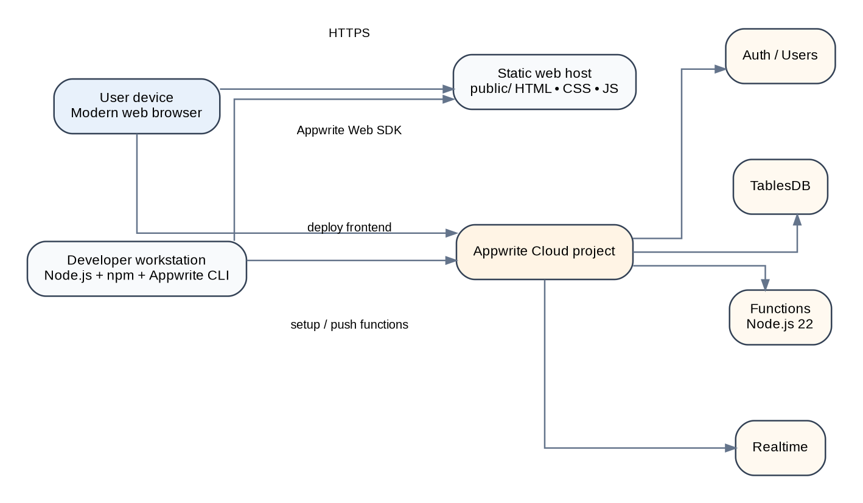
Figure 6. Deployment view.
Deployment concern | As-built approach
Frontend | Serve the public/ directory from a static web host or local static server.
Backend | Managed Appwrite Cloud project.
Functions | Seven Node.js 22 Appwrite Functions defined in appwrite.config.json.
Database setup | scripts/setup.js creates tables, columns, permissions and seed accounts.
Function deployment | Appwrite CLI: appwrite push functions.
Secrets | Setup API key and environment variables stay in .env; .env is gitignored.
Client configuration | Appwrite endpoint/project/database constants are configured in the web client; Functions contain matching defaults/variables.

Configuration risk. The project currently duplicates some Appwrite/database constants between setup, client and Functions. This is workable for an MVP but creates configuration-drift risk. A production iteration should standardise these values through environment variables or a deployment pipeline.

11. Quality Attributes
Attribute | How the design addresses it
Security | Managed authentication, role labels, Function-level commands, row permissions and protected verification data.
Reliability | Server-side state validation prevents skipped or backward lifecycle changes.
Maintainability | Role-specific portals and one Function per command keep responsibilities understandable.
Scalability | Appwrite handles the managed platform and serverless execution; no long-running application server is required.
Performance | Permission-gated direct reads avoid a custom API hop; Realtime reduces unnecessary polling.
Auditability | History records the actor and time associated with delivery state changes.
Usability | Each operational role receives a focused portal rather than one overloaded interface.

12. Testing Strategy
The repository includes a domain test script for vehicle compatibility and capacity behaviour. For system validation, the following end-to-end cases should be used during demo or acceptance testing.
Scenario | Expected outcome
Retailer creates valid request | OPEN delivery is created; protected confirmation row exists.
Non-retailer attempts create command | Command is rejected.
Dispatcher assigns incompatible vehicle | Assignment is rejected.
Dispatcher assigns rider at capacity | Assignment is rejected.
Rider accepts another rider’s job | Ownership check rejects action.
Rider attempts to skip a delivery state | advance-status rejects invalid transition.
Rider rejects active assignment | Delivery returns to OPEN and slot is released.
Wrong customer code | Delivery remains OUT_FOR_DELIVERY.
Correct customer code | Delivery becomes DELIVERED and rider workload is reduced.
Cancel delivered delivery | Terminal delivery cannot be cancelled.

13. Design Decisions and Trade-offs
Decision | Reason | Trade-off
Appwrite BaaS rather than custom server | Faster MVP delivery and less infrastructure management. | Application architecture depends strongly on Appwrite permissions/configuration.
Direct reads, Function writes | Keeps simple reads efficient and rule-based writes controlled. | Two access paths must be understood and secured correctly.
One Function per command | Clear responsibility and easier reasoning. | More deployment units and duplicated domain constants.
History stored on delivery | Simple MVP audit trail without another table. | String size grows; querying individual events is awkward.
Tiered vehicle compatibility | Matches operational idea that larger vehicles can cover smaller jobs. | May need richer rules for cost, geography or special cargo later.
Synthetic-email username login | Works with Appwrite password sessions without SMS provider dependency. | Not a true phone/OTP identity model.

14. Known Gaps and Recommended Next Iteration
- Resolve the admin-role inconsistency between the UI/source permissions and Function execute labels, or formally remove admin from the MVP.
- Move duplicated project/database configuration into environment-driven deployment configuration.
- Introduce stronger concurrency/transaction handling around activeDeliveries if assignment volume becomes high.
- Move delivery history to a dedicated append-only status/event table when audit/query requirements grow.
- Add notification services for assignment, pickup and delivery completion.
- Add customer tracking as a public tokenised view without exposing the confirmation secret.
- Add analytics for turnaround time, rider utilisation, cancellations and delivery success rate.
- Consider real SMS/OTP authentication only when provider cost and operational requirements justify it.

15. Conclusion
The Wasili design is a compact serverless delivery-management architecture. Its strongest design choice is the separation between presentation and business-rule writes: the web portals remain lightweight, while Appwrite Functions enforce the delivery state machine, assignment eligibility and proof-of-delivery checks. TablesDB permissions and Realtime complete the operational model by controlling visibility and keeping role dashboards current.
For the current MVP, the design is appropriate and demonstrable. The next engineering priority should be consistency and hardening rather than adding many features: align admin execution permissions, centralise configuration and improve concurrency/audit structures before expanding into routing, customer tracking or notifications.

Appendix A. Source-to-Design Traceability
Design concern | Primary source evidence
Roles and scope | README.md; scripts/setup.js; portal JavaScript.
State flow | DOMAIN_RULES.js; advance-status Function.
Vehicle compatibility | DOMAIN_RULES.js; assign-delivery Function; scripts/test-domain.js.
Database schema | scripts/setup.js.
Client integration | public/js/wasili-client.js.
Function callers/scopes | appwrite.config.json.
Admin partial capability | public/admin.html + admin.js; setup permissions; appwrite.config.json.
Deployment | README.md; appwrite.config.json; package.json.

Appendix B. Project Structure
Wasili-Retailers-Delivery-Management-System/
├── public/ # static role portals
│ ├── index.html
│ ├── retailer.html
│ ├── dispatcher.html
│ ├── rider.html
│ ├── admin.html
│ ├── js/wasili-client.js
│ └── css/
├── functions/ # seven Appwrite Functions
├── scripts/setup.js # schema + seed
├── scripts/test-domain.js
├── DOMAIN_RULES.js
├── appwrite.config.json
└── package.json

