Av. Cramer 3695 -Saavedra

Ciudad Autónoma de Buenos Aires

(54) 11 5581 5805

LEDISALVO@GMAIL.COM

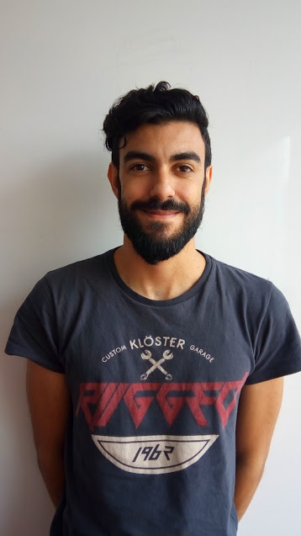 Leonardo Adrian Di SalvoRectángulo largo y fino para dividir las secciones del documento

# INTRO

I've 10 years in software development, I've been working in the private sector like telecommunications industry, retail and bank. In the projects I've been participated I fomented new technologies and tools. I want to improve my skills and learn new technologies.

# EXPERIENCE

## Around - Vicente Lopez, GBA *— Full stack developer*

DECEMBER 2019 - NOW

* React, Bootstrap, CSS, NodeJS, .NET Core, SQL Server, MongoDb, GIT, CI

## Zoo Logic, Belgrano, CABA*— .NET Developer*

DECEMBER 2018 - OCTOBER 2019

* .NET Framework 4.6.1, NodeJs, C#, Oracle, AWS Services, Tortoise

## Lagash Systems, Almagro, CABA*— .NET Developer*

SEPTEMBER 2014 - NOVEMBER 2018

* IRSA: AWS Services
* ISBAN: .NET Framework 4.6.1, C#, AngularJS, MVC, Bootstrap, Visual Studio 2013, Oracle, Dependency Injection, SOLID, GIT
* Supermarket Vital: Framework 4.5, Winforms, Oracle, Tortoise

## Sofrecom Argentina, Coghlan, CABA *— .NET Developer*

FEBRERO DE 2010 - SEPTEMBER 2014

* Telecom: Silverlight 5, Net Framework, C#, Html5, Bootstrap, CSS, MongoDb, Visual Studio 2013, Patrones de desarrollo PRISM,MVVM, Ria Services, MS Expression Blend, SQL Server, Tortoise

# EDUCATION

## UTN-INSPT, Villa Ortuzar, CABA*— Senior Technician in Applied Computing*

FEBRUARY 2014 - DECEMBER 2016

## ET 21 - Fragata Escuela Libertad, Saavedra, CABA*— Computer Technician*

FEBRUARY 2000 - DECEMBER 2005