ViraPhD

Titouan

2023-02-13

# %C, %N, C stocks and N stocks Analysis

# Bos Khnor 2022

#Checking for aberrant value through statistics  
#-> We need to remove negative %N and C/N data  
TAB2 <- subset(TAB, Ncont > 0)  
#-> We remove N value < 0.3 (Too low) and N value == 2.86 (unexplained high value)  
TAB3 <- subset(TAB2, Ncont > 0.3)  
TAB4 <- subset(TAB3, Ncont != 2.86)  
#-> Some C values are low, we remove all values < 0.03  
TAB5 <- subset(TAB4, Ccont > 0.03)  
#We remove values of Referent Vegetaion, we will be able to analyze these values later  
TAB6 <- subset(TAB5, Experiment != "Referentvegetation")

## [1] "Summary"

## Experiment Treatment Depth Replicate Year   
## CasEx :168 CT :126 0-5 :75 Min. :1 2011:273   
## MaiEx :168 NT1:126 5-10 :75 1st Qu.:1 2021:252   
## Referentvegetation: 21 NT2:126 10-20 :75 Median :2   
## SoyEx :168 NT3:126 20-40 :75 Mean :2   
## RV : 21 40-60 :75 3rd Qu.:3   
## 60-80 :75 Max. :3   
## 80-100:75   
## SamplelistforR Ncont Ccont CN   
## CasExCTR10-5 : 2 Min. :-3.300 Min. : 0.01 Min. :-14.75   
## CasExCTR110-20: 2 1st Qu.: 0.840 1st Qu.: 5.49 1st Qu.: 6.52   
## CasExCTR120-40: 2 Median : 1.120 Median : 9.21 Median : 8.37   
## CasExCTR140-60: 2 Mean : 1.242 Mean :11.40 Mean : 8.29   
## CasExCTR15-10 : 2 3rd Qu.: 1.630 3rd Qu.:16.60 3rd Qu.: 10.34   
## CasExCTR160-80: 2 Max. : 3.480 Max. :32.95 Max. : 14.16   
## (Other) :513   
## BD NSTOCK CSTOCK NSTOCK2 CSTOCK2   
## Min. :0.880 Min. :0.000 Min. : 0.02 Min. :0.00 Min. : 0.02   
## 1st Qu.:1.010 1st Qu.:1.100 1st Qu.: 9.59 1st Qu.:1.12 1st Qu.: 9.61   
## Median :1.100 Median :1.620 Median :11.84 Median :1.62 Median :11.90   
## Mean :1.092 Mean :1.632 Mean :13.10 Mean :1.63 Mean :13.10   
## 3rd Qu.:1.170 3rd Qu.:1.980 3rd Qu.:16.00 3rd Qu.:2.00 3rd Qu.:16.00   
## Max. :1.340 Max. :6.760 Max. :28.74 Max. :6.54 Max. :28.77   
##   
## X   
## Mode:logical   
## NA's:525   
##   
##   
##   
##   
##

## [1] "Ncont"

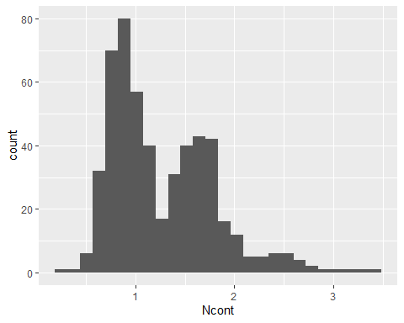

## [1] "Ncont MaiEx"  
## # A tibble: 56 × 7  
## Treatment Depth Year variable n mean sd  
## <fct> <fct> <fct> <chr> <dbl> <dbl> <dbl>  
## 1 CT 0-5 2011 Ncont 3 1.82 0.191  
## 2 NT1 0-5 2011 Ncont 3 1.88 0.159  
## 3 NT2 0-5 2011 Ncont 3 1.89 0.075  
## 4 NT3 0-5 2011 Ncont 3 1.96 0.026  
## 5 CT 5-10 2011 Ncont 3 1.64 0.136  
## 6 NT1 5-10 2011 Ncont 3 1.66 0.066  
## 7 NT2 5-10 2011 Ncont 3 1.70 0.101  
## 8 NT3 5-10 2011 Ncont 3 1.79 0.021  
## 9 CT 10-20 2011 Ncont 3 1.34 0.165  
## 10 NT1 10-20 2011 Ncont 3 1.46 0.112  
## # … with 46 more rows  
## [1] "Ncont MaiEx 0-5"

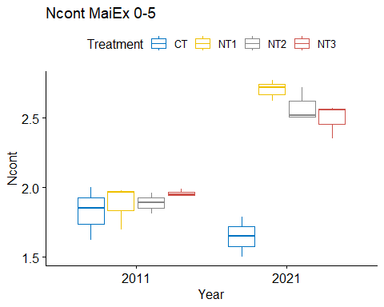

## [1] "Normality"

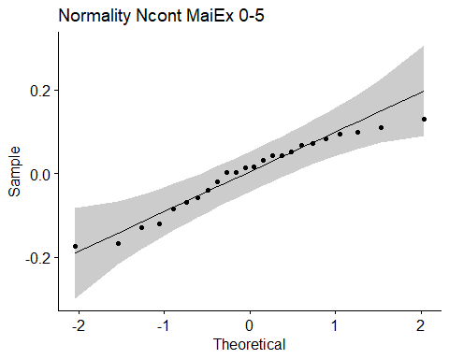

## [1] "Shapiro test for normality"  
## # A tibble: 1 × 3  
## variable statistic p.value  
## <chr> <dbl> <dbl>  
## 1 residuals(model) 0.947 0.229  
## [1] "Homoscedasticity"

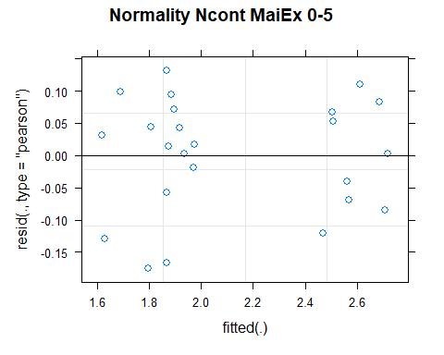

## [1] "Levene test for homoscedasticity"  
## # A tibble: 1 × 4  
## df1 df2 statistic p  
## <int> <int> <dbl> <dbl>  
## 1 7 16 0.369 0.907  
## [1] "ANOVA"  
## Treatment = CT:  
## Year emmean SE df lower.CL upper.CL .group  
## 2021 1.65 0.0723 15.6 1.49 1.80 1   
## 2011 1.82 0.0723 15.6 1.67 1.98 1   
##   
## Treatment = NT1:  
## Year emmean SE df lower.CL upper.CL .group  
## 2011 1.88 0.0723 15.6 1.73 2.04 1   
## 2021 2.70 0.0723 15.6 2.55 2.86 2   
##   
## Treatment = NT2:  
## Year emmean SE df lower.CL upper.CL .group  
## 2011 1.89 0.0723 15.6 1.73 2.04 1   
## 2021 2.58 0.0723 15.6 2.43 2.73 2   
##   
## Treatment = NT3:  
## Year emmean SE df lower.CL upper.CL .group  
## 2011 1.96 0.0723 15.6 1.81 2.11 1   
## 2021 2.49 0.0723 15.6 2.34 2.65 2   
##   
## Degrees-of-freedom method: kenward-roger   
## Results are given on the [ (not the response) scale.   
## Confidence level used: 0.95   
## Note: contrasts are still on the [ scale   
## significance level used: alpha = 0.05   
## NOTE: If two or more means share the same grouping symbol,  
## then we cannot show them to be different.  
## But we also did not show them to be the same.   
## Year = 2011:  
## Treatment emmean SE df lower.CL upper.CL .group  
## CT 1.82 0.0723 15.6 1.67 1.98 1   
## NT1 1.88 0.0723 15.6 1.73 2.04 1   
## NT2 1.89 0.0723 15.6 1.73 2.04 1   
## NT3 1.96 0.0723 15.6 1.81 2.11 1   
##   
## Year = 2021:  
## Treatment emmean SE df lower.CL upper.CL .group  
## CT 1.65 0.0723 15.6 1.49 1.80 1   
## NT3 2.49 0.0723 15.6 2.34 2.65 2   
## NT2 2.58 0.0723 15.6 2.43 2.73 2   
## NT1 2.70 0.0723 15.6 2.55 2.86 2   
##   
## Degrees-of-freedom method: kenward-roger   
## Results are given on the [ (not the response) scale.   
## Confidence level used: 0.95   
## Note: contrasts are still on the [ scale   
## P value adjustment: tukey method for comparing a family of 4 estimates   
## significance level used: alpha = 0.05   
## NOTE: If two or more means share the same grouping symbol,  
## then we cannot show them to be different.  
## But we also did not show them to be the same.   
## [1] "ANOVA plot"

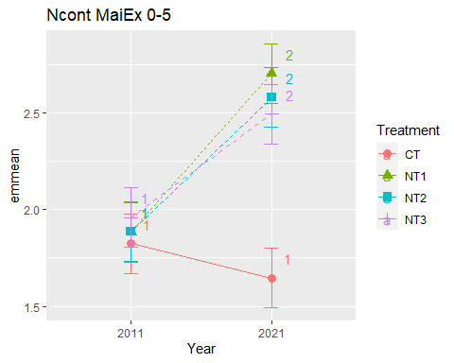

## [1] "Ncont MaiEx 5-10"

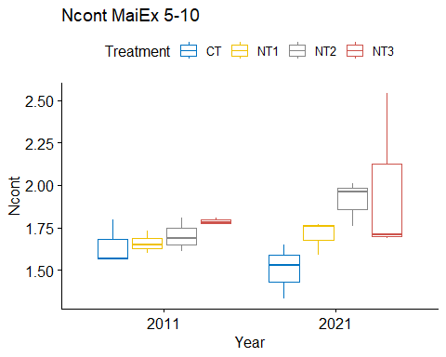

## [1] "Normality"

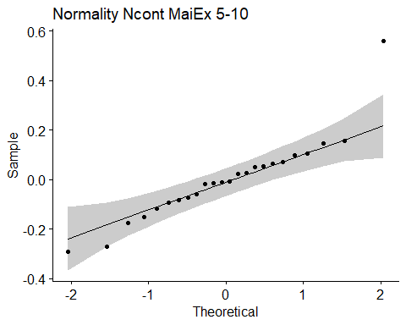

## [1] "Shapiro test for normality"  
## # A tibble: 1 × 3  
## variable statistic p.value  
## <chr> <dbl> <dbl>  
## 1 residuals(model) 0.889 0.0127  
## [1] "Homoscedasticity"

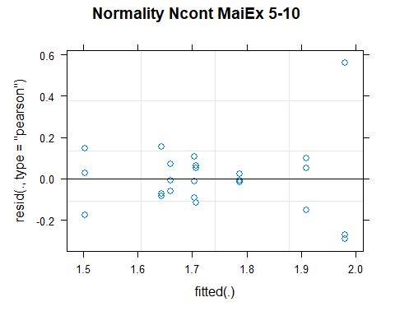

## [1] "Levene test for homoscedasticity"  
## # A tibble: 1 × 4  
## df1 df2 statistic p  
## <int> <int> <dbl> <dbl>  
## 1 7 16 0.585 0.758  
## [1] "ANOVA"  
## Treatment = CT:  
## Year emmean SE df lower.CL upper.CL .group  
## 2021 1.50 0.116 16 1.26 1.75 1   
## 2011 1.64 0.116 16 1.40 1.89 1   
##   
## Treatment = NT1:  
## Year emmean SE df lower.CL upper.CL .group  
## 2011 1.66 0.116 16 1.41 1.91 1   
## 2021 1.71 0.116 16 1.46 1.95 1   
##   
## Treatment = NT2:  
## Year emmean SE df lower.CL upper.CL .group  
## 2011 1.70 0.116 16 1.46 1.95 1   
## 2021 1.91 0.116 16 1.66 2.16 1   
##   
## Treatment = NT3:  
## Year emmean SE df lower.CL upper.CL .group  
## 2011 1.79 0.116 16 1.54 2.03 1   
## 2021 1.98 0.116 16 1.73 2.23 1   
##   
## Degrees-of-freedom method: kenward-roger   
## Results are given on the [ (not the response) scale.   
## Confidence level used: 0.95   
## Note: contrasts are still on the [ scale   
## significance level used: alpha = 0.05   
## NOTE: If two or more means share the same grouping symbol,  
## then we cannot show them to be different.  
## But we also did not show them to be the same.   
## Year = 2011:  
## Treatment emmean SE df lower.CL upper.CL .group  
## CT 1.64 0.116 16 1.40 1.89 1   
## NT1 1.66 0.116 16 1.41 1.91 1   
## NT2 1.70 0.116 16 1.46 1.95 1   
## NT3 1.79 0.116 16 1.54 2.03 1   
##   
## Year = 2021:  
## Treatment emmean SE df lower.CL upper.CL .group  
## CT 1.50 0.116 16 1.26 1.75 1   
## NT1 1.71 0.116 16 1.46 1.95 12   
## NT2 1.91 0.116 16 1.66 2.16 12   
## NT3 1.98 0.116 16 1.73 2.23 2   
##   
## Degrees-of-freedom method: kenward-roger   
## Results are given on the [ (not the response) scale.   
## Confidence level used: 0.95   
## Note: contrasts are still on the [ scale   
## P value adjustment: tukey method for comparing a family of 4 estimates   
## significance level used: alpha = 0.05   
## NOTE: If two or more means share the same grouping symbol,  
## then we cannot show them to be different.  
## But we also did not show them to be the same.   
## [1] "ANOVA plot"

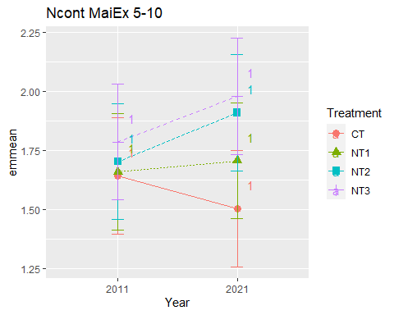

## [1] "Ncont MaiEx 10-20"

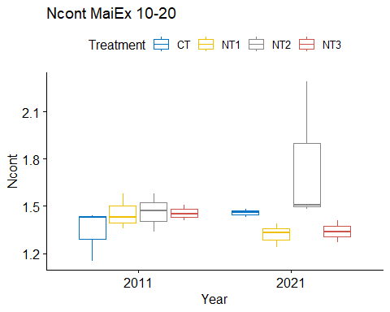

## [1] "Normality"

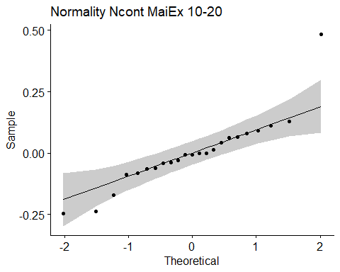

## [1] "Shapiro test for normality"  
## # A tibble: 1 × 3  
## variable statistic p.value  
## <chr> <dbl> <dbl>  
## 1 residuals(model) 0.869 0.00610  
## [1] "Homoscedasticity"

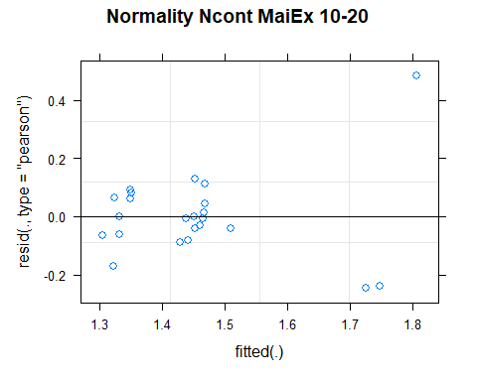

## [1] "Levene test for homoscedasticity"  
## # A tibble: 1 × 4  
## df1 df2 statistic p  
## <int> <int> <dbl> <dbl>  
## 1 7 15 0.593 0.752  
## [1] "ANOVA"  
## Treatment = CT:  
## Year emmean SE df lower.CL upper.CL .group  
## 2011 1.34 0.111 14.9 1.10 1.58 1   
## 2021 1.46 0.111 14.9 1.22 1.69 1   
##   
## Treatment = NT1:  
## Year emmean SE df lower.CL upper.CL .group  
## 2021 1.32 0.111 14.9 1.08 1.56 1   
## 2011 1.46 0.111 14.9 1.22 1.69 1   
##   
## Treatment = NT2:  
## Year emmean SE df lower.CL upper.CL .group  
## 2011 1.46 0.111 14.9 1.23 1.70 1   
## 2021 1.76 0.111 14.9 1.52 2.00 1   
##   
## Treatment = NT3:  
## Year emmean SE df lower.CL upper.CL .group  
## 2021 1.34 0.142 15.0 1.03 1.64 1   
## 2011 1.46 0.111 14.9 1.22 1.69 1   
##   
## Degrees-of-freedom method: kenward-roger   
## Results are given on the [ (not the response) scale.   
## Confidence level used: 0.95   
## Note: contrasts are still on the [ scale   
## significance level used: alpha = 0.05   
## NOTE: If two or more means share the same grouping symbol,  
## then we cannot show them to be different.  
## But we also did not show them to be the same.   
## Year = 2011:  
## Treatment emmean SE df lower.CL upper.CL .group  
## CT 1.34 0.111 14.9 1.10 1.58 1   
## NT1 1.46 0.111 14.9 1.22 1.69 1   
## NT3 1.46 0.111 14.9 1.22 1.69 1   
## NT2 1.46 0.111 14.9 1.23 1.70 1   
##   
## Year = 2021:  
## Treatment emmean SE df lower.CL upper.CL .group  
## NT1 1.32 0.111 14.9 1.08 1.56 1   
## NT3 1.34 0.142 15.0 1.03 1.64 1   
## CT 1.46 0.111 14.9 1.22 1.69 1   
## NT2 1.76 0.111 14.9 1.52 2.00 1   
##   
## Degrees-of-freedom method: kenward-roger   
## Results are given on the [ (not the response) scale.   
## Confidence level used: 0.95   
## Note: contrasts are still on the [ scale   
## P value adjustment: tukey method for comparing a family of 4 estimates   
## significance level used: alpha = 0.05   
## NOTE: If two or more means share the same grouping symbol,  
## then we cannot show them to be different.  
## But we also did not show them to be the same.   
## [1] "ANOVA plot"

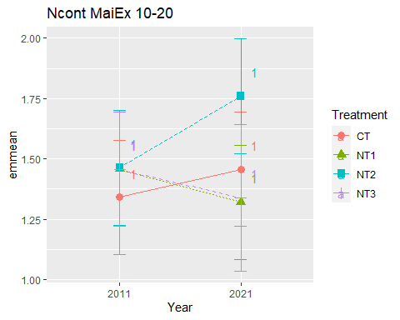

## [1] "Ncont MaiEx 20-40"

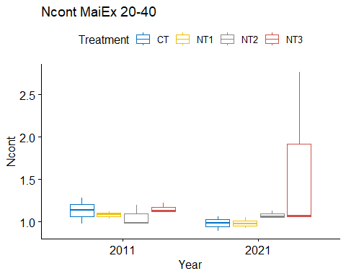

## [1] "Normality"

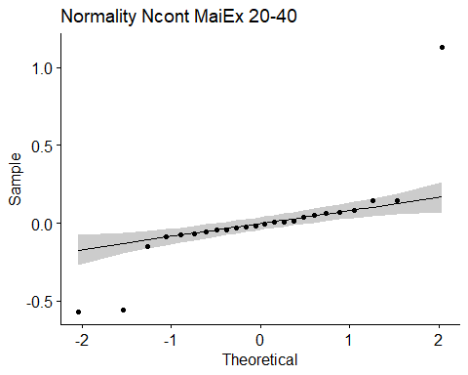

## [1] "Shapiro test for normality"  
## # A tibble: 1 × 3  
## variable statistic p.value  
## <chr> <dbl> <dbl>  
## 1 residuals(model) 0.673 0.00000452  
## [1] "Homoscedasticity"

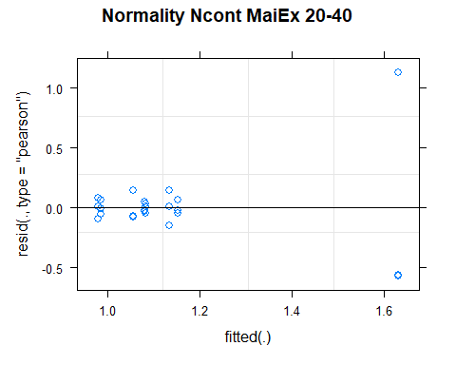

## [1] "Levene test for homoscedasticity"  
## # A tibble: 1 × 4  
## df1 df2 statistic p  
## <int> <int> <dbl> <dbl>  
## 1 7 16 0.831 0.577  
## [1] "ANOVA"  
## Treatment = CT:  
## Year emmean SE df lower.CL upper.CL .group  
## 2021 0.980 0.206 16 0.544 1.42 1   
## 2011 1.133 0.206 16 0.698 1.57 1   
##   
## Treatment = NT1:  
## Year emmean SE df lower.CL upper.CL .group  
## 2021 0.987 0.206 16 0.551 1.42 1   
## 2011 1.083 0.206 16 0.648 1.52 1   
##   
## Treatment = NT2:  
## Year emmean SE df lower.CL upper.CL .group  
## 2011 1.057 0.206 16 0.621 1.49 1   
## 2021 1.080 0.206 16 0.644 1.52 1   
##   
## Treatment = NT3:  
## Year emmean SE df lower.CL upper.CL .group  
## 2011 1.153 0.206 16 0.718 1.59 1   
## 2021 1.630 0.206 16 1.194 2.07 1   
##   
## Degrees-of-freedom method: kenward-roger   
## Results are given on the [ (not the response) scale.   
## Confidence level used: 0.95   
## Note: contrasts are still on the [ scale   
## significance level used: alpha = 0.05   
## NOTE: If two or more means share the same grouping symbol,  
## then we cannot show them to be different.  
## But we also did not show them to be the same.   
## Year = 2011:  
## Treatment emmean SE df lower.CL upper.CL .group  
## NT2 1.057 0.206 16 0.621 1.49 1   
## NT1 1.083 0.206 16 0.648 1.52 1   
## CT 1.133 0.206 16 0.698 1.57 1   
## NT3 1.153 0.206 16 0.718 1.59 1   
##   
## Year = 2021:  
## Treatment emmean SE df lower.CL upper.CL .group  
## CT 0.980 0.206 16 0.544 1.42 1   
## NT1 0.987 0.206 16 0.551 1.42 1   
## NT2 1.080 0.206 16 0.644 1.52 1   
## NT3 1.630 0.206 16 1.194 2.07 1   
##   
## Degrees-of-freedom method: kenward-roger   
## Results are given on the [ (not the response) scale.   
## Confidence level used: 0.95   
## Note: contrasts are still on the [ scale   
## P value adjustment: tukey method for comparing a family of 4 estimates   
## significance level used: alpha = 0.05   
## NOTE: If two or more means share the same grouping symbol,  
## then we cannot show them to be different.  
## But we also did not show them to be the same.   
## [1] "ANOVA plot"

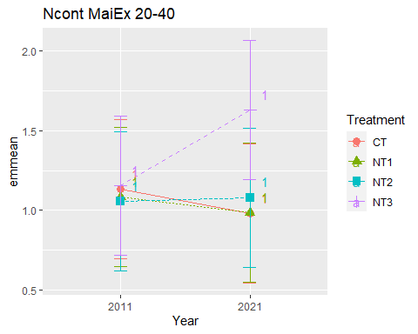

## [1] "Ncont MaiEx 40-60"

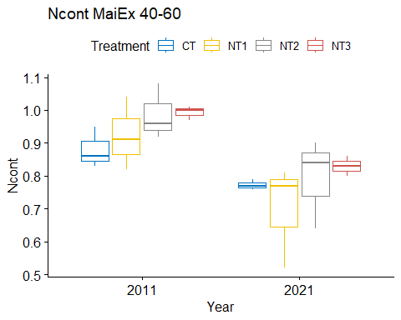

## [1] "Normality"

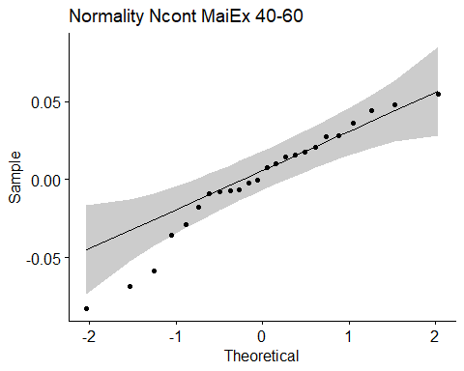

## [1] "Shapiro test for normality"  
## # A tibble: 1 × 3  
## variable statistic p.value  
## <chr> <dbl> <dbl>  
## 1 residuals(model) 0.949 0.264  
## [1] "Homoscedasticity"

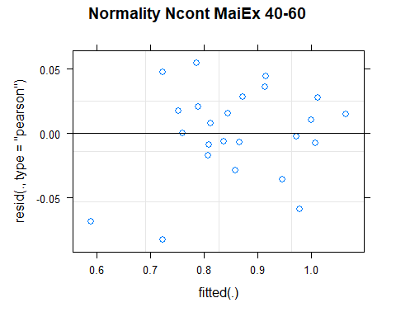

## [1] "Levene test for homoscedasticity"  
## # A tibble: 1 × 4  
## df1 df2 statistic p  
## <int> <int> <dbl> <dbl>  
## 1 7 16 0.696 0.675  
## [1] "ANOVA"  
## Treatment = CT:  
## Year emmean SE df lower.CL upper.CL .group  
## 2021 0.773 0.0532 11.3 0.657 0.890 1   
## 2011 0.880 0.0532 11.3 0.763 0.997 2   
##   
## Treatment = NT1:  
## Year emmean SE df lower.CL upper.CL .group  
## 2021 0.700 0.0532 11.3 0.583 0.817 1   
## 2011 0.923 0.0532 11.3 0.807 1.040 2   
##   
## Treatment = NT2:  
## Year emmean SE df lower.CL upper.CL .group  
## 2021 0.793 0.0532 11.3 0.677 0.910 1   
## 2011 0.987 0.0532 11.3 0.870 1.103 2   
##   
## Treatment = NT3:  
## Year emmean SE df lower.CL upper.CL .group  
## 2021 0.830 0.0532 11.3 0.713 0.947 1   
## 2011 0.993 0.0532 11.3 0.877 1.110 2   
##   
## Degrees-of-freedom method: kenward-roger   
## Results are given on the [ (not the response) scale.   
## Confidence level used: 0.95   
## Note: contrasts are still on the [ scale   
## significance level used: alpha = 0.05   
## NOTE: If two or more means share the same grouping symbol,  
## then we cannot show them to be different.  
## But we also did not show them to be the same.   
## Year = 2011:  
## Treatment emmean SE df lower.CL upper.CL .group  
## CT 0.880 0.0532 11.3 0.763 0.997 1   
## NT1 0.923 0.0532 11.3 0.807 1.040 1   
## NT2 0.987 0.0532 11.3 0.870 1.103 1   
## NT3 0.993 0.0532 11.3 0.877 1.110 1   
##   
## Year = 2021:  
## Treatment emmean SE df lower.CL upper.CL .group  
## NT1 0.700 0.0532 11.3 0.583 0.817 1   
## CT 0.773 0.0532 11.3 0.657 0.890 1   
## NT2 0.793 0.0532 11.3 0.677 0.910 1   
## NT3 0.830 0.0532 11.3 0.713 0.947 1   
##   
## Degrees-of-freedom method: kenward-roger   
## Results are given on the [ (not the response) scale.   
## Confidence level used: 0.95   
## Note: contrasts are still on the [ scale   
## P value adjustment: tukey method for comparing a family of 4 estimates   
## significance level used: alpha = 0.05   
## NOTE: If two or more means share the same grouping symbol,  
## then we cannot show them to be different.  
## But we also did not show them to be the same.   
## [1] "ANOVA plot"

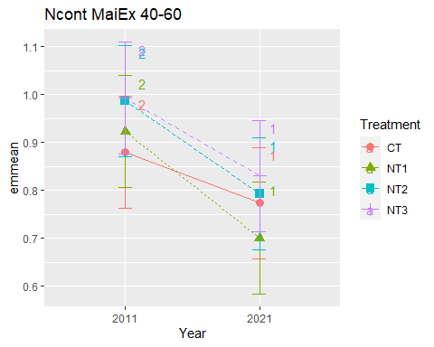

## [1] "Ncont MaiEx 60-80"

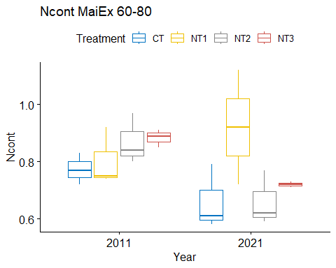

## [1] "Normality"

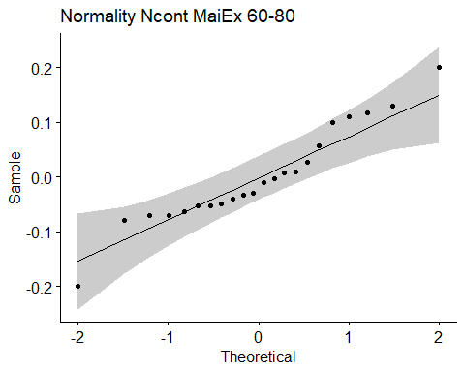

## [1] "Shapiro test for normality"  
## # A tibble: 1 × 3  
## variable statistic p.value  
## <chr> <dbl> <dbl>  
## 1 residuals(model) 0.946 0.261  
## [1] "Homoscedasticity"

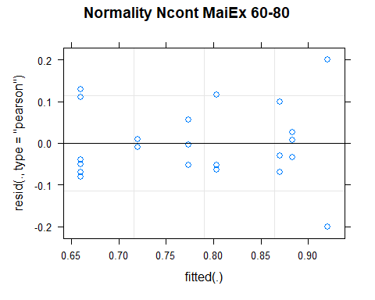

## [1] "Levene test for homoscedasticity"  
## # A tibble: 1 × 4  
## df1 df2 statistic p  
## <int> <int> <dbl> <dbl>  
## 1 7 14 1.67 0.197  
## [1] "ANOVA"  
## Treatment = CT:  
## Year emmean SE df lower.CL upper.CL .group  
## 2021 0.660 0.0634 14 0.524 0.796 1   
## 2011 0.773 0.0634 14 0.637 0.909 1   
##   
## Treatment = NT1:  
## Year emmean SE df lower.CL upper.CL .group  
## 2011 0.803 0.0634 14 0.667 0.939 1   
## 2021 0.920 0.0818 14 0.744 1.096 1   
##   
## Treatment = NT2:  
## Year emmean SE df lower.CL upper.CL .group  
## 2021 0.660 0.0634 14 0.524 0.796 1   
## 2011 0.870 0.0634 14 0.734 1.006 1   
##   
## Treatment = NT3:  
## Year emmean SE df lower.CL upper.CL .group  
## 2021 0.720 0.0818 14 0.544 0.896 1   
## 2011 0.883 0.0634 14 0.747 1.019 1   
##   
## Degrees-of-freedom method: kenward-roger   
## Results are given on the [ (not the response) scale.   
## Confidence level used: 0.95   
## Note: contrasts are still on the [ scale   
## significance level used: alpha = 0.05   
## NOTE: If two or more means share the same grouping symbol,  
## then we cannot show them to be different.  
## But we also did not show them to be the same.   
## Year = 2011:  
## Treatment emmean SE df lower.CL upper.CL .group  
## CT 0.773 0.0634 14 0.637 0.909 1   
## NT1 0.803 0.0634 14 0.667 0.939 1   
## NT2 0.870 0.0634 14 0.734 1.006 1   
## NT3 0.883 0.0634 14 0.747 1.019 1   
##   
## Year = 2021:  
## Treatment emmean SE df lower.CL upper.CL .group  
## CT 0.660 0.0634 14 0.524 0.796 1   
## NT2 0.660 0.0634 14 0.524 0.796 1   
## NT3 0.720 0.0818 14 0.544 0.896 1   
## NT1 0.920 0.0818 14 0.744 1.096 1   
##   
## Degrees-of-freedom method: kenward-roger   
## Results are given on the [ (not the response) scale.   
## Confidence level used: 0.95   
## Note: contrasts are still on the [ scale   
## P value adjustment: tukey method for comparing a family of 4 estimates   
## significance level used: alpha = 0.05   
## NOTE: If two or more means share the same grouping symbol,  
## then we cannot show them to be different.  
## But we also did not show them to be the same.   
## [1] "ANOVA plot"

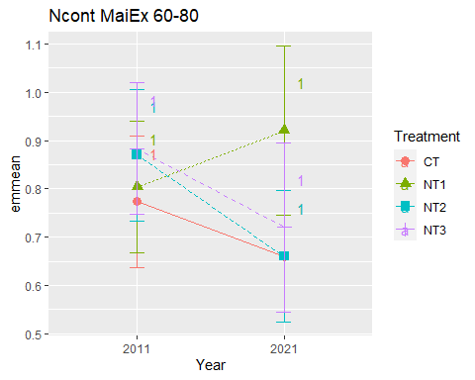

## [1] "Ncont MaiEx 80-100"

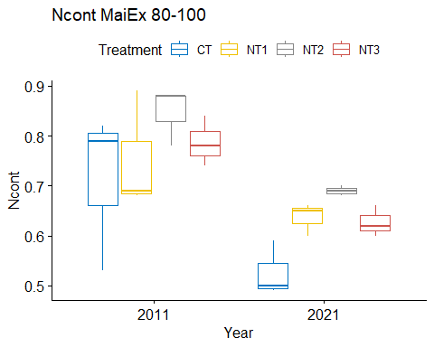

## [1] "Normality"

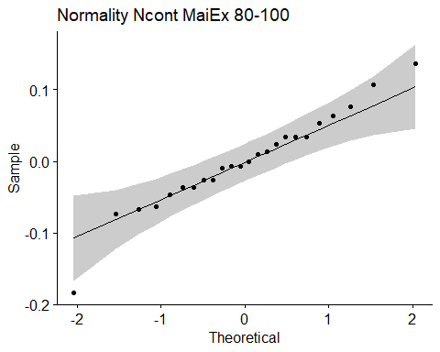

## [1] "Shapiro test for normality"  
## # A tibble: 1 × 3  
## variable statistic p.value  
## <chr> <dbl> <dbl>  
## 1 residuals(model) 0.967 0.587  
## [1] "Homoscedasticity"

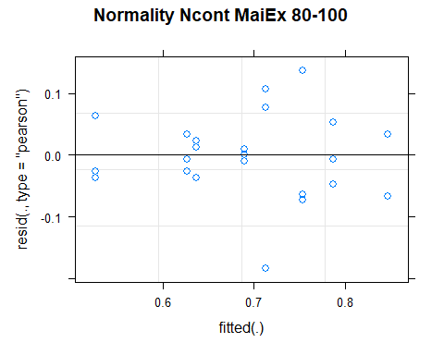

## [1] "Levene test for homoscedasticity"  
## # A tibble: 1 × 4  
## df1 df2 statistic p  
## <int> <int> <dbl> <dbl>  
## 1 7 16 0.517 0.809  
## [1] "ANOVA"  
## Treatment = CT:  
## Year emmean SE df lower.CL upper.CL .group  
## 2021 0.527 0.0458 16 0.429 0.624 1   
## 2011 0.713 0.0458 16 0.616 0.811 2   
##   
## Treatment = NT1:  
## Year emmean SE df lower.CL upper.CL .group  
## 2021 0.637 0.0458 16 0.539 0.734 1   
## 2011 0.753 0.0458 16 0.656 0.851 1   
##   
## Treatment = NT2:  
## Year emmean SE df lower.CL upper.CL .group  
## 2021 0.690 0.0458 16 0.593 0.787 1   
## 2011 0.847 0.0458 16 0.749 0.944 2   
##   
## Treatment = NT3:  
## Year emmean SE df lower.CL upper.CL .group  
## 2021 0.627 0.0458 16 0.529 0.724 1   
## 2011 0.787 0.0458 16 0.689 0.884 2   
##   
## Degrees-of-freedom method: kenward-roger   
## Results are given on the [ (not the response) scale.   
## Confidence level used: 0.95   
## Note: contrasts are still on the [ scale   
## significance level used: alpha = 0.05   
## NOTE: If two or more means share the same grouping symbol,  
## then we cannot show them to be different.  
## But we also did not show them to be the same.   
## Year = 2011:  
## Treatment emmean SE df lower.CL upper.CL .group  
## CT 0.713 0.0458 16 0.616 0.811 1   
## NT1 0.753 0.0458 16 0.656 0.851 1   
## NT3 0.787 0.0458 16 0.689 0.884 1   
## NT2 0.847 0.0458 16 0.749 0.944 1   
##   
## Year = 2021:  
## Treatment emmean SE df lower.CL upper.CL .group  
## CT 0.527 0.0458 16 0.429 0.624 1   
## NT3 0.627 0.0458 16 0.529 0.724 1   
## NT1 0.637 0.0458 16 0.539 0.734 1   
## NT2 0.690 0.0458 16 0.593 0.787 1   
##   
## Degrees-of-freedom method: kenward-roger   
## Results are given on the [ (not the response) scale.   
## Confidence level used: 0.95   
## Note: contrasts are still on the [ scale   
## P value adjustment: tukey method for comparing a family of 4 estimates   
## significance level used: alpha = 0.05   
## NOTE: If two or more means share the same grouping symbol,  
## then we cannot show them to be different.  
## But we also did not show them to be the same.   
## [1] "ANOVA plot"

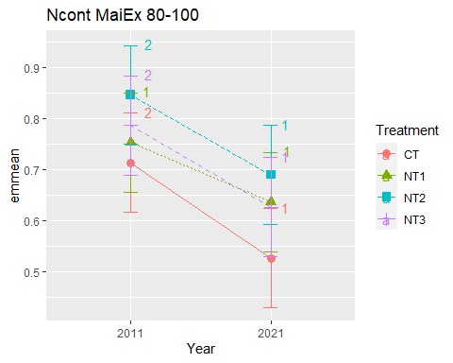

## [1] "Summary for soil depths"

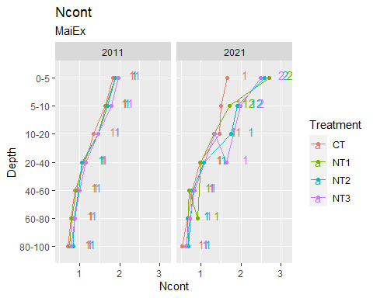

## [1] "Ncont SoyEx"  
## # A tibble: 56 × 7  
## Treatment Depth Year variable n mean sd  
## <fct> <fct> <fct> <chr> <dbl> <dbl> <dbl>  
## 1 CT 0-5 2011 Ncont 3 1.87 0.047  
## 2 NT1 0-5 2011 Ncont 3 1.92 0.06   
## 3 NT2 0-5 2011 Ncont 3 2.02 0.093  
## 4 NT3 0-5 2011 Ncont 3 1.95 0.068  
## 5 CT 5-10 2011 Ncont 3 1.65 0.128  
## 6 NT1 5-10 2011 Ncont 3 1.67 0.107  
## 7 NT2 5-10 2011 Ncont 3 1.72 0.098  
## 8 NT3 5-10 2011 Ncont 3 1.72 0.081  
## 9 CT 10-20 2011 Ncont 3 1.39 0.139  
## 10 NT1 10-20 2011 Ncont 3 1.53 0.068  
## # … with 46 more rows  
## [1] "Ncont SoyEx 0-5"

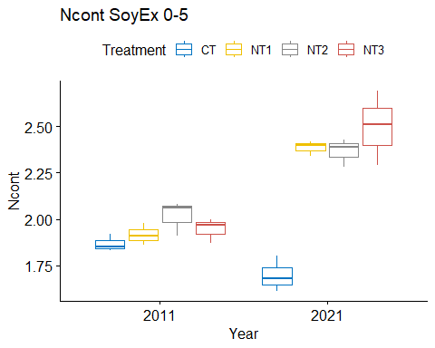

## [1] "Normality"

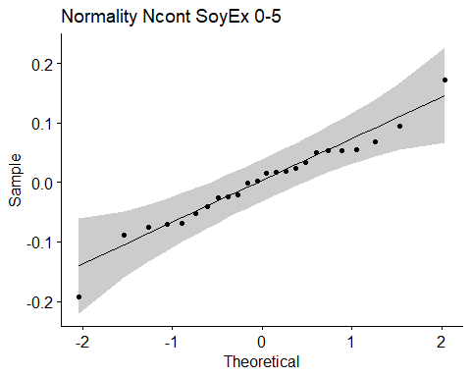

## [1] "Shapiro test for normality"  
## # A tibble: 1 × 3  
## variable statistic p.value  
## <chr> <dbl> <dbl>  
## 1 residuals(model) 0.969 0.648  
## [1] "Homoscedasticity"

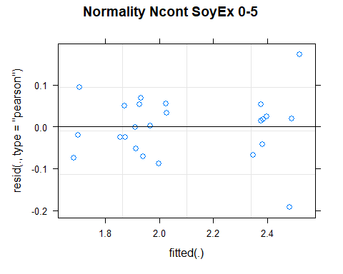

## [1] "Levene test for homoscedasticity"  
## # A tibble: 1 × 4  
## df1 df2 statistic p  
## <int> <int> <dbl> <dbl>  
## 1 7 16 0.827 0.580  
## [1] "ANOVA"  
## Treatment = CT:  
## Year emmean SE df lower.CL upper.CL .group  
## 2021 1.70 0.0564 15.8 1.58 1.82 1   
## 2011 1.87 0.0564 15.8 1.75 1.99 1   
##   
## Treatment = NT1:  
## Year emmean SE df lower.CL upper.CL .group  
## 2011 1.92 0.0564 15.8 1.80 2.04 1   
## 2021 2.39 0.0564 15.8 2.27 2.51 2   
##   
## Treatment = NT2:  
## Year emmean SE df lower.CL upper.CL .group  
## 2011 2.02 0.0564 15.8 1.90 2.14 1   
## 2021 2.37 0.0564 15.8 2.25 2.49 2   
##   
## Treatment = NT3:  
## Year emmean SE df lower.CL upper.CL .group  
## 2011 1.95 0.0564 15.8 1.83 2.07 1   
## 2021 2.50 0.0564 15.8 2.38 2.62 2   
##   
## Degrees-of-freedom method: kenward-roger   
## Results are given on the [ (not the response) scale.   
## Confidence level used: 0.95   
## Note: contrasts are still on the [ scale   
## significance level used: alpha = 0.05   
## NOTE: If two or more means share the same grouping symbol,  
## then we cannot show them to be different.  
## But we also did not show them to be the same.   
## Year = 2011:  
## Treatment emmean SE df lower.CL upper.CL .group  
## CT 1.87 0.0564 15.8 1.75 1.99 1   
## NT1 1.92 0.0564 15.8 1.80 2.04 1   
## NT3 1.95 0.0564 15.8 1.83 2.07 1   
## NT2 2.02 0.0564 15.8 1.90 2.14 1   
##   
## Year = 2021:  
## Treatment emmean SE df lower.CL upper.CL .group  
## CT 1.70 0.0564 15.8 1.58 1.82 1   
## NT2 2.37 0.0564 15.8 2.25 2.49 2   
## NT1 2.39 0.0564 15.8 2.27 2.51 2   
## NT3 2.50 0.0564 15.8 2.38 2.62 2   
##   
## Degrees-of-freedom method: kenward-roger   
## Results are given on the [ (not the response) scale.   
## Confidence level used: 0.95   
## Note: contrasts are still on the [ scale   
## P value adjustment: tukey method for comparing a family of 4 estimates   
## significance level used: alpha = 0.05   
## NOTE: If two or more means share the same grouping symbol,  
## then we cannot show them to be different.  
## But we also did not show them to be the same.   
## [1] "ANOVA plot"

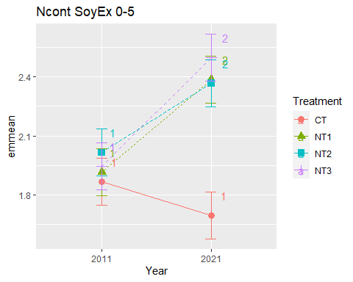

## [1] "Ncont SoyEx 5-10"

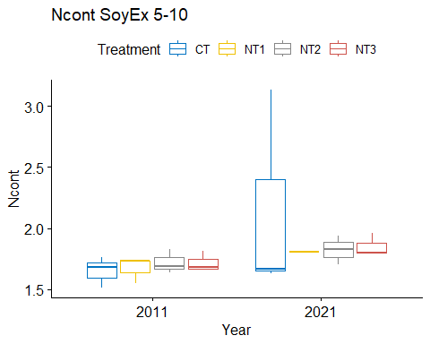

## [1] "Normality"

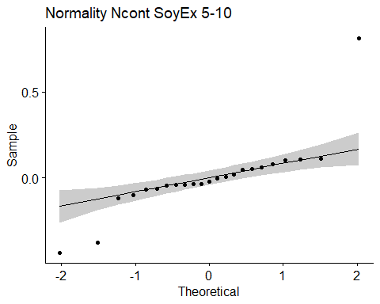

## [1] "Shapiro test for normality"  
## # A tibble: 1 × 3  
## variable statistic p.value  
## <chr> <dbl> <dbl>  
## 1 residuals(model) 0.736 0.0000431  
## [1] "Homoscedasticity"

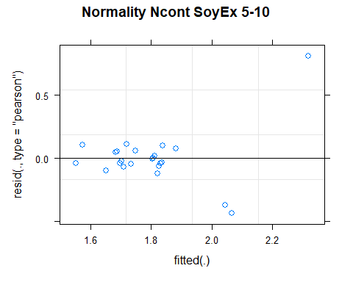

## [1] "Levene test for homoscedasticity"  
## # A tibble: 1 × 4  
## df1 df2 statistic p  
## <int> <int> <dbl> <dbl>  
## 1 7 15 0.753 0.633  
## [1] "ANOVA"  
## Treatment = CT:  
## Year emmean SE df lower.CL upper.CL .group  
## 2011 1.65 0.188 14.5 1.25 2.05 1   
## 2021 2.14 0.188 14.5 1.74 2.55 1   
##   
## Treatment = NT1:  
## Year emmean SE df lower.CL upper.CL .group  
## 2011 1.67 0.188 14.5 1.27 2.08 1   
## 2021 1.79 0.239 14.9 1.28 2.30 1   
##   
## Treatment = NT2:  
## Year emmean SE df lower.CL upper.CL .group  
## 2011 1.72 0.188 14.5 1.32 2.12 1   
## 2021 1.82 0.188 14.5 1.42 2.23 1   
##   
## Treatment = NT3:  
## Year emmean SE df lower.CL upper.CL .group  
## 2011 1.72 0.188 14.5 1.31 2.12 1   
## 2021 1.85 0.188 14.5 1.45 2.25 1   
##   
## Degrees-of-freedom method: kenward-roger   
## Results are given on the [ (not the response) scale.   
## Confidence level used: 0.95   
## Note: contrasts are still on the [ scale   
## significance level used: alpha = 0.05   
## NOTE: If two or more means share the same grouping symbol,  
## then we cannot show them to be different.  
## But we also did not show them to be the same.   
## Year = 2011:  
## Treatment emmean SE df lower.CL upper.CL .group  
## CT 1.65 0.188 14.5 1.25 2.05 1   
## NT1 1.67 0.188 14.5 1.27 2.08 1   
## NT3 1.72 0.188 14.5 1.31 2.12 1   
## NT2 1.72 0.188 14.5 1.32 2.12 1   
##   
## Year = 2021:  
## Treatment emmean SE df lower.CL upper.CL .group  
## NT1 1.79 0.239 14.9 1.28 2.30 1   
## NT2 1.82 0.188 14.5 1.42 2.23 1   
## NT3 1.85 0.188 14.5 1.45 2.25 1   
## CT 2.14 0.188 14.5 1.74 2.55 1   
##   
## Degrees-of-freedom method: kenward-roger   
## Results are given on the [ (not the response) scale.   
## Confidence level used: 0.95   
## Note: contrasts are still on the [ scale   
## P value adjustment: tukey method for comparing a family of 4 estimates   
## significance level used: alpha = 0.05   
## NOTE: If two or more means share the same grouping symbol,  
## then we cannot show them to be different.  
## But we also did not show them to be the same.   
## [1] "ANOVA plot"

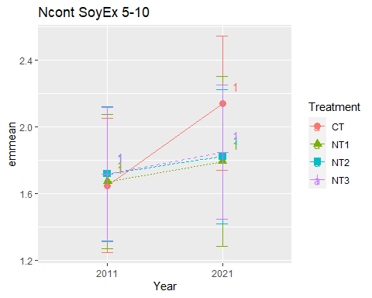

## [1] "Ncont SoyEx 10-20"

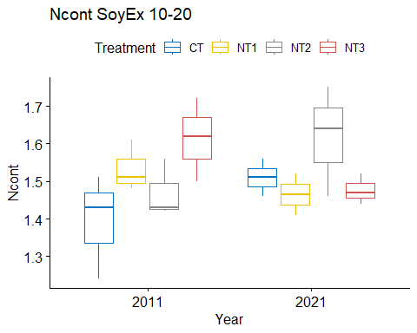

## [1] "Normality"

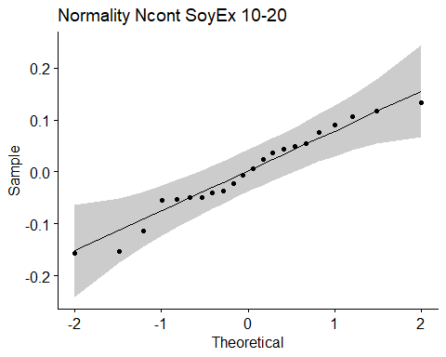

## [1] "Shapiro test for normality"  
## # A tibble: 1 × 3  
## variable statistic p.value  
## <chr> <dbl> <dbl>  
## 1 residuals(model) 0.963 0.562  
## [1] "Homoscedasticity"

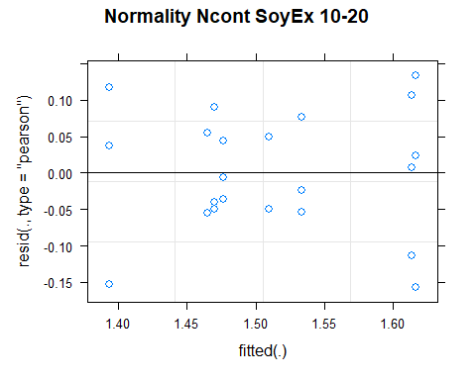

## [1] "Levene test for homoscedasticity"  
## # A tibble: 1 × 4  
## df1 df2 statistic p  
## <int> <int> <dbl> <dbl>  
## 1 7 14 0.407 0.882  
## [1] "ANOVA"  
## Treatment = CT:  
## Year emmean SE df lower.CL upper.CL .group  
## 2011 1.39 0.0580 14 1.27 1.52 1   
## 2021 1.51 0.0749 14 1.35 1.67 1   
##   
## Treatment = NT1:  
## Year emmean SE df lower.CL upper.CL .group  
## 2021 1.47 0.0749 14 1.30 1.63 1   
## 2011 1.53 0.0580 14 1.41 1.66 1   
##   
## Treatment = NT2:  
## Year emmean SE df lower.CL upper.CL .group  
## 2011 1.47 0.0580 14 1.35 1.59 1   
## 2021 1.62 0.0580 14 1.49 1.74 1   
##   
## Treatment = NT3:  
## Year emmean SE df lower.CL upper.CL .group  
## 2021 1.48 0.0580 14 1.35 1.60 1   
## 2011 1.61 0.0580 14 1.49 1.74 1   
##   
## Degrees-of-freedom method: kenward-roger   
## Results are given on the [ (not the response) scale.   
## Confidence level used: 0.95   
## Note: contrasts are still on the [ scale   
## significance level used: alpha = 0.05   
## NOTE: If two or more means share the same grouping symbol,  
## then we cannot show them to be different.  
## But we also did not show them to be the same.   
## Year = 2011:  
## Treatment emmean SE df lower.CL upper.CL .group  
## CT 1.39 0.0580 14 1.27 1.52 1   
## NT2 1.47 0.0580 14 1.35 1.59 1   
## NT1 1.53 0.0580 14 1.41 1.66 1   
## NT3 1.61 0.0580 14 1.49 1.74 1   
##   
## Year = 2021:  
## Treatment emmean SE df lower.CL upper.CL .group  
## NT1 1.47 0.0749 14 1.30 1.63 1   
## NT3 1.48 0.0580 14 1.35 1.60 1   
## CT 1.51 0.0749 14 1.35 1.67 1   
## NT2 1.62 0.0580 14 1.49 1.74 1   
##   
## Degrees-of-freedom method: kenward-roger   
## Results are given on the [ (not the response) scale.   
## Confidence level used: 0.95   
## Note: contrasts are still on the [ scale   
## P value adjustment: tukey method for comparing a family of 4 estimates   
## significance level used: alpha = 0.05   
## NOTE: If two or more means share the same grouping symbol,  
## then we cannot show them to be different.  
## But we also did not show them to be the same.   
## [1] "ANOVA plot"

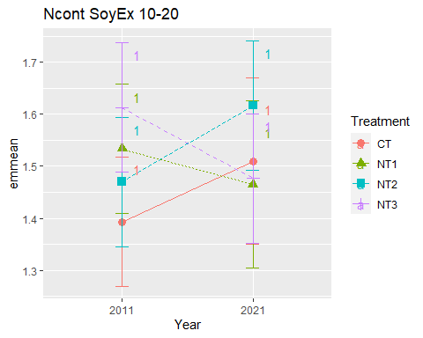

## [1] "Ncont SoyEx 20-40"

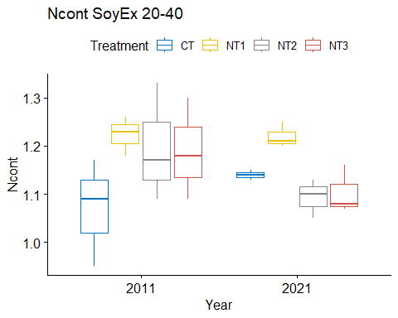

## [1] "Normality"

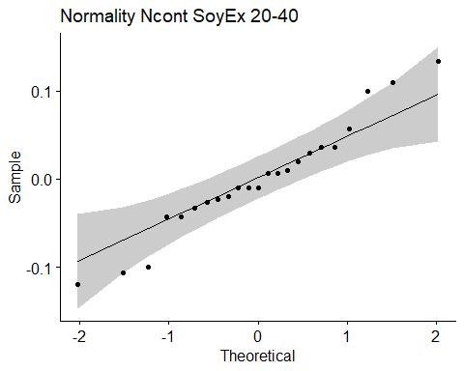

## [1] "Shapiro test for normality"  
## # A tibble: 1 × 3  
## variable statistic p.value  
## <chr> <dbl> <dbl>  
## 1 residuals(model) 0.964 0.543  
## [1] "Homoscedasticity"

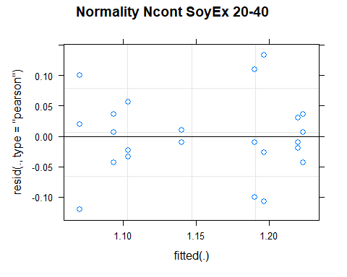

## [1] "Levene test for homoscedasticity"  
## # A tibble: 1 × 4  
## df1 df2 statistic p  
## <int> <int> <dbl> <dbl>  
## 1 7 15 0.877 0.546  
## [1] "ANOVA"  
## Treatment = CT:  
## Year emmean SE df lower.CL upper.CL .group  
## 2011 1.07 0.0447 15 0.975 1.17 1   
## 2021 1.14 0.0573 15 1.018 1.26 1   
##   
## Treatment = NT1:  
## Year emmean SE df lower.CL upper.CL .group  
## 2021 1.22 0.0447 15 1.125 1.32 1   
## 2011 1.22 0.0447 15 1.128 1.32 1   
##   
## Treatment = NT2:  
## Year emmean SE df lower.CL upper.CL .group  
## 2021 1.09 0.0447 15 0.998 1.19 1   
## 2011 1.20 0.0447 15 1.101 1.29 1   
##   
## Treatment = NT3:  
## Year emmean SE df lower.CL upper.CL .group  
## 2021 1.10 0.0447 15 1.008 1.20 1   
## 2011 1.19 0.0447 15 1.095 1.29 1   
##   
## Degrees-of-freedom method: kenward-roger   
## Results are given on the [ (not the response) scale.   
## Confidence level used: 0.95   
## Note: contrasts are still on the [ scale   
## significance level used: alpha = 0.05   
## NOTE: If two or more means share the same grouping symbol,  
## then we cannot show them to be different.  
## But we also did not show them to be the same.   
## Year = 2011:  
## Treatment emmean SE df lower.CL upper.CL .group  
## CT 1.07 0.0447 15 0.975 1.17 1   
## NT3 1.19 0.0447 15 1.095 1.29 1   
## NT2 1.20 0.0447 15 1.101 1.29 1   
## NT1 1.22 0.0447 15 1.128 1.32 1   
##   
## Year = 2021:  
## Treatment emmean SE df lower.CL upper.CL .group  
## NT2 1.09 0.0447 15 0.998 1.19 1   
## NT3 1.10 0.0447 15 1.008 1.20 1   
## CT 1.14 0.0573 15 1.018 1.26 1   
## NT1 1.22 0.0447 15 1.125 1.32 1   
##   
## Degrees-of-freedom method: kenward-roger   
## Results are given on the [ (not the response) scale.   
## Confidence level used: 0.95   
## Note: contrasts are still on the [ scale   
## P value adjustment: tukey method for comparing a family of 4 estimates   
## significance level used: alpha = 0.05   
## NOTE: If two or more means share the same grouping symbol,  
## then we cannot show them to be different.  
## But we also did not show them to be the same.   
## [1] "ANOVA plot"

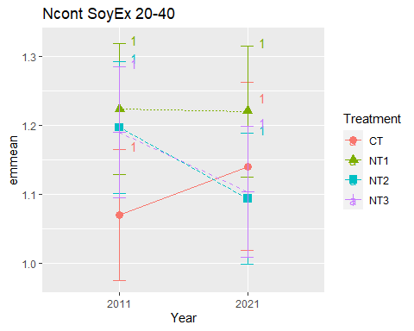

## [1] "Ncont SoyEx 40-60"

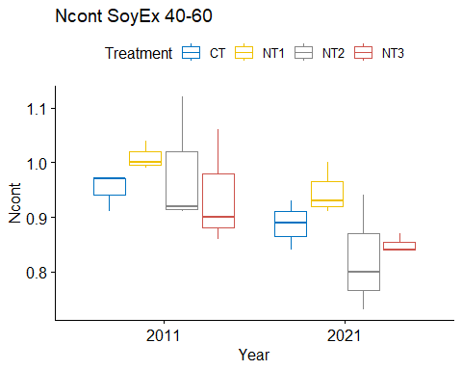

## [1] "Normality"

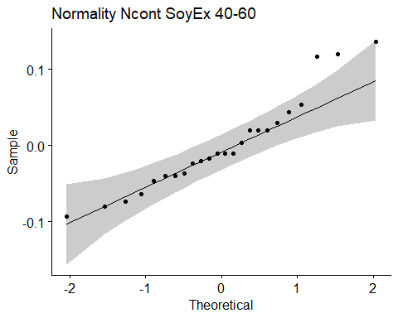

## [1] "Shapiro test for normality"  
## # A tibble: 1 × 3  
## variable statistic p.value  
## <chr> <dbl> <dbl>  
## 1 residuals(model) 0.933 0.115  
## [1] "Homoscedasticity"

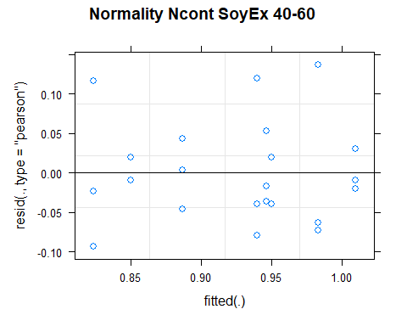

## [1] "Levene test for homoscedasticity"  
## # A tibble: 1 × 4  
## df1 df2 statistic p  
## <int> <int> <dbl> <dbl>  
## 1 7 16 0.548 0.786  
## [1] "ANOVA"  
## Treatment = CT:  
## Year emmean SE df lower.CL upper.CL .group  
## 2021 0.887 0.0424 16 0.797 0.977 1   
## 2011 0.950 0.0424 16 0.860 1.040 1   
##   
## Treatment = NT1:  
## Year emmean SE df lower.CL upper.CL .group  
## 2021 0.947 0.0424 16 0.857 1.037 1   
## 2011 1.010 0.0424 16 0.920 1.100 1   
##   
## Treatment = NT2:  
## Year emmean SE df lower.CL upper.CL .group  
## 2021 0.823 0.0424 16 0.733 0.913 1   
## 2011 0.983 0.0424 16 0.893 1.073 2   
##   
## Treatment = NT3:  
## Year emmean SE df lower.CL upper.CL .group  
## 2021 0.850 0.0424 16 0.760 0.940 1   
## 2011 0.940 0.0424 16 0.850 1.030 1   
##   
## Degrees-of-freedom method: kenward-roger   
## Results are given on the [ (not the response) scale.   
## Confidence level used: 0.95   
## Note: contrasts are still on the [ scale   
## significance level used: alpha = 0.05   
## NOTE: If two or more means share the same grouping symbol,  
## then we cannot show them to be different.  
## But we also did not show them to be the same.   
## Year = 2011:  
## Treatment emmean SE df lower.CL upper.CL .group  
## NT3 0.940 0.0424 16 0.850 1.030 1   
## CT 0.950 0.0424 16 0.860 1.040 1   
## NT2 0.983 0.0424 16 0.893 1.073 1   
## NT1 1.010 0.0424 16 0.920 1.100 1   
##   
## Year = 2021:  
## Treatment emmean SE df lower.CL upper.CL .group  
## NT2 0.823 0.0424 16 0.733 0.913 1   
## NT3 0.850 0.0424 16 0.760 0.940 1   
## CT 0.887 0.0424 16 0.797 0.977 1   
## NT1 0.947 0.0424 16 0.857 1.037 1   
##   
## Degrees-of-freedom method: kenward-roger   
## Results are given on the [ (not the response) scale.   
## Confidence level used: 0.95   
## Note: contrasts are still on the [ scale   
## P value adjustment: tukey method for comparing a family of 4 estimates   
## significance level used: alpha = 0.05   
## NOTE: If two or more means share the same grouping symbol,  
## then we cannot show them to be different.  
## But we also did not show them to be the same.   
## [1] "ANOVA plot"

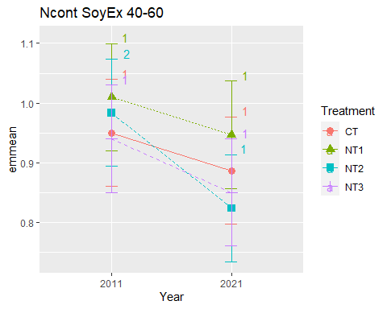

## [1] "Ncont SoyEx 60-80"

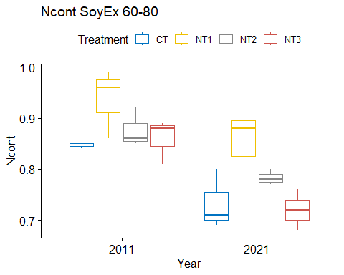

## [1] "Normality"

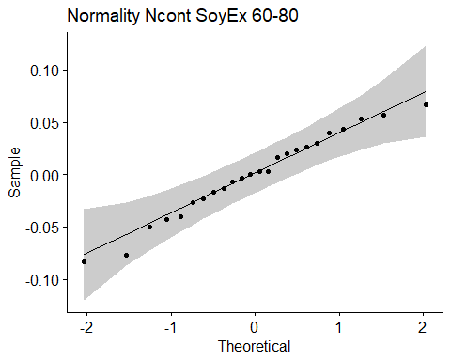

## [1] "Shapiro test for normality"  
## # A tibble: 1 × 3  
## variable statistic p.value  
## <chr> <dbl> <dbl>  
## 1 residuals(model) 0.976 0.815  
## [1] "Homoscedasticity"

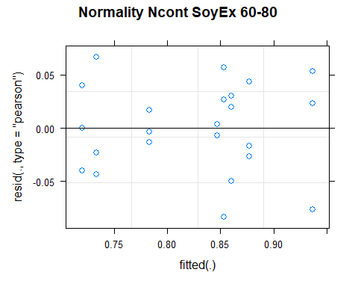

## [1] "Levene test for homoscedasticity"  
## # A tibble: 1 × 4  
## df1 df2 statistic p  
## <int> <int> <dbl> <dbl>  
## 1 7 16 0.491 0.827  
## [1] "ANOVA"  
## Treatment = CT:  
## Year emmean SE df lower.CL upper.CL .group  
## 2021 0.733 0.0279 16 0.674 0.793 1   
## 2011 0.847 0.0279 16 0.787 0.906 2   
##   
## Treatment = NT1:  
## Year emmean SE df lower.CL upper.CL .group  
## 2021 0.853 0.0279 16 0.794 0.913 1   
## 2011 0.937 0.0279 16 0.877 0.996 1   
##   
## Treatment = NT2:  
## Year emmean SE df lower.CL upper.CL .group  
## 2021 0.783 0.0279 16 0.724 0.843 1   
## 2011 0.877 0.0279 16 0.817 0.936 2   
##   
## Treatment = NT3:  
## Year emmean SE df lower.CL upper.CL .group  
## 2021 0.720 0.0279 16 0.661 0.779 1   
## 2011 0.860 0.0279 16 0.801 0.919 2   
##   
## Degrees-of-freedom method: kenward-roger   
## Results are given on the [ (not the response) scale.   
## Confidence level used: 0.95   
## Note: contrasts are still on the [ scale   
## significance level used: alpha = 0.05   
## NOTE: If two or more means share the same grouping symbol,  
## then we cannot show them to be different.  
## But we also did not show them to be the same.   
## Year = 2011:  
## Treatment emmean SE df lower.CL upper.CL .group  
## CT 0.847 0.0279 16 0.787 0.906 1   
## NT3 0.860 0.0279 16 0.801 0.919 1   
## NT2 0.877 0.0279 16 0.817 0.936 1   
## NT1 0.937 0.0279 16 0.877 0.996 1   
##   
## Year = 2021:  
## Treatment emmean SE df lower.CL upper.CL .group  
## NT3 0.720 0.0279 16 0.661 0.779 1   
## CT 0.733 0.0279 16 0.674 0.793 1   
## NT2 0.783 0.0279 16 0.724 0.843 12   
## NT1 0.853 0.0279 16 0.794 0.913 2   
##   
## Degrees-of-freedom method: kenward-roger   
## Results are given on the [ (not the response) scale.   
## Confidence level used: 0.95   
## Note: contrasts are still on the [ scale   
## P value adjustment: tukey method for comparing a family of 4 estimates   
## significance level used: alpha = 0.05   
## NOTE: If two or more means share the same grouping symbol,  
## then we cannot show them to be different.  
## But we also did not show them to be the same.   
## [1] "ANOVA plot"

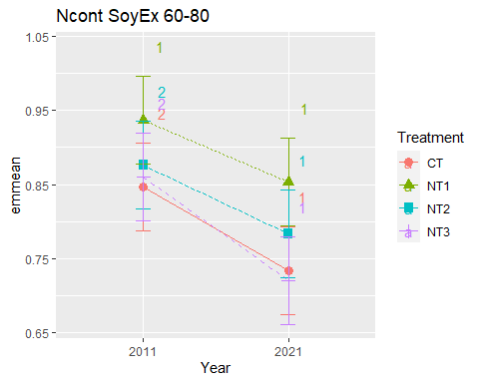

## [1] "Ncont SoyEx 80-100"

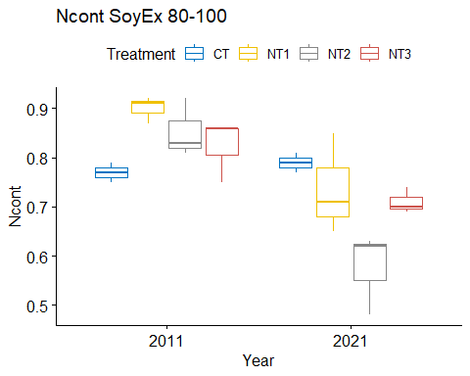

## [1] "Normality"

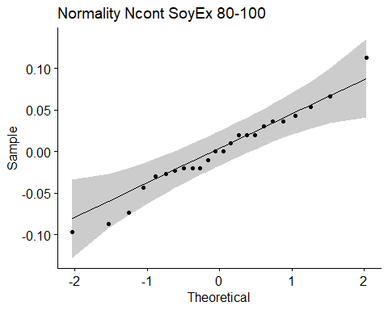

## [1] "Shapiro test for normality"  
## # A tibble: 1 × 3  
## variable statistic p.value  
## <chr> <dbl> <dbl>  
## 1 residuals(model) 0.979 0.881  
## [1] "Homoscedasticity"

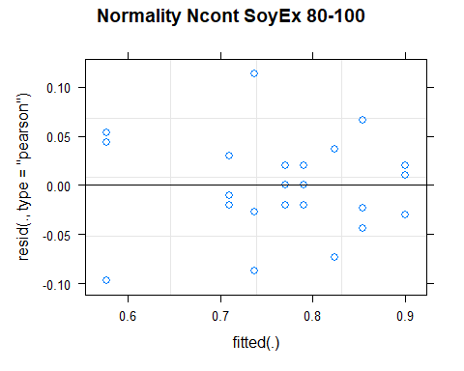

## [1] "Levene test for homoscedasticity"  
## # A tibble: 1 × 4  
## df1 df2 statistic p  
## <int> <int> <dbl> <dbl>  
## 1 7 16 0.508 0.815  
## [1] "ANOVA"  
## Treatment = CT:  
## Year emmean SE df lower.CL upper.CL .group  
## 2011 0.770 0.0337 16 0.699 0.841 1   
## 2021 0.790 0.0337 16 0.719 0.861 1   
##   
## Treatment = NT1:  
## Year emmean SE df lower.CL upper.CL .group  
## 2021 0.737 0.0337 16 0.665 0.808 1   
## 2011 0.900 0.0337 16 0.829 0.971 2   
##   
## Treatment = NT2:  
## Year emmean SE df lower.CL upper.CL .group  
## 2021 0.577 0.0337 16 0.505 0.648 1   
## 2011 0.853 0.0337 16 0.782 0.925 2   
##   
## Treatment = NT3:  
## Year emmean SE df lower.CL upper.CL .group  
## 2021 0.710 0.0337 16 0.639 0.781 1   
## 2011 0.823 0.0337 16 0.752 0.895 2   
##   
## Degrees-of-freedom method: kenward-roger   
## Results are given on the [ (not the response) scale.   
## Confidence level used: 0.95   
## Note: contrasts are still on the [ scale   
## significance level used: alpha = 0.05   
## NOTE: If two or more means share the same grouping symbol,  
## then we cannot show them to be different.  
## But we also did not show them to be the same.   
## Year = 2011:  
## Treatment emmean SE df lower.CL upper.CL .group  
## CT 0.770 0.0337 16 0.699 0.841 1   
## NT3 0.823 0.0337 16 0.752 0.895 1   
## NT2 0.853 0.0337 16 0.782 0.925 1   
## NT1 0.900 0.0337 16 0.829 0.971 1   
##   
## Year = 2021:  
## Treatment emmean SE df lower.CL upper.CL .group  
## NT2 0.577 0.0337 16 0.505 0.648 1   
## NT3 0.710 0.0337 16 0.639 0.781 12   
## NT1 0.737 0.0337 16 0.665 0.808 2   
## CT 0.790 0.0337 16 0.719 0.861 2   
##   
## Degrees-of-freedom method: kenward-roger   
## Results are given on the [ (not the response) scale.   
## Confidence level used: 0.95   
## Note: contrasts are still on the [ scale   
## P value adjustment: tukey method for comparing a family of 4 estimates   
## significance level used: alpha = 0.05   
## NOTE: If two or more means share the same grouping symbol,  
## then we cannot show them to be different.  
## But we also did not show them to be the same.   
## [1] "ANOVA plot"

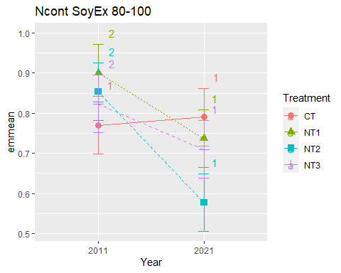

## [1] "Summary for soil depths"

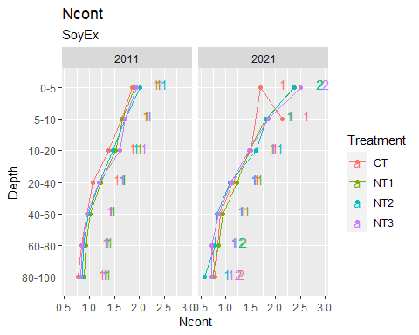

## [1] "Ncont CasEx"  
## # A tibble: 56 × 7  
## Treatment Depth Year variable n mean sd  
## <fct> <fct> <fct> <chr> <dbl> <dbl> <dbl>  
## 1 CT 0-5 2011 Ncont 3 1.57 0.132  
## 2 NT1 0-5 2011 Ncont 3 1.74 0.072  
## 3 NT2 0-5 2011 Ncont 3 1.7 0.07   
## 4 NT3 0-5 2011 Ncont 3 1.90 0.179  
## 5 CT 5-10 2011 Ncont 3 1.69 0.141  
## 6 NT1 5-10 2011 Ncont 3 1.72 0.075  
## 7 NT2 5-10 2011 Ncont 3 1.53 0.06   
## 8 NT3 5-10 2011 Ncont 3 1.67 0.023  
## 9 CT 10-20 2011 Ncont 3 1.52 0.125  
## 10 NT1 10-20 2011 Ncont 3 1.54 0.075  
## # … with 46 more rows  
## [1] "Ncont CasEx 0-5"

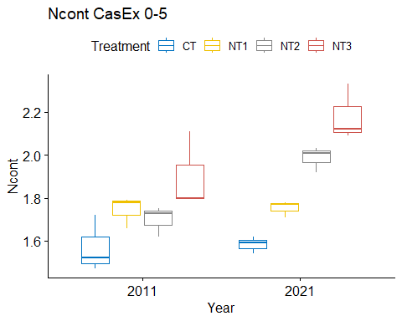

## [1] "Normality"

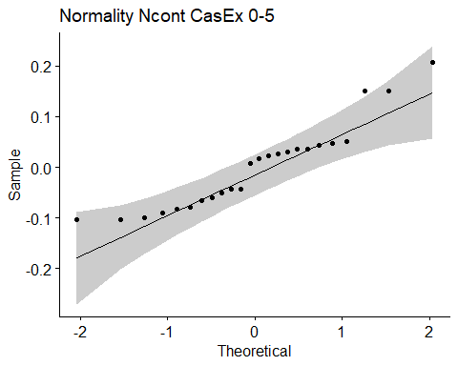

## [1] "Shapiro test for normality"  
## # A tibble: 1 × 3  
## variable statistic p.value  
## <chr> <dbl> <dbl>  
## 1 residuals(model) 0.907 0.0296  
## [1] "Homoscedasticity"

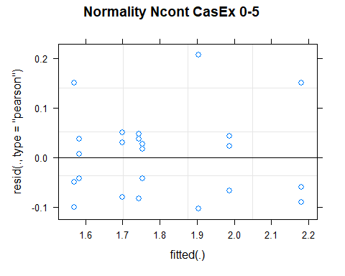

## [1] "Levene test for homoscedasticity"  
## # A tibble: 1 × 4  
## df1 df2 statistic p  
## <int> <int> <dbl> <dbl>  
## 1 7 16 0.314 0.937  
## [1] "ANOVA"  
## Treatment = CT:  
## Year emmean SE df lower.CL upper.CL .group  
## 2011 1.57 0.0589 16 1.45 1.69 1   
## 2021 1.58 0.0589 16 1.46 1.71 1   
##   
## Treatment = NT1:  
## Year emmean SE df lower.CL upper.CL .group  
## 2011 1.74 0.0589 16 1.62 1.87 1   
## 2021 1.75 0.0589 16 1.63 1.88 1   
##   
## Treatment = NT2:  
## Year emmean SE df lower.CL upper.CL .group  
## 2011 1.70 0.0589 16 1.58 1.82 1   
## 2021 1.99 0.0589 16 1.86 2.11 2   
##   
## Treatment = NT3:  
## Year emmean SE df lower.CL upper.CL .group  
## 2011 1.90 0.0589 16 1.78 2.03 1   
## 2021 2.18 0.0589 16 2.06 2.30 2   
##   
## Degrees-of-freedom method: kenward-roger   
## Results are given on the [ (not the response) scale.   
## Confidence level used: 0.95   
## Note: contrasts are still on the [ scale   
## significance level used: alpha = 0.05   
## NOTE: If two or more means share the same grouping symbol,  
## then we cannot show them to be different.  
## But we also did not show them to be the same.   
## Year = 2011:  
## Treatment emmean SE df lower.CL upper.CL .group  
## CT 1.57 0.0589 16 1.45 1.69 1   
## NT2 1.70 0.0589 16 1.58 1.82 12   
## NT1 1.74 0.0589 16 1.62 1.87 12   
## NT3 1.90 0.0589 16 1.78 2.03 2   
##   
## Year = 2021:  
## Treatment emmean SE df lower.CL upper.CL .group  
## CT 1.58 0.0589 16 1.46 1.71 1   
## NT1 1.75 0.0589 16 1.63 1.88 12   
## NT2 1.99 0.0589 16 1.86 2.11 23   
## NT3 2.18 0.0589 16 2.06 2.30 3   
##   
## Degrees-of-freedom method: kenward-roger   
## Results are given on the [ (not the response) scale.   
## Confidence level used: 0.95   
## Note: contrasts are still on the [ scale   
## P value adjustment: tukey method for comparing a family of 4 estimates   
## significance level used: alpha = 0.05   
## NOTE: If two or more means share the same grouping symbol,  
## then we cannot show them to be different.  
## But we also did not show them to be the same.   
## [1] "ANOVA plot"

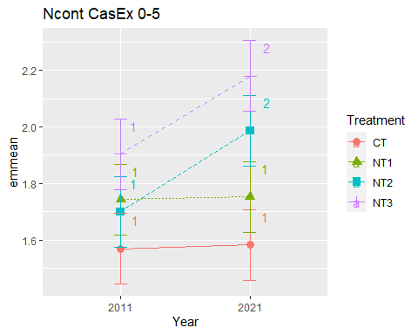

## [1] "Ncont CasEx 5-10"

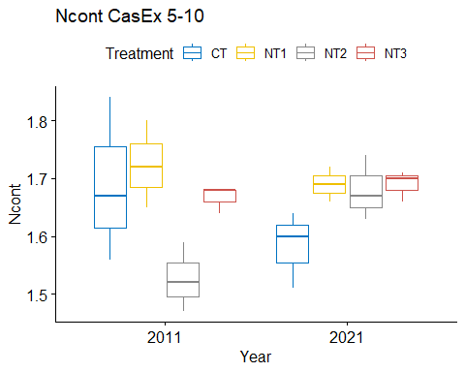

## [1] "Normality"

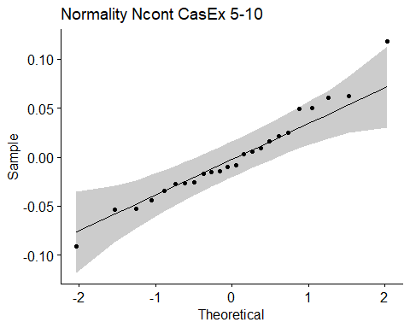

## [1] "Shapiro test for normality"  
## # A tibble: 1 × 3  
## variable statistic p.value  
## <chr> <dbl> <dbl>  
## 1 residuals(model) 0.970 0.667  
## [1] "Homoscedasticity"

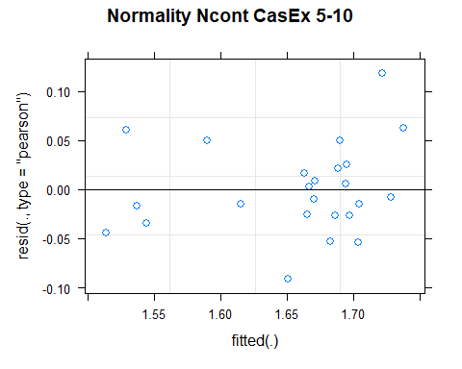

## [1] "Levene test for homoscedasticity"  
## # A tibble: 1 × 4  
## df1 df2 statistic p  
## <int> <int> <dbl> <dbl>  
## 1 7 16 1.04 0.440  
## [1] "ANOVA"  
## Treatment = CT:  
## Year emmean SE df lower.CL upper.CL .group  
## 2021 1.58 0.0402 15.2 1.50 1.67 1   
## 2011 1.69 0.0402 15.2 1.60 1.78 1   
##   
## Treatment = NT1:  
## Year emmean SE df lower.CL upper.CL .group  
## 2021 1.69 0.0402 15.2 1.60 1.78 1   
## 2011 1.72 0.0402 15.2 1.64 1.81 1   
##   
## Treatment = NT2:  
## Year emmean SE df lower.CL upper.CL .group  
## 2011 1.53 0.0402 15.2 1.44 1.61 1   
## 2021 1.68 0.0402 15.2 1.59 1.77 2   
##   
## Treatment = NT3:  
## Year emmean SE df lower.CL upper.CL .group  
## 2011 1.67 0.0402 15.2 1.58 1.75 1   
## 2021 1.69 0.0402 15.2 1.60 1.78 1   
##   
## Degrees-of-freedom method: kenward-roger   
## Results are given on the [ (not the response) scale.   
## Confidence level used: 0.95   
## Note: contrasts are still on the [ scale   
## significance level used: alpha = 0.05   
## NOTE: If two or more means share the same grouping symbol,  
## then we cannot show them to be different.  
## But we also did not show them to be the same.   
## Year = 2011:  
## Treatment emmean SE df lower.CL upper.CL .group  
## NT2 1.53 0.0402 15.2 1.44 1.61 1   
## NT3 1.67 0.0402 15.2 1.58 1.75 12   
## CT 1.69 0.0402 15.2 1.60 1.78 12   
## NT1 1.72 0.0402 15.2 1.64 1.81 2   
##   
## Year = 2021:  
## Treatment emmean SE df lower.CL upper.CL .group  
## CT 1.58 0.0402 15.2 1.50 1.67 1   
## NT2 1.68 0.0402 15.2 1.59 1.77 1   
## NT3 1.69 0.0402 15.2 1.60 1.78 1   
## NT1 1.69 0.0402 15.2 1.60 1.78 1   
##   
## Degrees-of-freedom method: kenward-roger   
## Results are given on the [ (not the response) scale.   
## Confidence level used: 0.95   
## Note: contrasts are still on the [ scale   
## P value adjustment: tukey method for comparing a family of 4 estimates   
## significance level used: alpha = 0.05   
## NOTE: If two or more means share the same grouping symbol,  
## then we cannot show them to be different.  
## But we also did not show them to be the same.   
## [1] "ANOVA plot"

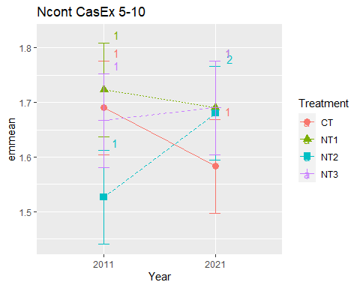

## [1] "Ncont CasEx 10-20"

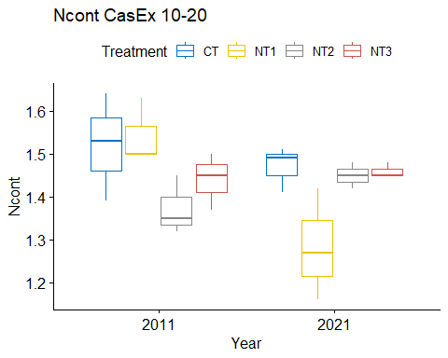

## [1] "Normality"

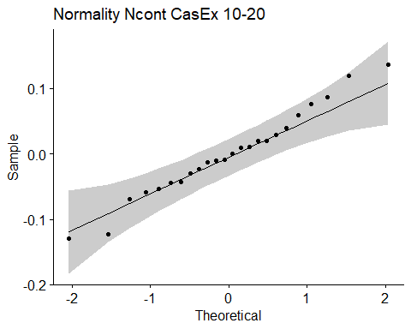

## [1] "Shapiro test for normality"  
## # A tibble: 1 × 3  
## variable statistic p.value  
## <chr> <dbl> <dbl>  
## 1 residuals(model) 0.980 0.903  
## [1] "Homoscedasticity"

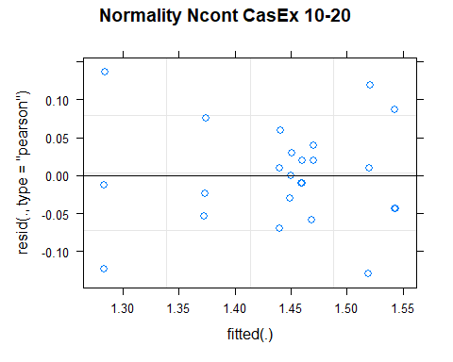

## [1] "Levene test for homoscedasticity"  
## # A tibble: 1 × 4  
## df1 df2 statistic p  
## <int> <int> <dbl> <dbl>  
## 1 7 16 0.752 0.634  
## [1] "ANOVA"  
## Treatment = CT:  
## Year emmean SE df lower.CL upper.CL .group  
## 2021 1.47 0.0462 16 1.37 1.57 1   
## 2011 1.52 0.0462 16 1.42 1.62 1   
##   
## Treatment = NT1:  
## Year emmean SE df lower.CL upper.CL .group  
## 2021 1.28 0.0462 16 1.19 1.38 1   
## 2011 1.54 0.0462 16 1.45 1.64 2   
##   
## Treatment = NT2:  
## Year emmean SE df lower.CL upper.CL .group  
## 2011 1.37 0.0462 16 1.28 1.47 1   
## 2021 1.45 0.0462 16 1.35 1.55 1   
##   
## Treatment = NT3:  
## Year emmean SE df lower.CL upper.CL .group  
## 2011 1.44 0.0462 16 1.34 1.54 1   
## 2021 1.46 0.0462 16 1.36 1.56 1   
##   
## Degrees-of-freedom method: kenward-roger   
## Results are given on the [ (not the response) scale.   
## Confidence level used: 0.95   
## Note: contrasts are still on the [ scale   
## significance level used: alpha = 0.05   
## NOTE: If two or more means share the same grouping symbol,  
## then we cannot show them to be different.  
## But we also did not show them to be the same.   
## Year = 2011:  
## Treatment emmean SE df lower.CL upper.CL .group  
## NT2 1.37 0.0462 16 1.28 1.47 1   
## NT3 1.44 0.0462 16 1.34 1.54 1   
## CT 1.52 0.0462 16 1.42 1.62 1   
## NT1 1.54 0.0462 16 1.45 1.64 1   
##   
## Year = 2021:  
## Treatment emmean SE df lower.CL upper.CL .group  
## NT1 1.28 0.0462 16 1.19 1.38 1   
## NT2 1.45 0.0462 16 1.35 1.55 1   
## NT3 1.46 0.0462 16 1.36 1.56 1   
## CT 1.47 0.0462 16 1.37 1.57 1   
##   
## Degrees-of-freedom method: kenward-roger   
## Results are given on the [ (not the response) scale.   
## Confidence level used: 0.95   
## Note: contrasts are still on the [ scale   
## P value adjustment: tukey method for comparing a family of 4 estimates   
## significance level used: alpha = 0.05   
## NOTE: If two or more means share the same grouping symbol,  
## then we cannot show them to be different.  
## But we also did not show them to be the same.   
## [1] "ANOVA plot"

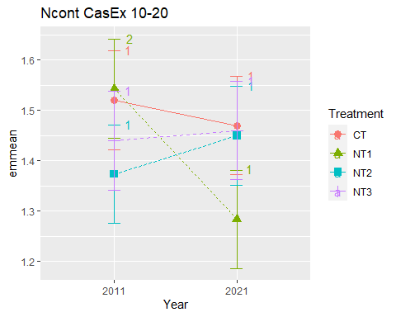

## [1] "Ncont CasEx 20-40"

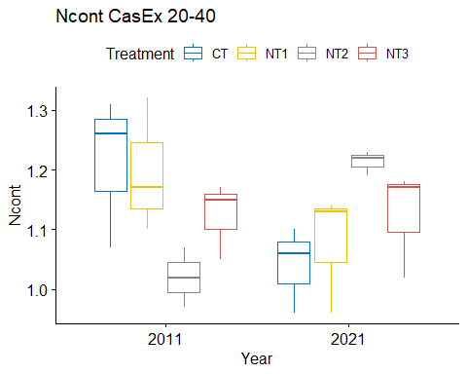

## [1] "Normality"

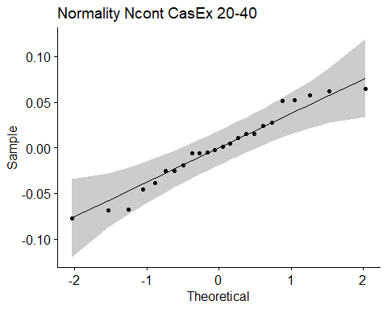

## [1] "Shapiro test for normality"  
## # A tibble: 1 × 3  
## variable statistic p.value  
## <chr> <dbl> <dbl>  
## 1 residuals(model) 0.959 0.424  
## [1] "Homoscedasticity"

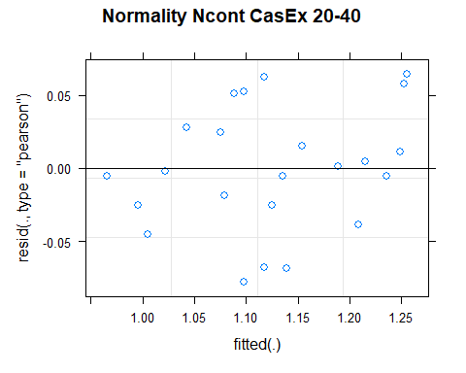

## [1] "Levene test for homoscedasticity"  
## # A tibble: 1 × 4  
## df1 df2 statistic p  
## <int> <int> <dbl> <dbl>  
## 1 7 16 0.298 0.945  
## [1] "ANOVA"  
## Treatment = CT:  
## Year emmean SE df lower.CL upper.CL .group  
## 2021 1.04 0.0497 12.8 0.933 1.15 1   
## 2011 1.21 0.0497 12.8 1.106 1.32 2   
##   
## Treatment = NT1:  
## Year emmean SE df lower.CL upper.CL .group  
## 2021 1.08 0.0497 12.8 0.969 1.18 1   
## 2011 1.20 0.0497 12.8 1.089 1.30 2   
##   
## Treatment = NT2:  
## Year emmean SE df lower.CL upper.CL .group  
## 2011 1.02 0.0497 12.8 0.913 1.13 1   
## 2021 1.21 0.0497 12.8 1.106 1.32 2   
##   
## Treatment = NT3:  
## Year emmean SE df lower.CL upper.CL .group  
## 2011 1.12 0.0497 12.8 1.016 1.23 1   
## 2021 1.12 0.0497 12.8 1.016 1.23 1   
##   
## Degrees-of-freedom method: kenward-roger   
## Results are given on the [ (not the response) scale.   
## Confidence level used: 0.95   
## Note: contrasts are still on the [ scale   
## significance level used: alpha = 0.05   
## NOTE: If two or more means share the same grouping symbol,  
## then we cannot show them to be different.  
## But we also did not show them to be the same.   
## Year = 2011:  
## Treatment emmean SE df lower.CL upper.CL .group  
## NT2 1.02 0.0497 12.8 0.913 1.13 1   
## NT3 1.12 0.0497 12.8 1.016 1.23 1   
## NT1 1.20 0.0497 12.8 1.089 1.30 1   
## CT 1.21 0.0497 12.8 1.106 1.32 1   
##   
## Year = 2021:  
## Treatment emmean SE df lower.CL upper.CL .group  
## CT 1.04 0.0497 12.8 0.933 1.15 1   
## NT1 1.08 0.0497 12.8 0.969 1.18 1   
## NT3 1.12 0.0497 12.8 1.016 1.23 1   
## NT2 1.21 0.0497 12.8 1.106 1.32 1   
##   
## Degrees-of-freedom method: kenward-roger   
## Results are given on the [ (not the response) scale.   
## Confidence level used: 0.95   
## Note: contrasts are still on the [ scale   
## P value adjustment: tukey method for comparing a family of 4 estimates   
## significance level used: alpha = 0.05   
## NOTE: If two or more means share the same grouping symbol,  
## then we cannot show them to be different.  
## But we also did not show them to be the same.   
## [1] "ANOVA plot"

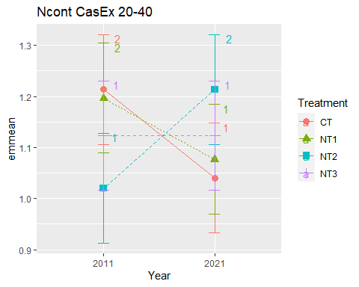

## [1] "Ncont CasEx 40-60"

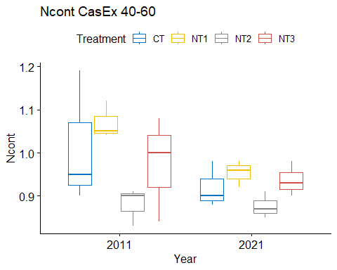

## [1] "Normality"

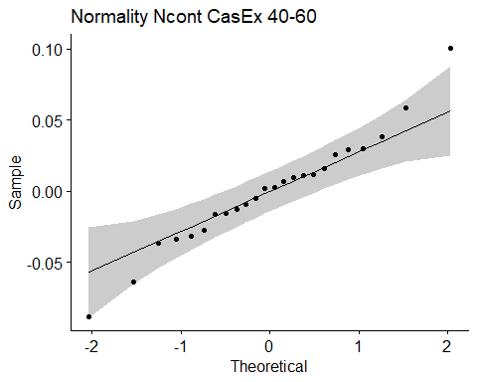

## [1] "Shapiro test for normality"  
## # A tibble: 1 × 3  
## variable statistic p.value  
## <chr> <dbl> <dbl>  
## 1 residuals(model) 0.974 0.765  
## [1] "Homoscedasticity"

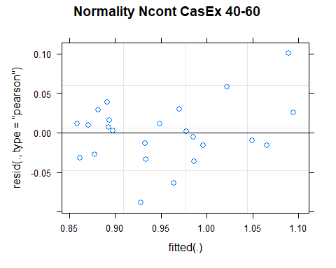

## [1] "Levene test for homoscedasticity"  
## # A tibble: 1 × 4  
## df1 df2 statistic p  
## <int> <int> <dbl> <dbl>  
## 1 7 16 0.744 0.640  
## [1] "ANOVA"  
## Treatment = CT:  
## Year emmean SE df lower.CL upper.CL .group  
## 2021 0.920 0.0452 13.1 0.822 1.018 1   
## 2011 1.013 0.0452 13.1 0.916 1.111 1   
##   
## Treatment = NT1:  
## Year emmean SE df lower.CL upper.CL .group  
## 2021 0.953 0.0452 13.1 0.856 1.051 1   
## 2011 1.070 0.0452 13.1 0.972 1.168 2   
##   
## Treatment = NT2:  
## Year emmean SE df lower.CL upper.CL .group  
## 2021 0.877 0.0452 13.1 0.779 0.974 1   
## 2011 0.880 0.0452 13.1 0.782 0.978 1   
##   
## Treatment = NT3:  
## Year emmean SE df lower.CL upper.CL .group  
## 2021 0.937 0.0452 13.1 0.839 1.034 1   
## 2011 0.973 0.0452 13.1 0.876 1.071 1   
##   
## Degrees-of-freedom method: kenward-roger   
## Results are given on the [ (not the response) scale.   
## Confidence level used: 0.95   
## Note: contrasts are still on the [ scale   
## significance level used: alpha = 0.05   
## NOTE: If two or more means share the same grouping symbol,  
## then we cannot show them to be different.  
## But we also did not show them to be the same.   
## Year = 2011:  
## Treatment emmean SE df lower.CL upper.CL .group  
## NT2 0.880 0.0452 13.1 0.782 0.978 1   
## NT3 0.973 0.0452 13.1 0.876 1.071 12   
## CT 1.013 0.0452 13.1 0.916 1.111 12   
## NT1 1.070 0.0452 13.1 0.972 1.168 2   
##   
## Year = 2021:  
## Treatment emmean SE df lower.CL upper.CL .group  
## NT2 0.877 0.0452 13.1 0.779 0.974 1   
## CT 0.920 0.0452 13.1 0.822 1.018 1   
## NT3 0.937 0.0452 13.1 0.839 1.034 1   
## NT1 0.953 0.0452 13.1 0.856 1.051 1   
##   
## Degrees-of-freedom method: kenward-roger   
## Results are given on the [ (not the response) scale.   
## Confidence level used: 0.95   
## Note: contrasts are still on the [ scale   
## P value adjustment: tukey method for comparing a family of 4 estimates   
## significance level used: alpha = 0.05   
## NOTE: If two or more means share the same grouping symbol,  
## then we cannot show them to be different.  
## But we also did not show them to be the same.   
## [1] "ANOVA plot"

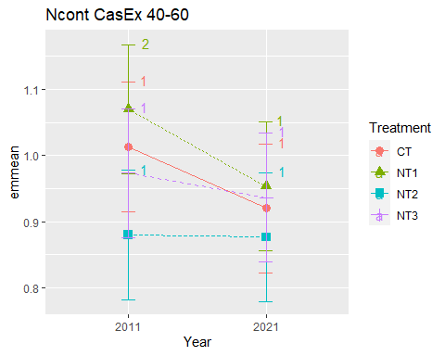

## [1] "Ncont CasEx 60-80"

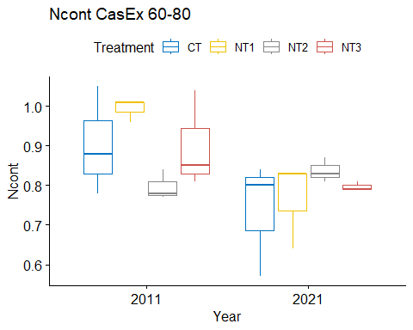

## [1] "Normality"

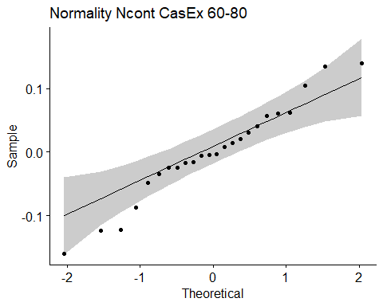

## [1] "Shapiro test for normality"  
## # A tibble: 1 × 3  
## variable statistic p.value  
## <chr> <dbl> <dbl>  
## 1 residuals(model) 0.969 0.652  
## [1] "Homoscedasticity"

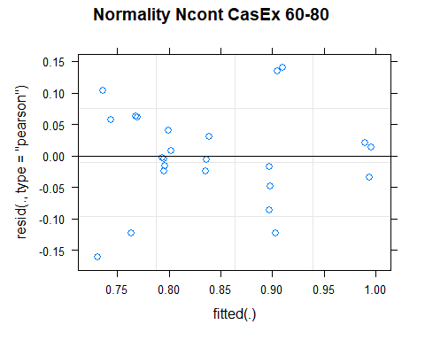

## [1] "Levene test for homoscedasticity"  
## # A tibble: 1 × 4  
## df1 df2 statistic p  
## <int> <int> <dbl> <dbl>  
## 1 7 16 0.634 0.722  
## [1] "ANOVA"  
## Treatment = CT:  
## Year emmean SE df lower.CL upper.CL .group  
## 2021 0.737 0.0541 16 0.622 0.851 1   
## 2011 0.903 0.0541 16 0.789 1.018 1   
##   
## Treatment = NT1:  
## Year emmean SE df lower.CL upper.CL .group  
## 2021 0.767 0.0541 16 0.652 0.881 1   
## 2011 0.993 0.0541 16 0.879 1.108 2   
##   
## Treatment = NT2:  
## Year emmean SE df lower.CL upper.CL .group  
## 2011 0.797 0.0541 16 0.682 0.911 1   
## 2021 0.837 0.0541 16 0.722 0.951 1   
##   
## Treatment = NT3:  
## Year emmean SE df lower.CL upper.CL .group  
## 2021 0.797 0.0541 16 0.682 0.911 1   
## 2011 0.900 0.0541 16 0.785 1.015 1   
##   
## Degrees-of-freedom method: kenward-roger   
## Results are given on the [ (not the response) scale.   
## Confidence level used: 0.95   
## Note: contrasts are still on the [ scale   
## significance level used: alpha = 0.05   
## NOTE: If two or more means share the same grouping symbol,  
## then we cannot show them to be different.  
## But we also did not show them to be the same.   
## Year = 2011:  
## Treatment emmean SE df lower.CL upper.CL .group  
## NT2 0.797 0.0541 16 0.682 0.911 1   
## NT3 0.900 0.0541 16 0.785 1.015 1   
## CT 0.903 0.0541 16 0.789 1.018 1   
## NT1 0.993 0.0541 16 0.879 1.108 1   
##   
## Year = 2021:  
## Treatment emmean SE df lower.CL upper.CL .group  
## CT 0.737 0.0541 16 0.622 0.851 1   
## NT1 0.767 0.0541 16 0.652 0.881 1   
## NT3 0.797 0.0541 16 0.682 0.911 1   
## NT2 0.837 0.0541 16 0.722 0.951 1   
##   
## Degrees-of-freedom method: kenward-roger   
## Results are given on the [ (not the response) scale.   
## Confidence level used: 0.95   
## Note: contrasts are still on the [ scale   
## P value adjustment: tukey method for comparing a family of 4 estimates   
## significance level used: alpha = 0.05   
## NOTE: If two or more means share the same grouping symbol,  
## then we cannot show them to be different.  
## But we also did not show them to be the same.   
## [1] "ANOVA plot"

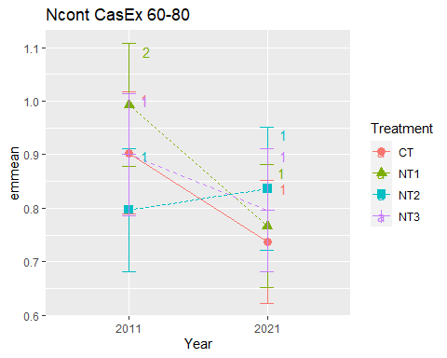

## [1] "Ncont CasEx 80-100"

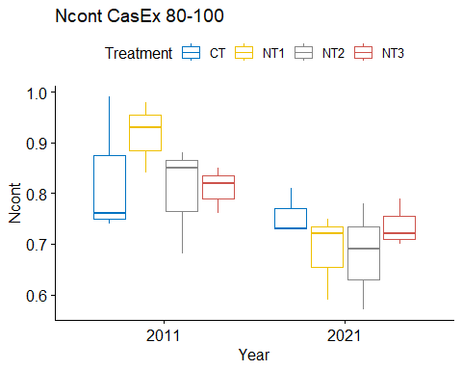

## [1] "Normality"

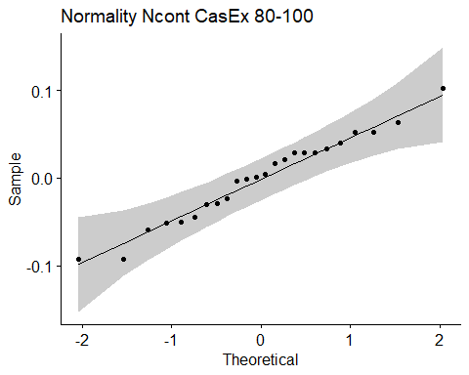

## [1] "Shapiro test for normality"  
## # A tibble: 1 × 3  
## variable statistic p.value  
## <chr> <dbl> <dbl>  
## 1 residuals(model) 0.976 0.813  
## [1] "Homoscedasticity"

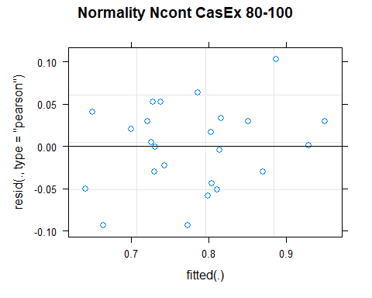

## [1] "Levene test for homoscedasticity"  
## # A tibble: 1 × 4  
## df1 df2 statistic p  
## <int> <int> <dbl> <dbl>  
## 1 7 16 0.274 0.955  
## [1] "ANOVA"  
## Treatment = CT:  
## Year emmean SE df lower.CL upper.CL .group  
## 2021 0.757 0.0503 14.1 0.649 0.865 1   
## 2011 0.830 0.0503 14.1 0.722 0.938 1   
##   
## Treatment = NT1:  
## Year emmean SE df lower.CL upper.CL .group  
## 2021 0.687 0.0503 14.1 0.579 0.795 1   
## 2011 0.917 0.0503 14.1 0.809 1.025 2   
##   
## Treatment = NT2:  
## Year emmean SE df lower.CL upper.CL .group  
## 2021 0.680 0.0503 14.1 0.572 0.788 1   
## 2011 0.803 0.0503 14.1 0.695 0.911 1   
##   
## Treatment = NT3:  
## Year emmean SE df lower.CL upper.CL .group  
## 2021 0.737 0.0503 14.1 0.629 0.845 1   
## 2011 0.810 0.0503 14.1 0.702 0.918 1   
##   
## Degrees-of-freedom method: kenward-roger   
## Results are given on the [ (not the response) scale.   
## Confidence level used: 0.95   
## Note: contrasts are still on the [ scale   
## significance level used: alpha = 0.05   
## NOTE: If two or more means share the same grouping symbol,  
## then we cannot show them to be different.  
## But we also did not show them to be the same.   
## Year = 2011:  
## Treatment emmean SE df lower.CL upper.CL .group  
## NT2 0.803 0.0503 14.1 0.695 0.911 1   
## NT3 0.810 0.0503 14.1 0.702 0.918 1   
## CT 0.830 0.0503 14.1 0.722 0.938 1   
## NT1 0.917 0.0503 14.1 0.809 1.025 1   
##   
## Year = 2021:  
## Treatment emmean SE df lower.CL upper.CL .group  
## NT2 0.680 0.0503 14.1 0.572 0.788 1   
## NT1 0.687 0.0503 14.1 0.579 0.795 1   
## NT3 0.737 0.0503 14.1 0.629 0.845 1   
## CT 0.757 0.0503 14.1 0.649 0.865 1   
##   
## Degrees-of-freedom method: kenward-roger   
## Results are given on the [ (not the response) scale.   
## Confidence level used: 0.95   
## Note: contrasts are still on the [ scale   
## P value adjustment: tukey method for comparing a family of 4 estimates   
## significance level used: alpha = 0.05   
## NOTE: If two or more means share the same grouping symbol,  
## then we cannot show them to be different.  
## But we also did not show them to be the same.   
## [1] "ANOVA plot"

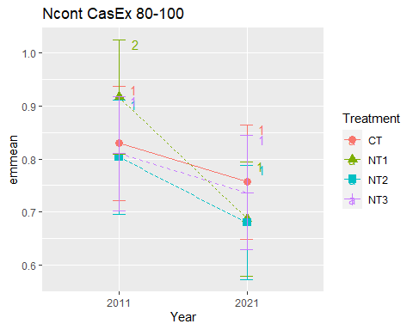

## [1] "Summary for soil depths"

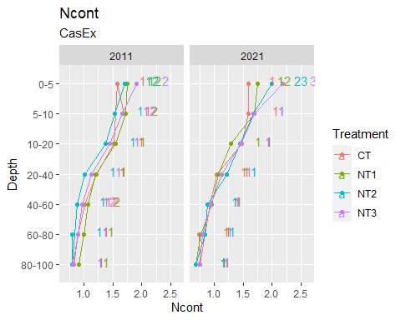

## [1] "Ccont"

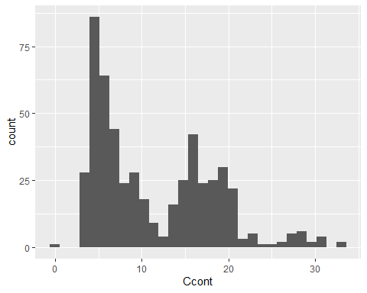

## [1] "Ccont MaiEx"  
## # A tibble: 56 × 7  
## Treatment Depth Year variable n mean sd  
## <fct> <fct> <fct> <chr> <dbl> <dbl> <dbl>  
## 1 CT 0-5 2011 Ccont 3 19.7 1.23   
## 2 NT1 0-5 2011 Ccont 3 18.6 0.937  
## 3 NT2 0-5 2011 Ccont 3 19.3 0.53   
## 4 NT3 0-5 2011 Ccont 3 19.0 1.42   
## 5 CT 5-10 2011 Ccont 3 17.6 0.687  
## 6 NT1 5-10 2011 Ccont 3 16.3 0.189  
## 7 NT2 5-10 2011 Ccont 3 16.4 0.076  
## 8 NT3 5-10 2011 Ccont 3 16.0 1.69   
## 9 CT 10-20 2011 Ccont 3 14.5 0.826  
## 10 NT1 10-20 2011 Ccont 3 13.9 0.687  
## # … with 46 more rows  
## [1] "Ccont MaiEx 0-5"

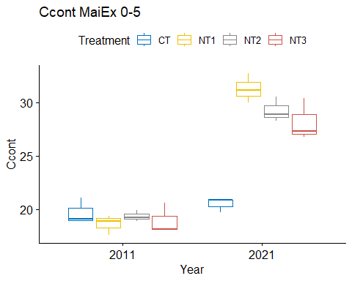

## [1] "Normality"

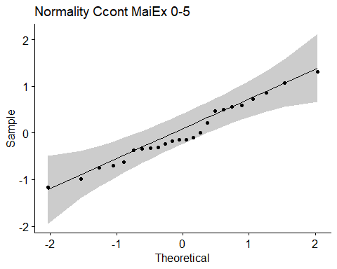

## [1] "Shapiro test for normality"  
## # A tibble: 1 × 3  
## variable statistic p.value  
## <chr> <dbl> <dbl>  
## 1 residuals(model) 0.972 0.713  
## [1] "Homoscedasticity"

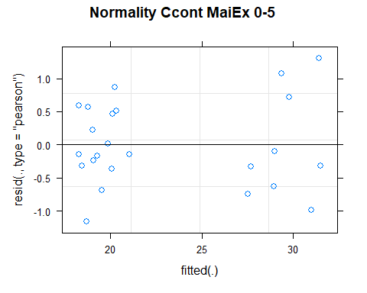

## [1] "Levene test for homoscedasticity"  
## # A tibble: 1 × 4  
## df1 df2 statistic p  
## <int> <int> <dbl> <dbl>  
## 1 7 16 0.230 0.972  
## [1] "ANOVA"  
## Treatment = CT:  
## Year emmean SE df lower.CL upper.CL .group  
## 2011 19.7 0.711 13.5 18.2 21.2 1   
## 2021 20.5 0.711 13.5 19.0 22.0 1   
##   
## Treatment = NT1:  
## Year emmean SE df lower.CL upper.CL .group  
## 2011 18.6 0.711 13.5 17.1 20.1 1   
## 2021 31.3 0.711 13.5 29.8 32.8 2   
##   
## Treatment = NT2:  
## Year emmean SE df lower.CL upper.CL .group  
## 2011 19.3 0.711 13.5 17.8 20.9 1   
## 2021 29.2 0.711 13.5 27.7 30.8 2   
##   
## Treatment = NT3:  
## Year emmean SE df lower.CL upper.CL .group  
## 2011 19.0 0.711 13.5 17.4 20.5 1   
## 2021 28.2 0.711 13.5 26.6 29.7 2   
##   
## Degrees-of-freedom method: kenward-roger   
## Results are given on the [ (not the response) scale.   
## Confidence level used: 0.95   
## Note: contrasts are still on the [ scale   
## significance level used: alpha = 0.05   
## NOTE: If two or more means share the same grouping symbol,  
## then we cannot show them to be different.  
## But we also did not show them to be the same.   
## Year = 2011:  
## Treatment emmean SE df lower.CL upper.CL .group  
## NT1 18.6 0.711 13.5 17.1 20.1 1   
## NT3 19.0 0.711 13.5 17.4 20.5 1   
## NT2 19.3 0.711 13.5 17.8 20.9 1   
## CT 19.7 0.711 13.5 18.2 21.2 1   
##   
## Year = 2021:  
## Treatment emmean SE df lower.CL upper.CL .group  
## CT 20.5 0.711 13.5 19.0 22.0 1   
## NT3 28.2 0.711 13.5 26.6 29.7 2   
## NT2 29.2 0.711 13.5 27.7 30.8 23   
## NT1 31.3 0.711 13.5 29.8 32.8 3   
##   
## Degrees-of-freedom method: kenward-roger   
## Results are given on the [ (not the response) scale.   
## Confidence level used: 0.95   
## Note: contrasts are still on the [ scale   
## P value adjustment: tukey method for comparing a family of 4 estimates   
## significance level used: alpha = 0.05   
## NOTE: If two or more means share the same grouping symbol,  
## then we cannot show them to be different.  
## But we also did not show them to be the same.   
## [1] "ANOVA plot"

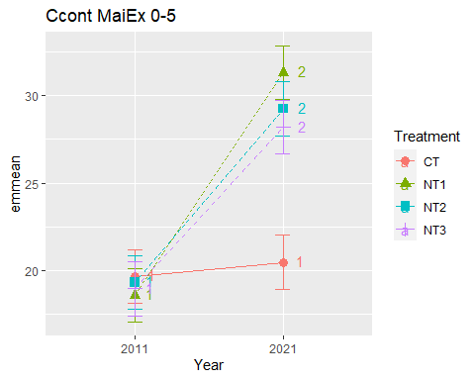

## [1] "Ccont MaiEx 5-10"

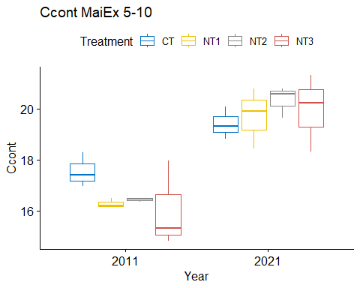

## [1] "Normality"

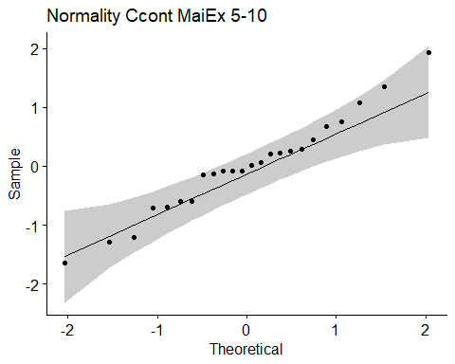

## [1] "Shapiro test for normality"  
## # A tibble: 1 × 3  
## variable statistic p.value  
## <chr> <dbl> <dbl>  
## 1 residuals(model) 0.978 0.849  
## [1] "Homoscedasticity"

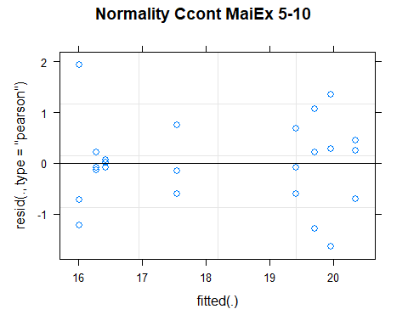

## [1] "Levene test for homoscedasticity"  
## # A tibble: 1 × 4  
## df1 df2 statistic p  
## <int> <int> <dbl> <dbl>  
## 1 7 16 0.830 0.578  
## [1] "ANOVA"  
## Treatment = CT:  
## Year emmean SE df lower.CL upper.CL .group  
## 2011 17.6 0.574 16 16.3 18.8 1   
## 2021 19.4 0.574 16 18.2 20.6 1   
##   
## Treatment = NT1:  
## Year emmean SE df lower.CL upper.CL .group  
## 2011 16.3 0.574 16 15.1 17.5 1   
## 2021 19.7 0.574 16 18.5 20.9 2   
##   
## Treatment = NT2:  
## Year emmean SE df lower.CL upper.CL .group  
## 2011 16.4 0.574 16 15.2 17.6 1   
## 2021 20.3 0.574 16 19.1 21.6 2   
##   
## Treatment = NT3:  
## Year emmean SE df lower.CL upper.CL .group  
## 2011 16.0 0.574 16 14.8 17.2 1   
## 2021 20.0 0.574 16 18.7 21.2 2   
##   
## Degrees-of-freedom method: kenward-roger   
## Results are given on the [ (not the response) scale.   
## Confidence level used: 0.95   
## Note: contrasts are still on the [ scale   
## significance level used: alpha = 0.05   
## NOTE: If two or more means share the same grouping symbol,  
## then we cannot show them to be different.  
## But we also did not show them to be the same.   
## Year = 2011:  
## Treatment emmean SE df lower.CL upper.CL .group  
## NT3 16.0 0.574 16 14.8 17.2 1   
## NT1 16.3 0.574 16 15.1 17.5 1   
## NT2 16.4 0.574 16 15.2 17.6 1   
## CT 17.6 0.574 16 16.3 18.8 1   
##   
## Year = 2021:  
## Treatment emmean SE df lower.CL upper.CL .group  
## CT 19.4 0.574 16 18.2 20.6 1   
## NT1 19.7 0.574 16 18.5 20.9 1   
## NT3 20.0 0.574 16 18.7 21.2 1   
## NT2 20.3 0.574 16 19.1 21.6 1   
##   
## Degrees-of-freedom method: kenward-roger   
## Results are given on the [ (not the response) scale.   
## Confidence level used: 0.95   
## Note: contrasts are still on the [ scale   
## P value adjustment: tukey method for comparing a family of 4 estimates   
## significance level used: alpha = 0.05   
## NOTE: If two or more means share the same grouping symbol,  
## then we cannot show them to be different.  
## But we also did not show them to be the same.   
## [1] "ANOVA plot"

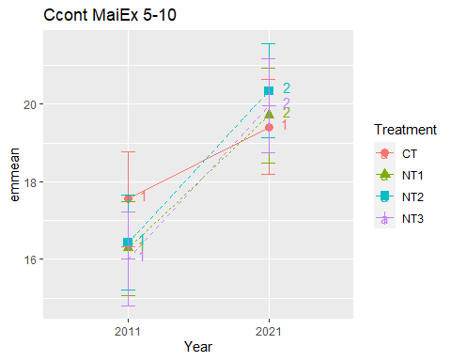

## [1] "Ccont MaiEx 10-20"

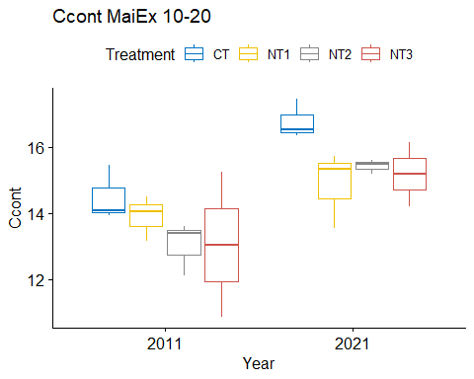

## [1] "Normality"

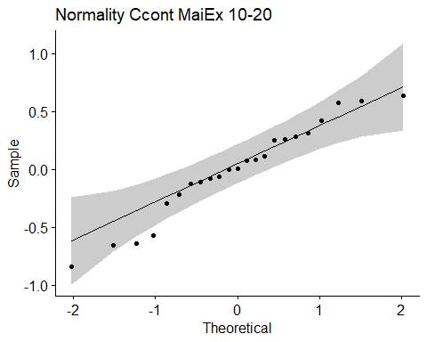

## [1] "Shapiro test for normality"  
## # A tibble: 1 × 3  
## variable statistic p.value  
## <chr> <dbl> <dbl>  
## 1 residuals(model) 0.960 0.454  
## [1] "Homoscedasticity"

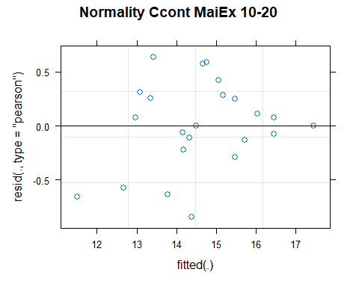

## [1] "Levene test for homoscedasticity"  
## # A tibble: 1 × 4  
## df1 df2 statistic p  
## <int> <int> <dbl> <dbl>  
## 1 7 15 0.927 0.514  
## [1] "ANOVA"  
## Treatment = CT:  
## Year emmean SE df lower.CL upper.CL .group  
## 2011 14.5 0.692 10.4 13.0 16.0 1   
## 2021 16.8 0.692 10.4 15.2 18.3 2   
##   
## Treatment = NT1:  
## Year emmean SE df lower.CL upper.CL .group  
## 2011 13.9 0.692 10.4 12.4 15.4 1   
## 2021 14.9 0.692 10.4 13.3 16.4 1   
##   
## Treatment = NT2:  
## Year emmean SE df lower.CL upper.CL .group  
## 2011 13.0 0.692 10.4 11.5 14.6 1   
## 2021 15.4 0.692 10.4 13.9 17.0 2   
##   
## Treatment = NT3:  
## Year emmean SE df lower.CL upper.CL .group  
## 2011 13.1 0.692 10.4 11.5 14.6 1   
## 2021 14.4 0.786 13.1 12.7 16.1 1   
##   
## Degrees-of-freedom method: kenward-roger   
## Results are given on the [ (not the response) scale.   
## Confidence level used: 0.95   
## Note: contrasts are still on the [ scale   
## significance level used: alpha = 0.05   
## NOTE: If two or more means share the same grouping symbol,  
## then we cannot show them to be different.  
## But we also did not show them to be the same.   
## Year = 2011:  
## Treatment emmean SE df lower.CL upper.CL .group  
## NT2 13.0 0.692 10.4 11.5 14.6 1   
## NT3 13.1 0.692 10.4 11.5 14.6 1   
## NT1 13.9 0.692 10.4 12.4 15.4 1   
## CT 14.5 0.692 10.4 13.0 16.0 1   
##   
## Year = 2021:  
## Treatment emmean SE df lower.CL upper.CL .group  
## NT3 14.4 0.786 13.1 12.7 16.1 1   
## NT1 14.9 0.692 10.4 13.3 16.4 1   
## NT2 15.4 0.692 10.4 13.9 17.0 1   
## CT 16.8 0.692 10.4 15.2 18.3 1   
##   
## Degrees-of-freedom method: kenward-roger   
## Results are given on the [ (not the response) scale.   
## Confidence level used: 0.95   
## Note: contrasts are still on the [ scale   
## P value adjustment: tukey method for comparing a family of 4 estimates   
## significance level used: alpha = 0.05   
## NOTE: If two or more means share the same grouping symbol,  
## then we cannot show them to be different.  
## But we also did not show them to be the same.   
## [1] "ANOVA plot"

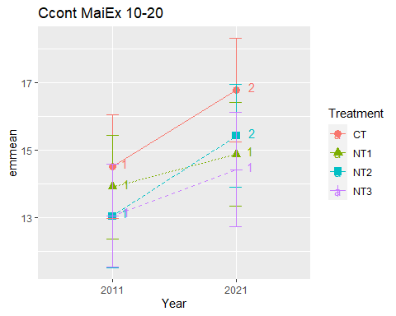

## [1] "Ccont MaiEx 20-40"

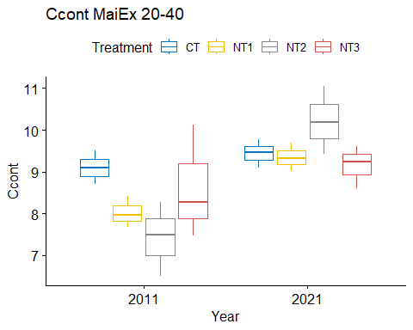

## [1] "Normality"

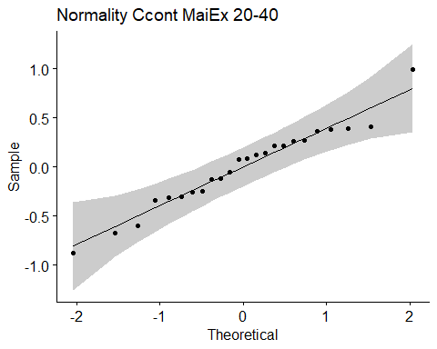

## [1] "Shapiro test for normality"  
## # A tibble: 1 × 3  
## variable statistic p.value  
## <chr> <dbl> <dbl>  
## 1 residuals(model) 0.970 0.677  
## [1] "Homoscedasticity"

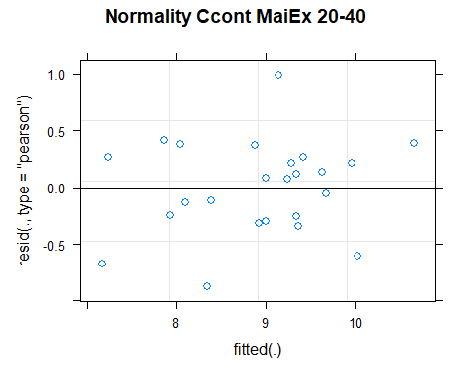

## [1] "Levene test for homoscedasticity"  
## # A tibble: 1 × 4  
## df1 df2 statistic p  
## <int> <int> <dbl> <dbl>  
## 1 7 16 0.819 0.585  
## [1] "ANOVA"  
## Treatment = CT:  
## Year emmean SE df lower.CL upper.CL .group  
## 2011 9.10 0.412 14.2 8.22 9.98 1   
## 2021 9.44 0.412 14.2 8.56 10.32 1   
##   
## Treatment = NT1:  
## Year emmean SE df lower.CL upper.CL .group  
## 2011 8.02 0.412 14.2 7.14 8.91 1   
## 2021 9.34 0.412 14.2 8.46 10.23 2   
##   
## Treatment = NT2:  
## Year emmean SE df lower.CL upper.CL .group  
## 2011 7.42 0.412 14.2 6.54 8.31 1   
## 2021 10.22 0.412 14.2 9.33 11.10 2   
##   
## Treatment = NT3:  
## Year emmean SE df lower.CL upper.CL .group  
## 2011 8.63 0.412 14.2 7.75 9.51 1   
## 2021 9.16 0.412 14.2 8.28 10.04 1   
##   
## Degrees-of-freedom method: kenward-roger   
## Results are given on the [ (not the response) scale.   
## Confidence level used: 0.95   
## Note: contrasts are still on the [ scale   
## significance level used: alpha = 0.05   
## NOTE: If two or more means share the same grouping symbol,  
## then we cannot show them to be different.  
## But we also did not show them to be the same.   
## Year = 2011:  
## Treatment emmean SE df lower.CL upper.CL .group  
## NT2 7.42 0.412 14.2 6.54 8.31 1   
## NT1 8.02 0.412 14.2 7.14 8.91 1   
## NT3 8.63 0.412 14.2 7.75 9.51 1   
## CT 9.10 0.412 14.2 8.22 9.98 1   
##   
## Year = 2021:  
## Treatment emmean SE df lower.CL upper.CL .group  
## NT3 9.16 0.412 14.2 8.28 10.04 1   
## NT1 9.34 0.412 14.2 8.46 10.23 1   
## CT 9.44 0.412 14.2 8.56 10.32 1   
## NT2 10.22 0.412 14.2 9.33 11.10 1   
##   
## Degrees-of-freedom method: kenward-roger   
## Results are given on the [ (not the response) scale.   
## Confidence level used: 0.95   
## Note: contrasts are still on the [ scale   
## P value adjustment: tukey method for comparing a family of 4 estimates   
## significance level used: alpha = 0.05   
## NOTE: If two or more means share the same grouping symbol,  
## then we cannot show them to be different.  
## But we also did not show them to be the same.   
## [1] "ANOVA plot"

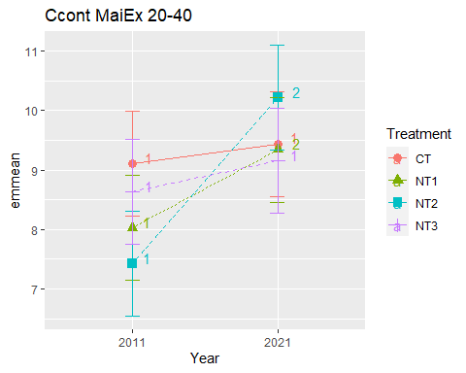

## [1] "Ccont MaiEx 40-60"

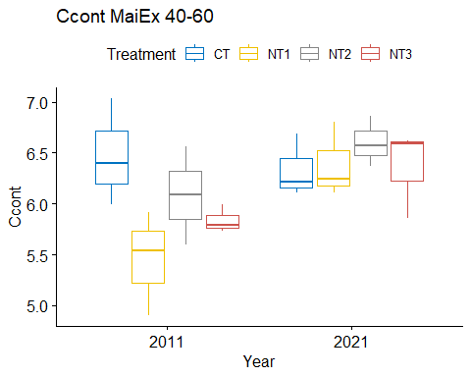

## [1] "Normality"

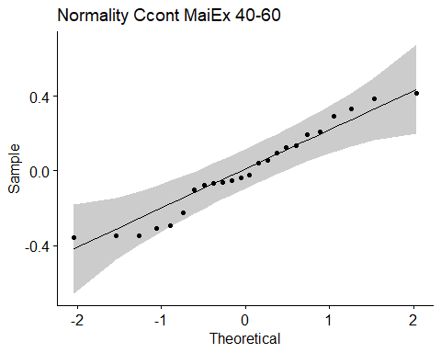

## [1] "Shapiro test for normality"  
## # A tibble: 1 × 3  
## variable statistic p.value  
## <chr> <dbl> <dbl>  
## 1 residuals(model) 0.953 0.318  
## [1] "Homoscedasticity"

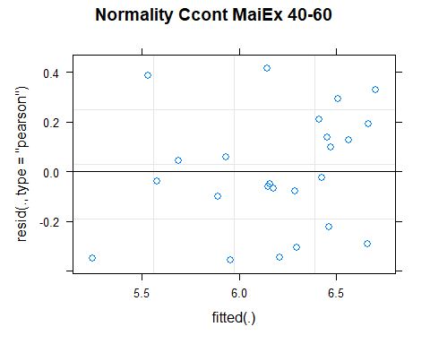

## [1] "Levene test for homoscedasticity"  
## # A tibble: 1 × 4  
## df1 df2 statistic p  
## <int> <int> <dbl> <dbl>  
## 1 7 16 0.321 0.933  
## [1] "ANOVA"  
## Treatment = CT:  
## Year emmean SE df lower.CL upper.CL .group  
## 2021 6.34 0.23 14.4 5.85 6.83 1   
## 2011 6.47 0.23 14.4 5.98 6.96 1   
##   
## Treatment = NT1:  
## Year emmean SE df lower.CL upper.CL .group  
## 2011 5.45 0.23 14.4 4.96 5.94 1   
## 2021 6.38 0.23 14.4 5.89 6.87 2   
##   
## Treatment = NT2:  
## Year emmean SE df lower.CL upper.CL .group  
## 2011 6.08 0.23 14.4 5.59 6.57 1   
## 2021 6.60 0.23 14.4 6.11 7.09 1   
##   
## Treatment = NT3:  
## Year emmean SE df lower.CL upper.CL .group  
## 2011 5.84 0.23 14.4 5.35 6.33 1   
## 2021 6.36 0.23 14.4 5.87 6.85 1   
##   
## Degrees-of-freedom method: kenward-roger   
## Results are given on the [ (not the response) scale.   
## Confidence level used: 0.95   
## Note: contrasts are still on the [ scale   
## significance level used: alpha = 0.05   
## NOTE: If two or more means share the same grouping symbol,  
## then we cannot show them to be different.  
## But we also did not show them to be the same.   
## Year = 2011:  
## Treatment emmean SE df lower.CL upper.CL .group  
## NT1 5.45 0.23 14.4 4.96 5.94 1   
## NT3 5.84 0.23 14.4 5.35 6.33 12   
## NT2 6.08 0.23 14.4 5.59 6.57 12   
## CT 6.47 0.23 14.4 5.98 6.96 2   
##   
## Year = 2021:  
## Treatment emmean SE df lower.CL upper.CL .group  
## CT 6.34 0.23 14.4 5.85 6.83 1   
## NT3 6.36 0.23 14.4 5.87 6.85 1   
## NT1 6.38 0.23 14.4 5.89 6.87 1   
## NT2 6.60 0.23 14.4 6.11 7.09 1   
##   
## Degrees-of-freedom method: kenward-roger   
## Results are given on the [ (not the response) scale.   
## Confidence level used: 0.95   
## Note: contrasts are still on the [ scale   
## P value adjustment: tukey method for comparing a family of 4 estimates   
## significance level used: alpha = 0.05   
## NOTE: If two or more means share the same grouping symbol,  
## then we cannot show them to be different.  
## But we also did not show them to be the same.   
## [1] "ANOVA plot"

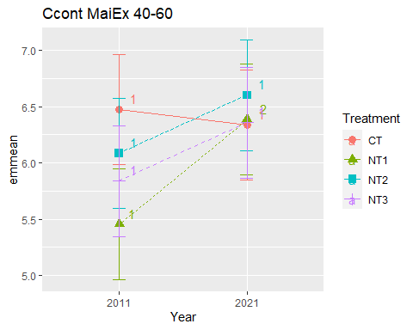

## [1] "Ccont MaiEx 60-80"

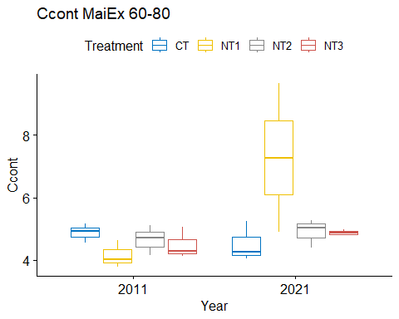

## [1] "Normality"

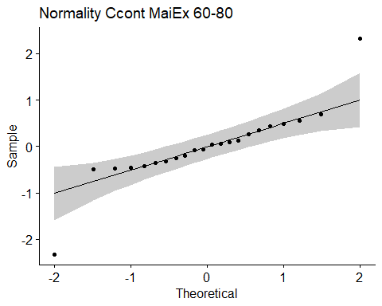

## [1] "Shapiro test for normality"  
## # A tibble: 1 × 3  
## variable statistic p.value  
## <chr> <dbl> <dbl>  
## 1 residuals(model) 0.836 0.00197  
## [1] "Homoscedasticity"

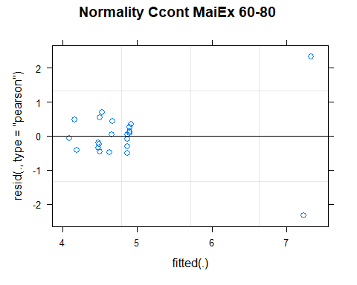

## [1] "Levene test for homoscedasticity"  
## # A tibble: 1 × 4  
## df1 df2 statistic p  
## <int> <int> <dbl> <dbl>  
## 1 7 14 10.9 0.000102  
## [1] "ANOVA"  
## Treatment = CT:  
## Year emmean SE df lower.CL upper.CL .group  
## 2021 4.51 0.579 14 3.27 5.75 1   
## 2011 4.88 0.579 14 3.64 6.12 1   
##   
## Treatment = NT1:  
## Year emmean SE df lower.CL upper.CL .group  
## 2011 4.15 0.579 14 2.91 5.39 1   
## 2021 7.28 0.747 14 5.68 8.88 2   
##   
## Treatment = NT2:  
## Year emmean SE df lower.CL upper.CL .group  
## 2011 4.65 0.579 14 3.41 5.89 1   
## 2021 4.89 0.579 14 3.65 6.13 1   
##   
## Treatment = NT3:  
## Year emmean SE df lower.CL upper.CL .group  
## 2011 4.49 0.579 14 3.25 5.73 1   
## 2021 4.88 0.747 14 3.28 6.48 1   
##   
## Degrees-of-freedom method: kenward-roger   
## Results are given on the [ (not the response) scale.   
## Confidence level used: 0.95   
## Note: contrasts are still on the [ scale   
## significance level used: alpha = 0.05   
## NOTE: If two or more means share the same grouping symbol,  
## then we cannot show them to be different.  
## But we also did not show them to be the same.   
## Year = 2011:  
## Treatment emmean SE df lower.CL upper.CL .group  
## NT1 4.15 0.579 14 2.91 5.39 1   
## NT3 4.49 0.579 14 3.25 5.73 1   
## NT2 4.65 0.579 14 3.41 5.89 1   
## CT 4.88 0.579 14 3.64 6.12 1   
##   
## Year = 2021:  
## Treatment emmean SE df lower.CL upper.CL .group  
## CT 4.51 0.579 14 3.27 5.75 1   
## NT3 4.88 0.747 14 3.28 6.48 12   
## NT2 4.89 0.579 14 3.65 6.13 12   
## NT1 7.28 0.747 14 5.68 8.88 2   
##   
## Degrees-of-freedom method: kenward-roger   
## Results are given on the [ (not the response) scale.   
## Confidence level used: 0.95   
## Note: contrasts are still on the [ scale   
## P value adjustment: tukey method for comparing a family of 4 estimates   
## significance level used: alpha = 0.05   
## NOTE: If two or more means share the same grouping symbol,  
## then we cannot show them to be different.  
## But we also did not show them to be the same.   
## [1] "ANOVA plot"

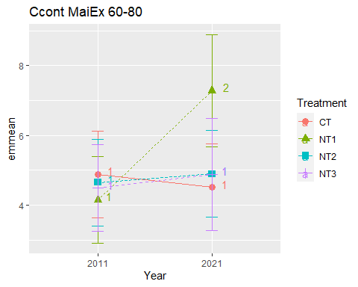

## [1] "Ccont MaiEx 80-100"

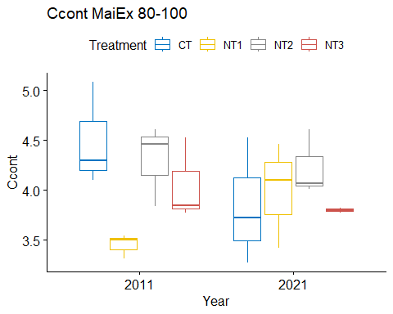

## [1] "Normality"

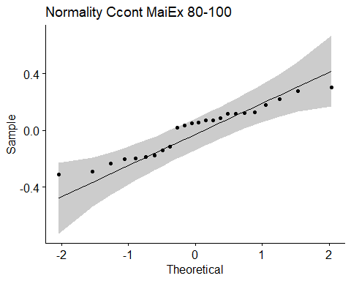

## [1] "Shapiro test for normality"  
## # A tibble: 1 × 3  
## variable statistic p.value  
## <chr> <dbl> <dbl>  
## 1 residuals(model) 0.937 0.141  
## [1] "Homoscedasticity"

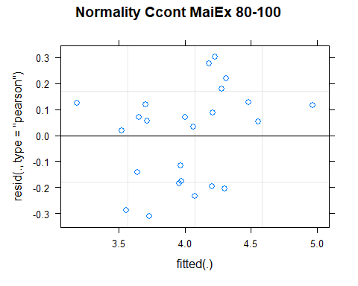

## [1] "Levene test for homoscedasticity"  
## # A tibble: 1 × 4  
## df1 df2 statistic p  
## <int> <int> <dbl> <dbl>  
## 1 7 16 0.567 0.772  
## [1] "ANOVA"  
## Treatment = CT:  
## Year emmean SE df lower.CL upper.CL .group  
## 2021 3.84 0.243 11.9 3.31 4.37 1   
## 2011 4.49 0.243 11.9 3.96 5.02 2   
##   
## Treatment = NT1:  
## Year emmean SE df lower.CL upper.CL .group  
## 2011 3.45 0.243 11.9 2.92 3.98 1   
## 2021 3.99 0.243 11.9 3.46 4.52 2   
##   
## Treatment = NT2:  
## Year emmean SE df lower.CL upper.CL .group  
## 2021 4.23 0.243 11.9 3.70 4.76 1   
## 2011 4.30 0.243 11.9 3.77 4.83 1   
##   
## Treatment = NT3:  
## Year emmean SE df lower.CL upper.CL .group  
## 2021 3.80 0.243 11.9 3.27 4.33 1   
## 2011 4.05 0.243 11.9 3.52 4.58 1   
##   
## Degrees-of-freedom method: kenward-roger   
## Results are given on the [ (not the response) scale.   
## Confidence level used: 0.95   
## Note: contrasts are still on the [ scale   
## significance level used: alpha = 0.05   
## NOTE: If two or more means share the same grouping symbol,  
## then we cannot show them to be different.  
## But we also did not show them to be the same.   
## Year = 2011:  
## Treatment emmean SE df lower.CL upper.CL .group  
## NT1 3.45 0.243 11.9 2.92 3.98 1   
## NT3 4.05 0.243 11.9 3.52 4.58 12   
## NT2 4.30 0.243 11.9 3.77 4.83 12   
## CT 4.49 0.243 11.9 3.96 5.02 2   
##   
## Year = 2021:  
## Treatment emmean SE df lower.CL upper.CL .group  
## NT3 3.80 0.243 11.9 3.27 4.33 1   
## CT 3.84 0.243 11.9 3.31 4.37 1   
## NT1 3.99 0.243 11.9 3.46 4.52 1   
## NT2 4.23 0.243 11.9 3.70 4.76 1   
##   
## Degrees-of-freedom method: kenward-roger   
## Results are given on the [ (not the response) scale.   
## Confidence level used: 0.95   
## Note: contrasts are still on the [ scale   
## P value adjustment: tukey method for comparing a family of 4 estimates   
## significance level used: alpha = 0.05   
## NOTE: If two or more means share the same grouping symbol,  
## then we cannot show them to be different.  
## But we also did not show them to be the same.   
## [1] "ANOVA plot"

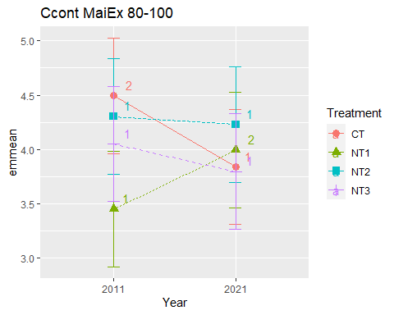

## [1] "Summary for soil depths"

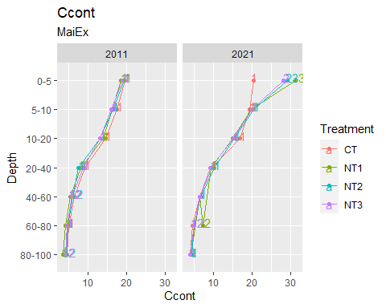

## [1] "Ccont SoyEx"  
## # A tibble: 56 × 7  
## Treatment Depth Year variable n mean sd  
## <fct> <fct> <fct> <chr> <dbl> <dbl> <dbl>  
## 1 CT 0-5 2011 Ccont 3 19.3 0.765  
## 2 NT1 0-5 2011 Ccont 3 19.9 0.333  
## 3 NT2 0-5 2011 Ccont 3 20.8 0.575  
## 4 NT3 0-5 2011 Ccont 3 20.1 0.551  
## 5 CT 5-10 2011 Ccont 3 18.6 0.737  
## 6 NT1 5-10 2011 Ccont 3 17.6 1.01   
## 7 NT2 5-10 2011 Ccont 3 17.1 0.944  
## 8 NT3 5-10 2011 Ccont 3 17.1 0.675  
## 9 CT 10-20 2011 Ccont 3 15.8 0.846  
## 10 NT1 10-20 2011 Ccont 3 15.6 0.721  
## # … with 46 more rows  
## [1] "Ccont SoyEx 0-5"

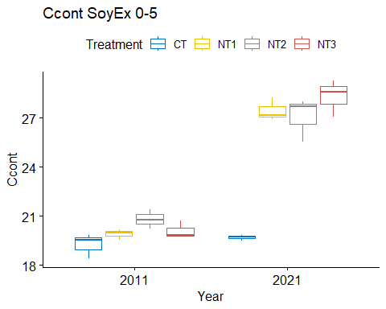

## [1] "Normality"

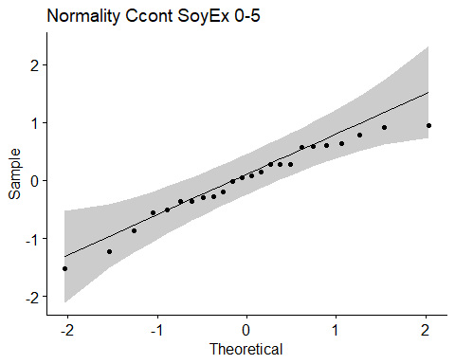

## [1] "Shapiro test for normality"  
## # A tibble: 1 × 3  
## variable statistic p.value  
## <chr> <dbl> <dbl>  
## 1 residuals(model) 0.960 0.430  
## [1] "Homoscedasticity"

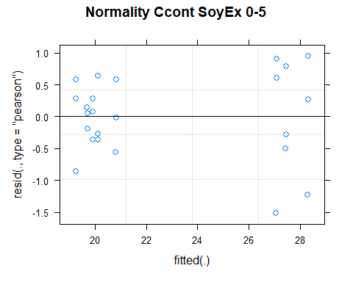

## [1] "Levene test for homoscedasticity"  
## # A tibble: 1 × 4  
## df1 df2 statistic p  
## <int> <int> <dbl> <dbl>  
## 1 7 16 0.452 0.854  
## [1] "ANOVA"  
## Treatment = CT:  
## Year emmean SE df lower.CL upper.CL .group  
## 2011 19.3 0.45 16 18.3 20.2 1   
## 2021 19.7 0.45 16 18.7 20.7 1   
##   
## Treatment = NT1:  
## Year emmean SE df lower.CL upper.CL .group  
## 2011 19.9 0.45 16 19.0 20.9 1   
## 2021 27.4 0.45 16 26.5 28.4 2   
##   
## Treatment = NT2:  
## Year emmean SE df lower.CL upper.CL .group  
## 2011 20.8 0.45 16 19.9 21.8 1   
## 2021 27.1 0.45 16 26.1 28.0 2   
##   
## Treatment = NT3:  
## Year emmean SE df lower.CL upper.CL .group  
## 2011 20.1 0.45 16 19.2 21.1 1   
## 2021 28.3 0.45 16 27.4 29.3 2   
##   
## Degrees-of-freedom method: kenward-roger   
## Results are given on the [ (not the response) scale.   
## Confidence level used: 0.95   
## Note: contrasts are still on the [ scale   
## significance level used: alpha = 0.05   
## NOTE: If two or more means share the same grouping symbol,  
## then we cannot show them to be different.  
## But we also did not show them to be the same.   
## Year = 2011:  
## Treatment emmean SE df lower.CL upper.CL .group  
## CT 19.3 0.45 16 18.3 20.2 1   
## NT1 19.9 0.45 16 19.0 20.9 1   
## NT3 20.1 0.45 16 19.2 21.1 1   
## NT2 20.8 0.45 16 19.9 21.8 1   
##   
## Year = 2021:  
## Treatment emmean SE df lower.CL upper.CL .group  
## CT 19.7 0.45 16 18.7 20.7 1   
## NT2 27.1 0.45 16 26.1 28.0 2   
## NT1 27.4 0.45 16 26.5 28.4 2   
## NT3 28.3 0.45 16 27.4 29.3 2   
##   
## Degrees-of-freedom method: kenward-roger   
## Results are given on the [ (not the response) scale.   
## Confidence level used: 0.95   
## Note: contrasts are still on the [ scale   
## P value adjustment: tukey method for comparing a family of 4 estimates   
## significance level used: alpha = 0.05   
## NOTE: If two or more means share the same grouping symbol,  
## then we cannot show them to be different.  
## But we also did not show them to be the same.   
## [1] "ANOVA plot"

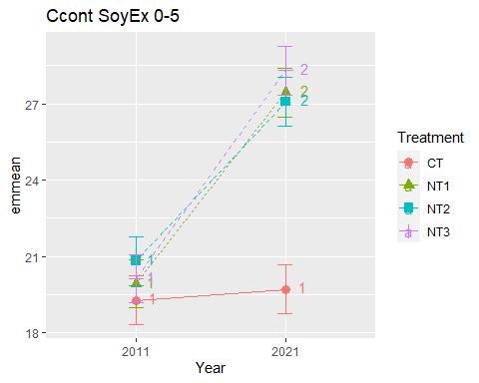

## [1] "Ccont SoyEx 5-10"

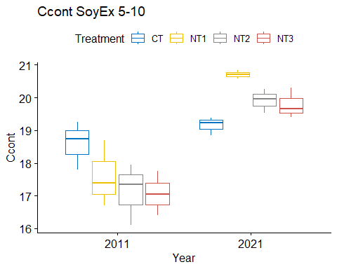

## [1] "Normality"

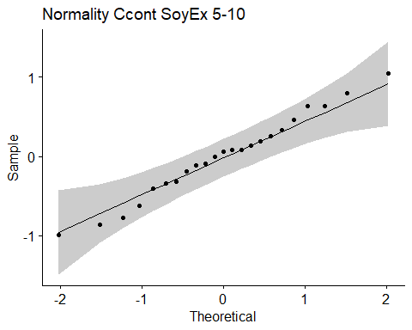

## [1] "Shapiro test for normality"  
## # A tibble: 1 × 3  
## variable statistic p.value  
## <chr> <dbl> <dbl>  
## 1 residuals(model) 0.985 0.973  
## [1] "Homoscedasticity"

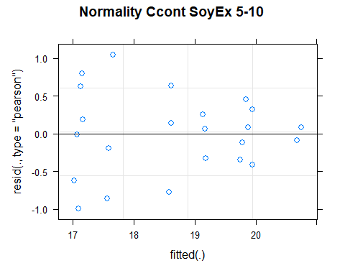

## [1] "Levene test for homoscedasticity"  
## # A tibble: 1 × 4  
## df1 df2 statistic p  
## <int> <int> <dbl> <dbl>  
## 1 7 15 0.610 0.740  
## [1] "ANOVA"  
## Treatment = CT:  
## Year emmean SE df lower.CL upper.CL .group  
## 2011 18.6 0.387 15 17.8 19.4 1   
## 2021 19.2 0.387 15 18.3 20.0 1   
##   
## Treatment = NT1:  
## Year emmean SE df lower.CL upper.CL .group  
## 2011 17.6 0.387 15 16.8 18.4 1   
## 2021 20.7 0.495 15 19.6 21.7 2   
##   
## Treatment = NT2:  
## Year emmean SE df lower.CL upper.CL .group  
## 2011 17.1 0.387 15 16.3 18.0 1   
## 2021 19.9 0.387 15 19.1 20.7 2   
##   
## Treatment = NT3:  
## Year emmean SE df lower.CL upper.CL .group  
## 2011 17.1 0.387 15 16.2 17.9 1   
## 2021 19.8 0.387 15 19.0 20.6 2   
##   
## Degrees-of-freedom method: kenward-roger   
## Results are given on the [ (not the response) scale.   
## Confidence level used: 0.95   
## Note: contrasts are still on the [ scale   
## significance level used: alpha = 0.05   
## NOTE: If two or more means share the same grouping symbol,  
## then we cannot show them to be different.  
## But we also did not show them to be the same.   
## Year = 2011:  
## Treatment emmean SE df lower.CL upper.CL .group  
## NT3 17.1 0.387 15 16.2 17.9 1   
## NT2 17.1 0.387 15 16.3 18.0 1   
## NT1 17.6 0.387 15 16.8 18.4 1   
## CT 18.6 0.387 15 17.8 19.4 1   
##   
## Year = 2021:  
## Treatment emmean SE df lower.CL upper.CL .group  
## CT 19.2 0.387 15 18.3 20.0 1   
## NT3 19.8 0.387 15 19.0 20.6 1   
## NT2 19.9 0.387 15 19.1 20.7 1   
## NT1 20.7 0.495 15 19.6 21.7 1   
##   
## Degrees-of-freedom method: kenward-roger   
## Results are given on the [ (not the response) scale.   
## Confidence level used: 0.95   
## Note: contrasts are still on the [ scale   
## P value adjustment: tukey method for comparing a family of 4 estimates   
## significance level used: alpha = 0.05   
## NOTE: If two or more means share the same grouping symbol,  
## then we cannot show them to be different.  
## But we also did not show them to be the same.   
## [1] "ANOVA plot"

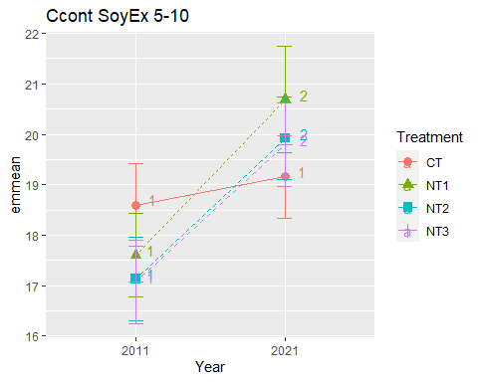

## [1] "Ccont SoyEx 10-20"

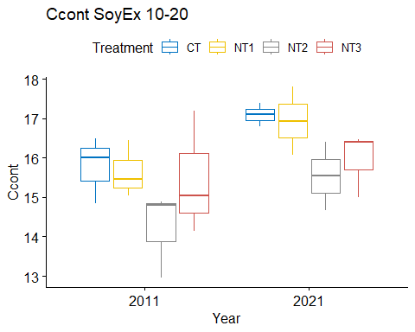

## [1] "Normality"

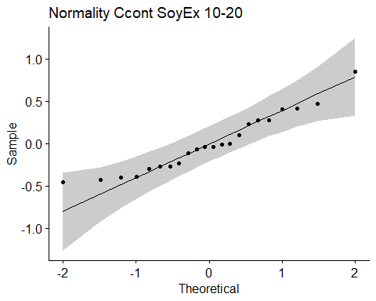

## [1] "Shapiro test for normality"  
## # A tibble: 1 × 3  
## variable statistic p.value  
## <chr> <dbl> <dbl>  
## 1 residuals(model) 0.942 0.215  
## [1] "Homoscedasticity"

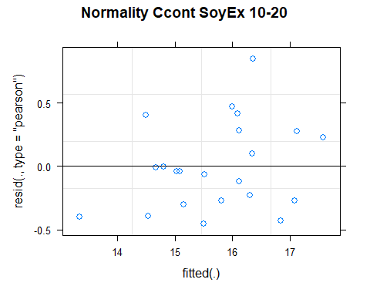

## [1] "Levene test for homoscedasticity"  
## # A tibble: 1 × 4  
## df1 df2 statistic p  
## <int> <int> <dbl> <dbl>  
## 1 7 14 0.254 0.962  
## [1] "ANOVA"  
## Treatment = CT:  
## Year emmean SE df lower.CL upper.CL .group  
## 2011 15.8 0.578 10.2 14.5 17.1 1   
## 2021 16.8 0.663 12.8 15.3 18.2 1   
##   
## Treatment = NT1:  
## Year emmean SE df lower.CL upper.CL .group  
## 2011 15.6 0.578 10.2 14.4 16.9 1   
## 2021 16.9 0.663 12.8 15.4 18.3 1   
##   
## Treatment = NT2:  
## Year emmean SE df lower.CL upper.CL .group  
## 2011 14.2 0.578 10.2 12.9 15.5 1   
## 2021 15.5 0.578 10.2 14.2 16.8 2   
##   
## Treatment = NT3:  
## Year emmean SE df lower.CL upper.CL .group  
## 2011 15.5 0.578 10.2 14.2 16.8 1   
## 2021 16.0 0.578 10.2 14.7 17.2 1   
##   
## Degrees-of-freedom method: kenward-roger   
## Results are given on the [ (not the response) scale.   
## Confidence level used: 0.95   
## Note: contrasts are still on the [ scale   
## significance level used: alpha = 0.05   
## NOTE: If two or more means share the same grouping symbol,  
## then we cannot show them to be different.  
## But we also did not show them to be the same.   
## Year = 2011:  
## Treatment emmean SE df lower.CL upper.CL .group  
## NT2 14.2 0.578 10.2 12.9 15.5 1   
## NT3 15.5 0.578 10.2 14.2 16.8 1   
## NT1 15.6 0.578 10.2 14.4 16.9 1   
## CT 15.8 0.578 10.2 14.5 17.1 1   
##   
## Year = 2021:  
## Treatment emmean SE df lower.CL upper.CL .group  
## NT2 15.5 0.578 10.2 14.2 16.8 1   
## NT3 16.0 0.578 10.2 14.7 17.2 1   
## CT 16.8 0.663 12.8 15.3 18.2 1   
## NT1 16.9 0.663 12.8 15.4 18.3 1   
##   
## Degrees-of-freedom method: kenward-roger   
## Results are given on the [ (not the response) scale.   
## Confidence level used: 0.95   
## Note: contrasts are still on the [ scale   
## P value adjustment: tukey method for comparing a family of 4 estimates   
## significance level used: alpha = 0.05   
## NOTE: If two or more means share the same grouping symbol,  
## then we cannot show them to be different.  
## But we also did not show them to be the same.   
## [1] "ANOVA plot"

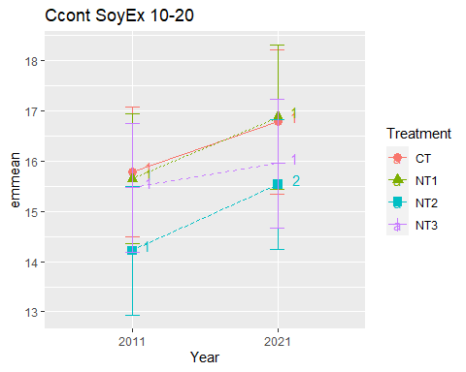

## [1] "Ccont SoyEx 20-40"

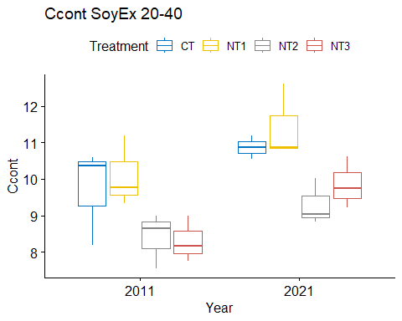

## [1] "Normality"

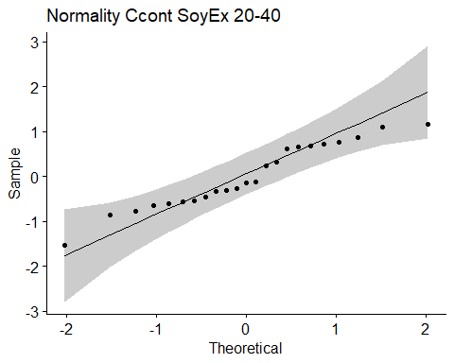

## [1] "Shapiro test for normality"  
## # A tibble: 1 × 3  
## variable statistic p.value  
## <chr> <dbl> <dbl>  
## 1 residuals(model) 0.950 0.298  
## [1] "Homoscedasticity"

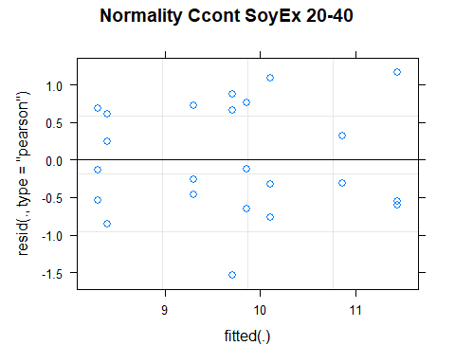

## [1] "Levene test for homoscedasticity"  
## # A tibble: 1 × 4  
## df1 df2 statistic p  
## <int> <int> <dbl> <dbl>  
## 1 7 15 0.129 0.995  
## [1] "ANOVA"  
## Treatment = CT:  
## Year emmean SE df lower.CL upper.CL .group  
## 2011 9.71 0.504 15 8.64 10.79 1   
## 2021 10.87 0.646 15 9.49 12.24 1   
##   
## Treatment = NT1:  
## Year emmean SE df lower.CL upper.CL .group  
## 2011 10.11 0.504 15 9.03 11.18 1   
## 2021 11.44 0.504 15 10.36 12.51 1   
##   
## Treatment = NT2:  
## Year emmean SE df lower.CL upper.CL .group  
## 2011 8.39 0.504 15 7.32 9.47 1   
## 2021 9.30 0.504 15 8.23 10.37 1   
##   
## Treatment = NT3:  
## Year emmean SE df lower.CL upper.CL .group  
## 2011 8.30 0.504 15 7.23 9.37 1   
## 2021 9.86 0.504 15 8.78 10.93 1   
##   
## Degrees-of-freedom method: kenward-roger   
## Results are given on the [ (not the response) scale.   
## Confidence level used: 0.95   
## Note: contrasts are still on the [ scale   
## significance level used: alpha = 0.05   
## NOTE: If two or more means share the same grouping symbol,  
## then we cannot show them to be different.  
## But we also did not show them to be the same.   
## Year = 2011:  
## Treatment emmean SE df lower.CL upper.CL .group  
## NT3 8.30 0.504 15 7.23 9.37 1   
## NT2 8.39 0.504 15 7.32 9.47 1   
## CT 9.71 0.504 15 8.64 10.79 1   
## NT1 10.11 0.504 15 9.03 11.18 1   
##   
## Year = 2021:  
## Treatment emmean SE df lower.CL upper.CL .group  
## NT2 9.30 0.504 15 8.23 10.37 1   
## NT3 9.86 0.504 15 8.78 10.93 12   
## CT 10.87 0.646 15 9.49 12.24 12   
## NT1 11.44 0.504 15 10.36 12.51 2   
##   
## Degrees-of-freedom method: kenward-roger   
## Results are given on the [ (not the response) scale.   
## Confidence level used: 0.95   
## Note: contrasts are still on the [ scale   
## P value adjustment: tukey method for comparing a family of 4 estimates   
## significance level used: alpha = 0.05   
## NOTE: If two or more means share the same grouping symbol,  
## then we cannot show them to be different.  
## But we also did not show them to be the same.   
## [1] "ANOVA plot"

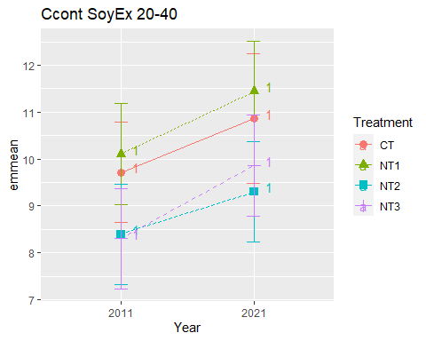

## [1] "Ccont SoyEx 40-60"

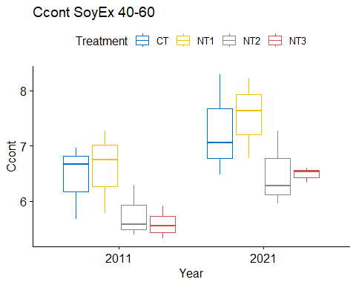

## [1] "Normality"

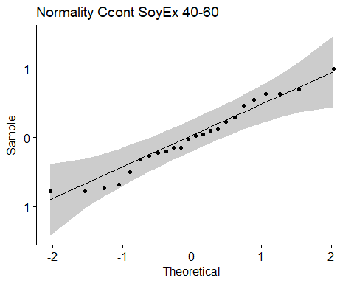

## [1] "Shapiro test for normality"  
## # A tibble: 1 × 3  
## variable statistic p.value  
## <chr> <dbl> <dbl>  
## 1 residuals(model) 0.966 0.579  
## [1] "Homoscedasticity"

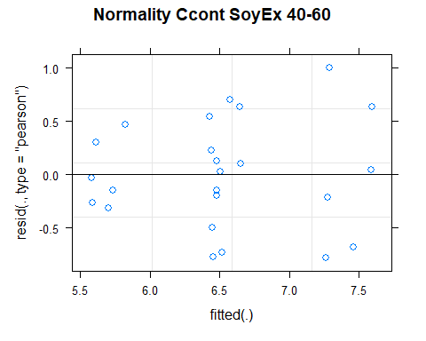

## [1] "Levene test for homoscedasticity"  
## # A tibble: 1 × 4  
## df1 df2 statistic p  
## <int> <int> <dbl> <dbl>  
## 1 7 16 0.470 0.842  
## [1] "ANOVA"  
## Treatment = CT:  
## Year emmean SE df lower.CL upper.CL .group  
## 2011 6.44 0.367 15.9 5.66 7.22 1   
## 2021 7.28 0.367 15.9 6.50 8.05 1   
##   
## Treatment = NT1:  
## Year emmean SE df lower.CL upper.CL .group  
## 2011 6.60 0.367 15.9 5.83 7.38 1   
## 2021 7.55 0.367 15.9 6.77 8.32 1   
##   
## Treatment = NT2:  
## Year emmean SE df lower.CL upper.CL .group  
## 2011 5.75 0.367 15.9 4.98 6.53 1   
## 2021 6.50 0.367 15.9 5.72 7.28 1   
##   
## Treatment = NT3:  
## Year emmean SE df lower.CL upper.CL .group  
## 2011 5.59 0.367 15.9 4.82 6.37 1   
## 2021 6.49 0.367 15.9 5.71 7.26 1   
##   
## Degrees-of-freedom method: kenward-roger   
## Results are given on the [ (not the response) scale.   
## Confidence level used: 0.95   
## Note: contrasts are still on the [ scale   
## significance level used: alpha = 0.05   
## NOTE: If two or more means share the same grouping symbol,  
## then we cannot show them to be different.  
## But we also did not show them to be the same.   
## Year = 2011:  
## Treatment emmean SE df lower.CL upper.CL .group  
## NT3 5.59 0.367 15.9 4.82 6.37 1   
## NT2 5.75 0.367 15.9 4.98 6.53 1   
## CT 6.44 0.367 15.9 5.66 7.22 1   
## NT1 6.60 0.367 15.9 5.83 7.38 1   
##   
## Year = 2021:  
## Treatment emmean SE df lower.CL upper.CL .group  
## NT3 6.49 0.367 15.9 5.71 7.26 1   
## NT2 6.50 0.367 15.9 5.72 7.28 1   
## CT 7.28 0.367 15.9 6.50 8.05 1   
## NT1 7.55 0.367 15.9 6.77 8.32 1   
##   
## Degrees-of-freedom method: kenward-roger   
## Results are given on the [ (not the response) scale.   
## Confidence level used: 0.95   
## Note: contrasts are still on the [ scale   
## P value adjustment: tukey method for comparing a family of 4 estimates   
## significance level used: alpha = 0.05   
## NOTE: If two or more means share the same grouping symbol,  
## then we cannot show them to be different.  
## But we also did not show them to be the same.   
## [1] "ANOVA plot"

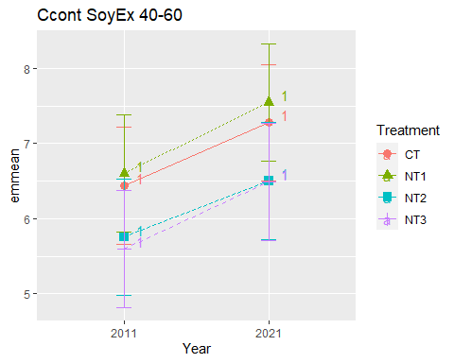

## [1] "Ccont SoyEx 60-80"

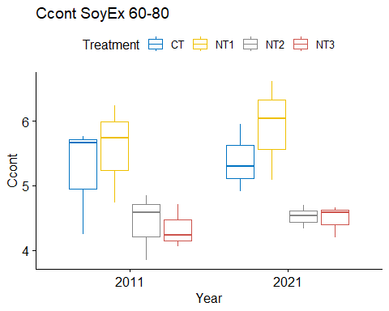

## [1] "Normality"

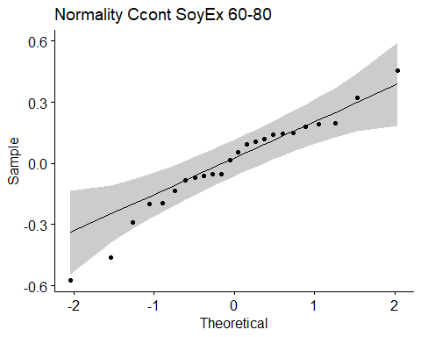

## [1] "Shapiro test for normality"  
## # A tibble: 1 × 3  
## variable statistic p.value  
## <chr> <dbl> <dbl>  
## 1 residuals(model) 0.960 0.435  
## [1] "Homoscedasticity"

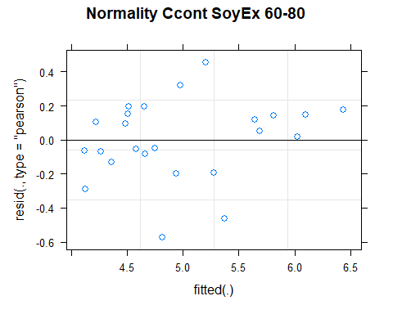

## [1] "Levene test for homoscedasticity"  
## # A tibble: 1 × 4  
## df1 df2 statistic p  
## <int> <int> <dbl> <dbl>  
## 1 7 16 0.418 0.877  
## [1] "ANOVA"  
## Treatment = CT:  
## Year emmean SE df lower.CL upper.CL .group  
## 2011 5.22 0.333 11.6 4.49 5.95 1   
## 2021 5.39 0.333 11.6 4.66 6.12 1   
##   
## Treatment = NT1:  
## Year emmean SE df lower.CL upper.CL .group  
## 2011 5.57 0.333 11.6 4.84 6.30 1   
## 2021 5.91 0.333 11.6 5.18 6.64 1   
##   
## Treatment = NT2:  
## Year emmean SE df lower.CL upper.CL .group  
## 2011 4.42 0.333 11.6 3.69 5.15 1   
## 2021 4.52 0.333 11.6 3.79 5.25 1   
##   
## Treatment = NT3:  
## Year emmean SE df lower.CL upper.CL .group  
## 2011 4.33 0.333 11.6 3.60 5.06 1   
## 2021 4.48 0.333 11.6 3.75 5.21 1   
##   
## Degrees-of-freedom method: kenward-roger   
## Results are given on the [ (not the response) scale.   
## Confidence level used: 0.95   
## Note: contrasts are still on the [ scale   
## significance level used: alpha = 0.05   
## NOTE: If two or more means share the same grouping symbol,  
## then we cannot show them to be different.  
## But we also did not show them to be the same.   
## Year = 2011:  
## Treatment emmean SE df lower.CL upper.CL .group  
## NT3 4.33 0.333 11.6 3.60 5.06 1   
## NT2 4.42 0.333 11.6 3.69 5.15 1   
## CT 5.22 0.333 11.6 4.49 5.95 1   
## NT1 5.57 0.333 11.6 4.84 6.30 1   
##   
## Year = 2021:  
## Treatment emmean SE df lower.CL upper.CL .group  
## NT3 4.48 0.333 11.6 3.75 5.21 1   
## NT2 4.52 0.333 11.6 3.79 5.25 12   
## CT 5.39 0.333 11.6 4.66 6.12 12   
## NT1 5.91 0.333 11.6 5.18 6.64 2   
##   
## Degrees-of-freedom method: kenward-roger   
## Results are given on the [ (not the response) scale.   
## Confidence level used: 0.95   
## Note: contrasts are still on the [ scale   
## P value adjustment: tukey method for comparing a family of 4 estimates   
## significance level used: alpha = 0.05   
## NOTE: If two or more means share the same grouping symbol,  
## then we cannot show them to be different.  
## But we also did not show them to be the same.   
## [1] "ANOVA plot"

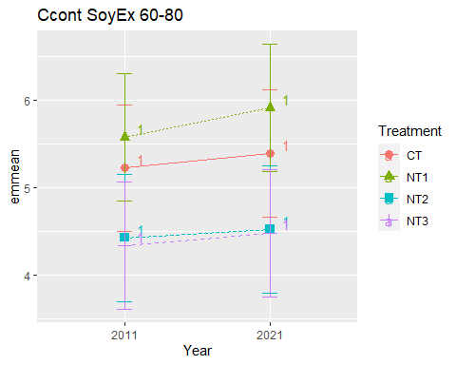

## [1] "Ccont SoyEx 80-100"

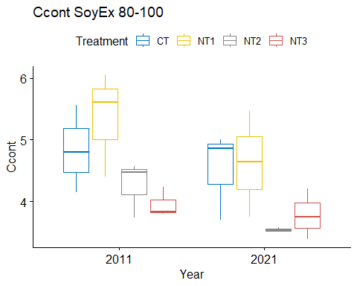

## [1] "Normality"

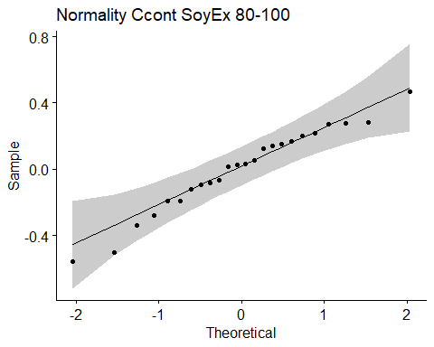

## [1] "Shapiro test for normality"  
## # A tibble: 1 × 3  
## variable statistic p.value  
## <chr> <dbl> <dbl>  
## 1 residuals(model) 0.968 0.623  
## [1] "Homoscedasticity"

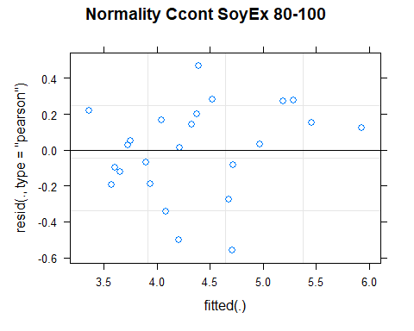

## [1] "Levene test for homoscedasticity"  
## # A tibble: 1 × 4  
## df1 df2 statistic p  
## <int> <int> <dbl> <dbl>  
## 1 7 16 0.635 0.721  
## [1] "ANOVA"  
## Treatment = CT:  
## Year emmean SE df lower.CL upper.CL .group  
## 2021 4.52 0.348 11.9 3.76 5.28 1   
## 2011 4.84 0.348 11.9 4.08 5.60 1   
##   
## Treatment = NT1:  
## Year emmean SE df lower.CL upper.CL .group  
## 2021 4.62 0.348 11.9 3.86 5.38 1   
## 2011 5.35 0.348 11.9 4.59 6.11 2   
##   
## Treatment = NT2:  
## Year emmean SE df lower.CL upper.CL .group  
## 2021 3.54 0.348 11.9 2.78 4.30 1   
## 2011 4.26 0.348 11.9 3.50 5.02 1   
##   
## Treatment = NT3:  
## Year emmean SE df lower.CL upper.CL .group  
## 2021 3.78 0.348 11.9 3.02 4.54 1   
## 2011 3.95 0.348 11.9 3.19 4.71 1   
##   
## Degrees-of-freedom method: kenward-roger   
## Results are given on the [ (not the response) scale.   
## Confidence level used: 0.95   
## Note: contrasts are still on the [ scale   
## significance level used: alpha = 0.05   
## NOTE: If two or more means share the same grouping symbol,  
## then we cannot show them to be different.  
## But we also did not show them to be the same.   
## Year = 2011:  
## Treatment emmean SE df lower.CL upper.CL .group  
## NT3 3.95 0.348 11.9 3.19 4.71 1   
## NT2 4.26 0.348 11.9 3.50 5.02 1   
## CT 4.84 0.348 11.9 4.08 5.60 1   
## NT1 5.35 0.348 11.9 4.59 6.11 1   
##   
## Year = 2021:  
## Treatment emmean SE df lower.CL upper.CL .group  
## NT2 3.54 0.348 11.9 2.78 4.30 1   
## NT3 3.78 0.348 11.9 3.02 4.54 1   
## CT 4.52 0.348 11.9 3.76 5.28 1   
## NT1 4.62 0.348 11.9 3.86 5.38 1   
##   
## Degrees-of-freedom method: kenward-roger   
## Results are given on the [ (not the response) scale.   
## Confidence level used: 0.95   
## Note: contrasts are still on the [ scale   
## P value adjustment: tukey method for comparing a family of 4 estimates   
## significance level used: alpha = 0.05   
## NOTE: If two or more means share the same grouping symbol,  
## then we cannot show them to be different.  
## But we also did not show them to be the same.   
## [1] "ANOVA plot"

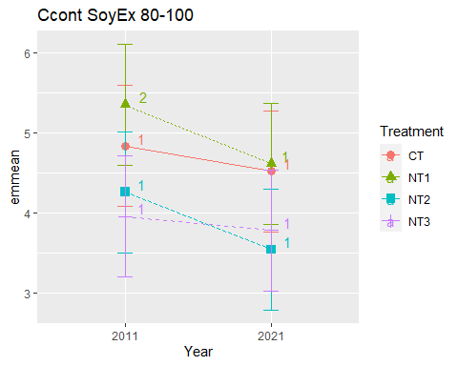

## [1] "Summary for soil depths"

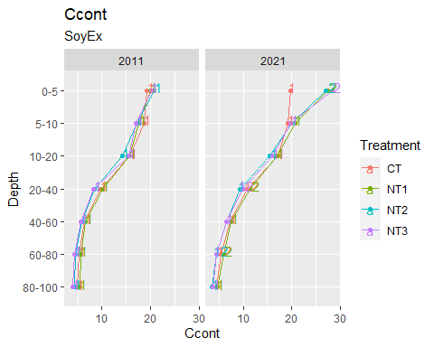

## [1] "Ccont CasEx"  
## # A tibble: 56 × 7  
## Treatment Depth Year variable n mean sd  
## <fct> <fct> <fct> <chr> <dbl> <dbl> <dbl>  
## 1 CT 0-5 2011 Ccont 3 15.6 0.589  
## 2 NT1 0-5 2011 Ccont 3 15.6 1.28   
## 3 NT2 0-5 2011 Ccont 3 18.0 0.247  
## 4 NT3 0-5 2011 Ccont 3 18.7 1.50   
## 5 CT 5-10 2011 Ccont 3 16.4 0.597  
## 6 NT1 5-10 2011 Ccont 3 15.2 1.12   
## 7 NT2 5-10 2011 Ccont 3 16.7 0.058  
## 8 NT3 5-10 2011 Ccont 3 16.1 0.115  
## 9 CT 10-20 2011 Ccont 3 15.2 0.999  
## 10 NT1 10-20 2011 Ccont 3 13.0 1.16   
## # … with 46 more rows  
## [1] "Ccont CasEx 0-5"

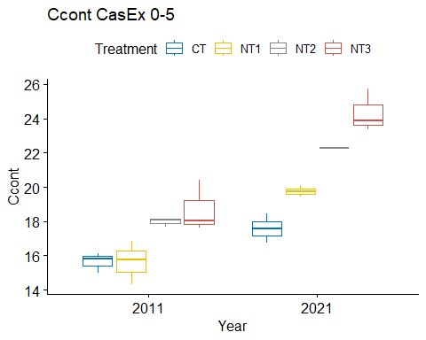

## [1] "Normality"

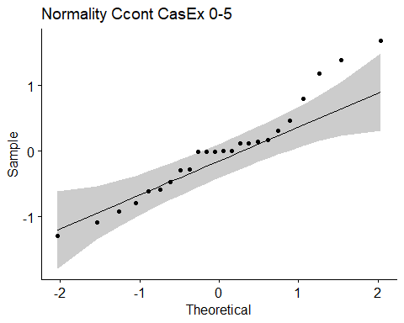

## [1] "Shapiro test for normality"  
## # A tibble: 1 × 3  
## variable statistic p.value  
## <chr> <dbl> <dbl>  
## 1 residuals(model) 0.956 0.368  
## [1] "Homoscedasticity"

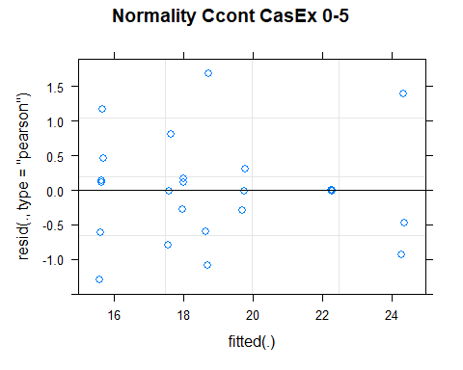

## [1] "Levene test for homoscedasticity"  
## # A tibble: 1 × 4  
## df1 df2 statistic p  
## <int> <int> <dbl> <dbl>  
## 1 7 16 0.835 0.574  
## [1] "ANOVA"  
## Treatment = CT:  
## Year emmean SE df lower.CL upper.CL .group  
## 2011 15.6 0.527 16 14.5 16.8 1   
## 2021 17.6 0.527 16 16.5 18.7 2   
##   
## Treatment = NT1:  
## Year emmean SE df lower.CL upper.CL .group  
## 2011 15.6 0.527 16 14.5 16.8 1   
## 2021 19.7 0.527 16 18.6 20.9 2   
##   
## Treatment = NT2:  
## Year emmean SE df lower.CL upper.CL .group  
## 2011 18.0 0.527 16 16.9 19.1 1   
## 2021 22.3 0.527 16 21.1 23.4 2   
##   
## Treatment = NT3:  
## Year emmean SE df lower.CL upper.CL .group  
## 2011 18.7 0.527 16 17.6 19.8 1   
## 2021 24.3 0.527 16 23.2 25.4 2   
##   
## Degrees-of-freedom method: kenward-roger   
## Results are given on the [ (not the response) scale.   
## Confidence level used: 0.95   
## Note: contrasts are still on the [ scale   
## significance level used: alpha = 0.05   
## NOTE: If two or more means share the same grouping symbol,  
## then we cannot show them to be different.  
## But we also did not show them to be the same.   
## Year = 2011:  
## Treatment emmean SE df lower.CL upper.CL .group  
## NT1 15.6 0.527 16 14.5 16.8 1   
## CT 15.6 0.527 16 14.5 16.8 1   
## NT2 18.0 0.527 16 16.9 19.1 2   
## NT3 18.7 0.527 16 17.6 19.8 2   
##   
## Year = 2021:  
## Treatment emmean SE df lower.CL upper.CL .group  
## CT 17.6 0.527 16 16.5 18.7 1   
## NT1 19.7 0.527 16 18.6 20.9 2   
## NT2 22.3 0.527 16 21.1 23.4 3   
## NT3 24.3 0.527 16 23.2 25.4 3   
##   
## Degrees-of-freedom method: kenward-roger   
## Results are given on the [ (not the response) scale.   
## Confidence level used: 0.95   
## Note: contrasts are still on the [ scale   
## P value adjustment: tukey method for comparing a family of 4 estimates   
## significance level used: alpha = 0.05   
## NOTE: If two or more means share the same grouping symbol,  
## then we cannot show them to be different.  
## But we also did not show them to be the same.   
## [1] "ANOVA plot"

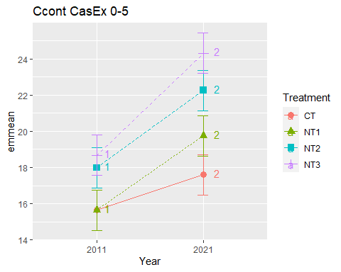

## [1] "Ccont CasEx 5-10"

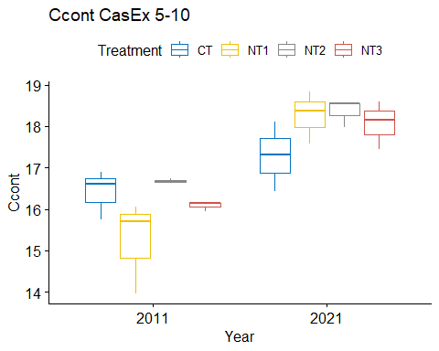

## [1] "Normality"

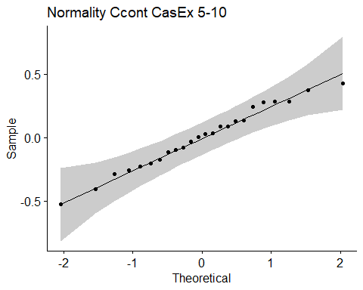

## [1] "Shapiro test for normality"  
## # A tibble: 1 × 3  
## variable statistic p.value  
## <chr> <dbl> <dbl>  
## 1 residuals(model) 0.983 0.937  
## [1] "Homoscedasticity"

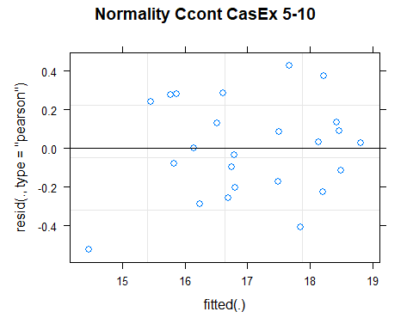

## [1] "Levene test for homoscedasticity"  
## # A tibble: 1 × 4  
## df1 df2 statistic p  
## <int> <int> <dbl> <dbl>  
## 1 7 16 0.759 0.628  
## [1] "ANOVA"  
## Treatment = CT:  
## Year emmean SE df lower.CL upper.CL .group  
## 2011 16.4 0.364 11.4 15.6 17.2 1   
## 2021 17.3 0.364 11.4 16.5 18.1 2   
##   
## Treatment = NT1:  
## Year emmean SE df lower.CL upper.CL .group  
## 2011 15.2 0.364 11.4 14.4 16.0 1   
## 2021 18.3 0.364 11.4 17.5 19.1 2   
##   
## Treatment = NT2:  
## Year emmean SE df lower.CL upper.CL .group  
## 2011 16.7 0.364 11.4 15.9 17.5 1   
## 2021 18.4 0.364 11.4 17.6 19.2 2   
##   
## Treatment = NT3:  
## Year emmean SE df lower.CL upper.CL .group  
## 2011 16.1 0.364 11.4 15.3 16.9 1   
## 2021 18.1 0.364 11.4 17.3 18.9 2   
##   
## Degrees-of-freedom method: kenward-roger   
## Results are given on the [ (not the response) scale.   
## Confidence level used: 0.95   
## Note: contrasts are still on the [ scale   
## significance level used: alpha = 0.05   
## NOTE: If two or more means share the same grouping symbol,  
## then we cannot show them to be different.  
## But we also did not show them to be the same.   
## Year = 2011:  
## Treatment emmean SE df lower.CL upper.CL .group  
## NT1 15.2 0.364 11.4 14.4 16.0 1   
## NT3 16.1 0.364 11.4 15.3 16.9 1   
## CT 16.4 0.364 11.4 15.6 17.2 1   
## NT2 16.7 0.364 11.4 15.9 17.5 1   
##   
## Year = 2021:  
## Treatment emmean SE df lower.CL upper.CL .group  
## CT 17.3 0.364 11.4 16.5 18.1 1   
## NT3 18.1 0.364 11.4 17.3 18.9 1   
## NT1 18.3 0.364 11.4 17.5 19.1 1   
## NT2 18.4 0.364 11.4 17.6 19.2 1   
##   
## Degrees-of-freedom method: kenward-roger   
## Results are given on the [ (not the response) scale.   
## Confidence level used: 0.95   
## Note: contrasts are still on the [ scale   
## P value adjustment: tukey method for comparing a family of 4 estimates   
## significance level used: alpha = 0.05   
## NOTE: If two or more means share the same grouping symbol,  
## then we cannot show them to be different.  
## But we also did not show them to be the same.   
## [1] "ANOVA plot"

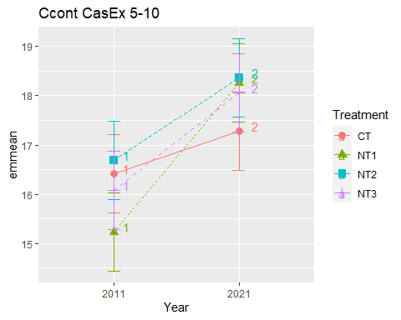

## [1] "Ccont CasEx 10-20"

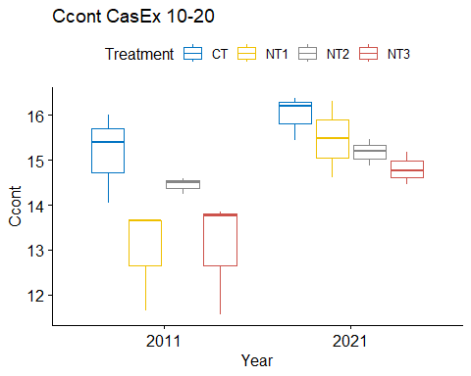

## [1] "Normality"

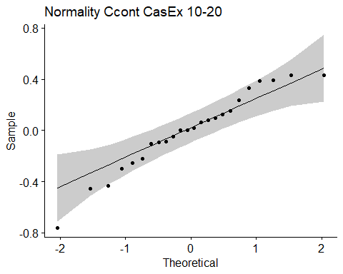

## [1] "Shapiro test for normality"  
## # A tibble: 1 × 3  
## variable statistic p.value  
## <chr> <dbl> <dbl>  
## 1 residuals(model) 0.958 0.395  
## [1] "Homoscedasticity"

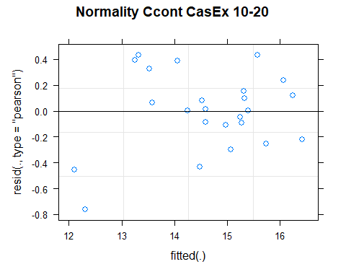

## [1] "Levene test for homoscedasticity"  
## # A tibble: 1 × 4  
## df1 df2 statistic p  
## <int> <int> <dbl> <dbl>  
## 1 7 16 0.389 0.895  
## [1] "ANOVA"  
## Treatment = CT:  
## Year emmean SE df lower.CL upper.CL .group  
## 2011 15.2 0.468 11.1 14.1 16.2 1   
## 2021 16.0 0.468 11.1 15.0 17.0 1   
##   
## Treatment = NT1:  
## Year emmean SE df lower.CL upper.CL .group  
## 2011 13.0 0.468 11.1 12.0 14.0 1   
## 2021 15.5 0.468 11.1 14.4 16.5 2   
##   
## Treatment = NT2:  
## Year emmean SE df lower.CL upper.CL .group  
## 2011 14.4 0.468 11.1 13.4 15.5 1   
## 2021 15.2 0.468 11.1 14.2 16.2 1   
##   
## Treatment = NT3:  
## Year emmean SE df lower.CL upper.CL .group  
## 2011 13.1 0.468 11.1 12.0 14.1 1   
## 2021 14.8 0.468 11.1 13.8 15.8 2   
##   
## Degrees-of-freedom method: kenward-roger   
## Results are given on the [ (not the response) scale.   
## Confidence level used: 0.95   
## Note: contrasts are still on the [ scale   
## significance level used: alpha = 0.05   
## NOTE: If two or more means share the same grouping symbol,  
## then we cannot show them to be different.  
## But we also did not show them to be the same.   
## Year = 2011:  
## Treatment emmean SE df lower.CL upper.CL .group  
## NT1 13.0 0.468 11.1 12.0 14.0 1   
## NT3 13.1 0.468 11.1 12.0 14.1 1   
## NT2 14.4 0.468 11.1 13.4 15.5 12   
## CT 15.2 0.468 11.1 14.1 16.2 2   
##   
## Year = 2021:  
## Treatment emmean SE df lower.CL upper.CL .group  
## NT3 14.8 0.468 11.1 13.8 15.8 1   
## NT2 15.2 0.468 11.1 14.2 16.2 1   
## NT1 15.5 0.468 11.1 14.4 16.5 1   
## CT 16.0 0.468 11.1 15.0 17.0 1   
##   
## Degrees-of-freedom method: kenward-roger   
## Results are given on the [ (not the response) scale.   
## Confidence level used: 0.95   
## Note: contrasts are still on the [ scale   
## P value adjustment: tukey method for comparing a family of 4 estimates   
## significance level used: alpha = 0.05   
## NOTE: If two or more means share the same grouping symbol,  
## then we cannot show them to be different.  
## But we also did not show them to be the same.   
## [1] "ANOVA plot"

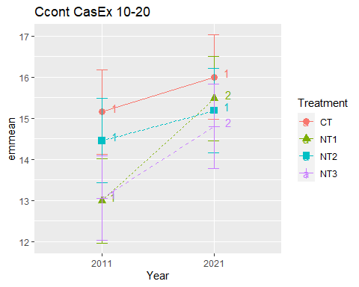

## [1] "Ccont CasEx 20-40"

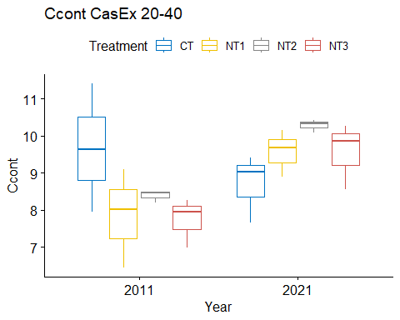

## [1] "Normality"

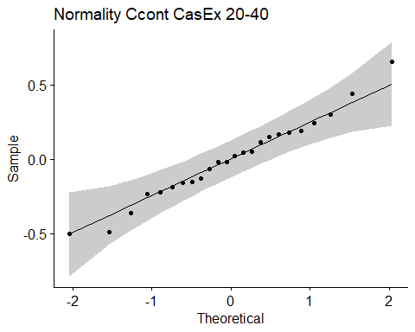

## [1] "Shapiro test for normality"  
## # A tibble: 1 × 3  
## variable statistic p.value  
## <chr> <dbl> <dbl>  
## 1 residuals(model) 0.982 0.930  
## [1] "Homoscedasticity"

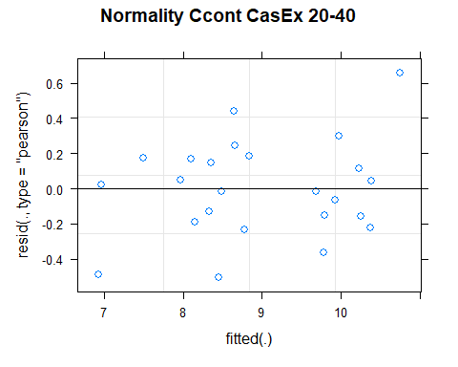

## [1] "Levene test for homoscedasticity"  
## # A tibble: 1 × 4  
## df1 df2 statistic p  
## <int> <int> <dbl> <dbl>  
## 1 7 16 1.02 0.454  
## [1] "ANOVA"  
## Treatment = CT:  
## Year emmean SE df lower.CL upper.CL .group  
## 2021 8.70 0.552 9.88 7.47 9.93 1   
## 2011 9.66 0.552 9.88 8.43 10.89 2   
##   
## Treatment = NT1:  
## Year emmean SE df lower.CL upper.CL .group  
## 2011 7.85 0.552 9.88 6.62 9.08 1   
## 2021 9.57 0.552 9.88 8.34 10.80 2   
##   
## Treatment = NT2:  
## Year emmean SE df lower.CL upper.CL .group  
## 2011 8.39 0.552 9.88 7.16 9.62 1   
## 2021 10.29 0.552 9.88 9.06 11.52 2   
##   
## Treatment = NT3:  
## Year emmean SE df lower.CL upper.CL .group  
## 2011 7.74 0.552 9.88 6.51 8.97 1   
## 2021 9.56 0.552 9.88 8.33 10.79 2   
##   
## Degrees-of-freedom method: kenward-roger   
## Results are given on the [ (not the response) scale.   
## Confidence level used: 0.95   
## Note: contrasts are still on the [ scale   
## significance level used: alpha = 0.05   
## NOTE: If two or more means share the same grouping symbol,  
## then we cannot show them to be different.  
## But we also did not show them to be the same.   
## Year = 2011:  
## Treatment emmean SE df lower.CL upper.CL .group  
## NT3 7.74 0.552 9.88 6.51 8.97 1   
## NT1 7.85 0.552 9.88 6.62 9.08 1   
## NT2 8.39 0.552 9.88 7.16 9.62 1   
## CT 9.66 0.552 9.88 8.43 10.89 1   
##   
## Year = 2021:  
## Treatment emmean SE df lower.CL upper.CL .group  
## CT 8.70 0.552 9.88 7.47 9.93 1   
## NT3 9.56 0.552 9.88 8.33 10.79 1   
## NT1 9.57 0.552 9.88 8.34 10.80 1   
## NT2 10.29 0.552 9.88 9.06 11.52 1   
##   
## Degrees-of-freedom method: kenward-roger   
## Results are given on the [ (not the response) scale.   
## Confidence level used: 0.95   
## Note: contrasts are still on the [ scale   
## P value adjustment: tukey method for comparing a family of 4 estimates   
## significance level used: alpha = 0.05   
## NOTE: If two or more means share the same grouping symbol,  
## then we cannot show them to be different.  
## But we also did not show them to be the same.   
## [1] "ANOVA plot"

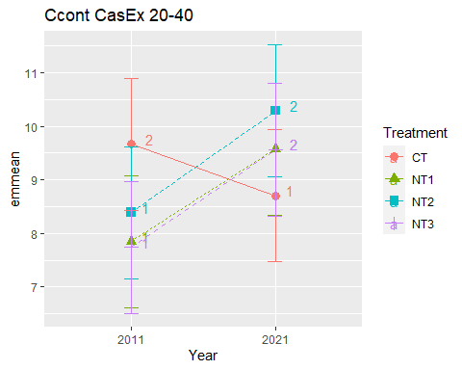

## [1] "Ccont CasEx 40-60"

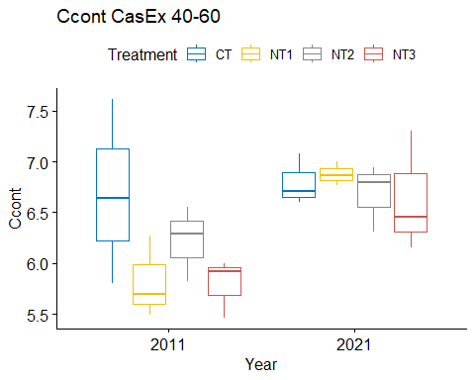

## [1] "Normality"

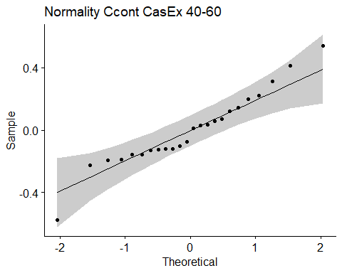

## [1] "Shapiro test for normality"  
## # A tibble: 1 × 3  
## variable statistic p.value  
## <chr> <dbl> <dbl>  
## 1 residuals(model) 0.954 0.326  
## [1] "Homoscedasticity"

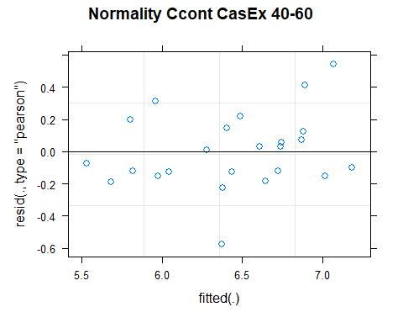

## [1] "Levene test for homoscedasticity"  
## # A tibble: 1 × 4  
## df1 df2 statistic p  
## <int> <int> <dbl> <dbl>  
## 1 7 16 0.836 0.573  
## [1] "ANOVA"  
## Treatment = CT:  
## Year emmean SE df lower.CL upper.CL .group  
## 2011 6.68 0.27 13.2 6.10 7.27 1   
## 2021 6.80 0.27 13.2 6.21 7.38 1   
##   
## Treatment = NT1:  
## Year emmean SE df lower.CL upper.CL .group  
## 2011 5.82 0.27 13.2 5.24 6.40 1   
## 2021 6.88 0.27 13.2 6.29 7.46 2   
##   
## Treatment = NT2:  
## Year emmean SE df lower.CL upper.CL .group  
## 2011 6.22 0.27 13.2 5.64 6.80 1   
## 2021 6.68 0.27 13.2 6.10 7.27 1   
##   
## Treatment = NT3:  
## Year emmean SE df lower.CL upper.CL .group  
## 2011 5.79 0.27 13.2 5.21 6.38 1   
## 2021 6.64 0.27 13.2 6.05 7.22 2   
##   
## Degrees-of-freedom method: kenward-roger   
## Results are given on the [ (not the response) scale.   
## Confidence level used: 0.95   
## Note: contrasts are still on the [ scale   
## significance level used: alpha = 0.05   
## NOTE: If two or more means share the same grouping symbol,  
## then we cannot show them to be different.  
## But we also did not show them to be the same.   
## Year = 2011:  
## Treatment emmean SE df lower.CL upper.CL .group  
## NT3 5.79 0.27 13.2 5.21 6.38 1   
## NT1 5.82 0.27 13.2 5.24 6.40 1   
## NT2 6.22 0.27 13.2 5.64 6.80 1   
## CT 6.68 0.27 13.2 6.10 7.27 1   
##   
## Year = 2021:  
## Treatment emmean SE df lower.CL upper.CL .group  
## NT3 6.64 0.27 13.2 6.05 7.22 1   
## NT2 6.68 0.27 13.2 6.10 7.27 1   
## CT 6.80 0.27 13.2 6.21 7.38 1   
## NT1 6.88 0.27 13.2 6.29 7.46 1   
##   
## Degrees-of-freedom method: kenward-roger   
## Results are given on the [ (not the response) scale.   
## Confidence level used: 0.95   
## Note: contrasts are still on the [ scale   
## P value adjustment: tukey method for comparing a family of 4 estimates   
## significance level used: alpha = 0.05   
## NOTE: If two or more means share the same grouping symbol,  
## then we cannot show them to be different.  
## But we also did not show them to be the same.   
## [1] "ANOVA plot"

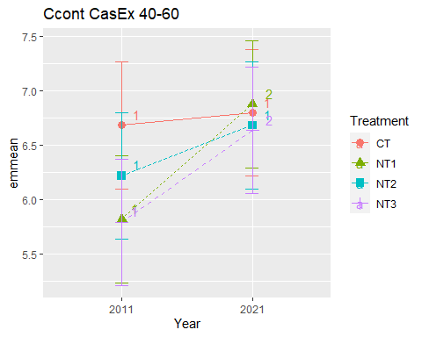

## [1] "Ccont CasEx 60-80"

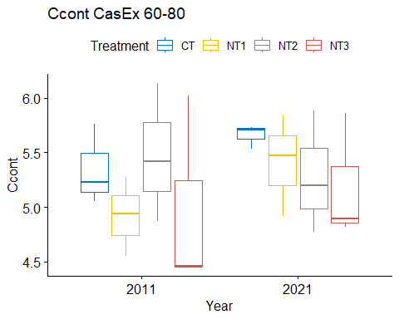

## [1] "Normality"

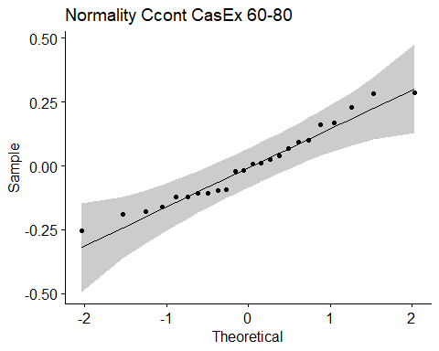

## [1] "Shapiro test for normality"  
## # A tibble: 1 × 3  
## variable statistic p.value  
## <chr> <dbl> <dbl>  
## 1 residuals(model) 0.960 0.440  
## [1] "Homoscedasticity"

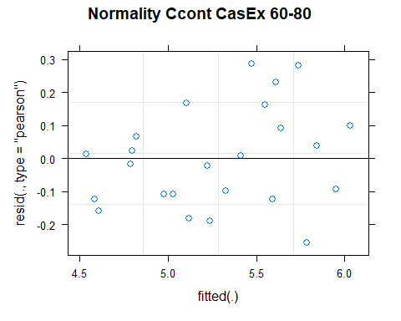

## [1] "Levene test for homoscedasticity"  
## # A tibble: 1 × 4  
## df1 df2 statistic p  
## <int> <int> <dbl> <dbl>  
## 1 7 16 0.290 0.948  
## [1] "ANOVA"  
## Treatment = CT:  
## Year emmean SE df lower.CL upper.CL .group  
## 2011 5.35 0.314 9.75 4.65 6.05 1   
## 2021 5.66 0.314 9.75 4.96 6.36 1   
##   
## Treatment = NT1:  
## Year emmean SE df lower.CL upper.CL .group  
## 2011 4.92 0.314 9.75 4.22 5.62 1   
## 2021 5.41 0.314 9.75 4.71 6.11 2   
##   
## Treatment = NT2:  
## Year emmean SE df lower.CL upper.CL .group  
## 2021 5.28 0.314 9.75 4.58 5.98 1   
## 2011 5.47 0.314 9.75 4.77 6.17 1   
##   
## Treatment = NT3:  
## Year emmean SE df lower.CL upper.CL .group  
## 2011 4.98 0.314 9.75 4.28 5.68 1   
## 2021 5.19 0.314 9.75 4.49 5.89 1   
##   
## Degrees-of-freedom method: kenward-roger   
## Results are given on the [ (not the response) scale.   
## Confidence level used: 0.95   
## Note: contrasts are still on the [ scale   
## significance level used: alpha = 0.05   
## NOTE: If two or more means share the same grouping symbol,  
## then we cannot show them to be different.  
## But we also did not show them to be the same.   
## Year = 2011:  
## Treatment emmean SE df lower.CL upper.CL .group  
## NT1 4.92 0.314 9.75 4.22 5.62 1   
## NT3 4.98 0.314 9.75 4.28 5.68 1   
## CT 5.35 0.314 9.75 4.65 6.05 1   
## NT2 5.47 0.314 9.75 4.77 6.17 1   
##   
## Year = 2021:  
## Treatment emmean SE df lower.CL upper.CL .group  
## NT3 5.19 0.314 9.75 4.49 5.89 1   
## NT2 5.28 0.314 9.75 4.58 5.98 1   
## NT1 5.41 0.314 9.75 4.71 6.11 1   
## CT 5.66 0.314 9.75 4.96 6.36 1   
##   
## Degrees-of-freedom method: kenward-roger   
## Results are given on the [ (not the response) scale.   
## Confidence level used: 0.95   
## Note: contrasts are still on the [ scale   
## P value adjustment: tukey method for comparing a family of 4 estimates   
## significance level used: alpha = 0.05   
## NOTE: If two or more means share the same grouping symbol,  
## then we cannot show them to be different.  
## But we also did not show them to be the same.   
## [1] "ANOVA plot"

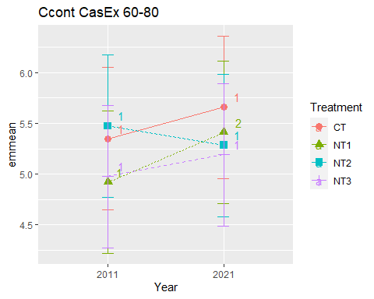

## [1] "Ccont CasEx 80-100"

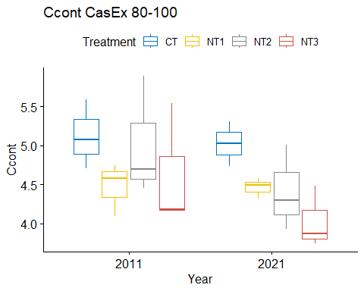

## [1] "Normality"

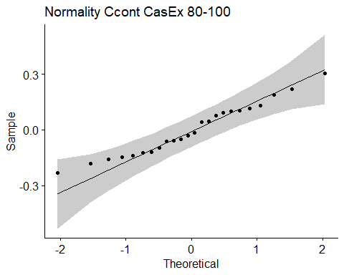

## [1] "Shapiro test for normality"  
## # A tibble: 1 × 3  
## variable statistic p.value  
## <chr> <dbl> <dbl>  
## 1 residuals(model) 0.970 0.658  
## [1] "Homoscedasticity"

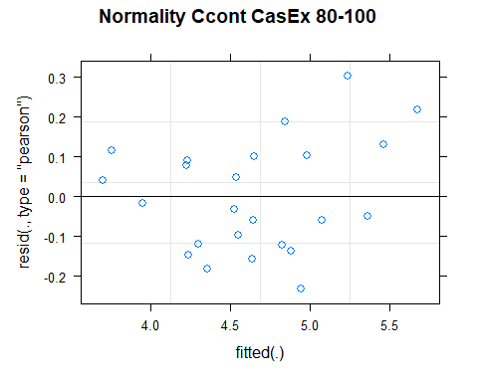

## [1] "Levene test for homoscedasticity"  
## # A tibble: 1 × 4  
## df1 df2 statistic p  
## <int> <int> <dbl> <dbl>  
## 1 7 16 0.311 0.939  
## [1] "ANOVA"  
## Treatment = CT:  
## Year emmean SE df lower.CL upper.CL .group  
## 2021 5.03 0.295 9.7 4.37 5.69 1   
## 2011 5.13 0.295 9.7 4.47 5.79 1   
##   
## Treatment = NT1:  
## Year emmean SE df lower.CL upper.CL .group  
## 2021 4.46 0.295 9.7 3.80 5.12 1   
## 2011 4.47 0.295 9.7 3.81 5.13 1   
##   
## Treatment = NT2:  
## Year emmean SE df lower.CL upper.CL .group  
## 2021 4.41 0.295 9.7 3.75 5.07 1   
## 2011 5.01 0.295 9.7 4.35 5.67 2   
##   
## Treatment = NT3:  
## Year emmean SE df lower.CL upper.CL .group  
## 2021 4.03 0.295 9.7 3.37 4.69 1   
## 2011 4.63 0.295 9.7 3.97 5.29 2   
##   
## Degrees-of-freedom method: kenward-roger   
## Results are given on the [ (not the response) scale.   
## Confidence level used: 0.95   
## Note: contrasts are still on the [ scale   
## significance level used: alpha = 0.05   
## NOTE: If two or more means share the same grouping symbol,  
## then we cannot show them to be different.  
## But we also did not show them to be the same.   
## Year = 2011:  
## Treatment emmean SE df lower.CL upper.CL .group  
## NT1 4.47 0.295 9.7 3.81 5.13 1   
## NT3 4.63 0.295 9.7 3.97 5.29 1   
## NT2 5.01 0.295 9.7 4.35 5.67 1   
## CT 5.13 0.295 9.7 4.47 5.79 1   
##   
## Year = 2021:  
## Treatment emmean SE df lower.CL upper.CL .group  
## NT3 4.03 0.295 9.7 3.37 4.69 1   
## NT2 4.41 0.295 9.7 3.75 5.07 1   
## NT1 4.46 0.295 9.7 3.80 5.12 1   
## CT 5.03 0.295 9.7 4.37 5.69 1   
##   
## Degrees-of-freedom method: kenward-roger   
## Results are given on the [ (not the response) scale.   
## Confidence level used: 0.95   
## Note: contrasts are still on the [ scale   
## P value adjustment: tukey method for comparing a family of 4 estimates   
## significance level used: alpha = 0.05   
## NOTE: If two or more means share the same grouping symbol,  
## then we cannot show them to be different.  
## But we also did not show them to be the same.   
## [1] "ANOVA plot"

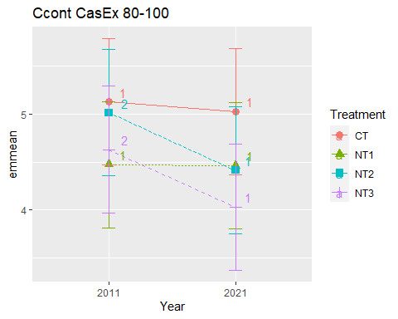

## [1] "Summary for soil depths"

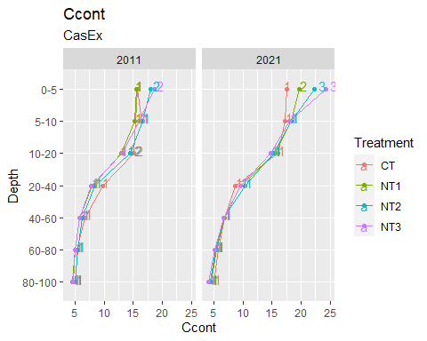

## [1] "BD"

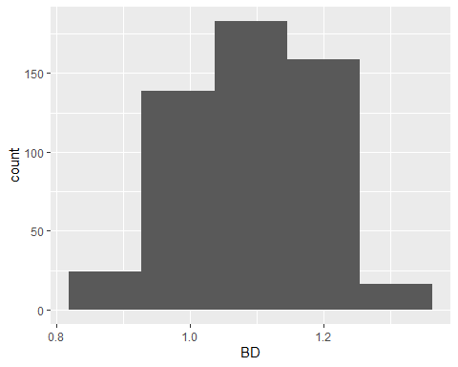

## [1] "BD MaiEx"  
## # A tibble: 56 × 7  
## Treatment Depth Year variable n mean sd  
## <fct> <fct> <fct> <chr> <dbl> <dbl> <dbl>  
## 1 CT 0-5 2011 BD 3 1.17 0.053  
## 2 NT1 0-5 2011 BD 3 1.20 0.04   
## 3 NT2 0-5 2011 BD 3 1.19 0.042  
## 4 NT3 0-5 2011 BD 3 1.21 0.089  
## 5 CT 5-10 2011 BD 3 1.21 0.055  
## 6 NT1 5-10 2011 BD 3 1.2 0.046  
## 7 NT2 5-10 2011 BD 3 1.23 0.05   
## 8 NT3 5-10 2011 BD 3 1.22 0.1   
## 9 CT 10-20 2011 BD 3 1.20 0.031  
## 10 NT1 10-20 2011 BD 3 1.21 0.029  
## # … with 46 more rows  
## [1] "BD MaiEx 0-5"

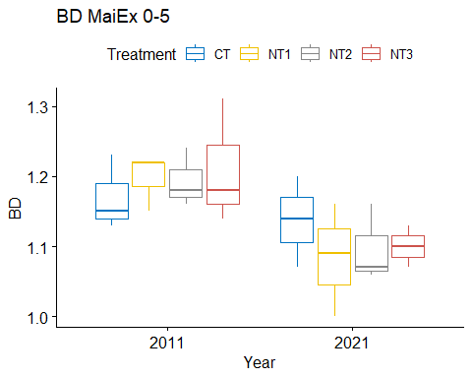

## [1] "Normality"

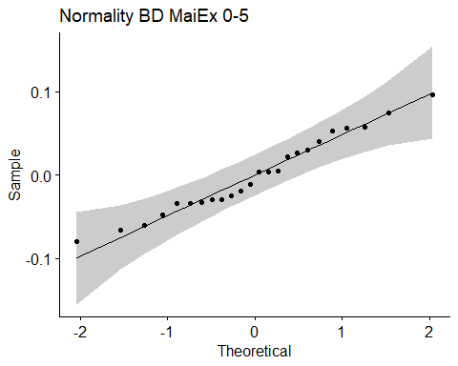

## [1] "Shapiro test for normality"  
## # A tibble: 1 × 3  
## variable statistic p.value  
## <chr> <dbl> <dbl>  
## 1 residuals(model) 0.970 0.677  
## [1] "Homoscedasticity"

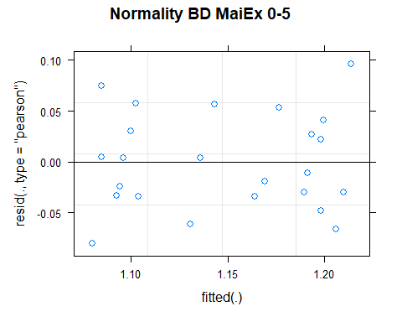

## [1] "Levene test for homoscedasticity"  
## # A tibble: 1 × 4  
## df1 df2 statistic p  
## <int> <int> <dbl> <dbl>  
## 1 7 16 0.294 0.946  
## [1] "ANOVA"  
## Treatment = CT:  
## Year emmean SE df lower.CL upper.CL .group  
## 2021 1.14 0.0346 15.9 1.06 1.21 1   
## 2011 1.17 0.0346 15.9 1.10 1.24 1   
##   
## Treatment = NT1:  
## Year emmean SE df lower.CL upper.CL .group  
## 2021 1.08 0.0346 15.9 1.01 1.16 1   
## 2011 1.20 0.0346 15.9 1.12 1.27 2   
##   
## Treatment = NT2:  
## Year emmean SE df lower.CL upper.CL .group  
## 2021 1.10 0.0346 15.9 1.02 1.17 1   
## 2011 1.19 0.0346 15.9 1.12 1.27 1   
##   
## Treatment = NT3:  
## Year emmean SE df lower.CL upper.CL .group  
## 2021 1.10 0.0346 15.9 1.03 1.17 1   
## 2011 1.21 0.0346 15.9 1.14 1.28 2   
##   
## Degrees-of-freedom method: kenward-roger   
## Results are given on the [ (not the response) scale.   
## Confidence level used: 0.95   
## Note: contrasts are still on the [ scale   
## significance level used: alpha = 0.05   
## NOTE: If two or more means share the same grouping symbol,  
## then we cannot show them to be different.  
## But we also did not show them to be the same.   
## Year = 2011:  
## Treatment emmean SE df lower.CL upper.CL .group  
## CT 1.17 0.0346 15.9 1.10 1.24 1   
## NT2 1.19 0.0346 15.9 1.12 1.27 1   
## NT1 1.20 0.0346 15.9 1.12 1.27 1   
## NT3 1.21 0.0346 15.9 1.14 1.28 1   
##   
## Year = 2021:  
## Treatment emmean SE df lower.CL upper.CL .group  
## NT1 1.08 0.0346 15.9 1.01 1.16 1   
## NT2 1.10 0.0346 15.9 1.02 1.17 1   
## NT3 1.10 0.0346 15.9 1.03 1.17 1   
## CT 1.14 0.0346 15.9 1.06 1.21 1   
##   
## Degrees-of-freedom method: kenward-roger   
## Results are given on the [ (not the response) scale.   
## Confidence level used: 0.95   
## Note: contrasts are still on the [ scale   
## P value adjustment: tukey method for comparing a family of 4 estimates   
## significance level used: alpha = 0.05   
## NOTE: If two or more means share the same grouping symbol,  
## then we cannot show them to be different.  
## But we also did not show them to be the same.   
## [1] "ANOVA plot"

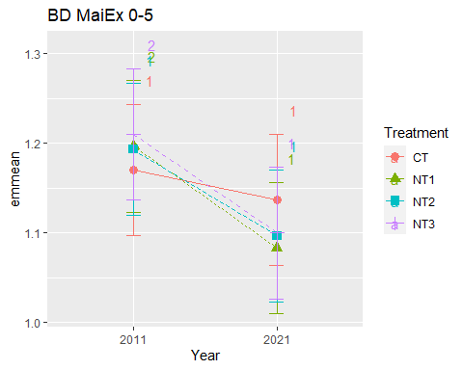

## [1] "BD MaiEx 5-10"

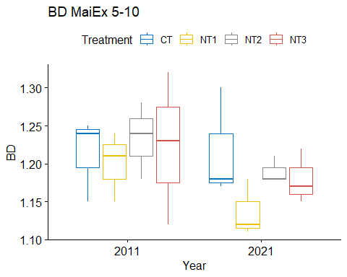

## [1] "Normality"

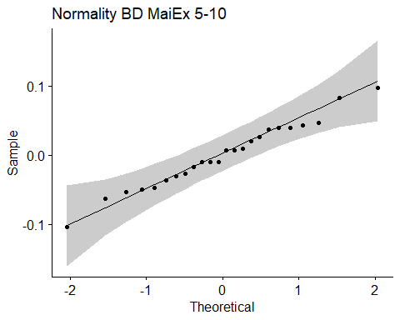

## [1] "Shapiro test for normality"  
## # A tibble: 1 × 3  
## variable statistic p.value  
## <chr> <dbl> <dbl>  
## 1 residuals(model) 0.987 0.981  
## [1] "Homoscedasticity"

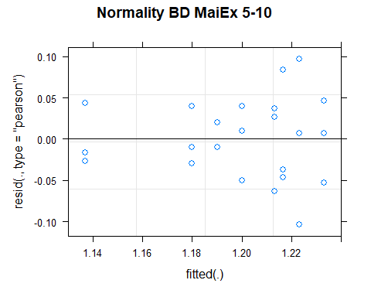

## [1] "Levene test for homoscedasticity"  
## # A tibble: 1 × 4  
## df1 df2 statistic p  
## <int> <int> <dbl> <dbl>  
## 1 7 16 0.478 0.837  
## [1] "ANOVA"  
## Treatment = CT:  
## Year emmean SE df lower.CL upper.CL .group  
## 2011 1.21 0.0329 16 1.14 1.28 1   
## 2021 1.22 0.0329 16 1.15 1.29 1   
##   
## Treatment = NT1:  
## Year emmean SE df lower.CL upper.CL .group  
## 2021 1.14 0.0329 16 1.07 1.21 1   
## 2011 1.20 0.0329 16 1.13 1.27 1   
##   
## Treatment = NT2:  
## Year emmean SE df lower.CL upper.CL .group  
## 2021 1.19 0.0329 16 1.12 1.26 1   
## 2011 1.23 0.0329 16 1.16 1.30 1   
##   
## Treatment = NT3:  
## Year emmean SE df lower.CL upper.CL .group  
## 2021 1.18 0.0329 16 1.11 1.25 1   
## 2011 1.22 0.0329 16 1.15 1.29 1   
##   
## Degrees-of-freedom method: kenward-roger   
## Results are given on the [ (not the response) scale.   
## Confidence level used: 0.95   
## Note: contrasts are still on the [ scale   
## significance level used: alpha = 0.05   
## NOTE: If two or more means share the same grouping symbol,  
## then we cannot show them to be different.  
## But we also did not show them to be the same.   
## Year = 2011:  
## Treatment emmean SE df lower.CL upper.CL .group  
## NT1 1.20 0.0329 16 1.13 1.27 1   
## CT 1.21 0.0329 16 1.14 1.28 1   
## NT3 1.22 0.0329 16 1.15 1.29 1   
## NT2 1.23 0.0329 16 1.16 1.30 1   
##   
## Year = 2021:  
## Treatment emmean SE df lower.CL upper.CL .group  
## NT1 1.14 0.0329 16 1.07 1.21 1   
## NT3 1.18 0.0329 16 1.11 1.25 1   
## NT2 1.19 0.0329 16 1.12 1.26 1   
## CT 1.22 0.0329 16 1.15 1.29 1   
##   
## Degrees-of-freedom method: kenward-roger   
## Results are given on the [ (not the response) scale.   
## Confidence level used: 0.95   
## Note: contrasts are still on the [ scale   
## P value adjustment: tukey method for comparing a family of 4 estimates   
## significance level used: alpha = 0.05   
## NOTE: If two or more means share the same grouping symbol,  
## then we cannot show them to be different.  
## But we also did not show them to be the same.   
## [1] "ANOVA plot"

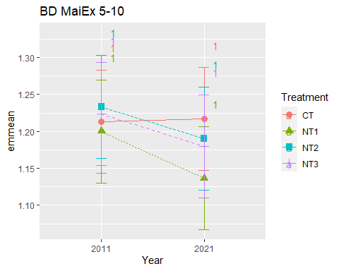

## [1] "BD MaiEx 10-20"

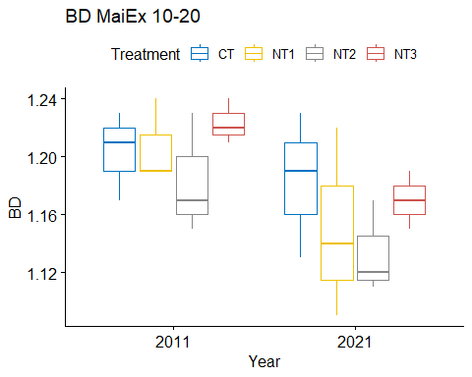

## [1] "Normality"

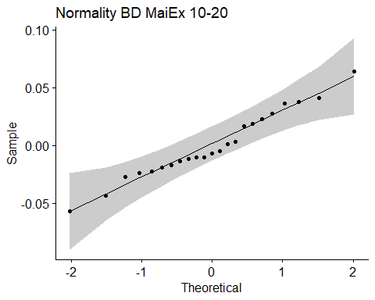

## [1] "Shapiro test for normality"  
## # A tibble: 1 × 3  
## variable statistic p.value  
## <chr> <dbl> <dbl>  
## 1 residuals(model) 0.974 0.777  
## [1] "Homoscedasticity"

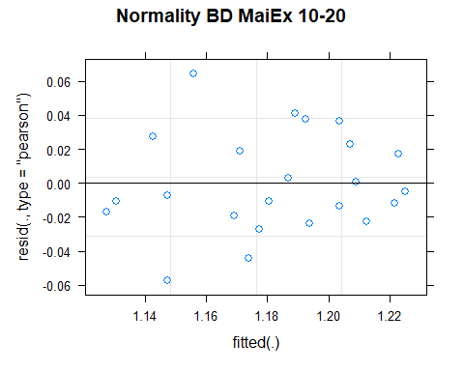

## [1] "Levene test for homoscedasticity"  
## # A tibble: 1 × 4  
## df1 df2 statistic p  
## <int> <int> <dbl> <dbl>  
## 1 7 15 0.442 0.861  
## [1] "ANOVA"  
## Treatment = CT:  
## Year emmean SE df lower.CL upper.CL .group  
## 2021 1.18 0.0231 14.8 1.13 1.23 1   
## 2011 1.20 0.0231 14.8 1.15 1.25 1   
##   
## Treatment = NT1:  
## Year emmean SE df lower.CL upper.CL .group  
## 2021 1.15 0.0231 14.8 1.10 1.20 1   
## 2011 1.21 0.0231 14.8 1.16 1.26 1   
##   
## Treatment = NT2:  
## Year emmean SE df lower.CL upper.CL .group  
## 2021 1.13 0.0231 14.8 1.08 1.18 1   
## 2011 1.18 0.0231 14.8 1.13 1.23 1   
##   
## Treatment = NT3:  
## Year emmean SE df lower.CL upper.CL .group  
## 2021 1.17 0.0295 15.0 1.11 1.23 1   
## 2011 1.22 0.0231 14.8 1.17 1.27 1   
##   
## Degrees-of-freedom method: kenward-roger   
## Results are given on the [ (not the response) scale.   
## Confidence level used: 0.95   
## Note: contrasts are still on the [ scale   
## significance level used: alpha = 0.05   
## NOTE: If two or more means share the same grouping symbol,  
## then we cannot show them to be different.  
## But we also did not show them to be the same.   
## Year = 2011:  
## Treatment emmean SE df lower.CL upper.CL .group  
## NT2 1.18 0.0231 14.8 1.13 1.23 1   
## CT 1.20 0.0231 14.8 1.15 1.25 1   
## NT1 1.21 0.0231 14.8 1.16 1.26 1   
## NT3 1.22 0.0231 14.8 1.17 1.27 1   
##   
## Year = 2021:  
## Treatment emmean SE df lower.CL upper.CL .group  
## NT2 1.13 0.0231 14.8 1.08 1.18 1   
## NT1 1.15 0.0231 14.8 1.10 1.20 1   
## NT3 1.17 0.0295 15.0 1.11 1.23 1   
## CT 1.18 0.0231 14.8 1.13 1.23 1   
##   
## Degrees-of-freedom method: kenward-roger   
## Results are given on the [ (not the response) scale.   
## Confidence level used: 0.95   
## Note: contrasts are still on the [ scale   
## P value adjustment: tukey method for comparing a family of 4 estimates   
## significance level used: alpha = 0.05   
## NOTE: If two or more means share the same grouping symbol,  
## then we cannot show them to be different.  
## But we also did not show them to be the same.   
## [1] "ANOVA plot"

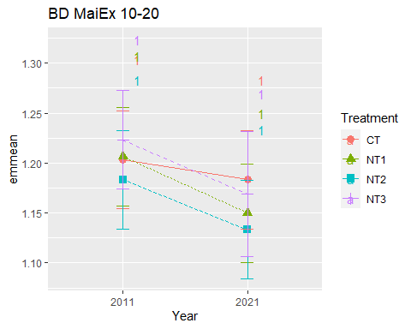

## [1] "BD MaiEx 20-40"

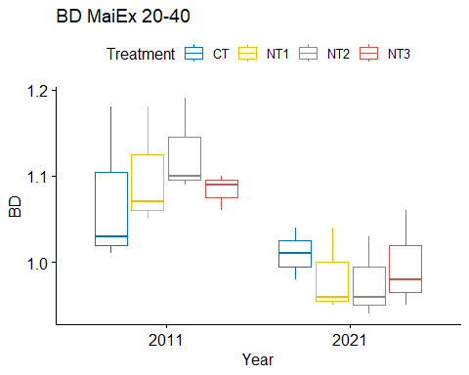

## [1] "Normality"

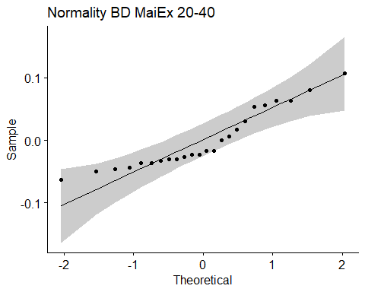

## [1] "Shapiro test for normality"  
## # A tibble: 1 × 3  
## variable statistic p.value  
## <chr> <dbl> <dbl>  
## 1 residuals(model) 0.898 0.0191  
## [1] "Homoscedasticity"

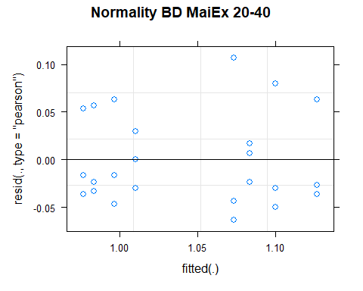

## [1] "Levene test for homoscedasticity"  
## # A tibble: 1 × 4  
## df1 df2 statistic p  
## <int> <int> <dbl> <dbl>  
## 1 7 16 0.241 0.968  
## [1] "ANOVA"  
## Treatment = CT:  
## Year emmean SE df lower.CL upper.CL .group  
## 2021 1.010 0.0328 16 0.940 1.08 1   
## 2011 1.073 0.0328 16 1.004 1.14 1   
##   
## Treatment = NT1:  
## Year emmean SE df lower.CL upper.CL .group  
## 2021 0.983 0.0328 16 0.914 1.05 1   
## 2011 1.100 0.0328 16 1.030 1.17 2   
##   
## Treatment = NT2:  
## Year emmean SE df lower.CL upper.CL .group  
## 2021 0.977 0.0328 16 0.907 1.05 1   
## 2011 1.127 0.0328 16 1.057 1.20 2   
##   
## Treatment = NT3:  
## Year emmean SE df lower.CL upper.CL .group  
## 2021 0.997 0.0328 16 0.927 1.07 1   
## 2011 1.083 0.0328 16 1.014 1.15 1   
##   
## Degrees-of-freedom method: kenward-roger   
## Results are given on the [ (not the response) scale.   
## Confidence level used: 0.95   
## Note: contrasts are still on the [ scale   
## significance level used: alpha = 0.05   
## NOTE: If two or more means share the same grouping symbol,  
## then we cannot show them to be different.  
## But we also did not show them to be the same.   
## Year = 2011:  
## Treatment emmean SE df lower.CL upper.CL .group  
## CT 1.073 0.0328 16 1.004 1.14 1   
## NT3 1.083 0.0328 16 1.014 1.15 1   
## NT1 1.100 0.0328 16 1.030 1.17 1   
## NT2 1.127 0.0328 16 1.057 1.20 1   
##   
## Year = 2021:  
## Treatment emmean SE df lower.CL upper.CL .group  
## NT2 0.977 0.0328 16 0.907 1.05 1   
## NT1 0.983 0.0328 16 0.914 1.05 1   
## NT3 0.997 0.0328 16 0.927 1.07 1   
## CT 1.010 0.0328 16 0.940 1.08 1   
##   
## Degrees-of-freedom method: kenward-roger   
## Results are given on the [ (not the response) scale.   
## Confidence level used: 0.95   
## Note: contrasts are still on the [ scale   
## P value adjustment: tukey method for comparing a family of 4 estimates   
## significance level used: alpha = 0.05   
## NOTE: If two or more means share the same grouping symbol,  
## then we cannot show them to be different.  
## But we also did not show them to be the same.   
## [1] "ANOVA plot"

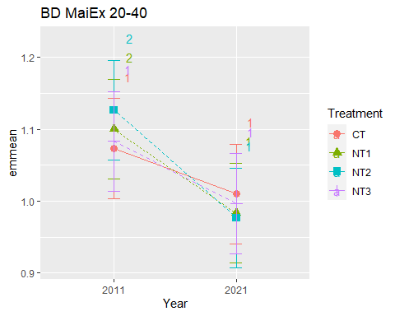

## [1] "BD MaiEx 40-60"

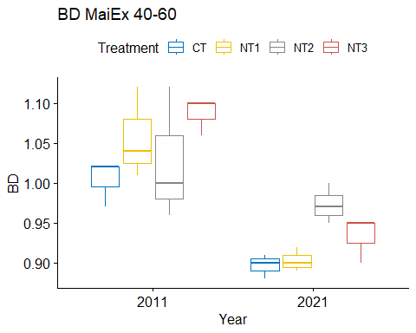

## [1] "Normality"

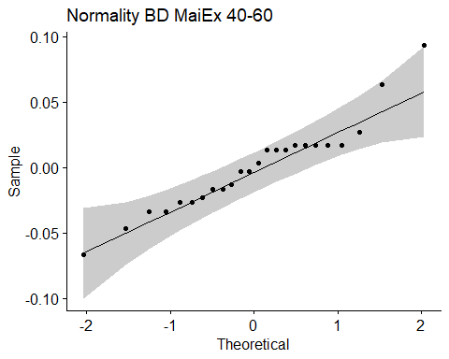

## [1] "Shapiro test for normality"  
## # A tibble: 1 × 3  
## variable statistic p.value  
## <chr> <dbl> <dbl>  
## 1 residuals(model) 0.939 0.158  
## [1] "Homoscedasticity"

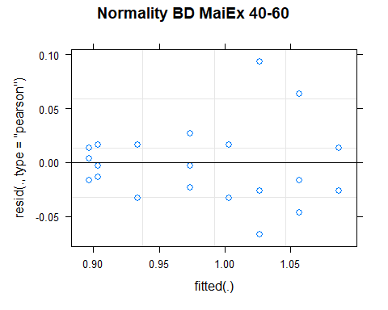

## [1] "Levene test for homoscedasticity"  
## # A tibble: 1 × 4  
## df1 df2 statistic p  
## <int> <int> <dbl> <dbl>  
## 1 7 16 0.705 0.669  
## [1] "ANOVA"  
## Treatment = CT:  
## Year emmean SE df lower.CL upper.CL .group  
## 2021 0.897 0.0237 16 0.846 0.947 1   
## 2011 1.003 0.0237 16 0.953 1.054 2   
##   
## Treatment = NT1:  
## Year emmean SE df lower.CL upper.CL .group  
## 2021 0.903 0.0237 16 0.853 0.954 1   
## 2011 1.057 0.0237 16 1.006 1.107 2   
##   
## Treatment = NT2:  
## Year emmean SE df lower.CL upper.CL .group  
## 2021 0.973 0.0237 16 0.923 1.024 1   
## 2011 1.027 0.0237 16 0.976 1.077 1   
##   
## Treatment = NT3:  
## Year emmean SE df lower.CL upper.CL .group  
## 2021 0.933 0.0237 16 0.883 0.984 1   
## 2011 1.087 0.0237 16 1.036 1.137 2   
##   
## Degrees-of-freedom method: kenward-roger   
## Results are given on the [ (not the response) scale.   
## Confidence level used: 0.95   
## Note: contrasts are still on the [ scale   
## significance level used: alpha = 0.05   
## NOTE: If two or more means share the same grouping symbol,  
## then we cannot show them to be different.  
## But we also did not show them to be the same.   
## Year = 2011:  
## Treatment emmean SE df lower.CL upper.CL .group  
## CT 1.003 0.0237 16 0.953 1.054 1   
## NT2 1.027 0.0237 16 0.976 1.077 1   
## NT1 1.057 0.0237 16 1.006 1.107 1   
## NT3 1.087 0.0237 16 1.036 1.137 1   
##   
## Year = 2021:  
## Treatment emmean SE df lower.CL upper.CL .group  
## CT 0.897 0.0237 16 0.846 0.947 1   
## NT1 0.903 0.0237 16 0.853 0.954 1   
## NT3 0.933 0.0237 16 0.883 0.984 1   
## NT2 0.973 0.0237 16 0.923 1.024 1   
##   
## Degrees-of-freedom method: kenward-roger   
## Results are given on the [ (not the response) scale.   
## Confidence level used: 0.95   
## Note: contrasts are still on the [ scale   
## P value adjustment: tukey method for comparing a family of 4 estimates   
## significance level used: alpha = 0.05   
## NOTE: If two or more means share the same grouping symbol,  
## then we cannot show them to be different.  
## But we also did not show them to be the same.   
## [1] "ANOVA plot"

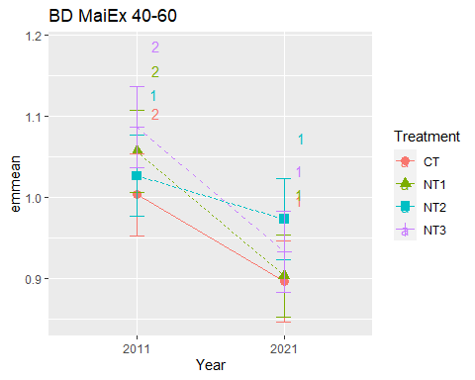

## [1] "BD MaiEx 60-80"

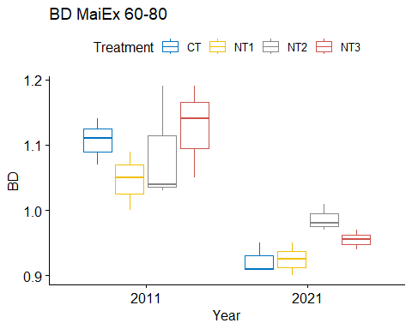

## [1] "Normality"

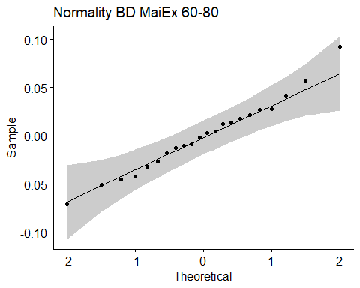

## [1] "Shapiro test for normality"  
## # A tibble: 1 × 3  
## variable statistic p.value  
## <chr> <dbl> <dbl>  
## 1 residuals(model) 0.985 0.979  
## [1] "Homoscedasticity"

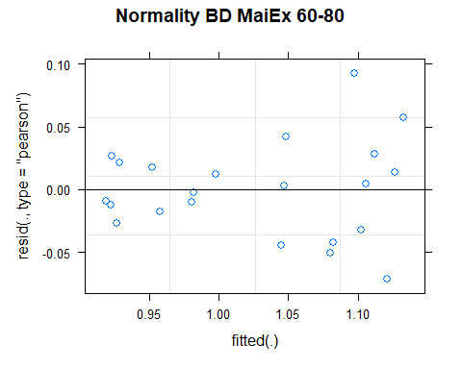

## [1] "Levene test for homoscedasticity"  
## # A tibble: 1 × 4  
## df1 df2 statistic p  
## <int> <int> <dbl> <dbl>  
## 1 7 14 0.428 0.869  
## [1] "ANOVA"  
## Treatment = CT:  
## Year emmean SE df lower.CL upper.CL .group  
## 2021 0.923 0.0294 13.9 0.860 0.986 1   
## 2011 1.107 0.0294 13.9 1.044 1.170 2   
##   
## Treatment = NT1:  
## Year emmean SE df lower.CL upper.CL .group  
## 2021 0.925 0.0379 14.0 0.844 1.006 1   
## 2011 1.047 0.0294 13.9 0.984 1.110 2   
##   
## Treatment = NT2:  
## Year emmean SE df lower.CL upper.CL .group  
## 2021 0.987 0.0294 13.9 0.924 1.050 1   
## 2011 1.087 0.0294 13.9 1.024 1.150 2   
##   
## Treatment = NT3:  
## Year emmean SE df lower.CL upper.CL .group  
## 2021 0.958 0.0379 14.0 0.877 1.039 1   
## 2011 1.127 0.0294 13.9 1.064 1.190 2   
##   
## Degrees-of-freedom method: kenward-roger   
## Results are given on the [ (not the response) scale.   
## Confidence level used: 0.95   
## Note: contrasts are still on the [ scale   
## significance level used: alpha = 0.05   
## NOTE: If two or more means share the same grouping symbol,  
## then we cannot show them to be different.  
## But we also did not show them to be the same.   
## Year = 2011:  
## Treatment emmean SE df lower.CL upper.CL .group  
## NT1 1.047 0.0294 13.9 0.984 1.110 1   
## NT2 1.087 0.0294 13.9 1.024 1.150 1   
## CT 1.107 0.0294 13.9 1.044 1.170 1   
## NT3 1.127 0.0294 13.9 1.064 1.190 1   
##   
## Year = 2021:  
## Treatment emmean SE df lower.CL upper.CL .group  
## CT 0.923 0.0294 13.9 0.860 0.986 1   
## NT1 0.925 0.0379 14.0 0.844 1.006 1   
## NT3 0.958 0.0379 14.0 0.877 1.039 1   
## NT2 0.987 0.0294 13.9 0.924 1.050 1   
##   
## Degrees-of-freedom method: kenward-roger   
## Results are given on the [ (not the response) scale.   
## Confidence level used: 0.95   
## Note: contrasts are still on the [ scale   
## P value adjustment: tukey method for comparing a family of 4 estimates   
## significance level used: alpha = 0.05   
## NOTE: If two or more means share the same grouping symbol,  
## then we cannot show them to be different.  
## But we also did not show them to be the same.   
## [1] "ANOVA plot"

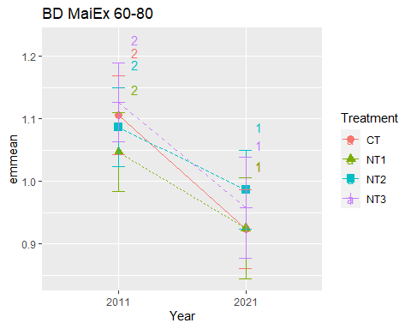

## [1] "BD MaiEx 80-100"

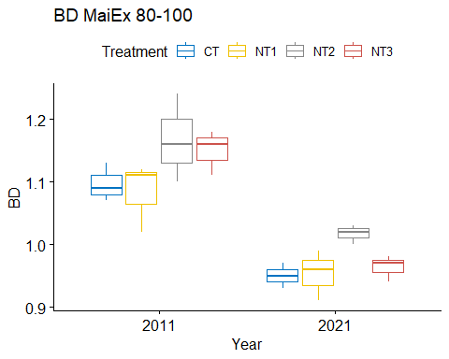

## [1] "Normality"

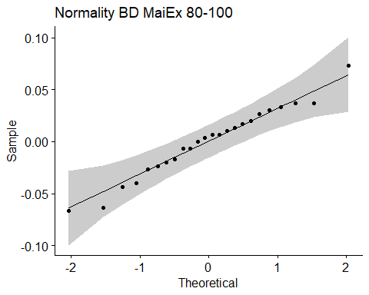

## [1] "Shapiro test for normality"  
## # A tibble: 1 × 3  
## variable statistic p.value  
## <chr> <dbl> <dbl>  
## 1 residuals(model) 0.978 0.855  
## [1] "Homoscedasticity"

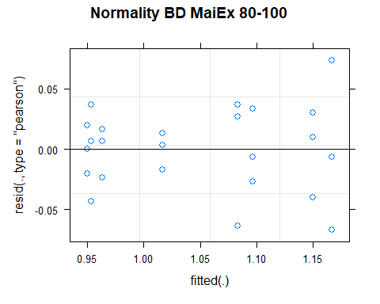

## [1] "Levene test for homoscedasticity"  
## # A tibble: 1 × 4  
## df1 df2 statistic p  
## <int> <int> <dbl> <dbl>  
## 1 7 16 0.568 0.771  
## [1] "ANOVA"  
## Treatment = CT:  
## Year emmean SE df lower.CL upper.CL .group  
## 2021 0.950 0.0232 16 0.901 0.999 1   
## 2011 1.097 0.0232 16 1.048 1.146 2   
##   
## Treatment = NT1:  
## Year emmean SE df lower.CL upper.CL .group  
## 2021 0.953 0.0232 16 0.904 1.002 1   
## 2011 1.083 0.0232 16 1.034 1.132 2   
##   
## Treatment = NT2:  
## Year emmean SE df lower.CL upper.CL .group  
## 2021 1.017 0.0232 16 0.968 1.066 1   
## 2011 1.167 0.0232 16 1.118 1.216 2   
##   
## Treatment = NT3:  
## Year emmean SE df lower.CL upper.CL .group  
## 2021 0.963 0.0232 16 0.914 1.012 1   
## 2011 1.150 0.0232 16 1.101 1.199 2   
##   
## Degrees-of-freedom method: kenward-roger   
## Results are given on the [ (not the response) scale.   
## Confidence level used: 0.95   
## Note: contrasts are still on the [ scale   
## significance level used: alpha = 0.05   
## NOTE: If two or more means share the same grouping symbol,  
## then we cannot show them to be different.  
## But we also did not show them to be the same.   
## Year = 2011:  
## Treatment emmean SE df lower.CL upper.CL .group  
## NT1 1.083 0.0232 16 1.034 1.132 1   
## CT 1.097 0.0232 16 1.048 1.146 1   
## NT3 1.150 0.0232 16 1.101 1.199 1   
## NT2 1.167 0.0232 16 1.118 1.216 1   
##   
## Year = 2021:  
## Treatment emmean SE df lower.CL upper.CL .group  
## CT 0.950 0.0232 16 0.901 0.999 1   
## NT1 0.953 0.0232 16 0.904 1.002 1   
## NT3 0.963 0.0232 16 0.914 1.012 1   
## NT2 1.017 0.0232 16 0.968 1.066 1   
##   
## Degrees-of-freedom method: kenward-roger   
## Results are given on the [ (not the response) scale.   
## Confidence level used: 0.95   
## Note: contrasts are still on the [ scale   
## P value adjustment: tukey method for comparing a family of 4 estimates   
## significance level used: alpha = 0.05   
## NOTE: If two or more means share the same grouping symbol,  
## then we cannot show them to be different.  
## But we also did not show them to be the same.   
## [1] "ANOVA plot"

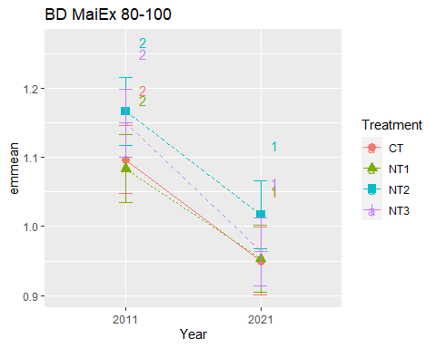

## [1] "Summary for soil depths"

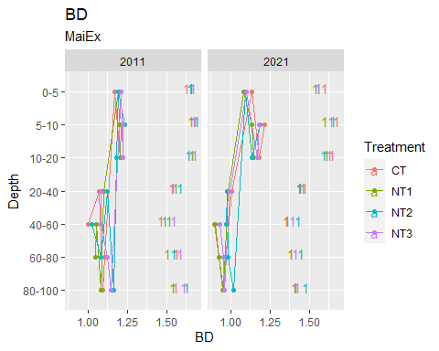

## [1] "BD SoyEx"  
## # A tibble: 56 × 7  
## Treatment Depth Year variable n mean sd  
## <fct> <fct> <fct> <chr> <dbl> <dbl> <dbl>  
## 1 CT 0-5 2011 BD 3 1.16 0.078  
## 2 NT1 0-5 2011 BD 3 1.16 0.04   
## 3 NT2 0-5 2011 BD 3 1.16 0.046  
## 4 NT3 0-5 2011 BD 3 1.14 0.04   
## 5 CT 5-10 2011 BD 3 1.22 0.085  
## 6 NT1 5-10 2011 BD 3 1.25 0.04   
## 7 NT2 5-10 2011 BD 3 1.19 0.015  
## 8 NT3 5-10 2011 BD 3 1.18 0.015  
## 9 CT 10-20 2011 BD 3 1.24 0.076  
## 10 NT1 10-20 2011 BD 3 1.23 0.042  
## # … with 46 more rows  
## [1] "BD SoyEx 0-5"

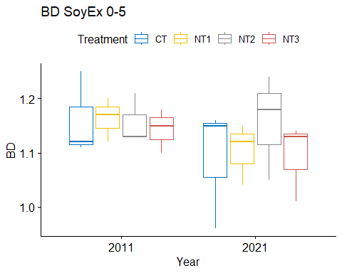

## [1] "Normality"

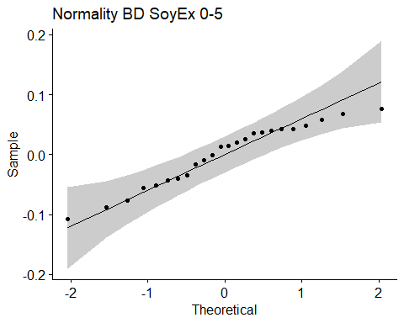

## [1] "Shapiro test for normality"  
## # A tibble: 1 × 3  
## variable statistic p.value  
## <chr> <dbl> <dbl>  
## 1 residuals(model) 0.948 0.243  
## [1] "Homoscedasticity"

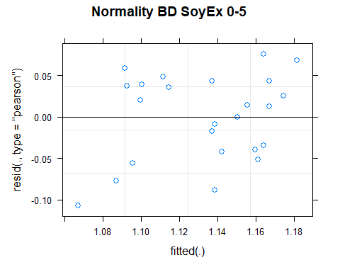

## [1] "Levene test for homoscedasticity"  
## # A tibble: 1 × 4  
## df1 df2 statistic p  
## <int> <int> <dbl> <dbl>  
## 1 7 16 0.206 0.979  
## [1] "ANOVA"  
## Treatment = CT:  
## Year emmean SE df lower.CL upper.CL .group  
## 2021 1.09 0.0419 15.6 1.00 1.18 1   
## 2011 1.16 0.0419 15.6 1.07 1.25 1   
##   
## Treatment = NT1:  
## Year emmean SE df lower.CL upper.CL .group  
## 2021 1.10 0.0419 15.6 1.01 1.19 1   
## 2011 1.16 0.0419 15.6 1.07 1.25 1   
##   
## Treatment = NT2:  
## Year emmean SE df lower.CL upper.CL .group  
## 2011 1.16 0.0419 15.6 1.07 1.25 1   
## 2021 1.16 0.0419 15.6 1.07 1.25 1   
##   
## Treatment = NT3:  
## Year emmean SE df lower.CL upper.CL .group  
## 2021 1.09 0.0419 15.6 1.00 1.18 1   
## 2011 1.14 0.0419 15.6 1.05 1.23 1   
##   
## Degrees-of-freedom method: kenward-roger   
## Results are given on the [ (not the response) scale.   
## Confidence level used: 0.95   
## Note: contrasts are still on the [ scale   
## significance level used: alpha = 0.05   
## NOTE: If two or more means share the same grouping symbol,  
## then we cannot show them to be different.  
## But we also did not show them to be the same.   
## Year = 2011:  
## Treatment emmean SE df lower.CL upper.CL .group  
## NT3 1.14 0.0419 15.6 1.05 1.23 1   
## NT2 1.16 0.0419 15.6 1.07 1.25 1   
## CT 1.16 0.0419 15.6 1.07 1.25 1   
## NT1 1.16 0.0419 15.6 1.07 1.25 1   
##   
## Year = 2021:  
## Treatment emmean SE df lower.CL upper.CL .group  
## CT 1.09 0.0419 15.6 1.00 1.18 1   
## NT3 1.09 0.0419 15.6 1.00 1.18 1   
## NT1 1.10 0.0419 15.6 1.01 1.19 1   
## NT2 1.16 0.0419 15.6 1.07 1.25 1   
##   
## Degrees-of-freedom method: kenward-roger   
## Results are given on the [ (not the response) scale.   
## Confidence level used: 0.95   
## Note: contrasts are still on the [ scale   
## P value adjustment: tukey method for comparing a family of 4 estimates   
## significance level used: alpha = 0.05   
## NOTE: If two or more means share the same grouping symbol,  
## then we cannot show them to be different.  
## But we also did not show them to be the same.   
## [1] "ANOVA plot"

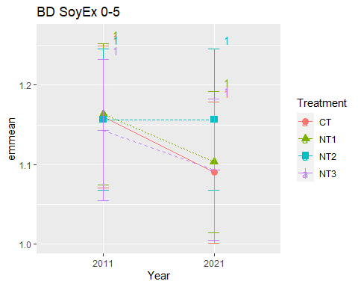

## [1] "BD SoyEx 5-10"

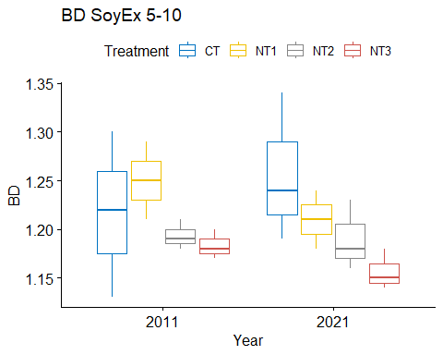

## [1] "Normality"

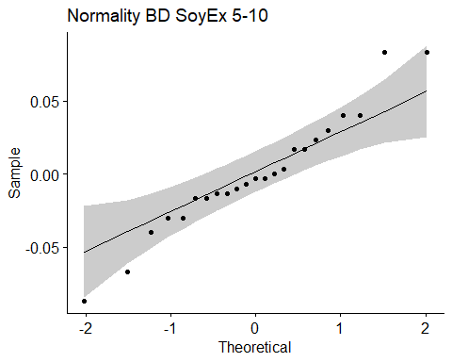

## [1] "Shapiro test for normality"  
## # A tibble: 1 × 3  
## variable statistic p.value  
## <chr> <dbl> <dbl>  
## 1 residuals(model) 0.962 0.498  
## [1] "Homoscedasticity"

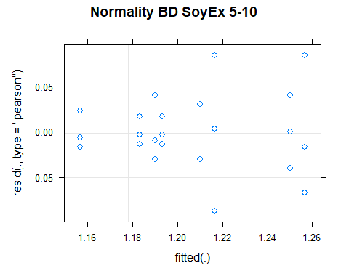

## [1] "Levene test for homoscedasticity"  
## # A tibble: 1 × 4  
## df1 df2 statistic p  
## <int> <int> <dbl> <dbl>  
## 1 7 15 1.08 0.423  
## [1] "ANOVA"  
## Treatment = CT:  
## Year emmean SE df lower.CL upper.CL .group  
## 2011 1.22 0.0281 15 1.16 1.28 1   
## 2021 1.26 0.0281 15 1.20 1.32 1   
##   
## Treatment = NT1:  
## Year emmean SE df lower.CL upper.CL .group  
## 2021 1.21 0.0360 15 1.13 1.29 1   
## 2011 1.25 0.0281 15 1.19 1.31 1   
##   
## Treatment = NT2:  
## Year emmean SE df lower.CL upper.CL .group  
## 2021 1.19 0.0281 15 1.13 1.25 1   
## 2011 1.19 0.0281 15 1.13 1.25 1   
##   
## Treatment = NT3:  
## Year emmean SE df lower.CL upper.CL .group  
## 2021 1.16 0.0281 15 1.10 1.22 1   
## 2011 1.18 0.0281 15 1.12 1.24 1   
##   
## Degrees-of-freedom method: kenward-roger   
## Results are given on the [ (not the response) scale.   
## Confidence level used: 0.95   
## Note: contrasts are still on the [ scale   
## significance level used: alpha = 0.05   
## NOTE: If two or more means share the same grouping symbol,  
## then we cannot show them to be different.  
## But we also did not show them to be the same.   
## Year = 2011:  
## Treatment emmean SE df lower.CL upper.CL .group  
## NT3 1.18 0.0281 15 1.12 1.24 1   
## NT2 1.19 0.0281 15 1.13 1.25 1   
## CT 1.22 0.0281 15 1.16 1.28 1   
## NT1 1.25 0.0281 15 1.19 1.31 1   
##   
## Year = 2021:  
## Treatment emmean SE df lower.CL upper.CL .group  
## NT3 1.16 0.0281 15 1.10 1.22 1   
## NT2 1.19 0.0281 15 1.13 1.25 1   
## NT1 1.21 0.0360 15 1.13 1.29 1   
## CT 1.26 0.0281 15 1.20 1.32 1   
##   
## Degrees-of-freedom method: kenward-roger   
## Results are given on the [ (not the response) scale.   
## Confidence level used: 0.95   
## Note: contrasts are still on the [ scale   
## P value adjustment: tukey method for comparing a family of 4 estimates   
## significance level used: alpha = 0.05   
## NOTE: If two or more means share the same grouping symbol,  
## then we cannot show them to be different.  
## But we also did not show them to be the same.   
## [1] "ANOVA plot"

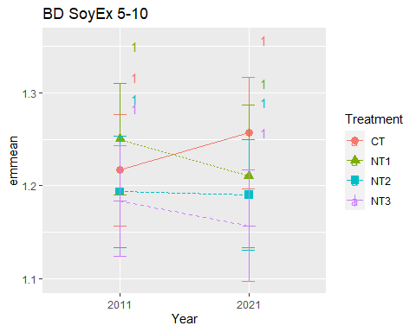

## [1] "BD SoyEx 10-20"

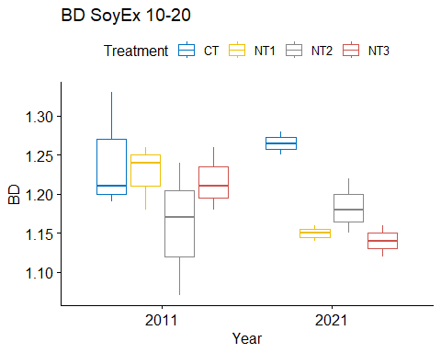

## [1] "Normality"

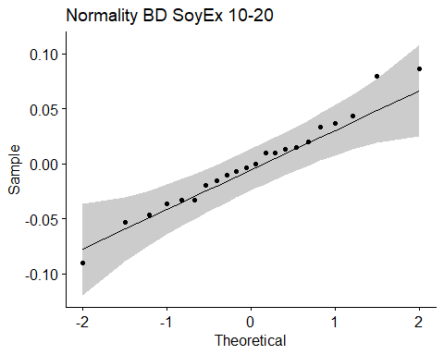

## [1] "Shapiro test for normality"  
## # A tibble: 1 × 3  
## variable statistic p.value  
## <chr> <dbl> <dbl>  
## 1 residuals(model) 0.982 0.940  
## [1] "Homoscedasticity"

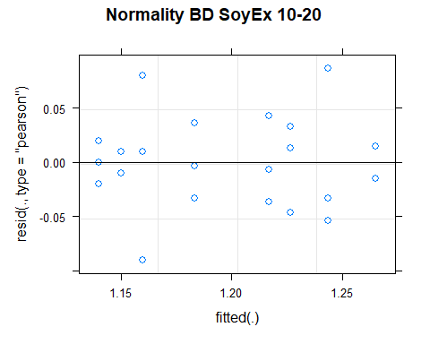

## [1] "Levene test for homoscedasticity"  
## # A tibble: 1 × 4  
## df1 df2 statistic p  
## <int> <int> <dbl> <dbl>  
## 1 7 14 0.585 0.757  
## [1] "ANOVA"  
## Treatment = CT:  
## Year emmean SE df lower.CL upper.CL .group  
## 2011 1.24 0.0296 14 1.18 1.31 1   
## 2021 1.26 0.0382 14 1.18 1.35 1   
##   
## Treatment = NT1:  
## Year emmean SE df lower.CL upper.CL .group  
## 2021 1.15 0.0382 14 1.07 1.23 1   
## 2011 1.23 0.0296 14 1.16 1.29 1   
##   
## Treatment = NT2:  
## Year emmean SE df lower.CL upper.CL .group  
## 2011 1.16 0.0296 14 1.10 1.22 1   
## 2021 1.18 0.0296 14 1.12 1.25 1   
##   
## Treatment = NT3:  
## Year emmean SE df lower.CL upper.CL .group  
## 2021 1.14 0.0296 14 1.08 1.20 1   
## 2011 1.22 0.0296 14 1.15 1.28 1   
##   
## Degrees-of-freedom method: kenward-roger   
## Results are given on the [ (not the response) scale.   
## Confidence level used: 0.95   
## Note: contrasts are still on the [ scale   
## significance level used: alpha = 0.05   
## NOTE: If two or more means share the same grouping symbol,  
## then we cannot show them to be different.  
## But we also did not show them to be the same.   
## Year = 2011:  
## Treatment emmean SE df lower.CL upper.CL .group  
## NT2 1.16 0.0296 14 1.10 1.22 1   
## NT3 1.22 0.0296 14 1.15 1.28 1   
## NT1 1.23 0.0296 14 1.16 1.29 1   
## CT 1.24 0.0296 14 1.18 1.31 1   
##   
## Year = 2021:  
## Treatment emmean SE df lower.CL upper.CL .group  
## NT3 1.14 0.0296 14 1.08 1.20 1   
## NT1 1.15 0.0382 14 1.07 1.23 1   
## NT2 1.18 0.0296 14 1.12 1.25 1   
## CT 1.26 0.0382 14 1.18 1.35 1   
##   
## Degrees-of-freedom method: kenward-roger   
## Results are given on the [ (not the response) scale.   
## Confidence level used: 0.95   
## Note: contrasts are still on the [ scale   
## P value adjustment: tukey method for comparing a family of 4 estimates   
## significance level used: alpha = 0.05   
## NOTE: If two or more means share the same grouping symbol,  
## then we cannot show them to be different.  
## But we also did not show them to be the same.   
## [1] "ANOVA plot"

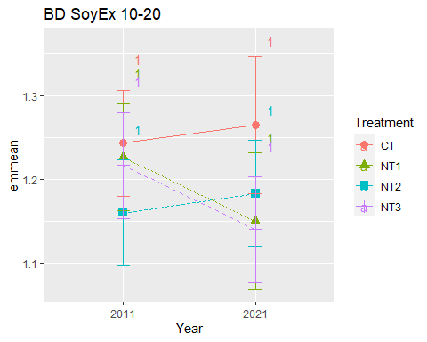

## [1] "BD SoyEx 20-40"

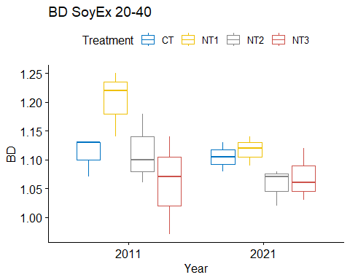

## [1] "Normality"

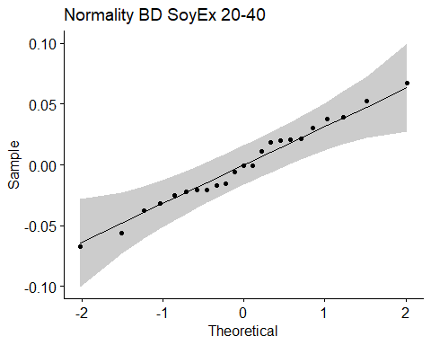

## [1] "Shapiro test for normality"  
## # A tibble: 1 × 3  
## variable statistic p.value  
## <chr> <dbl> <dbl>  
## 1 residuals(model) 0.984 0.966  
## [1] "Homoscedasticity"

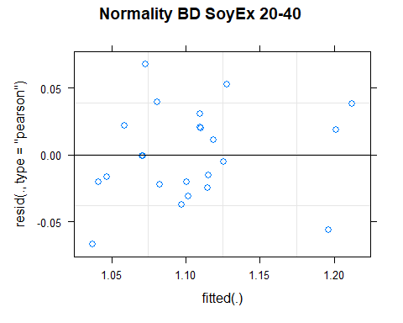

## [1] "Levene test for homoscedasticity"  
## # A tibble: 1 × 4  
## df1 df2 statistic p  
## <int> <int> <dbl> <dbl>  
## 1 7 15 0.449 0.856  
## [1] "ANOVA"  
## Treatment = CT:  
## Year emmean SE df lower.CL upper.CL .group  
## 2021 1.10 0.0376 14.9 1.020 1.18 1   
## 2011 1.11 0.0297 14.4 1.046 1.17 1   
##   
## Treatment = NT1:  
## Year emmean SE df lower.CL upper.CL .group  
## 2021 1.12 0.0297 14.4 1.053 1.18 1   
## 2011 1.20 0.0297 14.4 1.140 1.27 1   
##   
## Treatment = NT2:  
## Year emmean SE df lower.CL upper.CL .group  
## 2021 1.06 0.0297 14.4 0.993 1.12 1   
## 2011 1.11 0.0297 14.4 1.050 1.18 1   
##   
## Treatment = NT3:  
## Year emmean SE df lower.CL upper.CL .group  
## 2011 1.06 0.0297 14.4 0.996 1.12 1   
## 2021 1.07 0.0297 14.4 1.006 1.13 1   
##   
## Degrees-of-freedom method: kenward-roger   
## Results are given on the [ (not the response) scale.   
## Confidence level used: 0.95   
## Note: contrasts are still on the [ scale   
## significance level used: alpha = 0.05   
## NOTE: If two or more means share the same grouping symbol,  
## then we cannot show them to be different.  
## But we also did not show them to be the same.   
## Year = 2011:  
## Treatment emmean SE df lower.CL upper.CL .group  
## NT3 1.06 0.0297 14.4 0.996 1.12 1   
## CT 1.11 0.0297 14.4 1.046 1.17 12   
## NT2 1.11 0.0297 14.4 1.050 1.18 12   
## NT1 1.20 0.0297 14.4 1.140 1.27 2   
##   
## Year = 2021:  
## Treatment emmean SE df lower.CL upper.CL .group  
## NT2 1.06 0.0297 14.4 0.993 1.12 1   
## NT3 1.07 0.0297 14.4 1.006 1.13 1   
## CT 1.10 0.0376 14.9 1.020 1.18 1   
## NT1 1.12 0.0297 14.4 1.053 1.18 1   
##   
## Degrees-of-freedom method: kenward-roger   
## Results are given on the [ (not the response) scale.   
## Confidence level used: 0.95   
## Note: contrasts are still on the [ scale   
## P value adjustment: tukey method for comparing a family of 4 estimates   
## significance level used: alpha = 0.05   
## NOTE: If two or more means share the same grouping symbol,  
## then we cannot show them to be different.  
## But we also did not show them to be the same.   
## [1] "ANOVA plot"

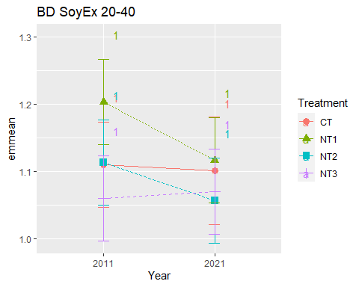

## [1] "BD SoyEx 40-60"

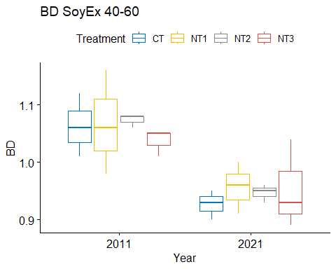

## [1] "Normality"

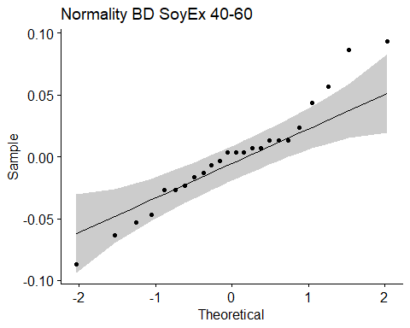

## [1] "Shapiro test for normality"  
## # A tibble: 1 × 3  
## variable statistic p.value  
## <chr> <dbl> <dbl>  
## 1 residuals(model) 0.962 0.490  
## [1] "Homoscedasticity"

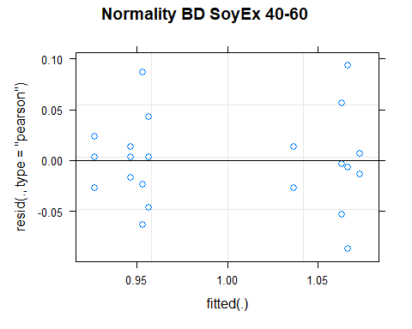

## [1] "Levene test for homoscedasticity"  
## # A tibble: 1 × 4  
## df1 df2 statistic p  
## <int> <int> <dbl> <dbl>  
## 1 7 16 1.08 0.422  
## [1] "ANOVA"  
## Treatment = CT:  
## Year emmean SE df lower.CL upper.CL .group  
## 2021 0.927 0.0294 16 0.864 0.989 1   
## 2011 1.063 0.0294 16 1.001 1.126 2   
##   
## Treatment = NT1:  
## Year emmean SE df lower.CL upper.CL .group  
## 2021 0.957 0.0294 16 0.894 1.019 1   
## 2011 1.067 0.0294 16 1.004 1.129 2   
##   
## Treatment = NT2:  
## Year emmean SE df lower.CL upper.CL .group  
## 2021 0.947 0.0294 16 0.884 1.009 1   
## 2011 1.073 0.0294 16 1.011 1.136 2   
##   
## Treatment = NT3:  
## Year emmean SE df lower.CL upper.CL .group  
## 2021 0.953 0.0294 16 0.891 1.016 1   
## 2011 1.037 0.0294 16 0.974 1.099 1   
##   
## Degrees-of-freedom method: kenward-roger   
## Results are given on the [ (not the response) scale.   
## Confidence level used: 0.95   
## Note: contrasts are still on the [ scale   
## significance level used: alpha = 0.05   
## NOTE: If two or more means share the same grouping symbol,  
## then we cannot show them to be different.  
## But we also did not show them to be the same.   
## Year = 2011:  
## Treatment emmean SE df lower.CL upper.CL .group  
## NT3 1.037 0.0294 16 0.974 1.099 1   
## CT 1.063 0.0294 16 1.001 1.126 1   
## NT1 1.067 0.0294 16 1.004 1.129 1   
## NT2 1.073 0.0294 16 1.011 1.136 1   
##   
## Year = 2021:  
## Treatment emmean SE df lower.CL upper.CL .group  
## CT 0.927 0.0294 16 0.864 0.989 1   
## NT2 0.947 0.0294 16 0.884 1.009 1   
## NT3 0.953 0.0294 16 0.891 1.016 1   
## NT1 0.957 0.0294 16 0.894 1.019 1   
##   
## Degrees-of-freedom method: kenward-roger   
## Results are given on the [ (not the response) scale.   
## Confidence level used: 0.95   
## Note: contrasts are still on the [ scale   
## P value adjustment: tukey method for comparing a family of 4 estimates   
## significance level used: alpha = 0.05   
## NOTE: If two or more means share the same grouping symbol,  
## then we cannot show them to be different.  
## But we also did not show them to be the same.   
## [1] "ANOVA plot"

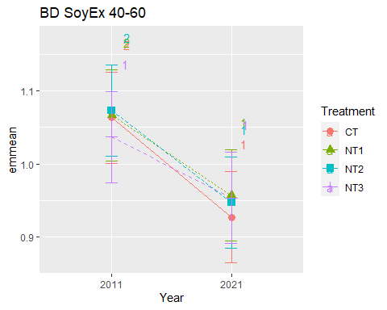

## [1] "BD SoyEx 60-80"

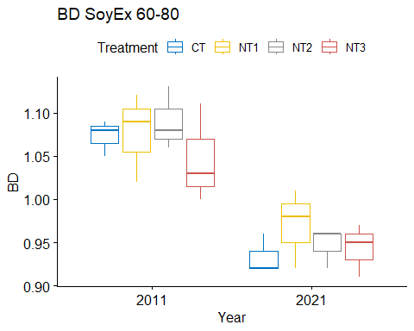

## [1] "Normality"

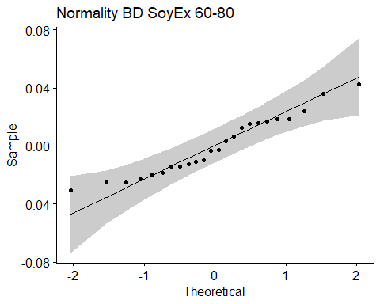

## [1] "Shapiro test for normality"  
## # A tibble: 1 × 3  
## variable statistic p.value  
## <chr> <dbl> <dbl>  
## 1 residuals(model) 0.951 0.282  
## [1] "Homoscedasticity"

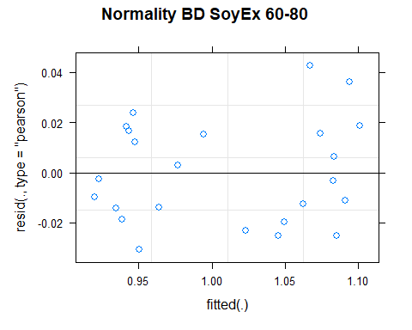

## [1] "Levene test for homoscedasticity"  
## # A tibble: 1 × 4  
## df1 df2 statistic p  
## <int> <int> <dbl> <dbl>  
## 1 7 16 0.355 0.915  
## [1] "ANOVA"  
## Treatment = CT:  
## Year emmean SE df lower.CL upper.CL .group  
## 2021 0.933 0.0221 13.6 0.886 0.981 1   
## 2011 1.073 0.0221 13.6 1.026 1.121 2   
##   
## Treatment = NT1:  
## Year emmean SE df lower.CL upper.CL .group  
## 2021 0.970 0.0221 13.6 0.923 1.017 1   
## 2011 1.077 0.0221 13.6 1.029 1.124 2   
##   
## Treatment = NT2:  
## Year emmean SE df lower.CL upper.CL .group  
## 2021 0.947 0.0221 13.6 0.899 0.994 1   
## 2011 1.090 0.0221 13.6 1.043 1.137 2   
##   
## Treatment = NT3:  
## Year emmean SE df lower.CL upper.CL .group  
## 2021 0.943 0.0221 13.6 0.896 0.991 1   
## 2011 1.047 0.0221 13.6 0.999 1.094 2   
##   
## Degrees-of-freedom method: kenward-roger   
## Results are given on the [ (not the response) scale.   
## Confidence level used: 0.95   
## Note: contrasts are still on the [ scale   
## significance level used: alpha = 0.05   
## NOTE: If two or more means share the same grouping symbol,  
## then we cannot show them to be different.  
## But we also did not show them to be the same.   
## Year = 2011:  
## Treatment emmean SE df lower.CL upper.CL .group  
## NT3 1.047 0.0221 13.6 0.999 1.094 1   
## CT 1.073 0.0221 13.6 1.026 1.121 1   
## NT1 1.077 0.0221 13.6 1.029 1.124 1   
## NT2 1.090 0.0221 13.6 1.043 1.137 1   
##   
## Year = 2021:  
## Treatment emmean SE df lower.CL upper.CL .group  
## CT 0.933 0.0221 13.6 0.886 0.981 1   
## NT3 0.943 0.0221 13.6 0.896 0.991 1   
## NT2 0.947 0.0221 13.6 0.899 0.994 1   
## NT1 0.970 0.0221 13.6 0.923 1.017 1   
##   
## Degrees-of-freedom method: kenward-roger   
## Results are given on the [ (not the response) scale.   
## Confidence level used: 0.95   
## Note: contrasts are still on the [ scale   
## P value adjustment: tukey method for comparing a family of 4 estimates   
## significance level used: alpha = 0.05   
## NOTE: If two or more means share the same grouping symbol,  
## then we cannot show them to be different.  
## But we also did not show them to be the same.   
## [1] "ANOVA plot"

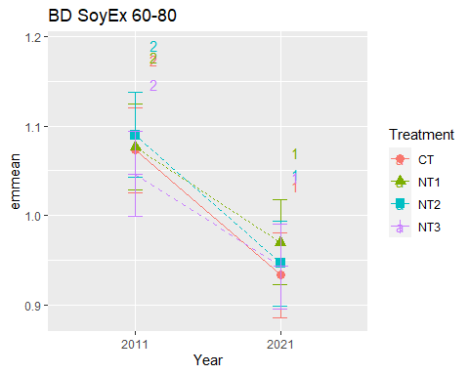

## [1] "BD SoyEx 80-100"

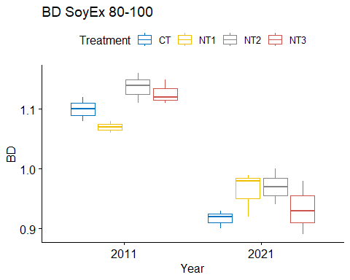

## [1] "Normality"

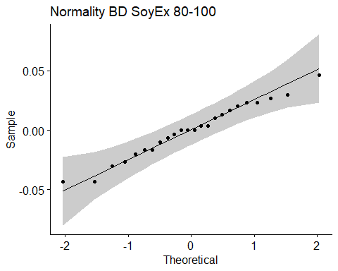

## [1] "Shapiro test for normality"  
## # A tibble: 1 × 3  
## variable statistic p.value  
## <chr> <dbl> <dbl>  
## 1 residuals(model) 0.981 0.909  
## [1] "Homoscedasticity"

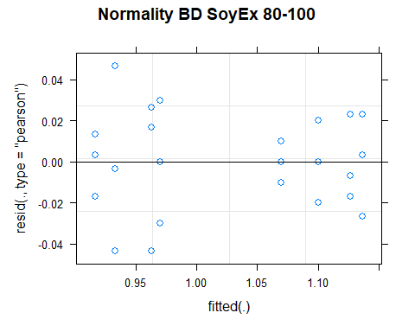

## [1] "Levene test for homoscedasticity"  
## # A tibble: 1 × 4  
## df1 df2 statistic p  
## <int> <int> <dbl> <dbl>  
## 1 7 16 0.496 0.824  
## [1] "ANOVA"  
## Treatment = CT:  
## Year emmean SE df lower.CL upper.CL .group  
## 2021 0.917 0.016 16 0.883 0.951 1   
## 2011 1.100 0.016 16 1.066 1.134 2   
##   
## Treatment = NT1:  
## Year emmean SE df lower.CL upper.CL .group  
## 2021 0.963 0.016 16 0.929 0.997 1   
## 2011 1.070 0.016 16 1.036 1.104 2   
##   
## Treatment = NT2:  
## Year emmean SE df lower.CL upper.CL .group  
## 2021 0.970 0.016 16 0.936 1.004 1   
## 2011 1.137 0.016 16 1.103 1.171 2   
##   
## Treatment = NT3:  
## Year emmean SE df lower.CL upper.CL .group  
## 2021 0.933 0.016 16 0.899 0.967 1   
## 2011 1.127 0.016 16 1.093 1.161 2   
##   
## Degrees-of-freedom method: kenward-roger   
## Results are given on the [ (not the response) scale.   
## Confidence level used: 0.95   
## Note: contrasts are still on the [ scale   
## significance level used: alpha = 0.05   
## NOTE: If two or more means share the same grouping symbol,  
## then we cannot show them to be different.  
## But we also did not show them to be the same.   
## Year = 2011:  
## Treatment emmean SE df lower.CL upper.CL .group  
## NT1 1.070 0.016 16 1.036 1.104 1   
## CT 1.100 0.016 16 1.066 1.134 12   
## NT3 1.127 0.016 16 1.093 1.161 12   
## NT2 1.137 0.016 16 1.103 1.171 2   
##   
## Year = 2021:  
## Treatment emmean SE df lower.CL upper.CL .group  
## CT 0.917 0.016 16 0.883 0.951 1   
## NT3 0.933 0.016 16 0.899 0.967 1   
## NT1 0.963 0.016 16 0.929 0.997 1   
## NT2 0.970 0.016 16 0.936 1.004 1   
##   
## Degrees-of-freedom method: kenward-roger   
## Results are given on the [ (not the response) scale.   
## Confidence level used: 0.95   
## Note: contrasts are still on the [ scale   
## P value adjustment: tukey method for comparing a family of 4 estimates   
## significance level used: alpha = 0.05   
## NOTE: If two or more means share the same grouping symbol,  
## then we cannot show them to be different.  
## But we also did not show them to be the same.   
## [1] "ANOVA plot"

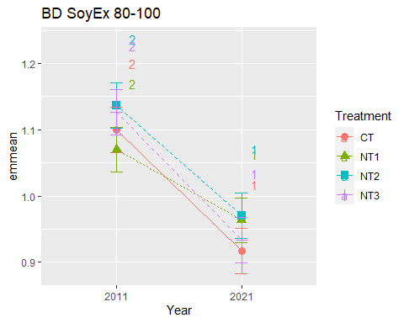

## [1] "Summary for soil depths"

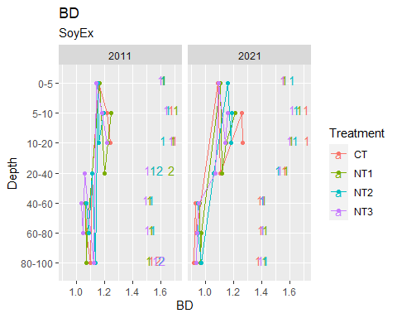

## [1] "BD CasEx"  
## # A tibble: 56 × 7  
## Treatment Depth Year variable n mean sd  
## <fct> <fct> <fct> <chr> <dbl> <dbl> <dbl>  
## 1 CT 0-5 2011 BD 3 1.10 0.067  
## 2 NT1 0-5 2011 BD 3 1.17 0.006  
## 3 NT2 0-5 2011 BD 3 1.17 0.056  
## 4 NT3 0-5 2011 BD 3 1.17 0.006  
## 5 CT 5-10 2011 BD 3 1.12 0.06   
## 6 NT1 5-10 2011 BD 3 1.19 0.026  
## 7 NT2 5-10 2011 BD 3 1.18 0.081  
## 8 NT3 5-10 2011 BD 3 1.18 0.061  
## 9 CT 10-20 2011 BD 3 1.15 0.095  
## 10 NT1 10-20 2011 BD 3 1.25 0.02   
## # … with 46 more rows  
## [1] "BD CasEx 0-5"

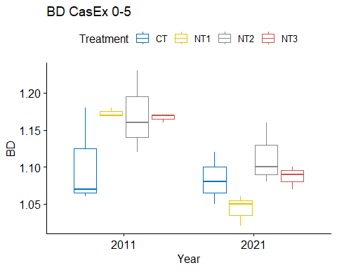

## [1] "Normality"

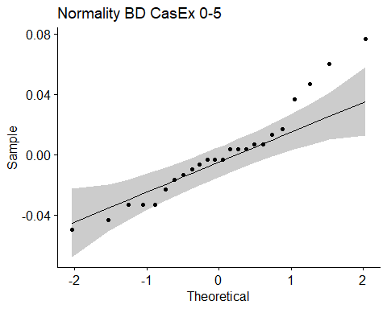

## [1] "Shapiro test for normality"  
## # A tibble: 1 × 3  
## variable statistic p.value  
## <chr> <dbl> <dbl>  
## 1 residuals(model) 0.945 0.206  
## [1] "Homoscedasticity"

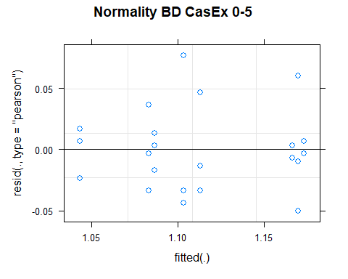

## [1] "Levene test for homoscedasticity"  
## # A tibble: 1 × 4  
## df1 df2 statistic p  
## <int> <int> <dbl> <dbl>  
## 1 7 16 0.733 0.648  
## [1] "ANOVA"  
## Treatment = CT:  
## Year emmean SE df lower.CL upper.CL .group  
## 2021 1.08 0.0216 16 1.037 1.13 1   
## 2011 1.10 0.0216 16 1.057 1.15 1   
##   
## Treatment = NT1:  
## Year emmean SE df lower.CL upper.CL .group  
## 2021 1.04 0.0216 16 0.997 1.09 1   
## 2011 1.17 0.0216 16 1.127 1.22 2   
##   
## Treatment = NT2:  
## Year emmean SE df lower.CL upper.CL .group  
## 2021 1.11 0.0216 16 1.067 1.16 1   
## 2011 1.17 0.0216 16 1.124 1.22 1   
##   
## Treatment = NT3:  
## Year emmean SE df lower.CL upper.CL .group  
## 2021 1.09 0.0216 16 1.041 1.13 1   
## 2011 1.17 0.0216 16 1.121 1.21 2   
##   
## Degrees-of-freedom method: kenward-roger   
## Results are given on the [ (not the response) scale.   
## Confidence level used: 0.95   
## Note: contrasts are still on the [ scale   
## significance level used: alpha = 0.05   
## NOTE: If two or more means share the same grouping symbol,  
## then we cannot show them to be different.  
## But we also did not show them to be the same.   
## Year = 2011:  
## Treatment emmean SE df lower.CL upper.CL .group  
## CT 1.10 0.0216 16 1.057 1.15 1   
## NT3 1.17 0.0216 16 1.121 1.21 1   
## NT2 1.17 0.0216 16 1.124 1.22 1   
## NT1 1.17 0.0216 16 1.127 1.22 1   
##   
## Year = 2021:  
## Treatment emmean SE df lower.CL upper.CL .group  
## NT1 1.04 0.0216 16 0.997 1.09 1   
## CT 1.08 0.0216 16 1.037 1.13 1   
## NT3 1.09 0.0216 16 1.041 1.13 1   
## NT2 1.11 0.0216 16 1.067 1.16 1   
##   
## Degrees-of-freedom method: kenward-roger   
## Results are given on the [ (not the response) scale.   
## Confidence level used: 0.95   
## Note: contrasts are still on the [ scale   
## P value adjustment: tukey method for comparing a family of 4 estimates   
## significance level used: alpha = 0.05   
## NOTE: If two or more means share the same grouping symbol,  
## then we cannot show them to be different.  
## But we also did not show them to be the same.   
## [1] "ANOVA plot"

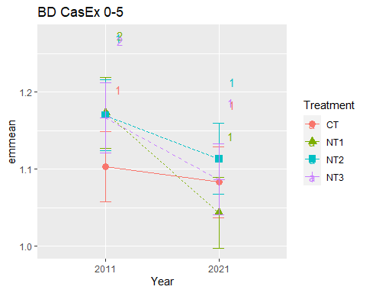

## [1] "BD CasEx 5-10"

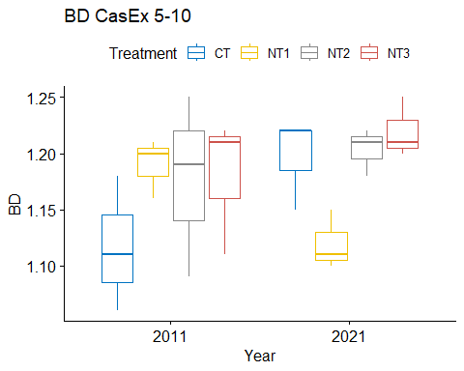

## [1] "Normality"

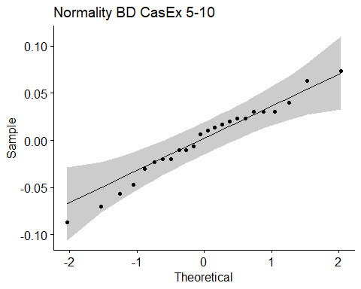

## [1] "Shapiro test for normality"  
## # A tibble: 1 × 3  
## variable statistic p.value  
## <chr> <dbl> <dbl>  
## 1 residuals(model) 0.974 0.769  
## [1] "Homoscedasticity"

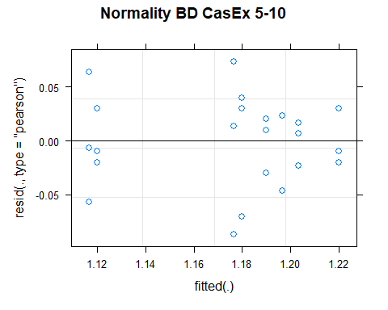

## [1] "Levene test for homoscedasticity"  
## # A tibble: 1 × 4  
## df1 df2 statistic p  
## <int> <int> <dbl> <dbl>  
## 1 7 16 0.505 0.818  
## [1] "ANOVA"  
## Treatment = CT:  
## Year emmean SE df lower.CL upper.CL .group  
## 2011 1.12 0.0274 16 1.06 1.17 1   
## 2021 1.20 0.0274 16 1.14 1.25 1   
##   
## Treatment = NT1:  
## Year emmean SE df lower.CL upper.CL .group  
## 2021 1.12 0.0274 16 1.06 1.18 1   
## 2011 1.19 0.0274 16 1.13 1.25 1   
##   
## Treatment = NT2:  
## Year emmean SE df lower.CL upper.CL .group  
## 2011 1.18 0.0274 16 1.12 1.23 1   
## 2021 1.20 0.0274 16 1.15 1.26 1   
##   
## Treatment = NT3:  
## Year emmean SE df lower.CL upper.CL .group  
## 2011 1.18 0.0274 16 1.12 1.24 1   
## 2021 1.22 0.0274 16 1.16 1.28 1   
##   
## Degrees-of-freedom method: kenward-roger   
## Results are given on the [ (not the response) scale.   
## Confidence level used: 0.95   
## Note: contrasts are still on the [ scale   
## significance level used: alpha = 0.05   
## NOTE: If two or more means share the same grouping symbol,  
## then we cannot show them to be different.  
## But we also did not show them to be the same.   
## Year = 2011:  
## Treatment emmean SE df lower.CL upper.CL .group  
## CT 1.12 0.0274 16 1.06 1.17 1   
## NT2 1.18 0.0274 16 1.12 1.23 1   
## NT3 1.18 0.0274 16 1.12 1.24 1   
## NT1 1.19 0.0274 16 1.13 1.25 1   
##   
## Year = 2021:  
## Treatment emmean SE df lower.CL upper.CL .group  
## NT1 1.12 0.0274 16 1.06 1.18 1   
## CT 1.20 0.0274 16 1.14 1.25 1   
## NT2 1.20 0.0274 16 1.15 1.26 1   
## NT3 1.22 0.0274 16 1.16 1.28 1   
##   
## Degrees-of-freedom method: kenward-roger   
## Results are given on the [ (not the response) scale.   
## Confidence level used: 0.95   
## Note: contrasts are still on the [ scale   
## P value adjustment: tukey method for comparing a family of 4 estimates   
## significance level used: alpha = 0.05   
## NOTE: If two or more means share the same grouping symbol,  
## then we cannot show them to be different.  
## But we also did not show them to be the same.   
## [1] "ANOVA plot"

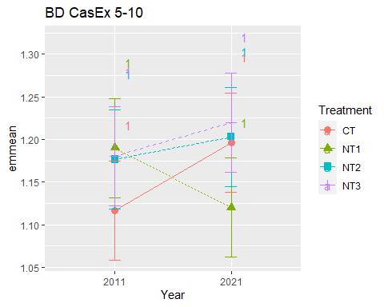

## [1] "BD CasEx 10-20"

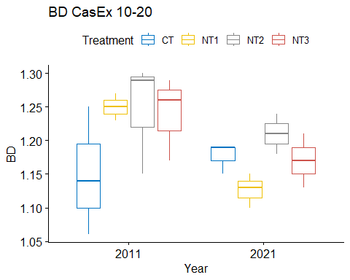

## [1] "Normality"

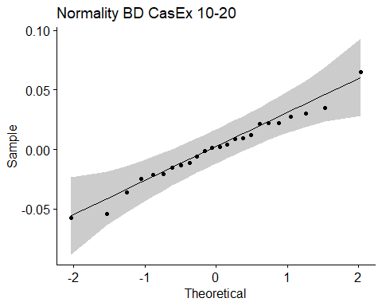

## [1] "Shapiro test for normality"  
## # A tibble: 1 × 3  
## variable statistic p.value  
## <chr> <dbl> <dbl>  
## 1 residuals(model) 0.982 0.925  
## [1] "Homoscedasticity"

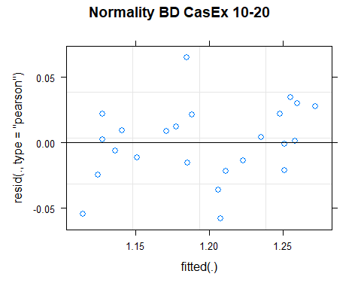

## [1] "Levene test for homoscedasticity"  
## # A tibble: 1 × 4  
## df1 df2 statistic p  
## <int> <int> <dbl> <dbl>  
## 1 7 16 0.639 0.718  
## [1] "ANOVA"  
## Treatment = CT:  
## Year emmean SE df lower.CL upper.CL .group  
## 2011 1.15 0.0317 13.4 1.08 1.22 1   
## 2021 1.18 0.0317 13.4 1.11 1.24 1   
##   
## Treatment = NT1:  
## Year emmean SE df lower.CL upper.CL .group  
## 2021 1.13 0.0317 13.4 1.06 1.19 1   
## 2011 1.25 0.0317 13.4 1.18 1.32 2   
##   
## Treatment = NT2:  
## Year emmean SE df lower.CL upper.CL .group  
## 2021 1.21 0.0317 13.4 1.14 1.28 1   
## 2011 1.25 0.0317 13.4 1.18 1.31 1   
##   
## Treatment = NT3:  
## Year emmean SE df lower.CL upper.CL .group  
## 2021 1.17 0.0317 13.4 1.10 1.24 1   
## 2011 1.24 0.0317 13.4 1.17 1.31 1   
##   
## Degrees-of-freedom method: kenward-roger   
## Results are given on the [ (not the response) scale.   
## Confidence level used: 0.95   
## Note: contrasts are still on the [ scale   
## significance level used: alpha = 0.05   
## NOTE: If two or more means share the same grouping symbol,  
## then we cannot show them to be different.  
## But we also did not show them to be the same.   
## Year = 2011:  
## Treatment emmean SE df lower.CL upper.CL .group  
## CT 1.15 0.0317 13.4 1.08 1.22 1   
## NT3 1.24 0.0317 13.4 1.17 1.31 1   
## NT2 1.25 0.0317 13.4 1.18 1.31 1   
## NT1 1.25 0.0317 13.4 1.18 1.32 1   
##   
## Year = 2021:  
## Treatment emmean SE df lower.CL upper.CL .group  
## NT1 1.13 0.0317 13.4 1.06 1.19 1   
## NT3 1.17 0.0317 13.4 1.10 1.24 1   
## CT 1.18 0.0317 13.4 1.11 1.24 1   
## NT2 1.21 0.0317 13.4 1.14 1.28 1   
##   
## Degrees-of-freedom method: kenward-roger   
## Results are given on the [ (not the response) scale.   
## Confidence level used: 0.95   
## Note: contrasts are still on the [ scale   
## P value adjustment: tukey method for comparing a family of 4 estimates   
## significance level used: alpha = 0.05   
## NOTE: If two or more means share the same grouping symbol,  
## then we cannot show them to be different.  
## But we also did not show them to be the same.   
## [1] "ANOVA plot"

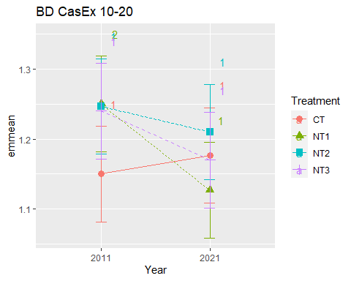

## [1] "BD CasEx 20-40"

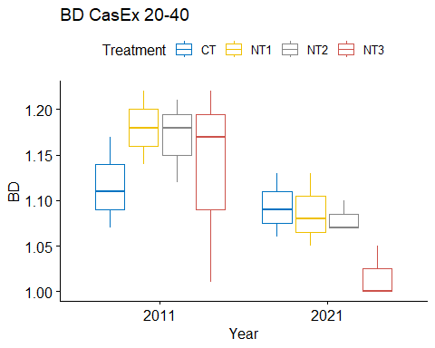

## [1] "Normality"

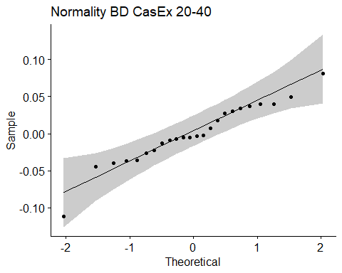

## [1] "Shapiro test for normality"  
## # A tibble: 1 × 3  
## variable statistic p.value  
## <chr> <dbl> <dbl>  
## 1 residuals(model) 0.957 0.386  
## [1] "Homoscedasticity"

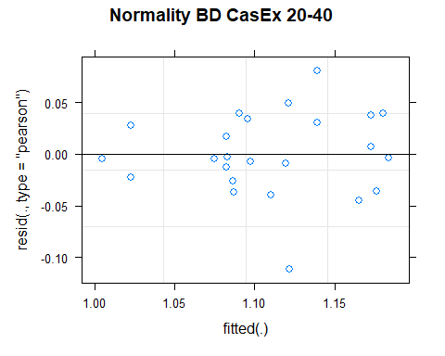

## [1] "Levene test for homoscedasticity"  
## # A tibble: 1 × 4  
## df1 df2 statistic p  
## <int> <int> <dbl> <dbl>  
## 1 7 16 0.686 0.683  
## [1] "ANOVA"  
## Treatment = CT:  
## Year emmean SE df lower.CL upper.CL .group  
## 2021 1.09 0.0305 15.9 1.029 1.16 1   
## 2011 1.12 0.0305 15.9 1.052 1.18 1   
##   
## Treatment = NT1:  
## Year emmean SE df lower.CL upper.CL .group  
## 2021 1.09 0.0305 15.9 1.022 1.15 1   
## 2011 1.18 0.0305 15.9 1.115 1.24 1   
##   
## Treatment = NT2:  
## Year emmean SE df lower.CL upper.CL .group  
## 2021 1.08 0.0305 15.9 1.015 1.14 1   
## 2011 1.17 0.0305 15.9 1.105 1.23 1   
##   
## Treatment = NT3:  
## Year emmean SE df lower.CL upper.CL .group  
## 2021 1.02 0.0305 15.9 0.952 1.08 1   
## 2011 1.13 0.0305 15.9 1.069 1.20 2   
##   
## Degrees-of-freedom method: kenward-roger   
## Results are given on the [ (not the response) scale.   
## Confidence level used: 0.95   
## Note: contrasts are still on the [ scale   
## significance level used: alpha = 0.05   
## NOTE: If two or more means share the same grouping symbol,  
## then we cannot show them to be different.  
## But we also did not show them to be the same.   
## Year = 2011:  
## Treatment emmean SE df lower.CL upper.CL .group  
## CT 1.12 0.0305 15.9 1.052 1.18 1   
## NT3 1.13 0.0305 15.9 1.069 1.20 1   
## NT2 1.17 0.0305 15.9 1.105 1.23 1   
## NT1 1.18 0.0305 15.9 1.115 1.24 1   
##   
## Year = 2021:  
## Treatment emmean SE df lower.CL upper.CL .group  
## NT3 1.02 0.0305 15.9 0.952 1.08 1   
## NT2 1.08 0.0305 15.9 1.015 1.14 1   
## NT1 1.09 0.0305 15.9 1.022 1.15 1   
## CT 1.09 0.0305 15.9 1.029 1.16 1   
##   
## Degrees-of-freedom method: kenward-roger   
## Results are given on the [ (not the response) scale.   
## Confidence level used: 0.95   
## Note: contrasts are still on the [ scale   
## P value adjustment: tukey method for comparing a family of 4 estimates   
## significance level used: alpha = 0.05   
## NOTE: If two or more means share the same grouping symbol,  
## then we cannot show them to be different.  
## But we also did not show them to be the same.   
## [1] "ANOVA plot"

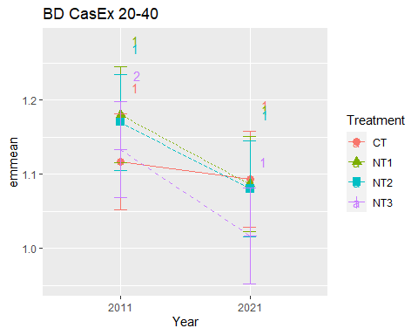

## [1] "BD CasEx 40-60"

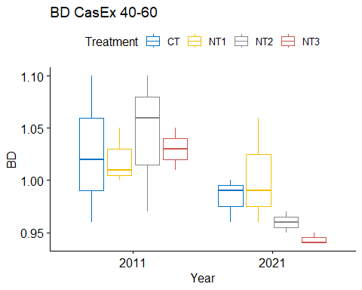

## [1] "Normality"

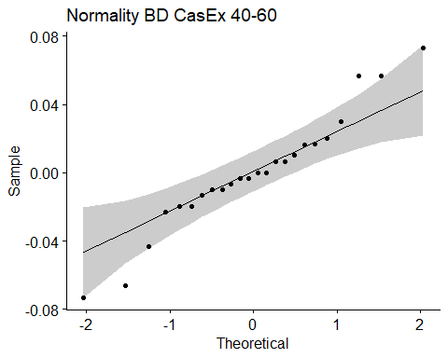

## [1] "Shapiro test for normality"  
## # A tibble: 1 × 3  
## variable statistic p.value  
## <chr> <dbl> <dbl>  
## 1 residuals(model) 0.958 0.397  
## [1] "Homoscedasticity"

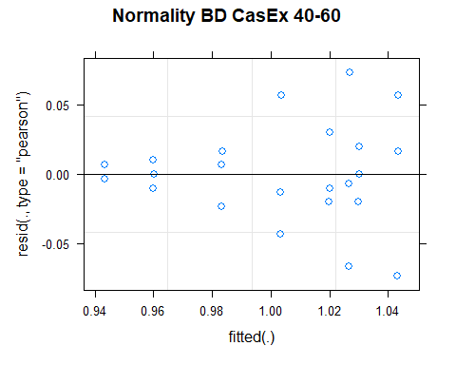

## [1] "Levene test for homoscedasticity"  
## # A tibble: 1 × 4  
## df1 df2 statistic p  
## <int> <int> <dbl> <dbl>  
## 1 7 16 1.14 0.386  
## [1] "ANOVA"  
## Treatment = CT:  
## Year emmean SE df lower.CL upper.CL .group  
## 2021 0.983 0.0239 16 0.933 1.034 1   
## 2011 1.027 0.0239 16 0.976 1.077 1   
##   
## Treatment = NT1:  
## Year emmean SE df lower.CL upper.CL .group  
## 2021 1.003 0.0239 16 0.953 1.054 1   
## 2011 1.020 0.0239 16 0.969 1.071 1   
##   
## Treatment = NT2:  
## Year emmean SE df lower.CL upper.CL .group  
## 2021 0.960 0.0239 16 0.909 1.011 1   
## 2011 1.043 0.0239 16 0.993 1.094 2   
##   
## Treatment = NT3:  
## Year emmean SE df lower.CL upper.CL .group  
## 2021 0.943 0.0239 16 0.893 0.994 1   
## 2011 1.030 0.0239 16 0.979 1.081 2   
##   
## Degrees-of-freedom method: kenward-roger   
## Results are given on the [ (not the response) scale.   
## Confidence level used: 0.95   
## Note: contrasts are still on the [ scale   
## significance level used: alpha = 0.05   
## NOTE: If two or more means share the same grouping symbol,  
## then we cannot show them to be different.  
## But we also did not show them to be the same.   
## Year = 2011:  
## Treatment emmean SE df lower.CL upper.CL .group  
## NT1 1.020 0.0239 16 0.969 1.071 1   
## CT 1.027 0.0239 16 0.976 1.077 1   
## NT3 1.030 0.0239 16 0.979 1.081 1   
## NT2 1.043 0.0239 16 0.993 1.094 1   
##   
## Year = 2021:  
## Treatment emmean SE df lower.CL upper.CL .group  
## NT3 0.943 0.0239 16 0.893 0.994 1   
## NT2 0.960 0.0239 16 0.909 1.011 1   
## CT 0.983 0.0239 16 0.933 1.034 1   
## NT1 1.003 0.0239 16 0.953 1.054 1   
##   
## Degrees-of-freedom method: kenward-roger   
## Results are given on the [ (not the response) scale.   
## Confidence level used: 0.95   
## Note: contrasts are still on the [ scale   
## P value adjustment: tukey method for comparing a family of 4 estimates   
## significance level used: alpha = 0.05   
## NOTE: If two or more means share the same grouping symbol,  
## then we cannot show them to be different.  
## But we also did not show them to be the same.   
## [1] "ANOVA plot"

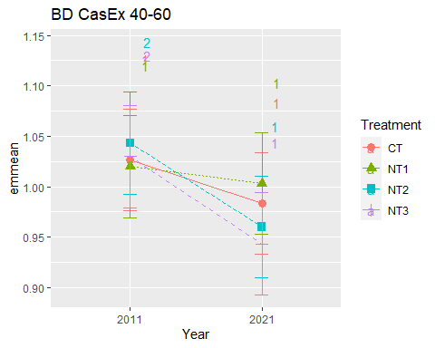

## [1] "BD CasEx 60-80"

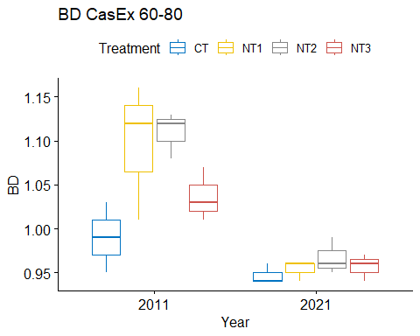

## [1] "Normality"

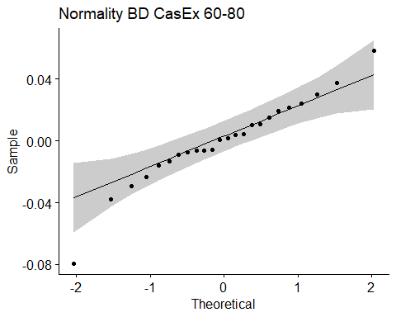

## [1] "Shapiro test for normality"  
## # A tibble: 1 × 3  
## variable statistic p.value  
## <chr> <dbl> <dbl>  
## 1 residuals(model) 0.958 0.398  
## [1] "Homoscedasticity"

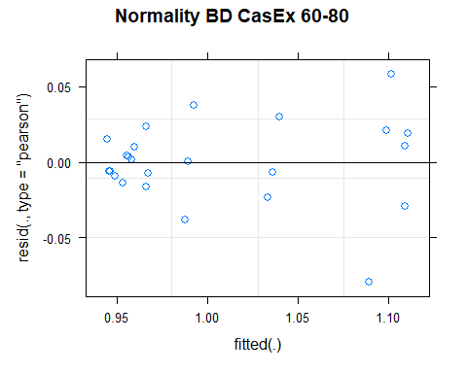

## [1] "Levene test for homoscedasticity"  
## # A tibble: 1 × 4  
## df1 df2 statistic p  
## <int> <int> <dbl> <dbl>  
## 1 7 16 0.977 0.481  
## [1] "ANOVA"  
## Treatment = CT:  
## Year emmean SE df lower.CL upper.CL .group  
## 2021 0.947 0.0206 15.9 0.903 0.990 1   
## 2011 0.990 0.0206 15.9 0.946 1.034 1   
##   
## Treatment = NT1:  
## Year emmean SE df lower.CL upper.CL .group  
## 2021 0.953 0.0206 15.9 0.910 0.997 1   
## 2011 1.097 0.0206 15.9 1.053 1.140 2   
##   
## Treatment = NT2:  
## Year emmean SE df lower.CL upper.CL .group  
## 2021 0.967 0.0206 15.9 0.923 1.010 1   
## 2011 1.110 0.0206 15.9 1.066 1.154 2   
##   
## Treatment = NT3:  
## Year emmean SE df lower.CL upper.CL .group  
## 2021 0.957 0.0206 15.9 0.913 1.000 1   
## 2011 1.037 0.0206 15.9 0.993 1.080 2   
##   
## Degrees-of-freedom method: kenward-roger   
## Results are given on the [ (not the response) scale.   
## Confidence level used: 0.95   
## Note: contrasts are still on the [ scale   
## significance level used: alpha = 0.05   
## NOTE: If two or more means share the same grouping symbol,  
## then we cannot show them to be different.  
## But we also did not show them to be the same.   
## Year = 2011:  
## Treatment emmean SE df lower.CL upper.CL .group  
## CT 0.990 0.0206 15.9 0.946 1.034 1   
## NT3 1.037 0.0206 15.9 0.993 1.080 12   
## NT1 1.097 0.0206 15.9 1.053 1.140 2   
## NT2 1.110 0.0206 15.9 1.066 1.154 2   
##   
## Year = 2021:  
## Treatment emmean SE df lower.CL upper.CL .group  
## CT 0.947 0.0206 15.9 0.903 0.990 1   
## NT1 0.953 0.0206 15.9 0.910 0.997 1   
## NT3 0.957 0.0206 15.9 0.913 1.000 1   
## NT2 0.967 0.0206 15.9 0.923 1.010 1   
##   
## Degrees-of-freedom method: kenward-roger   
## Results are given on the [ (not the response) scale.   
## Confidence level used: 0.95   
## Note: contrasts are still on the [ scale   
## P value adjustment: tukey method for comparing a family of 4 estimates   
## significance level used: alpha = 0.05   
## NOTE: If two or more means share the same grouping symbol,  
## then we cannot show them to be different.  
## But we also did not show them to be the same.   
## [1] "ANOVA plot"

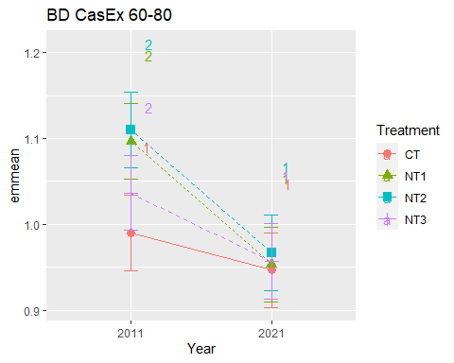

## [1] "BD CasEx 80-100"

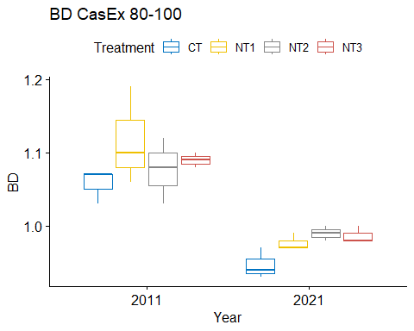

## [1] "Normality"

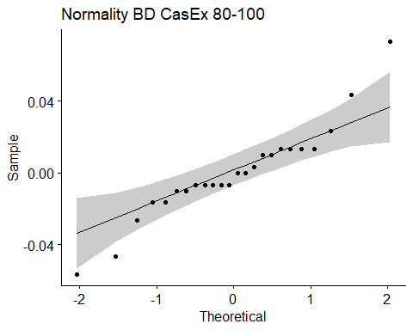

## [1] "Shapiro test for normality"  
## # A tibble: 1 × 3  
## variable statistic p.value  
## <chr> <dbl> <dbl>  
## 1 residuals(model) 0.929 0.0914  
## [1] "Homoscedasticity"

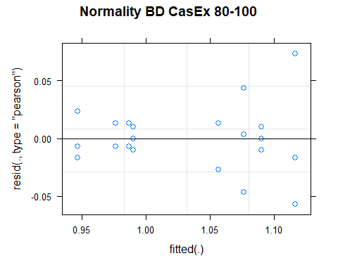

## [1] "Levene test for homoscedasticity"  
## # A tibble: 1 × 4  
## df1 df2 statistic p  
## <int> <int> <dbl> <dbl>  
## 1 7 16 1.17 0.373  
## [1] "ANOVA"  
## Treatment = CT:  
## Year emmean SE df lower.CL upper.CL .group  
## 2021 0.947 0.0181 16 0.908 0.985 1   
## 2011 1.057 0.0181 16 1.018 1.095 2   
##   
## Treatment = NT1:  
## Year emmean SE df lower.CL upper.CL .group  
## 2021 0.977 0.0181 16 0.938 1.015 1   
## 2011 1.117 0.0181 16 1.078 1.155 2   
##   
## Treatment = NT2:  
## Year emmean SE df lower.CL upper.CL .group  
## 2021 0.990 0.0181 16 0.952 1.028 1   
## 2011 1.077 0.0181 16 1.038 1.115 2   
##   
## Treatment = NT3:  
## Year emmean SE df lower.CL upper.CL .group  
## 2021 0.987 0.0181 16 0.948 1.025 1   
## 2011 1.090 0.0181 16 1.052 1.128 2   
##   
## Degrees-of-freedom method: kenward-roger   
## Results are given on the [ (not the response) scale.   
## Confidence level used: 0.95   
## Note: contrasts are still on the [ scale   
## significance level used: alpha = 0.05   
## NOTE: If two or more means share the same grouping symbol,  
## then we cannot show them to be different.  
## But we also did not show them to be the same.   
## Year = 2011:  
## Treatment emmean SE df lower.CL upper.CL .group  
## CT 1.057 0.0181 16 1.018 1.095 1   
## NT2 1.077 0.0181 16 1.038 1.115 1   
## NT3 1.090 0.0181 16 1.052 1.128 1   
## NT1 1.117 0.0181 16 1.078 1.155 1   
##   
## Year = 2021:  
## Treatment emmean SE df lower.CL upper.CL .group  
## CT 0.947 0.0181 16 0.908 0.985 1   
## NT1 0.977 0.0181 16 0.938 1.015 1   
## NT3 0.987 0.0181 16 0.948 1.025 1   
## NT2 0.990 0.0181 16 0.952 1.028 1   
##   
## Degrees-of-freedom method: kenward-roger   
## Results are given on the [ (not the response) scale.   
## Confidence level used: 0.95   
## Note: contrasts are still on the [ scale   
## P value adjustment: tukey method for comparing a family of 4 estimates   
## significance level used: alpha = 0.05   
## NOTE: If two or more means share the same grouping symbol,  
## then we cannot show them to be different.  
## But we also did not show them to be the same.   
## [1] "ANOVA plot"

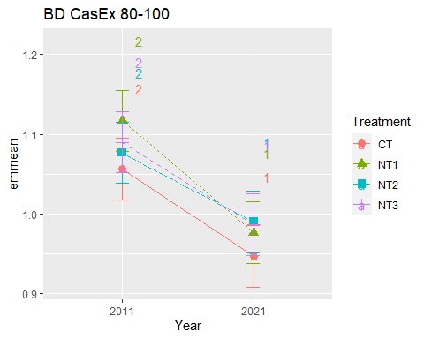

## [1] "Summary for soil depths"

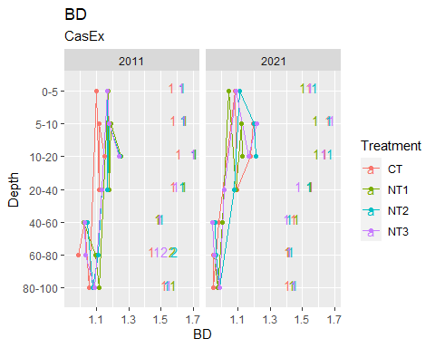

## [1] "NSTOCK2"

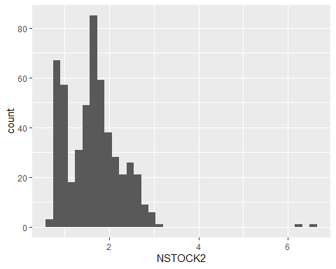

## [1] "NSTOCK2 MaiEx"  
## # A tibble: 56 × 7  
## Treatment Depth Year variable n mean sd  
## <fct> <fct> <fct> <chr> <dbl> <dbl> <dbl>  
## 1 CT 0-5 2011 NSTOCK2 3 0.91 0.095  
## 2 NT1 0-5 2011 NSTOCK2 3 0.943 0.081  
## 3 NT2 0-5 2011 NSTOCK2 3 0.943 0.035  
## 4 NT3 0-5 2011 NSTOCK2 3 0.977 0.012  
## 5 CT 5-10 2011 NSTOCK2 3 0.867 0.072  
## 6 NT1 5-10 2011 NSTOCK2 3 0.873 0.035  
## 7 NT2 5-10 2011 NSTOCK2 3 0.897 0.05   
## 8 NT3 5-10 2011 NSTOCK2 3 0.937 0.012  
## 9 CT 10-20 2011 NSTOCK2 3 1.48 0.179  
## 10 NT1 10-20 2011 NSTOCK2 3 1.61 0.122  
## # … with 46 more rows  
## [1] "NSTOCK2 MaiEx 0-5"

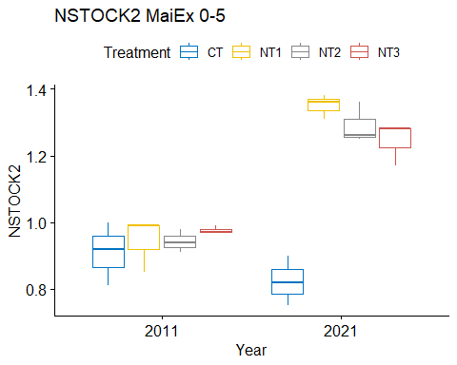

## [1] "Normality"

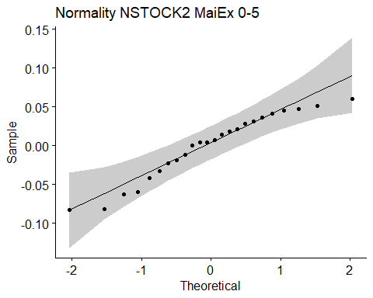

## [1] "Shapiro test for normality"  
## # A tibble: 1 × 3  
## variable statistic p.value  
## <chr> <dbl> <dbl>  
## 1 residuals(model) 0.940 0.164  
## [1] "Homoscedasticity"

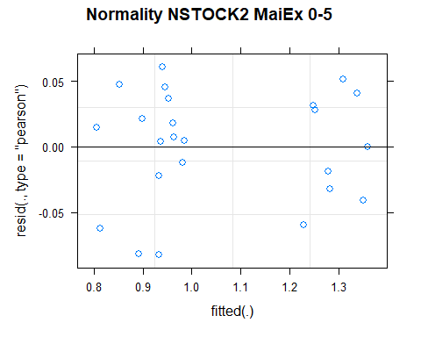

## [1] "Levene test for homoscedasticity"  
## # A tibble: 1 × 4  
## df1 df2 statistic p  
## <int> <int> <dbl> <dbl>  
## 1 7 16 0.385 0.898  
## [1] "ANOVA"  
## Treatment = CT:  
## Year emmean SE df lower.CL upper.CL .group  
## 2021 0.823 0.0363 15.3 0.746 0.901 1   
## 2011 0.910 0.0363 15.3 0.833 0.987 1   
##   
## Treatment = NT1:  
## Year emmean SE df lower.CL upper.CL .group  
## 2011 0.943 0.0363 15.3 0.866 1.021 1   
## 2021 1.350 0.0363 15.3 1.273 1.427 2   
##   
## Treatment = NT2:  
## Year emmean SE df lower.CL upper.CL .group  
## 2011 0.943 0.0363 15.3 0.866 1.021 1   
## 2021 1.290 0.0363 15.3 1.213 1.367 2   
##   
## Treatment = NT3:  
## Year emmean SE df lower.CL upper.CL .group  
## 2011 0.977 0.0363 15.3 0.899 1.054 1   
## 2021 1.243 0.0363 15.3 1.166 1.321 2   
##   
## Degrees-of-freedom method: kenward-roger   
## Results are given on the [ (not the response) scale.   
## Confidence level used: 0.95   
## Note: contrasts are still on the [ scale   
## significance level used: alpha = 0.05   
## NOTE: If two or more means share the same grouping symbol,  
## then we cannot show them to be different.  
## But we also did not show them to be the same.   
## Year = 2011:  
## Treatment emmean SE df lower.CL upper.CL .group  
## CT 0.910 0.0363 15.3 0.833 0.987 1   
## NT1 0.943 0.0363 15.3 0.866 1.021 1   
## NT2 0.943 0.0363 15.3 0.866 1.021 1   
## NT3 0.977 0.0363 15.3 0.899 1.054 1   
##   
## Year = 2021:  
## Treatment emmean SE df lower.CL upper.CL .group  
## CT 0.823 0.0363 15.3 0.746 0.901 1   
## NT3 1.243 0.0363 15.3 1.166 1.321 2   
## NT2 1.290 0.0363 15.3 1.213 1.367 2   
## NT1 1.350 0.0363 15.3 1.273 1.427 2   
##   
## Degrees-of-freedom method: kenward-roger   
## Results are given on the [ (not the response) scale.   
## Confidence level used: 0.95   
## Note: contrasts are still on the [ scale   
## P value adjustment: tukey method for comparing a family of 4 estimates   
## significance level used: alpha = 0.05   
## NOTE: If two or more means share the same grouping symbol,  
## then we cannot show them to be different.  
## But we also did not show them to be the same.   
## [1] "ANOVA plot"

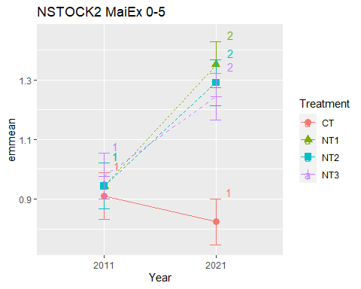

## [1] "NSTOCK2 MaiEx 5-10"

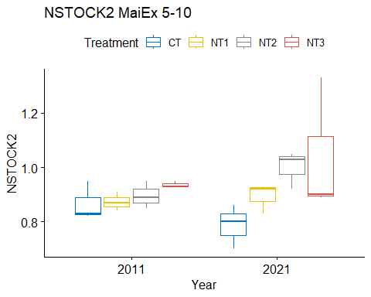

## [1] "Normality"

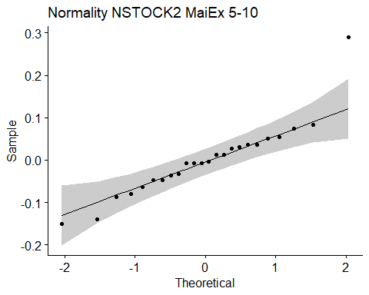

## [1] "Shapiro test for normality"  
## # A tibble: 1 × 3  
## variable statistic p.value  
## <chr> <dbl> <dbl>  
## 1 residuals(model) 0.889 0.0127  
## [1] "Homoscedasticity"

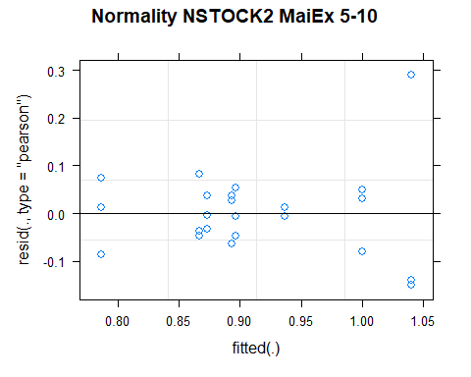

## [1] "Levene test for homoscedasticity"  
## # A tibble: 1 × 4  
## df1 df2 statistic p  
## <int> <int> <dbl> <dbl>  
## 1 7 16 0.577 0.764  
## [1] "ANOVA"  
## Treatment = CT:  
## Year emmean SE df lower.CL upper.CL .group  
## 2021 0.787 0.0601 16 0.659 0.914 1   
## 2011 0.867 0.0601 16 0.739 0.994 1   
##   
## Treatment = NT1:  
## Year emmean SE df lower.CL upper.CL .group  
## 2011 0.873 0.0601 16 0.746 1.001 1   
## 2021 0.893 0.0601 16 0.766 1.021 1   
##   
## Treatment = NT2:  
## Year emmean SE df lower.CL upper.CL .group  
## 2011 0.897 0.0601 16 0.769 1.024 1   
## 2021 1.000 0.0601 16 0.873 1.127 1   
##   
## Treatment = NT3:  
## Year emmean SE df lower.CL upper.CL .group  
## 2011 0.937 0.0601 16 0.809 1.064 1   
## 2021 1.040 0.0601 16 0.913 1.167 1   
##   
## Degrees-of-freedom method: kenward-roger   
## Results are given on the [ (not the response) scale.   
## Confidence level used: 0.95   
## Note: contrasts are still on the [ scale   
## significance level used: alpha = 0.05   
## NOTE: If two or more means share the same grouping symbol,  
## then we cannot show them to be different.  
## But we also did not show them to be the same.   
## Year = 2011:  
## Treatment emmean SE df lower.CL upper.CL .group  
## CT 0.867 0.0601 16 0.739 0.994 1   
## NT1 0.873 0.0601 16 0.746 1.001 1   
## NT2 0.897 0.0601 16 0.769 1.024 1   
## NT3 0.937 0.0601 16 0.809 1.064 1   
##   
## Year = 2021:  
## Treatment emmean SE df lower.CL upper.CL .group  
## CT 0.787 0.0601 16 0.659 0.914 1   
## NT1 0.893 0.0601 16 0.766 1.021 12   
## NT2 1.000 0.0601 16 0.873 1.127 12   
## NT3 1.040 0.0601 16 0.913 1.167 2   
##   
## Degrees-of-freedom method: kenward-roger   
## Results are given on the [ (not the response) scale.   
## Confidence level used: 0.95   
## Note: contrasts are still on the [ scale   
## P value adjustment: tukey method for comparing a family of 4 estimates   
## significance level used: alpha = 0.05   
## NOTE: If two or more means share the same grouping symbol,  
## then we cannot show them to be different.  
## But we also did not show them to be the same.   
## [1] "ANOVA plot"

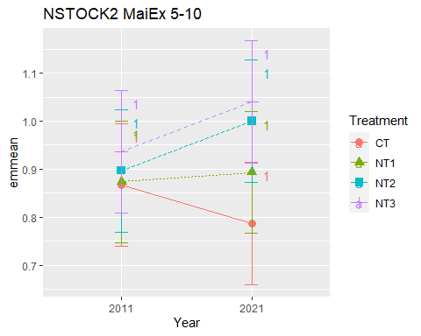

## [1] "NSTOCK2 MaiEx 10-20"

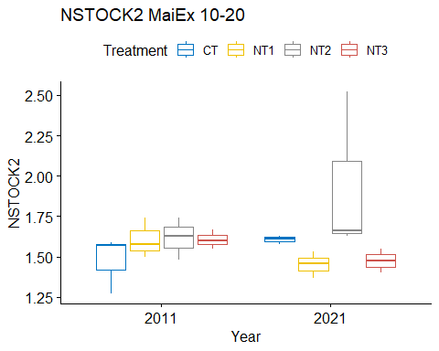

## [1] "Normality"

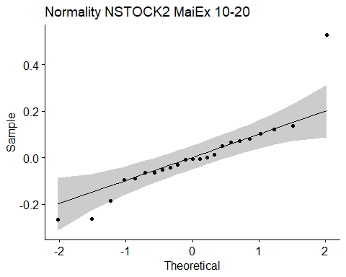

## [1] "Shapiro test for normality"  
## # A tibble: 1 × 3  
## variable statistic p.value  
## <chr> <dbl> <dbl>  
## 1 residuals(model) 0.865 0.00520  
## [1] "Homoscedasticity"

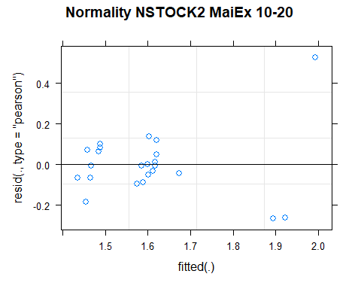

## [1] "Levene test for homoscedasticity"  
## # A tibble: 1 × 4  
## df1 df2 statistic p  
## <int> <int> <dbl> <dbl>  
## 1 7 15 0.595 0.751  
## [1] "ANOVA"  
## Treatment = CT:  
## Year emmean SE df lower.CL upper.CL .group  
## 2011 1.48 0.122 14.8 1.22 1.74 1   
## 2021 1.61 0.122 14.8 1.35 1.87 1   
##   
## Treatment = NT1:  
## Year emmean SE df lower.CL upper.CL .group  
## 2021 1.45 0.122 14.8 1.19 1.71 1   
## 2011 1.61 0.122 14.8 1.35 1.87 1   
##   
## Treatment = NT2:  
## Year emmean SE df lower.CL upper.CL .group  
## 2011 1.62 0.122 14.8 1.36 1.88 1   
## 2021 1.94 0.122 14.8 1.68 2.20 1   
##   
## Treatment = NT3:  
## Year emmean SE df lower.CL upper.CL .group  
## 2021 1.47 0.156 15.0 1.14 1.80 1   
## 2011 1.61 0.122 14.8 1.35 1.87 1   
##   
## Degrees-of-freedom method: kenward-roger   
## Results are given on the [ (not the response) scale.   
## Confidence level used: 0.95   
## Note: contrasts are still on the [ scale   
## significance level used: alpha = 0.05   
## NOTE: If two or more means share the same grouping symbol,  
## then we cannot show them to be different.  
## But we also did not show them to be the same.   
## Year = 2011:  
## Treatment emmean SE df lower.CL upper.CL .group  
## CT 1.48 0.122 14.8 1.22 1.74 1   
## NT1 1.61 0.122 14.8 1.35 1.87 1   
## NT3 1.61 0.122 14.8 1.35 1.87 1   
## NT2 1.62 0.122 14.8 1.36 1.88 1   
##   
## Year = 2021:  
## Treatment emmean SE df lower.CL upper.CL .group  
## NT1 1.45 0.122 14.8 1.19 1.71 1   
## NT3 1.47 0.156 15.0 1.14 1.80 1   
## CT 1.61 0.122 14.8 1.35 1.87 1   
## NT2 1.94 0.122 14.8 1.68 2.20 1   
##   
## Degrees-of-freedom method: kenward-roger   
## Results are given on the [ (not the response) scale.   
## Confidence level used: 0.95   
## Note: contrasts are still on the [ scale   
## P value adjustment: tukey method for comparing a family of 4 estimates   
## significance level used: alpha = 0.05   
## NOTE: If two or more means share the same grouping symbol,  
## then we cannot show them to be different.  
## But we also did not show them to be the same.   
## [1] "ANOVA plot"

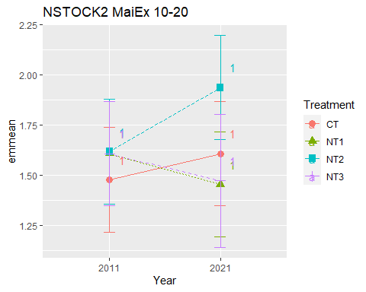

## [1] "NSTOCK2 MaiEx 20-40"

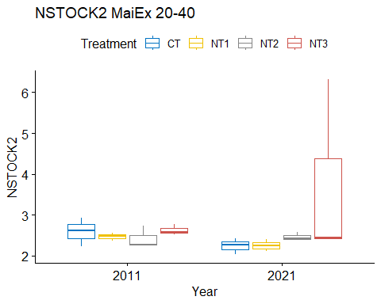

## [1] "Normality"

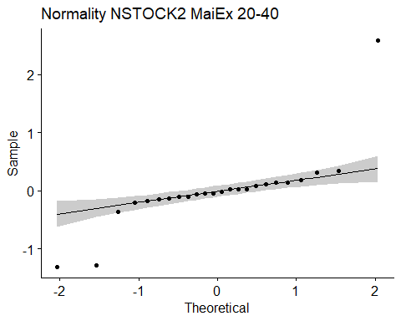

## [1] "Shapiro test for normality"  
## # A tibble: 1 × 3  
## variable statistic p.value  
## <chr> <dbl> <dbl>  
## 1 residuals(model) 0.673 0.00000449  
## [1] "Homoscedasticity"

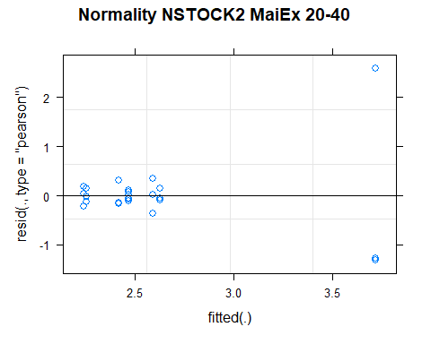

## [1] "Levene test for homoscedasticity"  
## # A tibble: 1 × 4  
## df1 df2 statistic p  
## <int> <int> <dbl> <dbl>  
## 1 7 16 0.838 0.572  
## [1] "ANOVA"  
## Treatment = CT:  
## Year emmean SE df lower.CL upper.CL .group  
## 2021 2.24 0.471 16 1.24 3.24 1   
## 2011 2.59 0.471 16 1.59 3.59 1   
##   
## Treatment = NT1:  
## Year emmean SE df lower.CL upper.CL .group  
## 2021 2.25 0.471 16 1.25 3.25 1   
## 2011 2.47 0.471 16 1.47 3.47 1   
##   
## Treatment = NT2:  
## Year emmean SE df lower.CL upper.CL .group  
## 2011 2.42 0.471 16 1.42 3.42 1   
## 2021 2.47 0.471 16 1.47 3.47 1   
##   
## Treatment = NT3:  
## Year emmean SE df lower.CL upper.CL .group  
## 2011 2.63 0.471 16 1.63 3.63 1   
## 2021 3.72 0.471 16 2.72 4.72 1   
##   
## Degrees-of-freedom method: kenward-roger   
## Results are given on the [ (not the response) scale.   
## Confidence level used: 0.95   
## Note: contrasts are still on the [ scale   
## significance level used: alpha = 0.05   
## NOTE: If two or more means share the same grouping symbol,  
## then we cannot show them to be different.  
## But we also did not show them to be the same.   
## Year = 2011:  
## Treatment emmean SE df lower.CL upper.CL .group  
## NT2 2.42 0.471 16 1.42 3.42 1   
## NT1 2.47 0.471 16 1.47 3.47 1   
## CT 2.59 0.471 16 1.59 3.59 1   
## NT3 2.63 0.471 16 1.63 3.63 1   
##   
## Year = 2021:  
## Treatment emmean SE df lower.CL upper.CL .group  
## CT 2.24 0.471 16 1.24 3.24 1   
## NT1 2.25 0.471 16 1.25 3.25 1   
## NT2 2.47 0.471 16 1.47 3.47 1   
## NT3 3.72 0.471 16 2.72 4.72 1   
##   
## Degrees-of-freedom method: kenward-roger   
## Results are given on the [ (not the response) scale.   
## Confidence level used: 0.95   
## Note: contrasts are still on the [ scale   
## P value adjustment: tukey method for comparing a family of 4 estimates   
## significance level used: alpha = 0.05   
## NOTE: If two or more means share the same grouping symbol,  
## then we cannot show them to be different.  
## But we also did not show them to be the same.   
## [1] "ANOVA plot"

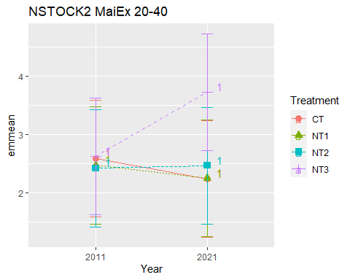

## [1] "NSTOCK2 MaiEx 40-60"

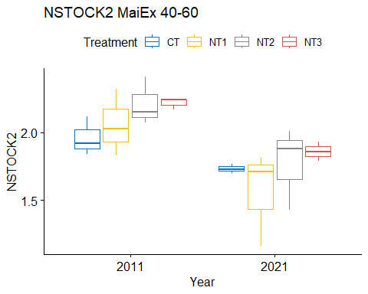

## [1] "Normality"

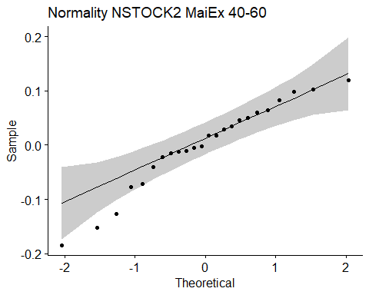

## [1] "Shapiro test for normality"  
## # A tibble: 1 × 3  
## variable statistic p.value  
## <chr> <dbl> <dbl>  
## 1 residuals(model) 0.950 0.274  
## [1] "Homoscedasticity"

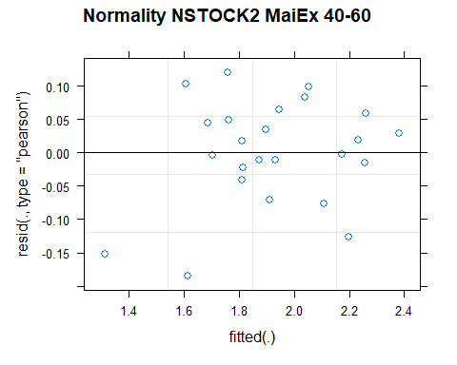

## [1] "Levene test for homoscedasticity"  
## # A tibble: 1 × 4  
## df1 df2 statistic p  
## <int> <int> <dbl> <dbl>  
## 1 7 16 0.710 0.665  
## [1] "ANOVA"  
## Treatment = CT:  
## Year emmean SE df lower.CL upper.CL .group  
## 2021 1.73 0.118 11.3 1.47 1.99 1   
## 2011 1.96 0.118 11.3 1.70 2.22 1   
##   
## Treatment = NT1:  
## Year emmean SE df lower.CL upper.CL .group  
## 2021 1.56 0.118 11.3 1.30 1.82 1   
## 2011 2.06 0.118 11.3 1.80 2.32 2   
##   
## Treatment = NT2:  
## Year emmean SE df lower.CL upper.CL .group  
## 2021 1.77 0.118 11.3 1.51 2.03 1   
## 2011 2.21 0.118 11.3 1.95 2.47 2   
##   
## Treatment = NT3:  
## Year emmean SE df lower.CL upper.CL .group  
## 2021 1.86 0.118 11.3 1.60 2.12 1   
## 2011 2.22 0.118 11.3 1.96 2.48 2   
##   
## Degrees-of-freedom method: kenward-roger   
## Results are given on the [ (not the response) scale.   
## Confidence level used: 0.95   
## Note: contrasts are still on the [ scale   
## significance level used: alpha = 0.05   
## NOTE: If two or more means share the same grouping symbol,  
## then we cannot show them to be different.  
## But we also did not show them to be the same.   
## Year = 2011:  
## Treatment emmean SE df lower.CL upper.CL .group  
## CT 1.96 0.118 11.3 1.70 2.22 1   
## NT1 2.06 0.118 11.3 1.80 2.32 1   
## NT2 2.21 0.118 11.3 1.95 2.47 1   
## NT3 2.22 0.118 11.3 1.96 2.48 1   
##   
## Year = 2021:  
## Treatment emmean SE df lower.CL upper.CL .group  
## NT1 1.56 0.118 11.3 1.30 1.82 1   
## CT 1.73 0.118 11.3 1.47 1.99 1   
## NT2 1.77 0.118 11.3 1.51 2.03 1   
## NT3 1.86 0.118 11.3 1.60 2.12 1   
##   
## Degrees-of-freedom method: kenward-roger   
## Results are given on the [ (not the response) scale.   
## Confidence level used: 0.95   
## Note: contrasts are still on the [ scale   
## P value adjustment: tukey method for comparing a family of 4 estimates   
## significance level used: alpha = 0.05   
## NOTE: If two or more means share the same grouping symbol,  
## then we cannot show them to be different.  
## But we also did not show them to be the same.   
## [1] "ANOVA plot"

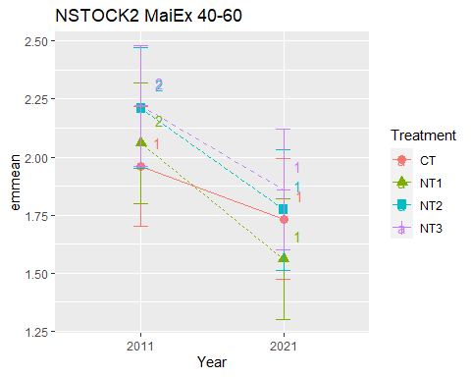

## [1] "NSTOCK2 MaiEx 60-80"

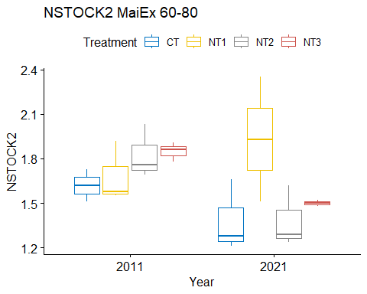

## [1] "Normality"

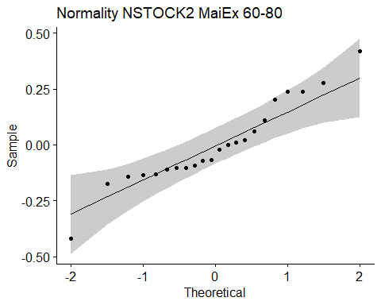

## [1] "Shapiro test for normality"  
## # A tibble: 1 × 3  
## variable statistic p.value  
## <chr> <dbl> <dbl>  
## 1 residuals(model) 0.945 0.252  
## [1] "Homoscedasticity"

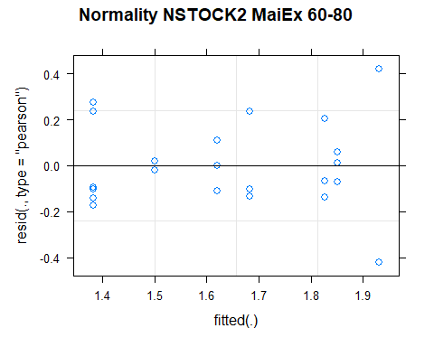

## [1] "Levene test for homoscedasticity"  
## # A tibble: 1 × 4  
## df1 df2 statistic p  
## <int> <int> <dbl> <dbl>  
## 1 7 14 1.70 0.189  
## [1] "ANOVA"  
## Treatment = CT:  
## Year emmean SE df lower.CL upper.CL .group  
## 2021 1.38 0.133 14 1.10 1.67 1   
## 2011 1.62 0.133 14 1.34 1.90 1   
##   
## Treatment = NT1:  
## Year emmean SE df lower.CL upper.CL .group  
## 2011 1.68 0.133 14 1.40 1.97 1   
## 2021 1.93 0.171 14 1.56 2.30 1   
##   
## Treatment = NT2:  
## Year emmean SE df lower.CL upper.CL .group  
## 2021 1.38 0.133 14 1.10 1.67 1   
## 2011 1.83 0.133 14 1.54 2.11 1   
##   
## Treatment = NT3:  
## Year emmean SE df lower.CL upper.CL .group  
## 2021 1.50 0.171 14 1.13 1.87 1   
## 2011 1.85 0.133 14 1.57 2.13 1   
##   
## Degrees-of-freedom method: kenward-roger   
## Results are given on the [ (not the response) scale.   
## Confidence level used: 0.95   
## Note: contrasts are still on the [ scale   
## significance level used: alpha = 0.05   
## NOTE: If two or more means share the same grouping symbol,  
## then we cannot show them to be different.  
## But we also did not show them to be the same.   
## Year = 2011:  
## Treatment emmean SE df lower.CL upper.CL .group  
## CT 1.62 0.133 14 1.34 1.90 1   
## NT1 1.68 0.133 14 1.40 1.97 1   
## NT2 1.83 0.133 14 1.54 2.11 1   
## NT3 1.85 0.133 14 1.57 2.13 1   
##   
## Year = 2021:  
## Treatment emmean SE df lower.CL upper.CL .group  
## NT2 1.38 0.133 14 1.10 1.67 1   
## CT 1.38 0.133 14 1.10 1.67 1   
## NT3 1.50 0.171 14 1.13 1.87 1   
## NT1 1.93 0.171 14 1.56 2.30 1   
##   
## Degrees-of-freedom method: kenward-roger   
## Results are given on the [ (not the response) scale.   
## Confidence level used: 0.95   
## Note: contrasts are still on the [ scale   
## P value adjustment: tukey method for comparing a family of 4 estimates   
## significance level used: alpha = 0.05   
## NOTE: If two or more means share the same grouping symbol,  
## then we cannot show them to be different.  
## But we also did not show them to be the same.   
## [1] "ANOVA plot"

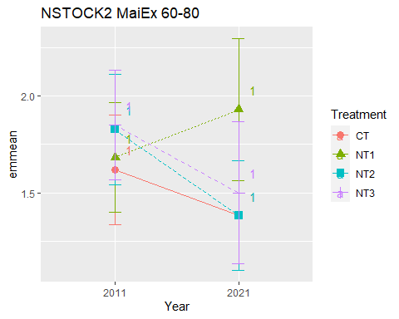

## [1] "NSTOCK2 MaiEx 80-100"

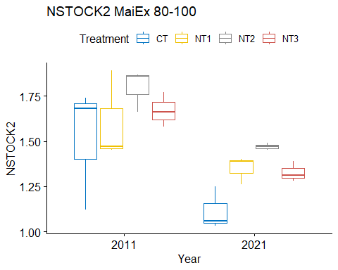

## [1] "Normality"

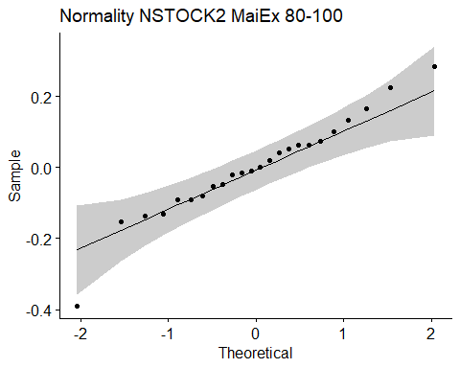

## [1] "Shapiro test for normality"  
## # A tibble: 1 × 3  
## variable statistic p.value  
## <chr> <dbl> <dbl>  
## 1 residuals(model) 0.964 0.513  
## [1] "Homoscedasticity"

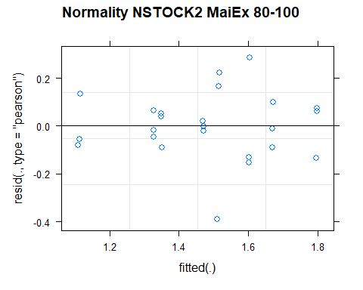

## [1] "Levene test for homoscedasticity"  
## # A tibble: 1 × 4  
## df1 df2 statistic p  
## <int> <int> <dbl> <dbl>  
## 1 7 16 0.527 0.801  
## [1] "ANOVA"  
## Treatment = CT:  
## Year emmean SE df lower.CL upper.CL .group  
## 2021 1.11 0.097 16 0.908 1.32 1   
## 2011 1.51 0.097 16 1.308 1.72 2   
##   
## Treatment = NT1:  
## Year emmean SE df lower.CL upper.CL .group  
## 2021 1.35 0.097 16 1.144 1.56 1   
## 2011 1.60 0.097 16 1.398 1.81 1   
##   
## Treatment = NT2:  
## Year emmean SE df lower.CL upper.CL .group  
## 2021 1.47 0.097 16 1.264 1.68 1   
## 2011 1.80 0.097 16 1.591 2.00 2   
##   
## Treatment = NT3:  
## Year emmean SE df lower.CL upper.CL .group  
## 2021 1.33 0.097 16 1.121 1.53 1   
## 2011 1.67 0.097 16 1.464 1.88 2   
##   
## Degrees-of-freedom method: kenward-roger   
## Results are given on the [ (not the response) scale.   
## Confidence level used: 0.95   
## Note: contrasts are still on the [ scale   
## significance level used: alpha = 0.05   
## NOTE: If two or more means share the same grouping symbol,  
## then we cannot show them to be different.  
## But we also did not show them to be the same.   
## Year = 2011:  
## Treatment emmean SE df lower.CL upper.CL .group  
## CT 1.51 0.097 16 1.308 1.72 1   
## NT1 1.60 0.097 16 1.398 1.81 1   
## NT3 1.67 0.097 16 1.464 1.88 1   
## NT2 1.80 0.097 16 1.591 2.00 1   
##   
## Year = 2021:  
## Treatment emmean SE df lower.CL upper.CL .group  
## CT 1.11 0.097 16 0.908 1.32 1   
## NT3 1.33 0.097 16 1.121 1.53 1   
## NT1 1.35 0.097 16 1.144 1.56 1   
## NT2 1.47 0.097 16 1.264 1.68 1   
##   
## Degrees-of-freedom method: kenward-roger   
## Results are given on the [ (not the response) scale.   
## Confidence level used: 0.95   
## Note: contrasts are still on the [ scale   
## P value adjustment: tukey method for comparing a family of 4 estimates   
## significance level used: alpha = 0.05   
## NOTE: If two or more means share the same grouping symbol,  
## then we cannot show them to be different.  
## But we also did not show them to be the same.   
## [1] "ANOVA plot"

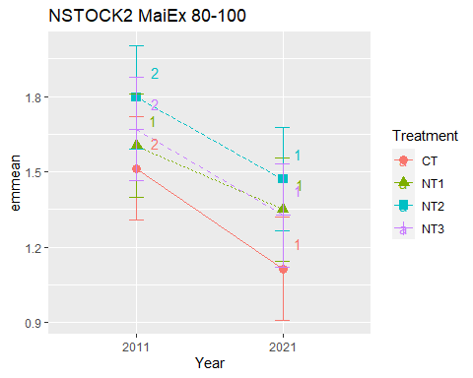

## [1] "NSTOCK2 010 Cumulated MaiEx"  
## [1] "Normality"

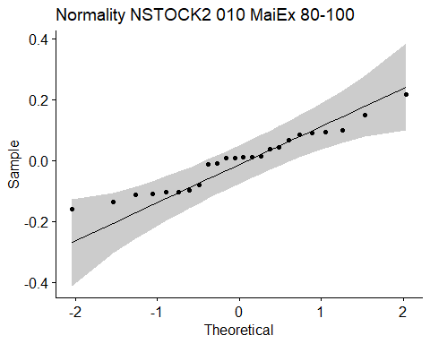

## [1] "Shapiro test for normality"  
## # A tibble: 1 × 3  
## variable statistic p.value  
## <chr> <dbl> <dbl>  
## 1 residuals(model) 0.959 0.426  
## [1] "Homoscedasticity"

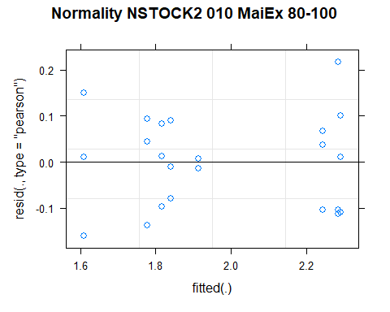

## [1] "Levene test for homoscedasticity"  
## # A tibble: 1 × 4  
## df1 df2 statistic p  
## <int> <int> <dbl> <dbl>  
## 1 7 16 0.377 0.902  
## [1] "ANOVA"  
## Treatment = CT:  
## Year emmean SE df lower.CL upper.CL .group  
## 2021 1.61 0.0674 16 1.47 1.75 1   
## 2011 1.78 0.0674 16 1.63 1.92 1   
##   
## Treatment = NT1:  
## Year emmean SE df lower.CL upper.CL .group  
## 2011 1.82 0.0674 16 1.67 1.96 1   
## 2021 2.24 0.0674 16 2.10 2.39 2   
##   
## Treatment = NT2:  
## Year emmean SE df lower.CL upper.CL .group  
## 2011 1.84 0.0674 16 1.70 1.98 1   
## 2021 2.29 0.0674 16 2.15 2.43 2   
##   
## Treatment = NT3:  
## Year emmean SE df lower.CL upper.CL .group  
## 2011 1.91 0.0674 16 1.77 2.06 1   
## 2021 2.28 0.0674 16 2.14 2.43 2   
##   
## Degrees-of-freedom method: kenward-roger   
## Results are given on the [ (not the response) scale.   
## Confidence level used: 0.95   
## Note: contrasts are still on the [ scale   
## significance level used: alpha = 0.05   
## NOTE: If two or more means share the same grouping symbol,  
## then we cannot show them to be different.  
## But we also did not show them to be the same.   
## Year = 2011:  
## Treatment emmean SE df lower.CL upper.CL .group  
## CT 1.78 0.0674 16 1.63 1.92 1   
## NT1 1.82 0.0674 16 1.67 1.96 1   
## NT2 1.84 0.0674 16 1.70 1.98 1   
## NT3 1.91 0.0674 16 1.77 2.06 1   
##   
## Year = 2021:  
## Treatment emmean SE df lower.CL upper.CL .group  
## CT 1.61 0.0674 16 1.47 1.75 1   
## NT1 2.24 0.0674 16 2.10 2.39 2   
## NT3 2.28 0.0674 16 2.14 2.43 2   
## NT2 2.29 0.0674 16 2.15 2.43 2   
##   
## Degrees-of-freedom method: kenward-roger   
## Results are given on the [ (not the response) scale.   
## Confidence level used: 0.95   
## Note: contrasts are still on the [ scale   
## P value adjustment: tukey method for comparing a family of 4 estimates   
## significance level used: alpha = 0.05   
## NOTE: If two or more means share the same grouping symbol,  
## then we cannot show them to be different.  
## But we also did not show them to be the same.   
## [1] "ANOVA Plot"

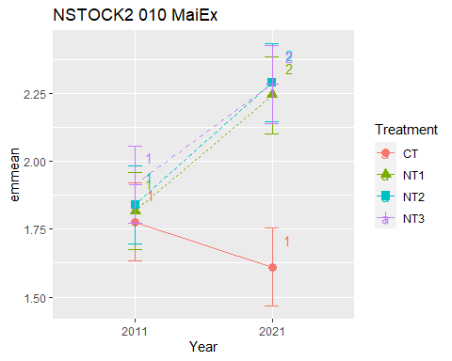

## [1] "NSTOCK2 020 Cumulated MaiEx"  
## [1] "Normality"

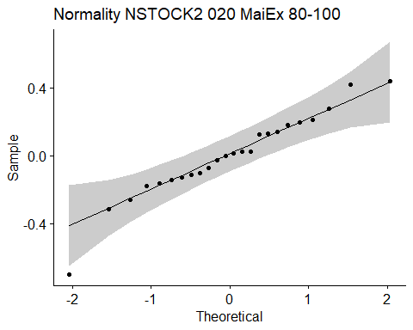

## [1] "Shapiro test for normality"  
## # A tibble: 1 × 3  
## variable statistic p.value  
## <chr> <dbl> <dbl>  
## 1 residuals(model) 0.957 0.387  
## [1] "Homoscedasticity"

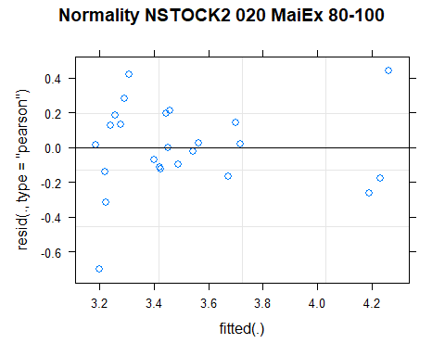

## [1] "Levene test for homoscedasticity"  
## # A tibble: 1 × 4  
## df1 df2 statistic p  
## <int> <int> <dbl> <dbl>  
## 1 7 16 0.539 0.793  
## [1] "ANOVA"  
## Treatment = CT:  
## Year emmean SE df lower.CL upper.CL .group  
## 2021 3.22 0.186 15.9 2.82 3.61 1   
## 2011 3.25 0.186 15.9 2.86 3.65 1   
##   
## Treatment = NT1:  
## Year emmean SE df lower.CL upper.CL .group  
## 2011 3.42 0.186 15.9 3.03 3.82 1   
## 2021 3.70 0.186 15.9 3.30 4.09 1   
##   
## Treatment = NT2:  
## Year emmean SE df lower.CL upper.CL .group  
## 2011 3.46 0.186 15.9 3.06 3.85 1   
## 2021 4.23 0.186 15.9 3.83 4.62 2   
##   
## Treatment = NT3:  
## Year emmean SE df lower.CL upper.CL .group  
## 2021 3.27 0.186 15.9 2.87 3.66 1   
## 2011 3.52 0.186 15.9 3.12 3.92 1   
##   
## Degrees-of-freedom method: kenward-roger   
## Results are given on the [ (not the response) scale.   
## Confidence level used: 0.95   
## Note: contrasts are still on the [ scale   
## significance level used: alpha = 0.05   
## NOTE: If two or more means share the same grouping symbol,  
## then we cannot show them to be different.  
## But we also did not show them to be the same.   
## Year = 2011:  
## Treatment emmean SE df lower.CL upper.CL .group  
## CT 3.25 0.186 15.9 2.86 3.65 1   
## NT1 3.42 0.186 15.9 3.03 3.82 1   
## NT2 3.46 0.186 15.9 3.06 3.85 1   
## NT3 3.52 0.186 15.9 3.12 3.92 1   
##   
## Year = 2021:  
## Treatment emmean SE df lower.CL upper.CL .group  
## CT 3.22 0.186 15.9 2.82 3.61 1   
## NT3 3.27 0.186 15.9 2.87 3.66 1   
## NT1 3.70 0.186 15.9 3.30 4.09 12   
## NT2 4.23 0.186 15.9 3.83 4.62 2   
##   
## Degrees-of-freedom method: kenward-roger   
## Results are given on the [ (not the response) scale.   
## Confidence level used: 0.95   
## Note: contrasts are still on the [ scale   
## P value adjustment: tukey method for comparing a family of 4 estimates   
## significance level used: alpha = 0.05   
## NOTE: If two or more means share the same grouping symbol,  
## then we cannot show them to be different.  
## But we also did not show them to be the same.   
## [1] "ANOVA Plot"

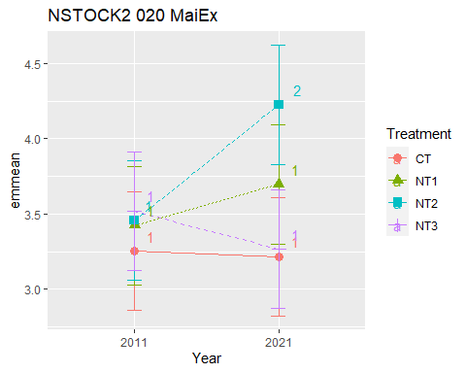

## [1] "NSTOCK2 040 Cumulated MaiEx"  
## [1] "Normality"

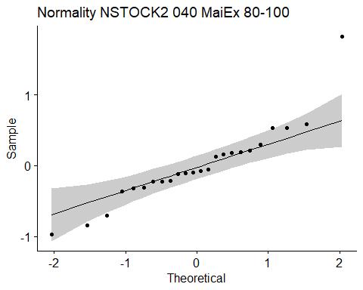

## [1] "Shapiro test for normality"  
## # A tibble: 1 × 3  
## variable statistic p.value  
## <chr> <dbl> <dbl>  
## 1 residuals(model) 0.897 0.0184  
## [1] "Homoscedasticity"

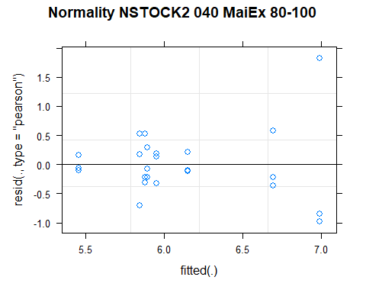

## [1] "Levene test for homoscedasticity"  
## # A tibble: 1 × 4  
## df1 df2 statistic p  
## <int> <int> <dbl> <dbl>  
## 1 7 16 0.611 0.739  
## [1] "ANOVA"  
## Treatment = CT:  
## Year emmean SE df lower.CL upper.CL .group  
## 2021 5.46 0.386 16 4.64 6.28 1   
## 2011 5.84 0.386 16 5.02 6.66 1   
##   
## Treatment = NT1:  
## Year emmean SE df lower.CL upper.CL .group  
## 2011 5.89 0.386 16 5.07 6.71 1   
## 2021 5.95 0.386 16 5.13 6.77 1   
##   
## Treatment = NT2:  
## Year emmean SE df lower.CL upper.CL .group  
## 2011 5.88 0.386 16 5.06 6.70 1   
## 2021 6.69 0.386 16 5.87 7.51 1   
##   
## Treatment = NT3:  
## Year emmean SE df lower.CL upper.CL .group  
## 2011 6.15 0.386 16 5.33 6.97 1   
## 2021 6.99 0.386 16 6.17 7.81 1   
##   
## Degrees-of-freedom method: kenward-roger   
## Results are given on the [ (not the response) scale.   
## Confidence level used: 0.95   
## Note: contrasts are still on the [ scale   
## significance level used: alpha = 0.05   
## NOTE: If two or more means share the same grouping symbol,  
## then we cannot show them to be different.  
## But we also did not show them to be the same.   
## Year = 2011:  
## Treatment emmean SE df lower.CL upper.CL .group  
## CT 5.84 0.386 16 5.02 6.66 1   
## NT2 5.88 0.386 16 5.06 6.70 1   
## NT1 5.89 0.386 16 5.07 6.71 1   
## NT3 6.15 0.386 16 5.33 6.97 1   
##   
## Year = 2021:  
## Treatment emmean SE df lower.CL upper.CL .group  
## CT 5.46 0.386 16 4.64 6.28 1   
## NT1 5.95 0.386 16 5.13 6.77 1   
## NT2 6.69 0.386 16 5.87 7.51 1   
## NT3 6.99 0.386 16 6.17 7.81 1   
##   
## Degrees-of-freedom method: kenward-roger   
## Results are given on the [ (not the response) scale.   
## Confidence level used: 0.95   
## Note: contrasts are still on the [ scale   
## P value adjustment: tukey method for comparing a family of 4 estimates   
## significance level used: alpha = 0.05   
## NOTE: If two or more means share the same grouping symbol,  
## then we cannot show them to be different.  
## But we also did not show them to be the same.   
## [1] "ANOVA Plot"

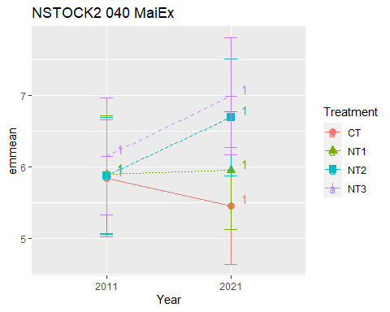

## [1] "NSTOCK2 060 Cumulated MaiEx"  
## [1] "Normality"

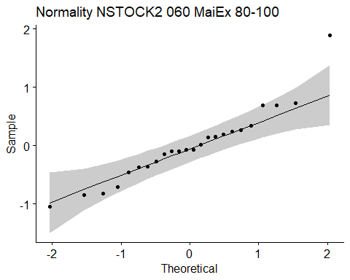

## [1] "Shapiro test for normality"  
## # A tibble: 1 × 3  
## variable statistic p.value  
## <chr> <dbl> <dbl>  
## 1 residuals(model) 0.933 0.115  
## [1] "Homoscedasticity"

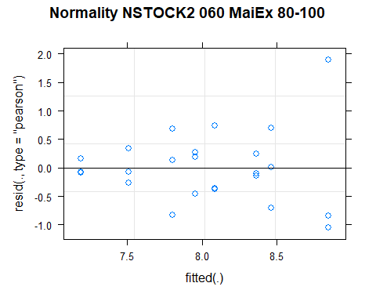

## [1] "Levene test for homoscedasticity"  
## # A tibble: 1 × 4  
## df1 df2 statistic p  
## <int> <int> <dbl> <dbl>  
## 1 7 16 0.601 0.747  
## [1] "ANOVA"  
## Treatment = CT:  
## Year emmean SE df lower.CL upper.CL .group  
## 2021 7.19 0.433 16 6.27 8.11 1   
## 2011 7.80 0.433 16 6.89 8.72 1   
##   
## Treatment = NT1:  
## Year emmean SE df lower.CL upper.CL .group  
## 2021 7.51 0.433 16 6.59 8.43 1   
## 2011 7.95 0.433 16 7.04 8.87 1   
##   
## Treatment = NT2:  
## Year emmean SE df lower.CL upper.CL .group  
## 2011 8.09 0.433 16 7.17 9.00 1   
## 2021 8.47 0.433 16 7.55 9.38 1   
##   
## Treatment = NT3:  
## Year emmean SE df lower.CL upper.CL .group  
## 2011 8.37 0.433 16 7.45 9.28 1   
## 2021 8.85 0.433 16 7.93 9.76 1   
##   
## Degrees-of-freedom method: kenward-roger   
## Results are given on the [ (not the response) scale.   
## Confidence level used: 0.95   
## Note: contrasts are still on the [ scale   
## significance level used: alpha = 0.05   
## NOTE: If two or more means share the same grouping symbol,  
## then we cannot show them to be different.  
## But we also did not show them to be the same.   
## Year = 2011:  
## Treatment emmean SE df lower.CL upper.CL .group  
## CT 7.80 0.433 16 6.89 8.72 1   
## NT1 7.95 0.433 16 7.04 8.87 1   
## NT2 8.09 0.433 16 7.17 9.00 1   
## NT3 8.37 0.433 16 7.45 9.28 1   
##   
## Year = 2021:  
## Treatment emmean SE df lower.CL upper.CL .group  
## CT 7.19 0.433 16 6.27 8.11 1   
## NT1 7.51 0.433 16 6.59 8.43 1   
## NT2 8.47 0.433 16 7.55 9.38 1   
## NT3 8.85 0.433 16 7.93 9.76 1   
##   
## Degrees-of-freedom method: kenward-roger   
## Results are given on the [ (not the response) scale.   
## Confidence level used: 0.95   
## Note: contrasts are still on the [ scale   
## P value adjustment: tukey method for comparing a family of 4 estimates   
## significance level used: alpha = 0.05   
## NOTE: If two or more means share the same grouping symbol,  
## then we cannot show them to be different.  
## But we also did not show them to be the same.   
## [1] "ANOVA Plot"

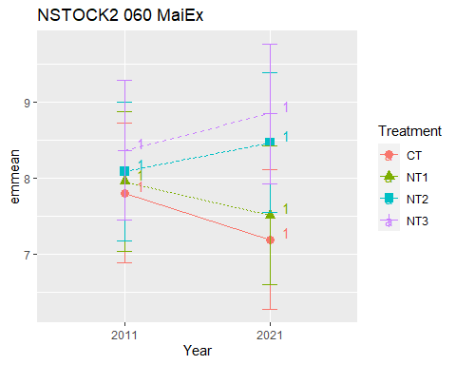

## [1] "NSTOCK2 080 Cumulated MaiEx"  
## [1] "Normality"

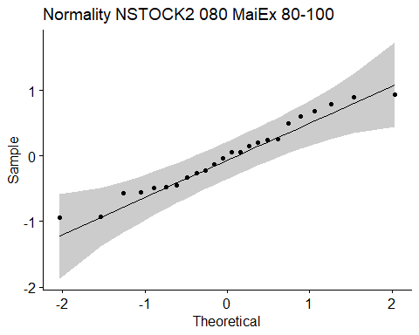

## [1] "Shapiro test for normality"  
## # A tibble: 1 × 3  
## variable statistic p.value  
## <chr> <dbl> <dbl>  
## 1 residuals(model) 0.966 0.566  
## [1] "Homoscedasticity"

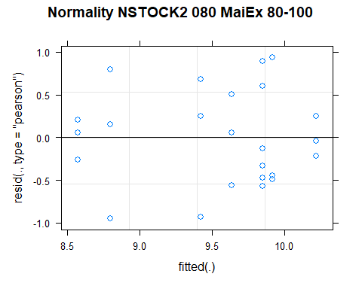

## [1] "Levene test for homoscedasticity"  
## # A tibble: 1 × 4  
## df1 df2 statistic p  
## <int> <int> <dbl> <dbl>  
## 1 7 16 0.325 0.931  
## [1] "ANOVA"  
## Treatment = CT:  
## Year emmean SE df lower.CL upper.CL .group  
## 2021 8.57 0.379 16 7.77 9.38 1   
## 2011 9.42 0.379 16 8.62 10.23 1   
##   
## Treatment = NT1:  
## Year emmean SE df lower.CL upper.CL .group  
## 2021 8.80 0.379 16 7.99 9.60 1   
## 2011 9.64 0.379 16 8.83 10.44 1   
##   
## Treatment = NT2:  
## Year emmean SE df lower.CL upper.CL .group  
## 2021 9.85 0.379 16 9.05 10.65 1   
## 2011 9.91 0.379 16 9.11 10.72 1   
##   
## Treatment = NT3:  
## Year emmean SE df lower.CL upper.CL .group  
## 2021 9.85 0.379 16 9.04 10.65 1   
## 2011 10.22 0.379 16 9.41 11.02 1   
##   
## Degrees-of-freedom method: kenward-roger   
## Results are given on the [ (not the response) scale.   
## Confidence level used: 0.95   
## Note: contrasts are still on the [ scale   
## significance level used: alpha = 0.05   
## NOTE: If two or more means share the same grouping symbol,  
## then we cannot show them to be different.  
## But we also did not show them to be the same.   
## Year = 2011:  
## Treatment emmean SE df lower.CL upper.CL .group  
## CT 9.42 0.379 16 8.62 10.23 1   
## NT1 9.64 0.379 16 8.83 10.44 1   
## NT2 9.91 0.379 16 9.11 10.72 1   
## NT3 10.22 0.379 16 9.41 11.02 1   
##   
## Year = 2021:  
## Treatment emmean SE df lower.CL upper.CL .group  
## CT 8.57 0.379 16 7.77 9.38 1   
## NT1 8.80 0.379 16 7.99 9.60 1   
## NT3 9.85 0.379 16 9.04 10.65 1   
## NT2 9.85 0.379 16 9.05 10.65 1   
##   
## Degrees-of-freedom method: kenward-roger   
## Results are given on the [ (not the response) scale.   
## Confidence level used: 0.95   
## Note: contrasts are still on the [ scale   
## P value adjustment: tukey method for comparing a family of 4 estimates   
## significance level used: alpha = 0.05   
## NOTE: If two or more means share the same grouping symbol,  
## then we cannot show them to be different.  
## But we also did not show them to be the same.   
## [1] "ANOVA Plot"

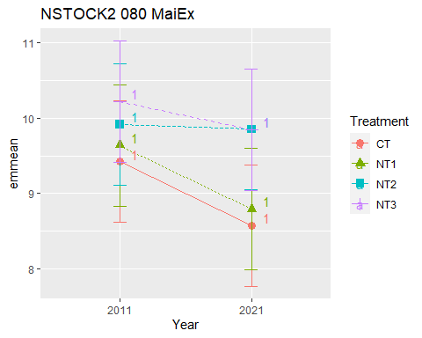

## [1] "NSTOCK2 0100 Cumulated MaiEx"  
## [1] "Normality"

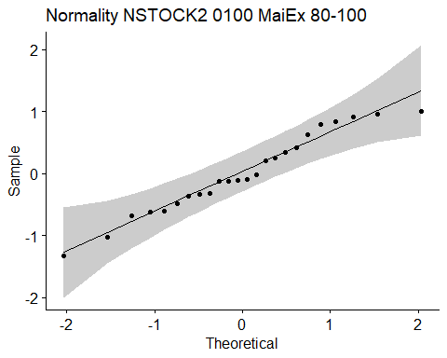

## [1] "Shapiro test for normality"  
## # A tibble: 1 × 3  
## variable statistic p.value  
## <chr> <dbl> <dbl>  
## 1 residuals(model) 0.964 0.529  
## [1] "Homoscedasticity"

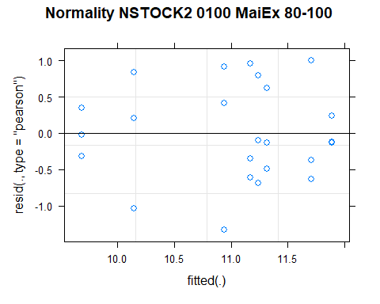

## [1] "Levene test for homoscedasticity"  
## # A tibble: 1 × 4  
## df1 df2 statistic p  
## <int> <int> <dbl> <dbl>  
## 1 7 16 0.393 0.893  
## [1] "ANOVA"  
## Treatment = CT:  
## Year emmean SE df lower.CL upper.CL .group  
## 2021 9.69 0.447 16 8.74 10.6 1   
## 2011 10.94 0.447 16 9.99 11.9 1   
##   
## Treatment = NT1:  
## Year emmean SE df lower.CL upper.CL .group  
## 2021 10.15 0.447 16 9.20 11.1 1   
## 2011 11.24 0.447 16 10.29 12.2 1   
##   
## Treatment = NT2:  
## Year emmean SE df lower.CL upper.CL .group  
## 2021 11.32 0.447 16 10.37 12.3 1   
## 2011 11.71 0.447 16 10.76 12.7 1   
##   
## Treatment = NT3:  
## Year emmean SE df lower.CL upper.CL .group  
## 2021 11.17 0.447 16 10.23 12.1 1   
## 2011 11.89 0.447 16 10.94 12.8 1   
##   
## Degrees-of-freedom method: kenward-roger   
## Results are given on the [ (not the response) scale.   
## Confidence level used: 0.95   
## Note: contrasts are still on the [ scale   
## significance level used: alpha = 0.05   
## NOTE: If two or more means share the same grouping symbol,  
## then we cannot show them to be different.  
## But we also did not show them to be the same.   
## Year = 2011:  
## Treatment emmean SE df lower.CL upper.CL .group  
## CT 10.94 0.447 16 9.99 11.9 1   
## NT1 11.24 0.447 16 10.29 12.2 1   
## NT2 11.71 0.447 16 10.76 12.7 1   
## NT3 11.89 0.447 16 10.94 12.8 1   
##   
## Year = 2021:  
## Treatment emmean SE df lower.CL upper.CL .group  
## CT 9.69 0.447 16 8.74 10.6 1   
## NT1 10.15 0.447 16 9.20 11.1 1   
## NT3 11.17 0.447 16 10.23 12.1 1   
## NT2 11.32 0.447 16 10.37 12.3 1   
##   
## Degrees-of-freedom method: kenward-roger   
## Results are given on the [ (not the response) scale.   
## Confidence level used: 0.95   
## Note: contrasts are still on the [ scale   
## P value adjustment: tukey method for comparing a family of 4 estimates   
## significance level used: alpha = 0.05   
## NOTE: If two or more means share the same grouping symbol,  
## then we cannot show them to be different.  
## But we also did not show them to be the same.   
## [1] "ANOVA Plot"

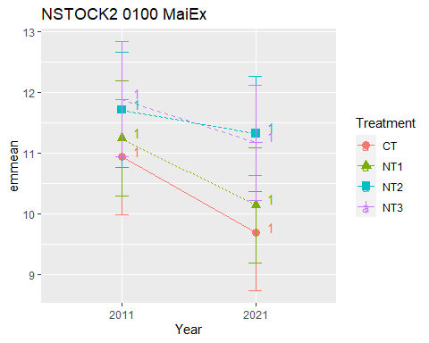

## [1] "NSTOCK2 SoyEx"  
## # A tibble: 56 × 7  
## Treatment Depth Year variable n mean sd  
## <fct> <fct> <fct> <chr> <dbl> <dbl> <dbl>  
## 1 CT 0-5 2011 NSTOCK2 3 0.93 0.026  
## 2 NT1 0-5 2011 NSTOCK2 3 0.957 0.031  
## 3 NT2 0-5 2011 NSTOCK2 3 1.01 0.044  
## 4 NT3 0-5 2011 NSTOCK2 3 0.97 0.036  
## 5 CT 5-10 2011 NSTOCK2 3 0.867 0.071  
## 6 NT1 5-10 2011 NSTOCK2 3 0.877 0.058  
## 7 NT2 5-10 2011 NSTOCK2 3 0.903 0.051  
## 8 NT3 5-10 2011 NSTOCK2 3 0.9 0.044  
## 9 CT 10-20 2011 NSTOCK2 3 1.54 0.159  
## 10 NT1 10-20 2011 NSTOCK2 3 1.69 0.079  
## # … with 46 more rows  
## [1] "NSTOCK2 SoyEx 0-5"

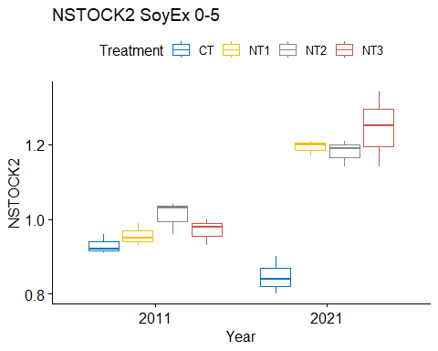

## [1] "Normality"

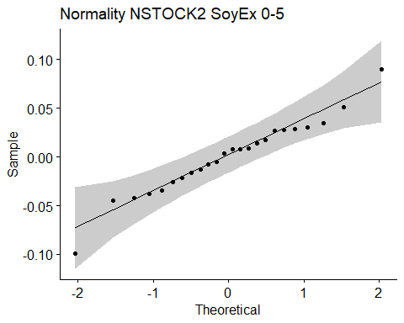

## [1] "Shapiro test for normality"  
## # A tibble: 1 × 3  
## variable statistic p.value  
## <chr> <dbl> <dbl>  
## 1 residuals(model) 0.972 0.724  
## [1] "Homoscedasticity"

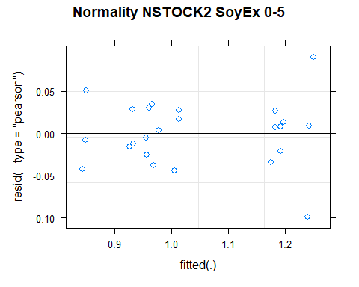

## [1] "Levene test for homoscedasticity"  
## # A tibble: 1 × 4  
## df1 df2 statistic p  
## <int> <int> <dbl> <dbl>  
## 1 7 16 0.833 0.575  
## [1] "ANOVA"  
## Treatment = CT:  
## Year emmean SE df lower.CL upper.CL .group  
## 2021 0.847 0.0282 15.9 0.787 0.907 1   
## 2011 0.930 0.0282 15.9 0.870 0.990 1   
##   
## Treatment = NT1:  
## Year emmean SE df lower.CL upper.CL .group  
## 2011 0.957 0.0282 15.9 0.897 1.017 1   
## 2021 1.193 0.0282 15.9 1.133 1.253 2   
##   
## Treatment = NT2:  
## Year emmean SE df lower.CL upper.CL .group  
## 2011 1.010 0.0282 15.9 0.950 1.070 1   
## 2021 1.180 0.0282 15.9 1.120 1.240 2   
##   
## Treatment = NT3:  
## Year emmean SE df lower.CL upper.CL .group  
## 2011 0.970 0.0282 15.9 0.910 1.030 1   
## 2021 1.243 0.0282 15.9 1.183 1.303 2   
##   
## Degrees-of-freedom method: kenward-roger   
## Results are given on the [ (not the response) scale.   
## Confidence level used: 0.95   
## Note: contrasts are still on the [ scale   
## significance level used: alpha = 0.05   
## NOTE: If two or more means share the same grouping symbol,  
## then we cannot show them to be different.  
## But we also did not show them to be the same.   
## Year = 2011:  
## Treatment emmean SE df lower.CL upper.CL .group  
## CT 0.930 0.0282 15.9 0.870 0.990 1   
## NT1 0.957 0.0282 15.9 0.897 1.017 1   
## NT3 0.970 0.0282 15.9 0.910 1.030 1   
## NT2 1.010 0.0282 15.9 0.950 1.070 1   
##   
## Year = 2021:  
## Treatment emmean SE df lower.CL upper.CL .group  
## CT 0.847 0.0282 15.9 0.787 0.907 1   
## NT2 1.180 0.0282 15.9 1.120 1.240 2   
## NT1 1.193 0.0282 15.9 1.133 1.253 2   
## NT3 1.243 0.0282 15.9 1.183 1.303 2   
##   
## Degrees-of-freedom method: kenward-roger   
## Results are given on the [ (not the response) scale.   
## Confidence level used: 0.95   
## Note: contrasts are still on the [ scale   
## P value adjustment: tukey method for comparing a family of 4 estimates   
## significance level used: alpha = 0.05   
## NOTE: If two or more means share the same grouping symbol,  
## then we cannot show them to be different.  
## But we also did not show them to be the same.   
## [1] "ANOVA plot"

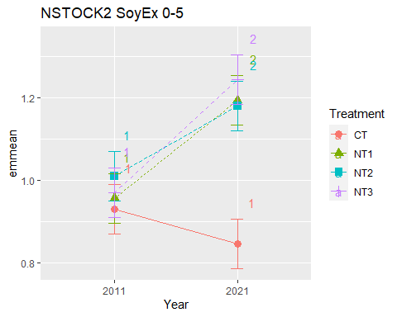

## [1] "NSTOCK2 SoyEx 5-10"

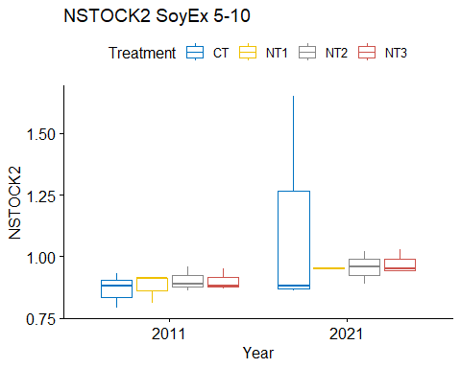

## [1] "Normality"

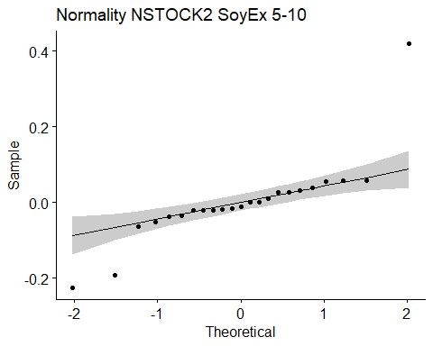

## [1] "Shapiro test for normality"  
## # A tibble: 1 × 3  
## variable statistic p.value  
## <chr> <dbl> <dbl>  
## 1 residuals(model) 0.741 0.0000503  
## [1] "Homoscedasticity"

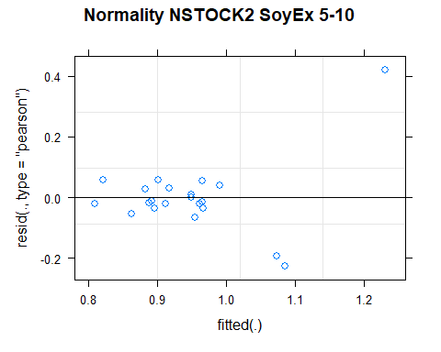

## [1] "Levene test for homoscedasticity"  
## # A tibble: 1 × 4  
## df1 df2 statistic p  
## <int> <int> <dbl> <dbl>  
## 1 7 15 0.750 0.636  
## [1] "ANOVA"  
## Treatment = CT:  
## Year emmean SE df lower.CL upper.CL .group  
## 2011 0.867 0.0993 14.4 0.654 1.08 1   
## 2021 1.130 0.0993 14.4 0.918 1.34 1   
##   
## Treatment = NT1:  
## Year emmean SE df lower.CL upper.CL .group  
## 2011 0.877 0.0993 14.4 0.664 1.09 1   
## 2021 0.943 0.1260 14.9 0.674 1.21 1   
##   
## Treatment = NT2:  
## Year emmean SE df lower.CL upper.CL .group  
## 2011 0.903 0.0993 14.4 0.691 1.12 1   
## 2021 0.957 0.0993 14.4 0.744 1.17 1   
##   
## Treatment = NT3:  
## Year emmean SE df lower.CL upper.CL .group  
## 2011 0.900 0.0993 14.4 0.688 1.11 1   
## 2021 0.973 0.0993 14.4 0.761 1.19 1   
##   
## Degrees-of-freedom method: kenward-roger   
## Results are given on the [ (not the response) scale.   
## Confidence level used: 0.95   
## Note: contrasts are still on the [ scale   
## significance level used: alpha = 0.05   
## NOTE: If two or more means share the same grouping symbol,  
## then we cannot show them to be different.  
## But we also did not show them to be the same.   
## Year = 2011:  
## Treatment emmean SE df lower.CL upper.CL .group  
## CT 0.867 0.0993 14.4 0.654 1.08 1   
## NT1 0.877 0.0993 14.4 0.664 1.09 1   
## NT3 0.900 0.0993 14.4 0.688 1.11 1   
## NT2 0.903 0.0993 14.4 0.691 1.12 1   
##   
## Year = 2021:  
## Treatment emmean SE df lower.CL upper.CL .group  
## NT1 0.943 0.1260 14.9 0.674 1.21 1   
## NT2 0.957 0.0993 14.4 0.744 1.17 1   
## NT3 0.973 0.0993 14.4 0.761 1.19 1   
## CT 1.130 0.0993 14.4 0.918 1.34 1   
##   
## Degrees-of-freedom method: kenward-roger   
## Results are given on the [ (not the response) scale.   
## Confidence level used: 0.95   
## Note: contrasts are still on the [ scale   
## P value adjustment: tukey method for comparing a family of 4 estimates   
## significance level used: alpha = 0.05   
## NOTE: If two or more means share the same grouping symbol,  
## then we cannot show them to be different.  
## But we also did not show them to be the same.   
## [1] "ANOVA plot"

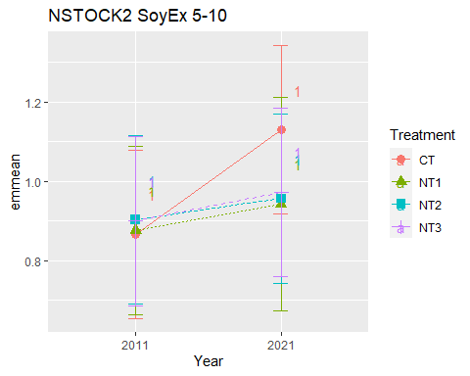

## [1] "NSTOCK2 SoyEx 10-20"

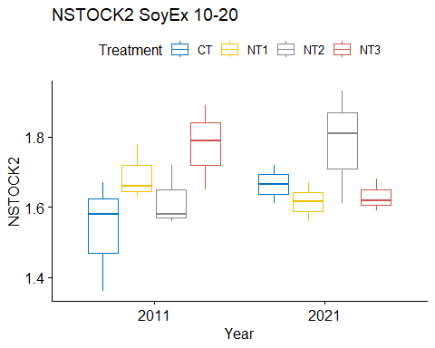

## [1] "Normality"

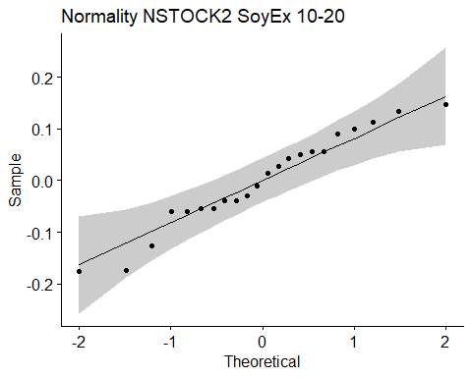

## [1] "Shapiro test for normality"  
## # A tibble: 1 × 3  
## variable statistic p.value  
## <chr> <dbl> <dbl>  
## 1 residuals(model) 0.960 0.489  
## [1] "Homoscedasticity"

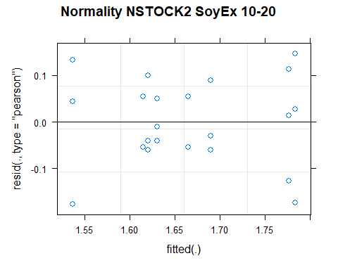

## [1] "Levene test for homoscedasticity"  
## # A tibble: 1 × 4  
## df1 df2 statistic p  
## <int> <int> <dbl> <dbl>  
## 1 7 14 0.401 0.886  
## [1] "ANOVA"  
## Treatment = CT:  
## Year emmean SE df lower.CL upper.CL .group  
## 2011 1.54 0.0648 14 1.40 1.68 1   
## 2021 1.66 0.0836 14 1.49 1.84 1   
##   
## Treatment = NT1:  
## Year emmean SE df lower.CL upper.CL .group  
## 2021 1.61 0.0836 14 1.44 1.79 1   
## 2011 1.69 0.0648 14 1.55 1.83 1   
##   
## Treatment = NT2:  
## Year emmean SE df lower.CL upper.CL .group  
## 2011 1.62 0.0648 14 1.48 1.76 1   
## 2021 1.78 0.0648 14 1.64 1.92 1   
##   
## Treatment = NT3:  
## Year emmean SE df lower.CL upper.CL .group  
## 2021 1.63 0.0648 14 1.49 1.77 1   
## 2011 1.78 0.0648 14 1.64 1.92 1   
##   
## Degrees-of-freedom method: kenward-roger   
## Results are given on the [ (not the response) scale.   
## Confidence level used: 0.95   
## Note: contrasts are still on the [ scale   
## significance level used: alpha = 0.05   
## NOTE: If two or more means share the same grouping symbol,  
## then we cannot show them to be different.  
## But we also did not show them to be the same.   
## Year = 2011:  
## Treatment emmean SE df lower.CL upper.CL .group  
## CT 1.54 0.0648 14 1.40 1.68 1   
## NT2 1.62 0.0648 14 1.48 1.76 1   
## NT1 1.69 0.0648 14 1.55 1.83 1   
## NT3 1.78 0.0648 14 1.64 1.92 1   
##   
## Year = 2021:  
## Treatment emmean SE df lower.CL upper.CL .group  
## NT1 1.61 0.0836 14 1.44 1.79 1   
## NT3 1.63 0.0648 14 1.49 1.77 1   
## CT 1.66 0.0836 14 1.49 1.84 1   
## NT2 1.78 0.0648 14 1.64 1.92 1   
##   
## Degrees-of-freedom method: kenward-roger   
## Results are given on the [ (not the response) scale.   
## Confidence level used: 0.95   
## Note: contrasts are still on the [ scale   
## P value adjustment: tukey method for comparing a family of 4 estimates   
## significance level used: alpha = 0.05   
## NOTE: If two or more means share the same grouping symbol,  
## then we cannot show them to be different.  
## But we also did not show them to be the same.   
## [1] "ANOVA plot"

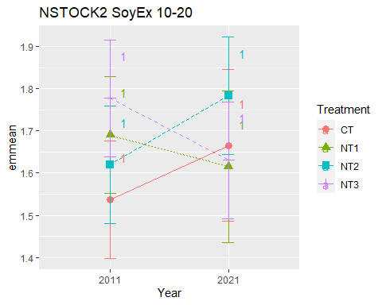

## [1] "NSTOCK2 SoyEx 20-40"

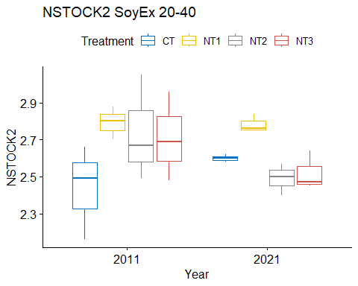

## [1] "Normality"

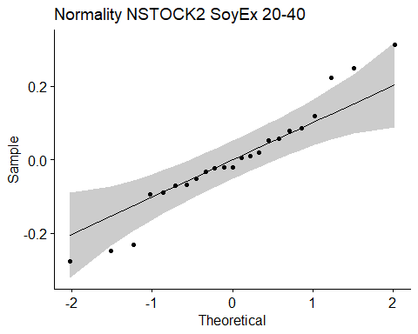

## [1] "Shapiro test for normality"  
## # A tibble: 1 × 3  
## variable statistic p.value  
## <chr> <dbl> <dbl>  
## 1 residuals(model) 0.960 0.460  
## [1] "Homoscedasticity"

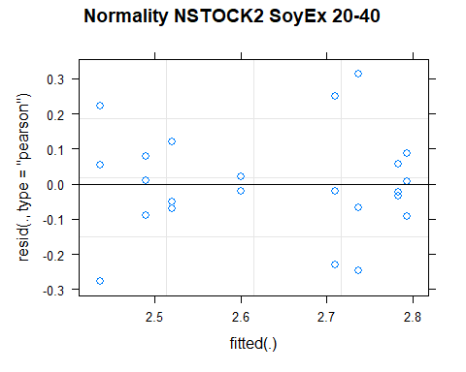

## [1] "Levene test for homoscedasticity"  
## # A tibble: 1 × 4  
## df1 df2 statistic p  
## <int> <int> <dbl> <dbl>  
## 1 7 15 0.951 0.498  
## [1] "ANOVA"  
## Treatment = CT:  
## Year emmean SE df lower.CL upper.CL .group  
## 2011 2.44 0.102 15 2.22 2.65 1   
## 2021 2.60 0.131 15 2.32 2.88 1   
##   
## Treatment = NT1:  
## Year emmean SE df lower.CL upper.CL .group  
## 2021 2.78 0.102 15 2.57 3.00 1   
## 2011 2.79 0.102 15 2.58 3.01 1   
##   
## Treatment = NT2:  
## Year emmean SE df lower.CL upper.CL .group  
## 2021 2.49 0.102 15 2.27 2.71 1   
## 2011 2.74 0.102 15 2.52 2.95 1   
##   
## Treatment = NT3:  
## Year emmean SE df lower.CL upper.CL .group  
## 2021 2.52 0.102 15 2.30 2.74 1   
## 2011 2.71 0.102 15 2.49 2.93 1   
##   
## Degrees-of-freedom method: kenward-roger   
## Results are given on the [ (not the response) scale.   
## Confidence level used: 0.95   
## Note: contrasts are still on the [ scale   
## significance level used: alpha = 0.05   
## NOTE: If two or more means share the same grouping symbol,  
## then we cannot show them to be different.  
## But we also did not show them to be the same.   
## Year = 2011:  
## Treatment emmean SE df lower.CL upper.CL .group  
## CT 2.44 0.102 15 2.22 2.65 1   
## NT3 2.71 0.102 15 2.49 2.93 1   
## NT2 2.74 0.102 15 2.52 2.95 1   
## NT1 2.79 0.102 15 2.58 3.01 1   
##   
## Year = 2021:  
## Treatment emmean SE df lower.CL upper.CL .group  
## NT2 2.49 0.102 15 2.27 2.71 1   
## NT3 2.52 0.102 15 2.30 2.74 1   
## CT 2.60 0.131 15 2.32 2.88 1   
## NT1 2.78 0.102 15 2.57 3.00 1   
##   
## Degrees-of-freedom method: kenward-roger   
## Results are given on the [ (not the response) scale.   
## Confidence level used: 0.95   
## Note: contrasts are still on the [ scale   
## P value adjustment: tukey method for comparing a family of 4 estimates   
## significance level used: alpha = 0.05   
## NOTE: If two or more means share the same grouping symbol,  
## then we cannot show them to be different.  
## But we also did not show them to be the same.   
## [1] "ANOVA plot"

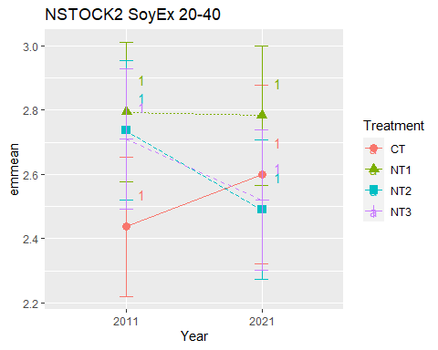

## [1] "NSTOCK2 SoyEx 40-60"

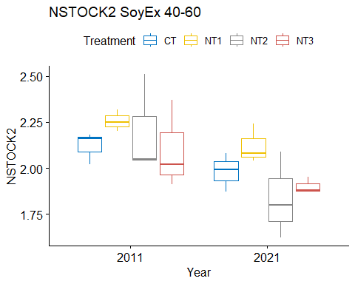

## [1] "Normality"

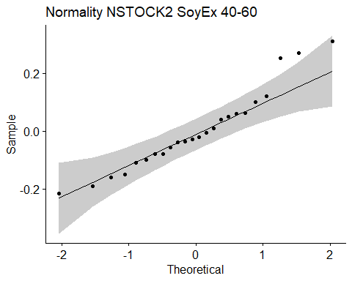

## [1] "Shapiro test for normality"  
## # A tibble: 1 × 3  
## variable statistic p.value  
## <chr> <dbl> <dbl>  
## 1 residuals(model) 0.945 0.215  
## [1] "Homoscedasticity"

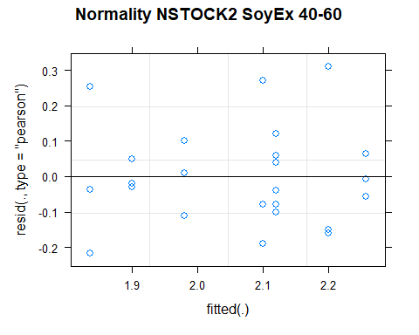

## [1] "Levene test for homoscedasticity"  
## # A tibble: 1 × 4  
## df1 df2 statistic p  
## <int> <int> <dbl> <dbl>  
## 1 7 16 0.525 0.803  
## [1] "ANOVA"  
## Treatment = CT:  
## Year emmean SE df lower.CL upper.CL .group  
## 2021 1.98 0.0961 16 1.78 2.18 1   
## 2011 2.12 0.0961 16 1.92 2.32 1   
##   
## Treatment = NT1:  
## Year emmean SE df lower.CL upper.CL .group  
## 2021 2.12 0.0961 16 1.92 2.32 1   
## 2011 2.26 0.0961 16 2.05 2.46 1   
##   
## Treatment = NT2:  
## Year emmean SE df lower.CL upper.CL .group  
## 2021 1.84 0.0961 16 1.63 2.04 1   
## 2011 2.20 0.0961 16 2.00 2.40 2   
##   
## Treatment = NT3:  
## Year emmean SE df lower.CL upper.CL .group  
## 2021 1.90 0.0961 16 1.70 2.10 1   
## 2011 2.10 0.0961 16 1.90 2.30 1   
##   
## Degrees-of-freedom method: kenward-roger   
## Results are given on the [ (not the response) scale.   
## Confidence level used: 0.95   
## Note: contrasts are still on the [ scale   
## significance level used: alpha = 0.05   
## NOTE: If two or more means share the same grouping symbol,  
## then we cannot show them to be different.  
## But we also did not show them to be the same.   
## Year = 2011:  
## Treatment emmean SE df lower.CL upper.CL .group  
## NT3 2.10 0.0961 16 1.90 2.30 1   
## CT 2.12 0.0961 16 1.92 2.32 1   
## NT2 2.20 0.0961 16 2.00 2.40 1   
## NT1 2.26 0.0961 16 2.05 2.46 1   
##   
## Year = 2021:  
## Treatment emmean SE df lower.CL upper.CL .group  
## NT2 1.84 0.0961 16 1.63 2.04 1   
## NT3 1.90 0.0961 16 1.70 2.10 1   
## CT 1.98 0.0961 16 1.78 2.18 1   
## NT1 2.12 0.0961 16 1.92 2.32 1   
##   
## Degrees-of-freedom method: kenward-roger   
## Results are given on the [ (not the response) scale.   
## Confidence level used: 0.95   
## Note: contrasts are still on the [ scale   
## P value adjustment: tukey method for comparing a family of 4 estimates   
## significance level used: alpha = 0.05   
## NOTE: If two or more means share the same grouping symbol,  
## then we cannot show them to be different.  
## But we also did not show them to be the same.   
## [1] "ANOVA plot"

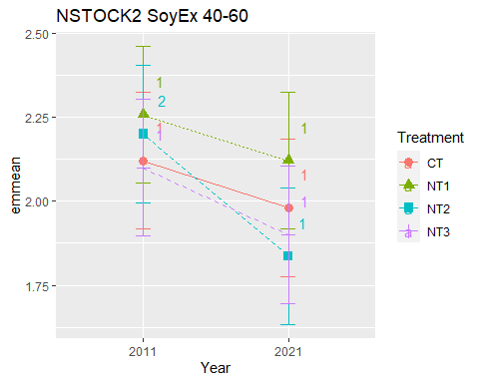

## [1] "NSTOCK2 SoyEx 60-80"

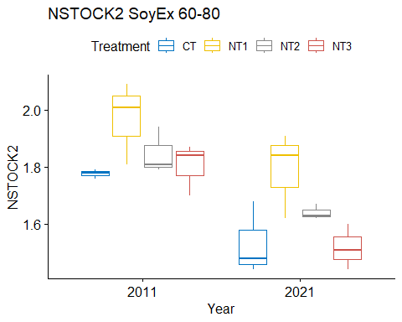

## [1] "Normality"

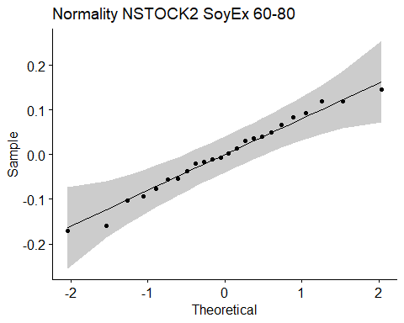

## [1] "Shapiro test for normality"  
## # A tibble: 1 × 3  
## variable statistic p.value  
## <chr> <dbl> <dbl>  
## 1 residuals(model) 0.980 0.898  
## [1] "Homoscedasticity"

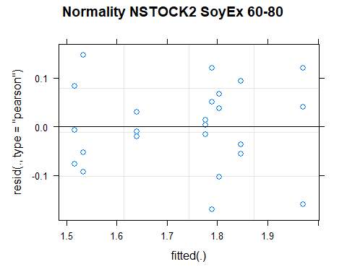

## [1] "Levene test for homoscedasticity"  
## # A tibble: 1 × 4  
## df1 df2 statistic p  
## <int> <int> <dbl> <dbl>  
## 1 7 16 0.533 0.797  
## [1] "ANOVA"  
## Treatment = CT:  
## Year emmean SE df lower.CL upper.CL .group  
## 2021 1.53 0.0586 16 1.41 1.66 1   
## 2011 1.78 0.0586 16 1.65 1.90 2   
##   
## Treatment = NT1:  
## Year emmean SE df lower.CL upper.CL .group  
## 2021 1.79 0.0586 16 1.67 1.91 1   
## 2011 1.97 0.0586 16 1.85 2.09 1   
##   
## Treatment = NT2:  
## Year emmean SE df lower.CL upper.CL .group  
## 2021 1.64 0.0586 16 1.52 1.76 1   
## 2011 1.85 0.0586 16 1.72 1.97 2   
##   
## Treatment = NT3:  
## Year emmean SE df lower.CL upper.CL .group  
## 2021 1.52 0.0586 16 1.39 1.64 1   
## 2011 1.80 0.0586 16 1.68 1.93 2   
##   
## Degrees-of-freedom method: kenward-roger   
## Results are given on the [ (not the response) scale.   
## Confidence level used: 0.95   
## Note: contrasts are still on the [ scale   
## significance level used: alpha = 0.05   
## NOTE: If two or more means share the same grouping symbol,  
## then we cannot show them to be different.  
## But we also did not show them to be the same.   
## Year = 2011:  
## Treatment emmean SE df lower.CL upper.CL .group  
## CT 1.78 0.0586 16 1.65 1.90 1   
## NT3 1.80 0.0586 16 1.68 1.93 1   
## NT2 1.85 0.0586 16 1.72 1.97 1   
## NT1 1.97 0.0586 16 1.85 2.09 1   
##   
## Year = 2021:  
## Treatment emmean SE df lower.CL upper.CL .group  
## NT3 1.52 0.0586 16 1.39 1.64 1   
## CT 1.53 0.0586 16 1.41 1.66 1   
## NT2 1.64 0.0586 16 1.52 1.76 12   
## NT1 1.79 0.0586 16 1.67 1.91 2   
##   
## Degrees-of-freedom method: kenward-roger   
## Results are given on the [ (not the response) scale.   
## Confidence level used: 0.95   
## Note: contrasts are still on the [ scale   
## P value adjustment: tukey method for comparing a family of 4 estimates   
## significance level used: alpha = 0.05   
## NOTE: If two or more means share the same grouping symbol,  
## then we cannot show them to be different.  
## But we also did not show them to be the same.   
## [1] "ANOVA plot"

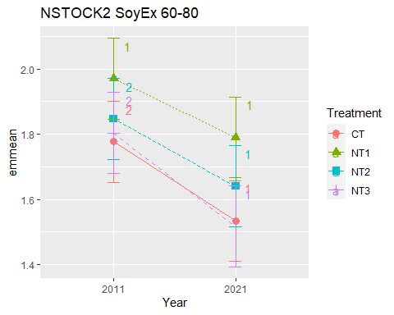

## [1] "NSTOCK2 SoyEx 80-100"

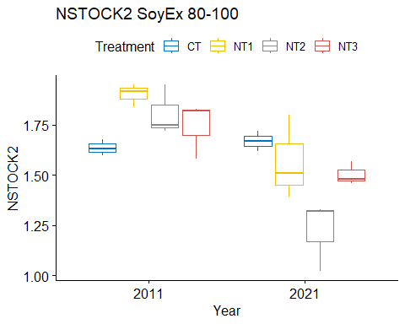

## [1] "Normality"

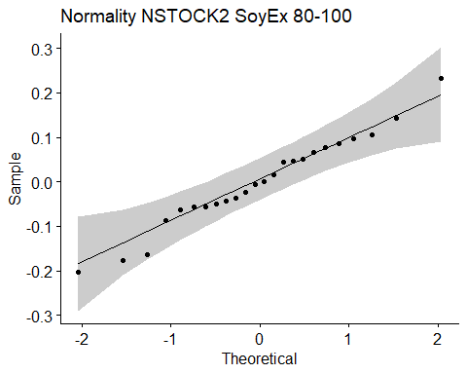

## [1] "Shapiro test for normality"  
## # A tibble: 1 × 3  
## variable statistic p.value  
## <chr> <dbl> <dbl>  
## 1 residuals(model) 0.980 0.894  
## [1] "Homoscedasticity"

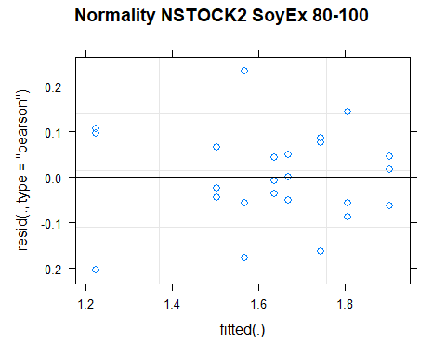

## [1] "Levene test for homoscedasticity"  
## # A tibble: 1 × 4  
## df1 df2 statistic p  
## <int> <int> <dbl> <dbl>  
## 1 7 16 0.446 0.859  
## [1] "ANOVA"  
## Treatment = CT:  
## Year emmean SE df lower.CL upper.CL .group  
## 2011 1.64 0.0713 16 1.49 1.79 1   
## 2021 1.67 0.0713 16 1.52 1.82 1   
##   
## Treatment = NT1:  
## Year emmean SE df lower.CL upper.CL .group  
## 2021 1.57 0.0713 16 1.42 1.72 1   
## 2011 1.90 0.0713 16 1.75 2.05 2   
##   
## Treatment = NT2:  
## Year emmean SE df lower.CL upper.CL .group  
## 2021 1.22 0.0713 16 1.07 1.37 1   
## 2011 1.81 0.0713 16 1.66 1.96 2   
##   
## Treatment = NT3:  
## Year emmean SE df lower.CL upper.CL .group  
## 2021 1.50 0.0713 16 1.35 1.65 1   
## 2011 1.74 0.0713 16 1.59 1.89 2   
##   
## Degrees-of-freedom method: kenward-roger   
## Results are given on the [ (not the response) scale.   
## Confidence level used: 0.95   
## Note: contrasts are still on the [ scale   
## significance level used: alpha = 0.05   
## NOTE: If two or more means share the same grouping symbol,  
## then we cannot show them to be different.  
## But we also did not show them to be the same.   
## Year = 2011:  
## Treatment emmean SE df lower.CL upper.CL .group  
## CT 1.64 0.0713 16 1.49 1.79 1   
## NT3 1.74 0.0713 16 1.59 1.89 1   
## NT2 1.81 0.0713 16 1.66 1.96 1   
## NT1 1.90 0.0713 16 1.75 2.05 1   
##   
## Year = 2021:  
## Treatment emmean SE df lower.CL upper.CL .group  
## NT2 1.22 0.0713 16 1.07 1.37 1   
## NT3 1.50 0.0713 16 1.35 1.65 12   
## NT1 1.57 0.0713 16 1.42 1.72 2   
## CT 1.67 0.0713 16 1.52 1.82 2   
##   
## Degrees-of-freedom method: kenward-roger   
## Results are given on the [ (not the response) scale.   
## Confidence level used: 0.95   
## Note: contrasts are still on the [ scale   
## P value adjustment: tukey method for comparing a family of 4 estimates   
## significance level used: alpha = 0.05   
## NOTE: If two or more means share the same grouping symbol,  
## then we cannot show them to be different.  
## But we also did not show them to be the same.   
## [1] "ANOVA plot"

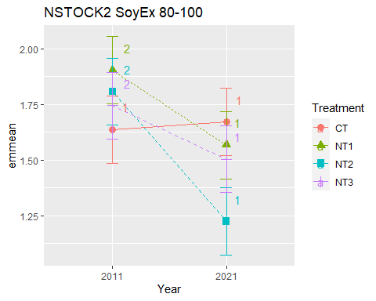

## [1] "NSTOCK2 010 Cumulated SoyEx"  
## [1] "Normality"

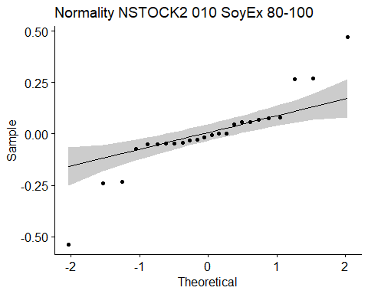

## [1] "Shapiro test for normality"  
## # A tibble: 1 × 3  
## variable statistic p.value  
## <chr> <dbl> <dbl>  
## 1 residuals(model) 0.881 0.00863  
## [1] "Homoscedasticity"

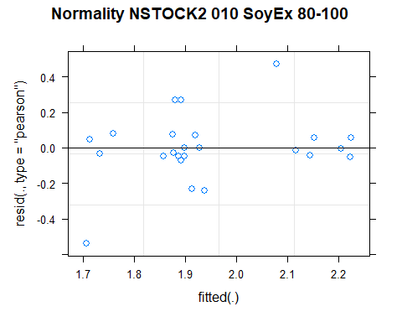

## [1] "Levene test for homoscedasticity"  
## # A tibble: 1 × 4  
## df1 df2 statistic p  
## <int> <int> <dbl> <dbl>  
## 1 7 16 0.636 0.720  
## [1] "ANOVA"  
## Treatment = CT:  
## Year emmean SE df lower.CL upper.CL .group  
## 2011 1.80 0.158 15.4 1.46 2.13 1   
## 2021 1.98 0.158 15.4 1.64 2.31 1   
##   
## Treatment = NT1:  
## Year emmean SE df lower.CL upper.CL .group  
## 2021 1.83 0.158 15.4 1.49 2.16 1   
## 2011 1.83 0.158 15.4 1.50 2.17 1   
##   
## Treatment = NT2:  
## Year emmean SE df lower.CL upper.CL .group  
## 2011 1.91 0.158 15.4 1.58 2.25 1   
## 2021 2.14 0.158 15.4 1.80 2.47 1   
##   
## Treatment = NT3:  
## Year emmean SE df lower.CL upper.CL .group  
## 2011 1.87 0.158 15.4 1.53 2.21 1   
## 2021 2.22 0.158 15.4 1.88 2.55 1   
##   
## Degrees-of-freedom method: kenward-roger   
## Results are given on the [ (not the response) scale.   
## Confidence level used: 0.95   
## Note: contrasts are still on the [ scale   
## significance level used: alpha = 0.05   
## NOTE: If two or more means share the same grouping symbol,  
## then we cannot show them to be different.  
## But we also did not show them to be the same.   
## Year = 2011:  
## Treatment emmean SE df lower.CL upper.CL .group  
## CT 1.80 0.158 15.4 1.46 2.13 1   
## NT1 1.83 0.158 15.4 1.50 2.17 1   
## NT3 1.87 0.158 15.4 1.53 2.21 1   
## NT2 1.91 0.158 15.4 1.58 2.25 1   
##   
## Year = 2021:  
## Treatment emmean SE df lower.CL upper.CL .group  
## NT1 1.83 0.158 15.4 1.49 2.16 1   
## CT 1.98 0.158 15.4 1.64 2.31 1   
## NT2 2.14 0.158 15.4 1.80 2.47 1   
## NT3 2.22 0.158 15.4 1.88 2.55 1   
##   
## Degrees-of-freedom method: kenward-roger   
## Results are given on the [ (not the response) scale.   
## Confidence level used: 0.95   
## Note: contrasts are still on the [ scale   
## P value adjustment: tukey method for comparing a family of 4 estimates   
## significance level used: alpha = 0.05   
## NOTE: If two or more means share the same grouping symbol,  
## then we cannot show them to be different.  
## But we also did not show them to be the same.   
## [1] "ANOVA Plot"

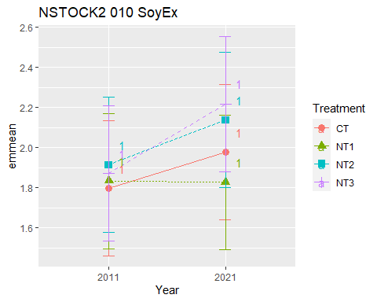

## [1] "NSTOCK2 020 Cumulated SoyEx"  
## [1] "Normality"

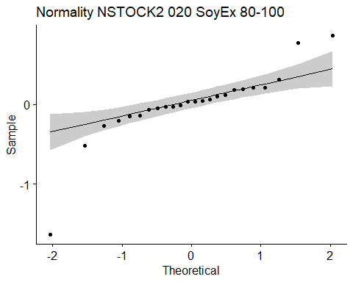

## [1] "Shapiro test for normality"  
## # A tibble: 1 × 3  
## variable statistic p.value  
## <chr> <dbl> <dbl>  
## 1 residuals(model) 0.792 0.000221  
## [1] "Homoscedasticity"

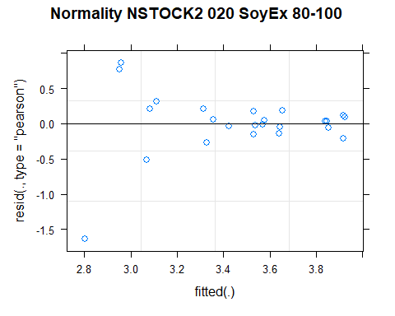

## [1] "Levene test for homoscedasticity"  
## # A tibble: 1 × 4  
## df1 df2 statistic p  
## <int> <int> <dbl> <dbl>  
## 1 7 16 0.794 0.603  
## [1] "ANOVA"  
## Treatment = CT:  
## Year emmean SE df lower.CL upper.CL .group  
## 2021 3.09 0.332 15.9 2.38 3.79 1   
## 2011 3.33 0.332 15.9 2.63 4.04 1   
##   
## Treatment = NT1:  
## Year emmean SE df lower.CL upper.CL .group  
## 2021 2.90 0.332 15.9 2.20 3.61 1   
## 2011 3.52 0.332 15.9 2.82 4.23 1   
##   
## Treatment = NT2:  
## Year emmean SE df lower.CL upper.CL .group  
## 2011 3.53 0.332 15.9 2.83 4.24 1   
## 2021 3.92 0.332 15.9 3.22 4.62 1   
##   
## Treatment = NT3:  
## Year emmean SE df lower.CL upper.CL .group  
## 2011 3.65 0.332 15.9 2.94 4.35 1   
## 2021 3.85 0.332 15.9 3.14 4.55 1   
##   
## Degrees-of-freedom method: kenward-roger   
## Results are given on the [ (not the response) scale.   
## Confidence level used: 0.95   
## Note: contrasts are still on the [ scale   
## significance level used: alpha = 0.05   
## NOTE: If two or more means share the same grouping symbol,  
## then we cannot show them to be different.  
## But we also did not show them to be the same.   
## Year = 2011:  
## Treatment emmean SE df lower.CL upper.CL .group  
## CT 3.33 0.332 15.9 2.63 4.04 1   
## NT1 3.52 0.332 15.9 2.82 4.23 1   
## NT2 3.53 0.332 15.9 2.83 4.24 1   
## NT3 3.65 0.332 15.9 2.94 4.35 1   
##   
## Year = 2021:  
## Treatment emmean SE df lower.CL upper.CL .group  
## NT1 2.90 0.332 15.9 2.20 3.61 1   
## CT 3.09 0.332 15.9 2.38 3.79 1   
## NT3 3.85 0.332 15.9 3.14 4.55 1   
## NT2 3.92 0.332 15.9 3.22 4.62 1   
##   
## Degrees-of-freedom method: kenward-roger   
## Results are given on the [ (not the response) scale.   
## Confidence level used: 0.95   
## Note: contrasts are still on the [ scale   
## P value adjustment: tukey method for comparing a family of 4 estimates   
## significance level used: alpha = 0.05   
## NOTE: If two or more means share the same grouping symbol,  
## then we cannot show them to be different.  
## But we also did not show them to be the same.   
## [1] "ANOVA Plot"

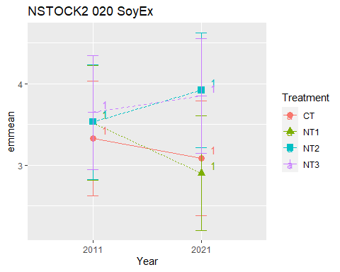

## [1] "NSTOCK2 040 Cumulated SoyEx"  
## [1] "Normality"

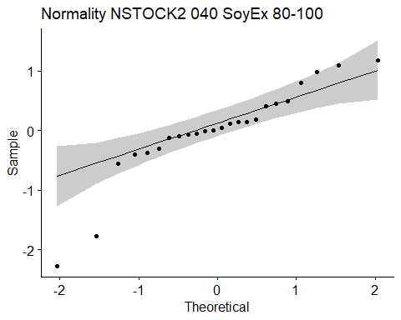

## [1] "Shapiro test for normality"  
## # A tibble: 1 × 3  
## variable statistic p.value  
## <chr> <dbl> <dbl>  
## 1 residuals(model) 0.872 0.00584  
## [1] "Homoscedasticity"

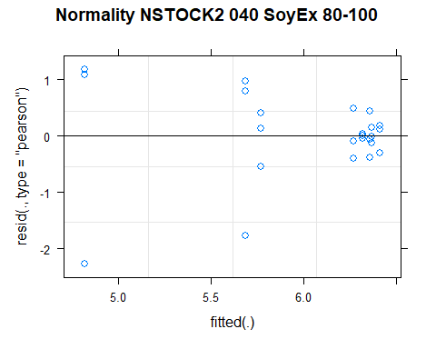

## [1] "Levene test for homoscedasticity"  
## # A tibble: 1 × 4  
## df1 df2 statistic p  
## <int> <int> <dbl> <dbl>  
## 1 7 16 0.653 0.707  
## [1] "ANOVA"  
## Treatment = CT:  
## Year emmean SE df lower.CL upper.CL .group  
## 2021 4.82 0.537 16 3.68 5.96 1   
## 2011 5.77 0.537 16 4.63 6.91 1   
##   
## Treatment = NT1:  
## Year emmean SE df lower.CL upper.CL .group  
## 2021 5.69 0.537 16 4.55 6.83 1   
## 2011 6.32 0.537 16 5.18 7.46 1   
##   
## Treatment = NT2:  
## Year emmean SE df lower.CL upper.CL .group  
## 2011 6.27 0.537 16 5.13 7.41 1   
## 2021 6.41 0.537 16 5.27 7.55 1   
##   
## Treatment = NT3:  
## Year emmean SE df lower.CL upper.CL .group  
## 2011 6.36 0.537 16 5.22 7.50 1   
## 2021 6.37 0.537 16 5.23 7.51 1   
##   
## Degrees-of-freedom method: kenward-roger   
## Results are given on the [ (not the response) scale.   
## Confidence level used: 0.95   
## Note: contrasts are still on the [ scale   
## significance level used: alpha = 0.05   
## NOTE: If two or more means share the same grouping symbol,  
## then we cannot show them to be different.  
## But we also did not show them to be the same.   
## Year = 2011:  
## Treatment emmean SE df lower.CL upper.CL .group  
## CT 5.77 0.537 16 4.63 6.91 1   
## NT2 6.27 0.537 16 5.13 7.41 1   
## NT1 6.32 0.537 16 5.18 7.46 1   
## NT3 6.36 0.537 16 5.22 7.50 1   
##   
## Year = 2021:  
## Treatment emmean SE df lower.CL upper.CL .group  
## CT 4.82 0.537 16 3.68 5.96 1   
## NT1 5.69 0.537 16 4.55 6.83 1   
## NT3 6.37 0.537 16 5.23 7.51 1   
## NT2 6.41 0.537 16 5.27 7.55 1   
##   
## Degrees-of-freedom method: kenward-roger   
## Results are given on the [ (not the response) scale.   
## Confidence level used: 0.95   
## Note: contrasts are still on the [ scale   
## P value adjustment: tukey method for comparing a family of 4 estimates   
## significance level used: alpha = 0.05   
## NOTE: If two or more means share the same grouping symbol,  
## then we cannot show them to be different.  
## But we also did not show them to be the same.   
## [1] "ANOVA Plot"

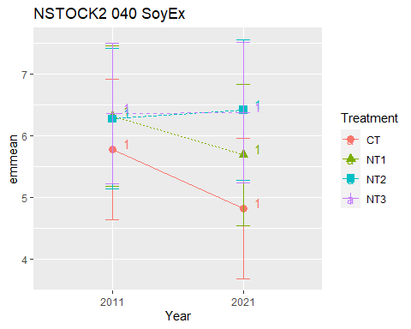

## [1] "NSTOCK2 060 Cumulated SoyEx"  
## [1] "Normality"

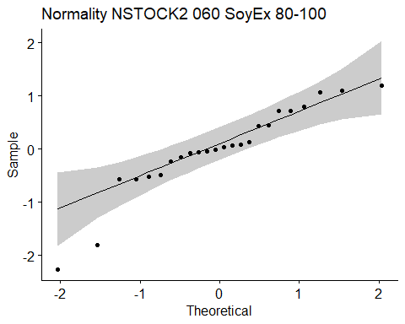

## [1] "Shapiro test for normality"  
## # A tibble: 1 × 3  
## variable statistic p.value  
## <chr> <dbl> <dbl>  
## 1 residuals(model) 0.904 0.0259  
## [1] "Homoscedasticity"

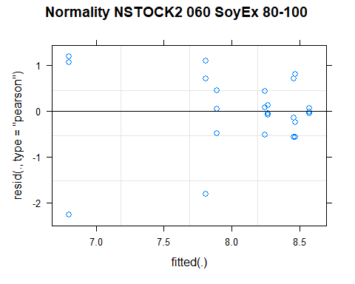

## [1] "Levene test for homoscedasticity"  
## # A tibble: 1 × 4  
## df1 df2 statistic p  
## <int> <int> <dbl> <dbl>  
## 1 7 16 0.626 0.728  
## [1] "ANOVA"  
## Treatment = CT:  
## Year emmean SE df lower.CL upper.CL .group  
## 2021 6.80 0.567 16 5.60 8.00 1   
## 2011 7.89 0.567 16 6.69 9.09 1   
##   
## Treatment = NT1:  
## Year emmean SE df lower.CL upper.CL .group  
## 2021 7.81 0.567 16 6.60 9.01 1   
## 2011 8.57 0.567 16 7.37 9.78 1   
##   
## Treatment = NT2:  
## Year emmean SE df lower.CL upper.CL .group  
## 2021 8.25 0.567 16 7.04 9.45 1   
## 2011 8.47 0.567 16 7.27 9.67 1   
##   
## Treatment = NT3:  
## Year emmean SE df lower.CL upper.CL .group  
## 2021 8.27 0.567 16 7.06 9.47 1   
## 2011 8.46 0.567 16 7.25 9.66 1   
##   
## Degrees-of-freedom method: kenward-roger   
## Results are given on the [ (not the response) scale.   
## Confidence level used: 0.95   
## Note: contrasts are still on the [ scale   
## significance level used: alpha = 0.05   
## NOTE: If two or more means share the same grouping symbol,  
## then we cannot show them to be different.  
## But we also did not show them to be the same.   
## Year = 2011:  
## Treatment emmean SE df lower.CL upper.CL .group  
## CT 7.89 0.567 16 6.69 9.09 1   
## NT3 8.46 0.567 16 7.25 9.66 1   
## NT2 8.47 0.567 16 7.27 9.67 1   
## NT1 8.57 0.567 16 7.37 9.78 1   
##   
## Year = 2021:  
## Treatment emmean SE df lower.CL upper.CL .group  
## CT 6.80 0.567 16 5.60 8.00 1   
## NT1 7.81 0.567 16 6.60 9.01 1   
## NT2 8.25 0.567 16 7.04 9.45 1   
## NT3 8.27 0.567 16 7.06 9.47 1   
##   
## Degrees-of-freedom method: kenward-roger   
## Results are given on the [ (not the response) scale.   
## Confidence level used: 0.95   
## Note: contrasts are still on the [ scale   
## P value adjustment: tukey method for comparing a family of 4 estimates   
## significance level used: alpha = 0.05   
## NOTE: If two or more means share the same grouping symbol,  
## then we cannot show them to be different.  
## But we also did not show them to be the same.   
## [1] "ANOVA Plot"

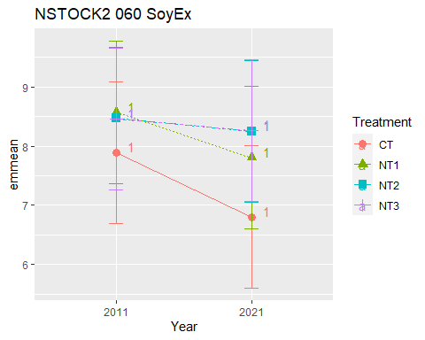

## [1] "NSTOCK2 080 Cumulated SoyEx"  
## [1] "Normality"

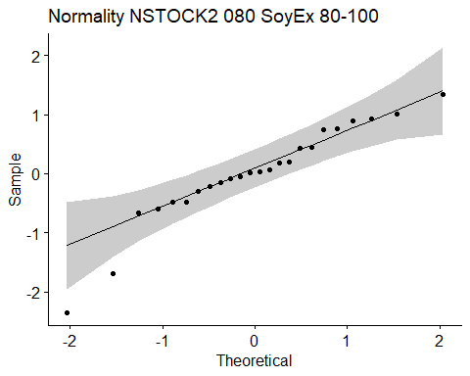

## [1] "Shapiro test for normality"  
## # A tibble: 1 × 3  
## variable statistic p.value  
## <chr> <dbl> <dbl>  
## 1 residuals(model) 0.926 0.0784  
## [1] "Homoscedasticity"

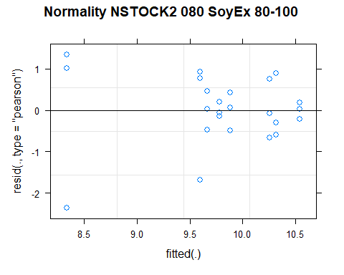

## [1] "Levene test for homoscedasticity"  
## # A tibble: 1 × 4  
## df1 df2 statistic p  
## <int> <int> <dbl> <dbl>  
## 1 7 16 0.576 0.765  
## [1] "ANOVA"  
## Treatment = CT:  
## Year emmean SE df lower.CL upper.CL .group  
## 2021 8.33 0.576 16 7.11 9.55 1   
## 2011 9.67 0.576 16 8.45 10.89 1   
##   
## Treatment = NT1:  
## Year emmean SE df lower.CL upper.CL .group  
## 2021 9.60 0.576 16 8.38 10.82 1   
## 2011 10.54 0.576 16 9.32 11.76 1   
##   
## Treatment = NT2:  
## Year emmean SE df lower.CL upper.CL .group  
## 2021 9.89 0.576 16 8.67 11.11 1   
## 2011 10.32 0.576 16 9.10 11.54 1   
##   
## Treatment = NT3:  
## Year emmean SE df lower.CL upper.CL .group  
## 2021 9.78 0.576 16 8.56 11.00 1   
## 2011 10.26 0.576 16 9.04 11.48 1   
##   
## Degrees-of-freedom method: kenward-roger   
## Results are given on the [ (not the response) scale.   
## Confidence level used: 0.95   
## Note: contrasts are still on the [ scale   
## significance level used: alpha = 0.05   
## NOTE: If two or more means share the same grouping symbol,  
## then we cannot show them to be different.  
## But we also did not show them to be the same.   
## Year = 2011:  
## Treatment emmean SE df lower.CL upper.CL .group  
## CT 9.67 0.576 16 8.45 10.89 1   
## NT3 10.26 0.576 16 9.04 11.48 1   
## NT2 10.32 0.576 16 9.10 11.54 1   
## NT1 10.54 0.576 16 9.32 11.76 1   
##   
## Year = 2021:  
## Treatment emmean SE df lower.CL upper.CL .group  
## CT 8.33 0.576 16 7.11 9.55 1   
## NT1 9.60 0.576 16 8.38 10.82 1   
## NT3 9.78 0.576 16 8.56 11.00 1   
## NT2 9.89 0.576 16 8.67 11.11 1   
##   
## Degrees-of-freedom method: kenward-roger   
## Results are given on the [ (not the response) scale.   
## Confidence level used: 0.95   
## Note: contrasts are still on the [ scale   
## P value adjustment: tukey method for comparing a family of 4 estimates   
## significance level used: alpha = 0.05   
## NOTE: If two or more means share the same grouping symbol,  
## then we cannot show them to be different.  
## But we also did not show them to be the same.   
## [1] "ANOVA Plot"

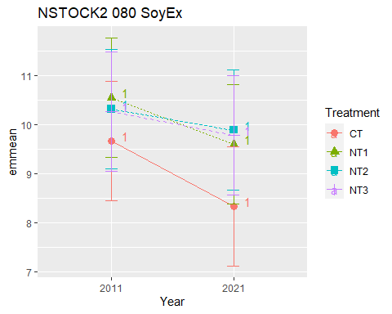

## [1] "NSTOCK2 0100 Cumulated SoyEx"  
## [1] "Normality"

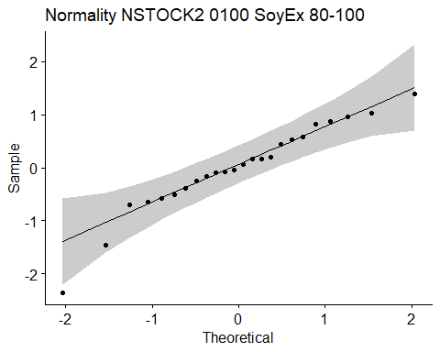

## [1] "Shapiro test for normality"  
## # A tibble: 1 × 3  
## variable statistic p.value  
## <chr> <dbl> <dbl>  
## 1 residuals(model) 0.947 0.233  
## [1] "Homoscedasticity"

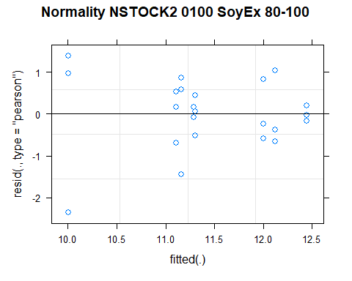

## [1] "Levene test for homoscedasticity"  
## # A tibble: 1 × 4  
## df1 df2 statistic p  
## <int> <int> <dbl> <dbl>  
## 1 7 16 0.602 0.746  
## [1] "ANOVA"  
## Treatment = CT:  
## Year emmean SE df lower.CL upper.CL .group  
## 2021 10.0 0.572 16 8.79 11.2 1   
## 2011 11.3 0.572 16 10.09 12.5 1   
##   
## Treatment = NT1:  
## Year emmean SE df lower.CL upper.CL .group  
## 2021 11.2 0.572 16 9.95 12.4 1   
## 2011 12.4 0.572 16 11.23 13.7 1   
##   
## Treatment = NT2:  
## Year emmean SE df lower.CL upper.CL .group  
## 2021 11.1 0.572 16 9.90 12.3 1   
## 2011 12.1 0.572 16 10.91 13.3 1   
##   
## Treatment = NT3:  
## Year emmean SE df lower.CL upper.CL .group  
## 2021 11.3 0.572 16 10.07 12.5 1   
## 2011 12.0 0.572 16 10.79 13.2 1   
##   
## Degrees-of-freedom method: kenward-roger   
## Results are given on the [ (not the response) scale.   
## Confidence level used: 0.95   
## Note: contrasts are still on the [ scale   
## significance level used: alpha = 0.05   
## NOTE: If two or more means share the same grouping symbol,  
## then we cannot show them to be different.  
## But we also did not show them to be the same.   
## Year = 2011:  
## Treatment emmean SE df lower.CL upper.CL .group  
## CT 11.3 0.572 16 10.09 12.5 1   
## NT3 12.0 0.572 16 10.79 13.2 1   
## NT2 12.1 0.572 16 10.91 13.3 1   
## NT1 12.4 0.572 16 11.23 13.7 1   
##   
## Year = 2021:  
## Treatment emmean SE df lower.CL upper.CL .group  
## CT 10.0 0.572 16 8.79 11.2 1   
## NT2 11.1 0.572 16 9.90 12.3 1   
## NT1 11.2 0.572 16 9.95 12.4 1   
## NT3 11.3 0.572 16 10.07 12.5 1   
##   
## Degrees-of-freedom method: kenward-roger   
## Results are given on the [ (not the response) scale.   
## Confidence level used: 0.95   
## Note: contrasts are still on the [ scale   
## P value adjustment: tukey method for comparing a family of 4 estimates   
## significance level used: alpha = 0.05   
## NOTE: If two or more means share the same grouping symbol,  
## then we cannot show them to be different.  
## But we also did not show them to be the same.   
## [1] "ANOVA Plot"

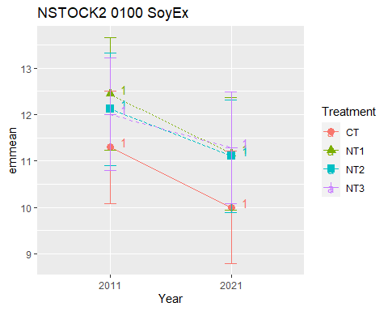

## [1] "NSTOCK2 CasEx"  
## # A tibble: 56 × 7  
## Treatment Depth Year variable n mean sd  
## <fct> <fct> <fct> <chr> <dbl> <dbl> <dbl>  
## 1 CT 0-5 2011 NSTOCK2 3 0.783 0.068  
## 2 NT1 0-5 2011 NSTOCK2 3 0.87 0.035  
## 3 NT2 0-5 2011 NSTOCK2 3 0.847 0.032  
## 4 NT3 0-5 2011 NSTOCK2 3 0.95 0.087  
## 5 CT 5-10 2011 NSTOCK2 3 0.89 0.075  
## 6 NT1 5-10 2011 NSTOCK2 3 0.903 0.035  
## 7 NT2 5-10 2011 NSTOCK2 3 0.803 0.035  
## 8 NT3 5-10 2011 NSTOCK2 3 0.873 0.012  
## 9 CT 10-20 2011 NSTOCK2 3 1.68 0.135  
## 10 NT1 10-20 2011 NSTOCK2 3 1.70 0.084  
## # … with 46 more rows  
## [1] "NSTOCK2 CasEx 0-5"

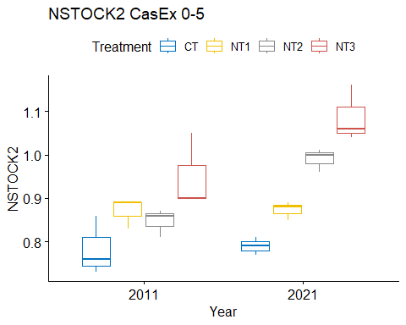

## [1] "Normality"

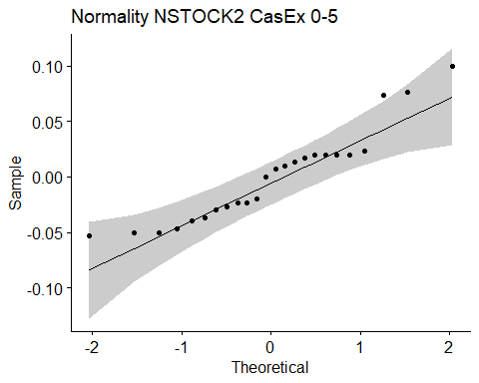

## [1] "Shapiro test for normality"  
## # A tibble: 1 × 3  
## variable statistic p.value  
## <chr> <dbl> <dbl>  
## 1 residuals(model) 0.911 0.0374  
## [1] "Homoscedasticity"

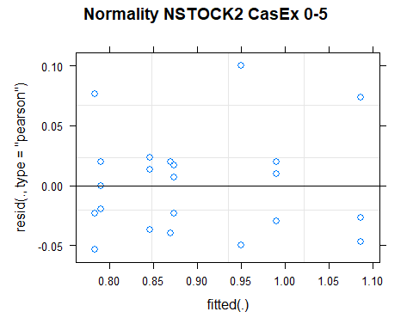

## [1] "Levene test for homoscedasticity"  
## # A tibble: 1 × 4  
## df1 df2 statistic p  
## <int> <int> <dbl> <dbl>  
## 1 7 16 0.338 0.924  
## [1] "ANOVA"  
## Treatment = CT:  
## Year emmean SE df lower.CL upper.CL .group  
## 2011 0.783 0.0289 16 0.722 0.845 1   
## 2021 0.790 0.0289 16 0.729 0.851 1   
##   
## Treatment = NT1:  
## Year emmean SE df lower.CL upper.CL .group  
## 2011 0.870 0.0289 16 0.809 0.931 1   
## 2021 0.873 0.0289 16 0.812 0.935 1   
##   
## Treatment = NT2:  
## Year emmean SE df lower.CL upper.CL .group  
## 2011 0.847 0.0289 16 0.785 0.908 1   
## 2021 0.990 0.0289 16 0.929 1.051 2   
##   
## Treatment = NT3:  
## Year emmean SE df lower.CL upper.CL .group  
## 2011 0.950 0.0289 16 0.889 1.011 1   
## 2021 1.087 0.0289 16 1.025 1.148 2   
##   
## Degrees-of-freedom method: kenward-roger   
## Results are given on the [ (not the response) scale.   
## Confidence level used: 0.95   
## Note: contrasts are still on the [ scale   
## significance level used: alpha = 0.05   
## NOTE: If two or more means share the same grouping symbol,  
## then we cannot show them to be different.  
## But we also did not show them to be the same.   
## Year = 2011:  
## Treatment emmean SE df lower.CL upper.CL .group  
## CT 0.783 0.0289 16 0.722 0.845 1   
## NT2 0.847 0.0289 16 0.785 0.908 12   
## NT1 0.870 0.0289 16 0.809 0.931 12   
## NT3 0.950 0.0289 16 0.889 1.011 2   
##   
## Year = 2021:  
## Treatment emmean SE df lower.CL upper.CL .group  
## CT 0.790 0.0289 16 0.729 0.851 1   
## NT1 0.873 0.0289 16 0.812 0.935 12   
## NT2 0.990 0.0289 16 0.929 1.051 23   
## NT3 1.087 0.0289 16 1.025 1.148 3   
##   
## Degrees-of-freedom method: kenward-roger   
## Results are given on the [ (not the response) scale.   
## Confidence level used: 0.95   
## Note: contrasts are still on the [ scale   
## P value adjustment: tukey method for comparing a family of 4 estimates   
## significance level used: alpha = 0.05   
## NOTE: If two or more means share the same grouping symbol,  
## then we cannot show them to be different.  
## But we also did not show them to be the same.   
## [1] "ANOVA plot"

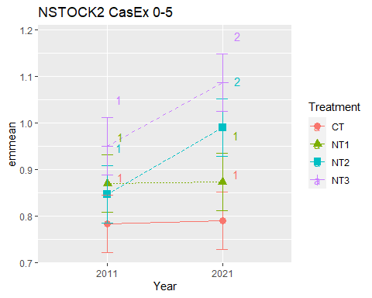

## [1] "NSTOCK2 CasEx 5-10"

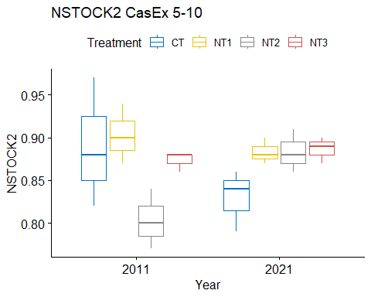

## [1] "Normality"

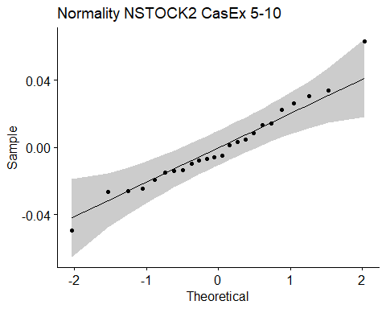

## [1] "Shapiro test for normality"  
## # A tibble: 1 × 3  
## variable statistic p.value  
## <chr> <dbl> <dbl>  
## 1 residuals(model) 0.972 0.706  
## [1] "Homoscedasticity"

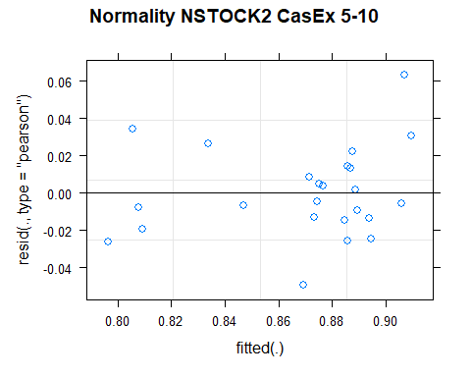

## [1] "Levene test for homoscedasticity"  
## # A tibble: 1 × 4  
## df1 df2 statistic p  
## <int> <int> <dbl> <dbl>  
## 1 7 16 1.09 0.416  
## [1] "ANOVA"  
## Treatment = CT:  
## Year emmean SE df lower.CL upper.CL .group  
## 2021 0.830 0.0211 15.2 0.785 0.875 1   
## 2011 0.890 0.0211 15.2 0.845 0.935 1   
##   
## Treatment = NT1:  
## Year emmean SE df lower.CL upper.CL .group  
## 2021 0.883 0.0211 15.2 0.838 0.928 1   
## 2011 0.903 0.0211 15.2 0.858 0.948 1   
##   
## Treatment = NT2:  
## Year emmean SE df lower.CL upper.CL .group  
## 2011 0.803 0.0211 15.2 0.758 0.848 1   
## 2021 0.883 0.0211 15.2 0.838 0.928 2   
##   
## Treatment = NT3:  
## Year emmean SE df lower.CL upper.CL .group  
## 2011 0.873 0.0211 15.2 0.828 0.918 1   
## 2021 0.887 0.0211 15.2 0.842 0.932 1   
##   
## Degrees-of-freedom method: kenward-roger   
## Results are given on the [ (not the response) scale.   
## Confidence level used: 0.95   
## Note: contrasts are still on the [ scale   
## significance level used: alpha = 0.05   
## NOTE: If two or more means share the same grouping symbol,  
## then we cannot show them to be different.  
## But we also did not show them to be the same.   
## Year = 2011:  
## Treatment emmean SE df lower.CL upper.CL .group  
## NT2 0.803 0.0211 15.2 0.758 0.848 1   
## NT3 0.873 0.0211 15.2 0.828 0.918 12   
## CT 0.890 0.0211 15.2 0.845 0.935 2   
## NT1 0.903 0.0211 15.2 0.858 0.948 2   
##   
## Year = 2021:  
## Treatment emmean SE df lower.CL upper.CL .group  
## CT 0.830 0.0211 15.2 0.785 0.875 1   
## NT1 0.883 0.0211 15.2 0.838 0.928 1   
## NT2 0.883 0.0211 15.2 0.838 0.928 1   
## NT3 0.887 0.0211 15.2 0.842 0.932 1   
##   
## Degrees-of-freedom method: kenward-roger   
## Results are given on the [ (not the response) scale.   
## Confidence level used: 0.95   
## Note: contrasts are still on the [ scale   
## P value adjustment: tukey method for comparing a family of 4 estimates   
## significance level used: alpha = 0.05   
## NOTE: If two or more means share the same grouping symbol,  
## then we cannot show them to be different.  
## But we also did not show them to be the same.   
## [1] "ANOVA plot"

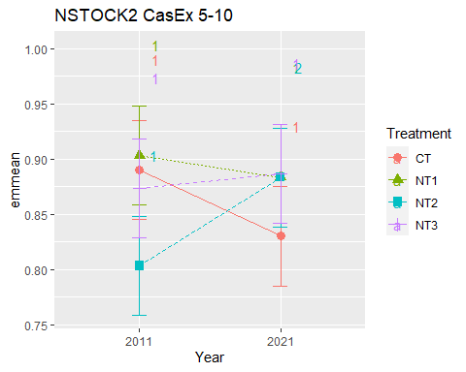

## [1] "NSTOCK2 CasEx 10-20"

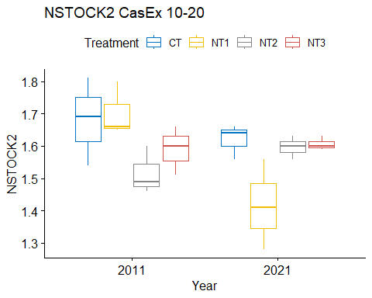

## [1] "Normality"

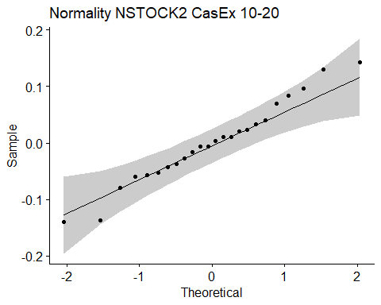

## [1] "Shapiro test for normality"  
## # A tibble: 1 × 3  
## variable statistic p.value  
## <chr> <dbl> <dbl>  
## 1 residuals(model) 0.978 0.856  
## [1] "Homoscedasticity"

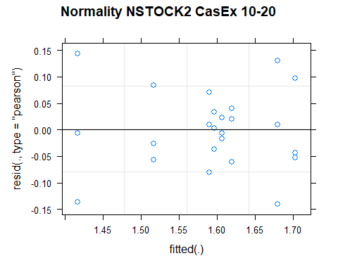

## [1] "Levene test for homoscedasticity"  
## # A tibble: 1 × 4  
## df1 df2 statistic p  
## <int> <int> <dbl> <dbl>  
## 1 7 16 0.746 0.638  
## [1] "ANOVA"  
## Treatment = CT:  
## Year emmean SE df lower.CL upper.CL .group  
## 2021 1.62 0.0502 16 1.51 1.73 1   
## 2011 1.68 0.0502 16 1.57 1.79 1   
##   
## Treatment = NT1:  
## Year emmean SE df lower.CL upper.CL .group  
## 2021 1.42 0.0502 16 1.31 1.52 1   
## 2011 1.70 0.0502 16 1.60 1.81 2   
##   
## Treatment = NT2:  
## Year emmean SE df lower.CL upper.CL .group  
## 2011 1.52 0.0502 16 1.41 1.62 1   
## 2021 1.60 0.0502 16 1.49 1.70 1   
##   
## Treatment = NT3:  
## Year emmean SE df lower.CL upper.CL .group  
## 2011 1.59 0.0502 16 1.48 1.70 1   
## 2021 1.61 0.0502 16 1.50 1.71 1   
##   
## Degrees-of-freedom method: kenward-roger   
## Results are given on the [ (not the response) scale.   
## Confidence level used: 0.95   
## Note: contrasts are still on the [ scale   
## significance level used: alpha = 0.05   
## NOTE: If two or more means share the same grouping symbol,  
## then we cannot show them to be different.  
## But we also did not show them to be the same.   
## Year = 2011:  
## Treatment emmean SE df lower.CL upper.CL .group  
## NT2 1.52 0.0502 16 1.41 1.62 1   
## NT3 1.59 0.0502 16 1.48 1.70 1   
## CT 1.68 0.0502 16 1.57 1.79 1   
## NT1 1.70 0.0502 16 1.60 1.81 1   
##   
## Year = 2021:  
## Treatment emmean SE df lower.CL upper.CL .group  
## NT1 1.42 0.0502 16 1.31 1.52 1   
## NT2 1.60 0.0502 16 1.49 1.70 12   
## NT3 1.61 0.0502 16 1.50 1.71 12   
## CT 1.62 0.0502 16 1.51 1.73 2   
##   
## Degrees-of-freedom method: kenward-roger   
## Results are given on the [ (not the response) scale.   
## Confidence level used: 0.95   
## Note: contrasts are still on the [ scale   
## P value adjustment: tukey method for comparing a family of 4 estimates   
## significance level used: alpha = 0.05   
## NOTE: If two or more means share the same grouping symbol,  
## then we cannot show them to be different.  
## But we also did not show them to be the same.   
## [1] "ANOVA plot"

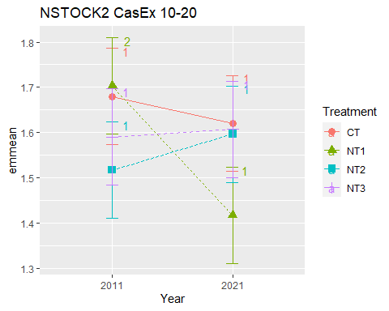

## [1] "NSTOCK2 CasEx 20-40"

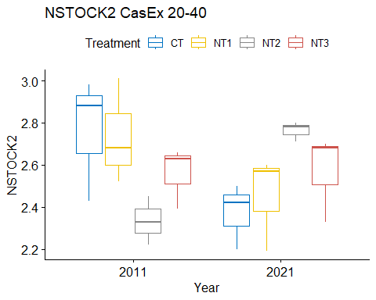

## [1] "Normality"

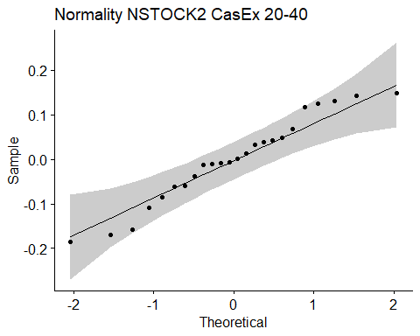

## [1] "Shapiro test for normality"  
## # A tibble: 1 × 3  
## variable statistic p.value  
## <chr> <dbl> <dbl>  
## 1 residuals(model) 0.957 0.378  
## [1] "Homoscedasticity"

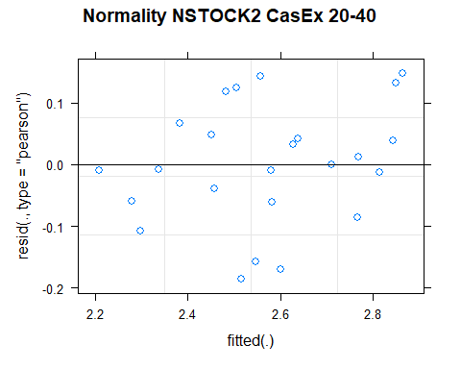

## [1] "Levene test for homoscedasticity"  
## # A tibble: 1 × 4  
## df1 df2 statistic p  
## <int> <int> <dbl> <dbl>  
## 1 7 16 0.290 0.948  
## [1] "ANOVA"  
## Treatment = CT:  
## Year emmean SE df lower.CL upper.CL .group  
## 2021 2.37 0.113 13 2.13 2.62 1   
## 2011 2.76 0.113 13 2.52 3.01 2   
##   
## Treatment = NT1:  
## Year emmean SE df lower.CL upper.CL .group  
## 2021 2.45 0.113 13 2.21 2.70 1   
## 2011 2.74 0.113 13 2.49 2.98 2   
##   
## Treatment = NT2:  
## Year emmean SE df lower.CL upper.CL .group  
## 2011 2.33 0.113 13 2.09 2.58 1   
## 2021 2.76 0.113 13 2.52 3.01 2   
##   
## Treatment = NT3:  
## Year emmean SE df lower.CL upper.CL .group  
## 2011 2.56 0.113 13 2.32 2.80 1   
## 2021 2.57 0.113 13 2.33 2.81 1   
##   
## Degrees-of-freedom method: kenward-roger   
## Results are given on the [ (not the response) scale.   
## Confidence level used: 0.95   
## Note: contrasts are still on the [ scale   
## significance level used: alpha = 0.05   
## NOTE: If two or more means share the same grouping symbol,  
## then we cannot show them to be different.  
## But we also did not show them to be the same.   
## Year = 2011:  
## Treatment emmean SE df lower.CL upper.CL .group  
## NT2 2.33 0.113 13 2.09 2.58 1   
## NT3 2.56 0.113 13 2.32 2.80 1   
## NT1 2.74 0.113 13 2.49 2.98 1   
## CT 2.76 0.113 13 2.52 3.01 1   
##   
## Year = 2021:  
## Treatment emmean SE df lower.CL upper.CL .group  
## CT 2.37 0.113 13 2.13 2.62 1   
## NT1 2.45 0.113 13 2.21 2.70 1   
## NT3 2.57 0.113 13 2.33 2.81 1   
## NT2 2.76 0.113 13 2.52 3.01 1   
##   
## Degrees-of-freedom method: kenward-roger   
## Results are given on the [ (not the response) scale.   
## Confidence level used: 0.95   
## Note: contrasts are still on the [ scale   
## P value adjustment: tukey method for comparing a family of 4 estimates   
## significance level used: alpha = 0.05   
## NOTE: If two or more means share the same grouping symbol,  
## then we cannot show them to be different.  
## But we also did not show them to be the same.   
## [1] "ANOVA plot"

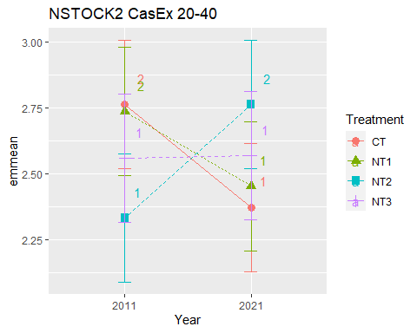

## [1] "NSTOCK2 CasEx 40-60"

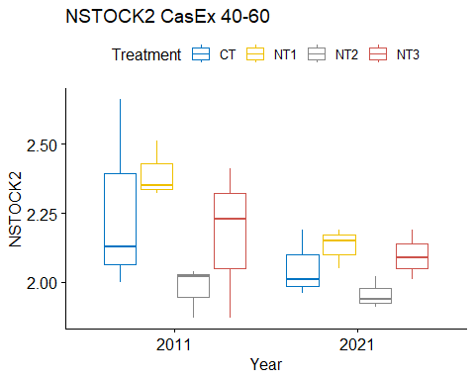

## [1] "Normality"

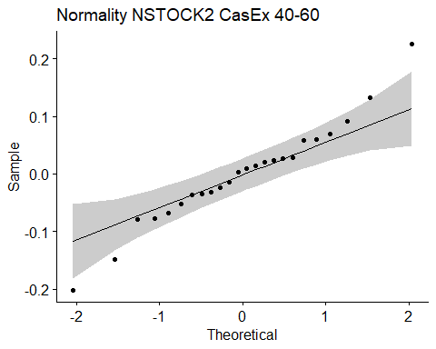

## [1] "Shapiro test for normality"  
## # A tibble: 1 × 3  
## variable statistic p.value  
## <chr> <dbl> <dbl>  
## 1 residuals(model) 0.970 0.669  
## [1] "Homoscedasticity"

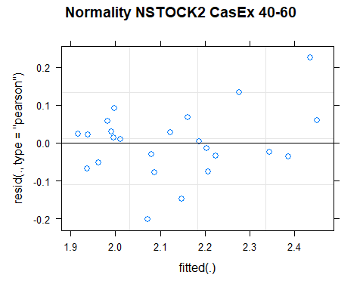

## [1] "Levene test for homoscedasticity"  
## # A tibble: 1 × 4  
## df1 df2 statistic p  
## <int> <int> <dbl> <dbl>  
## 1 7 16 0.808 0.593  
## [1] "ANOVA"  
## Treatment = CT:  
## Year emmean SE df lower.CL upper.CL .group  
## 2021 2.05 0.102 13.1 1.83 2.27 1   
## 2011 2.26 0.102 13.1 2.04 2.48 1   
##   
## Treatment = NT1:  
## Year emmean SE df lower.CL upper.CL .group  
## 2021 2.13 0.102 13.1 1.91 2.35 1   
## 2011 2.39 0.102 13.1 2.17 2.61 2   
##   
## Treatment = NT2:  
## Year emmean SE df lower.CL upper.CL .group  
## 2021 1.96 0.102 13.1 1.74 2.18 1   
## 2011 1.98 0.102 13.1 1.76 2.20 1   
##   
## Treatment = NT3:  
## Year emmean SE df lower.CL upper.CL .group  
## 2021 2.10 0.102 13.1 1.88 2.32 1   
## 2011 2.17 0.102 13.1 1.95 2.39 1   
##   
## Degrees-of-freedom method: kenward-roger   
## Results are given on the [ (not the response) scale.   
## Confidence level used: 0.95   
## Note: contrasts are still on the [ scale   
## significance level used: alpha = 0.05   
## NOTE: If two or more means share the same grouping symbol,  
## then we cannot show them to be different.  
## But we also did not show them to be the same.   
## Year = 2011:  
## Treatment emmean SE df lower.CL upper.CL .group  
## NT2 1.98 0.102 13.1 1.76 2.20 1   
## NT3 2.17 0.102 13.1 1.95 2.39 1   
## CT 2.26 0.102 13.1 2.04 2.48 1   
## NT1 2.39 0.102 13.1 2.17 2.61 1   
##   
## Year = 2021:  
## Treatment emmean SE df lower.CL upper.CL .group  
## NT2 1.96 0.102 13.1 1.74 2.18 1   
## CT 2.05 0.102 13.1 1.83 2.27 1   
## NT3 2.10 0.102 13.1 1.88 2.32 1   
## NT1 2.13 0.102 13.1 1.91 2.35 1   
##   
## Degrees-of-freedom method: kenward-roger   
## Results are given on the [ (not the response) scale.   
## Confidence level used: 0.95   
## Note: contrasts are still on the [ scale   
## P value adjustment: tukey method for comparing a family of 4 estimates   
## significance level used: alpha = 0.05   
## NOTE: If two or more means share the same grouping symbol,  
## then we cannot show them to be different.  
## But we also did not show them to be the same.   
## [1] "ANOVA plot"

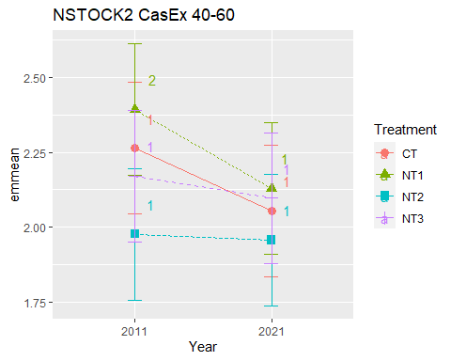

## [1] "NSTOCK2 CasEx 60-80"

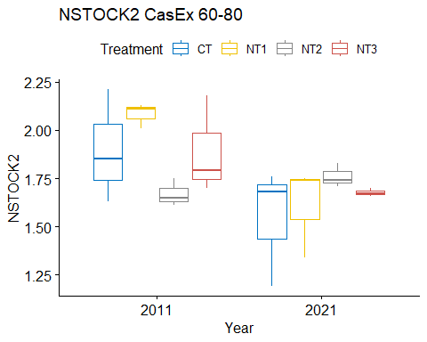

## [1] "Normality"

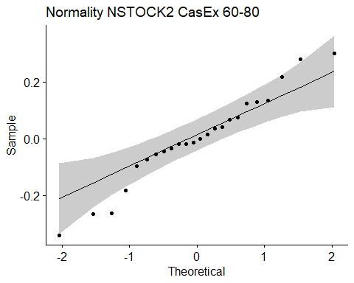

## [1] "Shapiro test for normality"  
## # A tibble: 1 × 3  
## variable statistic p.value  
## <chr> <dbl> <dbl>  
## 1 residuals(model) 0.969 0.631  
## [1] "Homoscedasticity"

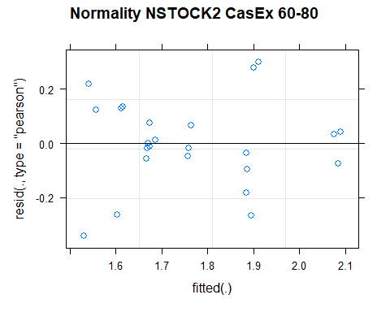

## [1] "Levene test for homoscedasticity"  
## # A tibble: 1 × 4  
## df1 df2 statistic p  
## <int> <int> <dbl> <dbl>  
## 1 7 16 0.662 0.701  
## [1] "ANOVA"  
## Treatment = CT:  
## Year emmean SE df lower.CL upper.CL .group  
## 2021 1.54 0.114 16 1.30 1.79 1   
## 2011 1.90 0.114 16 1.65 2.14 1   
##   
## Treatment = NT1:  
## Year emmean SE df lower.CL upper.CL .group  
## 2021 1.61 0.114 16 1.37 1.85 1   
## 2011 2.08 0.114 16 1.84 2.33 2   
##   
## Treatment = NT2:  
## Year emmean SE df lower.CL upper.CL .group  
## 2011 1.67 0.114 16 1.43 1.91 1   
## 2021 1.76 0.114 16 1.52 2.00 1   
##   
## Treatment = NT3:  
## Year emmean SE df lower.CL upper.CL .group  
## 2021 1.68 0.114 16 1.43 1.92 1   
## 2011 1.89 0.114 16 1.65 2.13 1   
##   
## Degrees-of-freedom method: kenward-roger   
## Results are given on the [ (not the response) scale.   
## Confidence level used: 0.95   
## Note: contrasts are still on the [ scale   
## significance level used: alpha = 0.05   
## NOTE: If two or more means share the same grouping symbol,  
## then we cannot show them to be different.  
## But we also did not show them to be the same.   
## Year = 2011:  
## Treatment emmean SE df lower.CL upper.CL .group  
## NT2 1.67 0.114 16 1.43 1.91 1   
## NT3 1.89 0.114 16 1.65 2.13 1   
## CT 1.90 0.114 16 1.65 2.14 1   
## NT1 2.08 0.114 16 1.84 2.33 1   
##   
## Year = 2021:  
## Treatment emmean SE df lower.CL upper.CL .group  
## CT 1.54 0.114 16 1.30 1.79 1   
## NT1 1.61 0.114 16 1.37 1.85 1   
## NT3 1.68 0.114 16 1.43 1.92 1   
## NT2 1.76 0.114 16 1.52 2.00 1   
##   
## Degrees-of-freedom method: kenward-roger   
## Results are given on the [ (not the response) scale.   
## Confidence level used: 0.95   
## Note: contrasts are still on the [ scale   
## P value adjustment: tukey method for comparing a family of 4 estimates   
## significance level used: alpha = 0.05   
## NOTE: If two or more means share the same grouping symbol,  
## then we cannot show them to be different.  
## But we also did not show them to be the same.   
## [1] "ANOVA plot"

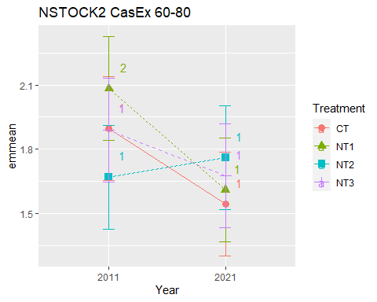

## [1] "NSTOCK2 CasEx 80-100"

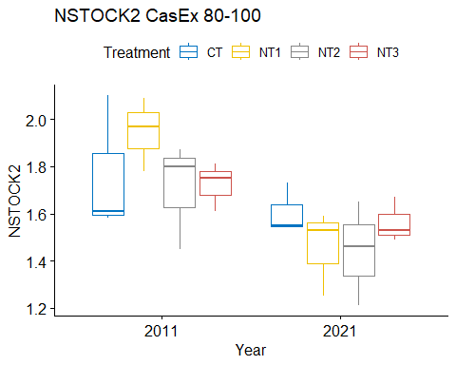

## [1] "Normality"

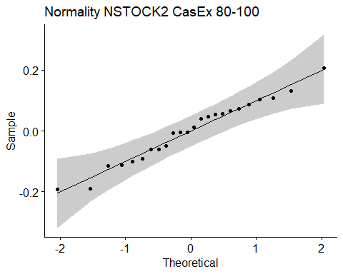

## [1] "Shapiro test for normality"  
## # A tibble: 1 × 3  
## variable statistic p.value  
## <chr> <dbl> <dbl>  
## 1 residuals(model) 0.976 0.818  
## [1] "Homoscedasticity"

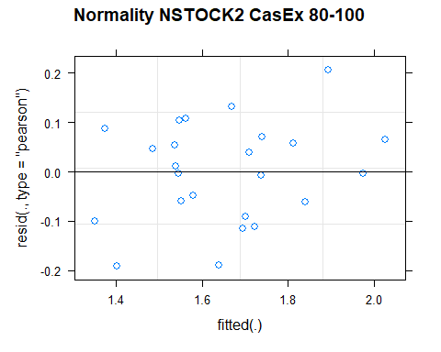

## [1] "Levene test for homoscedasticity"  
## # A tibble: 1 × 4  
## df1 df2 statistic p  
## <int> <int> <dbl> <dbl>  
## 1 7 16 0.247 0.966  
## [1] "ANOVA"  
## Treatment = CT:  
## Year emmean SE df lower.CL upper.CL .group  
## 2021 1.61 0.107 13.8 1.38 1.84 1   
## 2011 1.76 0.107 13.8 1.53 1.99 1   
##   
## Treatment = NT1:  
## Year emmean SE df lower.CL upper.CL .group  
## 2021 1.46 0.107 13.8 1.23 1.69 1   
## 2011 1.95 0.107 13.8 1.72 2.18 2   
##   
## Treatment = NT2:  
## Year emmean SE df lower.CL upper.CL .group  
## 2021 1.44 0.107 13.8 1.21 1.67 1   
## 2011 1.71 0.107 13.8 1.48 1.94 1   
##   
## Treatment = NT3:  
## Year emmean SE df lower.CL upper.CL .group  
## 2021 1.56 0.107 13.8 1.33 1.79 1   
## 2011 1.72 0.107 13.8 1.49 1.95 1   
##   
## Degrees-of-freedom method: kenward-roger   
## Results are given on the [ (not the response) scale.   
## Confidence level used: 0.95   
## Note: contrasts are still on the [ scale   
## significance level used: alpha = 0.05   
## NOTE: If two or more means share the same grouping symbol,  
## then we cannot show them to be different.  
## But we also did not show them to be the same.   
## Year = 2011:  
## Treatment emmean SE df lower.CL upper.CL .group  
## NT2 1.71 0.107 13.8 1.48 1.94 1   
## NT3 1.72 0.107 13.8 1.49 1.95 1   
## CT 1.76 0.107 13.8 1.53 1.99 1   
## NT1 1.95 0.107 13.8 1.72 2.18 1   
##   
## Year = 2021:  
## Treatment emmean SE df lower.CL upper.CL .group  
## NT2 1.44 0.107 13.8 1.21 1.67 1   
## NT1 1.46 0.107 13.8 1.23 1.69 1   
## NT3 1.56 0.107 13.8 1.33 1.79 1   
## CT 1.61 0.107 13.8 1.38 1.84 1   
##   
## Degrees-of-freedom method: kenward-roger   
## Results are given on the [ (not the response) scale.   
## Confidence level used: 0.95   
## Note: contrasts are still on the [ scale   
## P value adjustment: tukey method for comparing a family of 4 estimates   
## significance level used: alpha = 0.05   
## NOTE: If two or more means share the same grouping symbol,  
## then we cannot show them to be different.  
## But we also did not show them to be the same.   
## [1] "ANOVA plot"

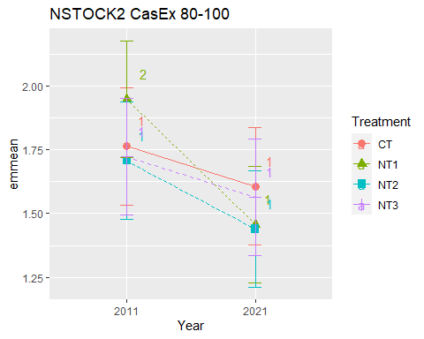

## [1] "NSTOCK2 010 Cumulated CasEx"  
## [1] "Normality"

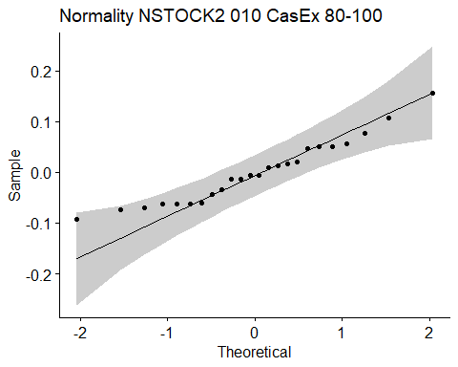

## [1] "Shapiro test for normality"  
## # A tibble: 1 × 3  
## variable statistic p.value  
## <chr> <dbl> <dbl>  
## 1 residuals(model) 0.951 0.288  
## [1] "Homoscedasticity"

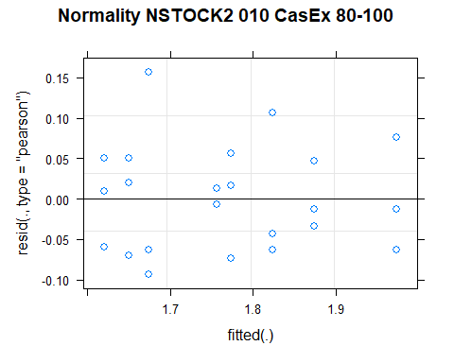

## [1] "Levene test for homoscedasticity"  
## # A tibble: 1 × 4  
## df1 df2 statistic p  
## <int> <int> <dbl> <dbl>  
## 1 7 16 0.405 0.886  
## [1] "ANOVA"  
## Treatment = CT:  
## Year emmean SE df lower.CL upper.CL .group  
## 2021 1.62 0.0436 16 1.53 1.71 1   
## 2011 1.67 0.0436 16 1.58 1.77 1   
##   
## Treatment = NT1:  
## Year emmean SE df lower.CL upper.CL .group  
## 2021 1.76 0.0436 16 1.66 1.85 1   
## 2011 1.77 0.0436 16 1.68 1.87 1   
##   
## Treatment = NT2:  
## Year emmean SE df lower.CL upper.CL .group  
## 2011 1.65 0.0436 16 1.56 1.74 1   
## 2021 1.87 0.0436 16 1.78 1.97 2   
##   
## Treatment = NT3:  
## Year emmean SE df lower.CL upper.CL .group  
## 2011 1.82 0.0436 16 1.73 1.92 1   
## 2021 1.97 0.0436 16 1.88 2.07 2   
##   
## Degrees-of-freedom method: kenward-roger   
## Results are given on the [ (not the response) scale.   
## Confidence level used: 0.95   
## Note: contrasts are still on the [ scale   
## significance level used: alpha = 0.05   
## NOTE: If two or more means share the same grouping symbol,  
## then we cannot show them to be different.  
## But we also did not show them to be the same.   
## Year = 2011:  
## Treatment emmean SE df lower.CL upper.CL .group  
## NT2 1.65 0.0436 16 1.56 1.74 1   
## CT 1.67 0.0436 16 1.58 1.77 1   
## NT1 1.77 0.0436 16 1.68 1.87 1   
## NT3 1.82 0.0436 16 1.73 1.92 1   
##   
## Year = 2021:  
## Treatment emmean SE df lower.CL upper.CL .group  
## CT 1.62 0.0436 16 1.53 1.71 1   
## NT1 1.76 0.0436 16 1.66 1.85 12   
## NT2 1.87 0.0436 16 1.78 1.97 23   
## NT3 1.97 0.0436 16 1.88 2.07 3   
##   
## Degrees-of-freedom method: kenward-roger   
## Results are given on the [ (not the response) scale.   
## Confidence level used: 0.95   
## Note: contrasts are still on the [ scale   
## P value adjustment: tukey method for comparing a family of 4 estimates   
## significance level used: alpha = 0.05   
## NOTE: If two or more means share the same grouping symbol,  
## then we cannot show them to be different.  
## But we also did not show them to be the same.   
## [1] "ANOVA Plot"

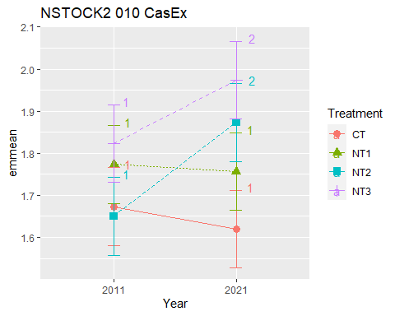

## [1] "NSTOCK2 020 Cumulated CasEx"  
## [1] "Normality"

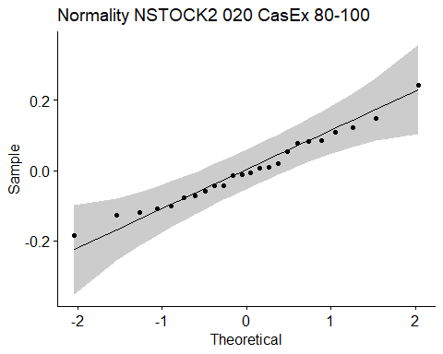

## [1] "Shapiro test for normality"  
## # A tibble: 1 × 3  
## variable statistic p.value  
## <chr> <dbl> <dbl>  
## 1 residuals(model) 0.982 0.929  
## [1] "Homoscedasticity"

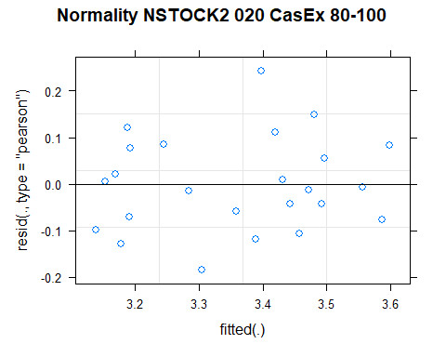

## [1] "Levene test for homoscedasticity"  
## # A tibble: 1 × 4  
## df1 df2 statistic p  
## <int> <int> <dbl> <dbl>  
## 1 7 16 0.512 0.813  
## [1] "ANOVA"  
## Treatment = CT:  
## Year emmean SE df lower.CL upper.CL .group  
## 2021 3.24 0.0825 15.6 3.06 3.42 1   
## 2011 3.35 0.0825 15.6 3.18 3.53 1   
##   
## Treatment = NT1:  
## Year emmean SE df lower.CL upper.CL .group  
## 2021 3.17 0.0825 15.6 3.00 3.35 1   
## 2011 3.48 0.0825 15.6 3.30 3.65 2   
##   
## Treatment = NT2:  
## Year emmean SE df lower.CL upper.CL .group  
## 2011 3.17 0.0825 15.6 2.99 3.34 1   
## 2021 3.47 0.0825 15.6 3.29 3.65 2   
##   
## Treatment = NT3:  
## Year emmean SE df lower.CL upper.CL .group  
## 2011 3.41 0.0825 15.6 3.24 3.59 1   
## 2021 3.58 0.0825 15.6 3.40 3.76 1   
##   
## Degrees-of-freedom method: kenward-roger   
## Results are given on the [ (not the response) scale.   
## Confidence level used: 0.95   
## Note: contrasts are still on the [ scale   
## significance level used: alpha = 0.05   
## NOTE: If two or more means share the same grouping symbol,  
## then we cannot show them to be different.  
## But we also did not show them to be the same.   
## Year = 2011:  
## Treatment emmean SE df lower.CL upper.CL .group  
## NT2 3.17 0.0825 15.6 2.99 3.34 1   
## CT 3.35 0.0825 15.6 3.18 3.53 1   
## NT3 3.41 0.0825 15.6 3.24 3.59 1   
## NT1 3.48 0.0825 15.6 3.30 3.65 1   
##   
## Year = 2021:  
## Treatment emmean SE df lower.CL upper.CL .group  
## NT1 3.17 0.0825 15.6 3.00 3.35 1   
## CT 3.24 0.0825 15.6 3.06 3.42 1   
## NT2 3.47 0.0825 15.6 3.29 3.65 12   
## NT3 3.58 0.0825 15.6 3.40 3.76 2   
##   
## Degrees-of-freedom method: kenward-roger   
## Results are given on the [ (not the response) scale.   
## Confidence level used: 0.95   
## Note: contrasts are still on the [ scale   
## P value adjustment: tukey method for comparing a family of 4 estimates   
## significance level used: alpha = 0.05   
## NOTE: If two or more means share the same grouping symbol,  
## then we cannot show them to be different.  
## But we also did not show them to be the same.   
## [1] "ANOVA Plot"

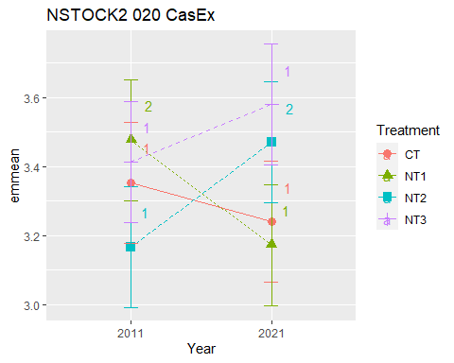

## [1] "NSTOCK2 040 Cumulated CasEx"  
## [1] "Normality"

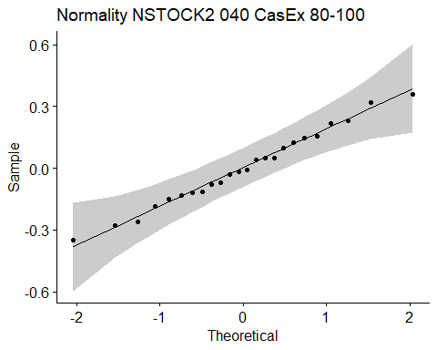

## [1] "Shapiro test for normality"  
## # A tibble: 1 × 3  
## variable statistic p.value  
## <chr> <dbl> <dbl>  
## 1 residuals(model) 0.987 0.985  
## [1] "Homoscedasticity"

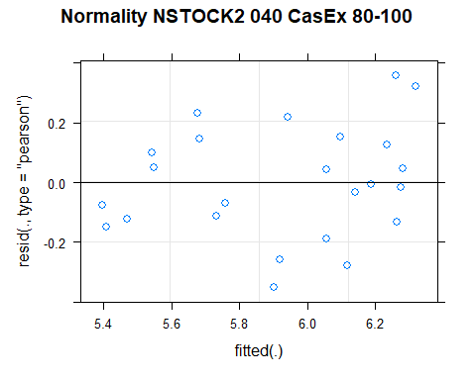

## [1] "Levene test for homoscedasticity"  
## # A tibble: 1 × 4  
## df1 df2 statistic p  
## <int> <int> <dbl> <dbl>  
## 1 7 16 0.470 0.842  
## [1] "ANOVA"  
## Treatment = CT:  
## Year emmean SE df lower.CL upper.CL .group  
## 2021 5.61 0.182 14.4 5.22 6.00 1   
## 2011 6.12 0.182 14.4 5.73 6.51 2   
##   
## Treatment = NT1:  
## Year emmean SE df lower.CL upper.CL .group  
## 2021 5.63 0.182 14.4 5.24 6.02 1   
## 2011 6.21 0.182 14.4 5.82 6.60 2   
##   
## Treatment = NT2:  
## Year emmean SE df lower.CL upper.CL .group  
## 2011 5.50 0.182 14.4 5.11 5.89 1   
## 2021 6.23 0.182 14.4 5.84 6.62 2   
##   
## Treatment = NT3:  
## Year emmean SE df lower.CL upper.CL .group  
## 2011 5.97 0.182 14.4 5.58 6.36 1   
## 2021 6.15 0.182 14.4 5.76 6.54 1   
##   
## Degrees-of-freedom method: kenward-roger   
## Results are given on the [ (not the response) scale.   
## Confidence level used: 0.95   
## Note: contrasts are still on the [ scale   
## significance level used: alpha = 0.05   
## NOTE: If two or more means share the same grouping symbol,  
## then we cannot show them to be different.  
## But we also did not show them to be the same.   
## Year = 2011:  
## Treatment emmean SE df lower.CL upper.CL .group  
## NT2 5.50 0.182 14.4 5.11 5.89 1   
## NT3 5.97 0.182 14.4 5.58 6.36 1   
## CT 6.12 0.182 14.4 5.73 6.51 1   
## NT1 6.21 0.182 14.4 5.82 6.60 1   
##   
## Year = 2021:  
## Treatment emmean SE df lower.CL upper.CL .group  
## CT 5.61 0.182 14.4 5.22 6.00 1   
## NT1 5.63 0.182 14.4 5.24 6.02 1   
## NT3 6.15 0.182 14.4 5.76 6.54 1   
## NT2 6.23 0.182 14.4 5.84 6.62 1   
##   
## Degrees-of-freedom method: kenward-roger   
## Results are given on the [ (not the response) scale.   
## Confidence level used: 0.95   
## Note: contrasts are still on the [ scale   
## P value adjustment: tukey method for comparing a family of 4 estimates   
## significance level used: alpha = 0.05   
## NOTE: If two or more means share the same grouping symbol,  
## then we cannot show them to be different.  
## But we also did not show them to be the same.   
## [1] "ANOVA Plot"

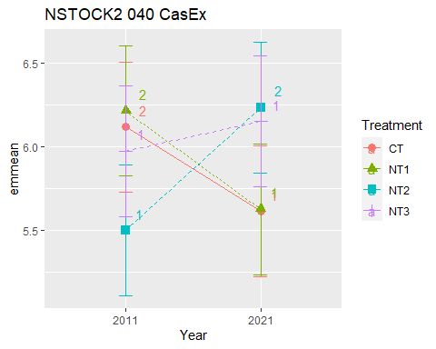

## [1] "NSTOCK2 060 Cumulated CasEx"  
## [1] "Normality"

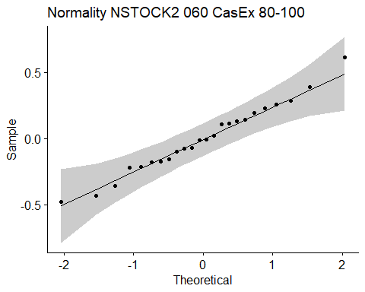

## [1] "Shapiro test for normality"  
## # A tibble: 1 × 3  
## variable statistic p.value  
## <chr> <dbl> <dbl>  
## 1 residuals(model) 0.987 0.981  
## [1] "Homoscedasticity"

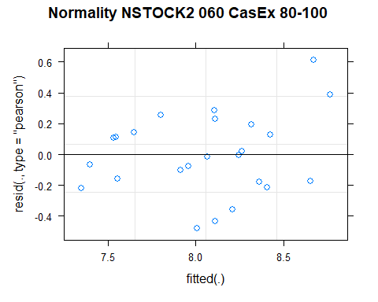

## [1] "Levene test for homoscedasticity"  
## # A tibble: 1 × 4  
## df1 df2 statistic p  
## <int> <int> <dbl> <dbl>  
## 1 7 16 0.507 0.816  
## [1] "ANOVA"  
## Treatment = CT:  
## Year emmean SE df lower.CL upper.CL .group  
## 2021 7.67 0.261 14.2 7.11 8.22 1   
## 2011 8.38 0.261 14.2 7.82 8.94 2   
##   
## Treatment = NT1:  
## Year emmean SE df lower.CL upper.CL .group  
## 2021 7.76 0.261 14.2 7.20 8.31 1   
## 2011 8.61 0.261 14.2 8.05 9.16 2   
##   
## Treatment = NT2:  
## Year emmean SE df lower.CL upper.CL .group  
## 2011 7.48 0.261 14.2 6.92 8.03 1   
## 2021 8.19 0.261 14.2 7.63 8.75 2   
##   
## Treatment = NT3:  
## Year emmean SE df lower.CL upper.CL .group  
## 2011 8.14 0.261 14.2 7.59 8.70 1   
## 2021 8.25 0.261 14.2 7.69 8.80 1   
##   
## Degrees-of-freedom method: kenward-roger   
## Results are given on the [ (not the response) scale.   
## Confidence level used: 0.95   
## Note: contrasts are still on the [ scale   
## significance level used: alpha = 0.05   
## NOTE: If two or more means share the same grouping symbol,  
## then we cannot show them to be different.  
## But we also did not show them to be the same.   
## Year = 2011:  
## Treatment emmean SE df lower.CL upper.CL .group  
## NT2 7.48 0.261 14.2 6.92 8.03 1   
## NT3 8.14 0.261 14.2 7.59 8.70 12   
## CT 8.38 0.261 14.2 7.82 8.94 12   
## NT1 8.61 0.261 14.2 8.05 9.16 2   
##   
## Year = 2021:  
## Treatment emmean SE df lower.CL upper.CL .group  
## CT 7.67 0.261 14.2 7.11 8.22 1   
## NT1 7.76 0.261 14.2 7.20 8.31 1   
## NT2 8.19 0.261 14.2 7.63 8.75 1   
## NT3 8.25 0.261 14.2 7.69 8.80 1   
##   
## Degrees-of-freedom method: kenward-roger   
## Results are given on the [ (not the response) scale.   
## Confidence level used: 0.95   
## Note: contrasts are still on the [ scale   
## P value adjustment: tukey method for comparing a family of 4 estimates   
## significance level used: alpha = 0.05   
## NOTE: If two or more means share the same grouping symbol,  
## then we cannot show them to be different.  
## But we also did not show them to be the same.   
## [1] "ANOVA Plot"

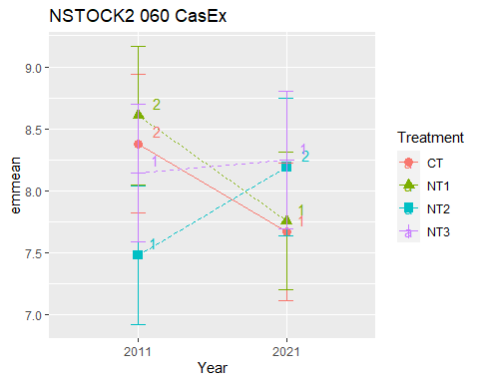

## [1] "NSTOCK2 080 Cumulated CasEx"  
## [1] "Normality"

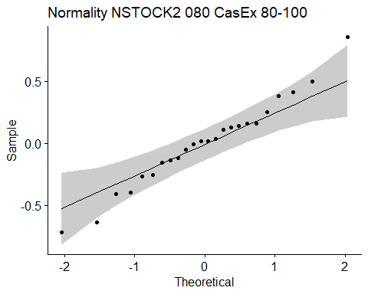

## [1] "Shapiro test for normality"  
## # A tibble: 1 × 3  
## variable statistic p.value  
## <chr> <dbl> <dbl>  
## 1 residuals(model) 0.982 0.930  
## [1] "Homoscedasticity"

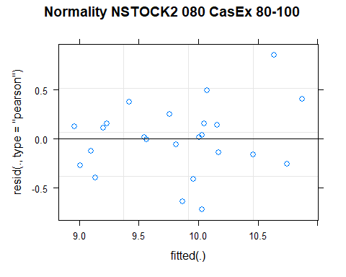

## [1] "Levene test for homoscedasticity"  
## # A tibble: 1 × 4  
## df1 df2 statistic p  
## <int> <int> <dbl> <dbl>  
## 1 7 16 0.643 0.715  
## [1] "ANOVA"  
## Treatment = CT:  
## Year emmean SE df lower.CL upper.CL .group  
## 2021 9.21 0.334 14.7 8.50 9.92 1   
## 2011 10.28 0.334 14.7 9.56 10.99 2   
##   
## Treatment = NT1:  
## Year emmean SE df lower.CL upper.CL .group  
## 2021 9.37 0.334 14.7 8.65 10.08 1   
## 2011 10.69 0.334 14.7 9.98 11.40 2   
##   
## Treatment = NT2:  
## Year emmean SE df lower.CL upper.CL .group  
## 2011 9.15 0.334 14.7 8.43 9.86 1   
## 2021 9.95 0.334 14.7 9.24 10.66 1   
##   
## Treatment = NT3:  
## Year emmean SE df lower.CL upper.CL .group  
## 2021 9.92 0.334 14.7 9.21 10.64 1   
## 2011 10.03 0.334 14.7 9.32 10.75 1   
##   
## Degrees-of-freedom method: kenward-roger   
## Results are given on the [ (not the response) scale.   
## Confidence level used: 0.95   
## Note: contrasts are still on the [ scale   
## significance level used: alpha = 0.05   
## NOTE: If two or more means share the same grouping symbol,  
## then we cannot show them to be different.  
## But we also did not show them to be the same.   
## Year = 2011:  
## Treatment emmean SE df lower.CL upper.CL .group  
## NT2 9.15 0.334 14.7 8.43 9.86 1   
## NT3 10.03 0.334 14.7 9.32 10.75 12   
## CT 10.28 0.334 14.7 9.56 10.99 12   
## NT1 10.69 0.334 14.7 9.98 11.40 2   
##   
## Year = 2021:  
## Treatment emmean SE df lower.CL upper.CL .group  
## CT 9.21 0.334 14.7 8.50 9.92 1   
## NT1 9.37 0.334 14.7 8.65 10.08 1   
## NT3 9.92 0.334 14.7 9.21 10.64 1   
## NT2 9.95 0.334 14.7 9.24 10.66 1   
##   
## Degrees-of-freedom method: kenward-roger   
## Results are given on the [ (not the response) scale.   
## Confidence level used: 0.95   
## Note: contrasts are still on the [ scale   
## P value adjustment: tukey method for comparing a family of 4 estimates   
## significance level used: alpha = 0.05   
## NOTE: If two or more means share the same grouping symbol,  
## then we cannot show them to be different.  
## But we also did not show them to be the same.   
## [1] "ANOVA Plot"

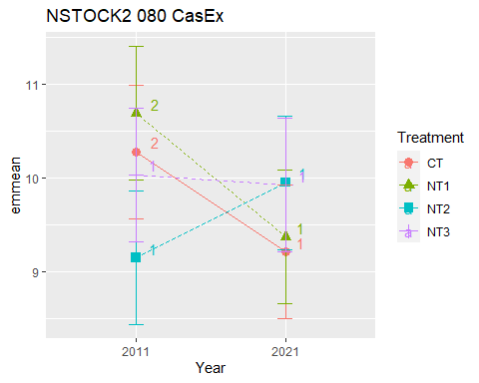

## [1] "NSTOCK2 0100 Cumulated CasEx"  
## [1] "Normality"

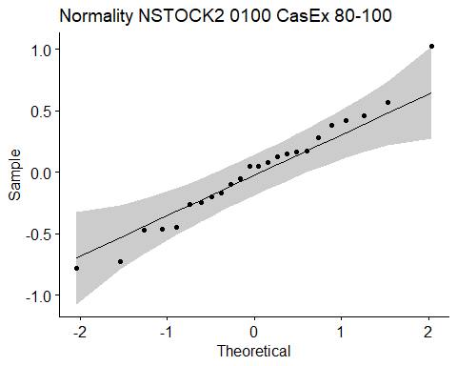

## [1] "Shapiro test for normality"  
## # A tibble: 1 × 3  
## variable statistic p.value  
## <chr> <dbl> <dbl>  
## 1 residuals(model) 0.982 0.929  
## [1] "Homoscedasticity"

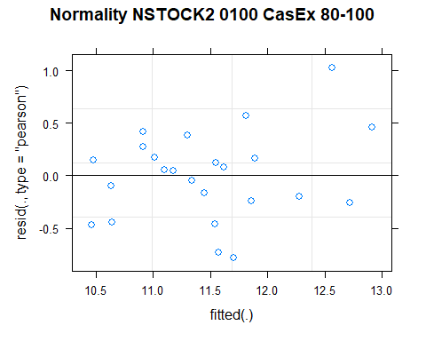

## [1] "Levene test for homoscedasticity"  
## # A tibble: 1 × 4  
## df1 df2 statistic p  
## <int> <int> <dbl> <dbl>  
## 1 7 16 0.501 0.820  
## [1] "ANOVA"  
## Treatment = CT:  
## Year emmean SE df lower.CL upper.CL .group  
## 2021 10.8 0.42 14.3 9.92 11.7 1   
## 2011 12.0 0.42 14.3 11.14 12.9 2   
##   
## Treatment = NT1:  
## Year emmean SE df lower.CL upper.CL .group  
## 2021 10.8 0.42 14.3 9.92 11.7 1   
## 2011 12.6 0.42 14.3 11.74 13.5 2   
##   
## Treatment = NT2:  
## Year emmean SE df lower.CL upper.CL .group  
## 2011 10.9 0.42 14.3 9.95 11.8 1   
## 2021 11.4 0.42 14.3 10.49 12.3 1   
##   
## Treatment = NT3:  
## Year emmean SE df lower.CL upper.CL .group  
## 2021 11.5 0.42 14.3 10.59 12.4 1   
## 2011 11.8 0.42 14.3 10.86 12.7 1   
##   
## Degrees-of-freedom method: kenward-roger   
## Results are given on the [ (not the response) scale.   
## Confidence level used: 0.95   
## Note: contrasts are still on the [ scale   
## significance level used: alpha = 0.05   
## NOTE: If two or more means share the same grouping symbol,  
## then we cannot show them to be different.  
## But we also did not show them to be the same.   
## Year = 2011:  
## Treatment emmean SE df lower.CL upper.CL .group  
## NT2 10.9 0.42 14.3 9.95 11.8 1   
## NT3 11.8 0.42 14.3 10.86 12.7 12   
## CT 12.0 0.42 14.3 11.14 12.9 12   
## NT1 12.6 0.42 14.3 11.74 13.5 2   
##   
## Year = 2021:  
## Treatment emmean SE df lower.CL upper.CL .group  
## CT 10.8 0.42 14.3 9.92 11.7 1   
## NT1 10.8 0.42 14.3 9.92 11.7 1   
## NT2 11.4 0.42 14.3 10.49 12.3 1   
## NT3 11.5 0.42 14.3 10.59 12.4 1   
##   
## Degrees-of-freedom method: kenward-roger   
## Results are given on the [ (not the response) scale.   
## Confidence level used: 0.95   
## Note: contrasts are still on the [ scale   
## P value adjustment: tukey method for comparing a family of 4 estimates   
## significance level used: alpha = 0.05   
## NOTE: If two or more means share the same grouping symbol,  
## then we cannot show them to be different.  
## But we also did not show them to be the same.   
## [1] "ANOVA Plot"

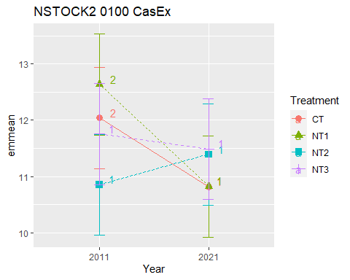

## [1] "CSTOCK2"

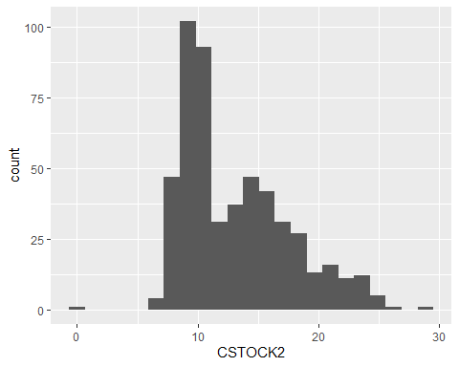

## [1] "CSTOCK2 MaiEx"  
## # A tibble: 56 × 7  
## Treatment Depth Year variable n mean sd  
## <fct> <fct> <fct> <chr> <dbl> <dbl> <dbl>  
## 1 CT 0-5 2011 CSTOCK2 3 9.83 0.618  
## 2 NT1 0-5 2011 CSTOCK2 3 9.29 0.469  
## 3 NT2 0-5 2011 CSTOCK2 3 9.65 0.268  
## 4 NT3 0-5 2011 CSTOCK2 3 9.47 0.71   
## 5 CT 5-10 2011 CSTOCK2 3 9.21 0.362  
## 6 NT1 5-10 2011 CSTOCK2 3 8.55 0.099  
## 7 NT2 5-10 2011 CSTOCK2 3 8.63 0.042  
## 8 NT3 5-10 2011 CSTOCK2 3 8.41 0.887  
## 9 CT 10-20 2011 CSTOCK2 3 16.0 0.908  
## 10 NT1 10-20 2011 CSTOCK2 3 15.3 0.758  
## # … with 46 more rows  
## [1] "CSTOCK2 MaiEx 0-5"

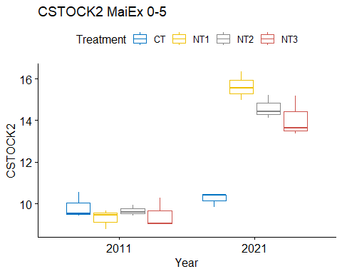

## [1] "Normality"

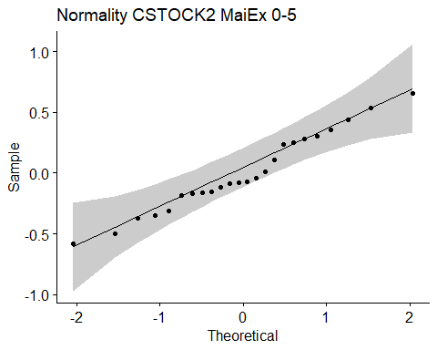

## [1] "Shapiro test for normality"  
## # A tibble: 1 × 3  
## variable statistic p.value  
## <chr> <dbl> <dbl>  
## 1 residuals(model) 0.972 0.721  
## [1] "Homoscedasticity"

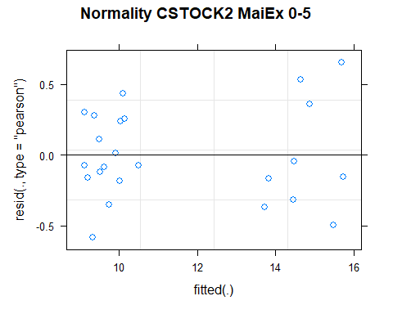

## [1] "Levene test for homoscedasticity"  
## # A tibble: 1 × 4  
## df1 df2 statistic p  
## <int> <int> <dbl> <dbl>  
## 1 7 16 0.228 0.972  
## [1] "ANOVA"  
## Treatment = CT:  
## Year emmean SE df lower.CL upper.CL .group  
## 2011 9.83 0.355 13.5 9.07 10.6 1   
## 2021 10.23 0.355 13.5 9.46 11.0 1   
##   
## Treatment = NT1:  
## Year emmean SE df lower.CL upper.CL .group  
## 2011 9.29 0.355 13.5 8.52 10.1 1   
## 2021 15.62 0.355 13.5 14.86 16.4 2   
##   
## Treatment = NT2:  
## Year emmean SE df lower.CL upper.CL .group  
## 2011 9.65 0.355 13.5 8.89 10.4 1   
## 2021 14.60 0.355 13.5 13.83 15.4 2   
##   
## Treatment = NT3:  
## Year emmean SE df lower.CL upper.CL .group  
## 2011 9.47 0.355 13.5 8.71 10.2 1   
## 2021 14.06 0.355 13.5 13.30 14.8 2   
##   
## Degrees-of-freedom method: kenward-roger   
## Results are given on the [ (not the response) scale.   
## Confidence level used: 0.95   
## Note: contrasts are still on the [ scale   
## significance level used: alpha = 0.05   
## NOTE: If two or more means share the same grouping symbol,  
## then we cannot show them to be different.  
## But we also did not show them to be the same.   
## Year = 2011:  
## Treatment emmean SE df lower.CL upper.CL .group  
## NT1 9.29 0.355 13.5 8.52 10.1 1   
## NT3 9.47 0.355 13.5 8.71 10.2 1   
## NT2 9.65 0.355 13.5 8.89 10.4 1   
## CT 9.83 0.355 13.5 9.07 10.6 1   
##   
## Year = 2021:  
## Treatment emmean SE df lower.CL upper.CL .group  
## CT 10.23 0.355 13.5 9.46 11.0 1   
## NT3 14.06 0.355 13.5 13.30 14.8 2   
## NT2 14.60 0.355 13.5 13.83 15.4 23   
## NT1 15.62 0.355 13.5 14.86 16.4 3   
##   
## Degrees-of-freedom method: kenward-roger   
## Results are given on the [ (not the response) scale.   
## Confidence level used: 0.95   
## Note: contrasts are still on the [ scale   
## P value adjustment: tukey method for comparing a family of 4 estimates   
## significance level used: alpha = 0.05   
## NOTE: If two or more means share the same grouping symbol,  
## then we cannot show them to be different.  
## But we also did not show them to be the same.   
## [1] "ANOVA plot"

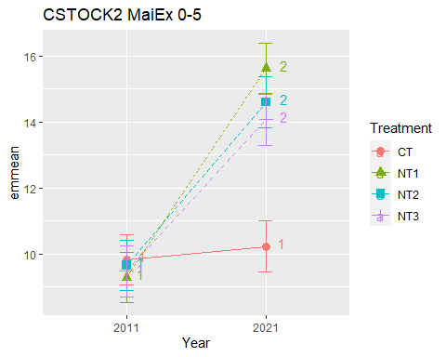

## [1] "CSTOCK2 MaiEx 5-10"

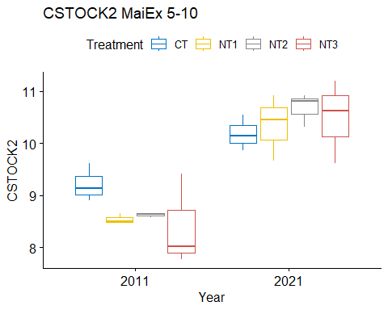

## [1] "Normality"

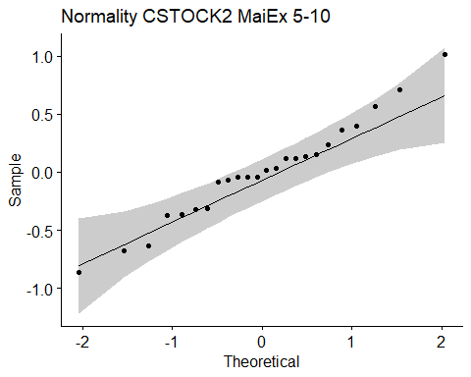

## [1] "Shapiro test for normality"  
## # A tibble: 1 × 3  
## variable statistic p.value  
## <chr> <dbl> <dbl>  
## 1 residuals(model) 0.978 0.862  
## [1] "Homoscedasticity"

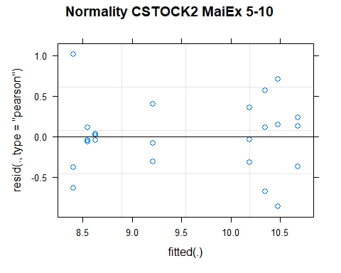

## [1] "Levene test for homoscedasticity"  
## # A tibble: 1 × 4  
## df1 df2 statistic p  
## <int> <int> <dbl> <dbl>  
## 1 7 16 0.825 0.581  
## [1] "ANOVA"  
## Treatment = CT:  
## Year emmean SE df lower.CL upper.CL .group  
## 2011 9.21 0.301 16 8.57 9.85 1   
## 2021 10.19 0.301 16 9.55 10.83 1   
##   
## Treatment = NT1:  
## Year emmean SE df lower.CL upper.CL .group  
## 2011 8.55 0.301 16 7.91 9.19 1   
## 2021 10.35 0.301 16 9.71 10.99 2   
##   
## Treatment = NT2:  
## Year emmean SE df lower.CL upper.CL .group  
## 2011 8.63 0.301 16 7.99 9.27 1   
## 2021 10.68 0.301 16 10.04 11.32 2   
##   
## Treatment = NT3:  
## Year emmean SE df lower.CL upper.CL .group  
## 2011 8.41 0.301 16 7.77 9.05 1   
## 2021 10.48 0.301 16 9.84 11.12 2   
##   
## Degrees-of-freedom method: kenward-roger   
## Results are given on the [ (not the response) scale.   
## Confidence level used: 0.95   
## Note: contrasts are still on the [ scale   
## significance level used: alpha = 0.05   
## NOTE: If two or more means share the same grouping symbol,  
## then we cannot show them to be different.  
## But we also did not show them to be the same.   
## Year = 2011:  
## Treatment emmean SE df lower.CL upper.CL .group  
## NT3 8.41 0.301 16 7.77 9.05 1   
## NT1 8.55 0.301 16 7.91 9.19 1   
## NT2 8.63 0.301 16 7.99 9.27 1   
## CT 9.21 0.301 16 8.57 9.85 1   
##   
## Year = 2021:  
## Treatment emmean SE df lower.CL upper.CL .group  
## CT 10.19 0.301 16 9.55 10.83 1   
## NT1 10.35 0.301 16 9.71 10.99 1   
## NT3 10.48 0.301 16 9.84 11.12 1   
## NT2 10.68 0.301 16 10.04 11.32 1   
##   
## Degrees-of-freedom method: kenward-roger   
## Results are given on the [ (not the response) scale.   
## Confidence level used: 0.95   
## Note: contrasts are still on the [ scale   
## P value adjustment: tukey method for comparing a family of 4 estimates   
## significance level used: alpha = 0.05   
## NOTE: If two or more means share the same grouping symbol,  
## then we cannot show them to be different.  
## But we also did not show them to be the same.   
## [1] "ANOVA plot"

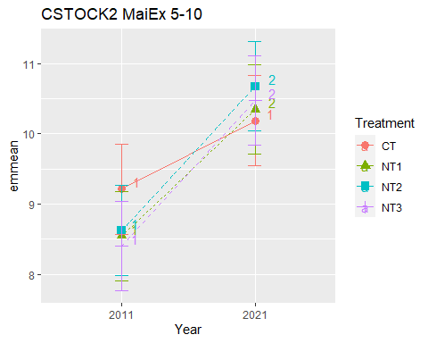

## [1] "CSTOCK2 MaiEx 10-20"

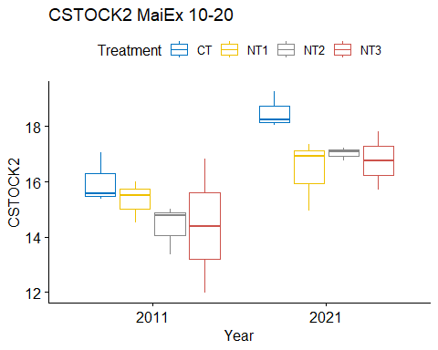

## [1] "Normality"

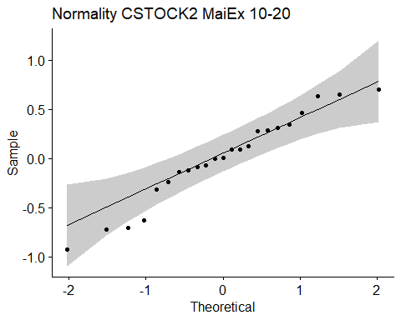

## [1] "Shapiro test for normality"  
## # A tibble: 1 × 3  
## variable statistic p.value  
## <chr> <dbl> <dbl>  
## 1 residuals(model) 0.960 0.459  
## [1] "Homoscedasticity"

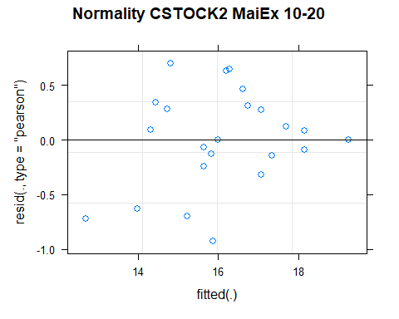

## [1] "Levene test for homoscedasticity"  
## # A tibble: 1 × 4  
## df1 df2 statistic p  
## <int> <int> <dbl> <dbl>  
## 1 7 15 0.933 0.510  
## [1] "ANOVA"  
## Treatment = CT:  
## Year emmean SE df lower.CL upper.CL .group  
## 2011 16.0 0.763 10.4 14.3 17.7 1   
## 2021 18.5 0.763 10.4 16.8 20.2 2   
##   
## Treatment = NT1:  
## Year emmean SE df lower.CL upper.CL .group  
## 2011 15.3 0.763 10.4 13.6 17.0 1   
## 2021 16.4 0.763 10.4 14.7 18.1 1   
##   
## Treatment = NT2:  
## Year emmean SE df lower.CL upper.CL .group  
## 2011 14.4 0.763 10.4 12.7 16.1 1   
## 2021 17.0 0.763 10.4 15.3 18.7 2   
##   
## Treatment = NT3:  
## Year emmean SE df lower.CL upper.CL .group  
## 2011 14.4 0.763 10.4 12.7 16.1 1   
## 2021 15.9 0.865 13.1 14.0 17.8 1   
##   
## Degrees-of-freedom method: kenward-roger   
## Results are given on the [ (not the response) scale.   
## Confidence level used: 0.95   
## Note: contrasts are still on the [ scale   
## significance level used: alpha = 0.05   
## NOTE: If two or more means share the same grouping symbol,  
## then we cannot show them to be different.  
## But we also did not show them to be the same.   
## Year = 2011:  
## Treatment emmean SE df lower.CL upper.CL .group  
## NT2 14.4 0.763 10.4 12.7 16.1 1   
## NT3 14.4 0.763 10.4 12.7 16.1 1   
## NT1 15.3 0.763 10.4 13.6 17.0 1   
## CT 16.0 0.763 10.4 14.3 17.7 1   
##   
## Year = 2021:  
## Treatment emmean SE df lower.CL upper.CL .group  
## NT3 15.9 0.865 13.1 14.0 17.8 1   
## NT1 16.4 0.763 10.4 14.7 18.1 1   
## NT2 17.0 0.763 10.4 15.3 18.7 1   
## CT 18.5 0.763 10.4 16.8 20.2 1   
##   
## Degrees-of-freedom method: kenward-roger   
## Results are given on the [ (not the response) scale.   
## Confidence level used: 0.95   
## Note: contrasts are still on the [ scale   
## P value adjustment: tukey method for comparing a family of 4 estimates   
## significance level used: alpha = 0.05   
## NOTE: If two or more means share the same grouping symbol,  
## then we cannot show them to be different.  
## But we also did not show them to be the same.   
## [1] "ANOVA plot"

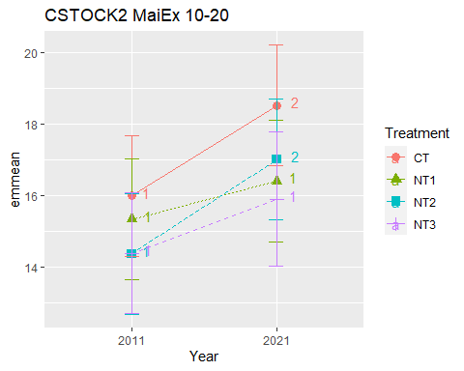

## [1] "CSTOCK2 MaiEx 20-40"

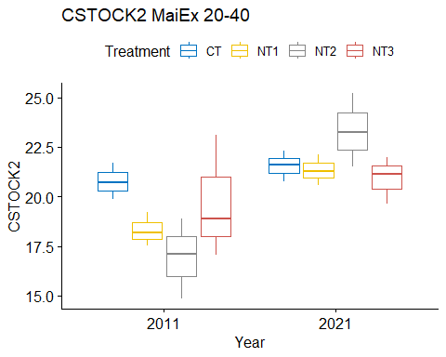

## [1] "Normality"

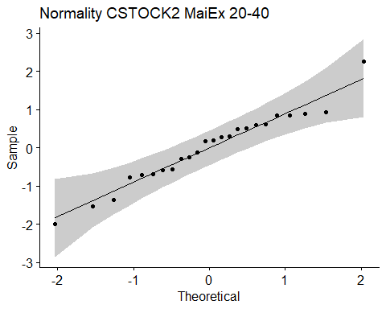

## [1] "Shapiro test for normality"  
## # A tibble: 1 × 3  
## variable statistic p.value  
## <chr> <dbl> <dbl>  
## 1 residuals(model) 0.970 0.672  
## [1] "Homoscedasticity"

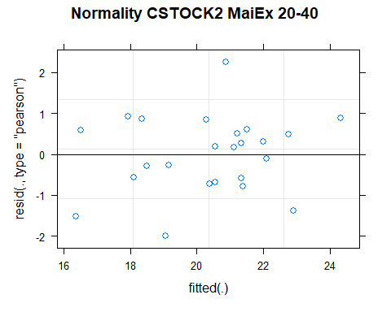

## [1] "Levene test for homoscedasticity"  
## # A tibble: 1 × 4  
## df1 df2 statistic p  
## <int> <int> <dbl> <dbl>  
## 1 7 16 0.820 0.585  
## [1] "ANOVA"  
## Treatment = CT:  
## Year emmean SE df lower.CL upper.CL .group  
## 2011 20.8 0.941 14.2 18.8 22.8 1   
## 2021 21.6 0.941 14.2 19.5 23.6 1   
##   
## Treatment = NT1:  
## Year emmean SE df lower.CL upper.CL .group  
## 2011 18.3 0.941 14.2 16.3 20.3 1   
## 2021 21.3 0.941 14.2 19.3 23.3 2   
##   
## Treatment = NT2:  
## Year emmean SE df lower.CL upper.CL .group  
## 2011 16.9 0.941 14.2 14.9 19.0 1   
## 2021 23.3 0.941 14.2 21.3 25.3 2   
##   
## Treatment = NT3:  
## Year emmean SE df lower.CL upper.CL .group  
## 2011 19.7 0.941 14.2 17.7 21.7 1   
## 2021 20.9 0.941 14.2 18.9 22.9 1   
##   
## Degrees-of-freedom method: kenward-roger   
## Results are given on the [ (not the response) scale.   
## Confidence level used: 0.95   
## Note: contrasts are still on the [ scale   
## significance level used: alpha = 0.05   
## NOTE: If two or more means share the same grouping symbol,  
## then we cannot show them to be different.  
## But we also did not show them to be the same.   
## Year = 2011:  
## Treatment emmean SE df lower.CL upper.CL .group  
## NT2 16.9 0.941 14.2 14.9 19.0 1   
## NT1 18.3 0.941 14.2 16.3 20.3 1   
## NT3 19.7 0.941 14.2 17.7 21.7 1   
## CT 20.8 0.941 14.2 18.8 22.8 1   
##   
## Year = 2021:  
## Treatment emmean SE df lower.CL upper.CL .group  
## NT3 20.9 0.941 14.2 18.9 22.9 1   
## NT1 21.3 0.941 14.2 19.3 23.3 1   
## CT 21.6 0.941 14.2 19.5 23.6 1   
## NT2 23.3 0.941 14.2 21.3 25.3 1   
##   
## Degrees-of-freedom method: kenward-roger   
## Results are given on the [ (not the response) scale.   
## Confidence level used: 0.95   
## Note: contrasts are still on the [ scale   
## P value adjustment: tukey method for comparing a family of 4 estimates   
## significance level used: alpha = 0.05   
## NOTE: If two or more means share the same grouping symbol,  
## then we cannot show them to be different.  
## But we also did not show them to be the same.   
## [1] "ANOVA plot"

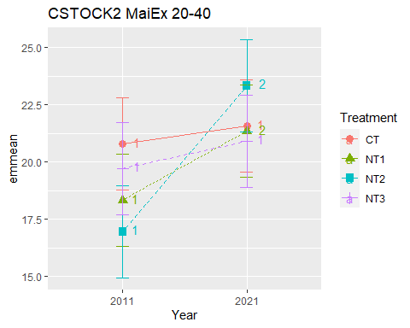

## [1] "CSTOCK2 MaiEx 40-60"

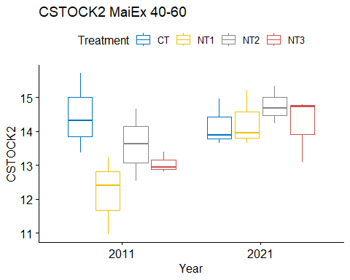

## [1] "Normality"

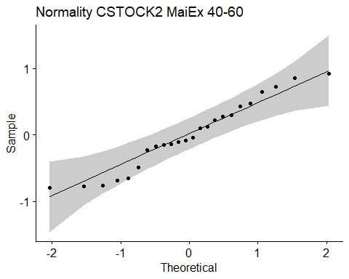

## [1] "Shapiro test for normality"  
## # A tibble: 1 × 3  
## variable statistic p.value  
## <chr> <dbl> <dbl>  
## 1 residuals(model) 0.954 0.336  
## [1] "Homoscedasticity"

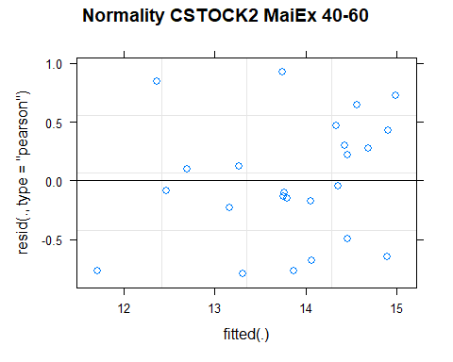

## [1] "Levene test for homoscedasticity"  
## # A tibble: 1 × 4  
## df1 df2 statistic p  
## <int> <int> <dbl> <dbl>  
## 1 7 16 0.319 0.934  
## [1] "ANOVA"  
## Treatment = CT:  
## Year emmean SE df lower.CL upper.CL .group  
## 2021 14.2 0.514 14.3 13.1 15.3 1   
## 2011 14.5 0.514 14.3 13.4 15.6 1   
##   
## Treatment = NT1:  
## Year emmean SE df lower.CL upper.CL .group  
## 2011 12.2 0.514 14.3 11.1 13.3 1   
## 2021 14.3 0.514 14.3 13.2 15.4 2   
##   
## Treatment = NT2:  
## Year emmean SE df lower.CL upper.CL .group  
## 2011 13.6 0.514 14.3 12.5 14.7 1   
## 2021 14.8 0.514 14.3 13.7 15.8 1   
##   
## Treatment = NT3:  
## Year emmean SE df lower.CL upper.CL .group  
## 2011 13.0 0.514 14.3 11.9 14.1 1   
## 2021 14.2 0.514 14.3 13.1 15.3 1   
##   
## Degrees-of-freedom method: kenward-roger   
## Results are given on the [ (not the response) scale.   
## Confidence level used: 0.95   
## Note: contrasts are still on the [ scale   
## significance level used: alpha = 0.05   
## NOTE: If two or more means share the same grouping symbol,  
## then we cannot show them to be different.  
## But we also did not show them to be the same.   
## Year = 2011:  
## Treatment emmean SE df lower.CL upper.CL .group  
## NT1 12.2 0.514 14.3 11.1 13.3 1   
## NT3 13.0 0.514 14.3 11.9 14.1 12   
## NT2 13.6 0.514 14.3 12.5 14.7 12   
## CT 14.5 0.514 14.3 13.4 15.6 2   
##   
## Year = 2021:  
## Treatment emmean SE df lower.CL upper.CL .group  
## CT 14.2 0.514 14.3 13.1 15.3 1   
## NT3 14.2 0.514 14.3 13.1 15.3 1   
## NT1 14.3 0.514 14.3 13.2 15.4 1   
## NT2 14.8 0.514 14.3 13.7 15.8 1   
##   
## Degrees-of-freedom method: kenward-roger   
## Results are given on the [ (not the response) scale.   
## Confidence level used: 0.95   
## Note: contrasts are still on the [ scale   
## P value adjustment: tukey method for comparing a family of 4 estimates   
## significance level used: alpha = 0.05   
## NOTE: If two or more means share the same grouping symbol,  
## then we cannot show them to be different.  
## But we also did not show them to be the same.   
## [1] "ANOVA plot"

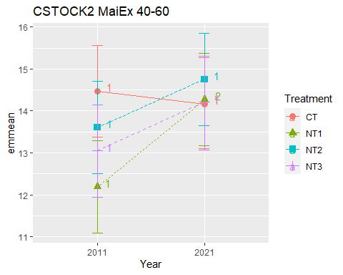

## [1] "CSTOCK2 MaiEx 60-80"

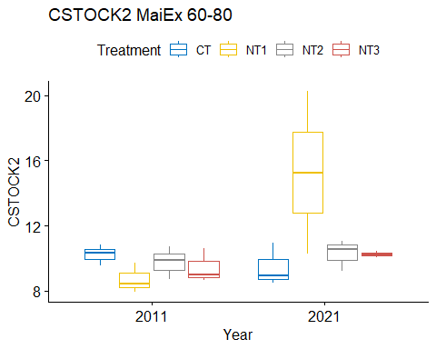

## [1] "Normality"

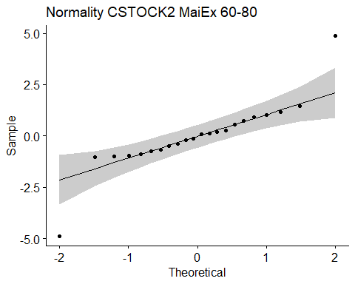

## [1] "Shapiro test for normality"  
## # A tibble: 1 × 3  
## variable statistic p.value  
## <chr> <dbl> <dbl>  
## 1 residuals(model) 0.836 0.00196  
## [1] "Homoscedasticity"

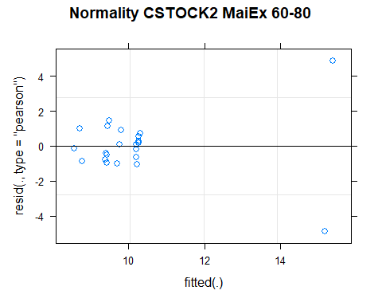

## [1] "Levene test for homoscedasticity"  
## # A tibble: 1 × 4  
## df1 df2 statistic p  
## <int> <int> <dbl> <dbl>  
## 1 7 14 11.0 0.0000960  
## [1] "ANOVA"  
## Treatment = CT:  
## Year emmean SE df lower.CL upper.CL .group  
## 2021 9.46 1.21 14 6.85 12.1 1   
## 2011 10.23 1.21 14 7.63 12.8 1   
##   
## Treatment = NT1:  
## Year emmean SE df lower.CL upper.CL .group  
## 2011 8.70 1.21 14 6.09 11.3 1   
## 2021 15.28 1.57 14 11.92 18.6 2   
##   
## Treatment = NT2:  
## Year emmean SE df lower.CL upper.CL .group  
## 2011 9.76 1.21 14 7.16 12.4 1   
## 2021 10.27 1.21 14 7.67 12.9 1   
##   
## Treatment = NT3:  
## Year emmean SE df lower.CL upper.CL .group  
## 2011 9.42 1.21 14 6.81 12.0 1   
## 2021 10.24 1.57 14 6.88 13.6 1   
##   
## Degrees-of-freedom method: kenward-roger   
## Results are given on the [ (not the response) scale.   
## Confidence level used: 0.95   
## Note: contrasts are still on the [ scale   
## significance level used: alpha = 0.05   
## NOTE: If two or more means share the same grouping symbol,  
## then we cannot show them to be different.  
## But we also did not show them to be the same.   
## Year = 2011:  
## Treatment emmean SE df lower.CL upper.CL .group  
## NT1 8.70 1.21 14 6.09 11.3 1   
## NT3 9.42 1.21 14 6.81 12.0 1   
## NT2 9.76 1.21 14 7.16 12.4 1   
## CT 10.23 1.21 14 7.63 12.8 1   
##   
## Year = 2021:  
## Treatment emmean SE df lower.CL upper.CL .group  
## CT 9.46 1.21 14 6.85 12.1 1   
## NT3 10.24 1.57 14 6.88 13.6 12   
## NT2 10.27 1.21 14 7.67 12.9 12   
## NT1 15.28 1.57 14 11.92 18.6 2   
##   
## Degrees-of-freedom method: kenward-roger   
## Results are given on the [ (not the response) scale.   
## Confidence level used: 0.95   
## Note: contrasts are still on the [ scale   
## P value adjustment: tukey method for comparing a family of 4 estimates   
## significance level used: alpha = 0.05   
## NOTE: If two or more means share the same grouping symbol,  
## then we cannot show them to be different.  
## But we also did not show them to be the same.   
## [1] "ANOVA plot"

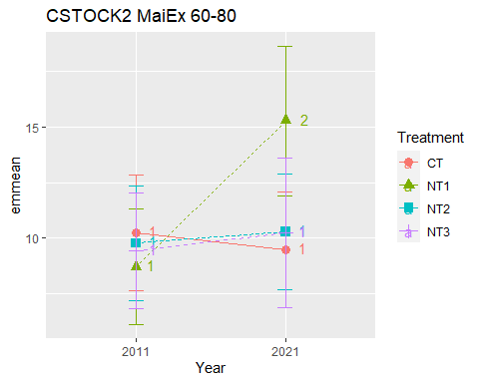

## [1] "CSTOCK2 MaiEx 80-100"

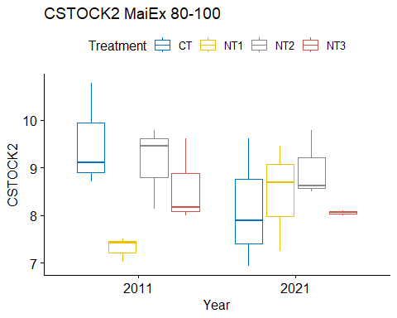

## [1] "Normality"

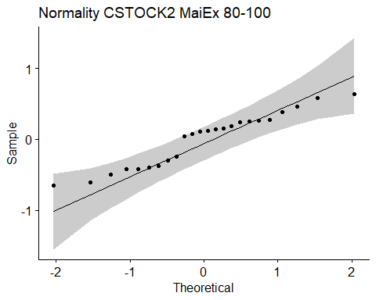

## [1] "Shapiro test for normality"  
## # A tibble: 1 × 3  
## variable statistic p.value  
## <chr> <dbl> <dbl>  
## 1 residuals(model) 0.937 0.143  
## [1] "Homoscedasticity"

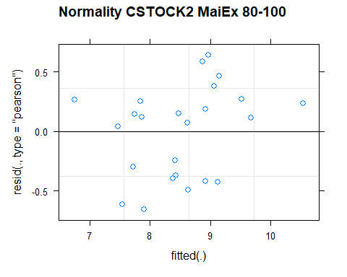

## [1] "Levene test for homoscedasticity"  
## # A tibble: 1 × 4  
## df1 df2 statistic p  
## <int> <int> <dbl> <dbl>  
## 1 7 16 0.565 0.774  
## [1] "ANOVA"  
## Treatment = CT:  
## Year emmean SE df lower.CL upper.CL .group  
## 2021 8.15 0.517 11.9 7.02 9.28 1   
## 2011 9.53 0.517 11.9 8.40 10.66 2   
##   
## Treatment = NT1:  
## Year emmean SE df lower.CL upper.CL .group  
## 2011 7.32 0.517 11.9 6.19 8.45 1   
## 2021 8.46 0.517 11.9 7.33 9.59 2   
##   
## Treatment = NT2:  
## Year emmean SE df lower.CL upper.CL .group  
## 2021 8.97 0.517 11.9 7.84 10.10 1   
## 2011 9.12 0.517 11.9 7.99 10.25 1   
##   
## Treatment = NT3:  
## Year emmean SE df lower.CL upper.CL .group  
## 2021 8.05 0.517 11.9 6.92 9.18 1   
## 2011 8.59 0.517 11.9 7.46 9.72 1   
##   
## Degrees-of-freedom method: kenward-roger   
## Results are given on the [ (not the response) scale.   
## Confidence level used: 0.95   
## Note: contrasts are still on the [ scale   
## significance level used: alpha = 0.05   
## NOTE: If two or more means share the same grouping symbol,  
## then we cannot show them to be different.  
## But we also did not show them to be the same.   
## Year = 2011:  
## Treatment emmean SE df lower.CL upper.CL .group  
## NT1 7.32 0.517 11.9 6.19 8.45 1   
## NT3 8.59 0.517 11.9 7.46 9.72 12   
## NT2 9.12 0.517 11.9 7.99 10.25 12   
## CT 9.53 0.517 11.9 8.40 10.66 2   
##   
## Year = 2021:  
## Treatment emmean SE df lower.CL upper.CL .group  
## NT3 8.05 0.517 11.9 6.92 9.18 1   
## CT 8.15 0.517 11.9 7.02 9.28 1   
## NT1 8.46 0.517 11.9 7.33 9.59 1   
## NT2 8.97 0.517 11.9 7.84 10.10 1   
##   
## Degrees-of-freedom method: kenward-roger   
## Results are given on the [ (not the response) scale.   
## Confidence level used: 0.95   
## Note: contrasts are still on the [ scale   
## P value adjustment: tukey method for comparing a family of 4 estimates   
## significance level used: alpha = 0.05   
## NOTE: If two or more means share the same grouping symbol,  
## then we cannot show them to be different.  
## But we also did not show them to be the same.   
## [1] "ANOVA plot"

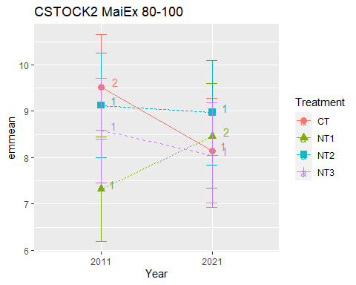

## [1] "CSTOCK2 010 Cumulated MaiEx"  
## [1] "Normality"

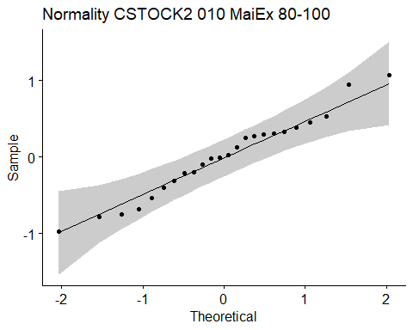

## [1] "Shapiro test for normality"  
## # A tibble: 1 × 3  
## variable statistic p.value  
## <chr> <dbl> <dbl>  
## 1 residuals(model) 0.977 0.826  
## [1] "Homoscedasticity"

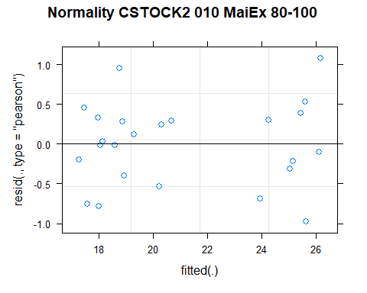

## [1] "Levene test for homoscedasticity"  
## # A tibble: 1 × 4  
## df1 df2 statistic p  
## <int> <int> <dbl> <dbl>  
## 1 7 16 0.518 0.808  
## [1] "ANOVA"  
## Treatment = CT:  
## Year emmean SE df lower.CL upper.CL .group  
## 2011 19.0 0.556 13.8 17.8 20.2 1   
## 2021 20.4 0.556 13.8 19.2 21.6 1   
##   
## Treatment = NT1:  
## Year emmean SE df lower.CL upper.CL .group  
## 2011 17.8 0.556 13.8 16.6 19.0 1   
## 2021 26.0 0.556 13.8 24.8 27.2 2   
##   
## Treatment = NT2:  
## Year emmean SE df lower.CL upper.CL .group  
## 2011 18.3 0.556 13.8 17.1 19.5 1   
## 2021 25.3 0.556 13.8 24.1 26.5 2   
##   
## Treatment = NT3:  
## Year emmean SE df lower.CL upper.CL .group  
## 2011 17.9 0.556 13.8 16.7 19.1 1   
## 2021 24.5 0.556 13.8 23.3 25.7 2   
##   
## Degrees-of-freedom method: kenward-roger   
## Results are given on the [ (not the response) scale.   
## Confidence level used: 0.95   
## Note: contrasts are still on the [ scale   
## significance level used: alpha = 0.05   
## NOTE: If two or more means share the same grouping symbol,  
## then we cannot show them to be different.  
## But we also did not show them to be the same.   
## Year = 2011:  
## Treatment emmean SE df lower.CL upper.CL .group  
## NT1 17.8 0.556 13.8 16.6 19.0 1   
## NT3 17.9 0.556 13.8 16.7 19.1 1   
## NT2 18.3 0.556 13.8 17.1 19.5 1   
## CT 19.0 0.556 13.8 17.8 20.2 1   
##   
## Year = 2021:  
## Treatment emmean SE df lower.CL upper.CL .group  
## CT 20.4 0.556 13.8 19.2 21.6 1   
## NT3 24.5 0.556 13.8 23.3 25.7 2   
## NT2 25.3 0.556 13.8 24.1 26.5 2   
## NT1 26.0 0.556 13.8 24.8 27.2 2   
##   
## Degrees-of-freedom method: kenward-roger   
## Results are given on the [ (not the response) scale.   
## Confidence level used: 0.95   
## Note: contrasts are still on the [ scale   
## P value adjustment: tukey method for comparing a family of 4 estimates   
## significance level used: alpha = 0.05   
## NOTE: If two or more means share the same grouping symbol,  
## then we cannot show them to be different.  
## But we also did not show them to be the same.   
## [1] "ANOVA Plot"

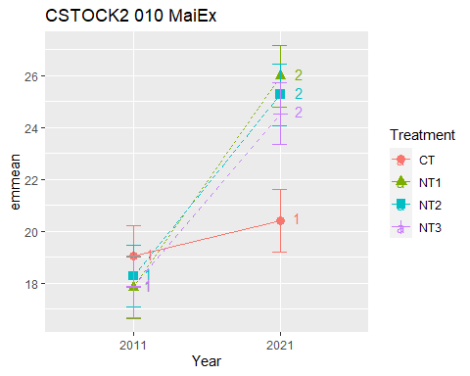

## [1] "CSTOCK2 020 Cumulated MaiEx"  
## [1] "Normality"

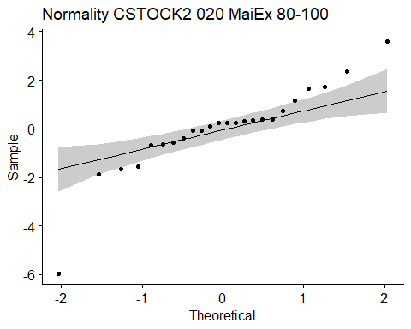

## [1] "Shapiro test for normality"  
## # A tibble: 1 × 3  
## variable statistic p.value  
## <chr> <dbl> <dbl>  
## 1 residuals(model) 0.873 0.00605  
## [1] "Homoscedasticity"

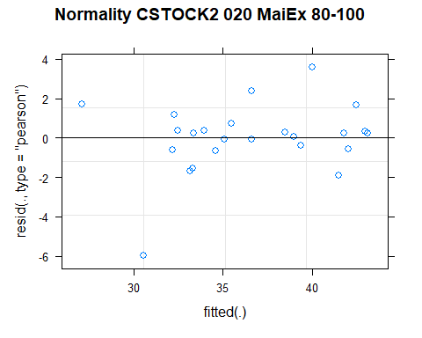

## [1] "Levene test for homoscedasticity"  
## # A tibble: 1 × 4  
## df1 df2 statistic p  
## <int> <int> <dbl> <dbl>  
## 1 7 16 1.49 0.238  
## [1] "ANOVA"  
## Treatment = CT:  
## Year emmean SE df lower.CL upper.CL .group  
## 2011 35.0 2.28 12.3 30.1 40.0 1   
## 2021 38.9 2.28 12.3 34.0 43.9 1   
##   
## Treatment = NT1:  
## Year emmean SE df lower.CL upper.CL .group  
## 2011 33.2 2.28 12.3 28.2 38.1 1   
## 2021 42.4 2.28 12.3 37.4 47.3 2   
##   
## Treatment = NT2:  
## Year emmean SE df lower.CL upper.CL .group  
## 2011 32.7 2.28 12.3 27.7 37.6 1   
## 2021 42.3 2.28 12.3 37.3 47.3 2   
##   
## Treatment = NT3:  
## Year emmean SE df lower.CL upper.CL .group  
## 2011 32.3 2.28 12.3 27.3 37.2 1   
## 2021 35.7 2.28 12.3 30.7 40.7 1   
##   
## Degrees-of-freedom method: kenward-roger   
## Results are given on the [ (not the response) scale.   
## Confidence level used: 0.95   
## Note: contrasts are still on the [ scale   
## significance level used: alpha = 0.05   
## NOTE: If two or more means share the same grouping symbol,  
## then we cannot show them to be different.  
## But we also did not show them to be the same.   
## Year = 2011:  
## Treatment emmean SE df lower.CL upper.CL .group  
## NT3 32.3 2.28 12.3 27.3 37.2 1   
## NT2 32.7 2.28 12.3 27.7 37.6 1   
## NT1 33.2 2.28 12.3 28.2 38.1 1   
## CT 35.0 2.28 12.3 30.1 40.0 1   
##   
## Year = 2021:  
## Treatment emmean SE df lower.CL upper.CL .group  
## NT3 35.7 2.28 12.3 30.7 40.7 1   
## CT 38.9 2.28 12.3 34.0 43.9 1   
## NT2 42.3 2.28 12.3 37.3 47.3 1   
## NT1 42.4 2.28 12.3 37.4 47.3 1   
##   
## Degrees-of-freedom method: kenward-roger   
## Results are given on the [ (not the response) scale.   
## Confidence level used: 0.95   
## Note: contrasts are still on the [ scale   
## P value adjustment: tukey method for comparing a family of 4 estimates   
## significance level used: alpha = 0.05   
## NOTE: If two or more means share the same grouping symbol,  
## then we cannot show them to be different.  
## But we also did not show them to be the same.   
## [1] "ANOVA Plot"

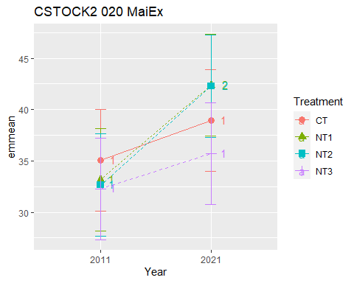

## [1] "CSTOCK2 040 Cumulated MaiEx"  
## [1] "Normality"

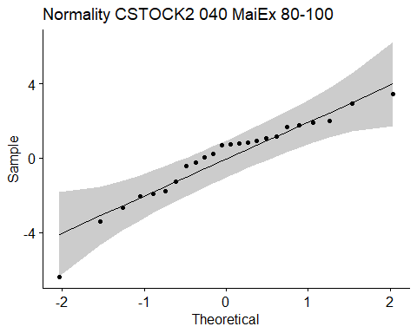

## [1] "Shapiro test for normality"  
## # A tibble: 1 × 3  
## variable statistic p.value  
## <chr> <dbl> <dbl>  
## 1 residuals(model) 0.930 0.0981  
## [1] "Homoscedasticity"

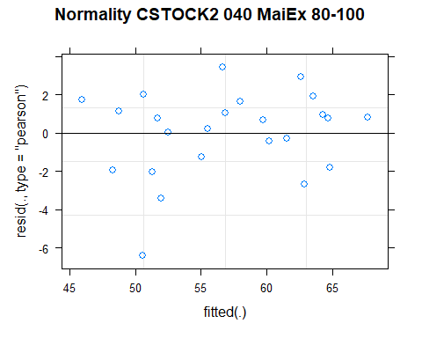

## [1] "Levene test for homoscedasticity"  
## # A tibble: 1 × 4  
## df1 df2 statistic p  
## <int> <int> <dbl> <dbl>  
## 1 7 16 0.889 0.537  
## [1] "ANOVA"  
## Treatment = CT:  
## Year emmean SE df lower.CL upper.CL .group  
## 2011 55.8 2.91 12.1 49.5 62.1 1   
## 2021 60.5 2.91 12.1 54.2 66.8 1   
##   
## Treatment = NT1:  
## Year emmean SE df lower.CL upper.CL .group  
## 2011 51.5 2.91 12.1 45.2 57.8 1   
## 2021 63.7 2.91 12.1 57.4 70.0 2   
##   
## Treatment = NT2:  
## Year emmean SE df lower.CL upper.CL .group  
## 2011 49.6 2.91 12.1 43.3 55.9 1   
## 2021 65.6 2.91 12.1 59.3 71.9 2   
##   
## Treatment = NT3:  
## Year emmean SE df lower.CL upper.CL .group  
## 2011 52.0 2.91 12.1 45.6 58.3 1   
## 2021 56.6 2.91 12.1 50.3 62.9 1   
##   
## Degrees-of-freedom method: kenward-roger   
## Results are given on the [ (not the response) scale.   
## Confidence level used: 0.95   
## Note: contrasts are still on the [ scale   
## significance level used: alpha = 0.05   
## NOTE: If two or more means share the same grouping symbol,  
## then we cannot show them to be different.  
## But we also did not show them to be the same.   
## Year = 2011:  
## Treatment emmean SE df lower.CL upper.CL .group  
## NT2 49.6 2.91 12.1 43.3 55.9 1   
## NT1 51.5 2.91 12.1 45.2 57.8 1   
## NT3 52.0 2.91 12.1 45.6 58.3 1   
## CT 55.8 2.91 12.1 49.5 62.1 1   
##   
## Year = 2021:  
## Treatment emmean SE df lower.CL upper.CL .group  
## NT3 56.6 2.91 12.1 50.3 62.9 1   
## CT 60.5 2.91 12.1 54.2 66.8 1   
## NT1 63.7 2.91 12.1 57.4 70.0 1   
## NT2 65.6 2.91 12.1 59.3 71.9 1   
##   
## Degrees-of-freedom method: kenward-roger   
## Results are given on the [ (not the response) scale.   
## Confidence level used: 0.95   
## Note: contrasts are still on the [ scale   
## P value adjustment: tukey method for comparing a family of 4 estimates   
## significance level used: alpha = 0.05   
## NOTE: If two or more means share the same grouping symbol,  
## then we cannot show them to be different.  
## But we also did not show them to be the same.   
## [1] "ANOVA Plot"

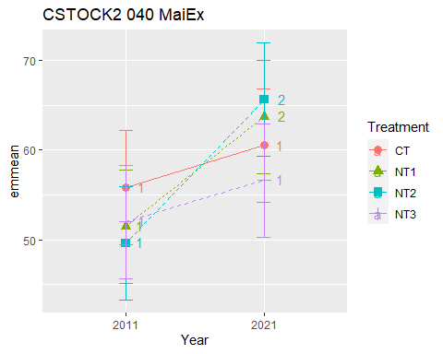

## [1] "CSTOCK2 060 Cumulated MaiEx"  
## [1] "Normality"

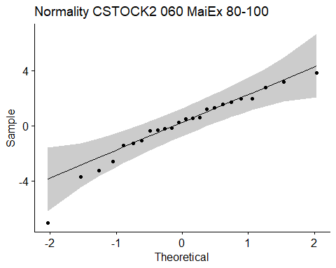

## [1] "Shapiro test for normality"  
## # A tibble: 1 × 3  
## variable statistic p.value  
## <chr> <dbl> <dbl>  
## 1 residuals(model) 0.940 0.161  
## [1] "Homoscedasticity"

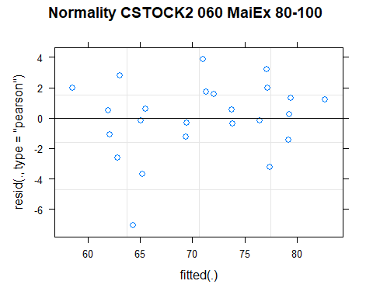

## [1] "Levene test for homoscedasticity"  
## # A tibble: 1 × 4  
## df1 df2 statistic p  
## <int> <int> <dbl> <dbl>  
## 1 7 16 0.762 0.626  
## [1] "ANOVA"  
## Treatment = CT:  
## Year emmean SE df lower.CL upper.CL .group  
## 2011 70.3 3.17 12.2 63.4 77.2 1   
## 2021 74.7 3.17 12.2 67.7 81.6 1   
##   
## Treatment = NT1:  
## Year emmean SE df lower.CL upper.CL .group  
## 2011 63.7 3.17 12.2 56.8 70.6 1   
## 2021 78.0 3.17 12.2 71.1 84.9 2   
##   
## Treatment = NT2:  
## Year emmean SE df lower.CL upper.CL .group  
## 2011 63.2 3.17 12.2 56.3 70.1 1   
## 2021 80.4 3.17 12.2 73.5 87.3 2   
##   
## Treatment = NT3:  
## Year emmean SE df lower.CL upper.CL .group  
## 2011 65.0 3.17 12.2 58.1 71.9 1   
## 2021 70.8 3.17 12.2 63.9 77.7 1   
##   
## Degrees-of-freedom method: kenward-roger   
## Results are given on the [ (not the response) scale.   
## Confidence level used: 0.95   
## Note: contrasts are still on the [ scale   
## significance level used: alpha = 0.05   
## NOTE: If two or more means share the same grouping symbol,  
## then we cannot show them to be different.  
## But we also did not show them to be the same.   
## Year = 2011:  
## Treatment emmean SE df lower.CL upper.CL .group  
## NT2 63.2 3.17 12.2 56.3 70.1 1   
## NT1 63.7 3.17 12.2 56.8 70.6 1   
## NT3 65.0 3.17 12.2 58.1 71.9 1   
## CT 70.3 3.17 12.2 63.4 77.2 1   
##   
## Year = 2021:  
## Treatment emmean SE df lower.CL upper.CL .group  
## NT3 70.8 3.17 12.2 63.9 77.7 1   
## CT 74.7 3.17 12.2 67.7 81.6 1   
## NT1 78.0 3.17 12.2 71.1 84.9 1   
## NT2 80.4 3.17 12.2 73.5 87.3 1   
##   
## Degrees-of-freedom method: kenward-roger   
## Results are given on the [ (not the response) scale.   
## Confidence level used: 0.95   
## Note: contrasts are still on the [ scale   
## P value adjustment: tukey method for comparing a family of 4 estimates   
## significance level used: alpha = 0.05   
## NOTE: If two or more means share the same grouping symbol,  
## then we cannot show them to be different.  
## But we also did not show them to be the same.   
## [1] "ANOVA Plot"

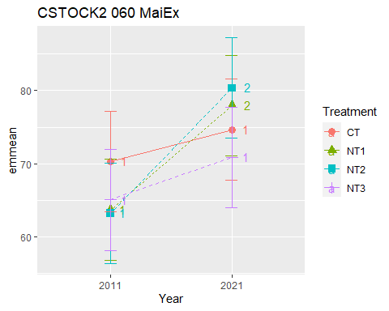

## [1] "CSTOCK2 080 Cumulated MaiEx"  
## [1] "Normality"

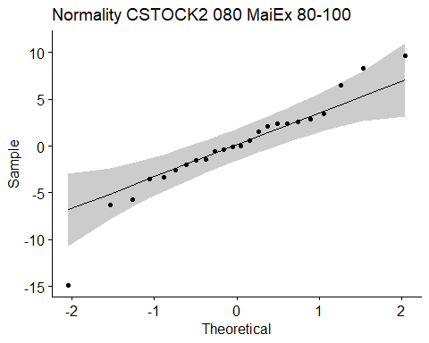

## [1] "Shapiro test for normality"  
## # A tibble: 1 × 3  
## variable statistic p.value  
## <chr> <dbl> <dbl>  
## 1 residuals(model) 0.941 0.172  
## [1] "Homoscedasticity"

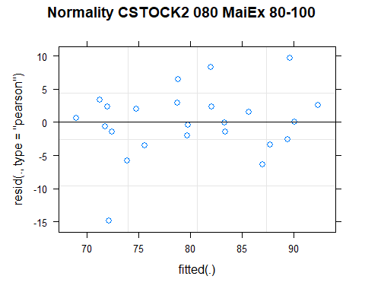

## [1] "Levene test for homoscedasticity"  
## # A tibble: 1 × 4  
## df1 df2 statistic p  
## <int> <int> <dbl> <dbl>  
## 1 7 16 0.706 0.668  
## [1] "ANOVA"  
## Treatment = CT:  
## Year emmean SE df lower.CL upper.CL .group  
## 2011 80.5 4.64 14.8 70.6 90.4 1   
## 2021 84.1 4.64 14.8 74.2 94.0 1   
##   
## Treatment = NT1:  
## Year emmean SE df lower.CL upper.CL .group  
## 2011 72.4 4.64 14.8 62.5 82.3 1   
## 2021 88.2 4.64 14.8 78.2 98.1 2   
##   
## Treatment = NT2:  
## Year emmean SE df lower.CL upper.CL .group  
## 2011 73.0 4.64 14.8 63.1 82.9 1   
## 2021 90.6 4.64 14.8 80.7 100.5 2   
##   
## Treatment = NT3:  
## Year emmean SE df lower.CL upper.CL .group  
## 2011 74.4 4.64 14.8 64.5 84.3 1   
## 2021 77.7 4.64 14.8 67.8 87.6 1   
##   
## Degrees-of-freedom method: kenward-roger   
## Results are given on the [ (not the response) scale.   
## Confidence level used: 0.95   
## Note: contrasts are still on the [ scale   
## significance level used: alpha = 0.05   
## NOTE: If two or more means share the same grouping symbol,  
## then we cannot show them to be different.  
## But we also did not show them to be the same.   
## Year = 2011:  
## Treatment emmean SE df lower.CL upper.CL .group  
## NT1 72.4 4.64 14.8 62.5 82.3 1   
## NT2 73.0 4.64 14.8 63.1 82.9 1   
## NT3 74.4 4.64 14.8 64.5 84.3 1   
## CT 80.5 4.64 14.8 70.6 90.4 1   
##   
## Year = 2021:  
## Treatment emmean SE df lower.CL upper.CL .group  
## NT3 77.7 4.64 14.8 67.8 87.6 1   
## CT 84.1 4.64 14.8 74.2 94.0 1   
## NT1 88.2 4.64 14.8 78.2 98.1 1   
## NT2 90.6 4.64 14.8 80.7 100.5 1   
##   
## Degrees-of-freedom method: kenward-roger   
## Results are given on the [ (not the response) scale.   
## Confidence level used: 0.95   
## Note: contrasts are still on the [ scale   
## P value adjustment: tukey method for comparing a family of 4 estimates   
## significance level used: alpha = 0.05   
## NOTE: If two or more means share the same grouping symbol,  
## then we cannot show them to be different.  
## But we also did not show them to be the same.   
## [1] "ANOVA Plot"

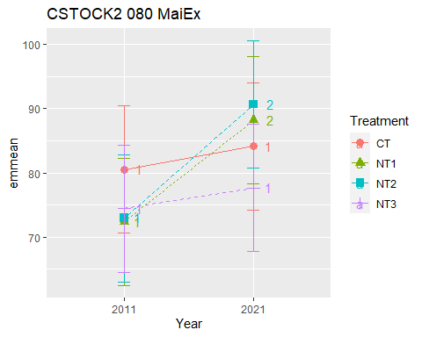

## [1] "CSTOCK2 0100 Cumulated MaiEx"  
## [1] "Normality"

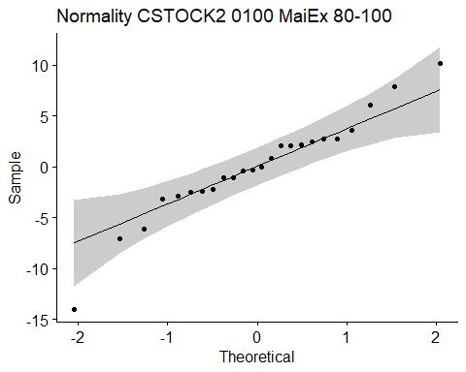

## [1] "Shapiro test for normality"  
## # A tibble: 1 × 3  
## variable statistic p.value  
## <chr> <dbl> <dbl>  
## 1 residuals(model) 0.955 0.348  
## [1] "Homoscedasticity"

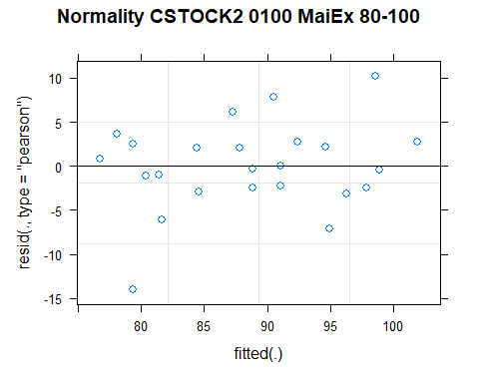

## [1] "Levene test for homoscedasticity"  
## # A tibble: 1 × 4  
## df1 df2 statistic p  
## <int> <int> <dbl> <dbl>  
## 1 7 16 0.636 0.720  
## [1] "ANOVA"  
## Treatment = CT:  
## Year emmean SE df lower.CL upper.CL .group  
## 2011 90.0 4.84 14.5 79.7 100.4 1   
## 2021 92.3 4.84 14.5 81.9 102.6 1   
##   
## Treatment = NT1:  
## Year emmean SE df lower.CL upper.CL .group  
## 2011 79.7 4.84 14.5 69.3 90.0 1   
## 2021 96.6 4.84 14.5 86.3 107.0 2   
##   
## Treatment = NT2:  
## Year emmean SE df lower.CL upper.CL .group  
## 2011 82.1 4.84 14.5 71.7 92.4 1   
## 2021 99.6 4.84 14.5 89.3 109.9 2   
##   
## Treatment = NT3:  
## Year emmean SE df lower.CL upper.CL .group  
## 2011 83.0 4.84 14.5 72.7 93.4 1   
## 2021 85.7 4.84 14.5 75.4 96.1 1   
##   
## Degrees-of-freedom method: kenward-roger   
## Results are given on the [ (not the response) scale.   
## Confidence level used: 0.95   
## Note: contrasts are still on the [ scale   
## significance level used: alpha = 0.05   
## NOTE: If two or more means share the same grouping symbol,  
## then we cannot show them to be different.  
## But we also did not show them to be the same.   
## Year = 2011:  
## Treatment emmean SE df lower.CL upper.CL .group  
## NT1 79.7 4.84 14.5 69.3 90.0 1   
## NT2 82.1 4.84 14.5 71.7 92.4 1   
## NT3 83.0 4.84 14.5 72.7 93.4 1   
## CT 90.0 4.84 14.5 79.7 100.4 1   
##   
## Year = 2021:  
## Treatment emmean SE df lower.CL upper.CL .group  
## NT3 85.7 4.84 14.5 75.4 96.1 1   
## CT 92.3 4.84 14.5 81.9 102.6 1   
## NT1 96.6 4.84 14.5 86.3 107.0 1   
## NT2 99.6 4.84 14.5 89.3 109.9 1   
##   
## Degrees-of-freedom method: kenward-roger   
## Results are given on the [ (not the response) scale.   
## Confidence level used: 0.95   
## Note: contrasts are still on the [ scale   
## P value adjustment: tukey method for comparing a family of 4 estimates   
## significance level used: alpha = 0.05   
## NOTE: If two or more means share the same grouping symbol,  
## then we cannot show them to be different.  
## But we also did not show them to be the same.   
## [1] "ANOVA Plot"

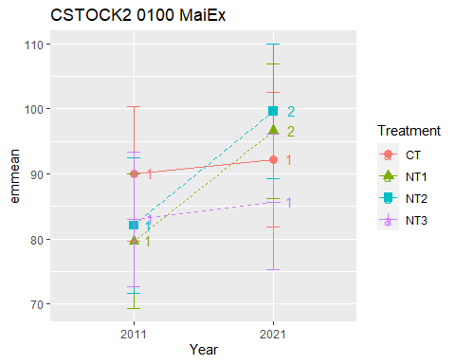

## [1] "CSTOCK2 SoyEx"  
## # A tibble: 56 × 7  
## Treatment Depth Year variable n mean sd  
## <fct> <fct> <fct> <chr> <dbl> <dbl> <dbl>  
## 1 CT 0-5 2011 CSTOCK2 3 9.62 0.38   
## 2 NT1 0-5 2011 CSTOCK2 3 9.95 0.169  
## 3 NT2 0-5 2011 CSTOCK2 3 10.4 0.29   
## 4 NT3 0-5 2011 CSTOCK2 3 10.0 0.275  
## 5 CT 5-10 2011 CSTOCK2 3 9.76 0.391  
## 6 NT1 5-10 2011 CSTOCK2 3 9.24 0.534  
## 7 NT2 5-10 2011 CSTOCK2 3 8.99 0.495  
## 8 NT3 5-10 2011 CSTOCK2 3 8.96 0.355  
## 9 CT 10-20 2011 CSTOCK2 3 17.4 0.933  
## 10 NT1 10-20 2011 CSTOCK2 3 17.3 0.799  
## # … with 46 more rows  
## [1] "CSTOCK2 SoyEx 0-5"

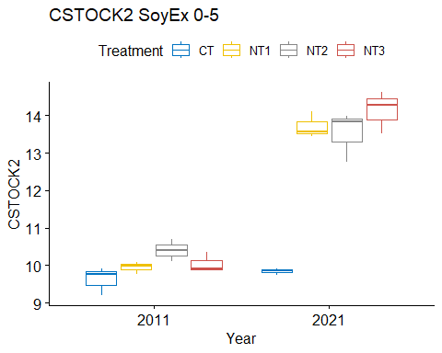

## [1] "Normality"

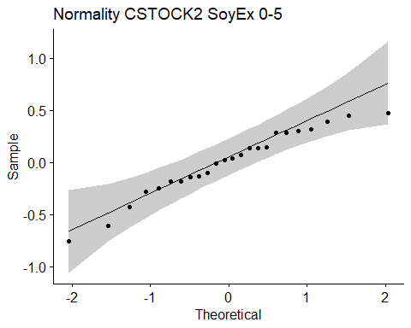

## [1] "Shapiro test for normality"  
## # A tibble: 1 × 3  
## variable statistic p.value  
## <chr> <dbl> <dbl>  
## 1 residuals(model) 0.960 0.433  
## [1] "Homoscedasticity"

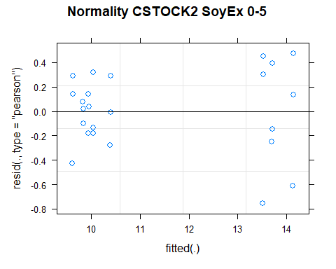

## [1] "Levene test for homoscedasticity"  
## # A tibble: 1 × 4  
## df1 df2 statistic p  
## <int> <int> <dbl> <dbl>  
## 1 7 16 0.448 0.857  
## [1] "ANOVA"  
## Treatment = CT:  
## Year emmean SE df lower.CL upper.CL .group  
## 2011 9.62 0.225 16 9.14 10.1 1   
## 2021 9.84 0.225 16 9.36 10.3 1   
##   
## Treatment = NT1:  
## Year emmean SE df lower.CL upper.CL .group  
## 2011 9.95 0.225 16 9.47 10.4 1   
## 2021 13.70 0.225 16 13.23 14.2 2   
##   
## Treatment = NT2:  
## Year emmean SE df lower.CL upper.CL .group  
## 2011 10.40 0.225 16 9.92 10.9 1   
## 2021 13.52 0.225 16 13.05 14.0 2   
##   
## Treatment = NT3:  
## Year emmean SE df lower.CL upper.CL .group  
## 2011 10.04 0.225 16 9.57 10.5 1   
## 2021 14.13 0.225 16 13.66 14.6 2   
##   
## Degrees-of-freedom method: kenward-roger   
## Results are given on the [ (not the response) scale.   
## Confidence level used: 0.95   
## Note: contrasts are still on the [ scale   
## significance level used: alpha = 0.05   
## NOTE: If two or more means share the same grouping symbol,  
## then we cannot show them to be different.  
## But we also did not show them to be the same.   
## Year = 2011:  
## Treatment emmean SE df lower.CL upper.CL .group  
## CT 9.62 0.225 16 9.14 10.1 1   
## NT1 9.95 0.225 16 9.47 10.4 1   
## NT3 10.04 0.225 16 9.57 10.5 1   
## NT2 10.40 0.225 16 9.92 10.9 1   
##   
## Year = 2021:  
## Treatment emmean SE df lower.CL upper.CL .group  
## CT 9.84 0.225 16 9.36 10.3 1   
## NT2 13.52 0.225 16 13.05 14.0 2   
## NT1 13.70 0.225 16 13.23 14.2 2   
## NT3 14.13 0.225 16 13.66 14.6 2   
##   
## Degrees-of-freedom method: kenward-roger   
## Results are given on the [ (not the response) scale.   
## Confidence level used: 0.95   
## Note: contrasts are still on the [ scale   
## P value adjustment: tukey method for comparing a family of 4 estimates   
## significance level used: alpha = 0.05   
## NOTE: If two or more means share the same grouping symbol,  
## then we cannot show them to be different.  
## But we also did not show them to be the same.   
## [1] "ANOVA plot"

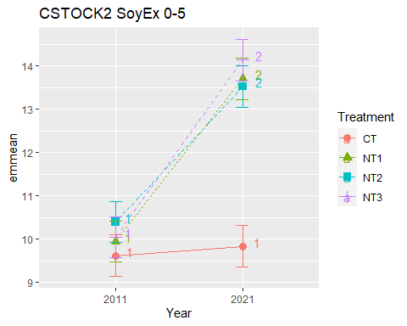

## [1] "CSTOCK2 SoyEx 5-10"

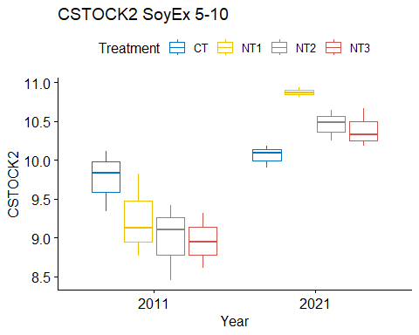

## [1] "Normality"

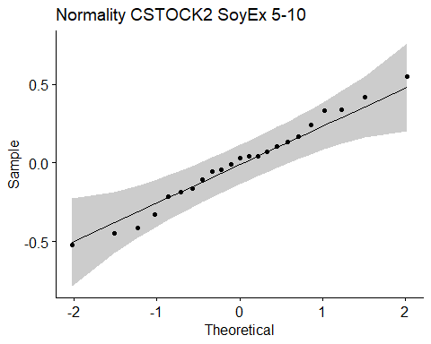

## [1] "Shapiro test for normality"  
## # A tibble: 1 × 3  
## variable statistic p.value  
## <chr> <dbl> <dbl>  
## 1 residuals(model) 0.985 0.975  
## [1] "Homoscedasticity"

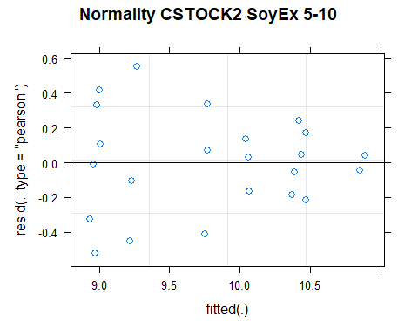

## [1] "Levene test for homoscedasticity"  
## # A tibble: 1 × 4  
## df1 df2 statistic p  
## <int> <int> <dbl> <dbl>  
## 1 7 15 0.611 0.739  
## [1] "ANOVA"  
## Treatment = CT:  
## Year emmean SE df lower.CL upper.CL .group  
## 2011 9.76 0.204 15 9.33 10.20 1   
## 2021 10.06 0.204 15 9.62 10.49 1   
##   
## Treatment = NT1:  
## Year emmean SE df lower.CL upper.CL .group  
## 2011 9.24 0.204 15 8.81 9.67 1   
## 2021 10.86 0.261 15 10.30 11.42 2   
##   
## Treatment = NT2:  
## Year emmean SE df lower.CL upper.CL .group  
## 2011 8.99 0.204 15 8.56 9.43 1   
## 2021 10.46 0.204 15 10.02 10.89 2   
##   
## Treatment = NT3:  
## Year emmean SE df lower.CL upper.CL .group  
## 2011 8.96 0.204 15 8.53 9.39 1   
## 2021 10.39 0.204 15 9.96 10.82 2   
##   
## Degrees-of-freedom method: kenward-roger   
## Results are given on the [ (not the response) scale.   
## Confidence level used: 0.95   
## Note: contrasts are still on the [ scale   
## significance level used: alpha = 0.05   
## NOTE: If two or more means share the same grouping symbol,  
## then we cannot show them to be different.  
## But we also did not show them to be the same.   
## Year = 2011:  
## Treatment emmean SE df lower.CL upper.CL .group  
## NT3 8.96 0.204 15 8.53 9.39 1   
## NT2 8.99 0.204 15 8.56 9.43 1   
## NT1 9.24 0.204 15 8.81 9.67 1   
## CT 9.76 0.204 15 9.33 10.20 1   
##   
## Year = 2021:  
## Treatment emmean SE df lower.CL upper.CL .group  
## CT 10.06 0.204 15 9.62 10.49 1   
## NT3 10.39 0.204 15 9.96 10.82 1   
## NT2 10.46 0.204 15 10.02 10.89 1   
## NT1 10.86 0.261 15 10.30 11.42 1   
##   
## Degrees-of-freedom method: kenward-roger   
## Results are given on the [ (not the response) scale.   
## Confidence level used: 0.95   
## Note: contrasts are still on the [ scale   
## P value adjustment: tukey method for comparing a family of 4 estimates   
## significance level used: alpha = 0.05   
## NOTE: If two or more means share the same grouping symbol,  
## then we cannot show them to be different.  
## But we also did not show them to be the same.   
## [1] "ANOVA plot"

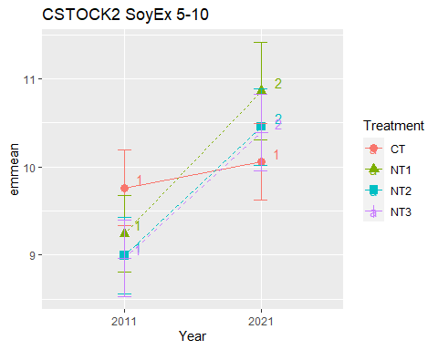

## [1] "CSTOCK2 SoyEx 10-20"

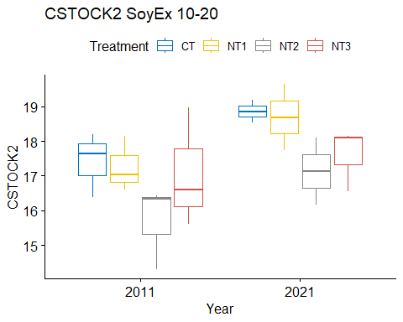

## [1] "Normality"

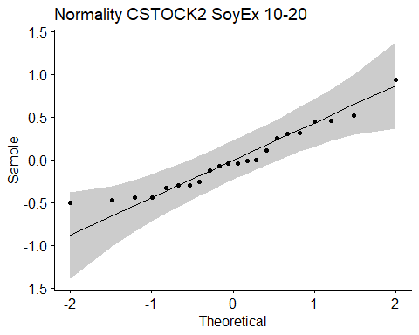

## [1] "Shapiro test for normality"  
## # A tibble: 1 × 3  
## variable statistic p.value  
## <chr> <dbl> <dbl>  
## 1 residuals(model) 0.942 0.218  
## [1] "Homoscedasticity"

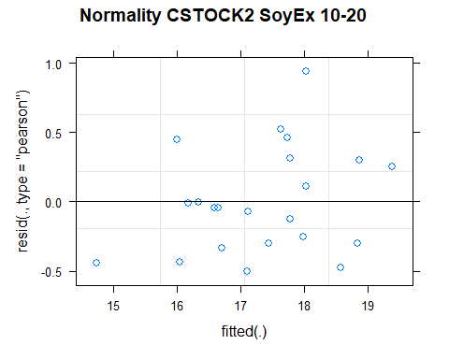

## [1] "Levene test for homoscedasticity"  
## # A tibble: 1 × 4  
## df1 df2 statistic p  
## <int> <int> <dbl> <dbl>  
## 1 7 14 0.254 0.962  
## [1] "ANOVA"  
## Treatment = CT:  
## Year emmean SE df lower.CL upper.CL .group  
## 2011 17.4 0.639 10.2 16.0 18.8 1   
## 2021 18.5 0.733 12.8 16.9 20.1 1   
##   
## Treatment = NT1:  
## Year emmean SE df lower.CL upper.CL .group  
## 2011 17.3 0.639 10.2 15.8 18.7 1   
## 2021 18.6 0.733 12.8 17.0 20.2 1   
##   
## Treatment = NT2:  
## Year emmean SE df lower.CL upper.CL .group  
## 2011 15.7 0.639 10.2 14.3 17.1 1   
## 2021 17.1 0.639 10.2 15.7 18.6 2   
##   
## Treatment = NT3:  
## Year emmean SE df lower.CL upper.CL .group  
## 2011 17.1 0.639 10.2 15.6 18.5 1   
## 2021 17.6 0.639 10.2 16.2 19.0 1   
##   
## Degrees-of-freedom method: kenward-roger   
## Results are given on the [ (not the response) scale.   
## Confidence level used: 0.95   
## Note: contrasts are still on the [ scale   
## significance level used: alpha = 0.05   
## NOTE: If two or more means share the same grouping symbol,  
## then we cannot show them to be different.  
## But we also did not show them to be the same.   
## Year = 2011:  
## Treatment emmean SE df lower.CL upper.CL .group  
## NT2 15.7 0.639 10.2 14.3 17.1 1   
## NT3 17.1 0.639 10.2 15.6 18.5 1   
## NT1 17.3 0.639 10.2 15.8 18.7 1   
## CT 17.4 0.639 10.2 16.0 18.8 1   
##   
## Year = 2021:  
## Treatment emmean SE df lower.CL upper.CL .group  
## NT2 17.1 0.639 10.2 15.7 18.6 1   
## NT3 17.6 0.639 10.2 16.2 19.0 1   
## CT 18.5 0.733 12.8 16.9 20.1 1   
## NT1 18.6 0.733 12.8 17.0 20.2 1   
##   
## Degrees-of-freedom method: kenward-roger   
## Results are given on the [ (not the response) scale.   
## Confidence level used: 0.95   
## Note: contrasts are still on the [ scale   
## P value adjustment: tukey method for comparing a family of 4 estimates   
## significance level used: alpha = 0.05   
## NOTE: If two or more means share the same grouping symbol,  
## then we cannot show them to be different.  
## But we also did not show them to be the same.   
## [1] "ANOVA plot"

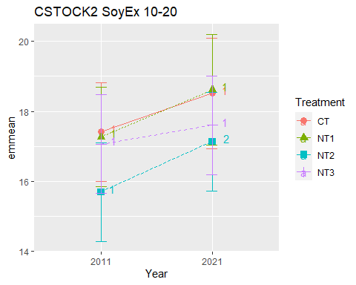

## [1] "CSTOCK2 SoyEx 20-40"

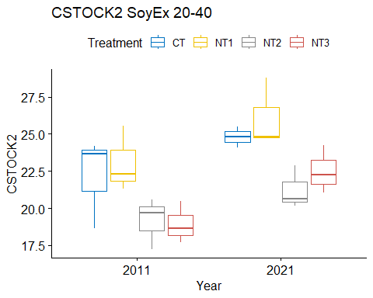

## [1] "Normality"

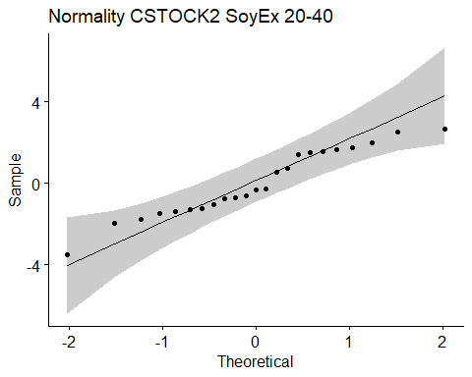

## [1] "Shapiro test for normality"  
## # A tibble: 1 × 3  
## variable statistic p.value  
## <chr> <dbl> <dbl>  
## 1 residuals(model) 0.950 0.293  
## [1] "Homoscedasticity"

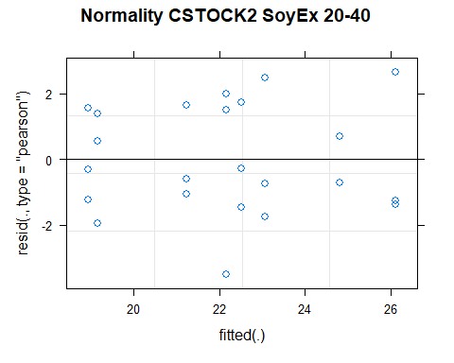

## [1] "Levene test for homoscedasticity"  
## # A tibble: 1 × 4  
## df1 df2 statistic p  
## <int> <int> <dbl> <dbl>  
## 1 7 15 0.129 0.995  
## [1] "ANOVA"  
## Treatment = CT:  
## Year emmean SE df lower.CL upper.CL .group  
## 2011 22.2 1.15 15 19.7 24.6 1   
## 2021 24.8 1.48 15 21.7 27.9 1   
##   
## Treatment = NT1:  
## Year emmean SE df lower.CL upper.CL .group  
## 2011 23.1 1.15 15 20.6 25.5 1   
## 2021 26.1 1.15 15 23.7 28.6 1   
##   
## Treatment = NT2:  
## Year emmean SE df lower.CL upper.CL .group  
## 2011 19.2 1.15 15 16.7 21.6 1   
## 2021 21.2 1.15 15 18.8 23.7 1   
##   
## Treatment = NT3:  
## Year emmean SE df lower.CL upper.CL .group  
## 2011 18.9 1.15 15 16.5 21.4 1   
## 2021 22.5 1.15 15 20.1 25.0 1   
##   
## Degrees-of-freedom method: kenward-roger   
## Results are given on the [ (not the response) scale.   
## Confidence level used: 0.95   
## Note: contrasts are still on the [ scale   
## significance level used: alpha = 0.05   
## NOTE: If two or more means share the same grouping symbol,  
## then we cannot show them to be different.  
## But we also did not show them to be the same.   
## Year = 2011:  
## Treatment emmean SE df lower.CL upper.CL .group  
## NT3 18.9 1.15 15 16.5 21.4 1   
## NT2 19.2 1.15 15 16.7 21.6 1   
## CT 22.2 1.15 15 19.7 24.6 1   
## NT1 23.1 1.15 15 20.6 25.5 1   
##   
## Year = 2021:  
## Treatment emmean SE df lower.CL upper.CL .group  
## NT2 21.2 1.15 15 18.8 23.7 1   
## NT3 22.5 1.15 15 20.1 25.0 12   
## CT 24.8 1.48 15 21.7 27.9 12   
## NT1 26.1 1.15 15 23.7 28.6 2   
##   
## Degrees-of-freedom method: kenward-roger   
## Results are given on the [ (not the response) scale.   
## Confidence level used: 0.95   
## Note: contrasts are still on the [ scale   
## P value adjustment: tukey method for comparing a family of 4 estimates   
## significance level used: alpha = 0.05   
## NOTE: If two or more means share the same grouping symbol,  
## then we cannot show them to be different.  
## But we also did not show them to be the same.   
## [1] "ANOVA plot"

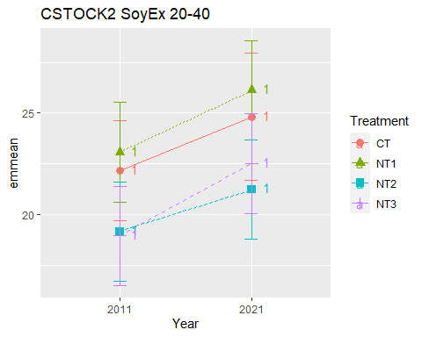

## [1] "CSTOCK2 SoyEx 40-60"

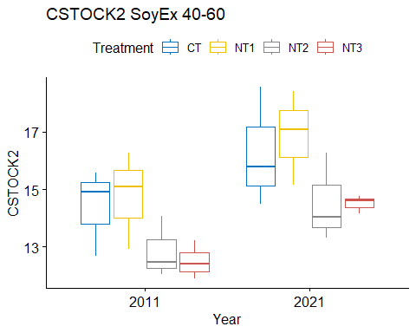

## [1] "Normality"

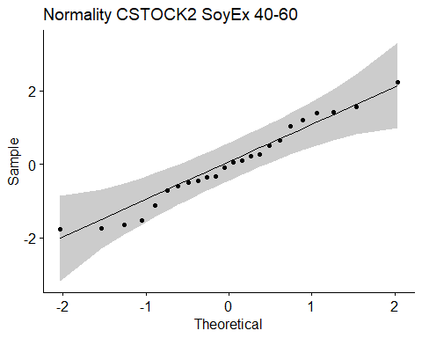

## [1] "Shapiro test for normality"  
## # A tibble: 1 × 3  
## variable statistic p.value  
## <chr> <dbl> <dbl>  
## 1 residuals(model) 0.967 0.594  
## [1] "Homoscedasticity"

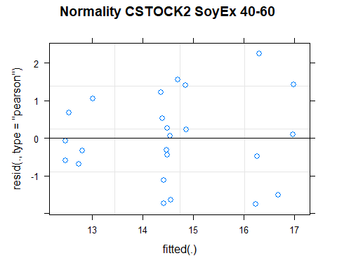

## [1] "Levene test for homoscedasticity"  
## # A tibble: 1 × 4  
## df1 df2 statistic p  
## <int> <int> <dbl> <dbl>  
## 1 7 16 0.468 0.844  
## [1] "ANOVA"  
## Treatment = CT:  
## Year emmean SE df lower.CL upper.CL .group  
## 2011 14.4 0.82 15.9 12.7 16.1 1   
## 2021 16.3 0.82 15.9 14.5 18.0 1   
##   
## Treatment = NT1:  
## Year emmean SE df lower.CL upper.CL .group  
## 2011 14.8 0.82 15.9 13.0 16.5 1   
## 2021 16.9 0.82 15.9 15.1 18.6 1   
##   
## Treatment = NT2:  
## Year emmean SE df lower.CL upper.CL .group  
## 2011 12.9 0.82 15.9 11.1 14.6 1   
## 2021 14.5 0.82 15.9 12.8 16.3 1   
##   
## Treatment = NT3:  
## Year emmean SE df lower.CL upper.CL .group  
## 2011 12.5 0.82 15.9 10.8 14.2 1   
## 2021 14.5 0.82 15.9 12.8 16.2 1   
##   
## Degrees-of-freedom method: kenward-roger   
## Results are given on the [ (not the response) scale.   
## Confidence level used: 0.95   
## Note: contrasts are still on the [ scale   
## significance level used: alpha = 0.05   
## NOTE: If two or more means share the same grouping symbol,  
## then we cannot show them to be different.  
## But we also did not show them to be the same.   
## Year = 2011:  
## Treatment emmean SE df lower.CL upper.CL .group  
## NT3 12.5 0.82 15.9 10.8 14.2 1   
## NT2 12.9 0.82 15.9 11.1 14.6 1   
## CT 14.4 0.82 15.9 12.7 16.1 1   
## NT1 14.8 0.82 15.9 13.0 16.5 1   
##   
## Year = 2021:  
## Treatment emmean SE df lower.CL upper.CL .group  
## NT3 14.5 0.82 15.9 12.8 16.2 1   
## NT2 14.5 0.82 15.9 12.8 16.3 1   
## CT 16.3 0.82 15.9 14.5 18.0 1   
## NT1 16.9 0.82 15.9 15.1 18.6 1   
##   
## Degrees-of-freedom method: kenward-roger   
## Results are given on the [ (not the response) scale.   
## Confidence level used: 0.95   
## Note: contrasts are still on the [ scale   
## P value adjustment: tukey method for comparing a family of 4 estimates   
## significance level used: alpha = 0.05   
## NOTE: If two or more means share the same grouping symbol,  
## then we cannot show them to be different.  
## But we also did not show them to be the same.   
## [1] "ANOVA plot"

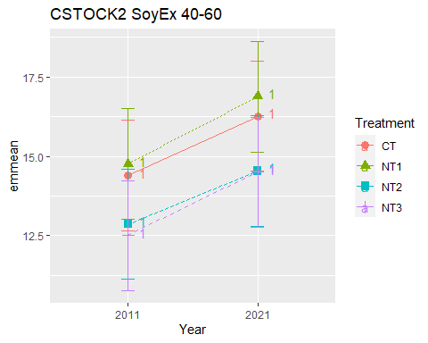

## [1] "CSTOCK2 SoyEx 60-80"

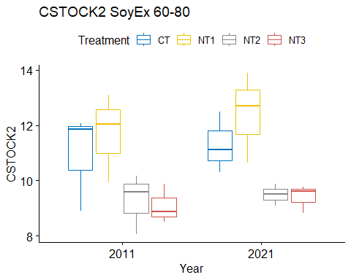

## [1] "Normality"

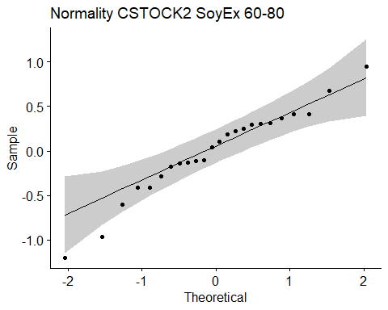

## [1] "Shapiro test for normality"  
## # A tibble: 1 × 3  
## variable statistic p.value  
## <chr> <dbl> <dbl>  
## 1 residuals(model) 0.961 0.458  
## [1] "Homoscedasticity"

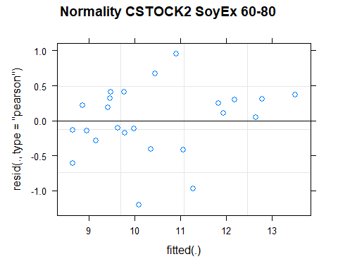

## [1] "Levene test for homoscedasticity"  
## # A tibble: 1 × 4  
## df1 df2 statistic p  
## <int> <int> <dbl> <dbl>  
## 1 7 16 0.420 0.876  
## [1] "ANOVA"  
## Treatment = CT:  
## Year emmean SE df lower.CL upper.CL .group  
## 2011 10.95 0.701 11.6 9.41 12.5 1   
## 2021 11.31 0.701 11.6 9.78 12.8 1   
##   
## Treatment = NT1:  
## Year emmean SE df lower.CL upper.CL .group  
## 2011 11.69 0.701 11.6 10.16 13.2 1   
## 2021 12.41 0.701 11.6 10.87 13.9 1   
##   
## Treatment = NT2:  
## Year emmean SE df lower.CL upper.CL .group  
## 2011 9.28 0.701 11.6 7.74 10.8 1   
## 2021 9.49 0.701 11.6 7.96 11.0 1   
##   
## Treatment = NT3:  
## Year emmean SE df lower.CL upper.CL .group  
## 2011 9.09 0.701 11.6 7.56 10.6 1   
## 2021 9.40 0.701 11.6 7.87 10.9 1   
##   
## Degrees-of-freedom method: kenward-roger   
## Results are given on the [ (not the response) scale.   
## Confidence level used: 0.95   
## Note: contrasts are still on the [ scale   
## significance level used: alpha = 0.05   
## NOTE: If two or more means share the same grouping symbol,  
## then we cannot show them to be different.  
## But we also did not show them to be the same.   
## Year = 2011:  
## Treatment emmean SE df lower.CL upper.CL .group  
## NT3 9.09 0.701 11.6 7.56 10.6 1   
## NT2 9.28 0.701 11.6 7.74 10.8 1   
## CT 10.95 0.701 11.6 9.41 12.5 1   
## NT1 11.69 0.701 11.6 10.16 13.2 1   
##   
## Year = 2021:  
## Treatment emmean SE df lower.CL upper.CL .group  
## NT3 9.40 0.701 11.6 7.87 10.9 1   
## NT2 9.49 0.701 11.6 7.96 11.0 12   
## CT 11.31 0.701 11.6 9.78 12.8 12   
## NT1 12.41 0.701 11.6 10.87 13.9 2   
##   
## Degrees-of-freedom method: kenward-roger   
## Results are given on the [ (not the response) scale.   
## Confidence level used: 0.95   
## Note: contrasts are still on the [ scale   
## P value adjustment: tukey method for comparing a family of 4 estimates   
## significance level used: alpha = 0.05   
## NOTE: If two or more means share the same grouping symbol,  
## then we cannot show them to be different.  
## But we also did not show them to be the same.   
## [1] "ANOVA plot"

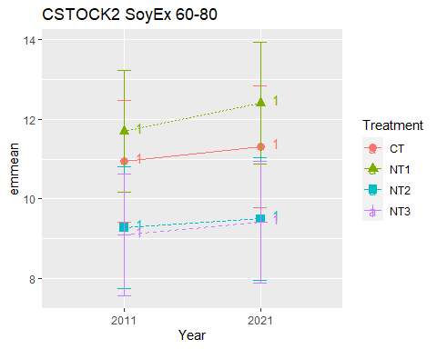

## [1] "CSTOCK2 SoyEx 80-100"

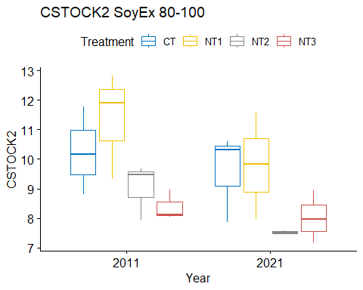

## [1] "Normality"

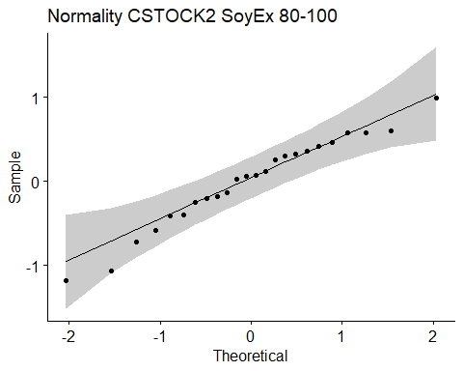

## [1] "Shapiro test for normality"  
## # A tibble: 1 × 3  
## variable statistic p.value  
## <chr> <dbl> <dbl>  
## 1 residuals(model) 0.968 0.629  
## [1] "Homoscedasticity"

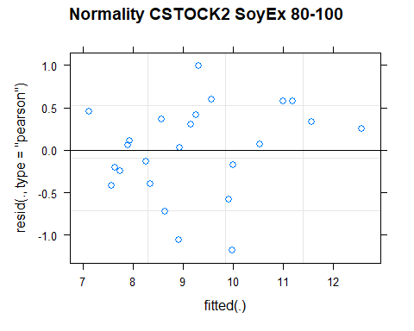

## [1] "Levene test for homoscedasticity"  
## # A tibble: 1 × 4  
## df1 df2 statistic p  
## <int> <int> <dbl> <dbl>  
## 1 7 16 0.631 0.724  
## [1] "ANOVA"  
## Treatment = CT:  
## Year emmean SE df lower.CL upper.CL .group  
## 2021 9.59 0.738 11.8 7.98 11.20 1   
## 2011 10.25 0.738 11.8 8.64 11.86 1   
##   
## Treatment = NT1:  
## Year emmean SE df lower.CL upper.CL .group  
## 2021 9.79 0.738 11.8 8.18 11.40 1   
## 2011 11.35 0.738 11.8 9.74 12.96 2   
##   
## Treatment = NT2:  
## Year emmean SE df lower.CL upper.CL .group  
## 2021 7.51 0.738 11.8 5.90 9.12 1   
## 2011 9.03 0.738 11.8 7.42 10.64 1   
##   
## Treatment = NT3:  
## Year emmean SE df lower.CL upper.CL .group  
## 2021 8.02 0.738 11.8 6.41 9.63 1   
## 2011 8.38 0.738 11.8 6.77 9.99 1   
##   
## Degrees-of-freedom method: kenward-roger   
## Results are given on the [ (not the response) scale.   
## Confidence level used: 0.95   
## Note: contrasts are still on the [ scale   
## significance level used: alpha = 0.05   
## NOTE: If two or more means share the same grouping symbol,  
## then we cannot show them to be different.  
## But we also did not show them to be the same.   
## Year = 2011:  
## Treatment emmean SE df lower.CL upper.CL .group  
## NT3 8.38 0.738 11.8 6.77 9.99 1   
## NT2 9.03 0.738 11.8 7.42 10.64 1   
## CT 10.25 0.738 11.8 8.64 11.86 1   
## NT1 11.35 0.738 11.8 9.74 12.96 1   
##   
## Year = 2021:  
## Treatment emmean SE df lower.CL upper.CL .group  
## NT2 7.51 0.738 11.8 5.90 9.12 1   
## NT3 8.02 0.738 11.8 6.41 9.63 1   
## CT 9.59 0.738 11.8 7.98 11.20 1   
## NT1 9.79 0.738 11.8 8.18 11.40 1   
##   
## Degrees-of-freedom method: kenward-roger   
## Results are given on the [ (not the response) scale.   
## Confidence level used: 0.95   
## Note: contrasts are still on the [ scale   
## P value adjustment: tukey method for comparing a family of 4 estimates   
## significance level used: alpha = 0.05   
## NOTE: If two or more means share the same grouping symbol,  
## then we cannot show them to be different.  
## But we also did not show them to be the same.   
## [1] "ANOVA plot"

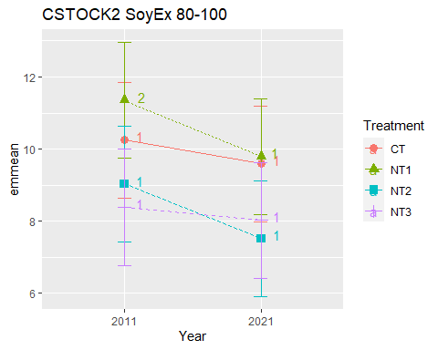

## [1] "CSTOCK2 010 Cumulated SoyEx"  
## [1] "Normality"

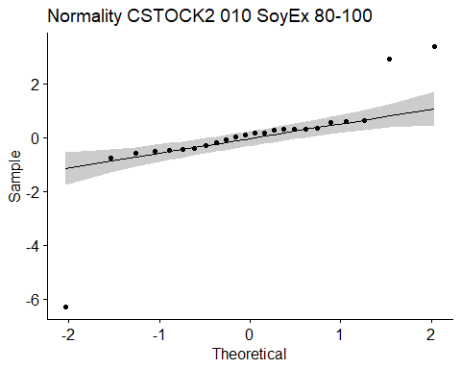

## [1] "Shapiro test for normality"  
## # A tibble: 1 × 3  
## variable statistic p.value  
## <chr> <dbl> <dbl>  
## 1 residuals(model) 0.679 0.00000545  
## [1] "Homoscedasticity"

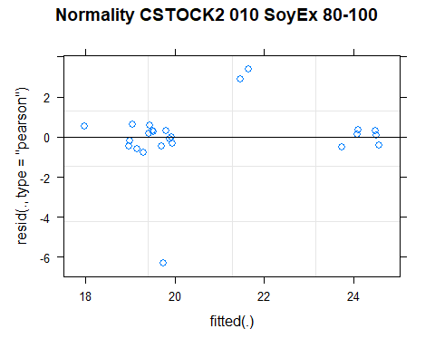

## [1] "Levene test for homoscedasticity"  
## # A tibble: 1 × 4  
## df1 df2 statistic p  
## <int> <int> <dbl> <dbl>  
## 1 7 16 0.954 0.495  
## [1] "ANOVA"  
## Treatment = CT:  
## Year emmean SE df lower.CL upper.CL .group  
## 2011 19.4 1.37 15.5 16.5 22.3 1   
## 2021 19.9 1.37 15.5 17.0 22.8 1   
##   
## Treatment = NT1:  
## Year emmean SE df lower.CL upper.CL .group  
## 2011 19.2 1.37 15.5 16.3 22.1 1   
## 2021 20.9 1.37 15.5 18.0 23.9 1   
##   
## Treatment = NT2:  
## Year emmean SE df lower.CL upper.CL .group  
## 2011 19.4 1.37 15.5 16.5 22.3 1   
## 2021 24.0 1.37 15.5 21.1 26.9 2   
##   
## Treatment = NT3:  
## Year emmean SE df lower.CL upper.CL .group  
## 2011 19.0 1.37 15.5 16.1 21.9 1   
## 2021 24.5 1.37 15.5 21.6 27.4 2   
##   
## Degrees-of-freedom method: kenward-roger   
## Results are given on the [ (not the response) scale.   
## Confidence level used: 0.95   
## Note: contrasts are still on the [ scale   
## significance level used: alpha = 0.05   
## NOTE: If two or more means share the same grouping symbol,  
## then we cannot show them to be different.  
## But we also did not show them to be the same.   
## Year = 2011:  
## Treatment emmean SE df lower.CL upper.CL .group  
## NT3 19.0 1.37 15.5 16.1 21.9 1   
## NT1 19.2 1.37 15.5 16.3 22.1 1   
## CT 19.4 1.37 15.5 16.5 22.3 1   
## NT2 19.4 1.37 15.5 16.5 22.3 1   
##   
## Year = 2021:  
## Treatment emmean SE df lower.CL upper.CL .group  
## CT 19.9 1.37 15.5 17.0 22.8 1   
## NT1 20.9 1.37 15.5 18.0 23.9 1   
## NT2 24.0 1.37 15.5 21.1 26.9 1   
## NT3 24.5 1.37 15.5 21.6 27.4 1   
##   
## Degrees-of-freedom method: kenward-roger   
## Results are given on the [ (not the response) scale.   
## Confidence level used: 0.95   
## Note: contrasts are still on the [ scale   
## P value adjustment: tukey method for comparing a family of 4 estimates   
## significance level used: alpha = 0.05   
## NOTE: If two or more means share the same grouping symbol,  
## then we cannot show them to be different.  
## But we also did not show them to be the same.   
## [1] "ANOVA Plot"

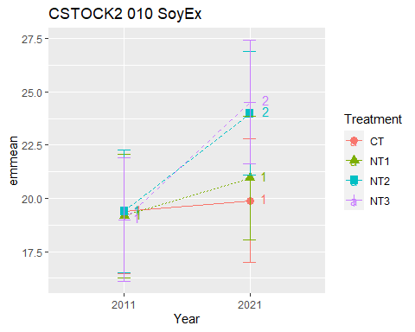

## [1] "CSTOCK2 020 Cumulated SoyEx"  
## [1] "Normality"

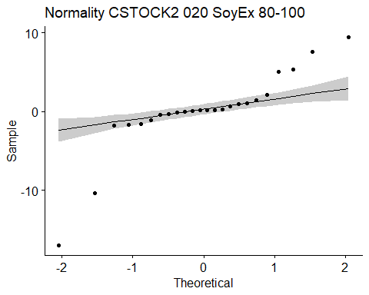

## [1] "Shapiro test for normality"  
## # A tibble: 1 × 3  
## variable statistic p.value  
## <chr> <dbl> <dbl>  
## 1 residuals(model) 0.796 0.000256  
## [1] "Homoscedasticity"

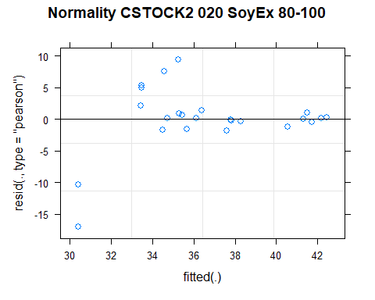

## [1] "Levene test for homoscedasticity"  
## # A tibble: 1 × 4  
## df1 df2 statistic p  
## <int> <int> <dbl> <dbl>  
## 1 7 16 0.838 0.572  
## [1] "ANOVA"  
## Treatment = CT:  
## Year emmean SE df lower.CL upper.CL .group  
## 2021 32.5 4.23 15.6 23.5 41.5 1   
## 2011 36.8 4.23 15.6 27.8 45.8 1   
##   
## Treatment = NT1:  
## Year emmean SE df lower.CL upper.CL .group  
## 2021 33.4 4.23 15.6 24.4 42.4 1   
## 2011 36.5 4.23 15.6 27.5 45.4 1   
##   
## Treatment = NT2:  
## Year emmean SE df lower.CL upper.CL .group  
## 2011 35.1 4.23 15.6 26.1 44.1 1   
## 2021 41.1 4.23 15.6 32.1 50.1 1   
##   
## Treatment = NT3:  
## Year emmean SE df lower.CL upper.CL .group  
## 2011 36.1 4.23 15.6 27.1 45.1 1   
## 2021 42.1 4.23 15.6 33.1 51.1 1   
##   
## Degrees-of-freedom method: kenward-roger   
## Results are given on the [ (not the response) scale.   
## Confidence level used: 0.95   
## Note: contrasts are still on the [ scale   
## significance level used: alpha = 0.05   
## NOTE: If two or more means share the same grouping symbol,  
## then we cannot show them to be different.  
## But we also did not show them to be the same.   
## Year = 2011:  
## Treatment emmean SE df lower.CL upper.CL .group  
## NT2 35.1 4.23 15.6 26.1 44.1 1   
## NT3 36.1 4.23 15.6 27.1 45.1 1   
## NT1 36.5 4.23 15.6 27.5 45.4 1   
## CT 36.8 4.23 15.6 27.8 45.8 1   
##   
## Year = 2021:  
## Treatment emmean SE df lower.CL upper.CL .group  
## CT 32.5 4.23 15.6 23.5 41.5 1   
## NT1 33.4 4.23 15.6 24.4 42.4 1   
## NT2 41.1 4.23 15.6 32.1 50.1 1   
## NT3 42.1 4.23 15.6 33.1 51.1 1   
##   
## Degrees-of-freedom method: kenward-roger   
## Results are given on the [ (not the response) scale.   
## Confidence level used: 0.95   
## Note: contrasts are still on the [ scale   
## P value adjustment: tukey method for comparing a family of 4 estimates   
## significance level used: alpha = 0.05   
## NOTE: If two or more means share the same grouping symbol,  
## then we cannot show them to be different.  
## But we also did not show them to be the same.   
## [1] "ANOVA Plot"

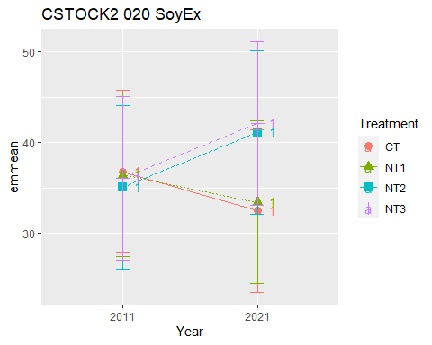

## [1] "CSTOCK2 040 Cumulated SoyEx"  
## [1] "Normality"

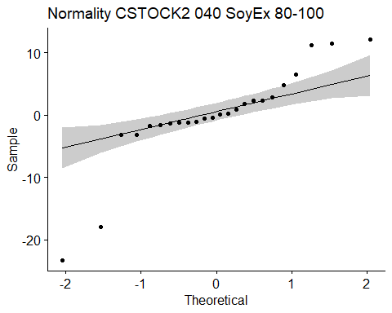

## [1] "Shapiro test for normality"  
## # A tibble: 1 × 3  
## variable statistic p.value  
## <chr> <dbl> <dbl>  
## 1 residuals(model) 0.823 0.000718  
## [1] "Homoscedasticity"

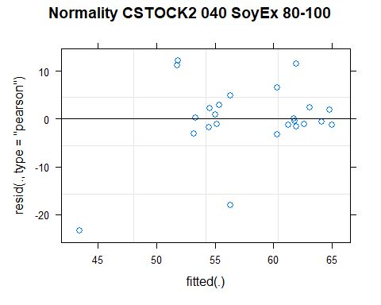

## [1] "Levene test for homoscedasticity"  
## # A tibble: 1 × 4  
## df1 df2 statistic p  
## <int> <int> <dbl> <dbl>  
## 1 7 16 0.792 0.604  
## [1] "ANOVA"  
## Treatment = CT:  
## Year emmean SE df lower.CL upper.CL .group  
## 2021 49.0 6.57 15.4 35.0 63.0 1   
## 2011 59.0 6.57 15.4 45.0 72.9 1   
##   
## Treatment = NT1:  
## Year emmean SE df lower.CL upper.CL .group  
## 2011 59.5 6.57 15.4 45.6 73.5 1   
## 2021 59.5 6.57 15.4 45.6 73.5 1   
##   
## Treatment = NT2:  
## Year emmean SE df lower.CL upper.CL .group  
## 2011 54.2 6.57 15.4 40.3 68.2 1   
## 2021 62.3 6.57 15.4 48.4 76.3 1   
##   
## Treatment = NT3:  
## Year emmean SE df lower.CL upper.CL .group  
## 2011 55.0 6.57 15.4 41.0 69.0 1   
## 2021 64.6 6.57 15.4 50.7 78.6 1   
##   
## Degrees-of-freedom method: kenward-roger   
## Results are given on the [ (not the response) scale.   
## Confidence level used: 0.95   
## Note: contrasts are still on the [ scale   
## significance level used: alpha = 0.05   
## NOTE: If two or more means share the same grouping symbol,  
## then we cannot show them to be different.  
## But we also did not show them to be the same.   
## Year = 2011:  
## Treatment emmean SE df lower.CL upper.CL .group  
## NT2 54.2 6.57 15.4 40.3 68.2 1   
## NT3 55.0 6.57 15.4 41.0 69.0 1   
## CT 59.0 6.57 15.4 45.0 72.9 1   
## NT1 59.5 6.57 15.4 45.6 73.5 1   
##   
## Year = 2021:  
## Treatment emmean SE df lower.CL upper.CL .group  
## CT 49.0 6.57 15.4 35.0 63.0 1   
## NT1 59.5 6.57 15.4 45.6 73.5 1   
## NT2 62.3 6.57 15.4 48.4 76.3 1   
## NT3 64.6 6.57 15.4 50.7 78.6 1   
##   
## Degrees-of-freedom method: kenward-roger   
## Results are given on the [ (not the response) scale.   
## Confidence level used: 0.95   
## Note: contrasts are still on the [ scale   
## P value adjustment: tukey method for comparing a family of 4 estimates   
## significance level used: alpha = 0.05   
## NOTE: If two or more means share the same grouping symbol,  
## then we cannot show them to be different.  
## But we also did not show them to be the same.   
## [1] "ANOVA Plot"

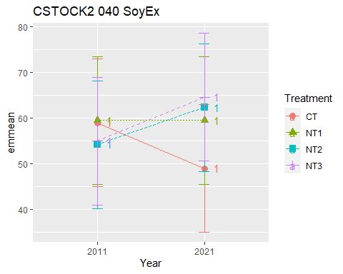

## [1] "CSTOCK2 060 Cumulated SoyEx"  
## [1] "Normality"

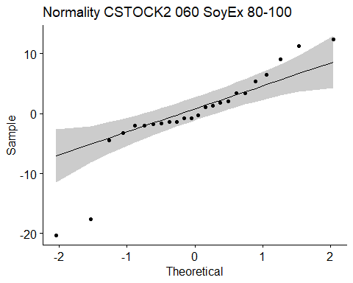

## [1] "Shapiro test for normality"  
## # A tibble: 1 × 3  
## variable statistic p.value  
## <chr> <dbl> <dbl>  
## 1 residuals(model) 0.868 0.00485  
## [1] "Homoscedasticity"

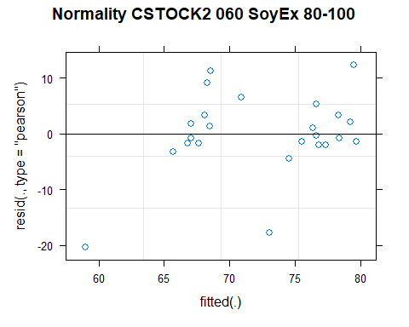

## [1] "Levene test for homoscedasticity"  
## # A tibble: 1 × 4  
## df1 df2 statistic p  
## <int> <int> <dbl> <dbl>  
## 1 7 16 0.803 0.597  
## [1] "ANOVA"  
## Treatment = CT:  
## Year emmean SE df lower.CL upper.CL .group  
## 2021 65.3 6.43 15.2 51.6 79.0 1   
## 2011 73.3 6.43 15.2 59.7 87.0 1   
##   
## Treatment = NT1:  
## Year emmean SE df lower.CL upper.CL .group  
## 2011 74.3 6.43 15.2 60.6 88.0 1   
## 2021 76.4 6.43 15.2 62.7 90.1 1   
##   
## Treatment = NT2:  
## Year emmean SE df lower.CL upper.CL .group  
## 2011 67.1 6.43 15.2 53.4 80.8 1   
## 2021 76.9 6.43 15.2 63.2 90.6 1   
##   
## Treatment = NT3:  
## Year emmean SE df lower.CL upper.CL .group  
## 2011 67.5 6.43 15.2 53.8 81.2 1   
## 2021 79.1 6.43 15.2 65.4 92.8 1   
##   
## Degrees-of-freedom method: kenward-roger   
## Results are given on the [ (not the response) scale.   
## Confidence level used: 0.95   
## Note: contrasts are still on the [ scale   
## significance level used: alpha = 0.05   
## NOTE: If two or more means share the same grouping symbol,  
## then we cannot show them to be different.  
## But we also did not show them to be the same.   
## Year = 2011:  
## Treatment emmean SE df lower.CL upper.CL .group  
## NT2 67.1 6.43 15.2 53.4 80.8 1   
## NT3 67.5 6.43 15.2 53.8 81.2 1   
## CT 73.3 6.43 15.2 59.7 87.0 1   
## NT1 74.3 6.43 15.2 60.6 88.0 1   
##   
## Year = 2021:  
## Treatment emmean SE df lower.CL upper.CL .group  
## CT 65.3 6.43 15.2 51.6 79.0 1   
## NT1 76.4 6.43 15.2 62.7 90.1 1   
## NT2 76.9 6.43 15.2 63.2 90.6 1   
## NT3 79.1 6.43 15.2 65.4 92.8 1   
##   
## Degrees-of-freedom method: kenward-roger   
## Results are given on the [ (not the response) scale.   
## Confidence level used: 0.95   
## Note: contrasts are still on the [ scale   
## P value adjustment: tukey method for comparing a family of 4 estimates   
## significance level used: alpha = 0.05   
## NOTE: If two or more means share the same grouping symbol,  
## then we cannot show them to be different.  
## But we also did not show them to be the same.   
## [1] "ANOVA Plot"

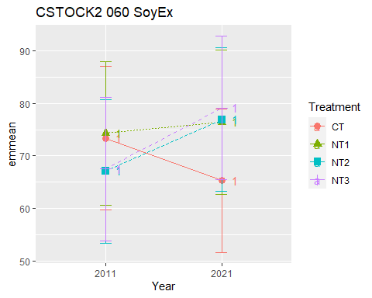

## [1] "CSTOCK2 080 Cumulated SoyEx"  
## [1] "Normality"

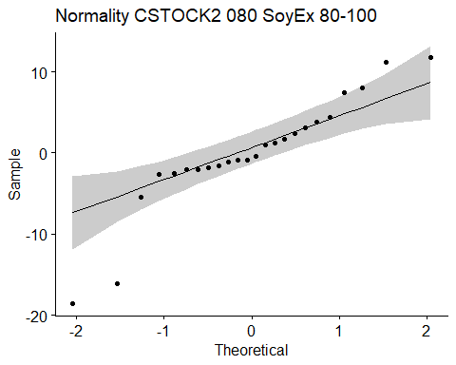

## [1] "Shapiro test for normality"  
## # A tibble: 1 × 3  
## variable statistic p.value  
## <chr> <dbl> <dbl>  
## 1 residuals(model) 0.892 0.0143  
## [1] "Homoscedasticity"

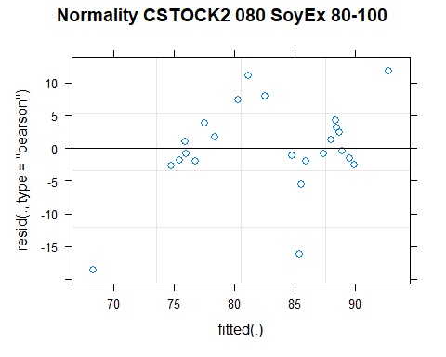

## [1] "Levene test for homoscedasticity"  
## # A tibble: 1 × 4  
## df1 df2 statistic p  
## <int> <int> <dbl> <dbl>  
## 1 7 16 0.811 0.591  
## [1] "ANOVA"  
## Treatment = CT:  
## Year emmean SE df lower.CL upper.CL .group  
## 2021 76.6 6.51 14.7 62.7 90.5 1   
## 2011 84.3 6.51 14.7 70.4 98.2 1   
##   
## Treatment = NT1:  
## Year emmean SE df lower.CL upper.CL .group  
## 2011 86.0 6.51 14.7 72.1 99.9 1   
## 2021 88.8 6.51 14.7 74.9 102.7 1   
##   
## Treatment = NT2:  
## Year emmean SE df lower.CL upper.CL .group  
## 2011 76.4 6.51 14.7 62.5 90.3 1   
## 2021 86.4 6.51 14.7 72.5 100.3 1   
##   
## Treatment = NT3:  
## Year emmean SE df lower.CL upper.CL .group  
## 2011 76.6 6.51 14.7 62.7 90.5 1   
## 2021 88.5 6.51 14.7 74.6 102.4 1   
##   
## Degrees-of-freedom method: kenward-roger   
## Results are given on the [ (not the response) scale.   
## Confidence level used: 0.95   
## Note: contrasts are still on the [ scale   
## significance level used: alpha = 0.05   
## NOTE: If two or more means share the same grouping symbol,  
## then we cannot show them to be different.  
## But we also did not show them to be the same.   
## Year = 2011:  
## Treatment emmean SE df lower.CL upper.CL .group  
## NT2 76.4 6.51 14.7 62.5 90.3 1   
## NT3 76.6 6.51 14.7 62.7 90.5 1   
## CT 84.3 6.51 14.7 70.4 98.2 1   
## NT1 86.0 6.51 14.7 72.1 99.9 1   
##   
## Year = 2021:  
## Treatment emmean SE df lower.CL upper.CL .group  
## CT 76.6 6.51 14.7 62.7 90.5 1   
## NT2 86.4 6.51 14.7 72.5 100.3 1   
## NT3 88.5 6.51 14.7 74.6 102.4 1   
## NT1 88.8 6.51 14.7 74.9 102.7 1   
##   
## Degrees-of-freedom method: kenward-roger   
## Results are given on the [ (not the response) scale.   
## Confidence level used: 0.95   
## Note: contrasts are still on the [ scale   
## P value adjustment: tukey method for comparing a family of 4 estimates   
## significance level used: alpha = 0.05   
## NOTE: If two or more means share the same grouping symbol,  
## then we cannot show them to be different.  
## But we also did not show them to be the same.   
## [1] "ANOVA Plot"

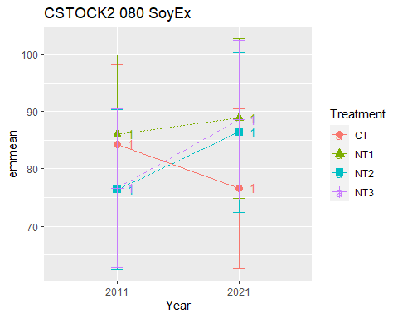

## [1] "CSTOCK2 0100 Cumulated SoyEx"  
## [1] "Normality"

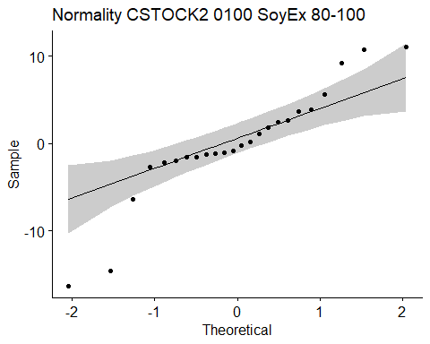

## [1] "Shapiro test for normality"  
## # A tibble: 1 × 3  
## variable statistic p.value  
## <chr> <dbl> <dbl>  
## 1 residuals(model) 0.903 0.0249  
## [1] "Homoscedasticity"

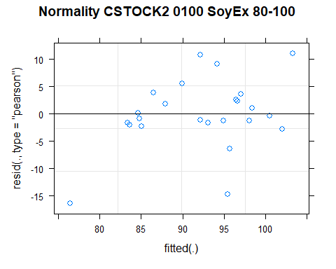

## [1] "Levene test for homoscedasticity"  
## # A tibble: 1 × 4  
## df1 df2 statistic p  
## <int> <int> <dbl> <dbl>  
## 1 7 16 0.837 0.573  
## [1] "ANOVA"  
## Treatment = CT:  
## Year emmean SE df lower.CL upper.CL .group  
## 2021 86.2 6.49 14.1 72.3 100.1 1   
## 2011 94.5 6.49 14.1 80.6 108.5 1   
##   
## Treatment = NT1:  
## Year emmean SE df lower.CL upper.CL .group  
## 2011 97.3 6.49 14.1 83.4 111.2 1   
## 2021 98.6 6.49 14.1 84.7 112.5 1   
##   
## Treatment = NT2:  
## Year emmean SE df lower.CL upper.CL .group  
## 2011 85.4 6.49 14.1 71.5 99.3 1   
## 2021 93.9 6.49 14.1 80.0 107.8 1   
##   
## Treatment = NT3:  
## Year emmean SE df lower.CL upper.CL .group  
## 2011 85.0 6.49 14.1 71.1 98.9 1   
## 2021 96.5 6.49 14.1 82.6 110.5 1   
##   
## Degrees-of-freedom method: kenward-roger   
## Results are given on the [ (not the response) scale.   
## Confidence level used: 0.95   
## Note: contrasts are still on the [ scale   
## significance level used: alpha = 0.05   
## NOTE: If two or more means share the same grouping symbol,  
## then we cannot show them to be different.  
## But we also did not show them to be the same.   
## Year = 2011:  
## Treatment emmean SE df lower.CL upper.CL .group  
## NT3 85.0 6.49 14.1 71.1 98.9 1   
## NT2 85.4 6.49 14.1 71.5 99.3 1   
## CT 94.5 6.49 14.1 80.6 108.5 1   
## NT1 97.3 6.49 14.1 83.4 111.2 1   
##   
## Year = 2021:  
## Treatment emmean SE df lower.CL upper.CL .group  
## CT 86.2 6.49 14.1 72.3 100.1 1   
## NT2 93.9 6.49 14.1 80.0 107.8 1   
## NT3 96.5 6.49 14.1 82.6 110.5 1   
## NT1 98.6 6.49 14.1 84.7 112.5 1   
##   
## Degrees-of-freedom method: kenward-roger   
## Results are given on the [ (not the response) scale.   
## Confidence level used: 0.95   
## Note: contrasts are still on the [ scale   
## P value adjustment: tukey method for comparing a family of 4 estimates   
## significance level used: alpha = 0.05   
## NOTE: If two or more means share the same grouping symbol,  
## then we cannot show them to be different.  
## But we also did not show them to be the same.   
## [1] "ANOVA Plot"

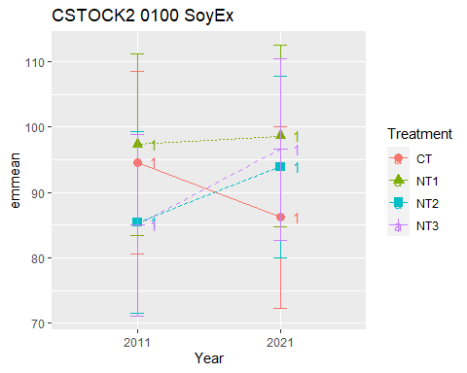

## [1] "CSTOCK2 CasEx"  
## # A tibble: 56 × 7  
## Treatment Depth Year variable n mean sd  
## <fct> <fct> <fct> <chr> <dbl> <dbl> <dbl>  
## 1 CT 0-5 2011 CSTOCK2 3 7.81 0.293  
## 2 NT1 0-5 2011 CSTOCK2 3 7.80 0.637  
## 3 NT2 0-5 2011 CSTOCK2 3 8.98 0.122  
## 4 NT3 0-5 2011 CSTOCK2 3 9.33 0.753  
## 5 CT 5-10 2011 CSTOCK2 3 8.62 0.311  
## 6 NT1 5-10 2011 CSTOCK2 3 8.00 0.594  
## 7 NT2 5-10 2011 CSTOCK2 3 8.76 0.029  
## 8 NT3 5-10 2011 CSTOCK2 3 8.44 0.064  
## 9 CT 10-20 2011 CSTOCK2 3 16.7 1.10   
## 10 NT1 10-20 2011 CSTOCK2 3 14.3 1.28   
## # … with 46 more rows  
## [1] "CSTOCK2 CasEx 0-5"

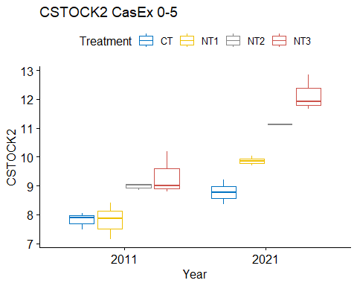

## [1] "Normality"

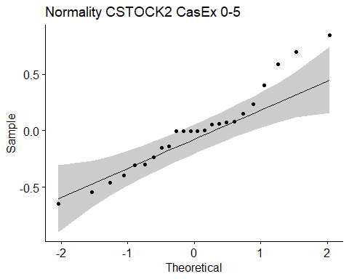

## [1] "Shapiro test for normality"  
## # A tibble: 1 × 3  
## variable statistic p.value  
## <chr> <dbl> <dbl>  
## 1 residuals(model) 0.956 0.360  
## [1] "Homoscedasticity"

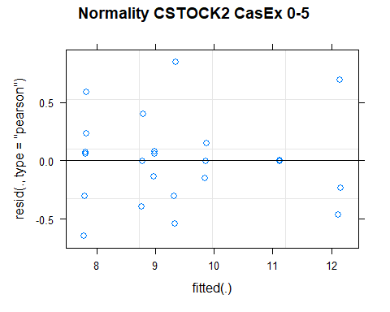

## [1] "Levene test for homoscedasticity"  
## # A tibble: 1 × 4  
## df1 df2 statistic p  
## <int> <int> <dbl> <dbl>  
## 1 7 16 0.833 0.576  
## [1] "ANOVA"  
## Treatment = CT:  
## Year emmean SE df lower.CL upper.CL .group  
## 2011 7.81 0.263 16 7.26 8.37 1   
## 2021 8.78 0.263 16 8.23 9.34 2   
##   
## Treatment = NT1:  
## Year emmean SE df lower.CL upper.CL .group  
## 2011 7.80 0.263 16 7.25 8.36 1   
## 2021 9.86 0.263 16 9.30 10.42 2   
##   
## Treatment = NT2:  
## Year emmean SE df lower.CL upper.CL .group  
## 2011 8.98 0.263 16 8.42 9.54 1   
## 2021 11.12 0.263 16 10.56 11.68 2   
##   
## Treatment = NT3:  
## Year emmean SE df lower.CL upper.CL .group  
## 2011 9.33 0.263 16 8.77 9.89 1   
## 2021 12.14 0.263 16 11.58 12.70 2   
##   
## Degrees-of-freedom method: kenward-roger   
## Results are given on the [ (not the response) scale.   
## Confidence level used: 0.95   
## Note: contrasts are still on the [ scale   
## significance level used: alpha = 0.05   
## NOTE: If two or more means share the same grouping symbol,  
## then we cannot show them to be different.  
## But we also did not show them to be the same.   
## Year = 2011:  
## Treatment emmean SE df lower.CL upper.CL .group  
## NT1 7.80 0.263 16 7.25 8.36 1   
## CT 7.81 0.263 16 7.26 8.37 1   
## NT2 8.98 0.263 16 8.42 9.54 2   
## NT3 9.33 0.263 16 8.77 9.89 2   
##   
## Year = 2021:  
## Treatment emmean SE df lower.CL upper.CL .group  
## CT 8.78 0.263 16 8.23 9.34 1   
## NT1 9.86 0.263 16 9.30 10.42 2   
## NT2 11.12 0.263 16 10.56 11.68 3   
## NT3 12.14 0.263 16 11.58 12.70 3   
##   
## Degrees-of-freedom method: kenward-roger   
## Results are given on the [ (not the response) scale.   
## Confidence level used: 0.95   
## Note: contrasts are still on the [ scale   
## P value adjustment: tukey method for comparing a family of 4 estimates   
## significance level used: alpha = 0.05   
## NOTE: If two or more means share the same grouping symbol,  
## then we cannot show them to be different.  
## But we also did not show them to be the same.   
## [1] "ANOVA plot"

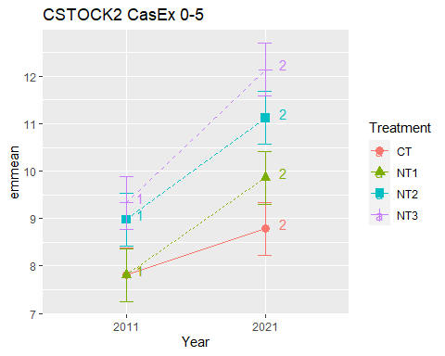

## [1] "CSTOCK2 CasEx 5-10"

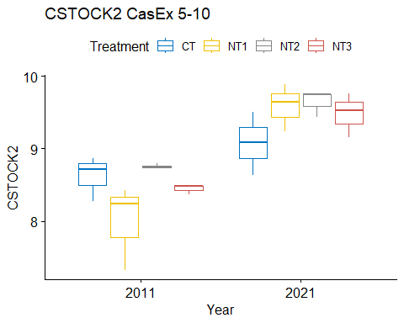

## [1] "Normality"

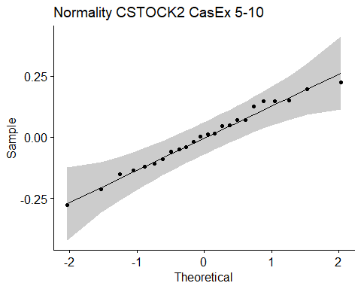

## [1] "Shapiro test for normality"  
## # A tibble: 1 × 3  
## variable statistic p.value  
## <chr> <dbl> <dbl>  
## 1 residuals(model) 0.983 0.941  
## [1] "Homoscedasticity"

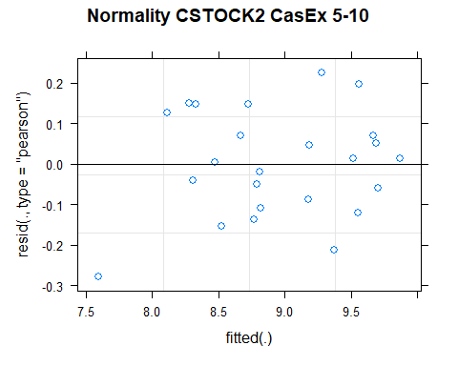

## [1] "Levene test for homoscedasticity"  
## # A tibble: 1 × 4  
## df1 df2 statistic p  
## <int> <int> <dbl> <dbl>  
## 1 7 16 0.765 0.624  
## [1] "ANOVA"  
## Treatment = CT:  
## Year emmean SE df lower.CL upper.CL .group  
## 2011 8.62 0.191 11.4 8.20 9.04 1   
## 2021 9.07 0.191 11.4 8.65 9.49 2   
##   
## Treatment = NT1:  
## Year emmean SE df lower.CL upper.CL .group  
## 2011 8.00 0.191 11.4 7.58 8.42 1   
## 2021 9.58 0.191 11.4 9.16 10.00 2   
##   
## Treatment = NT2:  
## Year emmean SE df lower.CL upper.CL .group  
## 2011 8.76 0.191 11.4 8.34 9.18 1   
## 2021 9.64 0.191 11.4 9.22 10.06 2   
##   
## Treatment = NT3:  
## Year emmean SE df lower.CL upper.CL .group  
## 2011 8.44 0.191 11.4 8.02 8.86 1   
## 2021 9.48 0.191 11.4 9.06 9.90 2   
##   
## Degrees-of-freedom method: kenward-roger   
## Results are given on the [ (not the response) scale.   
## Confidence level used: 0.95   
## Note: contrasts are still on the [ scale   
## significance level used: alpha = 0.05   
## NOTE: If two or more means share the same grouping symbol,  
## then we cannot show them to be different.  
## But we also did not show them to be the same.   
## Year = 2011:  
## Treatment emmean SE df lower.CL upper.CL .group  
## NT1 8.00 0.191 11.4 7.58 8.42 1   
## NT3 8.44 0.191 11.4 8.02 8.86 1   
## CT 8.62 0.191 11.4 8.20 9.04 1   
## NT2 8.76 0.191 11.4 8.34 9.18 1   
##   
## Year = 2021:  
## Treatment emmean SE df lower.CL upper.CL .group  
## CT 9.07 0.191 11.4 8.65 9.49 1   
## NT3 9.48 0.191 11.4 9.06 9.90 1   
## NT1 9.58 0.191 11.4 9.16 10.00 1   
## NT2 9.64 0.191 11.4 9.22 10.06 1   
##   
## Degrees-of-freedom method: kenward-roger   
## Results are given on the [ (not the response) scale.   
## Confidence level used: 0.95   
## Note: contrasts are still on the [ scale   
## P value adjustment: tukey method for comparing a family of 4 estimates   
## significance level used: alpha = 0.05   
## NOTE: If two or more means share the same grouping symbol,  
## then we cannot show them to be different.  
## But we also did not show them to be the same.   
## [1] "ANOVA plot"

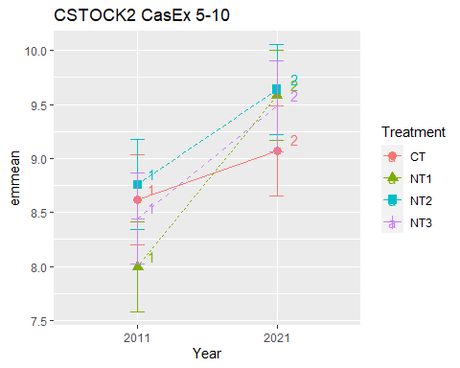

## [1] "CSTOCK2 CasEx 10-20"

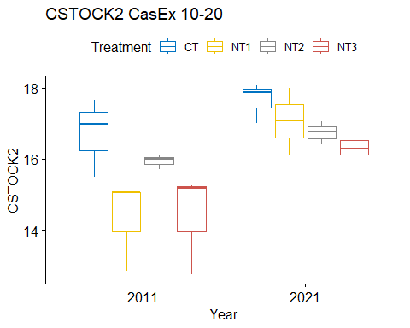

## [1] "Normality"

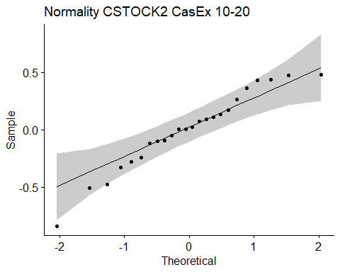

## [1] "Shapiro test for normality"  
## # A tibble: 1 × 3  
## variable statistic p.value  
## <chr> <dbl> <dbl>  
## 1 residuals(model) 0.958 0.403  
## [1] "Homoscedasticity"

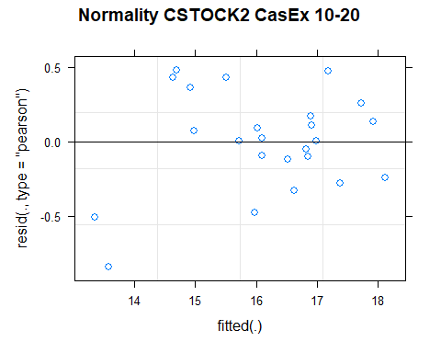

## [1] "Levene test for homoscedasticity"  
## # A tibble: 1 × 4  
## df1 df2 statistic p  
## <int> <int> <dbl> <dbl>  
## 1 7 16 0.386 0.897  
## [1] "ANOVA"  
## Treatment = CT:  
## Year emmean SE df lower.CL upper.CL .group  
## 2011 16.7 0.516 11.1 15.6 17.8 1   
## 2021 17.6 0.516 11.1 16.5 18.8 1   
##   
## Treatment = NT1:  
## Year emmean SE df lower.CL upper.CL .group  
## 2011 14.3 0.516 11.1 13.2 15.5 1   
## 2021 17.1 0.516 11.1 15.9 18.2 2   
##   
## Treatment = NT2:  
## Year emmean SE df lower.CL upper.CL .group  
## 2011 15.9 0.516 11.1 14.8 17.1 1   
## 2021 16.7 0.516 11.1 15.6 17.9 1   
##   
## Treatment = NT3:  
## Year emmean SE df lower.CL upper.CL .group  
## 2011 14.4 0.516 11.1 13.3 15.5 1   
## 2021 16.3 0.516 11.1 15.2 17.5 2   
##   
## Degrees-of-freedom method: kenward-roger   
## Results are given on the [ (not the response) scale.   
## Confidence level used: 0.95   
## Note: contrasts are still on the [ scale   
## significance level used: alpha = 0.05   
## NOTE: If two or more means share the same grouping symbol,  
## then we cannot show them to be different.  
## But we also did not show them to be the same.   
## Year = 2011:  
## Treatment emmean SE df lower.CL upper.CL .group  
## NT1 14.3 0.516 11.1 13.2 15.5 1   
## NT3 14.4 0.516 11.1 13.3 15.5 1   
## NT2 15.9 0.516 11.1 14.8 17.1 12   
## CT 16.7 0.516 11.1 15.6 17.8 2   
##   
## Year = 2021:  
## Treatment emmean SE df lower.CL upper.CL .group  
## NT3 16.3 0.516 11.1 15.2 17.5 1   
## NT2 16.7 0.516 11.1 15.6 17.9 1   
## NT1 17.1 0.516 11.1 15.9 18.2 1   
## CT 17.6 0.516 11.1 16.5 18.8 1   
##   
## Degrees-of-freedom method: kenward-roger   
## Results are given on the [ (not the response) scale.   
## Confidence level used: 0.95   
## Note: contrasts are still on the [ scale   
## P value adjustment: tukey method for comparing a family of 4 estimates   
## significance level used: alpha = 0.05   
## NOTE: If two or more means share the same grouping symbol,  
## then we cannot show them to be different.  
## But we also did not show them to be the same.   
## [1] "ANOVA plot"

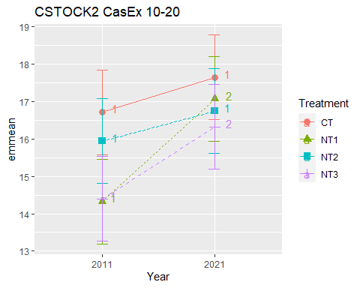

## [1] "CSTOCK2 CasEx 20-40"

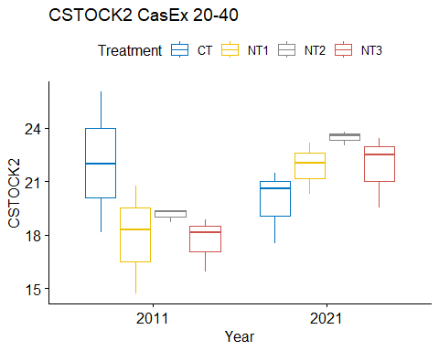

## [1] "Normality"

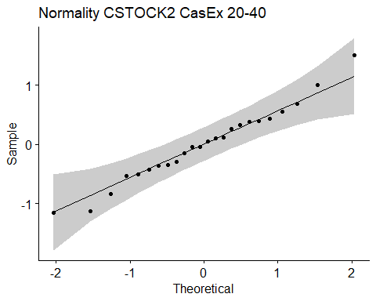

## [1] "Shapiro test for normality"  
## # A tibble: 1 × 3  
## variable statistic p.value  
## <chr> <dbl> <dbl>  
## 1 residuals(model) 0.982 0.931  
## [1] "Homoscedasticity"

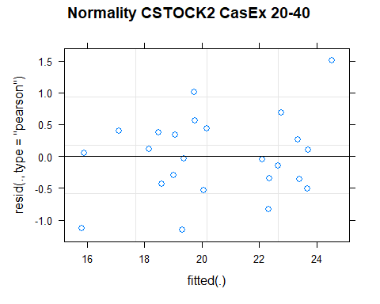

## [1] "Levene test for homoscedasticity"  
## # A tibble: 1 × 4  
## df1 df2 statistic p  
## <int> <int> <dbl> <dbl>  
## 1 7 16 1.02 0.452  
## [1] "ANOVA"  
## Treatment = CT:  
## Year emmean SE df lower.CL upper.CL .group  
## 2021 19.9 1.26 9.89 17.1 22.7 1   
## 2011 22.1 1.26 9.89 19.2 24.9 2   
##   
## Treatment = NT1:  
## Year emmean SE df lower.CL upper.CL .group  
## 2011 17.9 1.26 9.89 15.1 20.7 1   
## 2021 21.9 1.26 9.89 19.0 24.7 2   
##   
## Treatment = NT2:  
## Year emmean SE df lower.CL upper.CL .group  
## 2011 19.1 1.26 9.89 16.3 22.0 1   
## 2021 23.5 1.26 9.89 20.7 26.3 2   
##   
## Treatment = NT3:  
## Year emmean SE df lower.CL upper.CL .group  
## 2011 17.7 1.26 9.89 14.9 20.5 1   
## 2021 21.8 1.26 9.89 19.0 24.6 2   
##   
## Degrees-of-freedom method: kenward-roger   
## Results are given on the [ (not the response) scale.   
## Confidence level used: 0.95   
## Note: contrasts are still on the [ scale   
## significance level used: alpha = 0.05   
## NOTE: If two or more means share the same grouping symbol,  
## then we cannot show them to be different.  
## But we also did not show them to be the same.   
## Year = 2011:  
## Treatment emmean SE df lower.CL upper.CL .group  
## NT3 17.7 1.26 9.89 14.9 20.5 1   
## NT1 17.9 1.26 9.89 15.1 20.7 1   
## NT2 19.1 1.26 9.89 16.3 22.0 1   
## CT 22.1 1.26 9.89 19.2 24.9 1   
##   
## Year = 2021:  
## Treatment emmean SE df lower.CL upper.CL .group  
## CT 19.9 1.26 9.89 17.1 22.7 1   
## NT3 21.8 1.26 9.89 19.0 24.6 1   
## NT1 21.9 1.26 9.89 19.0 24.7 1   
## NT2 23.5 1.26 9.89 20.7 26.3 1   
##   
## Degrees-of-freedom method: kenward-roger   
## Results are given on the [ (not the response) scale.   
## Confidence level used: 0.95   
## Note: contrasts are still on the [ scale   
## P value adjustment: tukey method for comparing a family of 4 estimates   
## significance level used: alpha = 0.05   
## NOTE: If two or more means share the same grouping symbol,  
## then we cannot show them to be different.  
## But we also did not show them to be the same.   
## [1] "ANOVA plot"

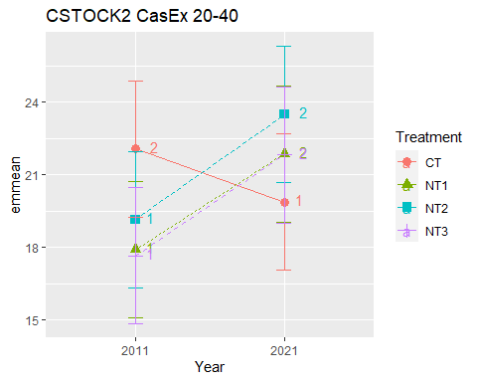

## [1] "CSTOCK2 CasEx 40-60"

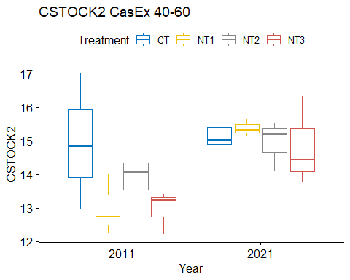

## [1] "Normality"

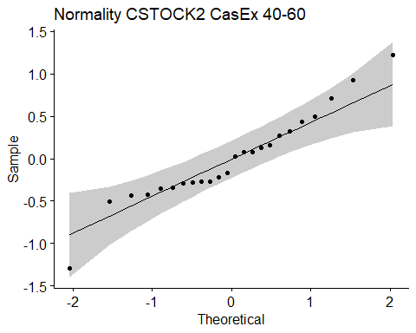

## [1] "Shapiro test for normality"  
## # A tibble: 1 × 3  
## variable statistic p.value  
## <chr> <dbl> <dbl>  
## 1 residuals(model) 0.954 0.336  
## [1] "Homoscedasticity"

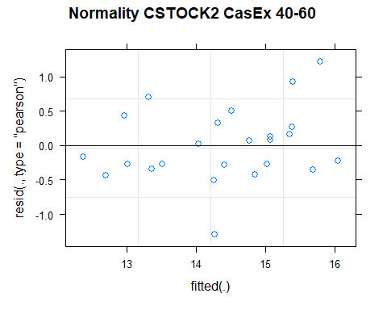

## [1] "Levene test for homoscedasticity"  
## # A tibble: 1 × 4  
## df1 df2 statistic p  
## <int> <int> <dbl> <dbl>  
## 1 7 16 0.833 0.575  
## [1] "ANOVA"  
## Treatment = CT:  
## Year emmean SE df lower.CL upper.CL .group  
## 2011 14.9 0.602 13.2 13.6 16.2 1   
## 2021 15.2 0.602 13.2 13.9 16.5 1   
##   
## Treatment = NT1:  
## Year emmean SE df lower.CL upper.CL .group  
## 2011 13.0 0.602 13.2 11.7 14.3 1   
## 2021 15.4 0.602 13.2 14.1 16.7 2   
##   
## Treatment = NT2:  
## Year emmean SE df lower.CL upper.CL .group  
## 2011 13.9 0.602 13.2 12.6 15.2 1   
## 2021 14.9 0.602 13.2 13.6 16.2 1   
##   
## Treatment = NT3:  
## Year emmean SE df lower.CL upper.CL .group  
## 2011 12.9 0.602 13.2 11.6 14.2 1   
## 2021 14.8 0.602 13.2 13.5 16.1 2   
##   
## Degrees-of-freedom method: kenward-roger   
## Results are given on the [ (not the response) scale.   
## Confidence level used: 0.95   
## Note: contrasts are still on the [ scale   
## significance level used: alpha = 0.05   
## NOTE: If two or more means share the same grouping symbol,  
## then we cannot show them to be different.  
## But we also did not show them to be the same.   
## Year = 2011:  
## Treatment emmean SE df lower.CL upper.CL .group  
## NT3 12.9 0.602 13.2 11.6 14.2 1   
## NT1 13.0 0.602 13.2 11.7 14.3 1   
## NT2 13.9 0.602 13.2 12.6 15.2 1   
## CT 14.9 0.602 13.2 13.6 16.2 1   
##   
## Year = 2021:  
## Treatment emmean SE df lower.CL upper.CL .group  
## NT3 14.8 0.602 13.2 13.5 16.1 1   
## NT2 14.9 0.602 13.2 13.6 16.2 1   
## CT 15.2 0.602 13.2 13.9 16.5 1   
## NT1 15.4 0.602 13.2 14.1 16.7 1   
##   
## Degrees-of-freedom method: kenward-roger   
## Results are given on the [ (not the response) scale.   
## Confidence level used: 0.95   
## Note: contrasts are still on the [ scale   
## P value adjustment: tukey method for comparing a family of 4 estimates   
## significance level used: alpha = 0.05   
## NOTE: If two or more means share the same grouping symbol,  
## then we cannot show them to be different.  
## But we also did not show them to be the same.   
## [1] "ANOVA plot"

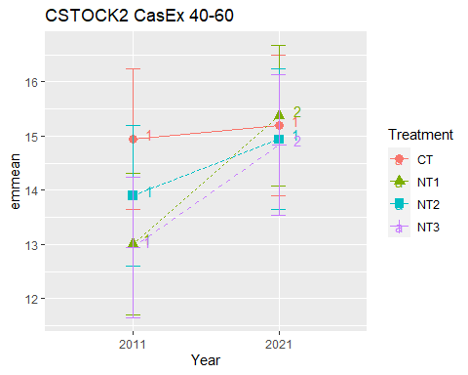

## [1] "CSTOCK2 CasEx 60-80"

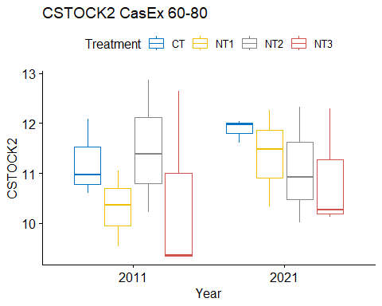

## [1] "Normality"

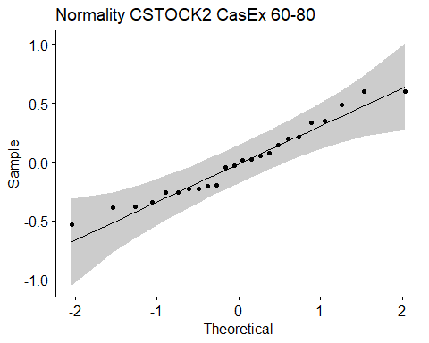

## [1] "Shapiro test for normality"  
## # A tibble: 1 × 3  
## variable statistic p.value  
## <chr> <dbl> <dbl>  
## 1 residuals(model) 0.958 0.401  
## [1] "Homoscedasticity"

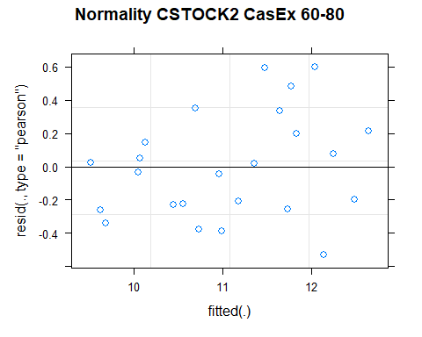

## [1] "Levene test for homoscedasticity"  
## # A tibble: 1 × 4  
## df1 df2 statistic p  
## <int> <int> <dbl> <dbl>  
## 1 7 16 0.291 0.948  
## [1] "ANOVA"  
## Treatment = CT:  
## Year emmean SE df lower.CL upper.CL .group  
## 2011 11.2 0.656 9.76 9.75 12.7 1   
## 2021 11.9 0.656 9.76 10.41 13.3 1   
##   
## Treatment = NT1:  
## Year emmean SE df lower.CL upper.CL .group  
## 2011 10.3 0.656 9.76 8.85 11.8 1   
## 2021 11.4 0.656 9.76 9.89 12.8 2   
##   
## Treatment = NT2:  
## Year emmean SE df lower.CL upper.CL .group  
## 2021 11.1 0.656 9.76 9.62 12.6 1   
## 2011 11.5 0.656 9.76 10.02 13.0 1   
##   
## Treatment = NT3:  
## Year emmean SE df lower.CL upper.CL .group  
## 2011 10.4 0.656 9.76 8.98 11.9 1   
## 2021 10.9 0.656 9.76 9.43 12.4 1   
##   
## Degrees-of-freedom method: kenward-roger   
## Results are given on the [ (not the response) scale.   
## Confidence level used: 0.95   
## Note: contrasts are still on the [ scale   
## significance level used: alpha = 0.05   
## NOTE: If two or more means share the same grouping symbol,  
## then we cannot show them to be different.  
## But we also did not show them to be the same.   
## Year = 2011:  
## Treatment emmean SE df lower.CL upper.CL .group  
## NT1 10.3 0.656 9.76 8.85 11.8 1   
## NT3 10.4 0.656 9.76 8.98 11.9 1   
## CT 11.2 0.656 9.76 9.75 12.7 1   
## NT2 11.5 0.656 9.76 10.02 13.0 1   
##   
## Year = 2021:  
## Treatment emmean SE df lower.CL upper.CL .group  
## NT3 10.9 0.656 9.76 9.43 12.4 1   
## NT2 11.1 0.656 9.76 9.62 12.6 1   
## NT1 11.4 0.656 9.76 9.89 12.8 1   
## CT 11.9 0.656 9.76 10.41 13.3 1   
##   
## Degrees-of-freedom method: kenward-roger   
## Results are given on the [ (not the response) scale.   
## Confidence level used: 0.95   
## Note: contrasts are still on the [ scale   
## P value adjustment: tukey method for comparing a family of 4 estimates   
## significance level used: alpha = 0.05   
## NOTE: If two or more means share the same grouping symbol,  
## then we cannot show them to be different.  
## But we also did not show them to be the same.   
## [1] "ANOVA plot"

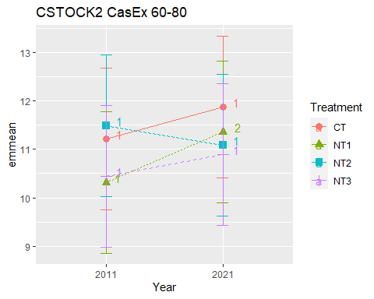

## [1] "CSTOCK2 CasEx 80-100"

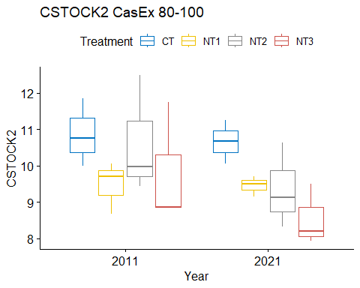

## [1] "Normality"

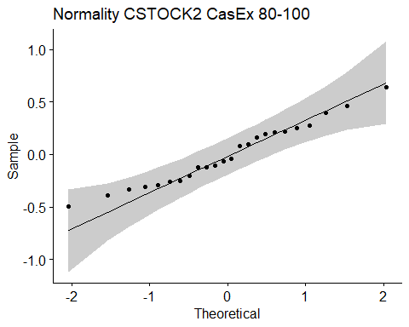

## [1] "Shapiro test for normality"  
## # A tibble: 1 × 3  
## variable statistic p.value  
## <chr> <dbl> <dbl>  
## 1 residuals(model) 0.971 0.681  
## [1] "Homoscedasticity"

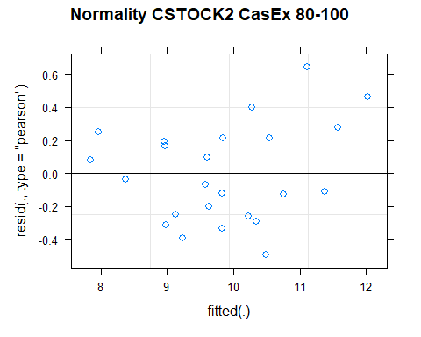

## [1] "Levene test for homoscedasticity"  
## # A tibble: 1 × 4  
## df1 df2 statistic p  
## <int> <int> <dbl> <dbl>  
## 1 7 16 0.314 0.937  
## [1] "ANOVA"  
## Treatment = CT:  
## Year emmean SE df lower.CL upper.CL .group  
## 2021 10.66 0.624 9.7 9.27 12.06 1   
## 2011 10.87 0.624 9.7 9.47 12.26 1   
##   
## Treatment = NT1:  
## Year emmean SE df lower.CL upper.CL .group  
## 2021 9.45 0.624 9.7 8.06 10.85 1   
## 2011 9.48 0.624 9.7 8.08 10.87 1   
##   
## Treatment = NT2:  
## Year emmean SE df lower.CL upper.CL .group  
## 2021 9.36 0.624 9.7 7.97 10.76 1   
## 2011 10.63 0.624 9.7 9.23 12.02 2   
##   
## Treatment = NT3:  
## Year emmean SE df lower.CL upper.CL .group  
## 2021 8.55 0.624 9.7 7.15 9.94 1   
## 2011 9.82 0.624 9.7 8.42 11.22 2   
##   
## Degrees-of-freedom method: kenward-roger   
## Results are given on the [ (not the response) scale.   
## Confidence level used: 0.95   
## Note: contrasts are still on the [ scale   
## significance level used: alpha = 0.05   
## NOTE: If two or more means share the same grouping symbol,  
## then we cannot show them to be different.  
## But we also did not show them to be the same.   
## Year = 2011:  
## Treatment emmean SE df lower.CL upper.CL .group  
## NT1 9.48 0.624 9.7 8.08 10.87 1   
## NT3 9.82 0.624 9.7 8.42 11.22 1   
## NT2 10.63 0.624 9.7 9.23 12.02 1   
## CT 10.87 0.624 9.7 9.47 12.26 1   
##   
## Year = 2021:  
## Treatment emmean SE df lower.CL upper.CL .group  
## NT3 8.55 0.624 9.7 7.15 9.94 1   
## NT2 9.36 0.624 9.7 7.97 10.76 1   
## NT1 9.45 0.624 9.7 8.06 10.85 1   
## CT 10.66 0.624 9.7 9.27 12.06 1   
##   
## Degrees-of-freedom method: kenward-roger   
## Results are given on the [ (not the response) scale.   
## Confidence level used: 0.95   
## Note: contrasts are still on the [ scale   
## P value adjustment: tukey method for comparing a family of 4 estimates   
## significance level used: alpha = 0.05   
## NOTE: If two or more means share the same grouping symbol,  
## then we cannot show them to be different.  
## But we also did not show them to be the same.   
## [1] "ANOVA plot"

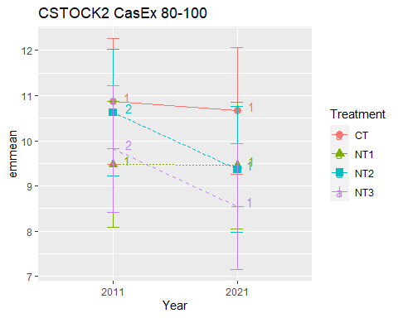

## [1] "CSTOCK2 010 Cumulated CasEx"  
## [1] "Normality"

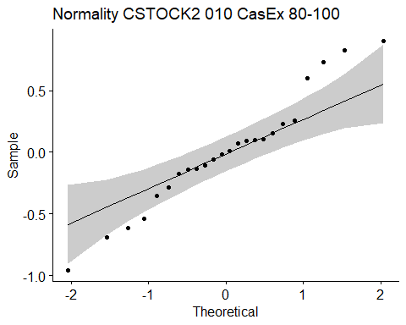

## [1] "Shapiro test for normality"  
## # A tibble: 1 × 3  
## variable statistic p.value  
## <chr> <dbl> <dbl>  
## 1 residuals(model) 0.967 0.590  
## [1] "Homoscedasticity"

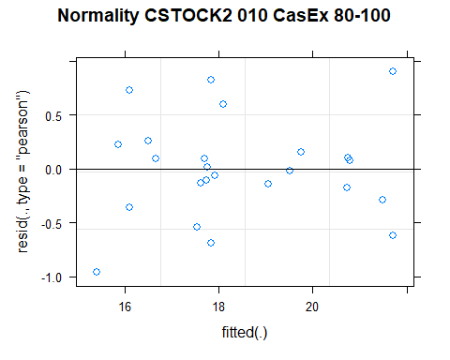

## [1] "Levene test for homoscedasticity"  
## # A tibble: 1 × 4  
## df1 df2 statistic p  
## <int> <int> <dbl> <dbl>  
## 1 7 16 0.609 0.740  
## [1] "ANOVA"  
## Treatment = CT:  
## Year emmean SE df lower.CL upper.CL .group  
## 2011 16.4 0.417 15 15.5 17.3 1   
## 2021 17.9 0.417 15 17.0 18.7 2   
##   
## Treatment = NT1:  
## Year emmean SE df lower.CL upper.CL .group  
## 2011 15.8 0.417 15 14.9 16.7 1   
## 2021 19.4 0.417 15 18.6 20.3 2   
##   
## Treatment = NT2:  
## Year emmean SE df lower.CL upper.CL .group  
## 2011 17.7 0.417 15 16.8 18.6 1   
## 2021 20.8 0.417 15 19.9 21.6 2   
##   
## Treatment = NT3:  
## Year emmean SE df lower.CL upper.CL .group  
## 2011 17.8 0.417 15 16.9 18.7 1   
## 2021 21.6 0.417 15 20.7 22.5 2   
##   
## Degrees-of-freedom method: kenward-roger   
## Results are given on the [ (not the response) scale.   
## Confidence level used: 0.95   
## Note: contrasts are still on the [ scale   
## significance level used: alpha = 0.05   
## NOTE: If two or more means share the same grouping symbol,  
## then we cannot show them to be different.  
## But we also did not show them to be the same.   
## Year = 2011:  
## Treatment emmean SE df lower.CL upper.CL .group  
## NT1 15.8 0.417 15 14.9 16.7 1   
## CT 16.4 0.417 15 15.5 17.3 12   
## NT2 17.7 0.417 15 16.8 18.6 2   
## NT3 17.8 0.417 15 16.9 18.7 2   
##   
## Year = 2021:  
## Treatment emmean SE df lower.CL upper.CL .group  
## CT 17.9 0.417 15 17.0 18.7 1   
## NT1 19.4 0.417 15 18.6 20.3 12   
## NT2 20.8 0.417 15 19.9 21.6 23   
## NT3 21.6 0.417 15 20.7 22.5 3   
##   
## Degrees-of-freedom method: kenward-roger   
## Results are given on the [ (not the response) scale.   
## Confidence level used: 0.95   
## Note: contrasts are still on the [ scale   
## P value adjustment: tukey method for comparing a family of 4 estimates   
## significance level used: alpha = 0.05   
## NOTE: If two or more means share the same grouping symbol,  
## then we cannot show them to be different.  
## But we also did not show them to be the same.   
## [1] "ANOVA Plot"

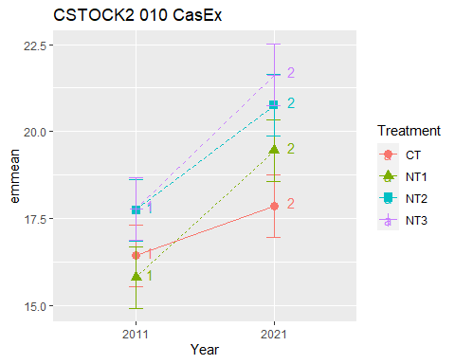

## [1] "CSTOCK2 020 Cumulated CasEx"  
## [1] "Normality"

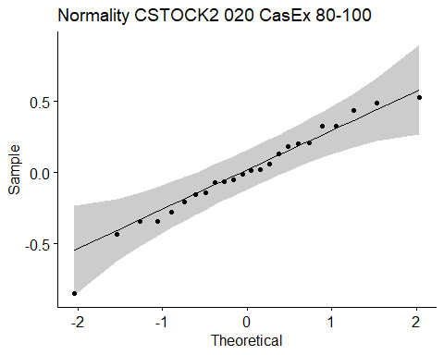

## [1] "Shapiro test for normality"  
## # A tibble: 1 × 3  
## variable statistic p.value  
## <chr> <dbl> <dbl>  
## 1 residuals(model) 0.970 0.672  
## [1] "Homoscedasticity"

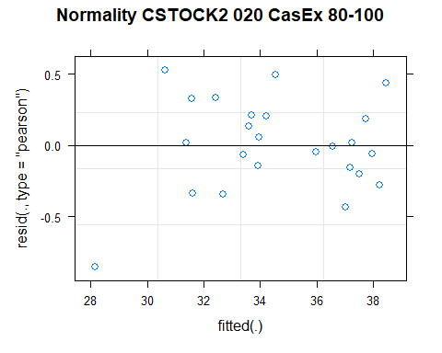

## [1] "Levene test for homoscedasticity"  
## # A tibble: 1 × 4  
## df1 df2 statistic p  
## <int> <int> <dbl> <dbl>  
## 1 7 16 0.610 0.740  
## [1] "ANOVA"  
## Treatment = CT:  
## Year emmean SE df lower.CL upper.CL .group  
## 2011 33.1 0.77 9.33 31.4 34.9 1   
## 2021 35.5 0.77 9.33 33.8 37.2 2   
##   
## Treatment = NT1:  
## Year emmean SE df lower.CL upper.CL .group  
## 2011 30.1 0.77 9.33 28.4 31.9 1   
## 2021 36.5 0.77 9.33 34.8 38.2 2   
##   
## Treatment = NT2:  
## Year emmean SE df lower.CL upper.CL .group  
## 2011 33.7 0.77 9.33 31.9 35.4 1   
## 2021 37.5 0.77 9.33 35.8 39.2 2   
##   
## Treatment = NT3:  
## Year emmean SE df lower.CL upper.CL .group  
## 2011 32.2 0.77 9.33 30.4 33.9 1   
## 2021 38.0 0.77 9.33 36.2 39.7 2   
##   
## Degrees-of-freedom method: kenward-roger   
## Results are given on the [ (not the response) scale.   
## Confidence level used: 0.95   
## Note: contrasts are still on the [ scale   
## significance level used: alpha = 0.05   
## NOTE: If two or more means share the same grouping symbol,  
## then we cannot show them to be different.  
## But we also did not show them to be the same.   
## Year = 2011:  
## Treatment emmean SE df lower.CL upper.CL .group  
## NT1 30.1 0.77 9.33 28.4 31.9 1   
## NT3 32.2 0.77 9.33 30.4 33.9 12   
## CT 33.1 0.77 9.33 31.4 34.9 12   
## NT2 33.7 0.77 9.33 31.9 35.4 2   
##   
## Year = 2021:  
## Treatment emmean SE df lower.CL upper.CL .group  
## CT 35.5 0.77 9.33 33.8 37.2 1   
## NT1 36.5 0.77 9.33 34.8 38.2 1   
## NT2 37.5 0.77 9.33 35.8 39.2 1   
## NT3 38.0 0.77 9.33 36.2 39.7 1   
##   
## Degrees-of-freedom method: kenward-roger   
## Results are given on the [ (not the response) scale.   
## Confidence level used: 0.95   
## Note: contrasts are still on the [ scale   
## P value adjustment: tukey method for comparing a family of 4 estimates   
## significance level used: alpha = 0.05   
## NOTE: If two or more means share the same grouping symbol,  
## then we cannot show them to be different.  
## But we also did not show them to be the same.   
## [1] "ANOVA Plot"

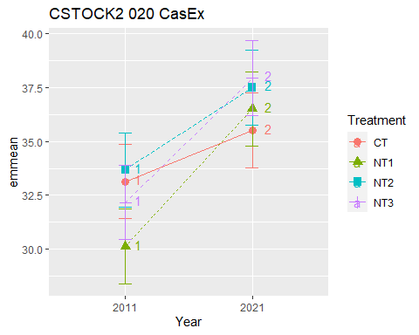

## [1] "CSTOCK2 040 Cumulated CasEx"  
## [1] "Normality"

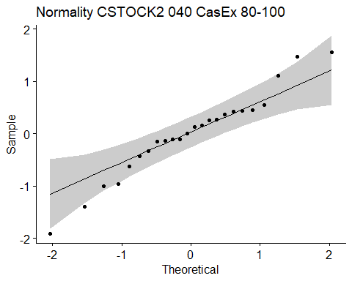

## [1] "Shapiro test for normality"  
## # A tibble: 1 × 3  
## variable statistic p.value  
## <chr> <dbl> <dbl>  
## 1 residuals(model) 0.966 0.573  
## [1] "Homoscedasticity"

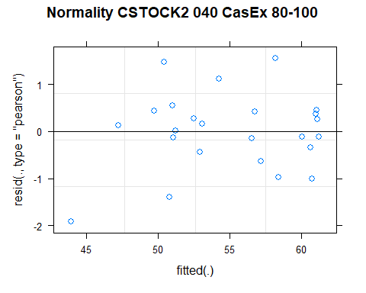

## [1] "Levene test for homoscedasticity"  
## # A tibble: 1 × 4  
## df1 df2 statistic p  
## <int> <int> <dbl> <dbl>  
## 1 7 16 0.560 0.777  
## [1] "ANOVA"  
## Treatment = CT:  
## Year emmean SE df lower.CL upper.CL .group  
## 2011 55.2 1.9 9.4 50.9 59.5 1   
## 2021 55.4 1.9 9.4 51.1 59.6 1   
##   
## Treatment = NT1:  
## Year emmean SE df lower.CL upper.CL .group  
## 2011 48.0 1.9 9.4 43.8 52.3 1   
## 2021 58.4 1.9 9.4 54.1 62.6 2   
##   
## Treatment = NT2:  
## Year emmean SE df lower.CL upper.CL .group  
## 2011 52.8 1.9 9.4 48.5 57.1 1   
## 2021 61.0 1.9 9.4 56.7 65.3 2   
##   
## Treatment = NT3:  
## Year emmean SE df lower.CL upper.CL .group  
## 2011 49.8 1.9 9.4 45.6 54.1 1   
## 2021 59.8 1.9 9.4 55.5 64.1 2   
##   
## Degrees-of-freedom method: kenward-roger   
## Results are given on the [ (not the response) scale.   
## Confidence level used: 0.95   
## Note: contrasts are still on the [ scale   
## significance level used: alpha = 0.05   
## NOTE: If two or more means share the same grouping symbol,  
## then we cannot show them to be different.  
## But we also did not show them to be the same.   
## Year = 2011:  
## Treatment emmean SE df lower.CL upper.CL .group  
## NT1 48.0 1.9 9.4 43.8 52.3 1   
## NT3 49.8 1.9 9.4 45.6 54.1 1   
## NT2 52.8 1.9 9.4 48.5 57.1 1   
## CT 55.2 1.9 9.4 50.9 59.5 1   
##   
## Year = 2021:  
## Treatment emmean SE df lower.CL upper.CL .group  
## CT 55.4 1.9 9.4 51.1 59.6 1   
## NT1 58.4 1.9 9.4 54.1 62.6 1   
## NT3 59.8 1.9 9.4 55.5 64.1 1   
## NT2 61.0 1.9 9.4 56.7 65.3 1   
##   
## Degrees-of-freedom method: kenward-roger   
## Results are given on the [ (not the response) scale.   
## Confidence level used: 0.95   
## Note: contrasts are still on the [ scale   
## P value adjustment: tukey method for comparing a family of 4 estimates   
## significance level used: alpha = 0.05   
## NOTE: If two or more means share the same grouping symbol,  
## then we cannot show them to be different.  
## But we also did not show them to be the same.   
## [1] "ANOVA Plot"

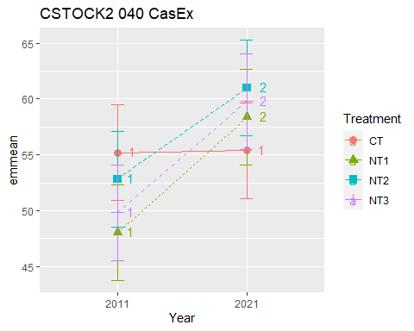

## [1] "CSTOCK2 060 Cumulated CasEx"  
## [1] "Normality"

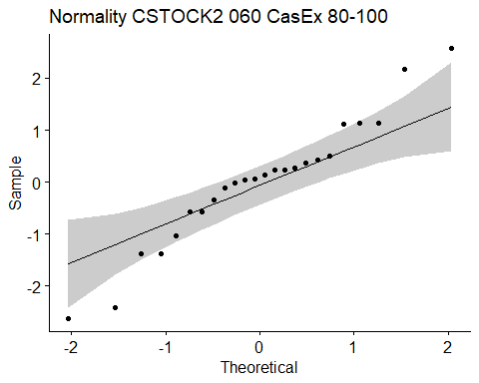

## [1] "Shapiro test for normality"  
## # A tibble: 1 × 3  
## variable statistic p.value  
## <chr> <dbl> <dbl>  
## 1 residuals(model) 0.959 0.427  
## [1] "Homoscedasticity"

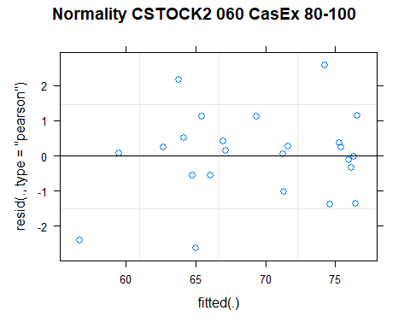

## [1] "Levene test for homoscedasticity"  
## # A tibble: 1 × 4  
## df1 df2 statistic p  
## <int> <int> <dbl> <dbl>  
## 1 7 16 0.823 0.583  
## [1] "ANOVA"  
## Treatment = CT:  
## Year emmean SE df lower.CL upper.CL .group  
## 2011 70.1 2.36 10 64.9 75.4 1   
## 2021 70.6 2.36 10 65.3 75.8 1   
##   
## Treatment = NT1:  
## Year emmean SE df lower.CL upper.CL .group  
## 2011 61.0 2.36 10 55.8 66.3 1   
## 2021 73.7 2.36 10 68.5 79.0 2   
##   
## Treatment = NT2:  
## Year emmean SE df lower.CL upper.CL .group  
## 2011 66.7 2.36 10 61.5 72.0 1   
## 2021 75.9 2.36 10 70.7 81.2 2   
##   
## Treatment = NT3:  
## Year emmean SE df lower.CL upper.CL .group  
## 2011 62.8 2.36 10 57.5 68.0 1   
## 2021 74.6 2.36 10 69.3 79.9 2   
##   
## Degrees-of-freedom method: kenward-roger   
## Results are given on the [ (not the response) scale.   
## Confidence level used: 0.95   
## Note: contrasts are still on the [ scale   
## significance level used: alpha = 0.05   
## NOTE: If two or more means share the same grouping symbol,  
## then we cannot show them to be different.  
## But we also did not show them to be the same.   
## Year = 2011:  
## Treatment emmean SE df lower.CL upper.CL .group  
## NT1 61.0 2.36 10 55.8 66.3 1   
## NT3 62.8 2.36 10 57.5 68.0 1   
## NT2 66.7 2.36 10 61.5 72.0 1   
## CT 70.1 2.36 10 64.9 75.4 1   
##   
## Year = 2021:  
## Treatment emmean SE df lower.CL upper.CL .group  
## CT 70.6 2.36 10 65.3 75.8 1   
## NT1 73.7 2.36 10 68.5 79.0 1   
## NT3 74.6 2.36 10 69.3 79.9 1   
## NT2 75.9 2.36 10 70.7 81.2 1   
##   
## Degrees-of-freedom method: kenward-roger   
## Results are given on the [ (not the response) scale.   
## Confidence level used: 0.95   
## Note: contrasts are still on the [ scale   
## P value adjustment: tukey method for comparing a family of 4 estimates   
## significance level used: alpha = 0.05   
## NOTE: If two or more means share the same grouping symbol,  
## then we cannot show them to be different.  
## But we also did not show them to be the same.   
## [1] "ANOVA Plot"

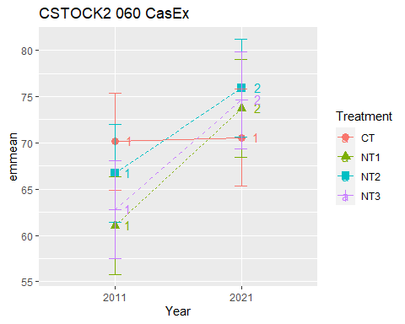

## [1] "CSTOCK2 080 Cumulated CasEx"  
## [1] "Normality"

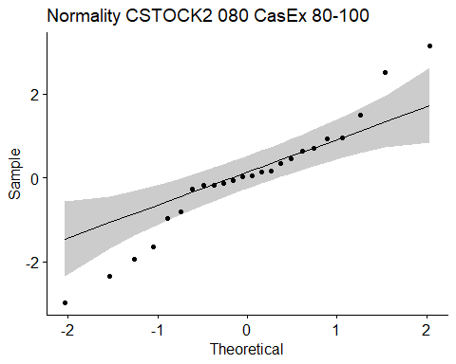

## [1] "Shapiro test for normality"  
## # A tibble: 1 × 3  
## variable statistic p.value  
## <chr> <dbl> <dbl>  
## 1 residuals(model) 0.959 0.421  
## [1] "Homoscedasticity"

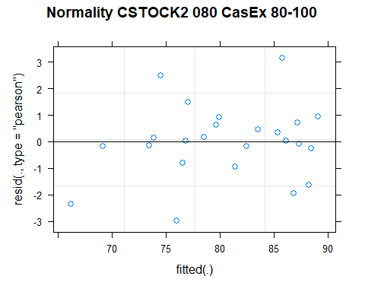

## [1] "Levene test for homoscedasticity"  
## # A tibble: 1 × 4  
## df1 df2 statistic p  
## <int> <int> <dbl> <dbl>  
## 1 7 16 0.646 0.712  
## [1] "ANOVA"  
## Treatment = CT:  
## Year emmean SE df lower.CL upper.CL .group  
## 2011 81.4 2.75 9.91 75.2 87.5 1   
## 2021 82.4 2.75 9.91 76.3 88.6 1   
##   
## Treatment = NT1:  
## Year emmean SE df lower.CL upper.CL .group  
## 2011 71.3 2.75 9.91 65.2 77.5 1   
## 2021 85.1 2.75 9.91 79.0 91.2 2   
##   
## Treatment = NT2:  
## Year emmean SE df lower.CL upper.CL .group  
## 2011 78.2 2.75 9.91 72.1 84.3 1   
## 2021 87.0 2.75 9.91 80.9 93.2 2   
##   
## Treatment = NT3:  
## Year emmean SE df lower.CL upper.CL .group  
## 2011 73.2 2.75 9.91 67.1 79.4 1   
## 2021 85.5 2.75 9.91 79.4 91.6 2   
##   
## Degrees-of-freedom method: kenward-roger   
## Results are given on the [ (not the response) scale.   
## Confidence level used: 0.95   
## Note: contrasts are still on the [ scale   
## significance level used: alpha = 0.05   
## NOTE: If two or more means share the same grouping symbol,  
## then we cannot show them to be different.  
## But we also did not show them to be the same.   
## Year = 2011:  
## Treatment emmean SE df lower.CL upper.CL .group  
## NT1 71.3 2.75 9.91 65.2 77.5 1   
## NT3 73.2 2.75 9.91 67.1 79.4 1   
## NT2 78.2 2.75 9.91 72.1 84.3 1   
## CT 81.4 2.75 9.91 75.2 87.5 1   
##   
## Year = 2021:  
## Treatment emmean SE df lower.CL upper.CL .group  
## CT 82.4 2.75 9.91 76.3 88.6 1   
## NT1 85.1 2.75 9.91 79.0 91.2 1   
## NT3 85.5 2.75 9.91 79.4 91.6 1   
## NT2 87.0 2.75 9.91 80.9 93.2 1   
##   
## Degrees-of-freedom method: kenward-roger   
## Results are given on the [ (not the response) scale.   
## Confidence level used: 0.95   
## Note: contrasts are still on the [ scale   
## P value adjustment: tukey method for comparing a family of 4 estimates   
## significance level used: alpha = 0.05   
## NOTE: If two or more means share the same grouping symbol,  
## then we cannot show them to be different.  
## But we also did not show them to be the same.   
## [1] "ANOVA Plot"

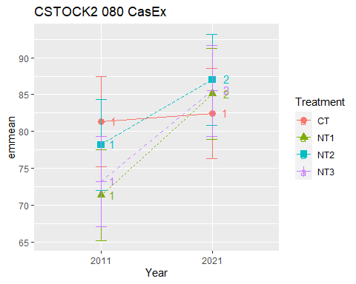

## [1] "CSTOCK2 0100 Cumulated CasEx"  
## [1] "Normality"

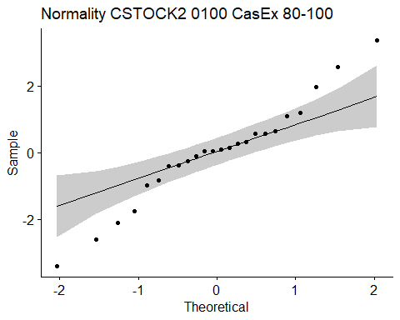

## [1] "Shapiro test for normality"  
## # A tibble: 1 × 3  
## variable statistic p.value  
## <chr> <dbl> <dbl>  
## 1 residuals(model) 0.967 0.594  
## [1] "Homoscedasticity"

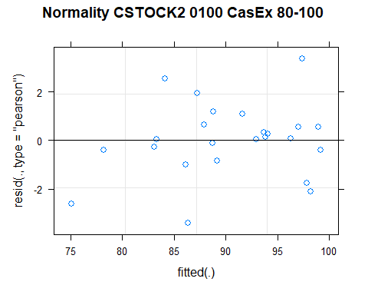

## [1] "Levene test for homoscedasticity"  
## # A tibble: 1 × 4  
## df1 df2 statistic p  
## <int> <int> <dbl> <dbl>  
## 1 7 16 0.481 0.835  
## [1] "ANOVA"  
## Treatment = CT:  
## Year emmean SE df lower.CL upper.CL .group  
## 2011 92.2 3.18 9.73 85.1 99.3 1   
## 2021 93.1 3.18 9.73 86.0 100.2 1   
##   
## Treatment = NT1:  
## Year emmean SE df lower.CL upper.CL .group  
## 2011 80.8 3.18 9.73 73.7 87.9 1   
## 2021 94.5 3.18 9.73 87.4 101.7 2   
##   
## Treatment = NT2:  
## Year emmean SE df lower.CL upper.CL .group  
## 2011 88.8 3.18 9.73 81.7 96.0 1   
## 2021 96.4 3.18 9.73 89.3 103.5 2   
##   
## Treatment = NT3:  
## Year emmean SE df lower.CL upper.CL .group  
## 2011 83.0 3.18 9.73 75.9 90.2 1   
## 2021 94.0 3.18 9.73 86.9 101.2 2   
##   
## Degrees-of-freedom method: kenward-roger   
## Results are given on the [ (not the response) scale.   
## Confidence level used: 0.95   
## Note: contrasts are still on the [ scale   
## significance level used: alpha = 0.05   
## NOTE: If two or more means share the same grouping symbol,  
## then we cannot show them to be different.  
## But we also did not show them to be the same.   
## Year = 2011:  
## Treatment emmean SE df lower.CL upper.CL .group  
## NT1 80.8 3.18 9.73 73.7 87.9 1   
## NT3 83.0 3.18 9.73 75.9 90.2 1   
## NT2 88.8 3.18 9.73 81.7 96.0 1   
## CT 92.2 3.18 9.73 85.1 99.3 1   
##   
## Year = 2021:  
## Treatment emmean SE df lower.CL upper.CL .group  
## CT 93.1 3.18 9.73 86.0 100.2 1   
## NT3 94.0 3.18 9.73 86.9 101.2 1   
## NT1 94.5 3.18 9.73 87.4 101.7 1   
## NT2 96.4 3.18 9.73 89.3 103.5 1   
##   
## Degrees-of-freedom method: kenward-roger   
## Results are given on the [ (not the response) scale.   
## Confidence level used: 0.95   
## Note: contrasts are still on the [ scale   
## P value adjustment: tukey method for comparing a family of 4 estimates   
## significance level used: alpha = 0.05   
## NOTE: If two or more means share the same grouping symbol,  
## then we cannot show them to be different.  
## But we also did not show them to be the same.   
## [1] "ANOVA Plot"

