# Order Chemo

## Page 1 – Cancer Dashboard:

**Background:**

The user has chosen a patient that is enrolled to the oncology program and navigates to the Cancer dashboard.

**Functionalities:**

1. In the breadcrumb see the name of the page.
2. In the “Current enrollment”-box see that the patient is enrolled to the oncology program.
3. Use the link “Order chemo” to get to the order chemo page.

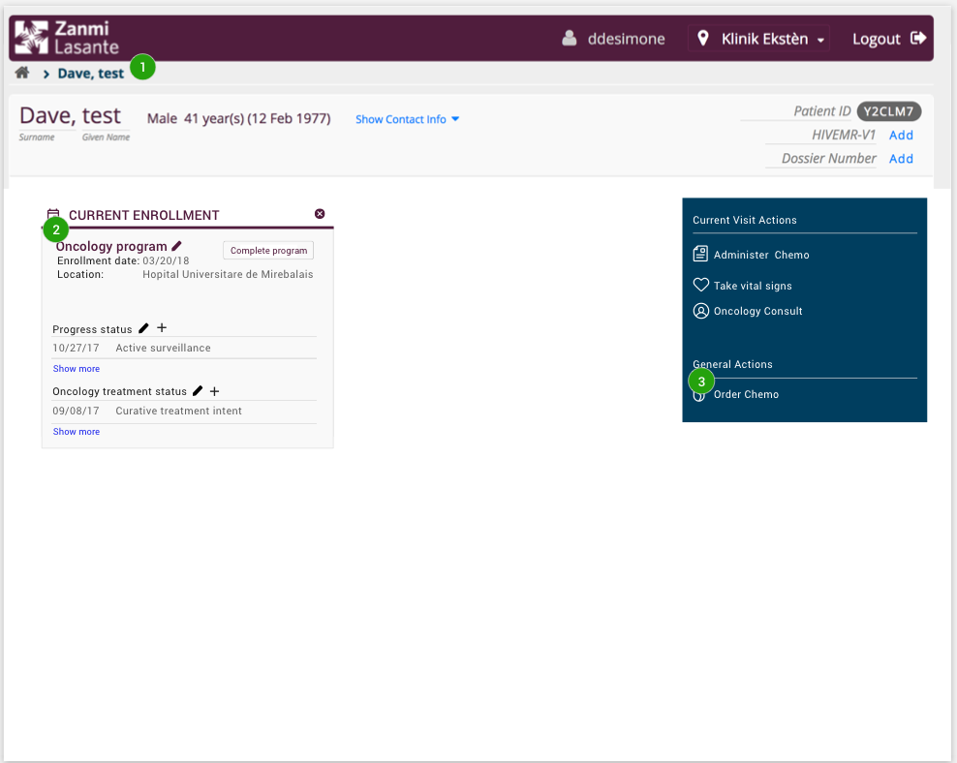

## Page 2 – Order New Chemo:

**Background:**

The patient can only have one active regimen at the time. If the patient already has an active regimen the user will receive a pop-up.

**Functionalities:**

1. A pop-up appears, informing the user that a regimen for the patient already exists.
2. The option to cancel the existing regimen and order a new one for the patient.
3. lose the pop-up and come back to the chemo dashboard again.

## 

## Page 3 – Order Chemo:

**Background:**

When pressing the “Order chemo”-link on the cancer dashboard or choosing “Cancel current and continue” option on the pop-up the doctor lands on the order chemo page.

**Functionalities:**

1. Choose between 12 different predefined regiments. At any time before pressing submit, change to another regiment. Changes done to one regiment are automatically saved.
2. Changes done to a regiment can be reset to the default one using the reset button.

For all predefined regimens, the following will be predefined:

* Cycles & Visits, When the medication should be given and for how many cycles.
* List of all pre-medications included in the chosen regimen. The name, dose, route & instructions for every premedication in the list.
* List of all chemotherapy medication included in the chosen regimen. The name, dose, route & instructions for every chemotherapy medication in the list.

1. Select one or more of the medications in the regiment and change dosage on it (them).
2. By selecting an individual medication, edit the information about the selected medication.
3. Select one or more of the medications in the regiment and delete it (them).
4. Add a new pre- and chemotherapy medication
5. Add free-text about the chemo order. The free-text written will be showed on all cycles in the regimen.
6. Press cancel and get back to the Chemo Dashboard and nothing that was done will be saved.
7. Press next and get to the review page of the chemo order.

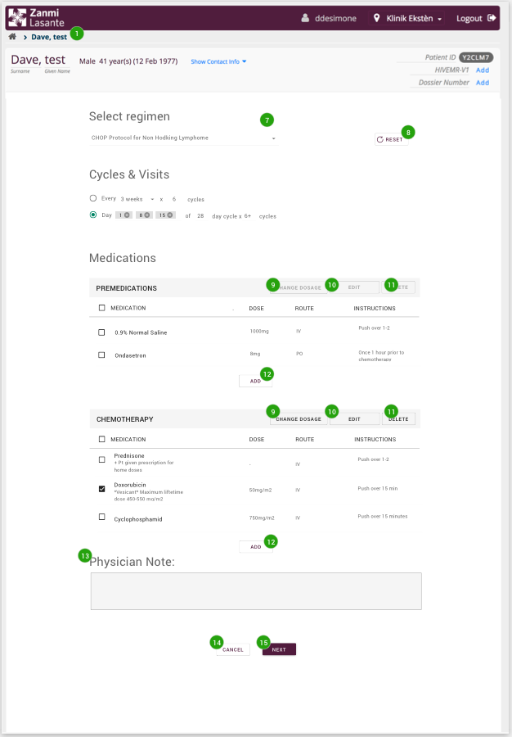

## Page 4 – Edit medication:

**Background:**

When the user selects one medication and then presses edit a pop-up will appear.

**Functionality:**

1. The title of the medication is the title of the pop-up (read only).
2. The dose and the dose unite is predefined and can be changed.
3. Dose reduction can be made up to 99%. If a medication previous had a reduction coming in to this pop-up, that will be overwritten.
4. Dose can also be increased by clicking the “I want to increase dosage”.
5. The route is predefined and can be changed to IV (Intravenous)
6. The instructions are predefined and can be changed. When changing the instructions, a drop-down will show the most common used instructions. The most common instructions are taken from the paper templates.
7. Press cancel and nothing will change.
8. Press save and the changes will be changed.

## 

## Page 5 – Reduction page using edit:

**Background:**

When the doctor has changes dosage for a medication using the “EDIT”-button and lands back on the order chemo page.

**Functionality:**

1. The reduced/increased medication will have a badge attached to it. The badge will present the reduction/increase in percentage. The badge will show a minus sign for reduced dosage and a plus sign for increased dosage.

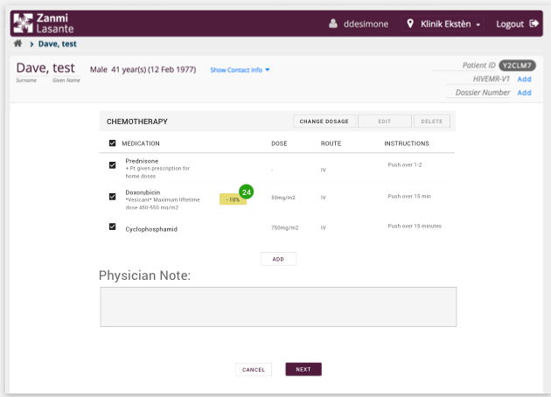

## Page 6 – Change dosage:

**Background:**

When the doctor selects one or more medications and then press the “CHANGE DOSAGE”-button on the chemo order page.

**Functionality:**

1. The title is always “Change dosage”
2. The number of selected medications will show at the top to the right of the pop-up.
3. The names of the medications are listed below the title
4. The percentage that will be reduced/increased is also listed.
5. Clicking on the percentage-bar will change the percentage number connected to the medication names.
6. Dose can also be increased by clicking the “I want to increase dosage”.
7. All medication will get the same reduction. To give an individual reduction that is done using edit from the ordering page.
8. If a medication previous had a reduction coming in to this pop-up, that will be overwritten.

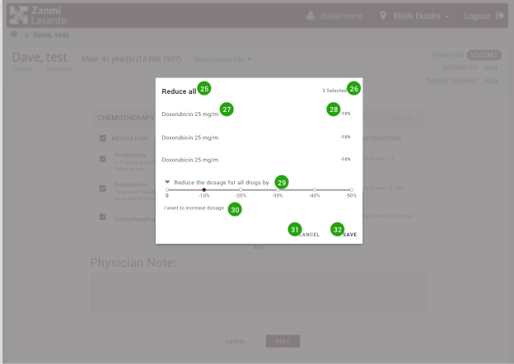

## Page 7 – Order chemo when using change dosage:

**Background:**

When the doctor has changes dosage for more than one medication using “CHANGE DOSAGE” and lands back on the order chemo page.

**Functionality:**

1. The reduced/increased medications will have a badge attached to it. The badge will present the reduction/increase in percentage. The badge will show a minus sign for reduced dosage and a plus sign for increased dosage.

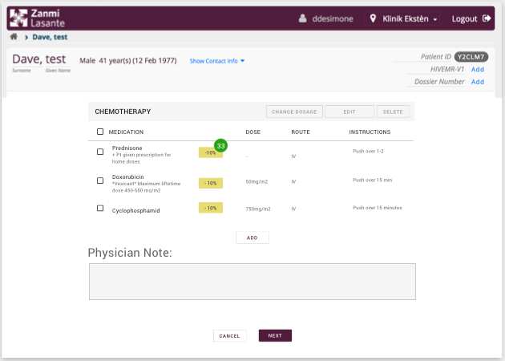

## Page 8 – Review page:

**Background:**

When the doctor is done with the order and presses “NEXT” on the chemo order page. Then the doctor lands on the review page.

**Functionality:**

1. Review what regimen that was chosen.
2. The length and number of cycles.
3. The premedication with additional information
4. The chemotherapy with additional information
5. If any reductions were made
6. The physician note

All information is read only

1. Press cancel on the review page and nothing that was done will be saved.
2. Press back on the review page and get back to the order chemo page.
3. Press submit, and the order is submitted.

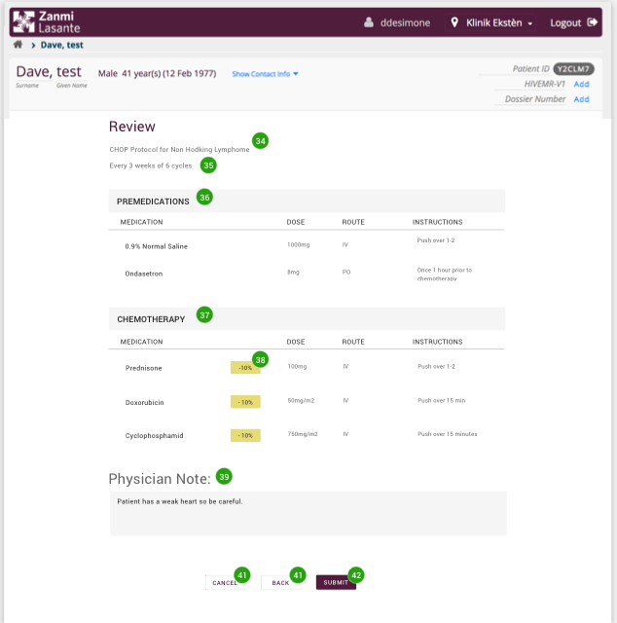

## Page 9 – Chemo Dashboard:

**Background:**

When the doctor submits the order the doctor is navigated back to the Chemo dashboard.

**Functionality:**

1. A success messages appears at the top of the page. Informing that the chemo order was successfully created.
2. A regimen box appears on the dashboard and includes information about the order that was created.
3. The information in the regimen box is the following:

* Name of the regimen
* What cycles is currently active. This will automatically be 1 direct after the order is placed.
* Physician note, will show the text the user wrote in the order. If no text was written this will only show the title.
* Last cycle date, will only show a title at this stage. When a cycle is administered, this will show the date when the administration was done by the nurse.
* Last cycle summary, will only show a title at this stage. When a cycle is administered, this will show the summery note that is required by the nurse to write after every cycle.

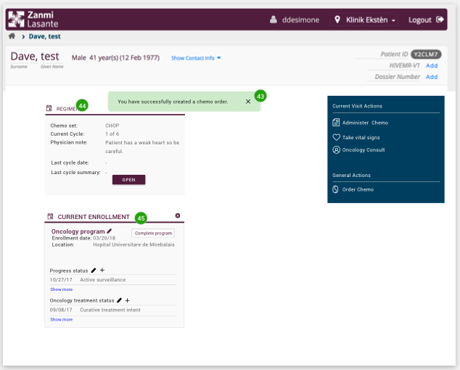

# Add administration details

## Page 10 – Chemo Dashboard:

**Background:**

A cycle for a patient is done and the nurse will document what was administered. To document what was administered the nurse navigates to the chemo dashboard for the patient.

**Functionalities:**

1. See that the patient has an active regiment in the “Regiment”-box. The regiment box gives the following information:

* Name of the regimen
* What cycles is currently active.
* Physician note, written by the doctor when the chemo order was created.
* Last cycle date, will show the date when the last cycle was administered by the nurse
* Last cycle summary, will show the summery note the nurse created for the last cycle.
* Open button that takes the nurse to the administer page.

1. Current enrollment shows that the patient is enrolled to the oncology program.
2. Use the link “Document chemo” to get to the patient regiment page.

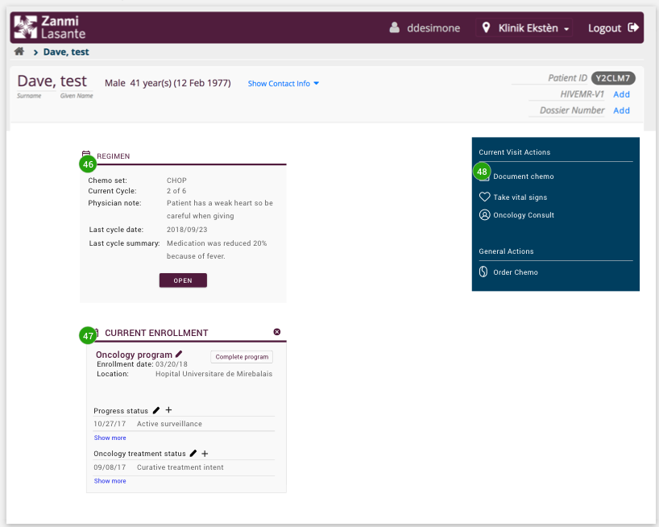

## Page 11 – Patient Regiment page:

**Background:**

When pressing the “Document chemo”-link or the “OPEN” button in the regimen box the nurse navigates to the patient regiment page.

**Functionality:**

1. See the active cycle and all the information. This includes:

* Name of regimen
* What cycle this is and the total number of cycles.
* Listed pre-medications, the names, dose, route & instructions.
* Listed chemotherapy medications, the names, dose rout & instructions.
* If there are any reductions in the regimen that is also presented.
* All text is read only.

1. The active regimen, all previous cycles that are already documented, the date for when the previous cycles were documented and the active cycle.
2. All previous regimens with connected documented cycles and the dates when the different cycles were documented.
3. If a cycle was disrupted that is displayed.
4. A button to administer the current active cycle.
5. A button to modify the chemo order.

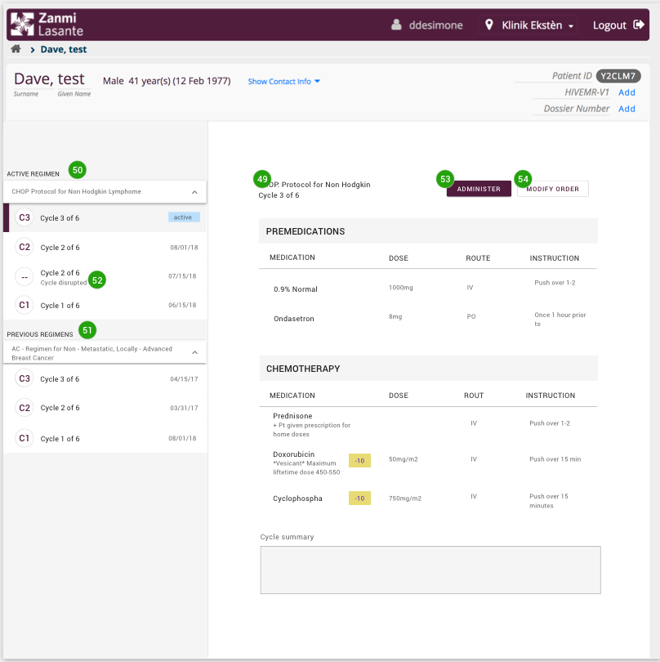

## Page 12 – Administer:

**Background:**

When pressing the “Administer” button on the document chemo page the nurse lands on the administer page where the given chemotherapy medication should be recorded.

**Functionality:**

1. See the name of the regimen
2. See what cycles it is and the total number of cycles
3. A list of all chemotherapy medication that is part of the chemo order
4. The ability to record the given dosage in mg and ml
5. Add a cycle summery that is required. If no medication were given or if anything happened during the cycle this can be recorded here.
6. The ability to mark the cycle as completed or if something happened during the cycles mark the cycle as not completed.
7. If nurse does typos and can’t submit the form a message will appear at the top of the page and explain why.
8. The nurse can cancel the administration and get back to the document chemo page.
9. The nurse can submit the administer form.

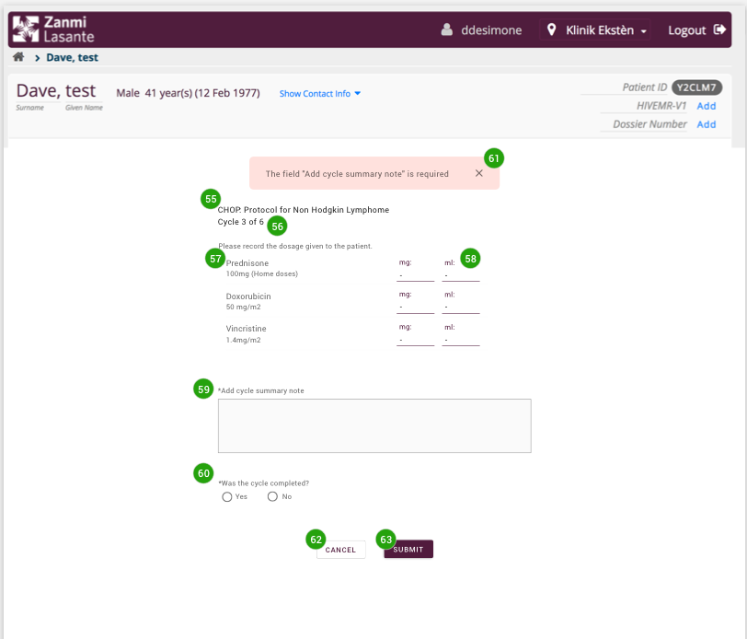

## Page 13 – Document chemo:

**Background:**

When an administration form is submitted the nurse automatically navigates back to the document chemo page.

**Functionality:**

1. A success message informing that the cycles was successfully administered and saved. The message also tells that a new cycle is created.
2. A new active cycle is created. The previous cycle is marked as finished and has a date.

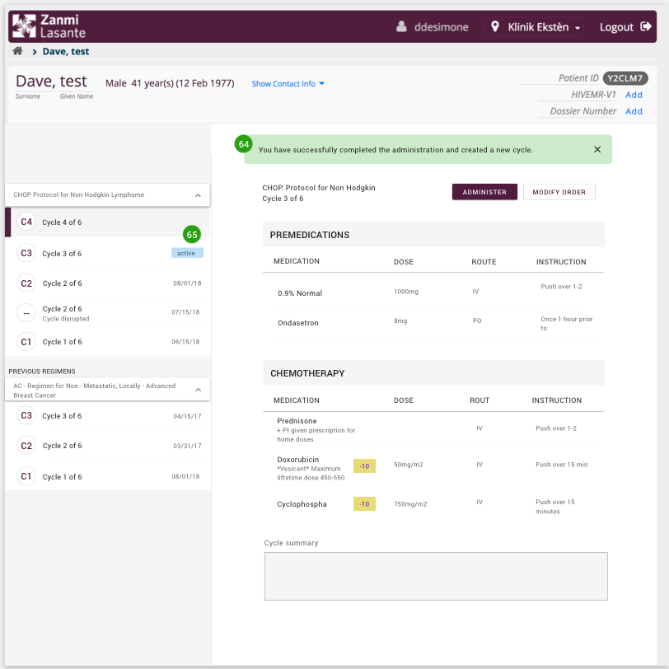

## Page 14 – Cycle completed:

**Background:**

When the user clicks on one of the not active cycles.

**Functionality:**

1. Title that says, “Cycle completed”
2. The date when the cycle was completed
3. The administrated dosage
4. A button to edit. The edit functionality is the same page as the administer page and gives has the following functionality:

* Edit the given dosage
* Edit the cycle summery note.
* Any changes will overwrite the previous.

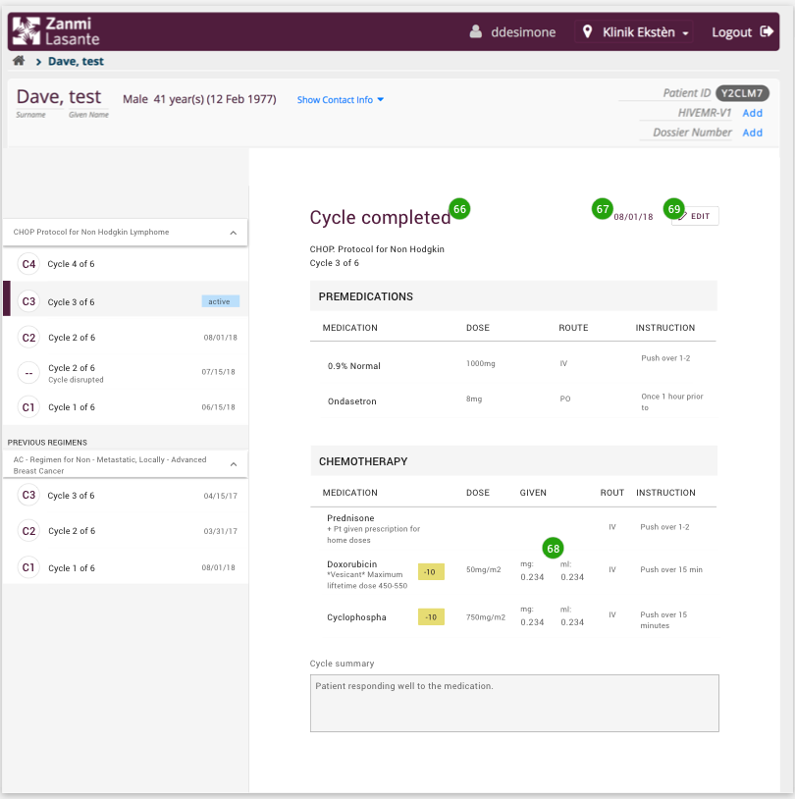

## Page 15 – Modify order:

**Background:**

When the user presses the “Modify order”-button that is located inside of the active cycle, then the user get to the modify order page.

**Functionality:**

1. See the regimen name, read only
2. See the current cycle (read only) and the total number of cycles.
3. The ability to update the total number of cycles.
4. Select on or more of the medications in the regiment and change dosage on it (them).
5. By selecting an individual medication, edit the information about the selected medication.
6. Select on or more of the medications in the regiment and delete it (them).
7. Add a new premedication
8. Add a new chemotherapy medication
9. Update free-text about the chemo order. The new free- text will overwrite the previous on all the upcoming cycles.
10. Press cancel and get back to the Document chemo page and nothing that was done will be saved.
11. Press save and all changes made will be reflected on all upcoming cycles in the regimen.
12. Press inactivate order and the chemo order is inactivated. This means that the patient does not have an active regimen.

