Working Draft: Chapter 3 and Chapter 5 Material
This document collects the writing-ready material produced while building the data pipeline for this thesis. It is organized by the chapter each section is expected to land in, following the structure recorded in WRITING_TRACKER.md. None of this is final prose — line numbers, wording, and even section order will change once the surrounding chapters exist — but the substance, the numbers, and the reasoning behind each decision are accurate as of this draft and worth keeping rather than reconstructing later from memory.

Chapter 3: Datasets and Feature Engineering

3.1 Data Acquisition and Schema Verification
Two datasets anchor this study: F-DATA, drawn from the Fugaku supercomputer, and PM100, drawn from CINECA's Marconi100 system. Both are published job-accounting traces, but they record different things, and I wanted that difference established from the schema itself rather than assumed from the papers describing them.
F-DATA arrived as 38 monthly parquet files, one per month from March 2021 through April 2024, totaling 25,866,900 job records — a number I confirmed directly from parquet metadata rather than the approximately-24-million figure quoted in the dataset's own paper. PM100 is a single file of 231,238 jobs from Marconi100, covering May through October 2020.
The original project proposal described both systems as heterogeneous CPU-GPU workloads. That framing does not survive contact with the schema. Fugaku's A64FX processors are CPU-only — there is no GPU field to speak of in F-DATA — while PM100's nodes do carry GPUs. F-DATA's columns include six hardware performance counters (labeled perf1 through perf6), a FLOP count, memory bandwidth, and an operational-intensity field, none of which appear anywhere in PM100. I searched PM100's 35 columns for anything matching flop, perf, cycle, instr, mbwidth, or opint as a final check before ruling out Roofline-style analysis there, and found nothing. The two datasets are complementary, not symmetric: F-DATA supports genuine Roofline analysis because it has the hardware counters that method needs, and PM100 does not.

3.2 Target Definitions and a Units Discrepancy
F-DATA's three prediction targets are duration (execution time), mmszu (memory used), and avgpcon (power). PM100's are run_time, mem_alloc, and node_power_consumption. PM100 has no field recording memory actually used, only requested and allocated amounts, so mem_alloc is not a preference between two options — it is the only one available.
avgpcon needed a closer look before I trusted it as a target. Its documented name, average node power consumption, implies a single node's draw, but the maximum value in a 5,000-row sample was 259,097 watts — far beyond anything a single A64FX node could draw. Restricting to single-node jobs (nnuma == 1) brought the range down to 39.6–149.9 watts, consistent with published A64FX power figures, and avgpcon correlated with the number of allocated nodes at 0.98. The field is a job-level total, summed across every allocated node and averaged over time, not a per-node figure. I checked the unit consistency a second way: dividing avgpcon multiplied by duration by the recorded energy field (econ) gave a ratio clustering around 1/3600 across the sample, which is exactly what you would expect if avgpcon is in watts, duration is in seconds, and econ is recorded in watt-hours rather than joules. The numbers are internally consistent once the units are understood correctly; the column name is just misleading about scope. This has one concrete consequence for later chapters: F-DATA's power target measures a whole job's total draw, while PM100's node_power_consumption is genuinely per-node. The two are not directly comparable, and any table that puts them side by side needs to say so.
Execution time, memory, and power are all heavy-tailed in both datasets: most jobs are short and small, and a long tail of much larger jobs pulls the mean well above the median. F-DATA's duration in a 5,000-row sample ranges from 1 second to 255,677 seconds (about 71 hours), with a median around 2,000 seconds — the kind of spread that will dominate a mean-squared-error loss if targets are trained on in raw units. All six targets across both datasets are therefore modeled in log1p space, with metrics reported back in real units afterward for interpretability. I did not assume the transform was safe; expm1(log1p(x)) was checked against the original values for all six targets and matched to within floating-point precision.
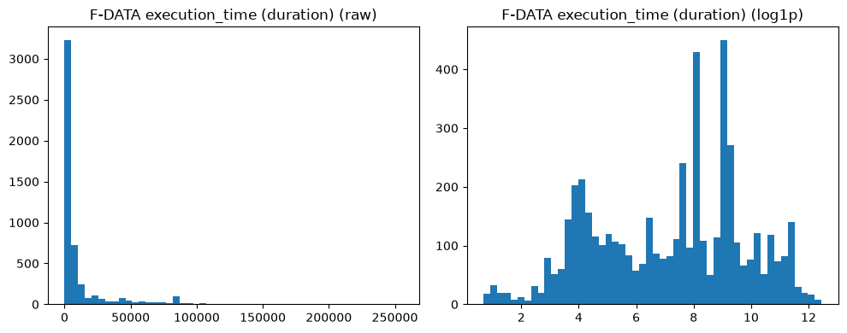
Figure 3.4. F-DATA execution time, raw versus log1p-transformed, illustrating the heavy-tailed distribution that motivates training in log space.
Only one month of F-DATA was available when this pipeline was first built; all 38 months were obtained shortly afterward. The two job-count-over-time plots below cover the full range now available for both datasets and will matter directly in Chapter 4, where the chronological train/test split depends on there being enough time span to split meaningfully.
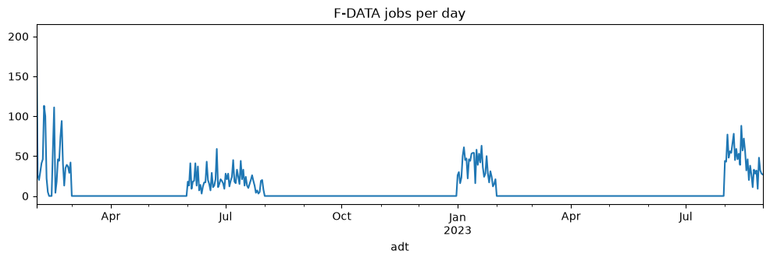
Figure 3.5. F-DATA jobs per day across the sampled files.
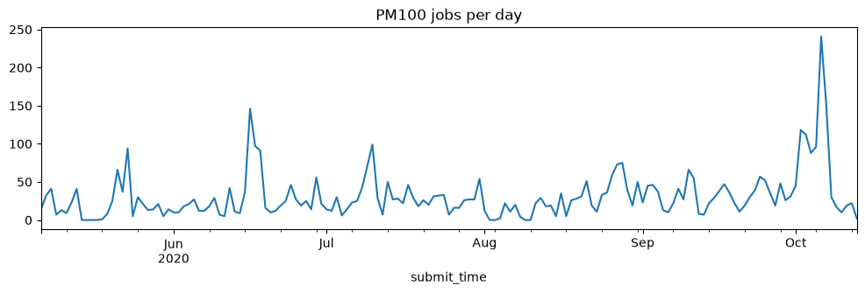
Figure 3.6. PM100 jobs per day across its full six-month span.

3.3 Submission-Time and Post-Hoc Feature Tiers
The proposal's original feature diagram feeds measured FLOPs, memory bandwidth, and power directly into a network that predicts duration and power for the same job. That is circular if the intended use case is predicting a job's behavior before it runs, since none of those measured quantities exist until the job has already executed.
I split every feature into two tiers to make this distinction impossible to blur by accident. Tier A holds only what is known at submission time: requested cores, nodes, and memory; queue and priority; requested wall time; an anonymized job-name embedding; and, for F-DATA, a rolling average of each user's recent job durations computed using only jobs strictly before the current one. Tier B holds everything measured during or after execution — allocated versus used resources, exit codes, the hardware counters, and the power fields. Tier A is what a scheduler could actually use to predict a job's behavior before running it; Tier B exists for characterizing what happened after the fact and for the residual-learning step of the hybrid model described in Chapter 4. The two tiers are built by separate functions rather than one function with a flag, specifically so that mixing them requires deliberately writing code to do it. An assertion checks for column overlap between the two lists every time the module loads, and a second assertion re-checks after every transformation step in the feature pipeline, not just once at the start.

3.4 Embedding Dimensionality Reduction
F-DATA's job-name field is anonymized and replaced with a 384-dimensional Sentence-BERT embedding. Feeding 384 raw dimensions into a random forest or gradient-boosted tree model is impractical, so the plan called for reducing it with PCA to, in the proposal's words, "a handful of components." I had originally set that handful to 10 without checking what fraction of the embedding's variance 10 components actually capture.
It turned out to be 68 percent on a single month's data — nowhere near enough to justify the number. I replaced the fixed default with an empirical check: fit PCA with up to 100 components, look at cumulative explained variance, and keep the smallest number that reaches a 90 percent threshold. On a sample drawn from one month, that threshold needed 43 components. On a sample drawn from five months spread across the full date range, it needed 59. The gap makes sense once you think about what the embedding encodes: a wider span of months carries more distinct job names and, presumably, more distinct applications, so capturing the same share of variance takes more components. The number is not fixed until a fit is done against the full 38-month dataset; treat 59 as current, not final.
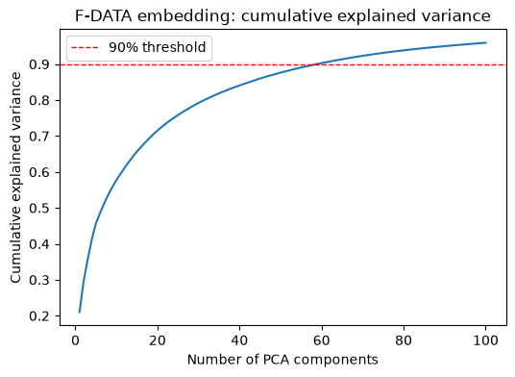
Figure 3.1. Cumulative explained variance of F-DATA's job-name embedding against number of PCA components retained, computed on a 5-file sample. The dashed line marks the 90% threshold used to select the component count.
I also decided, after an earlier round of discussion, to use the PCA-reduced embedding everywhere — for the tree-based models and for the neural network architectures alike — rather than giving the deep learning models the option of the raw 384-dimensional vector, which the original proposal allowed for. The reason is practical rather than statistical: loading the raw embedding for the full F-DATA dataset measures at over 100 gigabytes of resident memory, against roughly 27 gigabytes for every other column combined, because each row's embedding is stored as an individually allocated array rather than one contiguous block. Section 5.2 covers this measurement and the loading strategy it led to in more detail.

3.5 Feature Vetting: PM100's Missing-by-Design Fields
Three PM100 columns are Tier A candidates and all three have missing values, but at very different rates: num_tasks is missing in 4.1 percent of jobs, req_nodes in 88.6 percent, and threads_per_core in 99.6 percent. Treating all three the same way — impute and move on — would have missed what turned out to be a fairly consequential distinction, so I worked through a four-part check on each candidate before deciding whether its derived feature belonged in the active Tier A set.
The first check is simply whether the missingness reflects an optional field or an incomplete one. req_nodes, when populated, holds a specific node identifier — values like [763] or [878] — which is Slurm's explicit node-pinning flag (--nodelist). Most jobs do not ask for a particular machine, so the field is null by design for them, not because logging failed. threads_per_core is the same story: its only non-null values are 1, 2, or 4, matching Slurm's explicit hyperthreading override (--threads-per-core), a setting almost nobody touches. num_tasks has no such documented optional-flag semantics; its gaps look like ordinary incomplete logging.
The second check is effect size against the three prediction targets, using median comparisons rather than leaning on p-values alone — at roughly 180,000 completed jobs, a Mann-Whitney test will report significance for almost any difference, trivial or not. All three derived flags (node_pinned, threads_per_core_set, and num_tasks_missing) showed real median differences. threads_per_core_set showed the largest of the three by a wide margin: median run_time roughly four times higher, median memory roughly four times lower, when the flag is set.
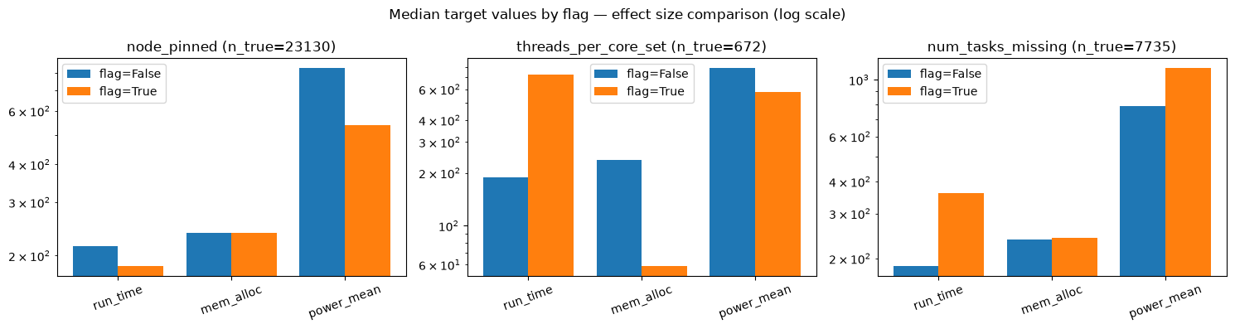
Figure 3.2. Median run_time, mem_alloc, and power for each candidate flag, true versus false, on a log scale. threads_per_core_set shows the largest separation of the three despite being the rarest.
The third check is redundancy: does an existing categorical column already carry the same information as the flag being considered? I cross-tabulated threads_per_core_set against partition, quality-of-service class, and GPU allocation. None of them explained it — the flag is set almost exclusively within the system's single dominant partition and QoS class, which is where nearly every job lives regardless, and GPU allocation among flagged jobs was close to the overall rate. Ruling out redundancy raised my confidence in the flag rather than lowering it, which is why the fourth check mattered more than I expected going in.
The fourth check is user concentration: is the signal broad, or is it a handful of individual users' behavior showing up as if it were a general pattern? Both datasets are naturally dominated by a small number of heavy users — PM100's top five account for 45.4 percent of all completed jobs, F-DATA's top five for 41.4 percent in a five-month sample — so some concentration is expected and not automatically disqualifying. The question is how much concentration is too much. node_pinned turned out to be far more concentrated than that baseline: only 19 users ever set it, and the top five account for 99.3 percent of every pinned job, 73.5 percent from one user alone. threads_per_core_set was similarly narrow: only 6 users, 85 percent of occurrences from a single one of them. num_tasks_missing, by contrast, spans 101 distinct users with the top five accounting for 47.1 percent — close enough to the dataset's own baseline that it reads as a genuine pattern rather than a few users' signature.
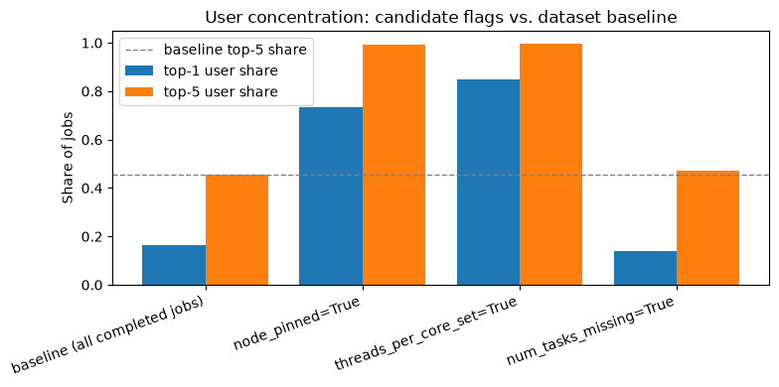
Figure 3.3. Top-1 and top-5 user share of jobs for each candidate flag, compared against the dataset's overall baseline concentration (dashed line). node_pinned and threads_per_core_set both sit well above the baseline; num_tasks_missing sits close to it.
Only num_tasks_missing passes all four checks, and it is the feature promoted into the active Tier A set. node_pinned and threads_per_core_set are both computed and kept in the processed dataset — along with the raw req_nodes and threads_per_core columns — but excluded from the general feature set, reserved for a narrower, explicitly scoped analysis later (a power-specific submodel is the most likely candidate, given threads_per_core_set's relationship to SMT settings) where the single-user-concentration caveat can be addressed directly rather than quietly inherited by every model that uses Tier A. threads_per_core_set having the largest raw effect size of the three, and still being the one excluded, is worth stating plainly: effect size on its own was not sufficient evidence, and would have been misleading without the concentration check that followed it.

3.6 Handling Incomplete Jobs
Both datasets record jobs that failed, were cancelled, or hit resource limits before completing. Their duration and power figures reflect the failure, not ordinary workload behavior, so both datasets are filtered to completed jobs only before any target is computed. F-DATA's exit-state field is a clean binary and excludes 5.1–5.6 percent of jobs depending on the sample; PM100's job-state field has six values — completed, failed, cancelled, timeout, out-of-memory, and node failure — and excludes a notably larger 21.0 percent. That gap between the two systems' failure rates is itself worth stating explicitly rather than treating the two datasets as symmetric on this point.

Chapter 5 (partial): Experimental Environment and Reproducibility
This chapter's final form will also cover model training details once those exist. The material below documents the computing environment and the memory constraints discovered while building the data pipeline, which belong here regardless of what else the chapter ends up containing.

5.1 Computing Environment
All experiments in this thesis, at least through the feature-engineering stage, run on a single workstation: an Intel i9-10900X (10 cores, 20 threads), 125 gigabytes of RAM, and an NVIDIA RTX 3090 with 24 gigabytes of VRAM. The environment is managed with uv rather than plain pip, pinned to Python 3.12 rather than the newer 3.13 available on the system. That choice was not arbitrary: numba, a dependency of the SHAP interpretability library used later in this work, does not yet build cleanly under Python 3.13. More specifically, resolving the full dependency set under the newer Python version led the package resolver to select numba 0.53.1, a version old enough that its own dependency, llvmlite, refuses to build at all above Python 3.9. The fix needed an explicit lower bound on numba in the project's dependency list; without it, the resolver's preference for a version whose metadata claims unbounded compatibility, even when that claim is stale, wins over a modern release that correctly declares its actual constraints. PyTorch is installed from the CUDA 13.0 build, matching the workstation's driver version exactly, and its GPU detection was confirmed directly rather than assumed from the installation succeeding.

5.2 Memory Constraints at Full Scale
F-DATA's 38 monthly files total roughly 26 gigabytes on disk, comfortably within the workstation's storage, but disk size is not the same question as memory footprint once loaded. Measuring one month's file directly: loading all 45 columns costs 5.54 gigabytes of resident memory, while loading the same file without the embedding column costs 1.39 gigabytes. Scaled to the full 25,866,900-row dataset, that difference becomes significant — upwards of 100 gigabytes with the embedding included, against roughly 27 gigabytes without it. Given 125 gigabytes of total RAM, the first scenario would leave little headroom for anything else running on the machine, let alone for the model training this dataset exists to support.
The inefficiency is specific to how the embedding is stored: each row's 384-dimensional vector is an individually allocated NumPy array rather than a slice of one contiguous block, which carries far more overhead per row than the memory the numbers themselves would need. The fix separates fitting the PCA transform from applying it. The transform is fit once, on a sample small enough to hold comfortably in memory, and the fitted model is then applied to one monthly file at a time in a loop, so the raw embedding for more than one month's worth of rows is never resident at once. A function that loads every other column across all 38 files without touching the embedding at all covers the case where embedding-derived features are not needed for a given step.

5.3 Notebook Execution and Monitoring
Early runs of the data-loading notebook appeared to hang for extended periods with no visible output, which turned out to have two distinct causes rather than one. The first was calling a generic describe() across a dataframe that still included the embedding column: pandas attempts to compute uniqueness and mode statistics on that column, which means comparing unhashable NumPy arrays across a million rows, and the fallback path for that is slow rather than an outright error. The second was treating PM100's node_power_consumption as if it were a single number per job, when it is in fact a time series — power sampled roughly every 20 seconds for the duration of the job, which is exactly the kind of sequence data the LSTM and TCN architectures in Chapter 4 are meant to use. Both were fixed at the source rather than worked around: the embedding column is excluded from any generic summary call, and any scalar treatment of the power column reduces the sequence to a per-job mean explicitly first.
Notebooks are now executed with papermill rather than plain jupyter nbconvert, specifically because nbconvert only writes output once execution finishes entirely, which gives no way to distinguish a slow cell from a stalled one while it is running. papermill logs each cell's start and end as it happens, which is what actually resolved the hanging-versus-slow question above rather than guesswork based on process CPU time.

