**Exercise 1** – **Tiia Iire** (Remember to fill your first and last name both here and in the file name)

Screen captures of the code Exercise1.py:  
1. 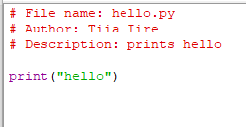

2. 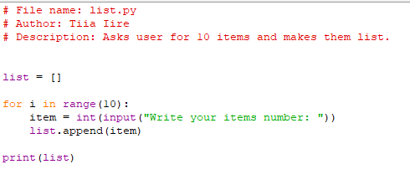

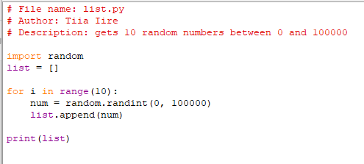

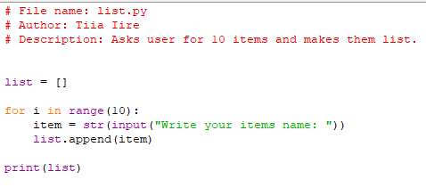

3. 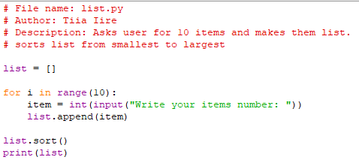

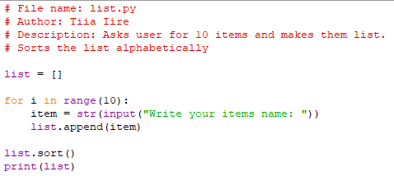

4. 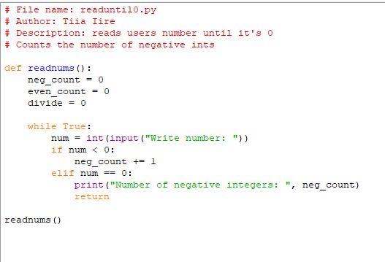

5. 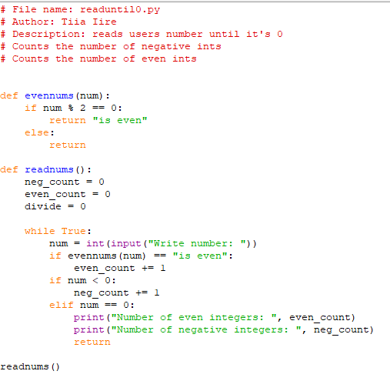

6. 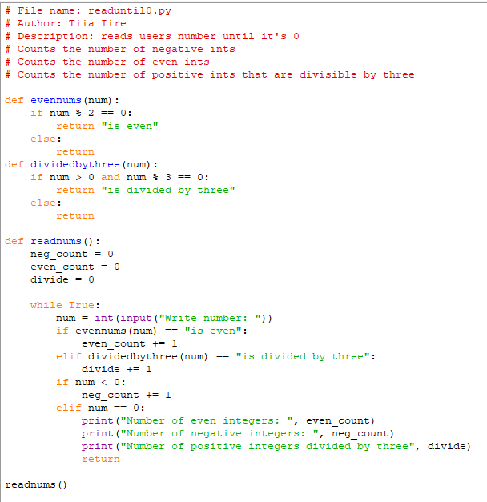

7. 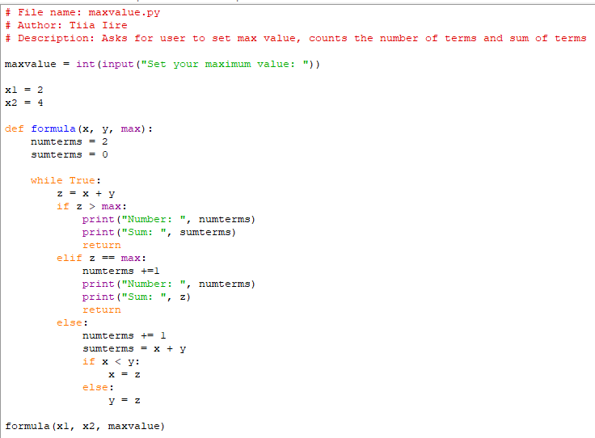

8. 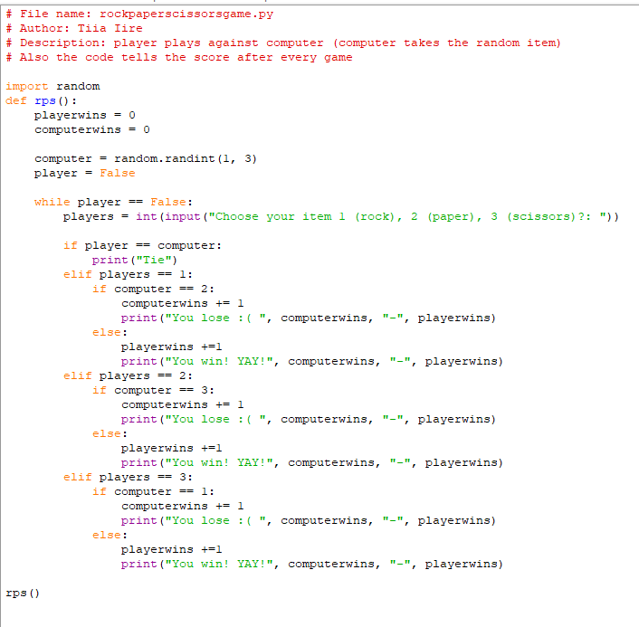

9. 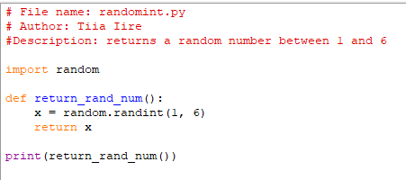

Screen capture of the output:

1.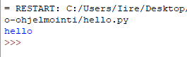

2.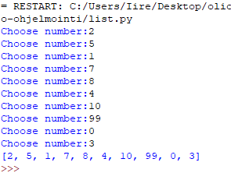

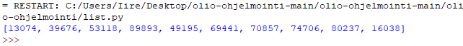

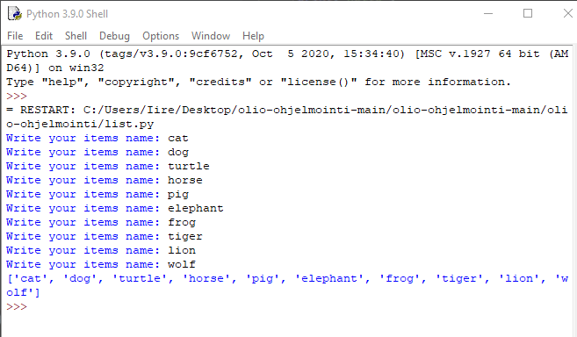

3.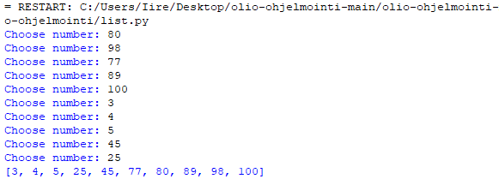

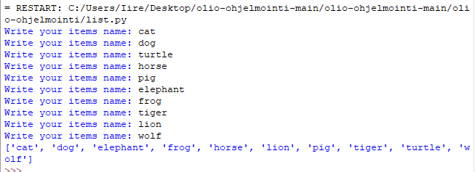

4.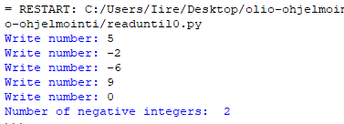

5.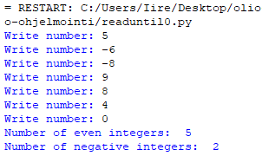

6.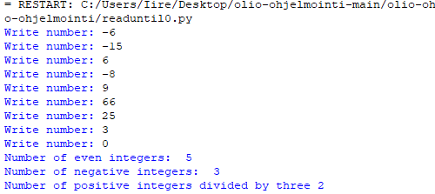

7.

8.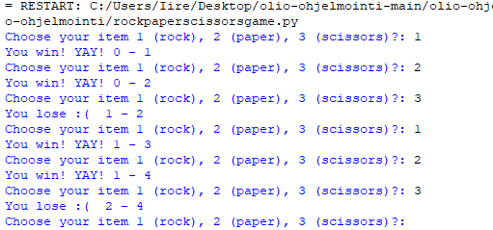

9.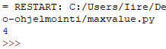

10.

1. Procedural programming
2. Functional programming  
   perustuu funktioiden käyttöön, arvoksi tulee aina sama jos käytetään samoja parametreja, eli funktionaalisella ohjelmoinnilla ei ole sivuvaikutuksia.
3. Object oriented programming   
   on luokkapohjaista sekä prototyyppipohjaista olio-ohjelmointia: luokkapohjaisessa oliot saavat tilan ja toiminnallisuuden luokan jäsenien mukaan ja prototyyppipohjaisessa ne saa toiminnallisuuden prototyyppiolioilta.
4. Class (in programming)  
   määrittelee olion tyypin.
5. Object (in programming)

Olio = tietorakenne jossa on tieto ja toiminnallisuus.

1. Instance(in programming)  
   määrittelee luokan muuttujille tietyt ”arvot”
2. Encapsulation(in programming)

kokoaa tiedot yhdeksi kokonaisuudeksi, kuten esim. luokaksi

Screen capture of the Git status:

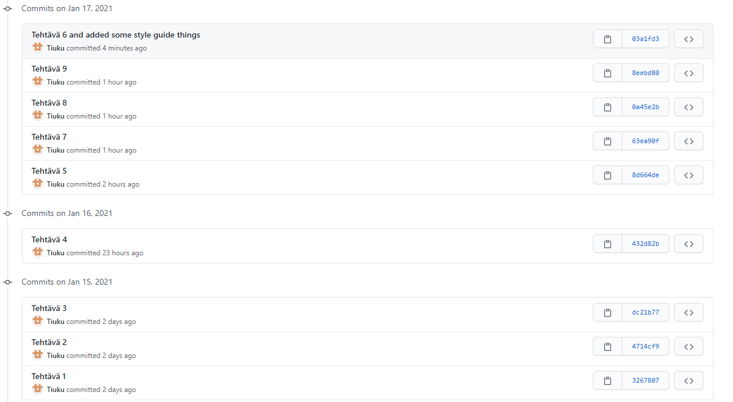

Self-assessment:

This exercise was easy/difficult for me because some of the exercises were easy because I have done some similar things. The rock paper scissor game was quite easy, because I did one game at autumn already and also I am quite good at if-functions already. Most difficult was to add function to another task, because I totally had forgotten how to “link” functions for another. But I asked help for a friend and now I remember it again. Also using Gitt was quite easy for me cause I have been using it already many times.

Doing this exercise, I learned how to link functions for another. Also I learned how to google efficiently to find some help for my exercises

I am still wondering what is procedural programming in finnish.

I understood that asking for help could end up so that friend finds just a little typo from my code which made the error.

I had some troubles with my internet connection so I made the last commits at the same time. (I did not have any internet connection for a while so I could not do them after every task).