Laravel

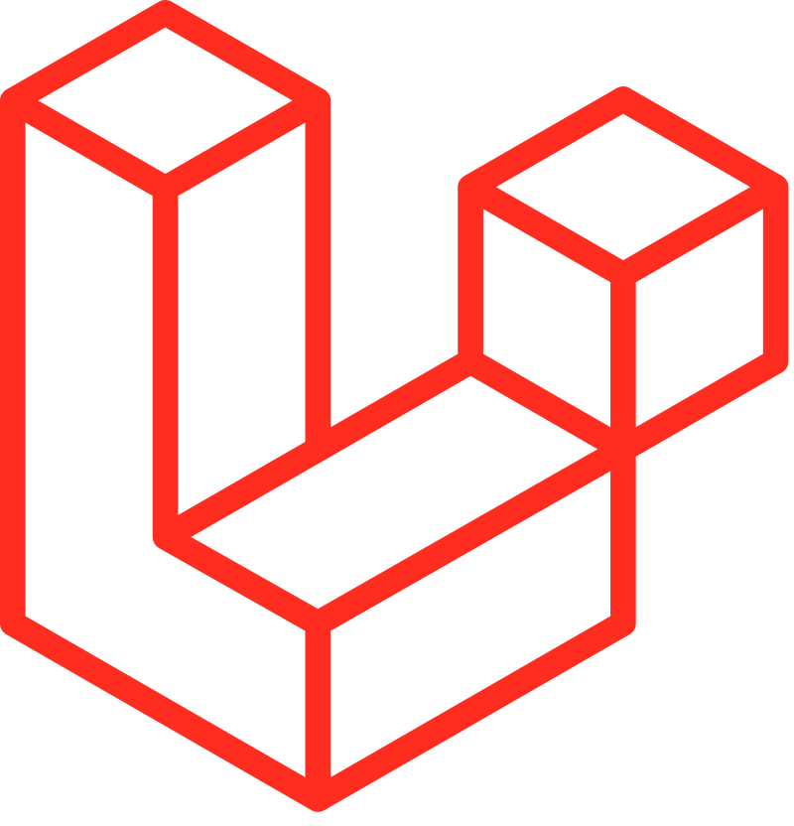

# [Introduction](https://laravel.com/docs/11.x)

## What is the Laralvel?

* + A free, open-source PHP framework provides tools and resources for building modern web applications. It's a popular back-end framework that comes with features for building web apps at scale, such as:
    1. Routing
    2. Validation
    3. File storage
    4. Model-view-controller (MVC) architecture
    5. Artisan command-line interface (CLI)
    6. Native authentication
    7. Eloquent object-relational mapper (ORM)

## Before can start the Laravel

* + Install the [VSCODE](https://code.visualstudio.com/)
  + Install the [composer](https://getcomposer.org/download/)
  + Install the [XAMPP](https://www.apachefriends.org/download.html) server

## [Create](https://laravel.com/docs/11.x) project Laravel

* + composer create-project laravel/laravel *example-app*
  + composer create-project laravel/laravel:^10.0 example-app

## Run to chrome

* php artisan serve

## Run Laravel to Chrome

* **php artisan serve**
  + The port run of Laravel is 8000
* how change port: **php artisan serve --port=8001**

## Commands

* Check the php version: **php –v**
* Check the laravel version: **php artisan --version**

## What is composer

* Composer is a tool for dependency management in PHP.

## Route, Controller, model, and migration

* Route is way to show data or run code to execute.
* Controller is a file that connects between model and migration.
* Model is a file that is used for storing the method and query data
* Migration is a feature in Laravel that allows users to create, modify, and share a database schema without using a database manager.

## Tinker, Seeder, and Factory

* Tinker is for interactive debugging and testing
* Seeders are for populating databases with test data
* Factories are for generating fake data for testing purposes.

## Call route and create a route

* Route::get('/user',[UserController::class,'index']);

## Create file

* php artisan make:*folder* *file*

## Create file model and migration

* + php artisan make:*model* *model_file* *–m*

## Create file mcr

* php artisan make:model Todo -mcr

## What should we do before sent the project to anyone?

* Delete the vendor

## What should I do before can start the code after download

* Composer install

# Connect to the database with Laravel

## Connect to database(MySQL)

* Go to the **.env** file to connect the database
  + 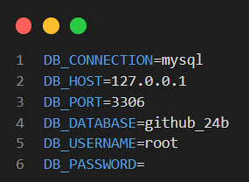

## What is .env?

* a configuration file used for storing sensitive information and environment-specific settings. It's a simple text file where you define key-value pairs, with each pair representing a configuration option.
* Secret keeper for your web application.
* It holds important information that your app needs to run smoothly, like passwords, database details, and API keys.

## Data type

* String
* Text
* Integer
* Boolean

## Run migrate

* **php artisan migrate**

## Fresh

* php artisan migrate:fresh

## [Add a new column to existing table in migration](https://stackoverflow.com/questions/16791613/laravel-add-a-new-column-to-existing-table-in-a-migration)

* php artisan make:migration add_paid_to_users_table --table=users
  + 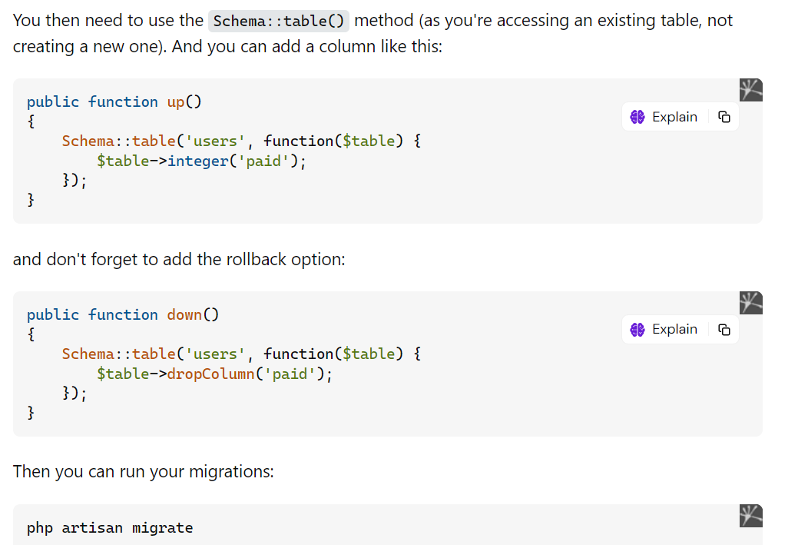

## Create a controller with API

* php artisan make:controller Api/*FileNameController* --api

## How to test in postman

* In code API : Route::get('/student/list',[StudentController::class,'index']);
* In Postman: http://127.0.0.1:8000/api/student/list

## Import and create route in api.php

* use App\Http\Controllers\Api\StudentController;
* Route::get('/student/list',[StudentController::class,'index']);

## Eloquent in Laravel

* Eloquent is an object-relational mapper (ORM) included with Laravel, providing a simple and beautiful ActiveRecord implementation for working with databases.
* 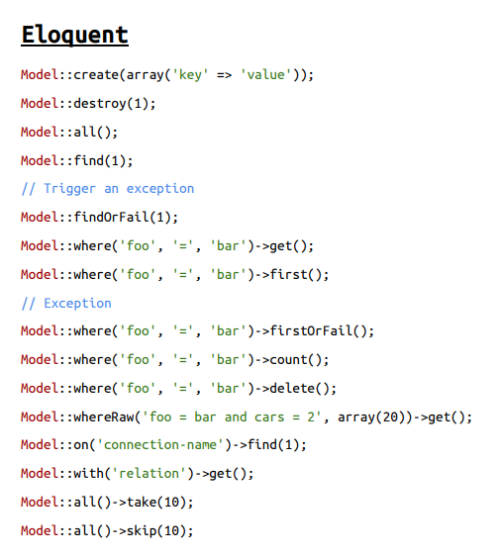

## softDeletes()

* SoftDeletes are a feature that allows you to mark a record as “deleted” without actually removing it from your database.
  + 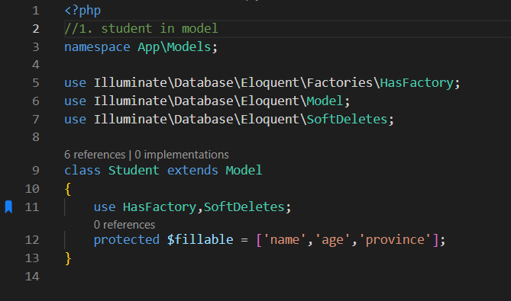
  + 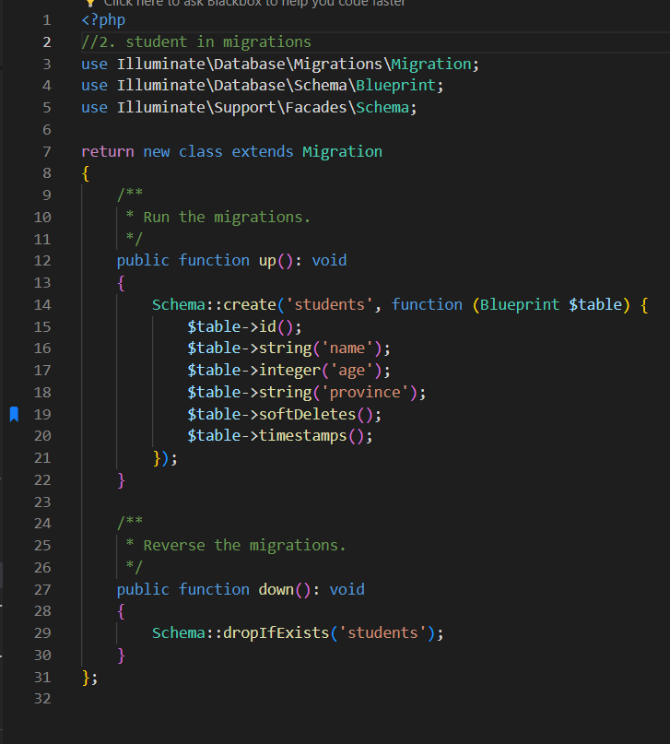

# Laravel with GitHub

## Before pushing the code to git

* Delete the folder ***vendor***

## After cloning the code

* Command to install the vendor folder: ***composer install***
* Copy the file .env example and rename to .env
* Connect the database in .env
* php artisan key:generate
* php artisan migrate
* php artisan db:seed (if you have a seeder)

## [Eloquent: API Resources](https://laravel.com/docs/11.x/eloquent-resources)

## What is api resources

* In Laravel, API resources are a way to transform models and model collections into JSON responses.

## Create API Resources

* php artisan make:resource NameResource

# Leravel view

## What is the view of Laravel?

* The view is a component responsible for rendering the HTML content of your application. Views are typically written in Blade, Laravel's powerful templating engine, which allows for writing clean and dynamic HTML code.

## How to create the file

* Create the begin start with lowercase and have .*blade*.php: filename.blade.php

## Access file

* We need to create a route to access the file

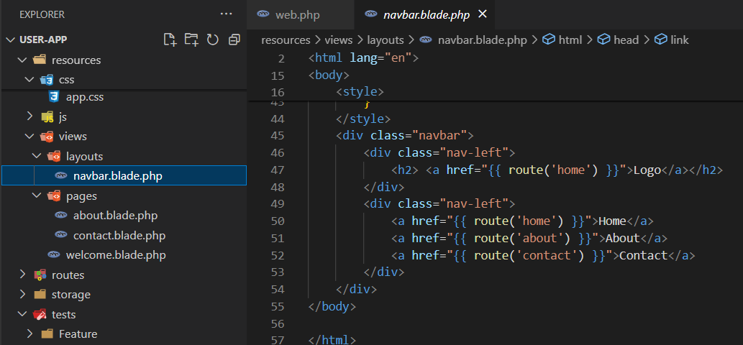

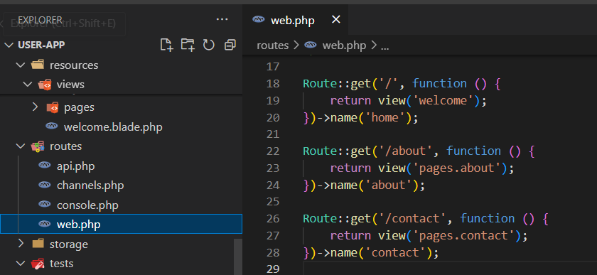

# Validation with request

## What is validation?

* The action of checking or proving the validity or accuracy of something.

## What is a request?

* Request is an object-oriented way to interact with the current HTTP request being handled by an application. The Illuminate\Http\Request class provides methods for examining the request and retrieving input, cookies, and files that were submitted with it.

## Create request

* php artisan make:request NameRequest
* way one:
  + 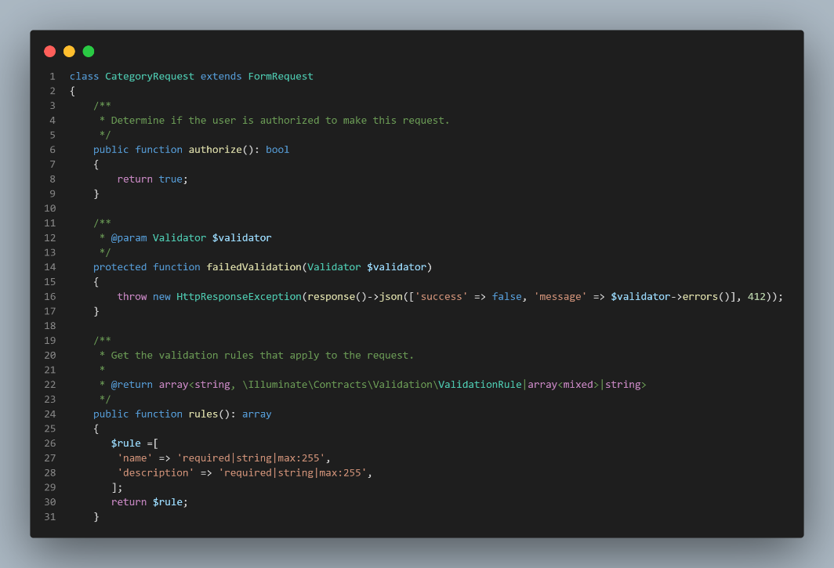
  + 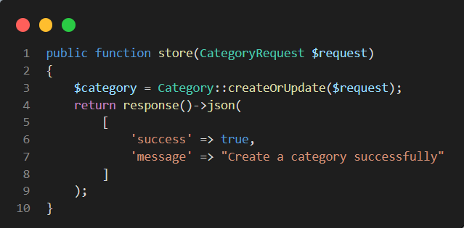

nn

* Way two:
  + 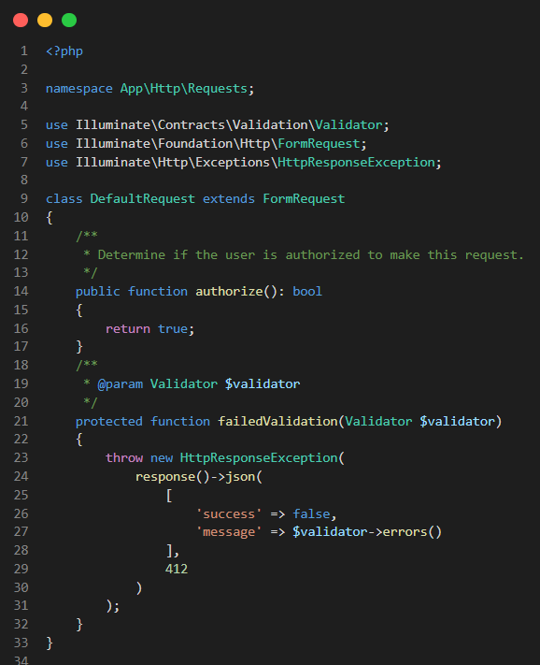
  + 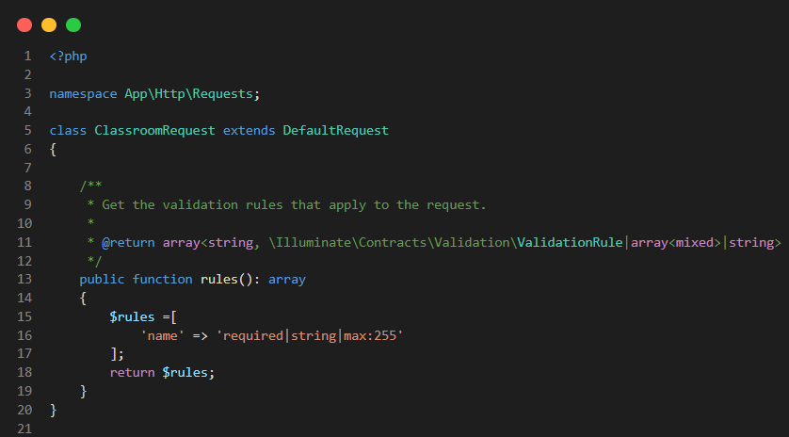

nn

* + 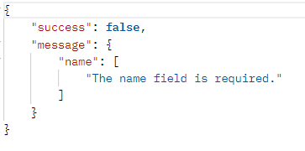

# Upload image in api

## Before can start

* php artisan storage:link

## Example

* 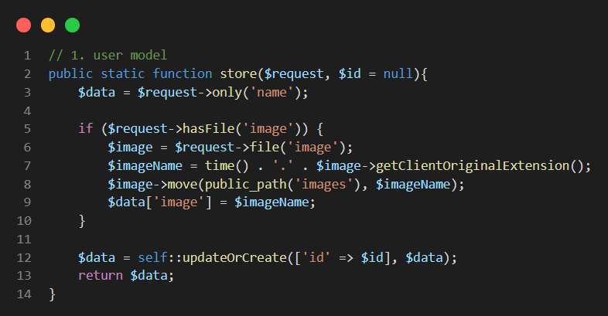
* 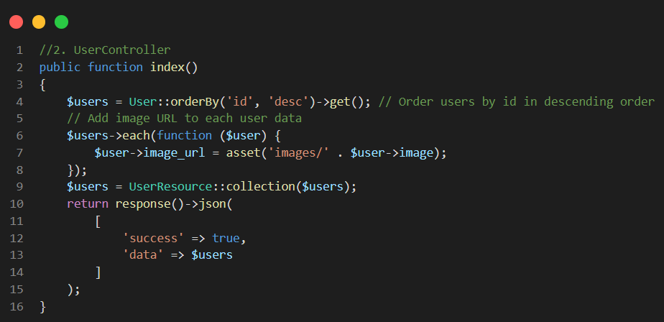

# Dfkldf

# Fd’

# Fd

# Hfd

# Jbd]h

# Jfbsh

# Jbs

# jdst