Laravel-Quiz 2

1. Laravel is a popular PHP web framework that employs the Model-View-Controller (MVC) architectural pattern.
2. MVC
   * M stands for model
   * V stands for view
   * C stands for controller
3. Query Builder provides a graphical user interface for creating SQL queries.
4. Laravel Eloquent is an object relational mapper (ORM) that's built into the Laravel PHP framework. It simplifies database interactions by representing data as objects and providing an intuitive syntax for common database operations
5. Laravel's default .env file contains some common configuration values that may differ based on whether your application is running locally or on a production web server.
6. Migrations are like version control for your database, allowing your team to modify and share the application's database schema.
7. A seeder in Laravel is a class used to insert data into the database by running a command.
8. Blade template files use the .blade.php file extension and are typically stored in the resources/views directory.
9. In Laravel, a factory is a class that generates test data for models, allowing you to test your application without using real data. Factories are closely tied to Laravel's data models, so you can define the data's attributes and relationships.
10. An API, or Application Programming Interface, is a set of defined rules that enable different applications, services, or systems to communicate with each other.
11. What is end-point, method, request-body, and handle error validation and respond?
    * An end-point in the context of web development refers to a specific URL or URI (Uniform Resource Identifier) that is used to access a particular resource or perform a specific action.
    * The request body is a part of an HTTP request that contains data that needs to be sent to the server.
    * Error validation refers to the process of checking and validating the data or input received from a client to ensure that it meets certain criteria or requirements. When handling error validation in the context of a RESTful API, there are several approaches that can be taken.
    * Response refers to the information that is returned to an application or client after making a request to an API.
12. The method “Post” to use when I want to create new Post
13. Why you need to use Resource and Request and getAttribute in Laravel?
    * Laravel API Resources provide a transformation layer between models and JSON responses. They allow you to expressively and easily transform models and collections into JSON structures.
    * The request class represents an HTTP request made to your application. It provides methods for accessing request data, such as query parameters, form data, and headers.
14. A Compact() is a handy helper function in Laravel that allows you to create an array with variables and their corresponding values.
15. list down at least 10 query builders and Laravel Eloquent.
    * $users = DB::table('users')->skip(10)->take(5)->get();
    * $users = DB::table('users')->cacheTags(['people', 'authors'])->remember(10)->get();
16. The whereHas() method is a versatile tool within Laravel's Eloquent ORM that enables you to filter query results based on the existence of related models.
17. The types at 10 in Laravel
    * $table->string('name');
    * $table->integer('age');
    * $table->boolean('is_active');
    * $table->text('description');
    * $table->date('birthdate');
    * $table->dateTime('created_at');
    * $table->decimal('price', 8, 2); // 8 digits total, 2 decimal places
    * $table->float('rating', 8, 2); // 8 digits total, 2 decimal places
    * $table->json('options');
    * $table->enum('status', ['pending', 'approved', 'rejected']);
18. The $table->integer('age')->nullable()->default(0):
    * $table->integer('age')
      1. This part of the statement creates a new column named age in the table.
      2. The column type is integer, meaning it will store integer values.
    * ->nullable()
      1. This method makes the age column nullable, which means it can contain NULL values.
      2. If no value is provided for the age column when inserting a record, it will default to NULL unless a default value is specified.
    * ->default(0)
      1. This method sets the default value of the age column to 0.
      2. If no value is provided for the age column when inserting a record and the column is not set to NULL, it will automatically be assigned a value of 0.
19. The web.php file is used for defining routes that are intended for web-based interactions. These routes typically serve HTML content, utilize sessions, and are protected by CSRF (Cross-Site Request Forgery) tokens.
20. Relationship Laravel
    * one to one

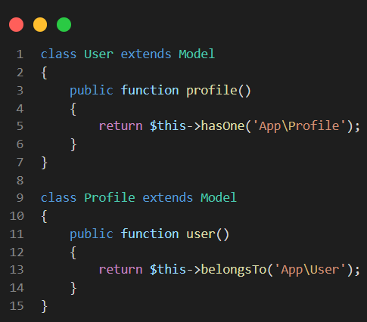

* + one to many

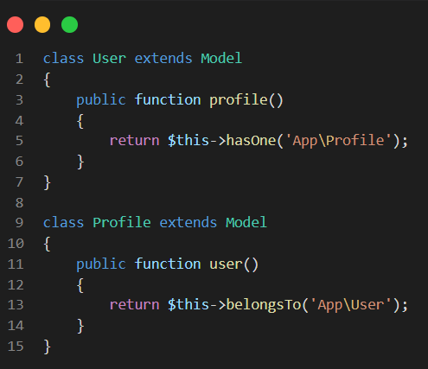

* + many to many

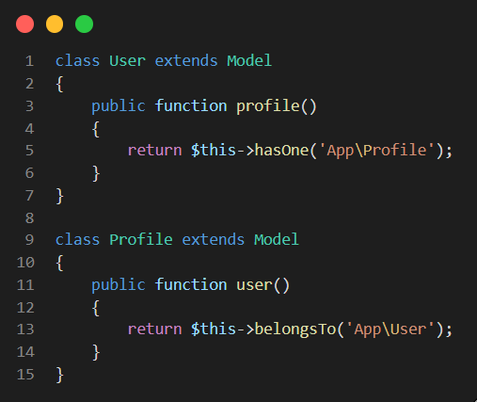

1. The Route::apiResource and Route::resource methods in Laravel are used to define RESTful routes for your application. They create a set of conventional routes that correspond to the typical CRUD operations (Create, Read, Update, Delete) for a given resource.
2. "php artisan route:list" and "php artisan install:api"
   * php artisan route:list : To list all the registered routes in your application. When you define routes in Laravel, they are typically stored in the routes directory of your project.
   * php artisan install:api : To install the API route.
3. A redirect is a response that instructs the browser to visit a different URL. In web development, redirects are commonly used to direct users from one route to another.
4. Clean the code using Route Prefixes

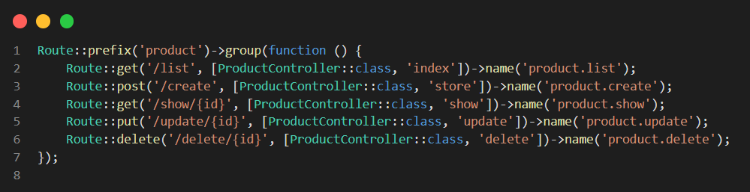

1. The difference between "php artisan migrate" and "php artisan migrate:fresh"
   * php artisan migrate used to create the tables to database
   * php artisan migrate:fresh use to fresh datas’ table if the change or add a new entity
2. The “protected $fillable” property is used to specify which model attributes can be mass-assigned.
3. The protected $hidden property is used to specify which attributes of a model should be hidden when the model is serialized to an array or JSON.
4. The protected $casts property allows you to specify how certain attributes should be cast to native PHP data types when interacting with the model.
5. The SoftDeletes feature is used to implement soft deletion of database records.
6. The composer.json file is a key component of PHP projects managed with Composer, a dependency manager for PHP.
7. A README.md file is a markdown file that provides essential information about a project.