PHP



1. Created in **1994** by **Rasmus Lerdorf**, the very first incarnation of PHP was a simple set of Common Gateway Interface (CGI) binaries written in the C programming language.
2. PHP stands for **Hypertext Preprocessor.**
3. PHP is a programming language used to script websites that are dynamic and interactive.
4. The GET method in PHP is used to retrieve data from a web server.
   1. Here's how the GET method works:
      1. Data is submitted from an HTML form
      2. The data is collected using a super global variable called $_GET
      3. The encoded information from the form is sent through the webpage URL

# Introduction

## What is the PHP?

* PHP stands for **Hypertext Preprocessor.**
* PHP is a programming language used to script websites that are dynamic and interactive.

## Before can start the PHP?

* Install the VSCODE
* Install the XAMPP
* [Install the PHP](https://www.php.net/downloads)

## Command in PHP

* Check the version: php -v
* Run the code: php -S localhost:8000

## Echo in terminal

* php filename.php

## What is XAMPP?

* A free, open-source web server platform that allows developers to test code locally on their computers

# Web sever

## Isset()

* Determines if a variable is declared and is different than null.
  + 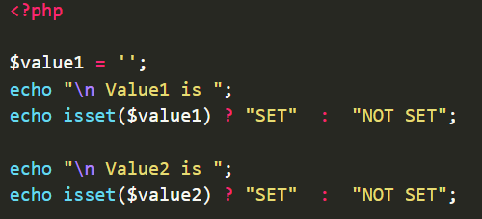

## require_once()

* require_once statement includes and evaluates the specified file during the execution of the script.

## $GET

* We use **GET** to **get data** from the server
* The the data from input we get by name=””.

## $POST

* We use **GET** to **get data** from the server

## The different between the $GET and $POS.

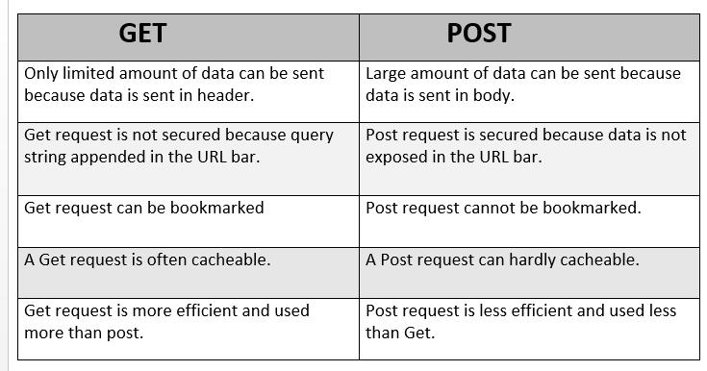

## Secure input form.

* htmlspecialchars is a function converts some predefined characters to HTML entities.
  + 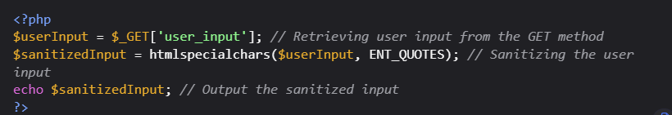

## Ggdf

## gf

## dsds

# Connect to SQL sever

## Connect to database

* We can many ways to connect to database.
* 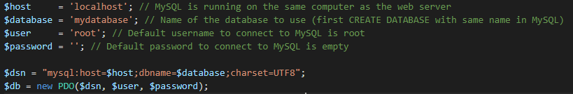

## Execute the query

* The **$db->query()** will execute a SQL query from PHP code
* 

## **Get results** from query

* The  **fetchAll()** function returns an array of associative arrays of query results
* 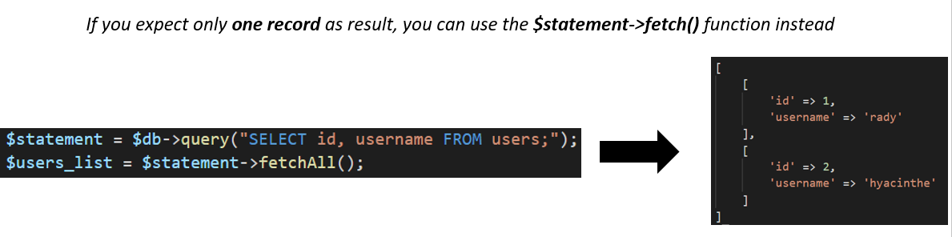

# MVC

## What is MVC in php?

* Model-View-Controller (MVC) is a software design pattern that organizes an application's logic into distinct layers, each with a specific purpose.
* 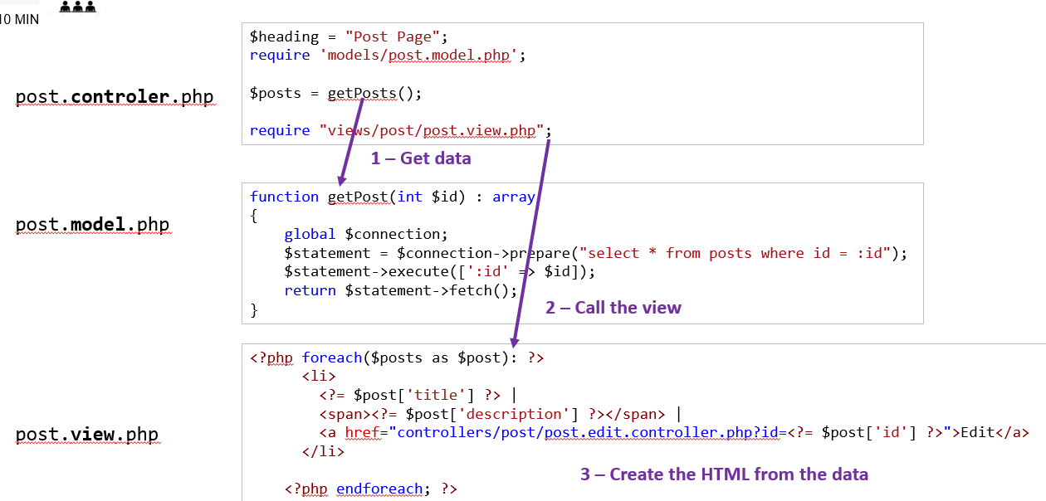

## Model

* The Model represents the application's data and business logic. It is responsible for interacting with the database, processing data, and performing data validations.
* The Model component is focused on managing the application's data and ensuring its integrity.

## View

* The View is responsible for presenting the data to the user in a specific format, typically as HTML pages. It handles the visual representation of the data.
* In the context of PHP, the View can be a complete web page or a page fragment, such as a header or footer.

## Controller

* The Controller acts as an intermediary between the Model and the View. It handles user input, processes requests, and interacts with the Model to retrieve or update data.
* It plays a crucial role in managing the flow of data and determining the appropriate response to user actions.