Ramp-up test report
Short description
Ramp-up test was carried out and during testing, the maximum load was revealed.
Test team:
Worker | Role
Novik Timofey Alexandrovich | Tester

Test environment:
Browser | Opera GX
Operating system | Windows 10
Testing tools | Blazemeter; Apache Jmeter 5.4.1; Xenu
Monitoring tools | Telegraf; Influxdb; Grafana
Description of the testing process
Beginning of work
Jmeter was opened and after that, the application was configured. After that, the load parameters were set. At this time, tests were carried out that were.
Сheck of work:

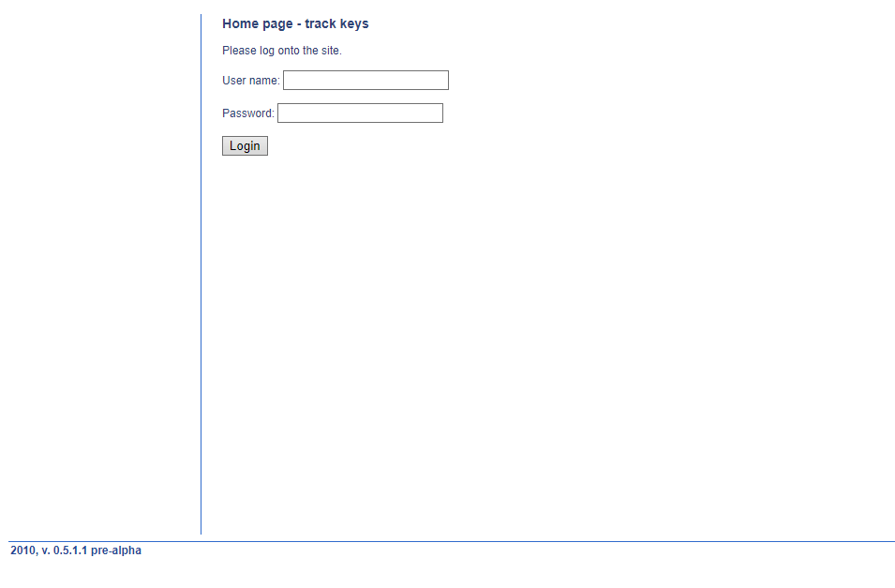
Image 1 – Homepage

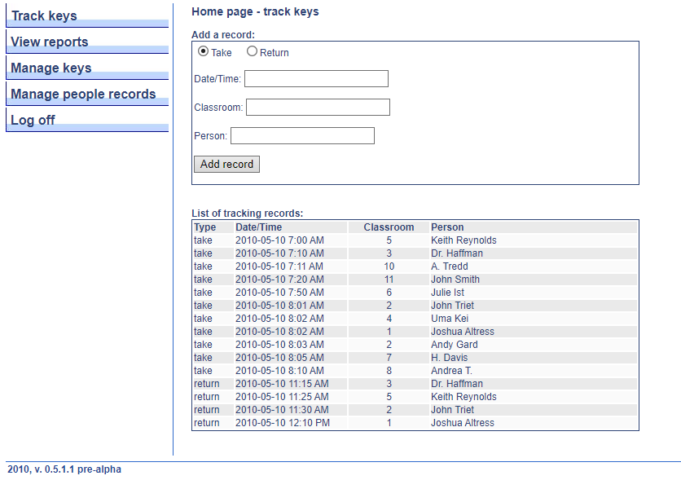
Image 2 – Check after requests
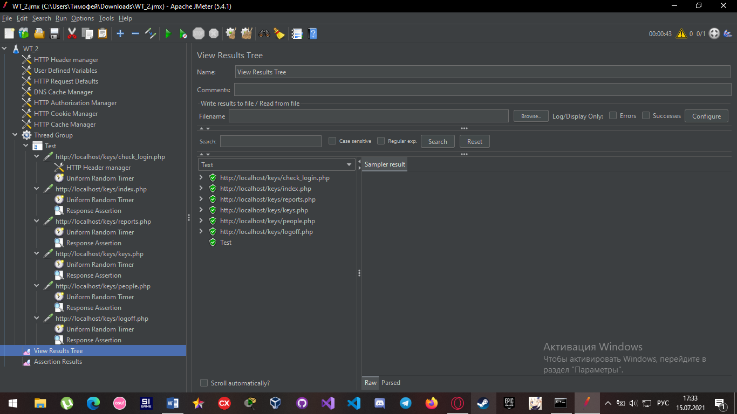
Image 3 – Test results
Test results
Load:
№ | Load | Outcome
1 | 1 users  1 seconds  1 loop count | Passed successfully
2 | 10 users  20 seconds  3 loop count | Passed successfully
3 | 50 users  30 seconds  5 loop count | Passed successfully
4 | 500 users  50 seconds  3 loop count | Test failed

Metrics
Test №1
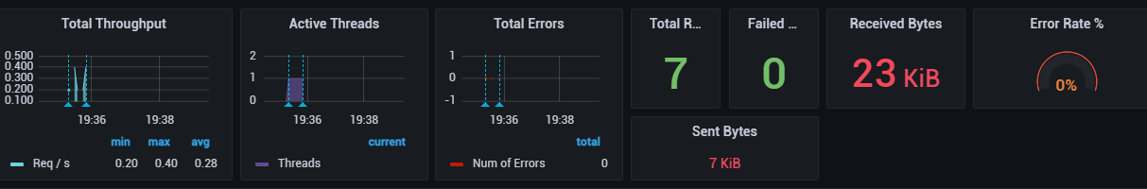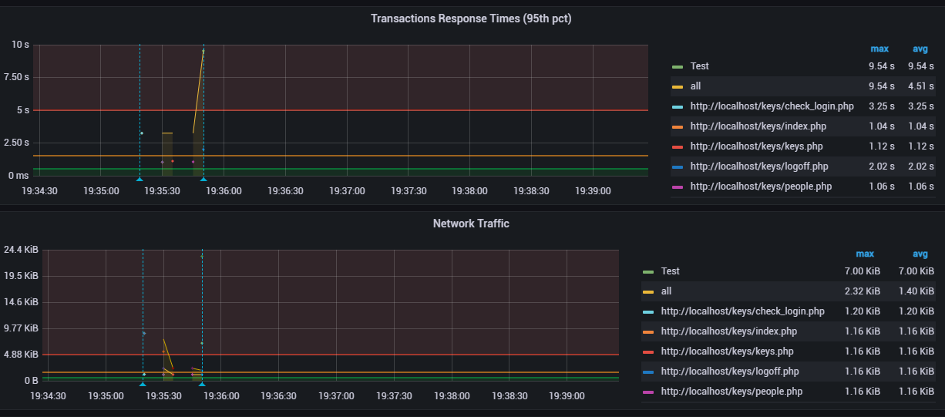

Test №2
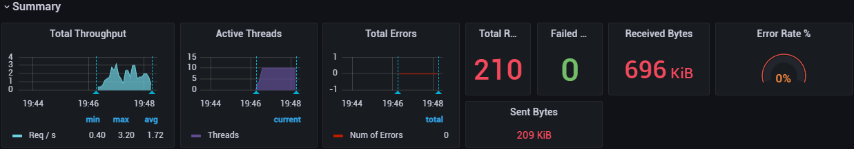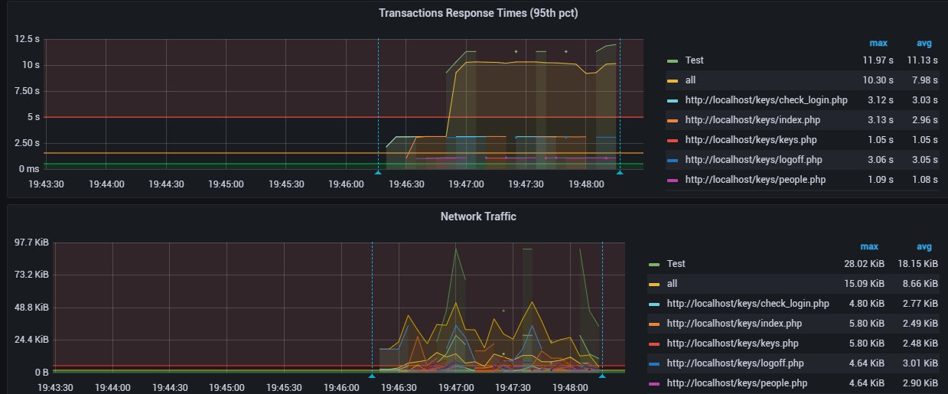

Test №3
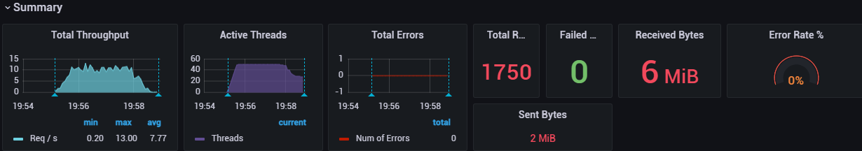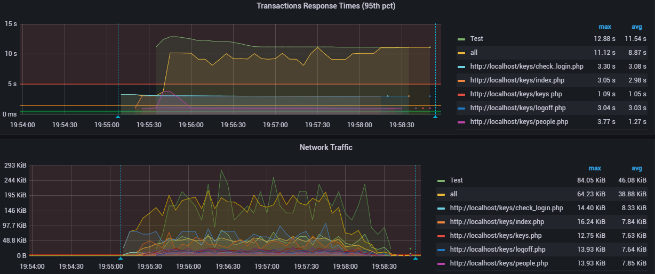

Test №4
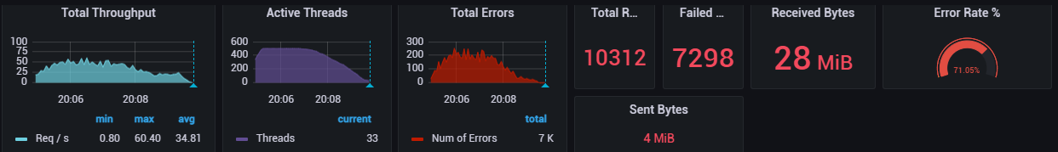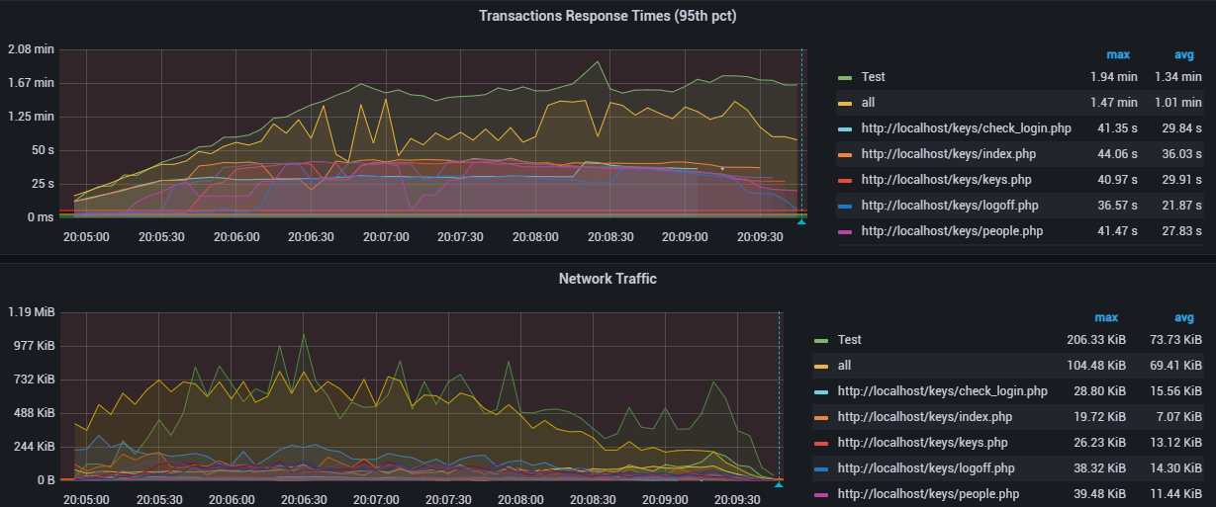
Recommendations
With a light load, the site copes well, but if there is an influx of users, the site will slow down, and it will "fall" altogether. If the customer plans that about 500 users will be active on his site, then he should start optimizing the site.
Applications
An internal audit of the site was carried out using Xenu. Below is the result:
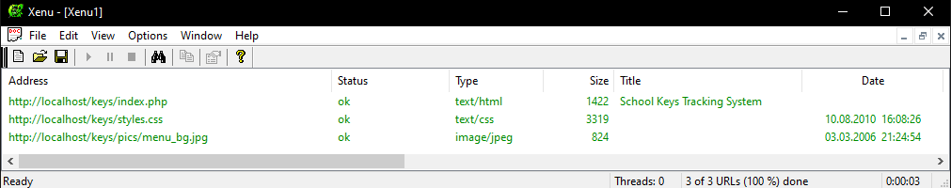

Test scenario (Double click on the image to open)

