CornerGrocer.exe

This program reads in a list of purchased products and outputs the frequency of items as a list or as a histogram. Users can search for a specific product or print all products frequencies.

How to run CornerGrocer.exe from the Command Prompt:

1. Go to where you saved the folder containing the source files.

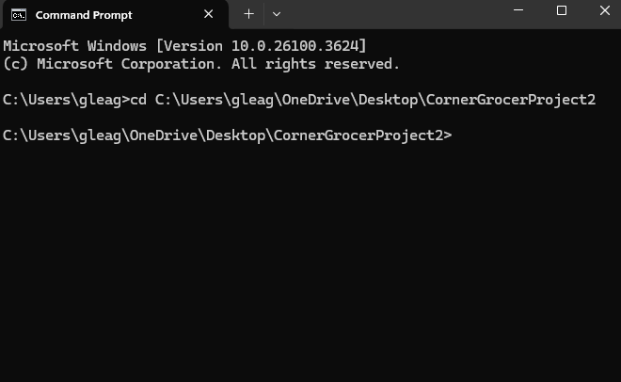

1. Input “CornerGrocer” to start the program. The program should read in a provided data file on start.

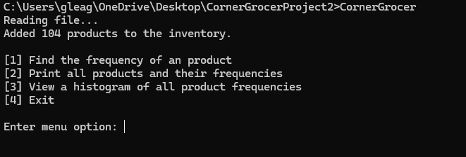

1. Select option 1 to output the purchase frequency of a specific item. Items currently must be plural, ex. it will not recognize (“apple”). This search function is not case sensitive.

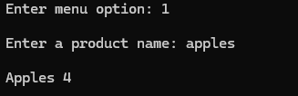

1. Selecting option 2 will output the frequency of all purchased products in the following format:

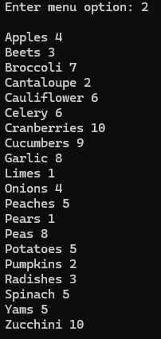

1. Option 3 will output the frequency of all purchased products as a histogram:

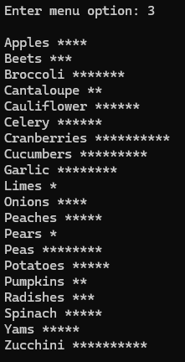

1. Selecting 4 from the main menu will exit the program.

