1. * 1. Frame
     2. Address Resolution Protocol (ARP) is a feature which perform a required function in IP routing. ARP can find the hardware address which also known ad Media Access Control (MAC) address. ARP maintains a cache in which MAC address are mapped on to IP address.
     3. 4
     4. Source: 222.222.222.220, 1A-23-F9-CD-06-9B

Destination: 222.222.222.222,49-DB-D2-C7-56-2A

* + 1. ARP query is sent in a broadcast frame as the inquire host does not which adapter address tally which the IP address. For response, the sending node will get the adapter address to which the response should be sent. Hence, there is no need to send a broadcast frame.
  1. 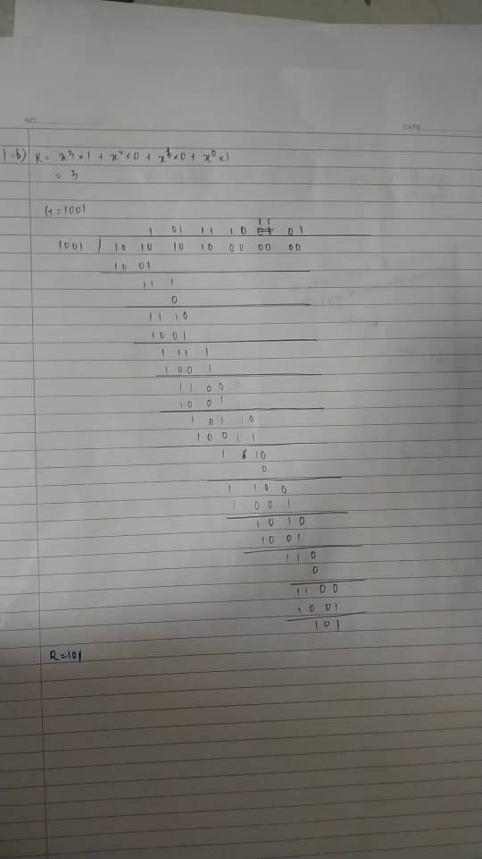

1. 1. 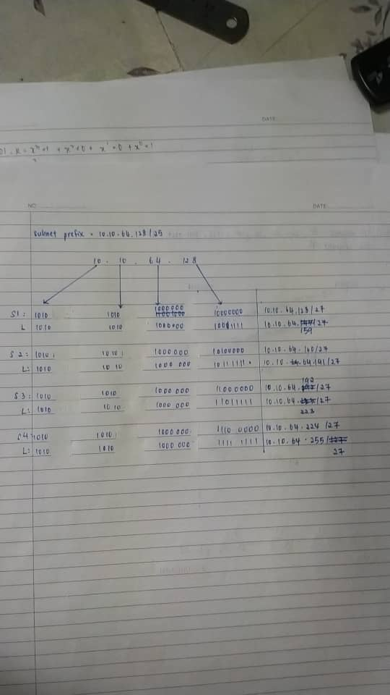
   2. Datagram = 3480 bytes

MTU = 900

Identification number = 508

Require number of fragments

= (datagram – IP header) / (MTU-IP header)

= (3480-20) / (900 – 20)

= 3460 / 880

= 4

|  |  |  |  |
| --- | --- | --- | --- |
| Length = 900 | ID = x | Frag Flag = 1 | Offset = 0 |
| Length = 900 | ID = x | Frag Flat = 1 | Offset = 110 |
| Length = 900 | ID = x | Frag Flat =1 | Offset = 220 |
| Length = 900 | ID = x | Frag Flat = 0 | Offset = 330 |

1. 1. TCP uses congestion window in the sender side to do a congestion avoidance. The congestion windows will display the maximum amount of data which can be sent out on a connection without the acknowledgement. When it fails to receive an acknowledgement of a packet within the estimated timeouts, TCP will detect congestion.
   2. Yes, the user can ensure the reliability by adding some ack functions at the application layer to make sure the data segments are received by user. Next, sequencing to help the order of data segments. Last, conduct the flow control to control the flow of data.
   3. 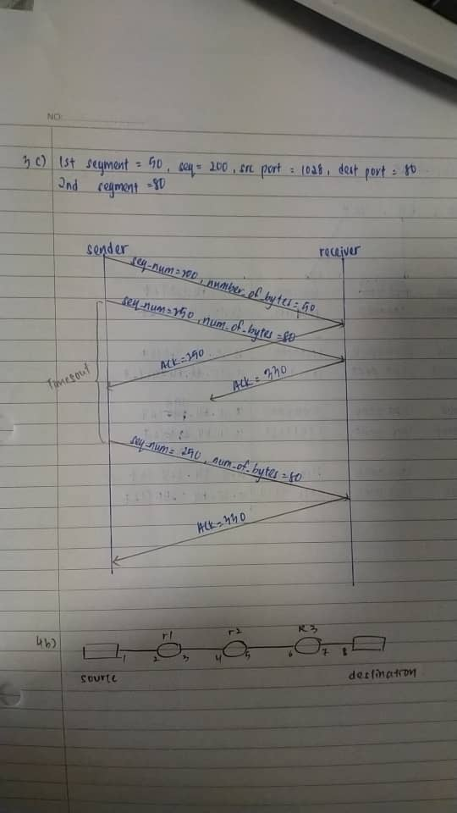
2. 1. 1. 1-6, 14-22
      2. After 16th transmission round, packet loss is detected by a triple duplicate ACK. The congestion window size would have to dropped to 1 if there was a timeout.
      3. Threshold = 22/2 = 11

Congestion window size = 11 + 3 = 14

* + 1. Threshold = 16/2 = 8

Congestion window size = 8 + 3 = 11

* 1. IP datagram ne need to split into fragment since fragment has been ignored. IP datagrams will forward by source to link interface 1. The first router will receive the datagram from interface 1 and display the datagrams to interface 3. Second router will receive data gram from interface 4 and display the datagram output to interface 5. Third router will get the datagram from interface 6 and output the datagram to interface 7. Destination host will receive the IP datagram from the link interface 8.
  2. 1. 1
     2. 2
     3. 3