***EXPERIMENT 2***

*Circuit Diagram:*

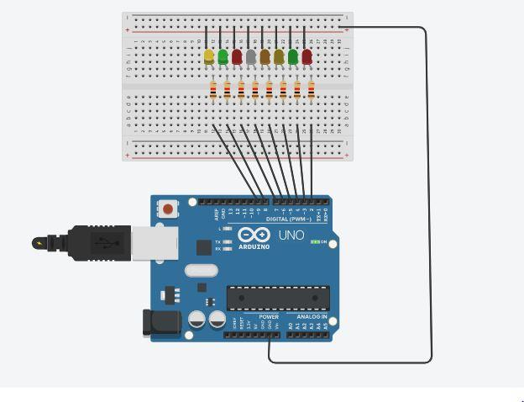

*Theory:*

Concept used:  Various concepts are used in this experiment as listed:

1. Combination of LEDs in parallel circuit.
2. How to use multiple digital pins of Arduino Uno at the same time.
3. Algorithm to obtain chaser effect.

4.Connections in BreadBoard.

**Combination of LEDs in Parallel circuits:**

We know in parallel connection voltage remain same while current divided in branches. So each LED glow with the same brightness. There is no lack in the brightness of any LED.

How to use multiple digital pins of Arduino Uno at the same time:

All the p terminals of LEDs are connected to the Arduino Uno Board with the help of separate wires and n terminal of the LEDs are connected to the ground pin of the Arduino Uno board with the help of single wire.

**Algorithm to obtain chaser effect:**

To obtain chaser effect our algorithm should be that when one LED is on and other should be off and one by one LED should glow. There should be continues pattern. When each LED glow one by one and line by line after that each led follow reverse path. The reverse path is the reverse of the starting pattern.

**Connections in Bread Board:**

Bottom two rows and top two rows of Breadboard are connected horizontally and middle rows are connected vertically. We connect LEDs in middle rows in order to give equal voltage to each LED and maintain their parallel connection. The n terminals of LEDs are connected to the top row with the help of wires, which finally connected to the ground pin of Arduino Uno Board.

Learning and Observations:

In this experiment we learnt about:

1. Detail code used in Arduino Uno.
2. Interface multiple LEDs with Arduino Uno board and Breadboard.
3. We learnt about LEDs parallel combination.
4. We learnt about the loop.

Observations:

1. We observe when we move delay one line up or down it change the whole pattern of the chaser.
2. If we don’t use delay in our code at specific points we get a continues pattern.
3. Very little modification can create a new unexpected pattern.

Precautions:

1. The Parallel connection of LEDs should be proper.
2. We define each pin in the code, which we used for output.
3. Before uploading the code to the Arduino Uno board, check the port and the board under  the tools menu.
4. Ensure that positive terminals of LEDs are connected to the Arduino digital input/output  pins and the negative terminal to the ground pin.

Learning Outcomes:

1. How to use multiple pins at the same time to give output.

1. Understanding the connections inside the Bread Board.
2. Different pattern, which we can create with the help of Arduino Uno.