

**FUTURE INSTITUTE OF ENGINEERING AND MANAGEMENT**

RESUME **Name :** PUNIT KUMAR TIWARI 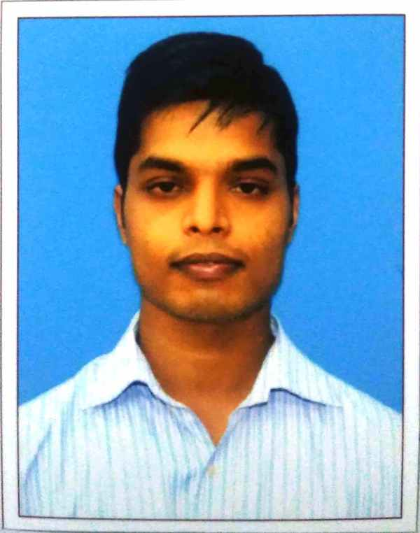

**Contact Number :**+91 8145380043 **|** +918240789361

**Email** **:** punit.kumar.tiwari.fiem.it15@teamfuture.in |

Punit139.tiwar@ gmail.com

**Career Objective:**

Being a fast learner, I would like to learn and earn in order to meet the common objectives of the organization as a whole by utilizing a positive approach in everything that I do.

**Academic Qualification:**

**Secondary & Higher Secondary**

|  |  |  |  |  |  |
| --- | --- | --- | --- | --- | --- |
| **Examination** | Board | **Year of Passing** | **Marks** | | |
| **Obtained** | **Out of (Total)** | **%** |
| **10th Std** | CBSE | 2012 | 9.2 | 10 | 87.4 |
| **12th Std** | CBSE | 2014 | 458 | 600 | 76.33 |

**Graduation: B-Tech in CSE (example)**

|  |  |  |  |  |  |  |  |  |
| --- | --- | --- | --- | --- | --- | --- | --- | --- |
| **SEM** | **1** | **2** | **3** | **4** | **5** | **6** | **7** | **8** |
| **SGPA** | 7.63 | 8.10 | 7.17 | 7.96 | 8.23 | 7.84 |  |  |
| **Average** | 7.821 | | | | | | | |

**Projects & Internships:**

|  |  |  |  |
| --- | --- | --- | --- |
| **SL. NO.** | **Company** | **Project Title** | **Duration** |
|
| **1** | GLOBSYN SKILLS | Titanic Project-Predicted survival on the Titanic using Python | 1 MONTH |
| **2** | INTERNSHALA | Temperature Monitoring system using IOT | 1MONTH |

**AMCAT SCORES:**

|  |  |  |  |  |  |
| --- | --- | --- | --- | --- | --- |
| **SUBJECT** | **ENGLISH COMPREHENSION** | **QUANTITATIVE**  **ABILITY** | **LOGICAL ABILITY** | **COMPUTER SCIENCE** | **COMPUTER PROGRAMMING** |
| **MARKS OBT:** | **500** | **400** | **485** | **469** | **455** |
| **TOTAL MARKS:** | **900** | **900** | **900** | **900** | **900** |
| **PERCENTILE** | **59.9** | **20.4** | **57.8** | **76.2** | **68.2** |

**Technical Proficiency & Certifications :**

* Ms Office,
* C
* PYTHON
* Java,
* C++

**Achievements (Academic & Social):**

* Successfully completed the self learning course in march 2018 which was offered by the Fossee project of IIT Bombay
* Participated in workshop on R,PHP and Big Data –Hadoop organized in my college
* Organized Blood Donation Camp with Matribhumi Student welfare seva samity(NGO).

**Interests & Extra Curricular :**

Event Management, Travelling and Photography, Playing an Instrument etc.

**Language Known :-**

English, Hindi,,Bengali

**Personal Details:**

|  |  |
| --- | --- |
| Permanent Address | 87,Ramkrishnanagar,Laskarpurroad,oppositeof:Mainaak gardens,Garia,Kolkata,700084,WestBengal |
| Date of Birth | 09-11-1995 |
| Passport No |  |
| ADHAR Card | **347628561109** |
| PAN Number | **BIQPT4405F** |

**Declaration:**

I hereby declare that the information given above is true and correct.

**DATE: 28-8-2019 SIGNATURE:** 