**1. Git-HOL**

## Step 1: Setup my machine with Git Configuration

1. Install Git Bash on my computer.  
   2. Open Git Bash and check installation by typing: git --version  
   3. Configure my user name: git config --global user.name "Tiyasa Kundu"  
   4. Configure your email: git config --global user.email "tiyasakundu18@gmail.com"  
   5. Verify configuration: git config --list  
   6. Sign up on GitLab and create a project named 'GitDemo

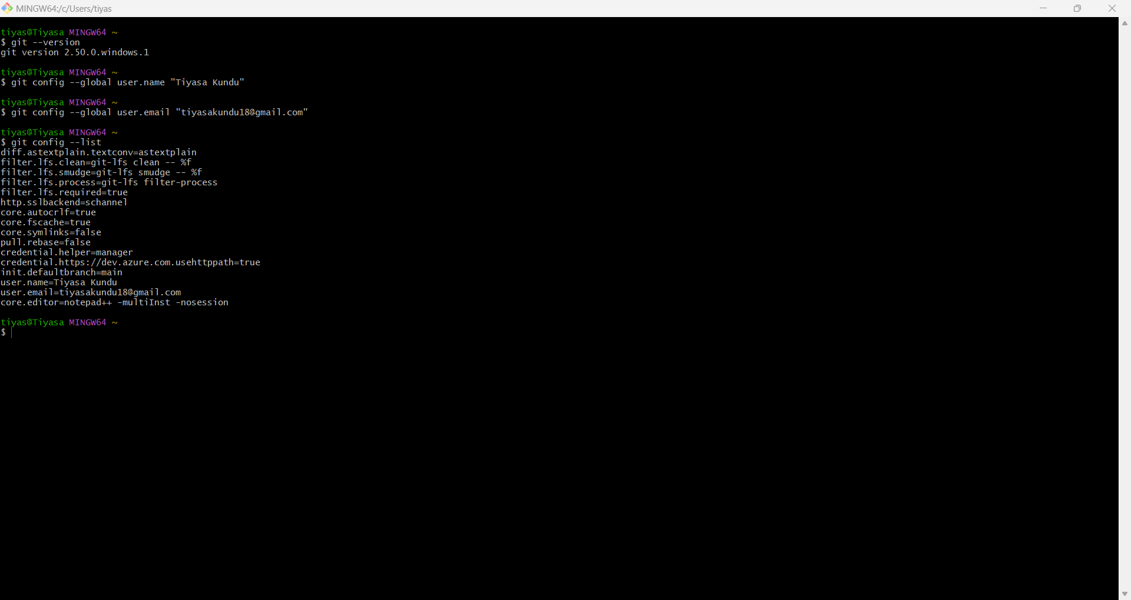'.

## Step 2: Integrate Notepad++ with Git

1. Check if Notepad++ runs in Git Bash by typing: notepad++  
2. If not recognized, add Notepad++ path to environment variables:  
 Control Panel → System → Advanced system settings → Environment Variables → Edit PATH.  
3. Restart Git Bash and test again.  
4. Create alias for Notepad++: alias np='notepad++'  
5. Set Notepad++ as default Git editor:  
 git config --global core.editor "notepad++ -multiInst -nosession"  
6. Verify with: git config --global –edit

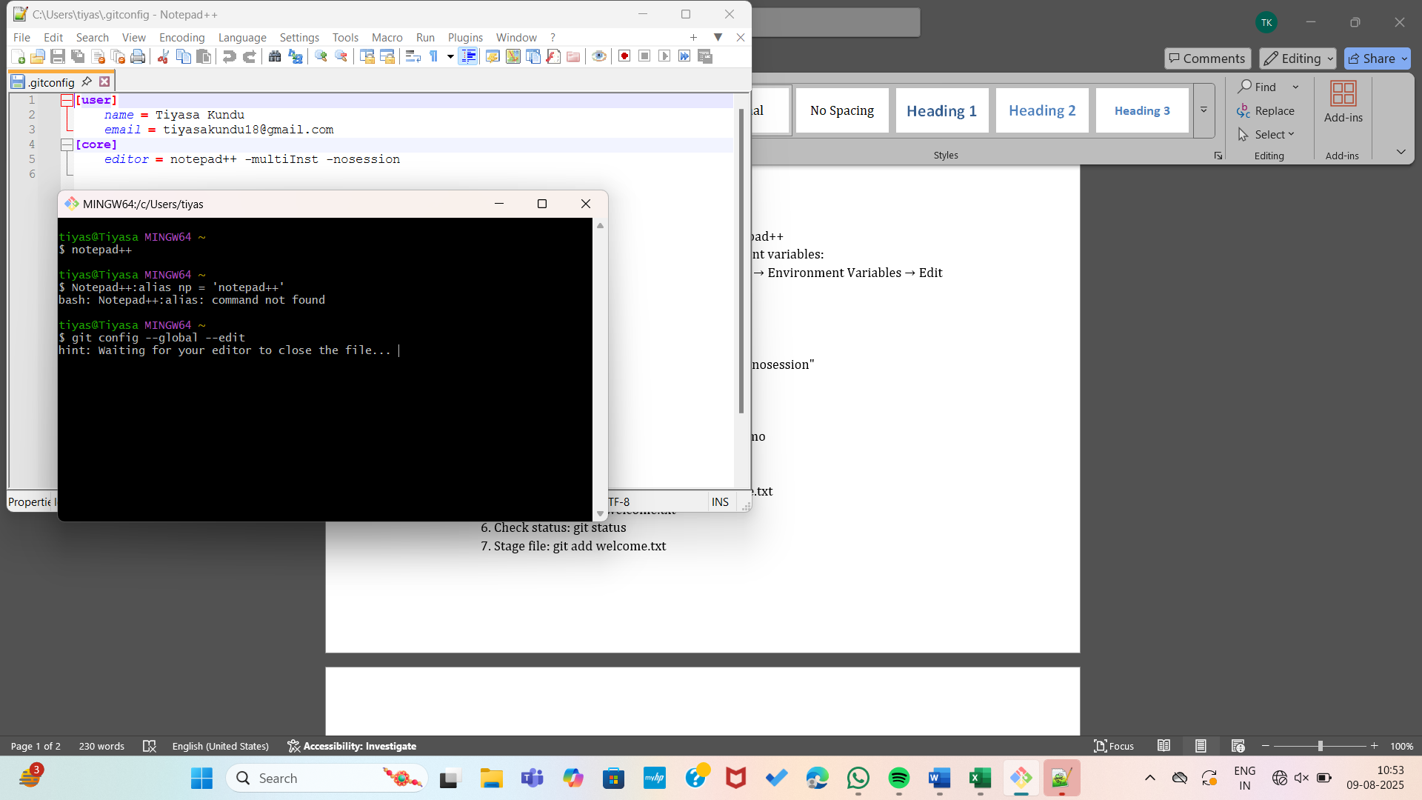

## Step 3: Add a file to Git repository

1. Create a project folder 'GitDemo': mkdir GitDemo  
   2. Go inside the folder: cd GitDemo  
   3. Initialize Git: git init  
   4. Create file: echo "Welcome to Git" > welcome.txt  
   5. Verify file: ls or cat welcome.txt  
   6. Check status: git status  
   7. Stage file: git add welcome.txt  
   8. Commit with message: git commit -m "Added welcome file"  
   9. Link remote repository: git remote add origin <https://github.com/Tiyasa0407/DN4.0_Deepskilling.git>  
   10. Push changes: git push origin master

