**T&T Lab**

**Name:** Tiyasha Mallick

**Roll No.:** 20051855

**Section:** CSE-1

**Topic:** Handwritten Digit Recognition

**Area of Topic:** Handwritten digit recognition is a field of computer vision and machine learning that recognizes handwritten digits in images. The MNIST dataset is widely used for this task. Techniques range from traditional methods to deep learning. Challenges include variations in handwriting, noisy input data, and achieving high accuracy. Applications include image processing, document analysis, and handwriting recognition.

**Tools to be used:** Python, OpenCV, Tensorflow, Keras

**Milestone-1:**

* **Objectives:-** Decide on the topic.

Decide and find which dataset to use.

Review the data.

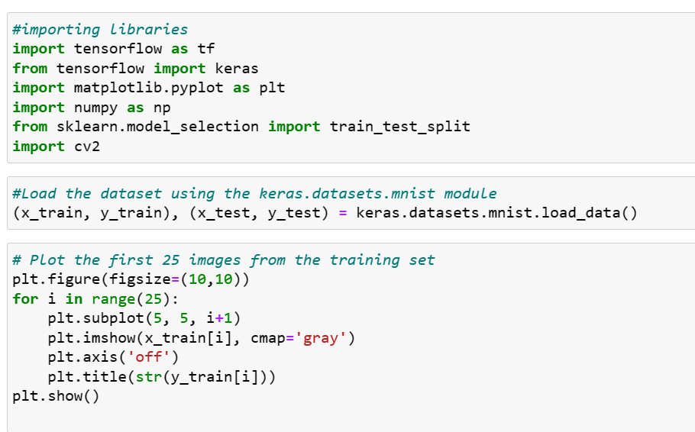

* **Code:-**

**Milestone-2:**

* **Objectives:-** Preprocess the data by normalizing the pixel values and flattening the images.

Split the dataset into training and testing sets.

* 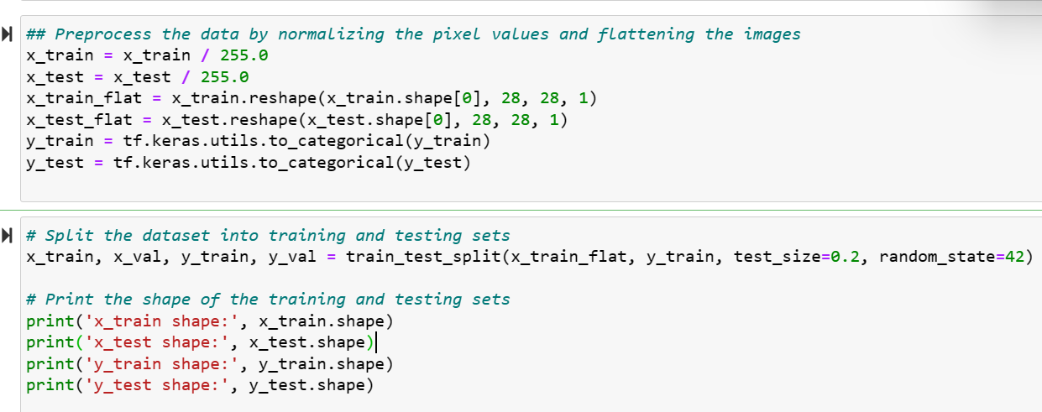**Code:-**