Problem Set #3

CS 352 Internet Technology

Released: November 29, 2022; Due: December 13, 2022 at 8 pm Eastern Time

**Instructions**

Please read and follow these instructions carefully.

1. You must work on this problem set **individually.**
2. Please complete your answers to the questions below and upload your responses to Canvas as **a single PDF file.**
3. Your answers (preferably typed up rather than handwritten) must be clear, legible, and con- cise. If we cannot understand your answer with reasonable effort, you will get zero credit. 4.If you leave a question out or clearly state “I don’t know”, you will receive 25% of the points

for that question.

1. We care not just about your final answer, but also how you approach the questions. In general, if you show us your reasoning for your answers, we will do our best to provide partial credit even if your final answer is incorrect. However, if you provide no reasoning, and your answer turns out to be incorrect, you will typically receive zero points. So, please explain yourself.
2. You are free to discuss the problem set on Piazza or through other means with your peers and the instructors. You may refer to the course materials, textbook, and resources on the Internet for a deeper understanding of topics. However, you cannot lift solutions from other students or from the web. Do not post these problems to question-answering services like Chegg. All written solutions must be your own. We run sophisticated software to detect plagiarism and carefully monitor student answers.
3. There is a due date/time but no “time limit” on problem sets. That is, you may take as long as you need to work on problem sets, as long as you submit them on time. Further, you may make an unlimited number of submissions on Canvas.
4. As a response to the last question of this problem set, please specify who you collaborated with, and also include all the resources you consulted to answer questions in this problem set, including URLs of pages you visited on the Internet. Also specify which question and aspect you got help with. Please be as thorough and complete as possible here. It is mandatory to answer this question.
5. If you have any questions or clarifications on the problem set, please post them on Piazza or contact the course staff. We are here to help.

# Questions

There are 8 questions in this problem set totalling to 50 points.

## Functional differences. (4 points)

* 1. What is the key difference between the functions of the transport and network layer?

The main function of the network layer is to move data from sending to receiving endpoint.

The main function of the transport layer is to provide a communication abstraction between application processes

* 1. What is the key difference between the control and data planes of a router?

The control plane determines how data will be forward from source to destination, network wide.

The data plane is about moving data from input port to output port over local router

1. **Netmask (2 points).** Suppose hosts A and B have the same netmask M. Host A has IP address 102.45.56.7. Host B has IP address 102.46.47.8. The netmask M is 255.252.0.0. Are A and B in the same IP network? Why or why not?

Yes, because the netmask M has first 16 bits of 11111111 11111111. So A & M = B & M. In the other word, any the combination of Host A first 16 bits is the same as the host B first 16 bits. So they are in the same IP network

1. **Forwarding lookup (2 points).** Which field on the packet is used to lookup the router’s forwarding table? What are the consequences of using this packet field (and ignoring others)?

Router lookups destination IP address. The consequences of using this packet field will be when forwarding behavior is independent of the source, we don’t know whether the message is from legitimate source or malicious attack traffic.

1. **Benefits of IP aggregation (2 points).** Describe any one benefit for aggregating IP ad- dresses into IP prefixes, or aggregating smaller IP prefixes into larger ones.

The benefit is it can reduce the size of the routing table. Also, save forwarding table memory and fewer routing protocol messages.

## Fabrics (3 points).

* 1. What is the benefit of using nonblocking fabrics in routers? (1.5 points)

With a nonblocking fabric, queues aren’t formed due to the switching fabric. With a nonblocking fabric, there are no queues due to inefficiencies at the input port or the switching fabric

* 1. Is a crossbar fabric nonblocking? Say YES or NO. (0.5 points)

yes

* 1. Is a shared memory fabric nonblocking? Justify. (1 point)

Shared memory can be designed to be nonblocking if the memory access is fast enough

1. **Forwarding table matching (10 points).** Suppose a router has the forwarding table entries shown in the picture below.

|  |  |
| --- | --- |
| **IP prefix** | **Output port** |
| 100.16.0.0/12 | 5 |
| 100.32.0.0/12 | 7 |
| 245.128.45.0/24 | 3 |
| 93.5.6.0/23 | 8 |
| 189.23.64.0/18 | 6 |
| 189.23.64.0/19 | 9 |
| 189.23.96.0/19 | 10 |
| default | 4 |

For the questions below, partial credit will be provided if you explain the reasoning behind your answers.

* 1. Suppose a packet enters the router with a source IP address of 93.5.6.145 and a destination IP address of 245.128.45.168. What output port is it forwarded to? (2 points)

Port 3, because the first 24 bits of destination IP address of 245.128.45.168 match the IP prefix for port 3. Also, internet routers perform the longest prefix matching on destination IP addresses of packets.

* 1. Suppose another packet arrives with a destination IP address of 100.31.105.54. What output port is it forwarded to? (3 points)

Based on the destination IP address, we can narrow it down to 2 IP prefixes,

100.16.0.0/12 and 100.32.0.0/12. We only care about the first 12 digits.

100.31.105.54: 0110 0100. 0001

Mask: 1111 1111. 1111

100.16.0.0/12: 0110 0100. 0001

100.32.0.0/12: 0110 0100. 0010

So the output port is port 5.

* 1. Suppose another packet arrives with a destination IP address of 189.23.80.4. What output port is it forwarded to? (3 points)

We can see that the first 16 bits of the destination IP match ports 6, 9, 10. However, port 6 has 18 prefix, port 9 and port 10 has 19 prefix.

Then, we see port 6 and port 9 has 64 as the third number in IP, which is 01000000. Port 10 has 96 as the third number in IP, which is 01100000. Our destination IP has 80 as the third number, which is 01010000.

Then we compare the 16 – 18 bits with port 6, we find out they all have 01.

Then we compare the 16 – 19 bits with port 9, we find out they all have 010.

Then we compare the 16 – 19 bits with port 10, we find out they don’t match.

So we will pick port 9, because Internet routers perform the longest prefix matching on destination IP addresses of packets.

Port 6: 01000000

Port 9: 01000000

Port 10: 01100000

Destination IP: 01010000

* 1. Suppose another packet arrives with a destination IP address of 8.8.8.8. What output port is it forwarded to? (2 points)

Port 4, because there is no IP prefix that matches this IP address on the table, so it will go to the default port

1. **Intra-domain routing protocols (27 points).** Consider the network whose graph abstrac- tion is shown in this picture. The IP prefixes “owned” by the router, i.e., the set of endpoints reachable directly through the router, are provided alongside the routers, labeled and identified as *A*, *B*, *C*, etc. The link metrics are shown next to the edges in the graph.

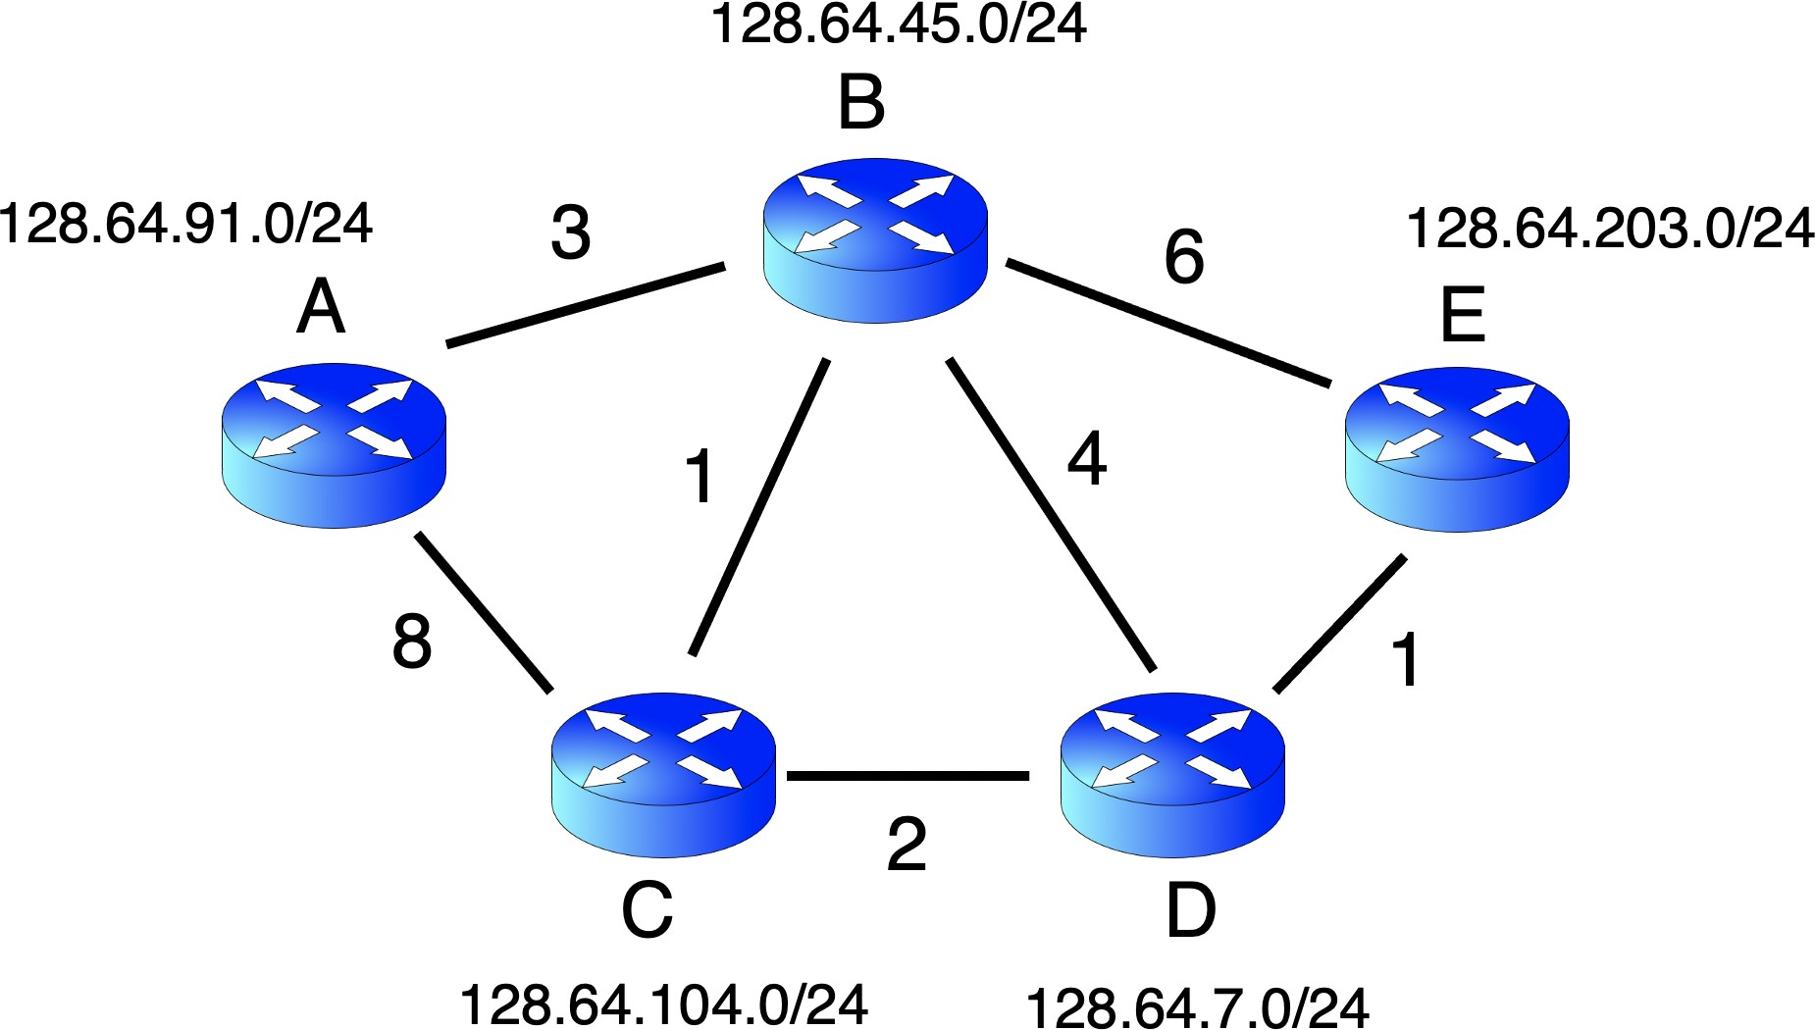

* 1. Suppose the network uses a **link state routing protocol.** Populate the following informa- tion in the link state advertisement originating from router *B*. (5 points)

router ID: *B*

IP prefix owned by the router (1 point): 128.64.45.0/24

IDs of neighboring routers (2 points): A, C, D, E

Link metrics to neighbors (2 points): A(3), C(1), D(4), E(6)

(For the last question, please write the metrics in the same order as the neighbor IDs before.)

* 1. This question builds on part (a). Suppose *d*(*V* ) represents the current best estimate of the shortest path distance from router *A* to a fixed router *V* , and *p*(*V* ) represents the predecessor on that shortest path. Suppose router *A* has received the link state advertisements from all other routers in

the network. What are the *initial values* of the following? (6 points)

*d*(*B*)*, p*(*B*): 3, A

*d*(*C*)*, p*(*C*): 8, A

*d*(*D*)*, p*(*D*): ∞, None

* 1. This question builds on part (b). *After 2 iterations* of Dijkstra’s algorithm, what are the values of the following? (6 points)

*d*(*C*)*, p*(*C*): 4, B

*d*(*D*)*, p*(*D*): 6, C

*d*(*E*)*, p*(*E*): 9, B

* 1. *After all routers have computed their shortest paths*, suppose a packet with destination IP address 128.64.203.67 arrives at router *B*. Towards which router is this packet directed? (2 points)

It will first go towards C, then D, then E

B, C, D, E

First, because the destination IP address is 128.64.203.67, and it matches the IP prefix on router E, so we have to go to router E

Since, we have computed all of the shortest paths, then we know that B-C-D-E, has the shortest path from B to E, which is value 4.

Therefore, we are using that path.

* 1. Let’s start afresh from the figure for this question. Suppose the network uses a distance vector protocol. For this part and the ones that follow, please assume that all routers know the existence of all other routers in the network. However, initially, each router is unaware of the

edges to its immediate neighbors. We use dX (Y ) to denote the component of the distance vector of shortest distances to any other router. To begin with, each router only knows the costs of its direct X corresponding to destination Y at any point in time. What are the initial values of the following

components (4 points)?

*dA*(*A*): 0

*dA*(*B*): 3

*dB*(*D*): 4

*dC*(*E*): ∞

* 1. This question builds on part (e). Suppose router *B* just shared its current distance vector with *A*. This distance vector is:

dB(A) = 3, dB(B) = 0, dB(C) = 1, dB(D) = 4, dB(E) = 6

value of dA(D) after this exchange? (4 points) Show the working of the Bellman-Ford equation at router A for destination D. What is the

node A table:

dA(A) = 0

dA(B) = 3

dA(C) = 8

dA(D) = ∞

dA(E) = ∞

node B table:

dB(A) = 3,

dB(B) = 0,

dB(C) = 1,

dB(D) = 4,

dB(E) = 6

dA(D) = min(c(x,y) + Dy(y), c(x,z) + Dz(y))

= min(dA(V) +dV(D)

V= {A,B,C,D,E}

1. V = A: dA(D) = ∞
2. V = B: dA(D) = dA(B) + dB(D) = 3+4 = 7
3. V = C: dA(D) = dA(C) + dC(D) = 8 + ∞
4. V = D: dA(D) = dA(D) + dD(D) = ∞
5. V = E: dA(D) = dA(E) + dE(D) = ∞

So we choose V = B: dA(D) = dA(B) + dB(D) = 3+4 = 7

1. **Collaboration and References (mandatory).** Who did you collaborate with on this prob- lem set? What resources and references did you consult? Please also specify on what questions and aspects of the problem set you got help on. If you did not consult any resources other than the lecture slides and textbook, just say “no collaboration”.

TA, recitation, lecture slides, and my partner JiaJing, we kind of discuss through every questions.