MARKETING

The Market (4ps product price promotion place)

The product which brain training games will be bringing to people is a brain training game aimed at children between the ages of 8 and 12, however the varying types of questions and categories will mean that people of all ages will be able to play our game. There are similar brain training apps currently on the market however we feel as tough they can be done better and take advantage of their huge market.

The majority of brain training applications market themselves as free however as soon as you try to play most of them you will soon realise that it is often barely half of the game which is free with the remaining 50% of the games being locked behind a paywall. We aim to always have the majority of our game completely free however we will also offer additional categories and questions for a small recurring monthly fee of € 1.99.

The game will not only need to appeal to kids but also their parents who will be the ones paying for the game. As part of advertising we will focus on social media marketing and also heavily focus on marketing our game inside of schools as our game is an educational game.

We believe schools are the best place to convert potential customers into real customers which is why in terms of locations schools will be our biggest focus of advertising and gaining interest in our game.

Overview

Market Trend

We were included by some games from the past with the main two being Big Brain Academy and Brain Age. Initially there was a huge worry that educational type of games would struggle a lot on the market as it is very difficult for anyone to combine the fun of playing games with education. The brain training games released by Nintendo in the mid 2000’s changed this approach as they rank very highly on the most sold Nintendo DS games of all time. Brain age reached number 4 of highest DS games of all time with over 19 million sales, with its sequel Brain Age 2 reaching nearly 15 million and number 7 on the list and at number 14 big brain academy with over 6.5 million downloads. (En.wikipedia.org, 2019) The trend from the past has vastly continued which can be seen on the google play store with 5 major mobile brain training games having over 10 million downloads each suggesting that the market trend is in a very good situation for our application.

Size and potential

The android platform has an estimated 3 billion users which offers a huge platform for our game. This combined with the current trend for brain training games makes our games potential very high. Currently there is a huge demand for games in our main age range with 91% of kids between the ages of 2-17 play video games which is around 64 million in the U.S alone (Digitaltrends.com, 2019). Parents however tend to be quite sceptical about how useful their kids time when spent playing video games, our game’s aim is to gain trust from parents who will prefer to direct their kids in the direction of our educational game therefore matching the fun of playing games with the usefulness of education which offers huge potential.

Competition

As described above there is quite a lot of competition from other games, when our game goes live it will be in direct competition against the well-established games on the google play store with multiple games having over 5 million downloads each. Despite this competition we could see that the current games are doing some things wrong. The first is that the games although are being marketed as free in reality it is typically the majority of the game that are locked behind a paywall we believe this is a mistake and is not user friendly and plan to always have the majority of our game completely free with some additional paid DLC (Downloadable Content).Other games which do not rely as heavily on locking most of their game behind a paywall rely overly heavily on advertisements which are often in the form of video ads which can take as long as 15 seconds which is sometimes more than the time it takes to complete a level which triggers the advertisement which is not customer friendly at all which is why we will not be relying on advertisements for our income. The last major downside in the competitions games is that the majority of their game categories are very linear and completely lack diversity making them very boring after not a big amount of use.

**P.E.S.T analysis**

**Political**

Politically right now what all companies need to be up to speed on is Brexit. Luckily in our position Brexit is not a major worry as our game will be primarily present through Irish schools and later globally. Another thing to consider is the grants which our company will need to use in order to get a good start. Lastly as our company is operating from within Ireland our company will be subject to Irelands business friendly taxes.

**Economic**

It is believed that as a result of Brexit Irelands economy although will continue to grow it will most likely grow at a slower rate after Brexit.

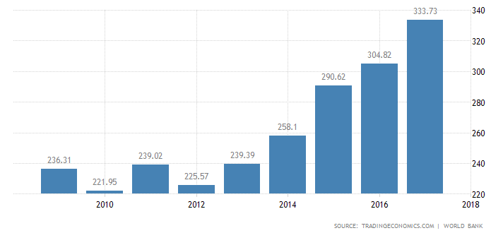

(Figure 1)

Another factor to consider when looking at the economics is Irelands employment rates which are quite stable/rising.

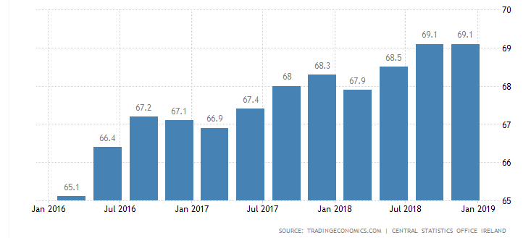

(Figure 2)

**Social**

Socially we are in a great position as Ireland has a very well-educated work force which will hugely help our company as there is a wade range of specialists which we could employ. There are no major ethnic and or religious issues which need to be considered. The only way in which a problem can be seen is that typically people in Ireland generally prefer to stick with what they are used to instead of moving on with new things.

**Technological**

Ireland’s very good access to internet and broadband will help a lot in the development and advertising of our game along with Irelands high computer/smartphone usage puts our company in a position where we have a lot of potential.

**S.W.O.T analysis**

**Strengths**

The company’s major strength is that the team behind the company is very dedicated and passionate about the project. Another strength is that we have found a market which despite already having a big market has some faults which we can fix. Another strength is our location as Ireland has a very well-educated workforce.

**Weaknesses**

The company’s biggest weakness comes from the team’s lack of experience.

**Opportunities**

The biggest opportunity comes from the angle of education. Education in the world for the most part has not changed too much and has been quite static for many years with exams such as the leaving certificate barely changing which is where out company’s biggest opportunity comes as we could be working alongside books to help educate and shape our future.

**Threats**

Our biggest and arguably only treat comes in the form of other well-established brain training games with a lot more capabilities in terms of resources, work force and money.

**References:**

En.wikipedia.org. (2019). *List of best-selling Nintendo DS video games*. [online] Available at: https://en.wikipedia.org/wiki/List_of_best-selling_Nintendo_DS_video_games [Accessed 7 Apr. 2019].

Digitaltrends.com. (2019). [online] Available at: https://www.digitaltrends.com/computing/91-percent-of-kids-play-video-games-says-study/ [Accessed 7 Apr. 2019].

(Figure 1 & 2) Tradingeconomics.com. (2019). *Ireland GDP | 2019 | Data | Chart | Calendar | Forecast | News*. [online] Available at: https://tradingeconomics.com/ireland/gdp [Accessed 8 Apr. 2019].