Web App Tyler - Database Assignment Two

This assessment is the second stage of your Database Cluster Assessment. In this assessment you are required to build a website as a GUI for the database you developed and designed in Practical Assessment 1 for Cluster 2.

Task 1

For this task you are required to research HTTP and answer a few questions about it:

* Questions:
  1. **Describe HTTP**  
     HTTP stands for Hypertext Transfer Protocol and is one of the application protocols that is used for distribution, collaboration and hypermedia information systems. HTTP is also the foundation for communication for the World Wide Web. HTTP does not save any information that has been inputted into the site by itself because it is a stateless programming protocol. If HTTP could save information by itself, there would not be a need for stateful (saves information) and stateless (does not save information) programming.
  2. **Describe limitations of HTTP when developing web applications.**Some methods (components) of HTTP (TRACE, TRACK, and DEBUG) are considered     potentially insecure because attackers can use these to bypass security controls or gather information. HTTP uses stateless programming (meaning that a session variable has not been set), so it will not be able to save any information that has been inputted into the site (login information, contact details etc.). To counteract this, you will need to add a session variable to the website so that it will be more user friendly.
  3. **Identify the advantages of HTTP when developing web applications.**One advantage of HTTP is that there is a way of establishing an encrypted connection by using HTTPS (HTTP Secure). Advantages of stateless programming is that it makes the loading time of the web page quicker in comparison to then a page is stateful. Stateless programming also simplifies the server design because there is no need to allocate storage for any information that has been inputted to the site.

Task 3 – Write a brief on you database/web application

* **Outline the output reports generated by your website, including screen shots of the reports and the SQL code used to fetch the data.**  
  There are two output reports generated by the website. The first output report is located in the *Used Vehicles* page and it shows a list of vehicles in the database.

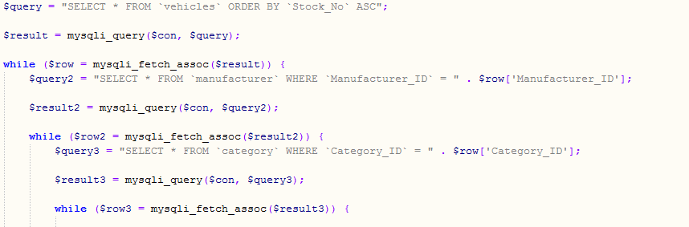

*SQL code*

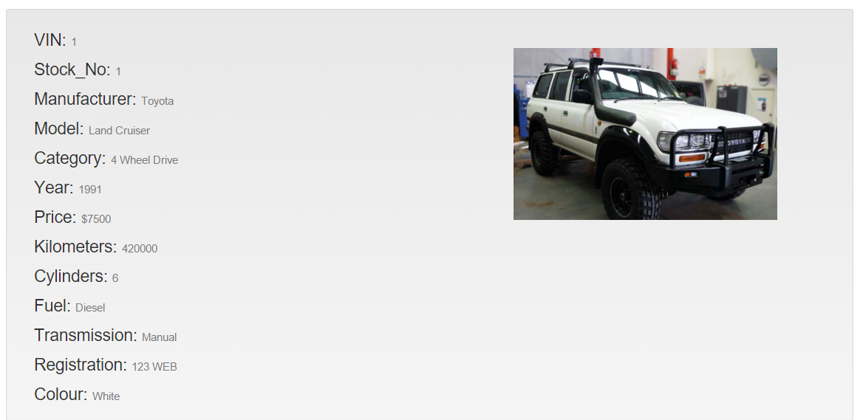

*Result*

The second output report is located in the *View Customers* page, it works by entering a customer’s last name into a search box which then prints out the results on the *View Customers* page.

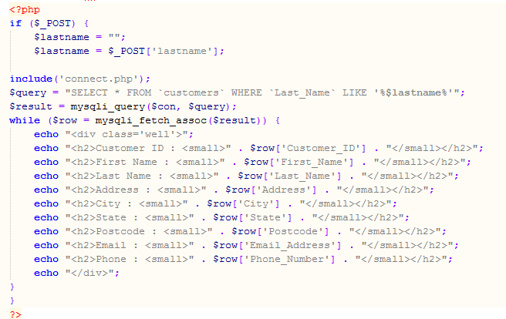

*SQL Code*

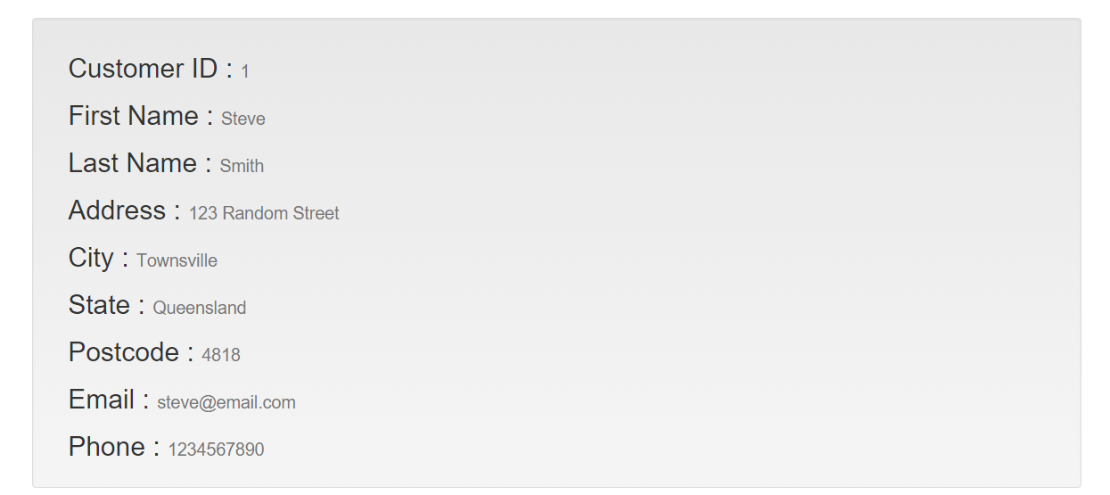

*Result after entering a last name*

* **Outline the security and access control for your website, including a documented test of the security system to ensure functionality.**Usernames and passwords are in place for the security aspect of the website, there are admin level users who have complete access/control over the database, meaning that they can add, remove and view information on the database, next are the salesperson usernames and passwords, they can view and add information to the database. There is a login page for salespeople and administrators to log in and add information to the database. You have to enter the right username and password to be able to access these features.
* **Outline and recommend a plan for implementing this web application.**Recommendation for implementation of the web application would be to create a series of video explaining how to use the site (One video for each aspect). E.g.  **1. Logging into The Site**

**2. Viewing customers**

**3. Viewing Vehicles**

**4. Add Customers**

**5. Add Sales**also hold a staff meeting when the site is live with the developer going through all aspects of the website with employees following along.

For database administrators, you would add a few more videos explaining how to work with the site on the database level;

* 1. Adding customers on the database.
  2. Removing customers on the database.
  3. View Customers, Vehicles and Staff on the database.
  4. Add Salesperson
  5. Add Vehicles
  6. Change passwords
  7. Create Backup

Also hold a meeting with the administrators and show them how to do the above.

* **Outline how to import old data into new database using PHPmyAdmin.**  
   1. Access database in PHPmyAdmin  
   2. Click Database you want to use

3. Click *Import* tab at the top of page

4. Browse computer for backup SQL file for database backup

5. Click go.

* **Identify and document user training requirements.**  
  Staff will need to know how to add customers, view customers, login, add a sale, and know their staff ID number. Administrators will need to know everything that the staff will need to know and how the database functions and how to maintain it. Administrators will also need to know how to add vehicles, salespeople, change passwords and how to create a backup of the database
* **Outline the web application’s use of stateful/statelessness.**This web application uses stateful and stateless programming. The site uses stateful programming when a user logs in, meaning that the site is setup to record and save information that has been inputted to the website for that session. The site uses stateless programming when a user first accesses the website, meaning that there is no session variable so no information is saved.

Task 4 – Present your brief to the client (Teacher)

For this task you are required to sit down and present your website to your teacher:

* You will need to be prepared to sit down with your teacher and explain your website and gain client approval. You will need to discuss:
  + Web application functionality
  + Security, and
  + Recommended implementation plan.