Screenshots

# Website Validation

## Index



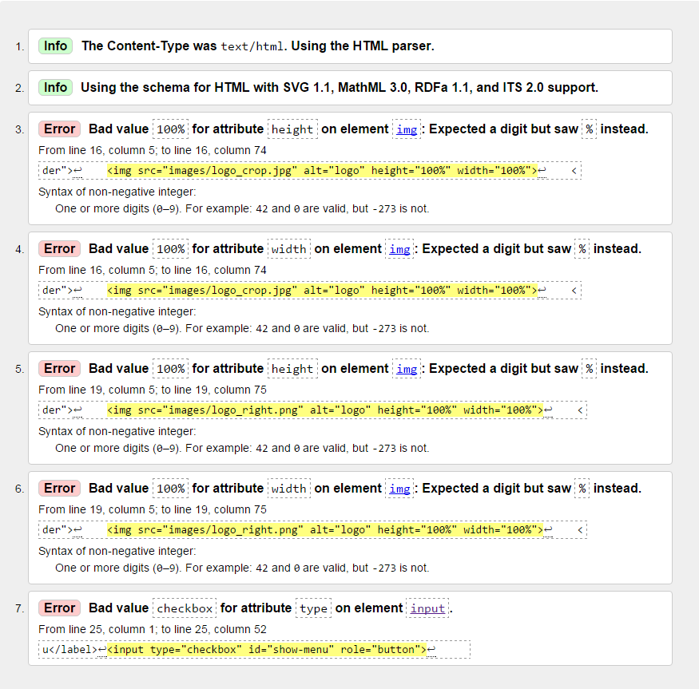

Initially came up with these error messages. I changed the first 4 by adding *height* and *width* to CSS instead of in-line styling. I fixed the last error message by removing the *role="button"* element.

## About



Same initial errors as Index

## Additionals



Same initial errors as Index

## Appliances



Same initial errors as Index

## Contacts

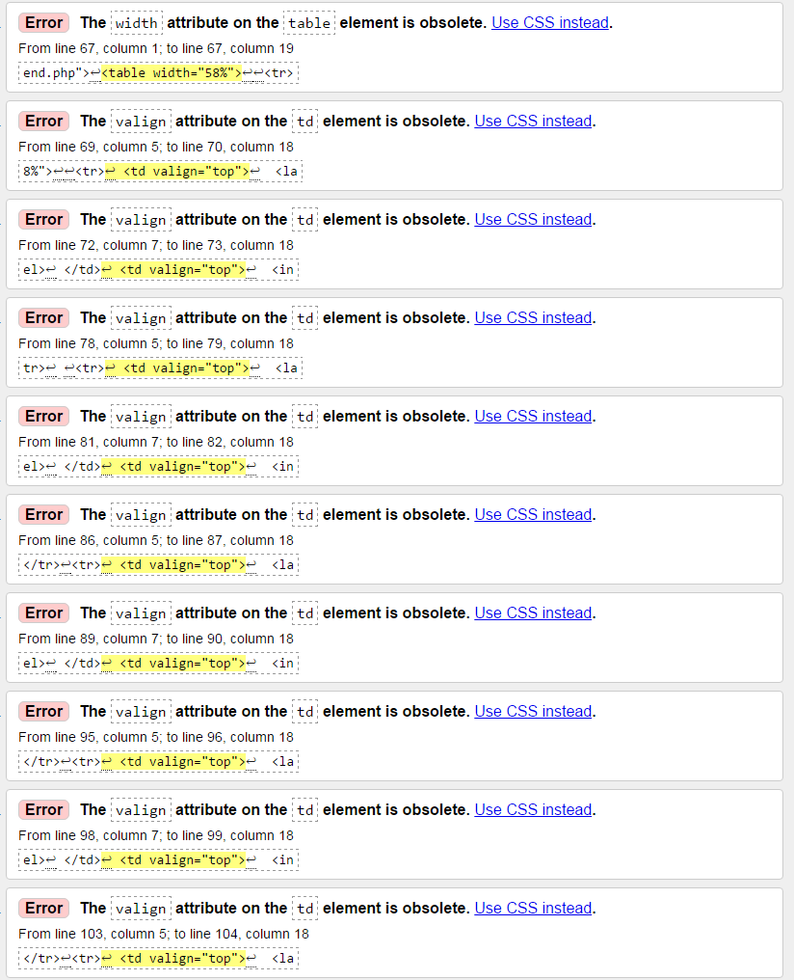Had a lot of these come up. Fixed by adding new CSS element for <td> element.

I had other problems with my Google Maps, I researched the error and found this link; http://stackoverflow.com/  
questions/17296065/meta-tags-stopping-website-from-html5-validating

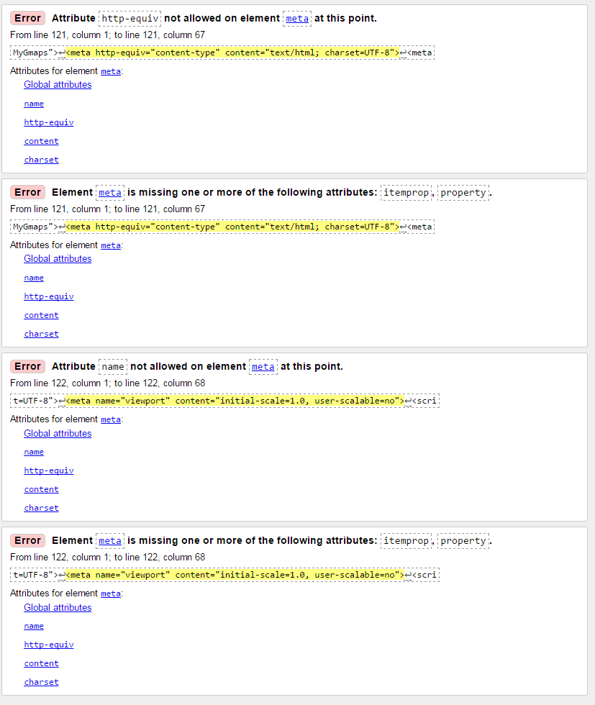I also has errors for the *Meta* tag and couldn’t find anything on the internet on how to fix it.

## Fit-Outs



Same initial errors as Index

## Designs



Same initial errors as Index

## Our Process



Same initial errors as Index

## FAQ



Same initial errors as Index

## Testimonials



## Privacy/Copyright



Same initial errors as Index

# CSS Validation

## Navigation

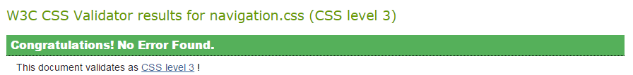

## My Style

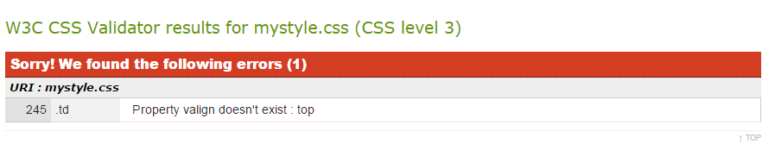

Initial validation error was corrected by changing *valign:top* to *vertical-align: top.*

## Animate

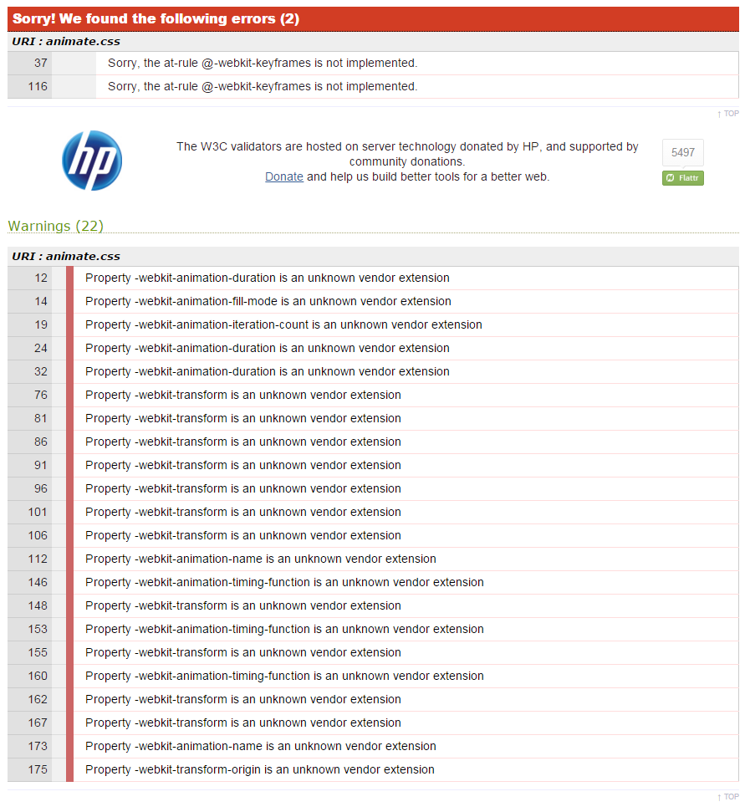All errors and warnings are for the vendor prefixes. I decided to leave them in the CSS in case it messed up the animations for the site

# Screenshots from Different Browsers

Google Chrome

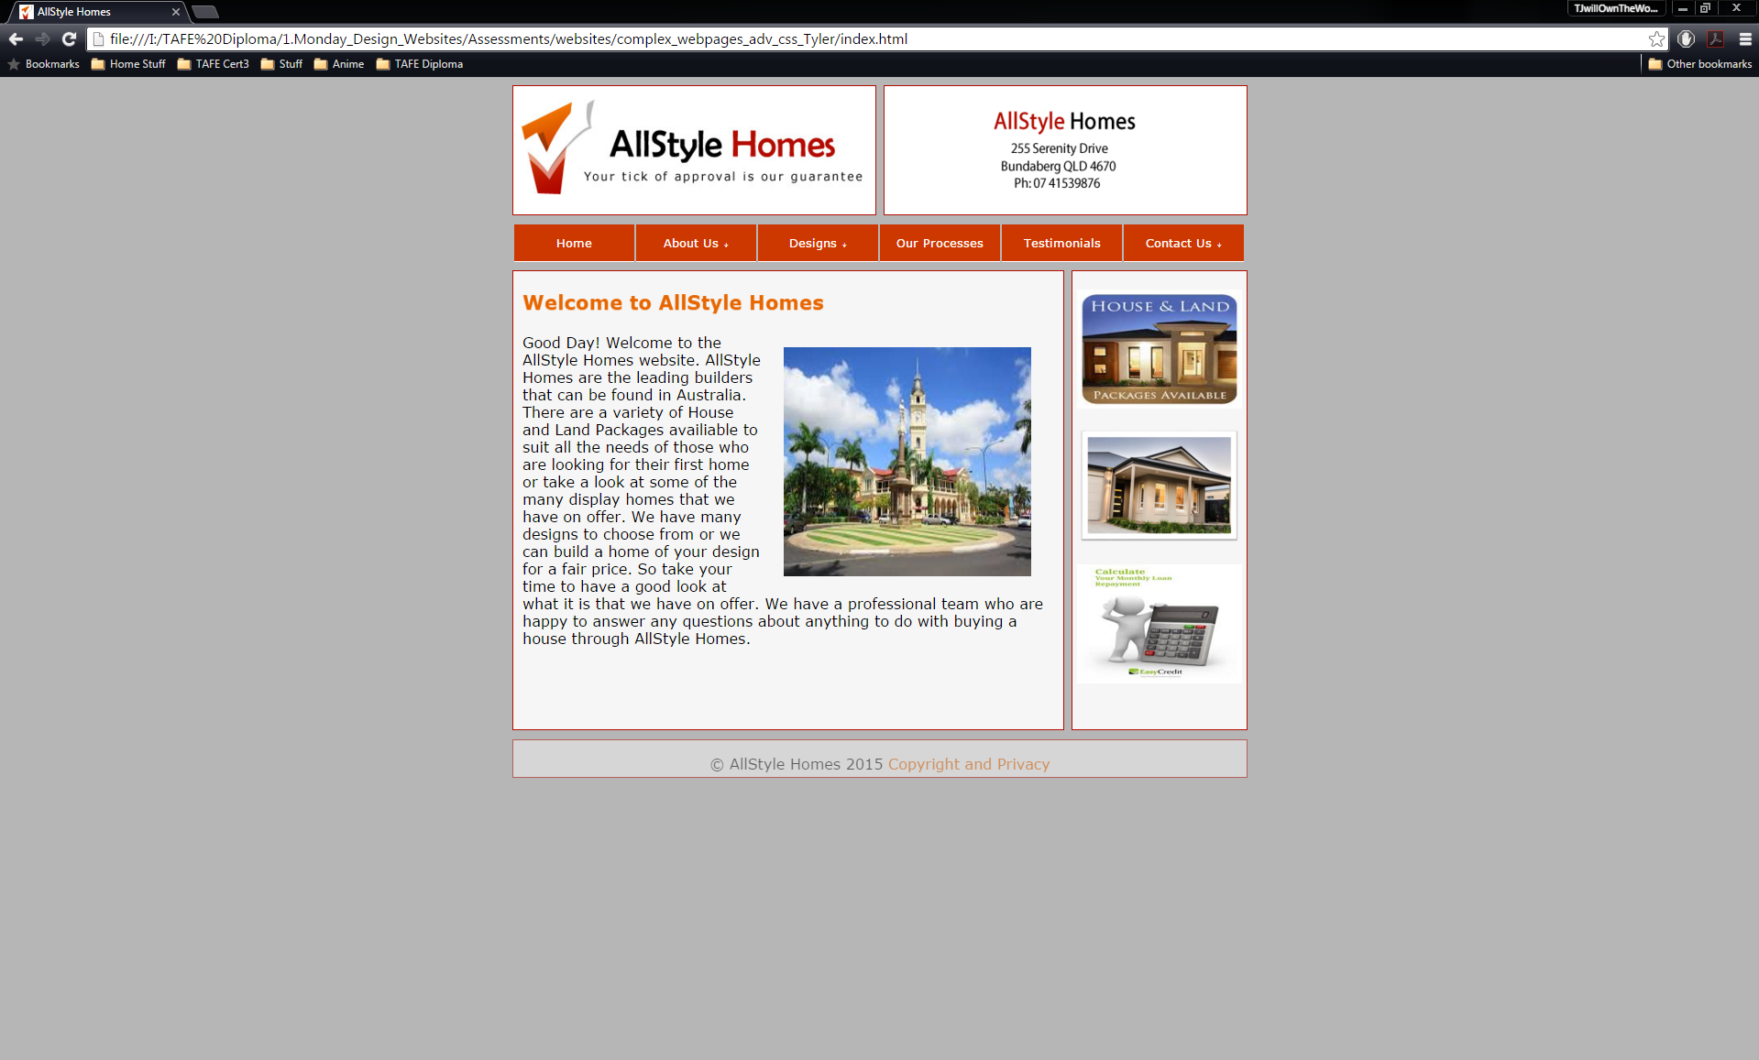

Firefox

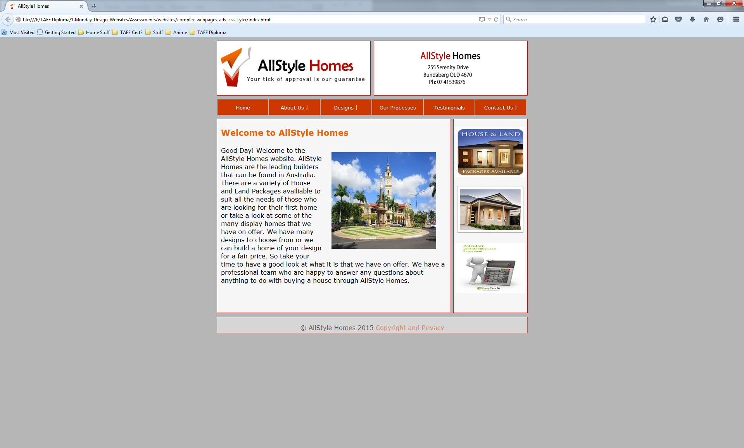

Internet Explorer

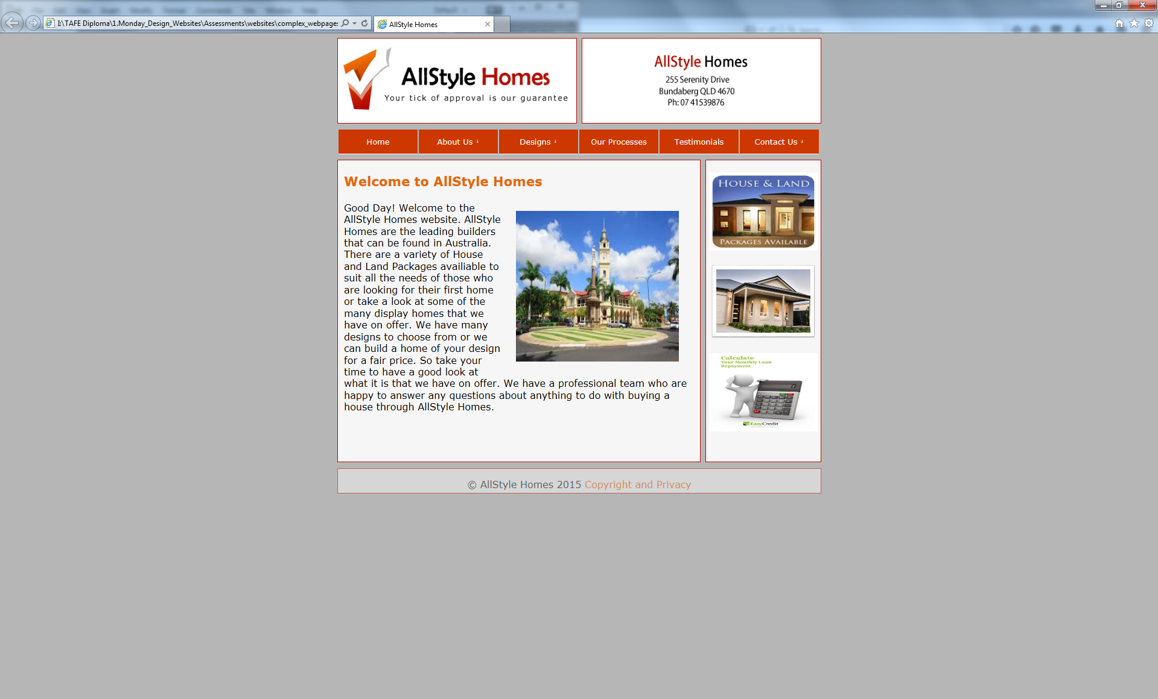

# Style Guide Comments-

I had made a change to the background colour of the site as I found that the darker grey looked better as opposed to the light grey that was specified. All other specifications were met according to the style guide.

# Page Layout

