Reproducing Evolutionary Suicide in the Life Engine
Reproducing Evolutionary Suicide in the Life Engine
​Oct 16, 2026 · ​@Ashley
Summary
We produced evolutionary suicide in the unmodified Life Engine, where zebras evolved a killer cell that destroyed their own food plants. In our modified savanna we did not produce it. There we saw failure to adapt in rhinos and some zebra lineages, and repeated boom-and-bust in leopards.
In the base engine (18 runs), killer cells damage everything they touch. Zebras that carried a kick cell destroyed all the plants and most of their own herd, and died out by tick 8,000.
When zebras had to evolve the killer themselves, one of three seeds met all four of our suicide criteria and the other two collapsed while keeping their grass. The base engine could not test our main hypothesis, that zebras would overgraze, because mouths cannot damage plants and nothing starves.
We then changed the engine (97 runs, including 18 follow-up runs of up to 200,000 ticks). We added grazing, poorer bush food, hunger, meat-eating leopards, a sprint rule, the four member cells (horn, stripe, cache and soil water), a river, trees and fire. Zebras evolved a second mouth wherever they survived, but grass never collapsed as a result, so the overgrazing suicide did not happen. The environment mattered as much as the species: without the river or the soil-water system every zebra lineage died out within 40,000 ticks, compared with one in five in the full design.
Introduction
The brief asks whether an evolving ecosystem can drive itself extinct through mis-adaptation, and how that differs from failure to adapt. We used two definitions throughout.
Evolutionary suicide: a trait spreads because it helps individuals, and the same trait removes something the population depends on, so the population collapses.
Failure to adapt: a species lacks the traits it needs and declines without first succeeding.
In Assignment 3 we agreed that a decline on its own would not count as suicide. Our analysis script ( analyze.py ) only labels a collapse as evolutionary suicide when four things hold:
Page 1 of 20

Reproducing Evolutionary Suicide in the Life Engine
1. The population grew to at least 1.5 times its starting size.
2. A trait spread before the decline (mouths per animal rose by 0.4 or more, or the share of animals with a killer cell rose by 0.3 or more).
3. The food plants (grass and bush organisms) fell by at least 25% between the peak and extinction.
4. Most deaths during the decline came from the lineage itself (starvation, old age without replacement, or its own evolved killers) rather than from another species.
A collapse that meets three of the four, including growth and trait spread, is reported as a suicide candidate. A collapse without growth is failure to adapt, and one where another species did most of the killing is collapse under predation.
Species
Each species is based on a real animal or plant. The base engine and the modified engine use different versions, because the base engine has none of our new cells and handles mover cells differently.
In the original Life Engine an organism needs only one mover cell. The engine's creator explains that adding more does not make an organism faster or give it anything else, since every mover moves one cell per tick. Our base zebra and leopard therefore have one mover each. In the modified engine we added our own rule that lets extra movers give extra speed during a chase (see Part 2), and the modified zebra and leopard carry two movers so they can use it.
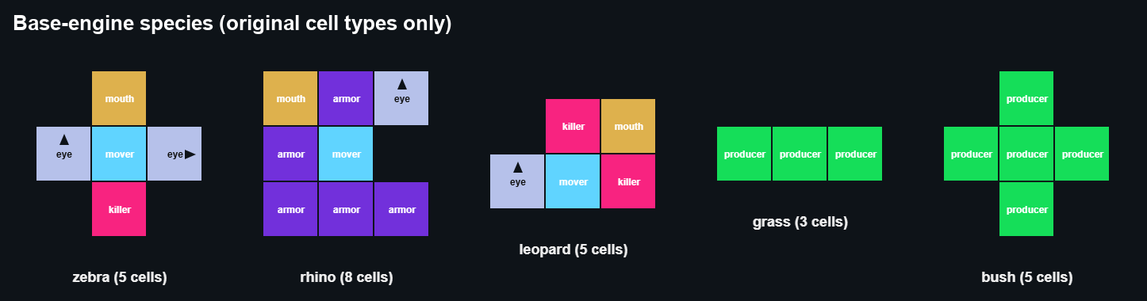
Species | Base-engine cells | Notes
Zebra | 1 mover, 1 mouth, forward eye, side eye, rear kick (killer), 5 cells | Herd grazer that kicks predators. In the original engine the kick also hurts other zebras and plants
Rhino | 1 mover, 1 mouth, forward eye, 5 armour, 8 cells | Armoured grazer. Armour only blocks killer cells

Page 2 of 20

Reproducing Evolutionary Suicide in the Life Engine
Species | Base-engine cells | Notes
Leopard | 1 mover, two killers beside the mouth, eye, 5 cells | Ambush hunter. Moves at the same speed as its prey and can also eat plant food
Grass | 3 producers in a row | Same food as bush
Bush | 5 producers in a plus shape | Same food as grass
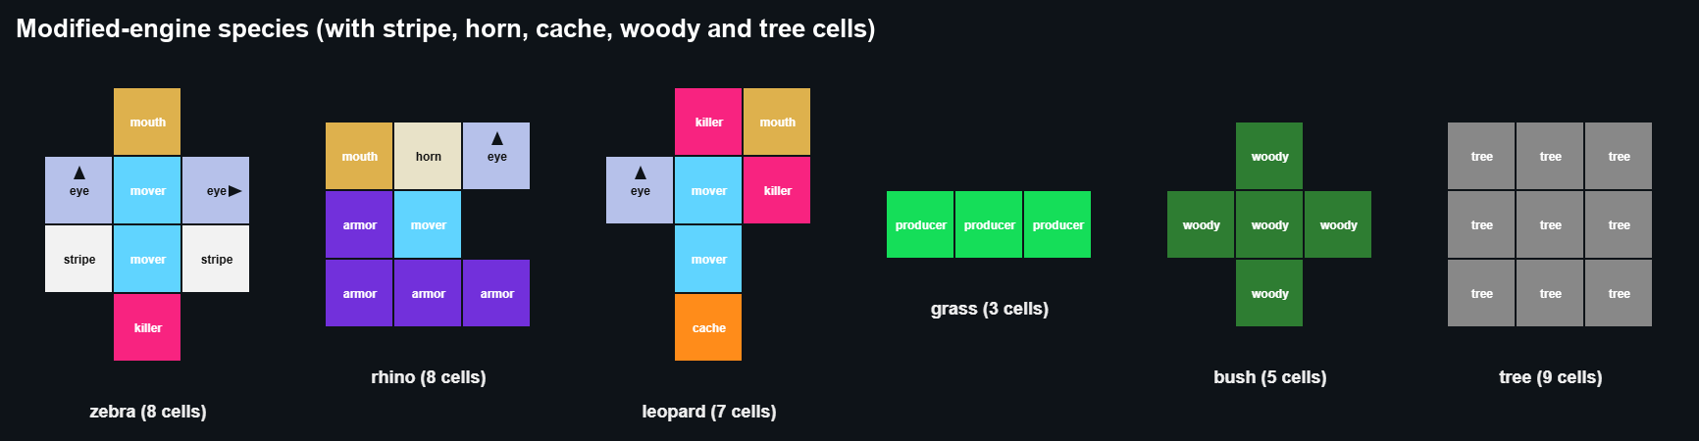
Species | Modified-engine cells | Strengths | Weaknesses
Zebra | 2 movers, 1 mouth,  forward eye, side eye, rear kick, 2 stripes, 8 cells | Sprints during a chase, herd camouflage, kick wounds leopards | One mouth, poor on bush food, no armour
Rhino | 1 mover, 1 mouth, horn, forward eye, 4 armour, 8 cells | Horn cannot be harmed and gores attackers; 20 health | Slow, and needs 16 food per calf
Leopard | 2 movers, two killers  beside the mouth, side eye looking forward,  cache, 7 cells | Sprints, bites for 4  damage, eats its kill on the spot, stores surplus food near trees | Eats only meat, no armour
Grass | 3 producers in a row | Spreads fastest, full-value food | Uses a lot of water, can be grazed
Bush | 5 woody cells in a plus shape | Cannot be grazed, uses half the water | Its browse is poor food
Tree | 3 x 3 tree cells | Long-lived, resists fire, hides animals next to it | Very slow, thirsty
Every run started with 140 grass, 45 bushes, 36 zebras in six herds, 12 rhinos and 16 leopards on a 160 x 100 grid, plus 14 trees in the modified engine. Zebras started without a flight response, which could evolve through brain mutation.
Page 3 of 20

Reproducing Evolutionary Suicide in the Life Engine
Part 1: the base engine
What the base engine can and cannot do
The base runs used the original rules, plus our Assignment 2 change that lets plants reproduce from the food they produce. None of our new settings were switched on, and mutation could not create our new cell types.
What the base engine allows | What it cannot do
Killer cells damage anything they touch, including plants and members of the same species, and anything that dies turns into food | Animals cannot starve; they only die of old age or damage
Uneaten food blocks births | Grass and bush food are identical, so there is no poorer fallback food
Mutation can add, change or remove any cell | Leopards can eat plant food, so they do not depend on prey
 | Mouths cannot damage plants, so animals cannot overgraze
 | Every animal moves one cell per tick
This meant the only way a species could destroy its own food was through killer cells.
How we tried to produce suicide or failure to adapt We ran six conditions, each for three seeds of 40,000 ticks.
Condition | What it tested
Default | The original settings (food production 5, lifespan multiplier 100, food blocks births). Does anything collapse on its own?
Plant-kill control | Zebras start without a killer cell; insta-kill is on, killers reach all eight neighbours and food  production is 3. Will a plant-killing trait evolve, spread and destroy the food supply?
Plant-kill, seeded | The same, but zebras start with the kick
Harsh | Food production 2. Does a species fail or adapt?

Page 4 of 20

Reproducing Evolutionary Suicide in the Life Engine
Condition | What it tested
No mutation | Food production 2 with mutation switched off, as a failure-to-adapt baseline
Clogging | Fast plants (food production 10, growing into all eight neighbours) and few grazers. Can plants choke on their own food?
Results
The clearest result came from the plant-kill control. In seed 2 a killer cell evolved and spread to between 89% and 100% of the herd. The herd peaked at 528, the last bush disappeared at tick 4,900 and the last grass at tick 11,700, and the zebras died out at tick 14,005. This run meets all four criteria.
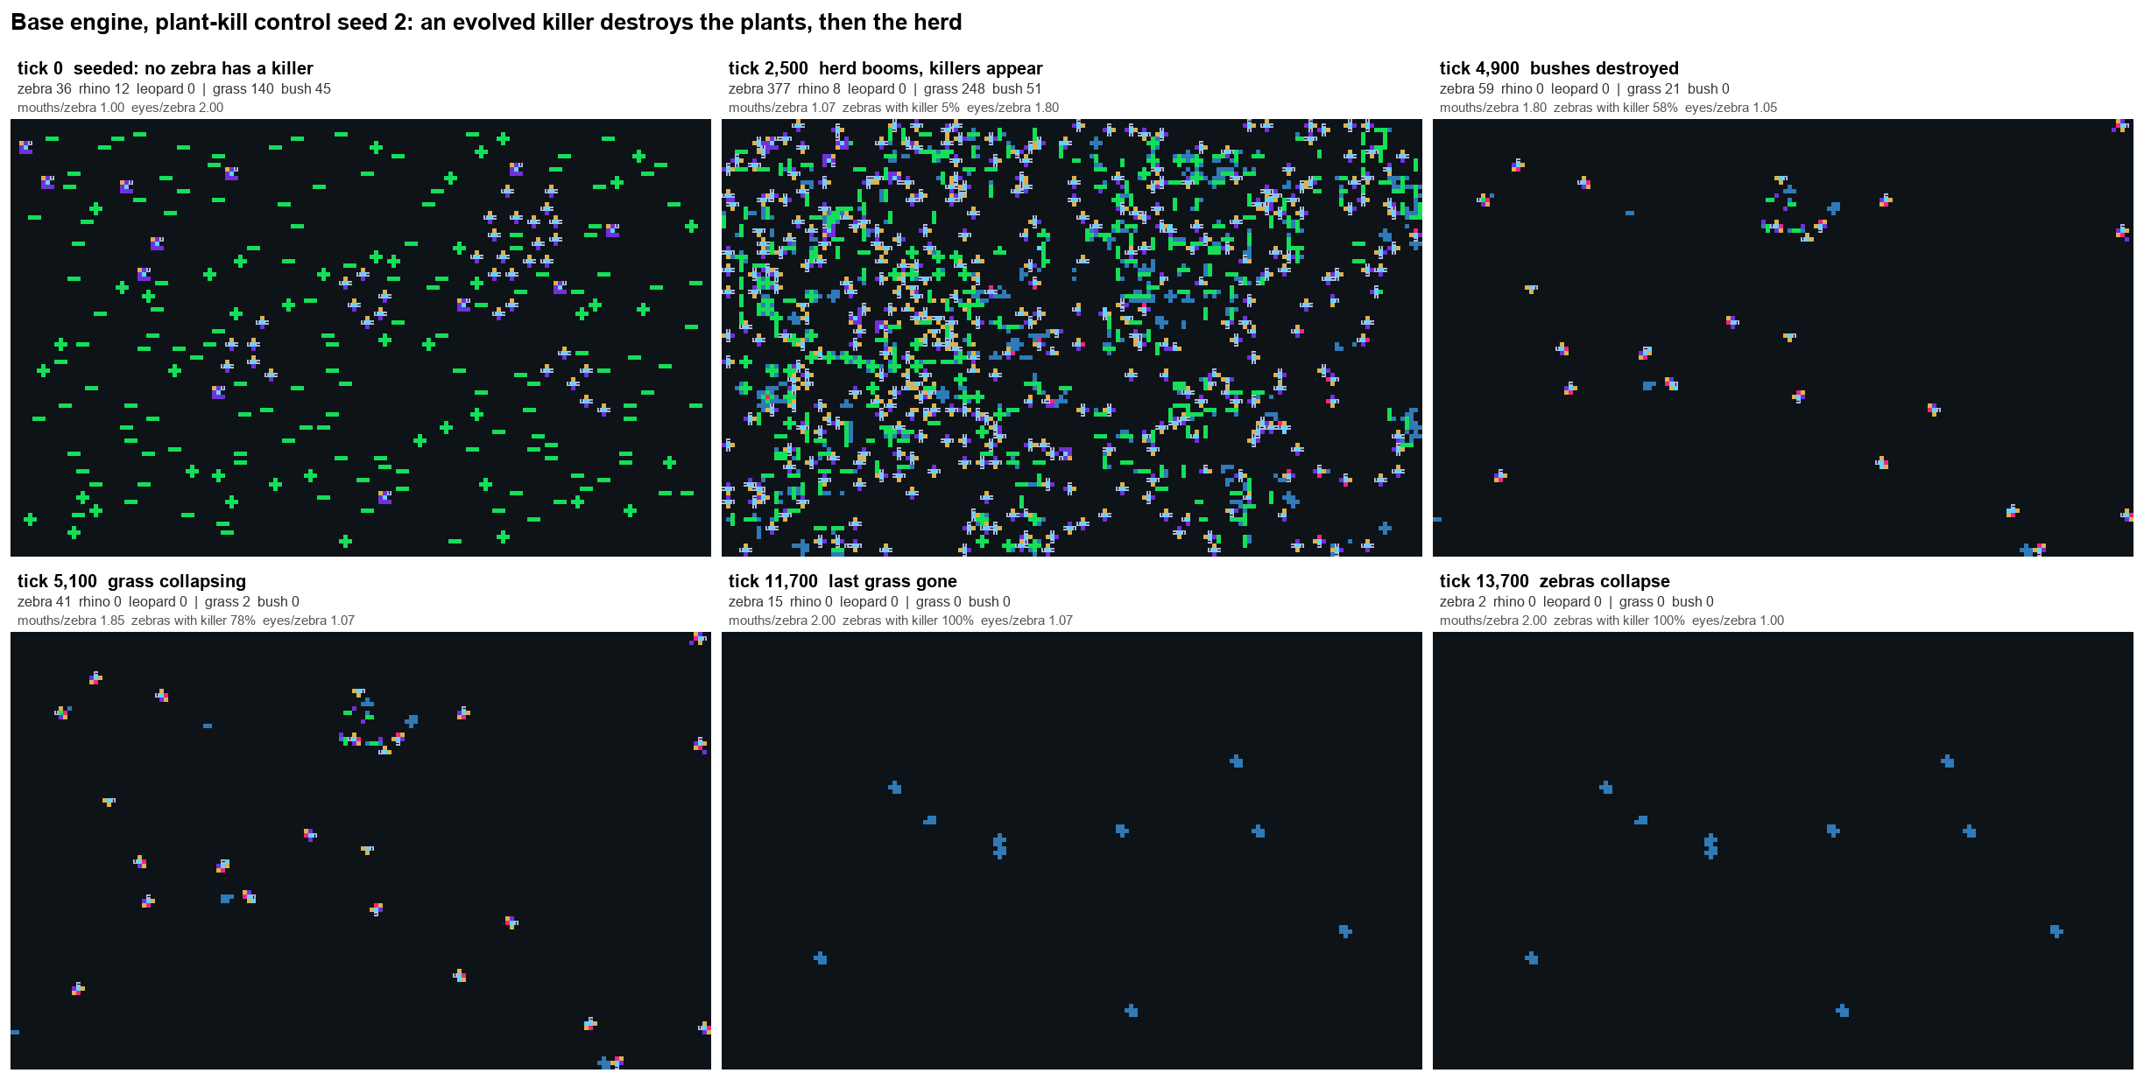
Page 5 of 20

Reproducing Evolutionary Suicide in the Life Engine
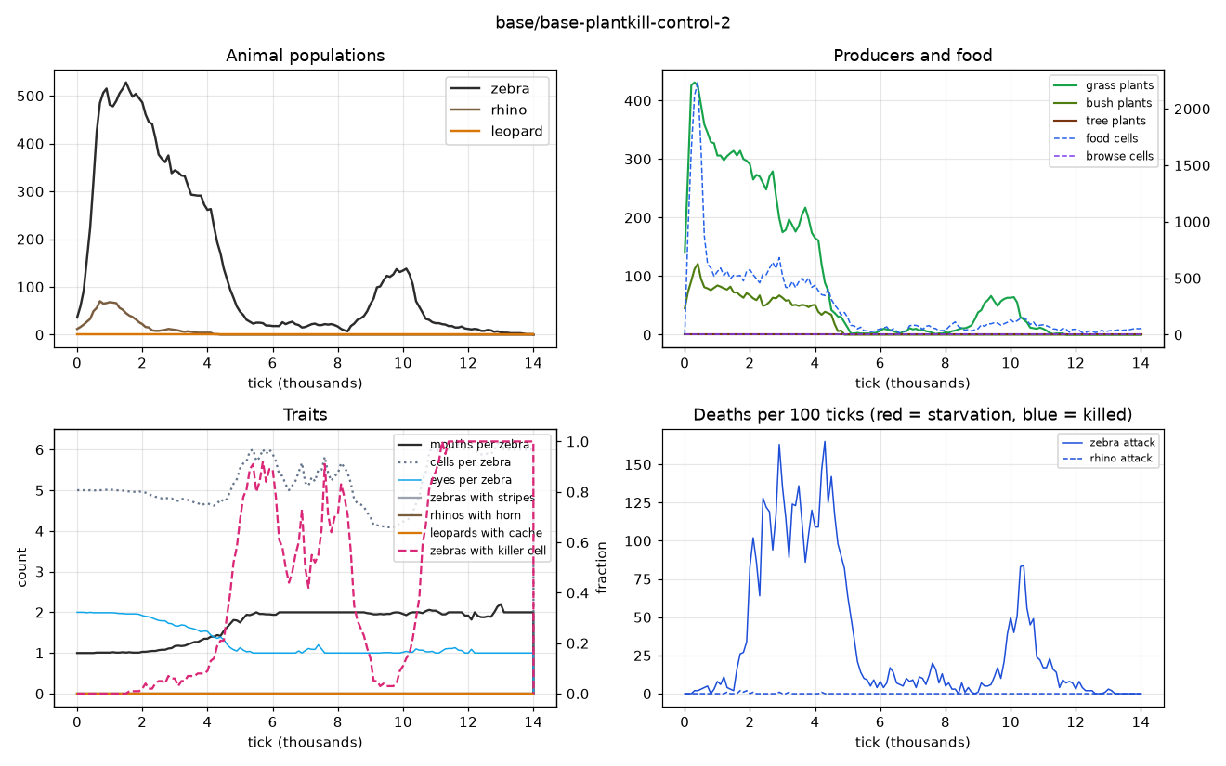
In seeds 1 and 3 the herd peaked at 594 and 582, but the evolved killers mostly killed other zebras instead of plants. The carcasses turned into food, food built up to between 5,000 and 7,400 cells, and because uneaten food blocks births the zebras stopped breeding. They died out at ticks 28,000 and 11,850 while the grass survived. These runs meet three of the four criteria.
In every condition where zebras started with the kick (default, harsh, no mutation and seeded plant-kill), the kick destroyed the plants and the herd. All bushes were gone by tick 500 to 1,500 and all grass by tick 700 to 6,100, and the zebras died out between ticks 2,800 and 8,000. Between 81% and 97% of zebra deaths were caused by other zebras, and leopards caused between 0% and 10%. The kick also killed most rhinos (69 of 90 rhino deaths in default seed 1), and rhinos were extinct by tick 2,800. The seeded plant-kill runs had no leopards at all, so the zebras did this on their own. Because the kick was present from the start rather than evolved, these runs do not meet the trait-spread criterion.
Page 6 of 20

Reproducing Evolutionary Suicide in the Life Engine
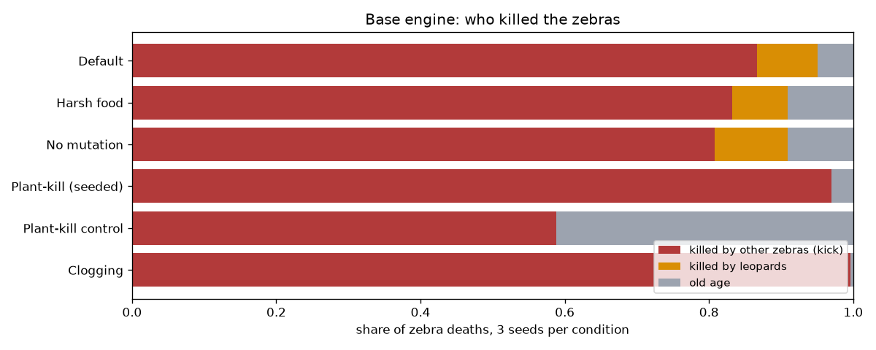
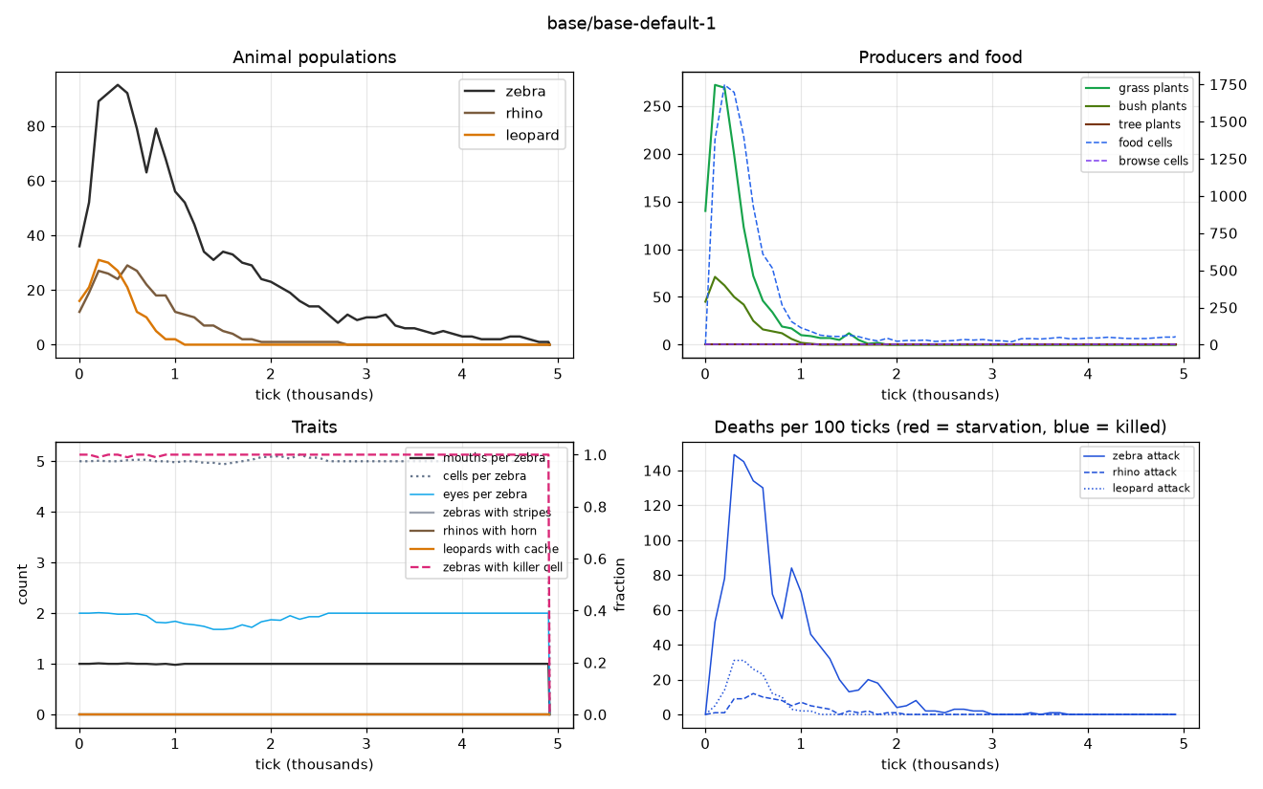
We also saw failure to adapt. With mutation switched off, zebras died out by about tick 5,000 in all three seeds. Leopards rose to between 22 and 35 in every condition and died out by tick 1,300, since they could not move faster than their prey. In the clogging runs the grass filled the map with about 2,000 plants but never choked itself; instead the few zebras boomed to between 242 and 348 and then kicked each other to death.
Page 7 of 20

Reproducing Evolutionary Suicide in the Life Engine
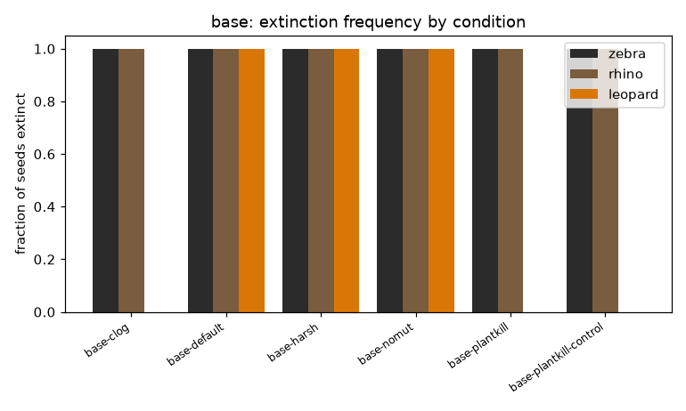
Why the base engine could not test our hypothesis
Our hypothesis was that zebras with extra mouths would overgraze, fall back on poorer bush food and collapse. In the base engine mouths cannot damage plants, bush food is the same as grass food, nothing starves and leopards do not need prey. Collapse could only come through killer cells, so we changed the engine in Part 2.
Part 2: the modified engine
What we changed
Each change addresses one of the base-engine limits above. Every change is switched off by default, which is why the base runs reproduce the original engine.
Base-engine limit | Our change
Mouths cannot damage plants | A mouth next to a grass plant damages it (2% chance per tick)
Grass and bush food are identical | Bushes drop browse worth 0.35 of grass food
Animals cannot starve | Animals pay 1 food every 80 ticks and die after 10 missed payments in a row

Page 8 of 20

Reproducing Evolutionary Suicide in the Life Engine
Base-engine limit | Our change
Leopards can eat plants | Dead animals leave meat; an animal with a killer beside its mouth can only digest meat; leopards eat their kill immediately
Every animal moves one cell per tick | Each extra mover gives one extra step per tick, but only while chasing or fleeing
Killers damage plants and their own kind | Killers no longer damage plants or their own lineage; a killer away from the mouth (the zebra kick) only hits predators
Plant growth is unlimited and the map is uniform | Soil water and fertility, a river, trees and fire
The sprint rule is our own addition and is not part of the Life Engine. When we tested leopards at equal speed they almost never caught a zebra. Sprinting only applies during a chase, so grazing animals still move one cell per tick and do not trample their own food.
Each group member built one feature.
Feature | Owner | Main files | How it can lead to collapse | What prevents an easy  collapse
Horn cell | Vimbai |  | Horned rhinos trample nearby plants and food | The horn  cannot be  harmed and  gores  attackers, so rhinos survive predation
  HornCell.js
Stripe  cell | Moreblessing | StripeCell.js , | More surviving zebras put  more pressure on grass | A leopard  misses a  striped zebra with 25%  chance per  striped  neighbour, up to 85%
  EyeCell.js

Page 9 of 20

Reproducing Evolutionary Suicide in the Life Engine
Feature | Owner | Main files | How it can lead to collapse | What prevents an easy  collapse
Cache cell | Ashley | CacheCell.js , | Storing food delays  breeding | Surplus food is stored near  trees and used when the  leopard would otherwise  starve
  Organism.js
Soil  water  and  fertility | Fourth  member | ProducerCell.js , WoodyCell.js , | Grass needs  water to  produce, so  dry, overgrazed soil recovers  slowly | Rain refills the soil, and deep-rooted bushes expand when grass declines
  WorldEnvironment.js
Other settings: armour costs 2 extra food to grow and adds 3 health, so rhinos are tough but breed slowly. Only animals of 9 or more cells can cross the river, and soil near the river refills three times faster. Trees hide nearby animals from animals of the other diet 60% of the time. Fires start more often in the dry season and spread through dry vegetation.
No part of the code sets a population size, a death or a survival. Every death comes from the same rules for each organism: old age, damage from cells or hunger. The world files only set the starting organisms and the settings, and runs of the same condition with different seeds end differently.
Page 10 of 20

Reproducing Evolutionary Suicide in the Life Engine
Experiments
Set | Runs | Length
Main runs (full design) | 5 seeds | 100,000 ticks
Ablations (one feature removed each) | 10 conditions x 3 seeds | 40,000 ticks
Sweeps (one setting changed each) | 12 conditions x 3 seeds | 40,000 ticks
Mechanism check (extra logging of body parts) | 8 runs | 40,000 ticks
Follow-up runs (longer, drier, more leopards, more fire) | 6 conditions x 3 seeds | 40,000 to 200,000 ticks
Main runs
In all five seeds, leopards died out within 13,000 ticks and rhinos within 18,000. Zebras
survived to the end in seed 1 only.
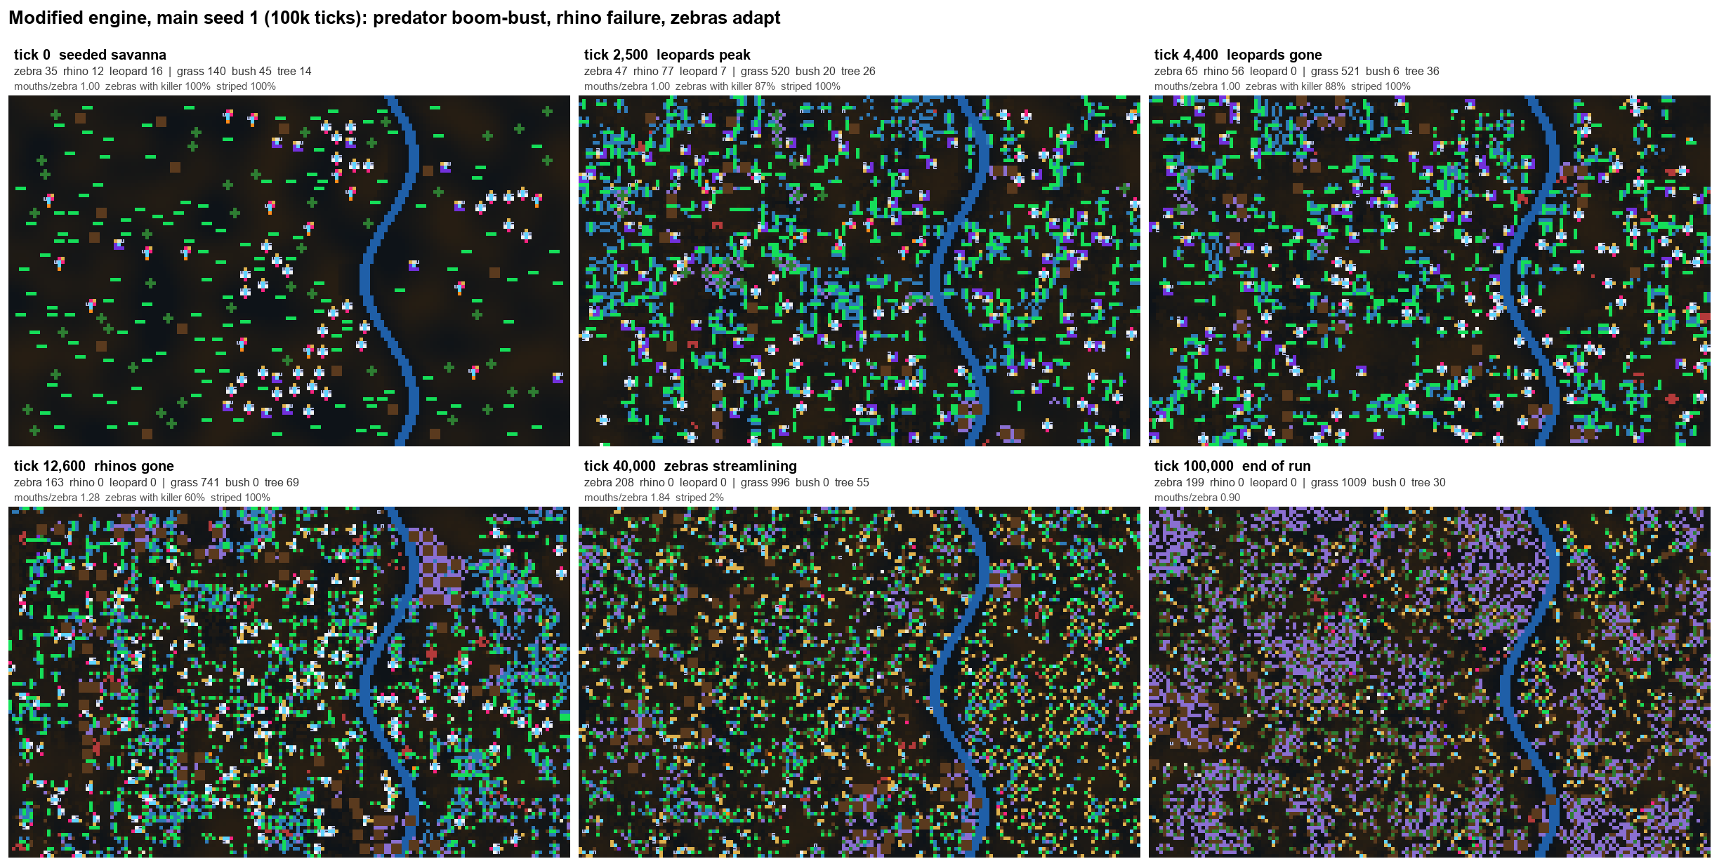
Seed | Leopards (peak, extinct at tick) | Rhinos (peak, extinct at tick) | Zebras (peak, outcome) | Highest mouths per zebra
1 | 35, 4,400 | 80, 12,600 | 290, survived (199 at tick 100,000) | 1.99

Page 11 of 20

Reproducing Evolutionary Suicide in the Life Engine
Seed | Leopards (peak, extinct at tick) | Rhinos (peak, extinct at tick) | Zebras (peak, outcome) | Highest mouths per zebra
2 | 26, 4,600 | 38, 13,900 | 120, extinct at 48,700 | 1.10
3 | 26, 12,800 | 67, 9,600 | 67, extinct at 94,400 | 1.20
4 | 26, 5,900 | 27, 5,100 | 136, extinct at 55,900 | 1.00
5 | 26, 3,600 | 31, 17,300 | 121, extinct at 18,200 | 1.03
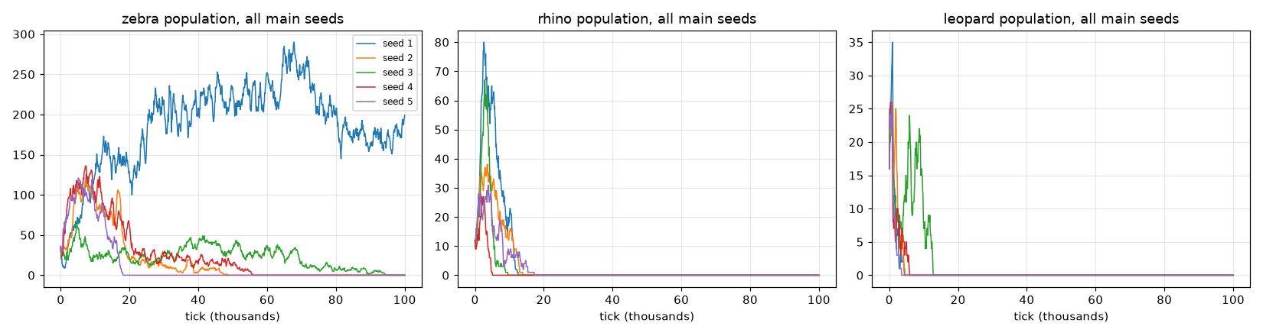
Leopards started at 16 and reached between 26 and 35 within about 1,000 ticks, killing 57 to 144 zebras and 17 to 66 rhinos per run. They then died out. In seeds 1 and 3 most leopards died of old age before they had made enough kills to replace themselves, and in seeds 2 and 4 most were killed by zebra kicks. Caches were used between 76 and 870 times per run, which slowed the decline but never stopped it. The zebras did not crash first, so the leopards failed to persist rather than over-hunting their prey.
Rhinos rose to between 27 and 80 and then died out, almost all of old age (54 to 358 deaths per run, against 17 to 66 killed by leopards). At 16 food per calf they could not replace themselves once zebras were eating most of the grass. Trampling never became large enough to matter.
In seed 1, mouths per zebra rose from 1.0 to 1.99 and the herd stayed large. In seeds 2 to 5 the extra mouth did not spread, and the zebras declined slowly over tens of thousands of ticks, dying of old age while food was still available. Starvation killed only 4 to 81 zebras per run. Fires were frequent (29 to 41 per run) but burnt only 154 to 381 cells in total.
Page 12 of 20

Reproducing Evolutionary Suicide in the Life Engine
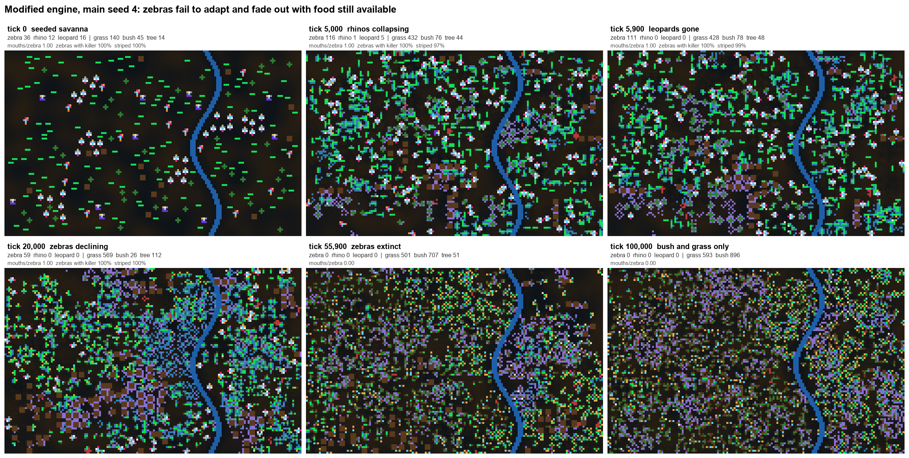
Ablations and sweeps
We compared each condition with the main runs at tick 40,000, when four of the five main zebra lineages were still alive. With three seeds a difference of one seed is within noise, so we only treat 0 of 3 or 3 of 3 as a clear result.
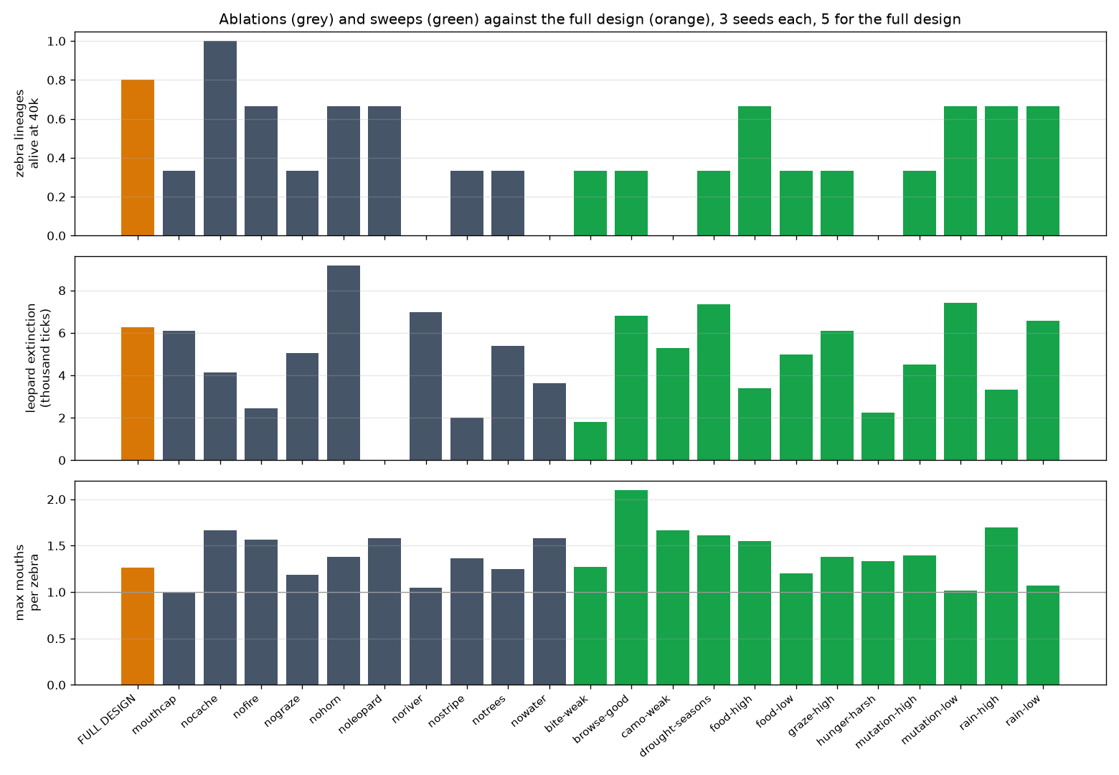
Page 13 of 20

Reproducing Evolutionary Suicide in the Life Engine
Condition | Zebra lineages alive at 40,000 ticks | Other result
Full design | 4 of 5 | Leopards extinct by about tick 6,300
No river | 0 of 3 | Lowest zebra peak (84)
No soil water | 0 of 3 | Grass spread without limit
No stripes | 1 of 3 | Zebras died out earliest (median tick 11,300)
Weak camouflage (maximum 30%) | 0 of 3
No cache | 3 of 3 | Leopards died out sooner (about tick 4,100)
No trees | 1 of 3 | Leopards could store food anywhere, reached 110 and survived in one seed
No horn | 2 of 3 | Leopards lasted longest (about tick 9,200)
Zebras limited to one mouth | 1 of 3 | Mouths stayed at 1.00
No grazing damage | 1 of 3
No leopards | 2 of 3 | Zebra peak 201
No fire | 2 of 3
High food production (8) | 2 of 3 | Highest zebra peak (225)
Low food production (3) | 1 of 3 | Rhinos survived in one seed
High rain / low rain | 2 of 3 each | High rain gave 1.70 mouths per zebra
Seasonal drought | 1 of 3
High grazing damage | 1 of 3
Better bush food (0.7) | 1 of 3 | Highest mouths per zebra (2.10)
Harsh hunger (6 missed payments) | 0 of 3 | Leopards extinct by about tick 2,200

Page 14 of 20

Reproducing Evolutionary Suicide in the Life Engine
Condition | Zebra lineages alive at 40,000 ticks | Other result
Weak bite (damage 2) | 1 of 3 | Leopards extinct by about tick 1,800
High / low mutation | 1 of 3 and 2 of 3 | Low mutation kept mouths at 1.01
The river, soil water and stripe camouflage protected zebras. Removing the cache helped zebras because leopards died sooner. Limiting zebras to one mouth made them worse off, which shows the extra mouth was an advantage rather than a cause of collapse.
Mechanism check
The main runs only logged mouths, so we reran eight runs that also logged eyes, movers, stripes and the kick. Once leopards were gone, surviving zebras lost cells they no longer needed and gained a second mouth.
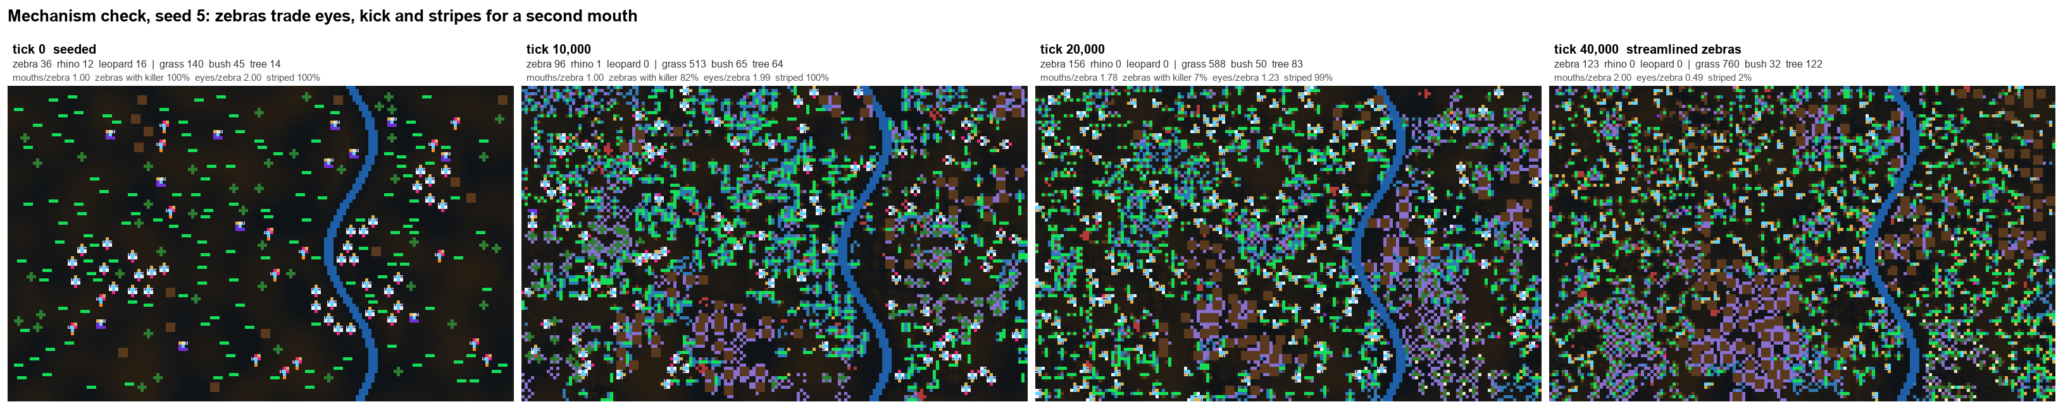
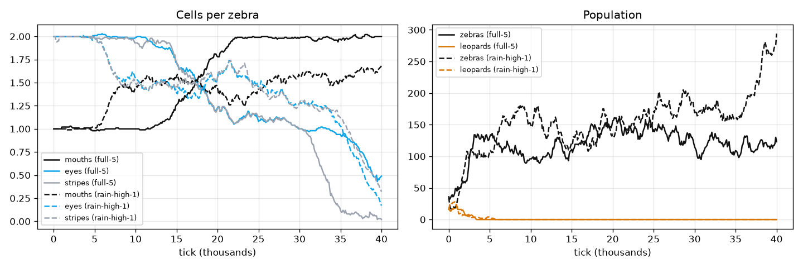
In default seed 5, eyes per zebra fell from 2.0 to 0.49, stripes from 2.0 to 0.02 and the kick from 1.0 to 0 by tick 25,000, while mouths rose to 2.0 and the herd held at about 110 to 150. In high-rain seed 1 the body shrank from 8 cells to 4.3 and the herd grew to 294. A smaller body needs less food per calf and a second mouth gathers food faster, so this streamlined body was an adaptation. In the four high-rain seeds where zebras died out, the change never started and mouths stayed at 1.0. Grass food stayed between about 500 and 2,000 cells under two-mouthed zebras, so the trait never removed its own food supply.
Page 15 of 20

Reproducing Evolutionary Suicide in the Life Engine
Follow-up runs
We ran 18 more runs to test three open questions: whether overgrazing needs more time
or less rain, whether more leopards can persist, and whether stronger fire matters.
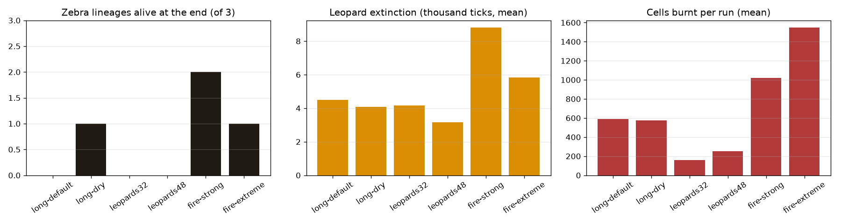
Condition | Settings | Zebras | Leopards | Fire
Long  default | 200,000 ticks | 0 of 3 survived; mouths reached 2.0 in two seeds | Extinct by tick 2,400 to 7,400 | About 590 cells burnt per run
Long dry | 200,000 ticks, 40% of normal rain | 1 of 3 survived; up to 2.8 mouths per zebra | Extinct by tick 2,000 to 7,100 | About 570 cells per run
32  leopards | 60,000 ticks | 0 of 3 survived | Peaked at 44 to 48, extinct by tick  3,200 to 5,800 | Small
48  leopards | 60,000 ticks | Herd eaten within about 1,300 ticks in two seeds | Peaked at 66 to 70, starved by tick  2,000 to 3,800 | Small
Strong fire | Fire chance x5, up to  4,000 cells | 2 of 3 alive at 40,000 | Extinct by tick 3,500 to 15,600 | About 1,020  cells per run;  largest fire 160 cells
Extreme fire | Fire chance x10, up to  8,000 cells | 1 of 3 alive at 40,000 | Extinct by tick 3,300 to 10,900 | About 1,550  cells per run;  largest fire 107 cells
Page 16 of 20

Reproducing Evolutionary Suicide in the Life Engine
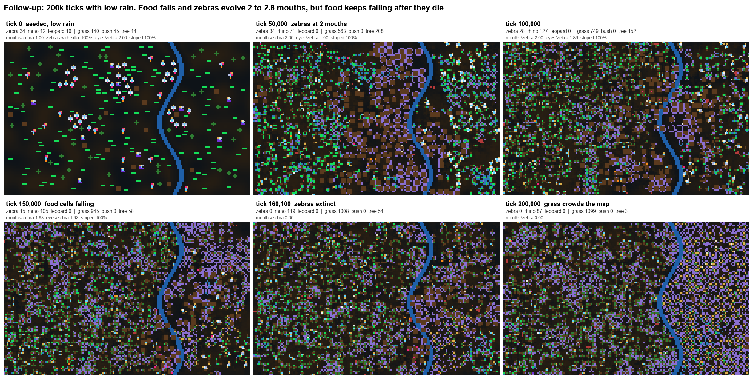
In long dry seed 3, grass food fell from about 1,550 cells at tick 20,000 to 166 at tick 160,000, and zebras evolved between 2 and 2.8 mouths. They died out at tick 160,100. Food kept falling after the last zebra died (to 36 cells at tick 190,000) while the number of grass plants doubled, so the shortage came from grass crowding the map rather than from grazing.
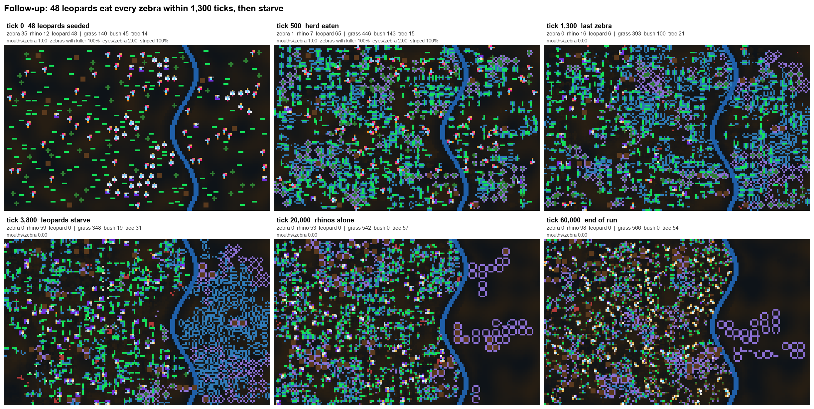
With 48 leopards the herd of 35 zebras was gone by tick 1,300 and the leopards starved by tick 3,800. This is ecological over-exploitation caused by the starting density we chose, with no trait spreading first, so it is not evolutionary suicide. With 32 leopards the peak was higher but the crash came just as quickly.
Page 17 of 20

Reproducing Evolutionary Suicide in the Life Engine
Raising the fire chance ten times only raised the area burnt by about 2.6 times, and no single fire passed 160 cells. Plants grow as small scattered organisms on mostly wet soil, so fires ran out of connected dry fuel.
Did the modified engine produce suicide or failure to adapt?
Target | Result | Reason
Zebra overgrazing suicide (our hypothesis) | Not observed | Zebras evolved a second  mouth, but water-limited  regrowth, the bush fallback and the river kept grass food from collapsing. Where food did fall, it kept falling after the zebras died
Rhino failure to adapt | Observed in every main seed | At 16 food per calf rhinos could not replace themselves, and most died of old age
Zebra failure to adapt | Observed where no  second mouth evolved | One-mouthed zebras barely covered their hunger cost and rarely bred
Leopard collapse | Observed in every run, but not suicide | With 16 leopards the first  generation aged out or was kicked to death; with 48 they ate every zebra and starved
Horn-trampling collapse | Not observed | Rhinos never became common enough
Fire-driven collapse | Not observed | Fires never had enough connected fuel
Our changes removed the collapse route the base engine used and made overgrazing possible, but overgrazing needs grass to regrow more slowly than it is eaten. In every setting we tried, regrowth and the fallback foods kept pace with the zebras.
Answers to the brief
Did an extinction event occur? Yes. Zebras died out in every base condition, and every leopard and rhino population died out in the modified main runs, as did the zebras in four of five main seeds.
Page 18 of 20

Reproducing Evolutionary Suicide in the Life Engine
Was it mis-adaptation or failure to adapt? Both occurred, in different places. Evolutionary suicide occurred in the base engine when zebras evolved a killer cell that paid off in food and then destroyed the plants (one seed meeting all four criteria, two more meeting three). The collapses caused by the seeded kick look similar, but the trait was there from the start, so we do not count them. Failure to adapt occurred in base zebras without mutation, in base leopards, in modified rhinos and in modified zebras that never evolved a second mouth. Our overgrazing hypothesis was not supported.
What was the role of the environment compared with the species? The engine rules decided how a population could collapse. In the base engine, killer cells could destroy plants and kin, and that is how populations collapsed. In the modified engine, regrowth, fallback food and the river protected zebras. Removing the river or soil water had as large an effect as removing a species trait.
Which features or traits were instrumental? Killer cells that damage plants and kin, the cost of rhino armour, the leopards' dependence on a single prey and harsh hunger pushed populations towards extinction. The river, soil water, stripes, the zebra kick against leopards and the evolved second mouth pushed them away from it. The cache delayed the leopards' decline but did not prevent it, and mainly kept predation on zebras going for longer.
Limitations
Before the final runs we changed several rules after seeing early results, because the first designs failed for mechanical reasons. The leopard body was redesigned three times, sprinting was limited to chases, armour cost and health were raised, and kicks were limited to predators. All of these are general rules about body parts, and every final run used the same rules.
Our first base runs gave zebras and leopards two movers. After confirming that extra movers have no effect in the original engine we reran all 18 base runs with one mover, and Part 1 uses only the reruns.
The base zebra's kick dominated Part 1. Without it, the base results would mostly come from the plant-kill control.
Ablations and sweeps used three seeds each, so differences of one seed are not meaningful.
Main runs lasted 100,000 ticks and ablations and sweeps 40,000, so we compared them at tick 40,000.
Seeds fix the starting world but not the engine's random numbers, so reruns follow different paths with the same overall patterns.
Page 19 of 20









Reproducing Evolutionary Suicide in the Life Engine
The thresholds in our criteria (1.5 times growth, 0.4 mouths, 0.3 killer share, 25% plant loss) are our own choice. The evidence for each run is saved in output/summary.json .
Lineages are named after their seeded ancestor. The grass lineage evolved mouths and a few mobile forms but is still counted as grass.
Leopards never persisted and fires stayed small even in the follow-up runs, so long-term predator-prey cycles and fire effects were not observed.
The base runs include our Assignment 2 change that lets plants reproduce from the food they make. Without it, plants without mouths never reproduce in the original engine.
Reproducing the results
The engine changes are in src/ and the experiment code and outputs are in savanna-
experiments/ .

Step | Command or file
Build the engine | npm install then npx webpack --
  mode=development
Generate a world | node savanna-experiments/make-world.js <variant> <seed>
Serve the engine and save outputs | python savanna-experiments/server.py 8138 , then open http://localhost:8138
Run the experiments | In the browser console, load /exp/harness.js and /exp/jobs.js , then call Savanna.queue(JOBS)
Charts and summary table | python savanna-experiments/analyze.py
Report figures
  python savanna-experiments/make_figures.py
Observation log | python savanna-experiments/obs_log.py
Each run folder in savanna-experiments/output/ contains log.csv (recorded every 100 ticks), events.json (collapses, extinctions and fires) and the screenshots. The world files can also be opened in the normal Life Engine interface with the load-world button.
Page 20 of 20

