TJ’S Rafting LLC Site Plan

Logo

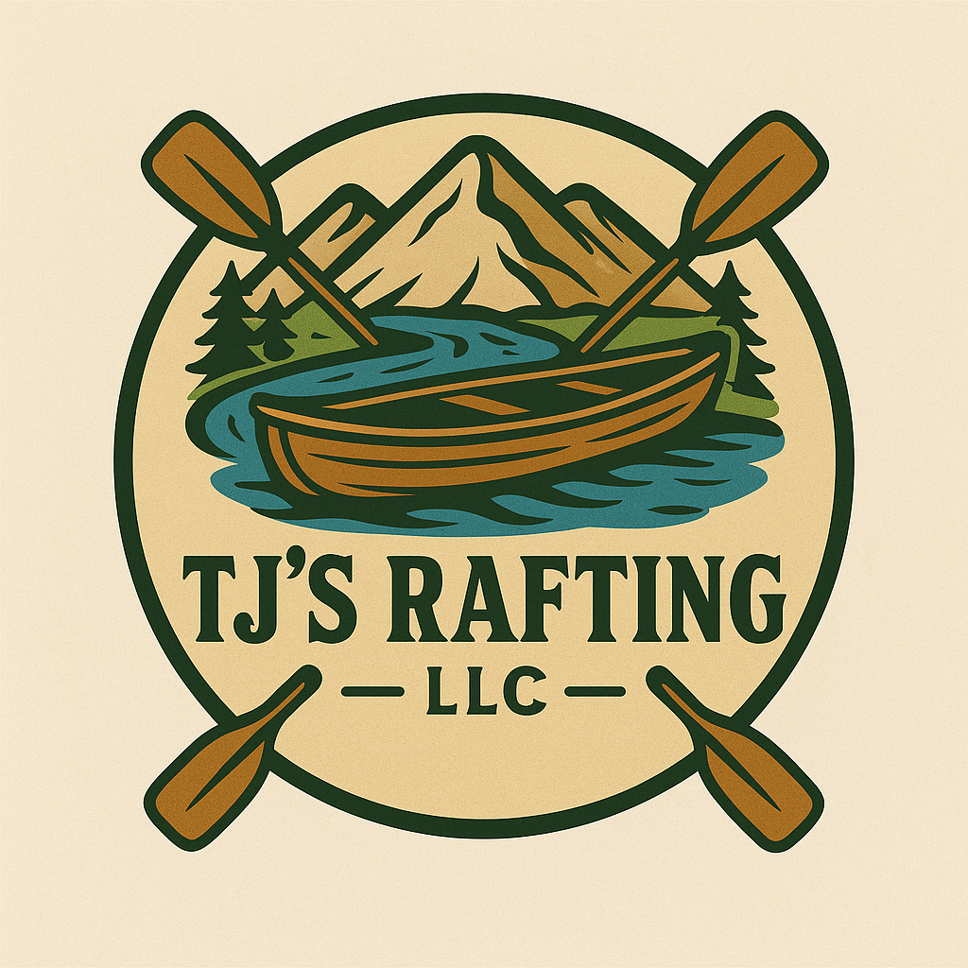

**Colors:**  
primary-color: #567568  
secondary-color: #7F9172  
accent1-color: #7D523C  
accent2-color: #D5DFE5

**Fonts:**  
heading-font: Rubik Dirt, Rye  
text-font: Ovo

**Color Palette URL:**  
<https://coolors.co/d5dfe5-7d523c-7f9172-567568>