RaceDay – Part 1
System Planning and Database
PROGRAMMING 2B (PROG6212/w)
Portfolio of Evidence
Total Part 1: 100 marks

1. Introduction
RaceDay is a full-stack event management system designed for the South African road running, walking and cycling community. The system separates the responsibilities of Organisers and Participants. Organisers manage events, categories, enrolments and results, while Participants can browse events, enter events, manage their profile and track their own results.
Part 1 focuses on planning before application code is written. The design below provides a single database model and API specification that can be followed consistently in Part 2 and Part 3.

2. Part 1 Deliverables
- Entity Relationship Diagram (ERD) with primary keys, foreign keys and relationship cardinality.
- API endpoint plan covering authentication, profiles, events, categories, enrolments and results.
- SQL Server database script containing tables, constraints, indexes and realistic seed data.
- Repository README and a GitHub Actions validation workflow.

3. Section A – Entity Relationship Diagram
The ERD uses five entities. Users stores both system roles, Events stores organiser-owned events, Categories belongs to Events, Enrolments connects Participants to Events and their selected Category, and Results stores the outcome of an Enrolment.
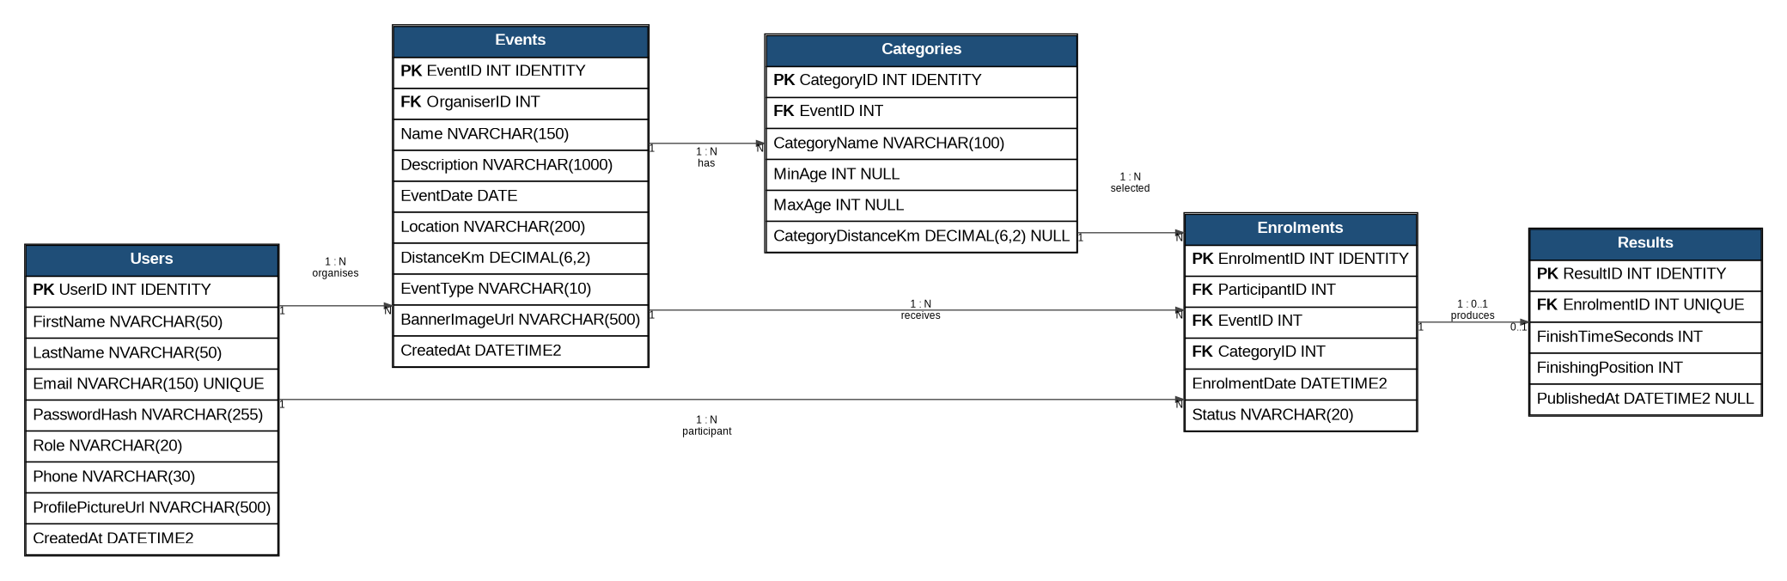
Relationship summary: one Organiser can create many Events; one Event can have many Categories; one Participant can have many Enrolments; one Event can have many Enrolments; one Category can be selected by many Enrolments; and an Enrolment can have zero or one Result.

4. Entity and Attribute Summary
Entity | Attributes | Purpose
Users | UserID PK; FirstName; LastName; Email UNIQUE; PasswordHash; Role; Phone; ProfilePictureUrl; CreatedAt | Stores both Organiser and Participant accounts.
Events | EventID PK; OrganiserID FK; Name; Description; EventDate; Location; DistanceKm; EventType; BannerImageUrl; CreatedAt | Stores each event and its owning Organiser.
Categories | CategoryID PK; EventID FK; CategoryName; MinAge; MaxAge; CategoryDistanceKm | Stores age or distance categories for an event.
Enrolments | EnrolmentID PK; ParticipantID FK; EventID FK; CategoryID FK; EnrolmentDate; Status | Links a Participant to an Event and selected Category.
Results | ResultID PK; EnrolmentID FK UNIQUE; FinishTimeSeconds; FinishingPosition; PublishedAt | Stores a Participant's result for an enrolment.

5. Section B – API Endpoint Plan
The endpoint plan is the specification for Part 2. It deliberately includes successful and failure responses so that authentication, authorisation and validation can be tested rather than only planning the happy path.
Method | Route | Description | Role | Request body | Response
POST | /api/auth/register | Register account | None | firstName, lastName, email, password, role, phone | 201 / 400 / 409
POST | /api/auth/login | Login and create session | None | email, password | 200 / 401
POST | /api/auth/logout | End session | Any | None | 204 / 401
GET | /api/profile | View own profile | Any | None | 200 / 401
PUT | /api/profile | Update own profile | Any | profile fields | 200 / 400 / 401
GET | /api/events | Browse upcoming events | None | None | 200
GET | /api/events/{id} | View event details | None | None | 200 / 404
POST | /api/events | Create event | Organiser | event fields | 201 / 400 / 401 / 403
PUT | /api/events/{id} | Update own event | Organiser | event fields | 200 / 403 / 404
DELETE | /api/events/{id} | Delete own event | Organiser | None | 204 / 403 / 404
GET | /api/events/{eventId}/categories | View event categories | None | None | 200 / 404
POST | /api/events/{eventId}/categories | Add category | Organiser | category fields | 201 / 400 / 403 / 404
PUT | /api/categories/{id} | Update category | Organiser | category fields | 200 / 403 / 404
DELETE | /api/categories/{id} | Delete category | Organiser | None | 204 / 403 / 404 / 409
POST | /api/events/{eventId}/enrolments | Enter event | Participant | categoryId | 201 / 400 / 404 / 409
GET | /api/enrolments/mine | View own enrolments | Participant | None | 200 / 401
GET | /api/events/{eventId}/enrolments | View event enrolments | Organiser | None | 200 / 403 / 404
GET | /api/enrolments/{id} | View authorised enrolment | Any authenticated | None | 200 / 403 / 404
POST | /api/events/{eventId}/results | Capture result | Organiser | enrolmentId, finishTimeSeconds, finishingPosition, publishedAt | 201 / 400 / 403 / 404 / 409
PUT | /api/results/{id} | Update result | Organiser | result fields | 200 / 403 / 404
GET | /api/results/mine | View personal results | Participant | None | 200 / 401
GET | /api/events/{eventId}/results | View event results | Organiser | None | 200 / 403 / 404

6. API Design Decisions
- Only Organisers can manage events, categories and event results. Ownership is checked using the OrganiserID stored on Events.
- Participants can enrol only for themselves and can select a category that belongs to the selected event.
- Authentication is planned around a server-side session. Part 2 will store the authenticated user ID and role in the session.
- Passwords must not be stored in plain text. Part 2 will hash passwords before storing them.
- GET endpoints that browse events and categories are public where the POE allows both roles to view them.
- Conflict responses such as an already-existing enrolment or result are included so duplicate operations can be handled predictably.

7. Section C – SQL Database Script
The SQL script creates RaceDayDB and the five tables shown in the ERD. Primary keys, foreign keys, NOT NULL, UNIQUE, DEFAULT and CHECK constraints are included. The script also seeds two Organisers, two Participants, three Events, categories for every event and sample enrolments and results.
- Users: enforces unique email addresses and limits Role to Organiser or Participant.
- Events: links each event to its Organiser and limits EventType to Run, Walk or Cycle.
- Categories: links each category to an event and prevents duplicate category names within one event.
- Enrolments: links Participant, Event and Category and prevents the same Participant from enrolling twice in one Event.
- Results: links to Enrolments and allows a maximum of one result per enrolment.
The SQL implementation uses standard SQL Server CREATE TABLE constraints and foreign-key relationships. Microsoft documents PRIMARY KEY, UNIQUE, FOREIGN KEY, DEFAULT and CHECK constraints as table-definition mechanisms for enforcing data integrity (Microsoft, 2026).

8. Testing the SQL Script in SSMS
1. Open SQL Server Management Studio and connect to a SQL Server instance.
2. Open docs/RaceDayDB.sql.
3. Execute the complete script on a test instance.
4. Confirm that RaceDayDB is created and that dbo.Users, dbo.Events, dbo.Categories, dbo.Enrolments and dbo.Results appear.
5. Run the verification SELECT statements at the end of the script.
6. Confirm that the seed data includes two Organisers, two Participants, three Events, categories for every Event and sample enrolments.

9. GitHub and CI/CD Preparation
The POE requires a minimum of 20 meaningful commits for Part 1 and a GitHub Actions workflow that validates the repository structure. The supplied workflow checks that the ERD, endpoint plan, SQL script and README are present.
1. Create repository structure and initial README
2. Add RaceDay system overview and roles
3. Create Users entity design
4. Create Events entity design
5. Create Categories entity design
6. Create Enrolments entity design
7. Create Results entity design
8. Define Users–Events relationship
9. Define Events–Categories relationship
10. Define Participant–Enrolment relationship
11. Define Event–Enrolment relationship
12. Define Category–Enrolment relationship
13. Define Enrolment–Result relationship
14. Complete ERD and export PNG
15. Draft authentication endpoints
16. Draft profile and event endpoints
17. Draft category and enrolment endpoints
18. Draft results endpoints and failure cases
19. Create SQL schema and constraints
20. Add seed data, README and CI workflow

10. Part 1 Submission Checklist
☐ ERD PNG placed in /docs.
☐ API endpoint plan placed in /docs.
☐ SQL script placed in /docs.
☐ README includes system description, roles, CI/CD screenshot and YouTube link.
☐ GitHub Actions workflow is in .github/workflows/.
☐ At least 20 meaningful commits are made using the student's own GitHub account.
☐ SQL script is tested in SSMS and runs successfully on a clean/test database.
☐ The submitted Part 1 documents are consistent with one another.

11. References
Microsoft (2026) 'CREATE TABLE (Transact-SQL)', Microsoft Learn. Available at: https://learn.microsoft.com/en-us/sql/t-sql/statements/create-table-transact-sql (Accessed: 2 September 2026).
Microsoft (2026) 'Primary and foreign key constraints', Microsoft Learn. Available at: https://learn.microsoft.com/en-us/sql/relational-databases/tables/primary-and-foreign-key-constraints (Accessed: 2 September 2026).

