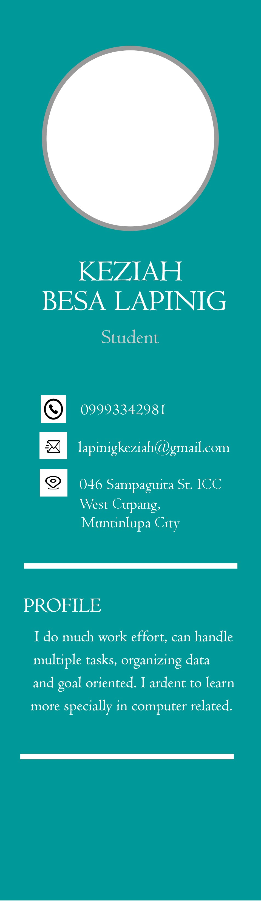

**EDUCATION**



De La Salle Santiago Zobel School

JUNIOR HIGH SCHOOL

Brother Rafael Donato FSC Night High School Grade 7 until Grade IO (S.Y. 20I 5 - 20I9)

SENIOR HIGH SCHOOL

Brother Rafael Donato FSC Night High School

Information Communication Technology (lCT Strand)

CSS NC II PASSER S.Y 2019 - 2021

COLLEGE (CURRENT)

Technological University of the Philippines - Manila Bachelor of Science in Information Technology

 **SKILLS**

Verbal and Written communication Creating design

Presentation and Demonstration

Computer System Services