Politecnico di Torino

Projects and Laboratory on Communication Systems

Inventory Management System  
Project Report

Authors:

Andreas Hølleland, Marcus Alexander Tjomsaas

Date:

30/06/2022

Contents

1 Introduction 1

1.1 Overview 1

1.2 Requirements 1

1.3 Extended functionality 3

2 Process and Tools 3

2.1 Components 3

2.2 Architecture 4

3 Implementation 5

3.1 Database and server 5

3.1.1 Tables 5

3.1.2 PHP 5

3.2 Totem software 5

3.2.1 Application 5

3.2.2 RFID script 6

3.3 Flutter application 6

3.3.1 API 6

3.3.2 Pages 6

# Introduction

This section aims to give a general overview of the developed software, explain  
any assumptions made regarding the system and its development, as well as  
introduce the main aspects of the implementation by presenting the achieved  
functionality of the system with respect to the given functional requirements.

## Overview

The Inventory Management System (IMS) is a multi-platform application for  
managing a physical inventory of items and is designed to be as generic as  
possible to be applicable in a wide variety of use-cases/businesses.

The general idea is that a customer (anything from a large business with ware-  
houses to a single person managing a shop), can purchase this software, register  
their items with RFID tags and manage their inventory. Users of the software  
can buy/borrow/return items from any registered customer with the application,  
which can be accessed through a website on any device, or native applications  
running on a PC (Windows/Linux/Mac) or a smartphone (Android/Iphone), as  
well as a dedicated on-site totem with a touch-screen and an RFID reader.

A customer can use the system with only a totem and still be able to get all  
functionality of the application, the only other requirements for the customer  
is to have an internet connection and RFID tags for each item. However, the  
system can also be used completely without a totem, where the only device  
needed is a phone/pc with RFID/NFC hardware, that can natively run the app   
(see the mentioned platforms above).

## Requirements

Below is a table of all the given functional requirements extracted from the assignment description slides, showing which ones have been implemented.

There are a few things that has been changed with respect to the assignment brief that were considered vague or unnecessary, in particular the requested features of each individual platform, the account type that are supposed to access them and their possibilities within each interface.

|  |  |  |
| --- | --- | --- |
| **ID** | **Description** | **Implemented** |
| **FR1** | **User account** | YES |
| FR1.1 | Get/return items | YES |
| FR1.2 | Register to one or more customers | YES |
| **FR2** | **Customer account** | YES |
| FR2.1 | Add/remove/reset its own users | YES |
| FR2.2 | Add/remove/modify items | YES |
| FR2.3 | Play the role of any of its users | YES |
| FR2.4 | Get/return items for its users | YES |
| FR2.5 | Check items (location, presence/absence) | YES |
| **FR3** | **Admin account** | YES |
| FR3.1 | Add/remove/reset customers and users | YES |
| FR3.2 | Play the role of any customer/user | YES |
| **FR4** | **Web interface** | YES |
| FR4.1 | Admin/customer/user can use it | YES |
| FR4.2 | Authentication through username/password | YES |
| FR4.3 | Authentication through social profile | NO |
| FR4.4 | Authentication through certificate | NO |
| **FR5** | **Totem interface** | YES |
| FR5.1 | Customer/user can use it | YES |
| FR5.2 | Authentication through username/password | YES |
| FR5.3 | Authentication through RFID | YES |
| FR5.4 | Authentication through smartphone | NO |
| **FR6** | **Smartphone interface** | YES |
| FR6.1 | Customer and User can use it | YES |
| FR6.2 | First time authentication through username/password | YES |
| FR6.3 | First time authentication through RFID | YES |
| FR6.4 | Log-in authentication through PIN | NO |
| FR6.5 | Log-in authentication through biometric data | NO |

Table 1 - Functional requirements

In the given requirements, some of the interfaces/platforms seem to be restricted to certain users and have limited functionality (see FR6.1 for instance). However, in the implementation, each platform runs the same application, and every account type can access the app through any of the supported interfaces and have the same functionality. The only exception here is the web-application, which cannot access the RFID hardware on the device running the browser.

## Extended functionality

Apart from the basic implemented functionality detailed in Table 1, some extra features and improvements has been added to the software, these include:

* The same user interface for every device
* User friendly touch keyboard integrated within the app
* Password encryption
* Error checking in both frontend and backend

# Process and Tools

This section will present the core software components required to run the system, the main tools and frameworks used for the development of these, and a high-level description of the overall system architecture.

## Components

The main components of the system are the:

* Application
* Web server
* Database
* Totem

The application software is written using Flutter and Dart, which has provided a universal framework for designing and building the application for all the previously mentioned interfaces without having to do any platform-specific tinkering. The API for sending http requests to the web server has also been written in Dart, which is very convenient as it made server integration with the application quite simple.

For this prototype, the web server and database are hosted using a program called XAMMP, which is designed for quick testing of clients and websites on a local host before publishing to a remote server. It comes pre-installed with all the software components needed, MariaDB relational database (MySQL), Apache HTTP server Filezilla FTP server, and phpMyAdmin (database admin tool for MariaDB), which is what has been used in this system. PHP has been used for the server-side scripting.

Python has been used for interfacing with the totem’s RFID reader as well as individually communicate with the web server. This is due to some issues with the RaspberryPi hardware and integration with the Flutter app (This is explained later).

## Architecture

Below is a diagram showing the overall architecture and internal communication of the prototype system. Some of this would obviously be different in a real-world scenario due to the tools and setup for this demo.

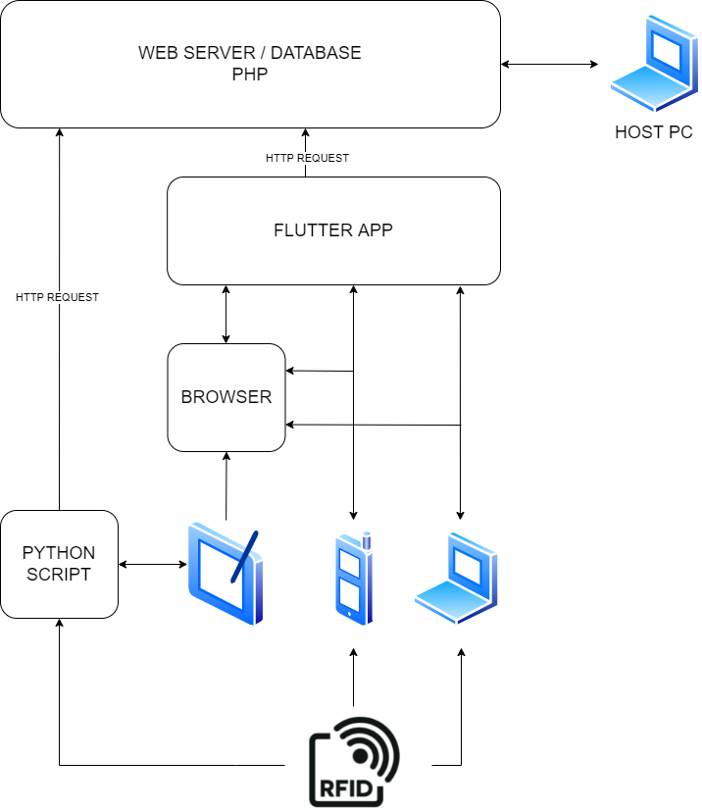

Figure 1 - High level view of architecture

As previously mentioned, there was some issues with building the flutter app for the totem hardware, so as can be seen in Figure 1 the totem is running the Flutter app in the browser, and the python script is reading the RFID module and transmitting information to the database. Since the browser cannot communicate with the module, it uses use the database to detect when the RFID has received an input, and if that input came from the same totem. This is discussed in more detail in the following section.

# Implementation

This section will present some details of the software implementation, which includes the database and server scripting, Flutter app, totem software, and the communication between these components.

## Database and server

### Tables

The database is mainly responsible for storing information about every account and their items. It consists of the following tables:

* Lekna
* Mjaa
* …

### PHP scripts

These are the server-side programs acting as the bridge between the application and the database. They are responsible for handling the incoming http requests and retrieving/storing data on the database.

Explain conn.php …

Explain general structure of the php scripts…

Present special cases (error checking, encryption, totem ip stuff)

## Totem software

### Application

The goal at first was to make the Flutter application run locally on the raspberry pi hardware, as that would allow the application to communicate directly with the raspberry pi GPIOs using the Flutter GPIO library. This shouldn’t be a problem as Flutter now has support for compiling native apps for Linux, but there seems to be some issues with Linux compilation and ARM processors.

Another option is using a Flutter engine embedder called flutter-pi (see github), which makes it possible to run any Flutter app without booting into the desktop environment, which others have also used previously with the Flutter GPIO library. However, this also didn’t work as there was some trouble with the installation.

Due to the above and time constraints, the app is running on the browser as it would on any other pc\smartphone.

### RFID script

This is a python script constantly running on the raspberry, responsible for communicating with the RFID module and the server. It is continuously waiting for an input from the RFID reader, and if a tag is scanned the ID is sent to the database server through a http request.

## Flutter application

### API

The API for communicating with the server is written in Dart and can be found under “flutter_demo/lib/services” in the project source directory.

It is divided into three files:

* account_service.dart
* item_service.dart
* totem_service.dart

### Pages

Below is flow-chart showing the transitions between the various pages in the Flutter app, for each type of account (user, customer and admin).

#### Login page

This is the startup page. To be able to log in, the user must enter their email and password and press the sign-in button. At this point the program makes a request to “getAccount.php” which checks the database for a match. There is also a button to transition to the “Register” page.

#### Register page

The register page is used to add or update accounts. The page will have a different layout depending on the type of account accessing it (no account, customer, admin), as the types have different privileges:

* **No account** (Accessed from login page)
* Scan RFID card/token
* Enter email/password
* **Customer** (Accessed after login)
* Create user accounts
* Update users
* Edit RFID, email, password of accounts
* **Admin** (Accessed after login)
* Do the same as customer
* Create/update customer accounts
* Edit account type, customer ID, registered customer ID of accounts

#### User page

This is the home page of the user. The user can scan an item on their phone or a totem, and depending on its current status, the item will be updated to “borrowed” or “returned” in the database. When an item is borrowed, it’s registered automatically with the user, and its location is changed to the name of the user. When returned, the status changes, but the location remains the same (name) until it’s updated by the customer.

#### Customer/Admin page

The customer and admin are greeted with the same home page as the user, with the addition of a few buttons redirecting them to some other pages. These include:

* User list

This page displays a list off all users, or if viewed by an admin; customers and users. From here it’s also possible to add/modify accounts (transitions to the Register page)

* Item list

Same functionality as for the User list, just for items.

* Help user

Here a customer/admin can log in for any user in case there is no totem, they don’t have a phone, forgot password, etc…

* Play user (default window)

The same functionality as explained previously for the user.