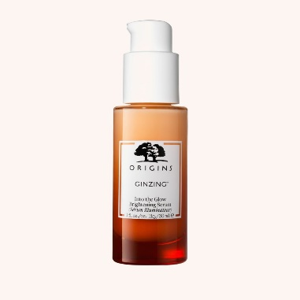**Origins** – GinZing. Into the Glow Brightening serum

Ca 300 kr

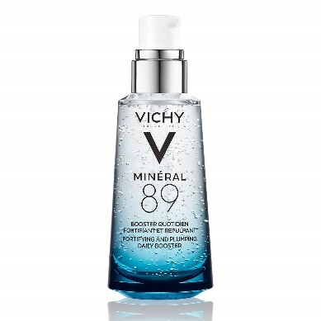**Vichy** Mineral 89

Ca 300 kr

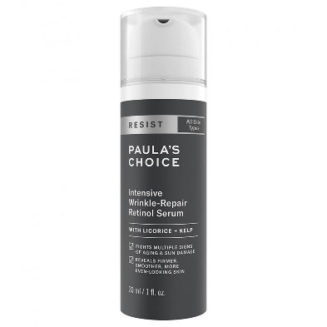**Paula’s choice** -Resist intensive wrinkle-repair retinol serum

Ca 500 kr

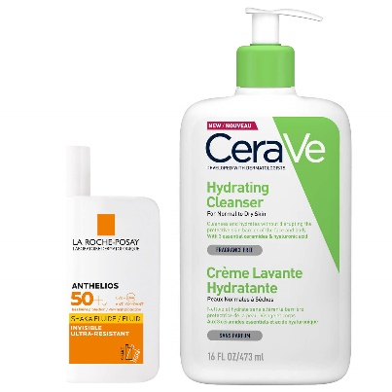CeraVe – Hydrating cleanser

La roche-posay – spf 50

Ca 400 kr