Після проведення міграції було створено папку та файли

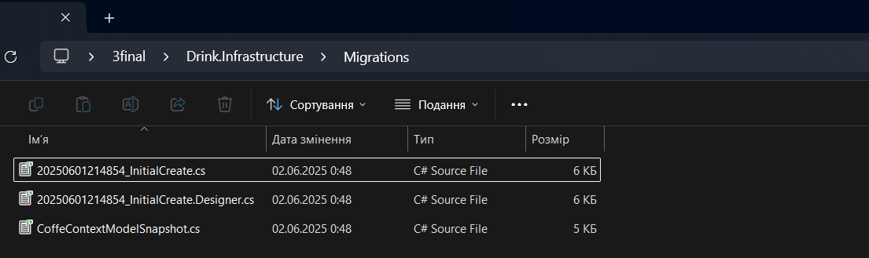  
  
PM> Add-Migration InitialCreate

Build started...

Build succeeded.

PM> Add-Migration InitialCreate

Build started...

Build succeeded.

To undo this action, use Remove-Migration.

PM> Update-Database

Build started...

Build succeeded.

Microsoft.EntityFrameworkCore.Database.Command[20101]

Executed DbCommand (7ms) [Parameters=[], CommandType='Text', CommandTimeout='30']

PRAGMA journal_mode = 'wal';

Microsoft.EntityFrameworkCore.Database.Command[20101]

Executed DbCommand (3ms) [Parameters=[], CommandType='Text', CommandTimeout='30']

CREATE TABLE "__EFMigrationsHistory" (

"MigrationId" TEXT NOT NULL CONSTRAINT "PK___EFMigrationsHistory" PRIMARY KEY,

"ProductVersion" TEXT NOT NULL

);

Microsoft.EntityFrameworkCore.Database.Command[20101]

Executed DbCommand (2ms) [Parameters=[], CommandType='Text', CommandTimeout='30']

SELECT COUNT(*) FROM "sqlite_master" WHERE "name" = '__EFMigrationsHistory' AND "type" = 'table';

Microsoft.EntityFrameworkCore.Database.Command[20101]

Executed DbCommand (0ms) [Parameters=[], CommandType='Text', CommandTimeout='30']

SELECT "MigrationId", "ProductVersion"

FROM "__EFMigrationsHistory"

ORDER BY "MigrationId";

Microsoft.EntityFrameworkCore.Migrations[20402]

Applying migration '20250601214854_InitialCreate'.

Applying migration '20250601214854_InitialCreate'.

Microsoft.EntityFrameworkCore.Database.Command[20101]

Executed DbCommand (0ms) [Parameters=[], CommandType='Text', CommandTimeout='30']

CREATE TABLE "Drinks" (

"Id" TEXT NOT NULL CONSTRAINT "PK_Drinks" PRIMARY KEY,

"Name" TEXT NOT NULL,

"Volume" INTEGER NOT NULL

);

Microsoft.EntityFrameworkCore.Database.Command[20101]

Executed DbCommand (0ms) [Parameters=[], CommandType='Text', CommandTimeout='30']

CREATE TABLE "Cocoas" (

"Id" TEXT NOT NULL CONSTRAINT "PK_Cocoas" PRIMARY KEY,

"Milk" INTEGER NOT NULL,

"CocoaPowder" INTEGER NOT NULL,

CONSTRAINT "FK_Cocoas_Drinks_Id" FOREIGN KEY ("Id") REFERENCES "Drinks" ("Id") ON DELETE CASCADE

);

Microsoft.EntityFrameworkCore.Database.Command[20101]

Executed DbCommand (0ms) [Parameters=[], CommandType='Text', CommandTimeout='30']

CREATE TABLE "Espressos" (

"Id" INTEGER NOT NULL CONSTRAINT "PK_Espressos" PRIMARY KEY AUTOINCREMENT,

"Coffee" INTEGER NOT NULL,

"SmallCup" INTEGER NOT NULL,

"DrinkId" TEXT NOT NULL,

CONSTRAINT "FK_Espressos_Drinks_DrinkId" FOREIGN KEY ("DrinkId") REFERENCES "Drinks" ("Id") ON DELETE CASCADE

);

Microsoft.EntityFrameworkCore.Database.Command[20101]

Executed DbCommand (0ms) [Parameters=[], CommandType='Text', CommandTimeout='30']

CREATE TABLE "Cappuccinos" (

"Id" INTEGER NOT NULL CONSTRAINT "PK_Cappuccinos" PRIMARY KEY AUTOINCREMENT,

"Milk" INTEGER NOT NULL,

"MediumCup" INTEGER NOT NULL,

CONSTRAINT "FK_Cappuccinos_Espressos_Id" FOREIGN KEY ("Id") REFERENCES "Espressos" ("Id") ON DELETE CASCADE

);

Microsoft.EntityFrameworkCore.Database.Command[20101]

Executed DbCommand (0ms) [Parameters=[], CommandType='Text', CommandTimeout='30']

CREATE TABLE "Rafs" (

"Id" INTEGER NOT NULL CONSTRAINT "PK_Rafs" PRIMARY KEY AUTOINCREMENT,

"Cream" INTEGER NOT NULL,

CONSTRAINT "FK_Rafs_Cappuccinos_Id" FOREIGN KEY ("Id") REFERENCES "Cappuccinos" ("Id") ON DELETE CASCADE

);

Microsoft.EntityFrameworkCore.Database.Command[20101]

Executed DbCommand (0ms) [Parameters=[], CommandType='Text', CommandTimeout='30']

CREATE INDEX "IX_Espressos_DrinkId" ON "Espressos" ("DrinkId");

Microsoft.EntityFrameworkCore.Database.Command[20101]

Executed DbCommand (0ms) [Parameters=[], CommandType='Text', CommandTimeout='30']

INSERT INTO "__EFMigrationsHistory" ("MigrationId", "ProductVersion")

VALUES ('20250601214854_InitialCreate', '8.0.5');

Done.

PM>

