[[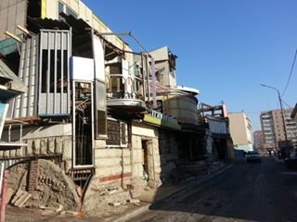](https://www.facebook.com/photo.php?fbid=902506046448875&set=pcb.902506149782198&type=1)](https://www.facebook.com/photo.php?fbid=902506046448875&set=pcb.902506149782198&type=1)

[[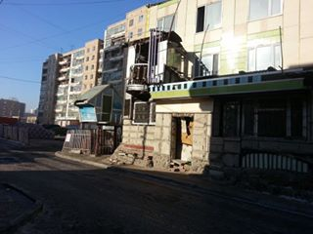](https://www.facebook.com/photo.php?fbid=902506063115540&set=pcb.902506149782198&type=1)](https://www.facebook.com/photo.php?fbid=902506063115540&set=pcb.902506149782198&type=1)

[[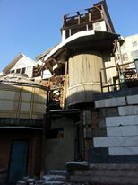](https://www.facebook.com/photo.php?fbid=902506079782205&set=pcb.902506149782198&type=1)](https://www.facebook.com/photo.php?fbid=902506079782205&set=pcb.902506149782198&type=1)

[[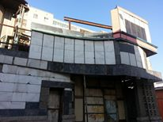](https://www.facebook.com/photo.php?fbid=902506099782203&set=pcb.902506149782198&type=1)](https://www.facebook.com/photo.php?fbid=902506099782203&set=pcb.902506149782198&type=1)

[[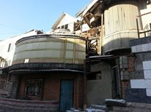](https://www.facebook.com/photo.php?fbid=902506133115533&set=pcb.902506149782198&type=1)](https://www.facebook.com/photo.php?fbid=902506133115533&set=pcb.902506149782198&type=1)