**p2**

use pandemic;

create table countries (

code varchar(255) primary key,

entity varchar(255) not null

);

insert into countries (code, entity)

select distinct Code, Entity from infectious_cases;

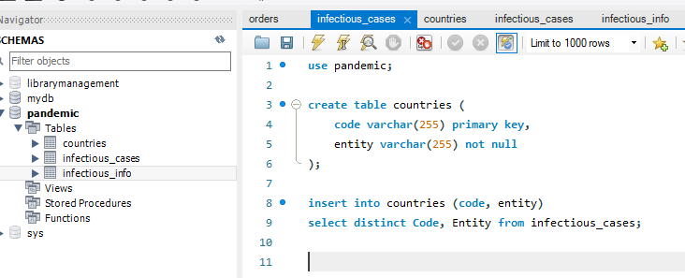

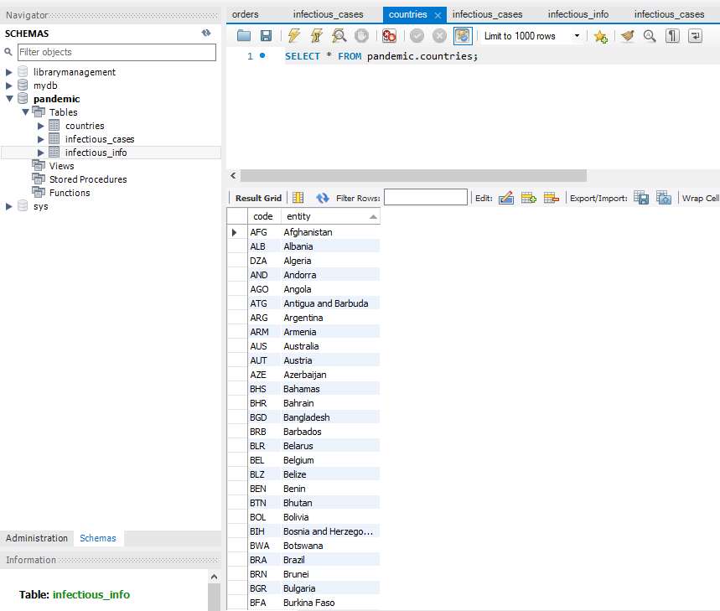

use pandemic;

create table infectious_info (

id int auto_increment primary key,

country_code varchar(255),

foreign key (country_code) references countries(code),

year int,

number_yaws varchar(255),

polio_cases int,

cases_guinea_worm int,

number_rabies varchar(255),

number_malaria varchar(255),

number_hiv varchar(255),

number_tuberculosis varchar(255),

number_smallpox varchar(255),

number_cholera_cases varchar(255)

);

insert into infectious_info

(country_code,

year,

number_yaws,

polio_cases,

cases_guinea_worm,

number_rabies,

number_malaria,

number_hiv,

number_tuberculosis,

number_smallpox,

number_cholera_cases

)

select

countries.code,

infectious_cases.Year,

infectious_cases.Number_yaws,

infectious_cases.polio_cases,

infectious_cases.cases_guinea_worm,

infectious_cases.Number_rabies,

infectious_cases.Number_malaria,

infectious_cases.Number_hiv,

infectious_cases.Number_tuberculosis,

infectious_cases.Number_smallpox,

infectious_cases.Number_cholera_cases

FROM infectious_cases

JOIN countries ON infectious_cases.Code = countries.code;

