**p5**

use pandemic;

drop function if exists CalculateYearDiff;

DELIMITER //

create function CalculateYearDiff(input_year INT)

returns int

no sql

begin

declare year_start date;

declare cur_date date;

declare year_diff int;

set year_start = CONCAT(input_year, '-01-01');

set cur_date = CURDATE();

SET year_diff = timestampdiff(year, year_start, cur_date);

return year_diff;

end//

DELIMITER ;

select CalculateYearDiff(2000) as year_diff;

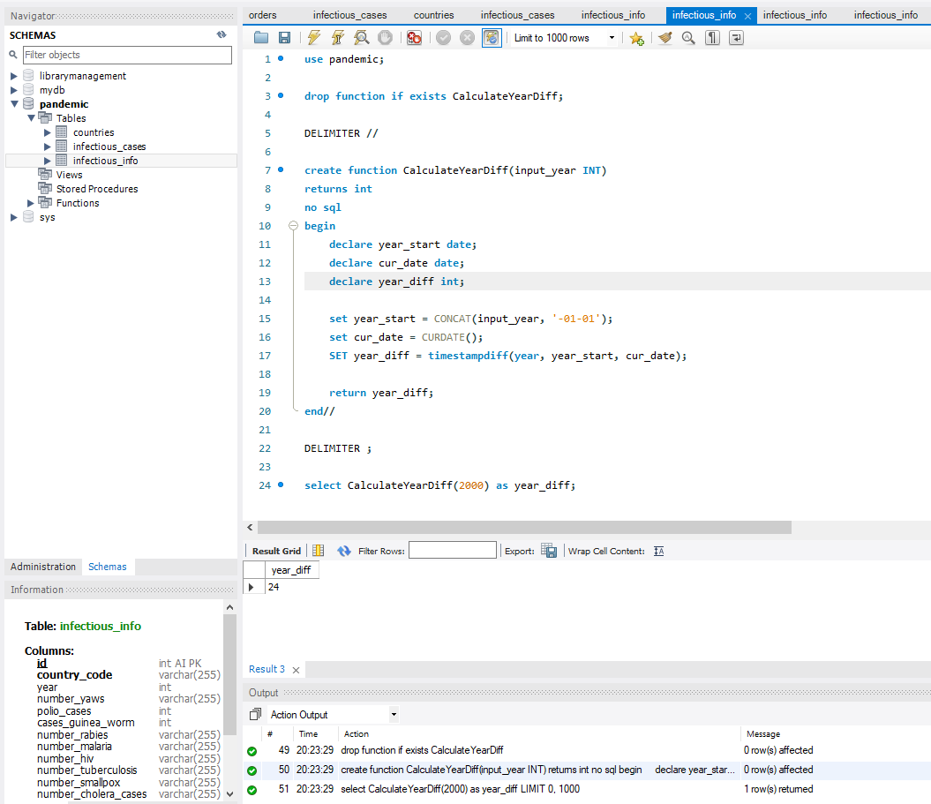

💡

use pandemic;

drop function if exists CountInfectious;

DELIMITER //

create function CountInfectious(total INT, period INT)

returns decimal(10, 2)

deterministic

no sql

reads sql data

begin

declare result decimal(10, 2);

if total != '' then

set result = total / period;

else

set result = 0;

end if;

return result;

end//

DELIMITER ;

select

CountInfectious(CAST(number_rabies as decimal), 12) as avg_per_month,

CountInfectious(CAST(number_rabies as decimal), 4) as avg_per_quarter,

CountInfectious(CAST(number_rabies as decimal), 2) as avg_per_half_year

from infectious_info

where number_rabies != '';

