р1_<https://docs.google.com/spreadsheets/d/1RF1Mdjnaz0D_srDVRCVPMQhz3DnU5ZuwEcL_N5KaoAw/edit?usp=sharing>

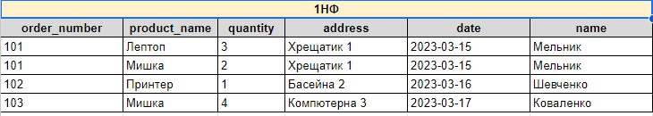

р2_<https://docs.google.com/spreadsheets/d/1x0J-SOxb0a_Ci0z7sUf0XxR34q6p5J7ip4FbN87wyM8/edit?usp=sharing>

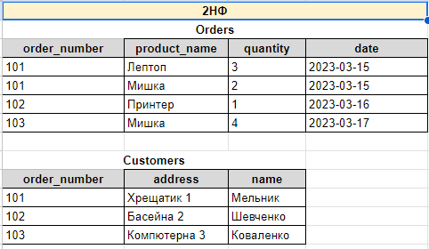

р3_<https://docs.google.com/spreadsheets/d/19-klRPfV_R3tr4TgZcDjkk8Tx6VPiIUUB9t3ImbOL6k/edit?usp=sharing>  
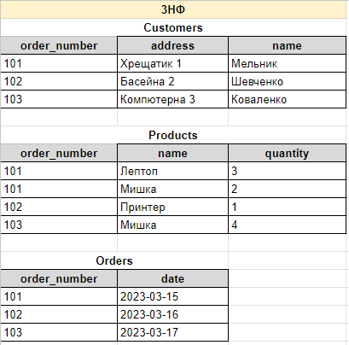

p4_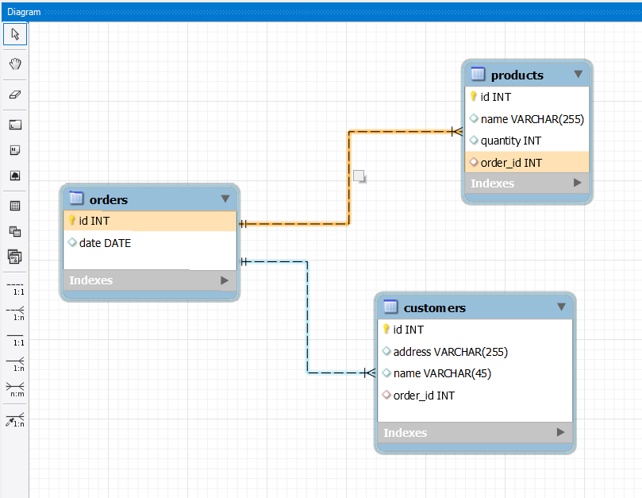

p5 