**p1.1**  
  
SELECT * FROM mydb.products;

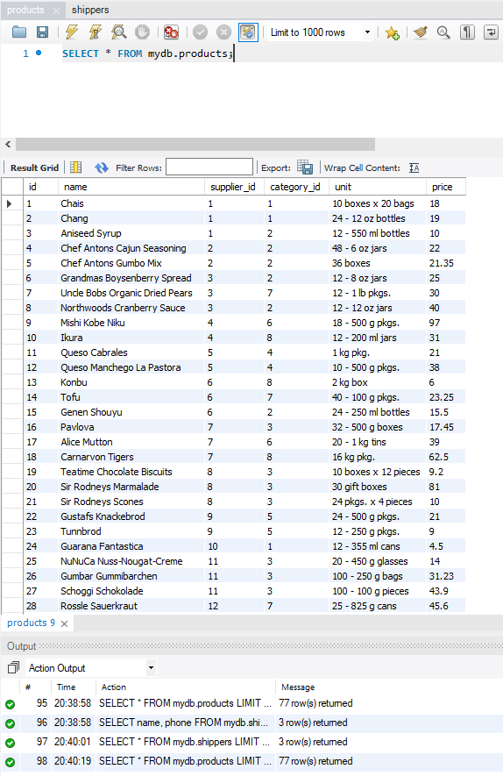

**p1.2**

**SELECT name, phone FROM mydb.shippers;**

