**p2**  
  
SELECT ROUND(AVG(price), 2) AS average_price, MAX(price) AS max_price, MIN(price) AS min_price

FROM mydb.products;

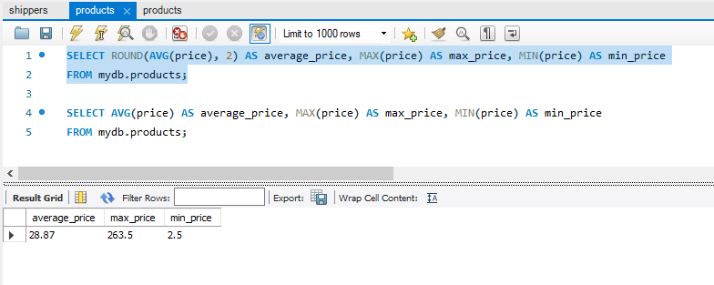

SELECT AVG(price) AS average_price, MAX(price) AS max_price, MIN(price) AS min_price

FROM mydb.products;

