**p5**  
  
SELECT supplier_id, COUNT(*) AS product_count, ROUND(AVG(price), 2) AS average_price

FROM mydb.products

group by supplier_id;

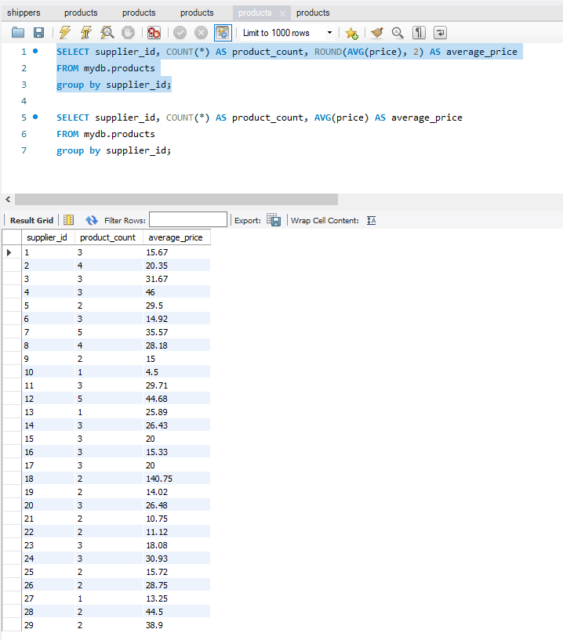

SELECT supplier_id, COUNT(*) AS product_count, AVG(price) AS average_price

FROM mydb.products

group by supplier_id;

