**p1.a**

create schema LibraryManagement;

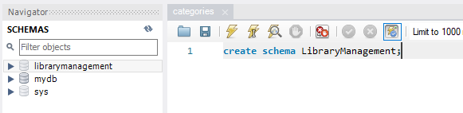

**p1.b**

use LibraryManagement;

create table authors (

author_id int auto_increment primary key,

author_name varchar(100)

);

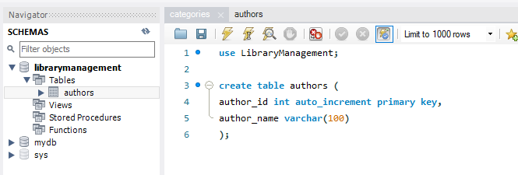

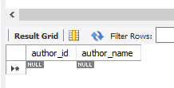

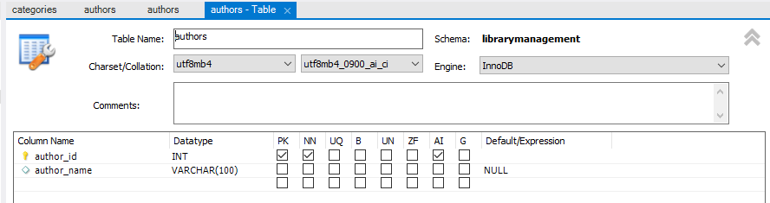

**p1.c**

use LibraryManagement;

create table genres (

genre_id int auto_increment primary key,

genre_name varchar(50)

);

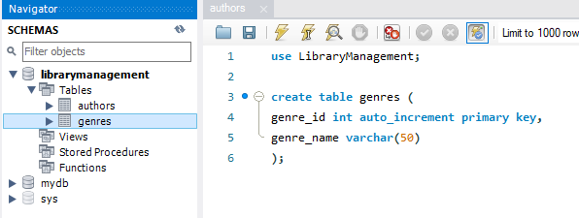

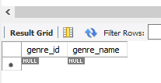

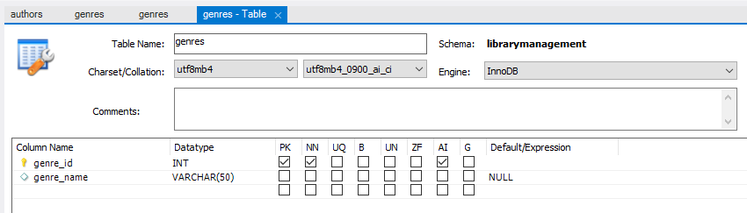

**p1.d**

use LibraryManagement;

create table books (

book_id int auto_increment primary key,

title varchar(255),

publication_year year,

author_id int,

genre_id int,

foreign key (author_id) references authors(author_id),

foreign key (genre_id) references genres(genre_id)

);

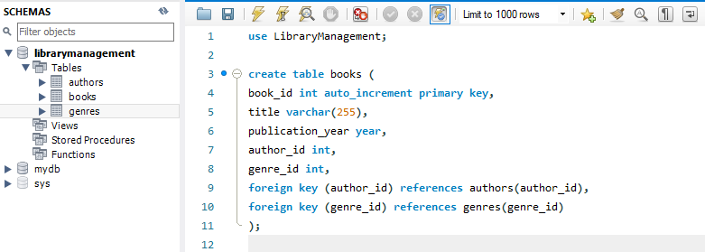

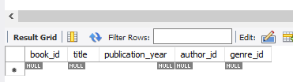

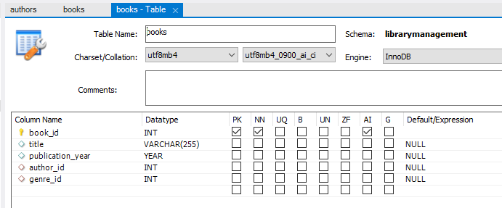

**p1.e**

use LibraryManagement;

create table users (

user_id int auto_increment primary key,

username varchar(255),

email varchar(255)

);

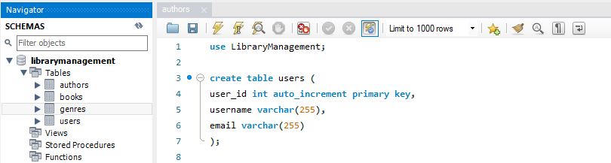

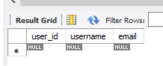

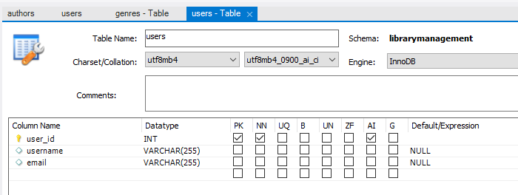

**p1.f**

use LibraryManagement;

create table borrowed_books (

borrow_id int auto_increment primary key,

book_id int,

user_id int,

foreign key (book_id) references books(book_id),

foreign key (user_id) references users(user_id),

borrow_date date,

return_date date

);

