**p2.b**

use librarymanagement;

INSERT INTO authors (author_id, author_name)

VALUES (1, 'Jake Knapp');

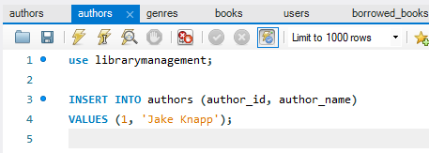

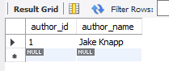

**p1.c**

use librarymanagement;

INSERT INTO genres (genre_id , genre_name )

VALUES (1, 'Business literature');

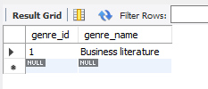

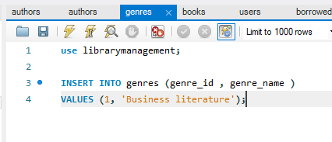

**p1.d**

use librarymanagement;

INSERT INTO books (book_id, title, publication_year, author_id, genre_id)

VALUES (1, 'Sprint', 2019, 1, 1);

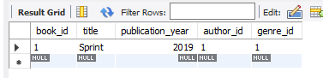

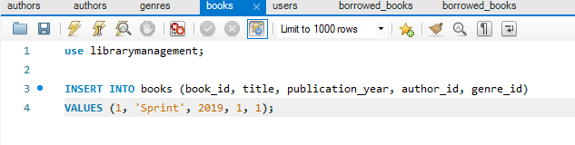

**p1.e**

use librarymanagement;

INSERT INTO users (user_id, username, email)

VALUES (1, 'Kateryna', 'tkachenko.city@gmail.com');

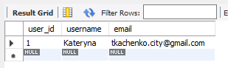

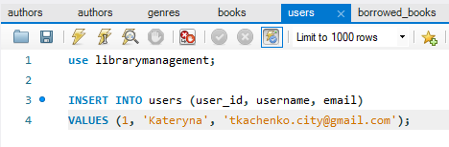

**p1.f**

use librarymanagement;

INSERT INTO borrowed_books (borrow_id , book_id, user_id, borrow_date, return_date)

VALUES (1, 1, 1, '2023-01-20', '2024-04-09');

