**p4.1**

use mydb;

select count(*) as total_rows

from order_details

inner join orders on order_details.order_id = orders.id

inner join customers on orders.customer_id = customers.id

inner join products on order_details.product_id = products.id

inner join categories on products.category_id = categories.id

inner join employees on orders.employee_id = employees.employee_id

inner join shippers on orders.shipper_id = shippers.id

inner join suppliers on products.supplier_id = suppliers.id;

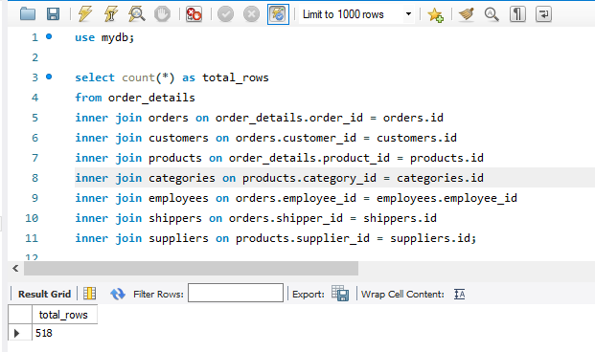

**p4.2**

use mydb;

select * from order_details

left join orders on order_details.order_id = orders.id

inner join customers on orders.customer_id = customers.id

inner join products on order_details.product_id = products.id

right join categories on products.category_id = categories.id

inner join employees on orders.employee_id = employees.employee_id

inner join shippers on orders.shipper_id = shippers.id

left join suppliers on products.supplier_id = suppliers.id;

В даному випадку при зміні деяких операторів на left та right кількість рядків не змінюється, але також Якщо використовувати LEFT або RIGHT JOIN, кількість рядків у вихідному наборі може змінитися в залежності від того, які записи відсутні у відповідних таблицях і які типи JOIN використовуються.

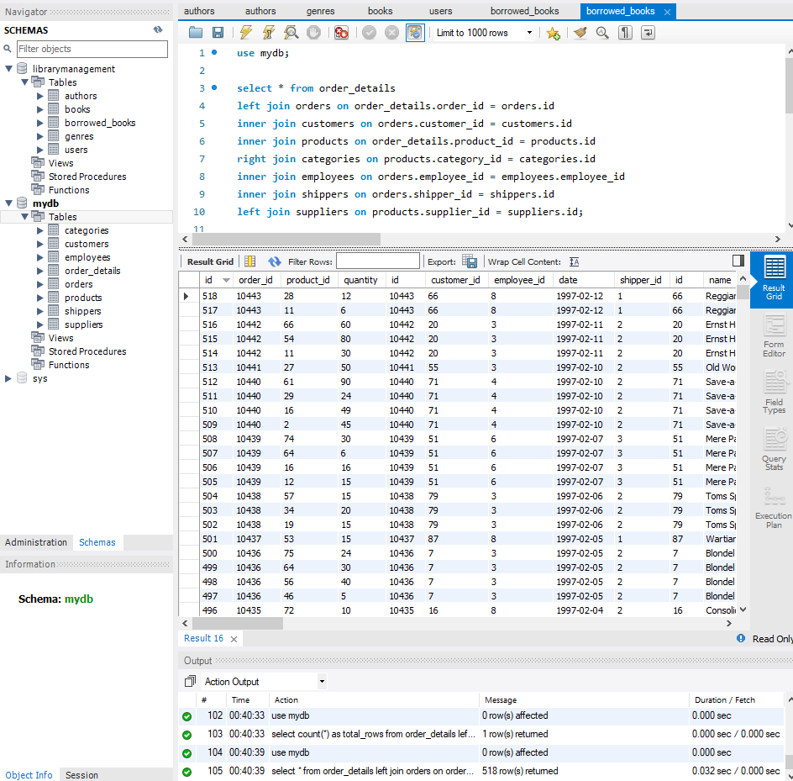

**p4.3**

use mydb;

select * from order_details

inner join orders on order_details.order_id = orders.id

inner join customers on orders.customer_id = customers.id

inner join products on order_details.product_id = products.id

inner join categories on products.category_id = categories.id

inner join employees on orders.employee_id = employees.employee_id

inner join shippers on orders.shipper_id = shippers.id

inner join suppliers on products.supplier_id = suppliers.id

where employees.employee_id > 3 AND employees.employee_id <= 10;

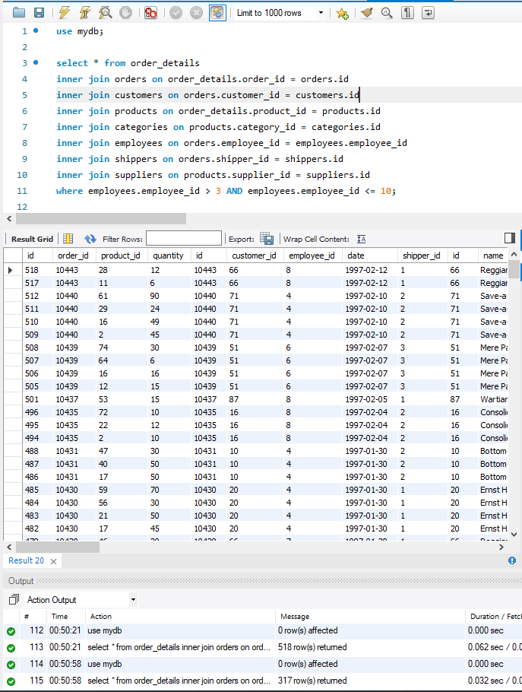

**p4.4**

use mydb;

select categories.name as category_name, count(*) as total_rows, avg(order_details.quantity) as average_quantity

from order_details

inner join orders on order_details.order_id = orders.id

inner join customers on orders.customer_id = customers.id

inner join products on order_details.product_id = products.id

inner join categories on products.category_id = categories.id

inner join employees on orders.employee_id = employees.employee_id

inner join shippers on orders.shipper_id = shippers.id

inner join suppliers on products.supplier_id = suppliers.id

where employees.employee_id > 3 AND employees.employee_id <= 10

group by categories.name;

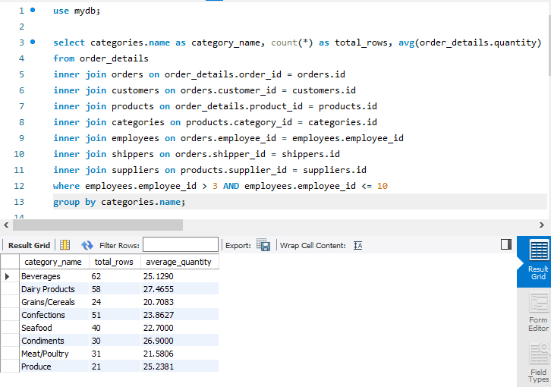

**p4.5**

use mydb;

select categories.name as category_name, count(*) as total_rows, avg(order_details.quantity) as average_quantity

from order_details

inner join orders on order_details.order_id = orders.id

inner join customers on orders.customer_id = customers.id

inner join products on order_details.product_id = products.id

inner join categories on products.category_id = categories.id

inner join employees on orders.employee_id = employees.employee_id

inner join shippers on orders.shipper_id = shippers.id

inner join suppliers on products.supplier_id = suppliers.id

where employees.employee_id > 3 AND employees.employee_id <= 10

group by categories.name

having avg(order_details.quantity) > 21;

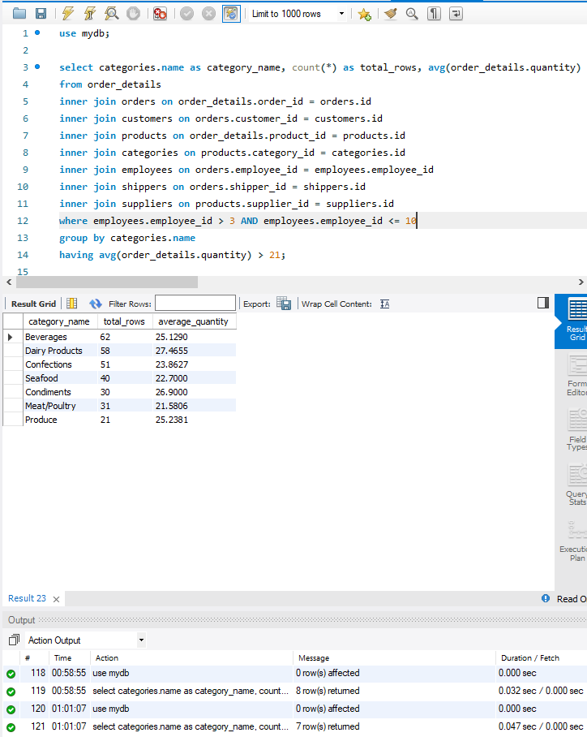

**p4.6**

use mydb;

select categories.name as category_name, count(*) as total_rows, avg(order_details.quantity) as average_quantity

from order_details

inner join orders on order_details.order_id = orders.id

inner join customers on orders.customer_id = customers.id

inner join products on order_details.product_id = products.id

inner join categories on products.category_id = categories.id

inner join employees on orders.employee_id = employees.employee_id

inner join shippers on orders.shipper_id = shippers.id

inner join suppliers on products.supplier_id = suppliers.id

where employees.employee_id > 3 AND employees.employee_id <= 10

group by categories.name

having avg(order_details.quantity) > 21

order by total_rows desc;

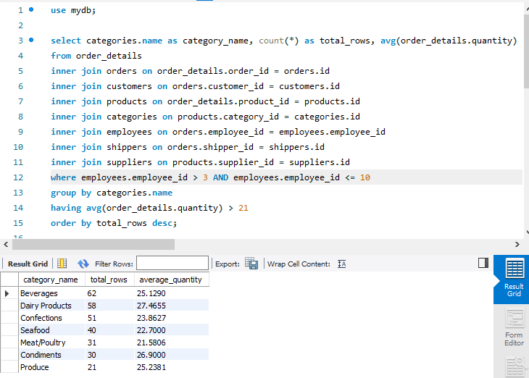

**p4.7**

use mydb;

select categories.name as category_name, count(*) as total_rows, avg(order_details.quantity) as average_quantity

from order_details

inner join orders on order_details.order_id = orders.id

inner join customers on orders.customer_id = customers.id

inner join products on order_details.product_id = products.id

inner join categories on products.category_id = categories.id

inner join employees on orders.employee_id = employees.employee_id

inner join shippers on orders.shipper_id = shippers.id

inner join suppliers on products.supplier_id = suppliers.id

where employees.employee_id > 3 AND employees.employee_id <= 10

group by categories.name

having avg(order_details.quantity) > 21

order by total_rows desc

limit 4 offset 1;

