**Robert Tkatchenko**

**SIT120 Introduction to Responsive Web Apps**

**Week 2: Responsive Web Design, HTML, CSS and JavaScript**

**Pass Task 1:**

***Write 1-2 sentences reflections of what is responsive web design and why it is important?***

Responsive web design is where the site design created responds to the needs and capabilities of the device of which it is viewed on. This is inclusive of layout changes and functionality capability and is only through HTML and CSS not a program or JavaScript.

**Pass Task 2:**

***Capture screenshots and write 1-2 sentences reflections about how to implement responsive web design with CSS***

Regarding CSS, it is important to use media queries to apply different styling for various screen sizes. For example, CSS width values set at a high value will not adjust to the viewport on a smaller device or absolute positioning may cause an element to be outside the viewport on small devices.

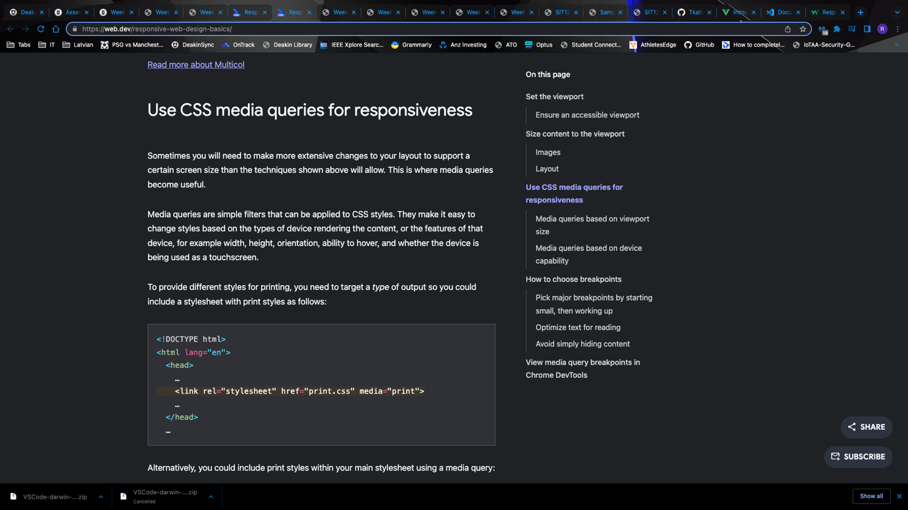

**Credit Task 3**

* ***Write 2 user stories for web page functions e.g., login function, produce a Figma demo (1 ~ 2 pages).***
* ***Write 1-2 sentences reflections about why user stories and UI/UX prototype is important in responsive web design?***

**Figma Demo: WorldDiscovery App**

* **Description**
  + World Discovery App allows a user to point the camera at whatever object they are curious about or don’t know what it is, and the app would search through databases and the internet to provide a quick response as to that the object is.
  + For example, someone sees a bug on the floor they don’t know the name of or know what is. They open the app, take a picture and within seconds the app tells what the object is.
* **Figma demo**

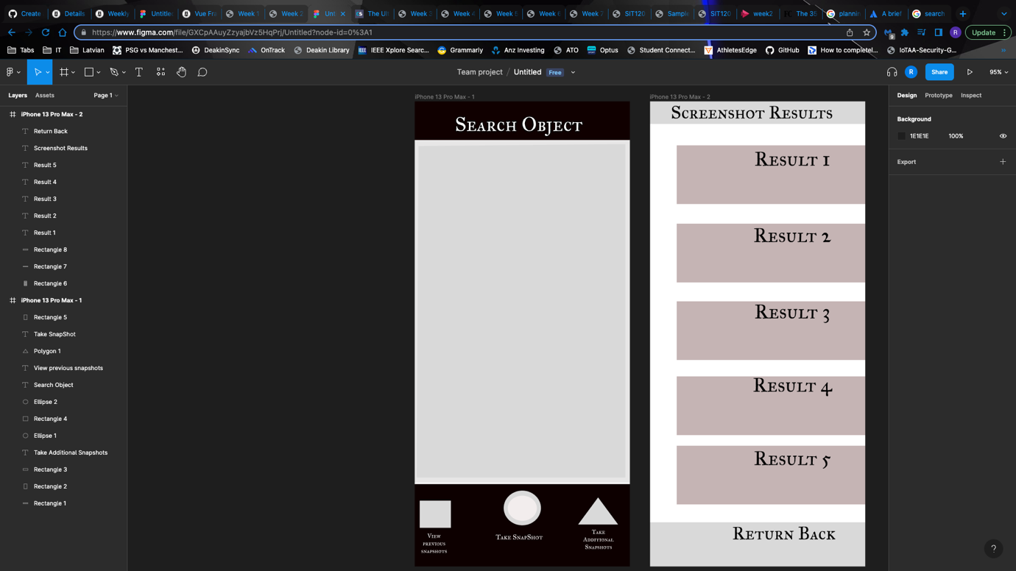

**User Story: 1**

|  |  |  |  |
| --- | --- | --- | --- |
| **Statement** | **Acceptance Criteria** | **Estimation** | **Priority** |
| As a WorldDiscovery App user, I want the camera function to load up quickly, so I don’t miss the capture. | 1. Once entered into the app, the camera should load up automatically 2. The camera should make up the whole screen 3. The app should make sure the snapshot is clear not blurry | According to the planning poker estimate approach this can be considered as:  **Story Points: 7** | Priority: 1  (High Priority) |

**User Story: 2**

|  |  |  |  |
| --- | --- | --- | --- |
| **Statement** | **Acceptance Criteria** | **Estimation** | **Priority** |
| As a WorldDiscovery App user, I want the discovery to be accurate and efficient | 1. When the user selects search, the results will need to be displayed 2. User should be able to enter single or multiple snapshots 3. The results should be displayed with a quick response time | According to the planning poker estimate approach this can be considered as:  **Story Points: 9** | Priority: 1  (High Priority) |

***Reflection:***

User stories and user experience and interface designs are important in responsive web design as it clearly defines the users who will interact with the website and as such what features are needed and how should the website be designed to interact with these users.